By : BADRI LAL MANMYA
ADDRESS : BRAHMANO KI SARERI
TEH – ASIND DIST- BHILWARA
RAJASTHAN PIN – 311026
MOBLE – 09571519276

VBM FUSION REACTOR
H – H CYCLE

INDEX
- Principle : How fusion occurs 6-7
- Principle : How to confine the desired charged particles . 8
- By how we can apply the principles. 9-10
- Ion source : A duoplasmatron 11
- Particle accelerator
(i) Minimum kinetic energy required for P-P fusion 12-14
(ii) A wideroe – type RF linac 15-16
- The tokamak 17-20
- The location of the point ‘ F ‘ [ the point of injection of charged particles ] to the tokamak . 21
- Magnetic field coils . 22-29
(i) Two horizontally lying semicircular coils that produce a magnetic field ( $\overset{→}{Bz}$ ) 24-25
(ii) Two vertically erected semicircular coils that produce a magnetic field ( $\overset{→}{By}$ ) 26-27
- The presence of magnetic fields is within into the main tokamak only .30
- The direction of the applied magnetic fields [ $\overset{→}{By}$ and $\overset{→}{Bz}$ ] in the main tokamak . 31
- Center of fusion : A governor of all the fusion reactions 32-36
- Center of plasma 37-38
VBM plasma
- Confinement of protons of 1st injected bunch :
(i) velocity with which each proton is injected 40-41
(ii) components of the momentum of the each injected proton with which it reaches at point ‘ F ‘ ( the point of injection ) 42-43
(iii) The forces acting on the proton ( when proton reaches at point ‘ F ‘ where the two perpendicular magnetic fields are applied ) 44-45
(iv) Radius of the circular orbit followed by the proton. 46
(v) the angles that make the resultant force $\overset{→}{Fr}$ [ acting on the proton when the proton is at point ‘ F ‘ ] with positive x,y, and z axes . 48-49
(vi) The Cartesian coordinates of the points P₁ ( x₁ , y₁ , z₁ ) and P₂ ( x₂ , y₂ , z₂ ) located on the circumference of the circle obtained by the confined proton . 50-52
- The fusion reactions that will occur during H – H cycle . 53
- How fusion occurs 54
- Proton – proton fusion reaction
(1) Formation of compound nucleus .
(i) Interaction of nuclei 55-56
(ii) formation of homogeneous compound nucleus 57-58
(iii) formation of lobes within into the homogeneous compound nucleus or the transformation of the homogeneous compound nucleus into the heterogeneous compound nucleus . 59-62
(iv) Final stage of the heterogeneous compound nucleus 63-65
calculations for the compound nucleus
(i) Just before fusion, the loss in the kinetic energy of the injected proton 66
(ii)Just before fusion , the components of the momentum of the injected proton that is reaching in the well of the confined proton at point ‘ F ‘ . 67-68
(iii) components of the momentum of the compound nucleus ($\overset{→}{Pcn}$) . 69-70
(iv) velocity of the compound nucleus . 71-73
(2) The splitting of the heterogeneous compound nucleus .
(i) The splitting of the heterogeneous compound nucleus . 74-75
(ii) inherited velocity ( $\overset{→}{Vinh}$) of the produced particles- deuteron and positron 76
(3) Propulsion of the particles
(i) inherited kinetic energy of the reduced mass . 77
(ii) total energy ( $\overset{→}{Et}$) carried by the neutrino 78-79
(iii) increased energy of the deuteron and positron 80
(iv) The final velocity of the deuteron and positron 81
- Confinement of the produced deuteron and positron
(1) confinement of the produced deuteron
(i) Forces acting on the deuteron 84-85
(ii) Radius of the circular orbit followed by the deuteron 86-87
(ii) The Cartesian coordinates of the points P₁ ( x₁ , y₁ , z₁ ) and P₂ ( x₂ , y₂ , z₂ ) located on the circumference of the circle obtained by the confined deuteron . 90-91
(2) confinement of the positron 92-95
(3) electron gun 96
(4) annihilation of the positron 97-102
18. proton – deuteron fusion reaction 103-146
19. proton – deuteron – proton fusion reaction 147-191
20. The power produced . 192-194
21. The horse pipe and the extraction of the undesired charged particle he-3 195
22. Summary 196-200
Either the charged particles are confined or not confined , the Cartesian coordinates of the charged particles and the extraction of the undesired charged particles ( helium -3 ) with the help of horse pipe .
23. Mode of output . 202

Principle : How fusion occurs
Verdict charged particles fuse to form a homogeneous compound nucleus. The homogeneous compound nucleus is unstable. So, the central group of quarks [ that which with gluons and other groups of quarks compose the homogeneous compound nucleus ] with its surrounding gluons to become a stable and the just lower nucleus [ a nucleus having lesser number of groups of quarks and lesser mass (or gluons ) than the homogeneous nucleus ] than the homogeneous one, includes the other nearby located groups of quarks with their surrounding gluons and rearrange to form the ‘A’ lobe of the heterogeneous compound nucleus. While the remaining groups of quarks [ the groups of quarks that are not involved in the formation of the lobe ‘A’ ] to become a stable nucleus includes their surrounding gluons ( or mass) [ out of the available mass ( or gluons ) that is not involved in the formation of the lobe ‘A’ ] and rearrange to form the ‘B’ lobe of the heterogeneous compound nucleus. The remaining gluons [ the gluons (or the mass) that are not involved in the formation of any lobe] keeps both the lobes joined them together. Thus , due to formation of two lobes within into the homogeneous compound nucleus, the homogeneous compound nucleus transforms into the heterogeneous compound nucleus.

The heterogeneous compound nucleus, due to its instability, splits according to the lines parallel to the direction of the velocity of the compound nucleus ( $\vec{Vcn}$ ) into three lobes. Where the each separated lobe represent a separated particle. So, the two particles that represent the lobes ‘A’ and ‘B’ are stable while the third particle that represent the remaining gluons ( or the reduced mass) is unstable . According to law of inertia each particle that has separated from the compound nucleus has an inherited velocity ( $\overset{→}{Vinh}$) equal to the velocity of the compound nucleus ( $\vec{Vcn}$ ) .

Principle : How to confine the desired charged particles
Verdict charged particles with different momentum by charge ratio when injected to a point ‘F’ where two uniform magnetic fields perpendicular to each other are applied the charged particles follow the confined circular paths of different radii passing though the common tangential magnetic field point ‘F’ (or the point of injection) by time and again.

Where ,
r α $\frac{mv}{q}$
Where , the radius of the circular orbit followed by the confined charged particle is directly proportional to the momentum by charge ratio.
Or
r = $\frac{2E}{Fr}$^{K}
Where ,
- E_{K} = Kinetic energy of the confined particle.
- F_{r} = The resultant force (net force ) acting on the charged particle due to the magnetic fields.

By how we can apply the principle : -
- Injection of bunches of charged particle :-
if the bunches of charged particles of same species (Protons) are injected to a point ‘F’ where the two magnetic fields are applied , the charged particles ( the Protons ) of the first bunch will undergo to a confined circular path and will pass through this point ‘F’ [ point of injection ] by time and again and thus the confined protons will be available for the protons of later injected bunch ( reaching at point ‘ F ‘ ) to be fused with at point ‘F’ .
2 Occurrence of fusion at point ‘F’ : -
As the proton of later injected n^{th} bunch reaches at point ‘F’ , it fuses with the proton of the first injected bunch ( that has already confined) passing through the point ‘F’ .

- Confinement of the produced useful charged nucleus : -
At point ‘F’ , the two protons fuse and form a compound nucleus. The compound nucleus splits and the deuteron (and the positron) is produced. The produced deuteron , due to applied magnetic fields , undergo to a circular orbit. The produced deuteron starts its circular motion from point ‘F’ [ the point of production of deuteron ] and pass through this common tangential magnetic field point ‘F’ [ or the point of production of nucleus ] by time and again during its circular motion . Thus the produced deuteron is confined and so the produced deuteron will be available at point ‘F’ ( point of injection ) for the proton of later injected bunch (that is reaching at point ‘F’ ) to be fused with .
- Exhausting the produced non – useful charged nuclei : -
The produced positron annihilates with free electrons and produce two gamma ray photons that in turn heat the tokamak .
The produced helium -3 nucleus starts its circular motion from point ‘F’ (0,0,0) or the point p₁ ( x₁ , y₁ , z₁ ) and reaches at point p₂ ( x₂ , y₂ , z₂ ) located on the circumference of the circle to be followed by the helium-3 nucleus . As the helium-3 nucleus reaches at point p₂ ( x₂ , y₂ , z₂ ) , it enters into the mouth of the horse pipe that is located at the point p₂ ( x₂ , y₂ , z₂ ) and thus the helium-3 nucleus is extracted out of the tokamak with the help of vacuum pumps .
Thus we can establish a steady state controlled nuclear fusion reactor based on H-H cycle .

Ion source

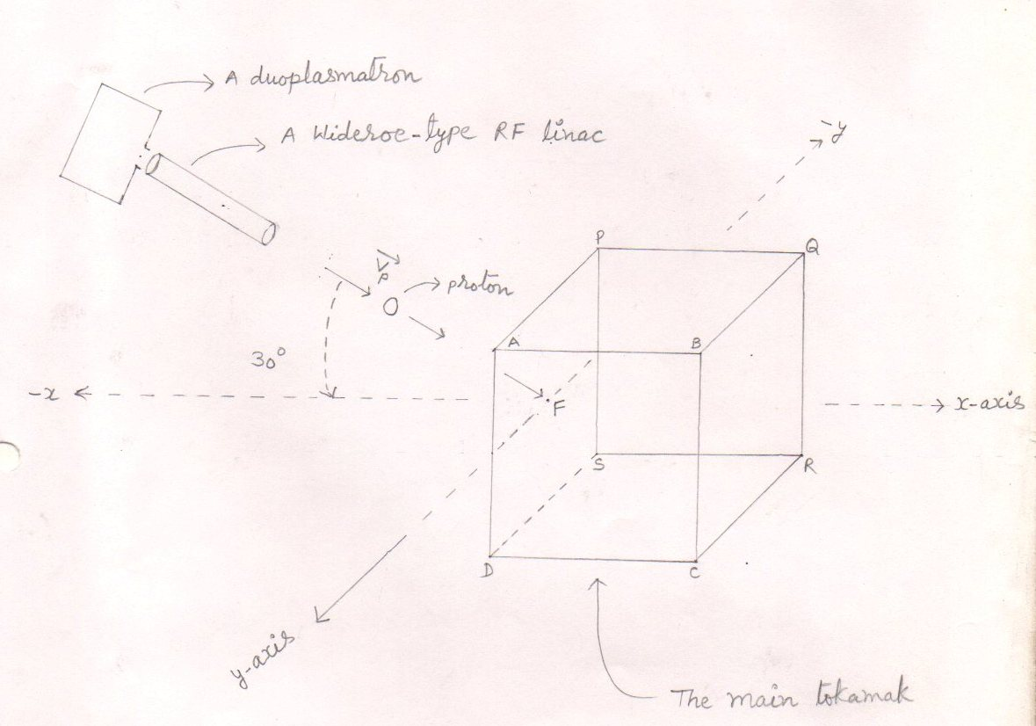
Fig. (1)
Source : - Ion source is a duoplasmatron that produce the 3 x 10¹⁹ Protons per second . The produced bunches of protons enters into a wideroe – Type RF linac .

Particle accelerator
- Minimum kinetic energy ( E_{m}) required for fusion :
- Tunneling – tunneling is a consequence of the Heisenberg uncertainty principle which states that we know the velocity of the particle the less we know about its position in the space and vice versa
The uncertainty in the position is such that
when a proton collides with another proton , it may find itself on the other side of the coulomb barrier and in the attractive potential well of the strong force .
- Work done to overcome the coulomb barriers

U = kz₁z₂q² / r₀
So, the kinetic energy of the particle should be equal to
E_{m} = ½ mv² = kz₁z₂q² / r₀

Rewriting the kinetic energy of the particle in terms of momentum
½ mv² = p² / 2m = (h/λ) ² / 2m
If we require that the nuclei must be closer than the de-broglie wavelength for tunneling to take over nuclei to fuse . (r_{o} = λ)
kz₁z₂q² / r₀ = kz₁z₂q² / λ
where ,
½ mv² = (h/λ) ² / 2m = kz₁z₂q² / λ
So, h²/λ²2m = kz₁z₂q² / λ
Or lambda (λ) = ½ h²/ kz₁z₂q²m
If we use this wavelength as the distance of closest approach , the kinetic energy required for fusion is –
E_{m} = ½ mv² = kz₁z₂q² / r₀ = kz₁z₂q² / λ = kz₁z₂q² x 2kz₁z₂q²m / h²

E_{m} = 2k² z₁² z₂² q⁴m / h² eq(1)
Where m is the mass of the penetrating ( injected ) nucleus .

- Minimum kinetic energy required for proton – proton fusion :

E_{m} = 2 K² Z₁² Z₂²q⁴m from eq.(1)
h²

Z₁ = Z₂ = 1
m = m_{p} = 1.6726 x 10⁻²⁷ kg
E_{P-P} = 2 X (9X10⁹)² X 1² X 1² X (1.6 X 10⁻¹⁹)⁴ X 1.6726 X 10⁻²⁷ J
(6.62 X 10⁻³⁴ )²
E_{P-P} = 1775.77132 X 10¹⁸ X 10⁻⁷⁶ X 10⁻²⁷ J
43.8244 X 10⁻⁶⁸
E_{P-P} = 40.52015133 X 10⁻¹⁷ J (1ev = 1.6 x 10⁻¹⁹ J)
E_{P-P} = 25.3250 X 10² ev
E_{P-P} = 2.5 kev eq.(2)

E_{P-P} = 0.0025 Mev (1ev = 1.6 x 10⁻¹⁹ J)
- Minimum kinetic energy required for proton –deuteron fusion :

E_{P-D} = E_{P-P} X Z₂²
Z₂ = 1
- E_{P-D} = 2.5 X 1² kev
E_{P-D} = 2.5 kev eq.(3)
E_{P-D} = 0.0025 mev

- For a wideroe – type RF linac
K_{n} = n q v_{o} T_{tr}
If parameters are
n = 4 , q = 1.6 x 10⁻¹⁹ c
v_{o} = v_{max} = 40 KV
T_{tr} = sinψ₀ = 0.64
K₄ = 4x 1.6 x 10⁻¹⁹ x 40x 0.64 KJ
K₄ = 102.4 Kev = 0.1024 Mev eq.(4)
- Length of the wideroe – type RF linac
1. length of the first drift tube
L₁ = n½ x $\frac{\sqrt{qv\frac{}{max}{\sin{ψ \frac{}{0}}}}}{}$ / $\sqrt{2m}$
f_{rf}
Where , f_{rf} = 7 x 10⁶ H_{Z} , n = 1
L₁ = $\frac{\sqrt{1}}{7X10^{6}}$ x $\frac{\sqrt{{1.6 X 10}^{-19}X 40 X {10}^{3} X 0.64 }}{}$ / $\sqrt{2 x 1.6726 x 10}$ ⁻²⁷ m

L₁ = $\frac{\sqrt{1}}{7X10^{6}}$ x $\frac{\sqrt{409.6 X{10}^{10} }}{}$ / $\sqrt{3.3452}$
L₁ = $\frac{1}{7X10^{6}}$ X $\sqrt{122.432141575 X}{10}^{10}$
L₁ = $\frac{11.0649058547 X{10}^{6}}{7 X {10}^{6}}$
L₁ = 1.5807 X 10⁻¹ m
L₁ = 0.1580 m eq.(5)
L₂ = $\sqrt{2}$ x L₁
L₂ = 1.4142 x 0.1580 m
L₂ = 0.2234 m eq.(6)

L₃ = $\sqrt{3}$ x L₁
= 1.732 x 0.1580
=0.2736 m eq.(7)
L₄ = $\sqrt{4}$ x L₁
= 2 x 0.1580 m
= 0.316 m eq.(8)
L = L₁ + L₂ + L₃ + L₄

L = 0.158+0.2234+0.2736+0.316 m From eq.(5,6,7,8)
L = 0.971 m

Conclusion : A wideroe – type RF linac accelerates the each proton with 102.4 kev enrgy .
Note : - A wideroe- type RF linac is attached to the ion source [ see fig. (1) ]

The tokamak
- The takamak has two parts – one is the main tokamak and the another is the extended tokamak .
- The points A, B , C , D , P , Q , R , and S represents the corners of the walls of the main tokamak while all the other remaining points represents the corners of the walls of the extended tokmak .
- The tokmak is made up of steel .
- The graphite of the boron is used as the inner liner of the tokamak to absorb the thermal neutrons .
see fig . ( 2 )

The main tokamak with its extension

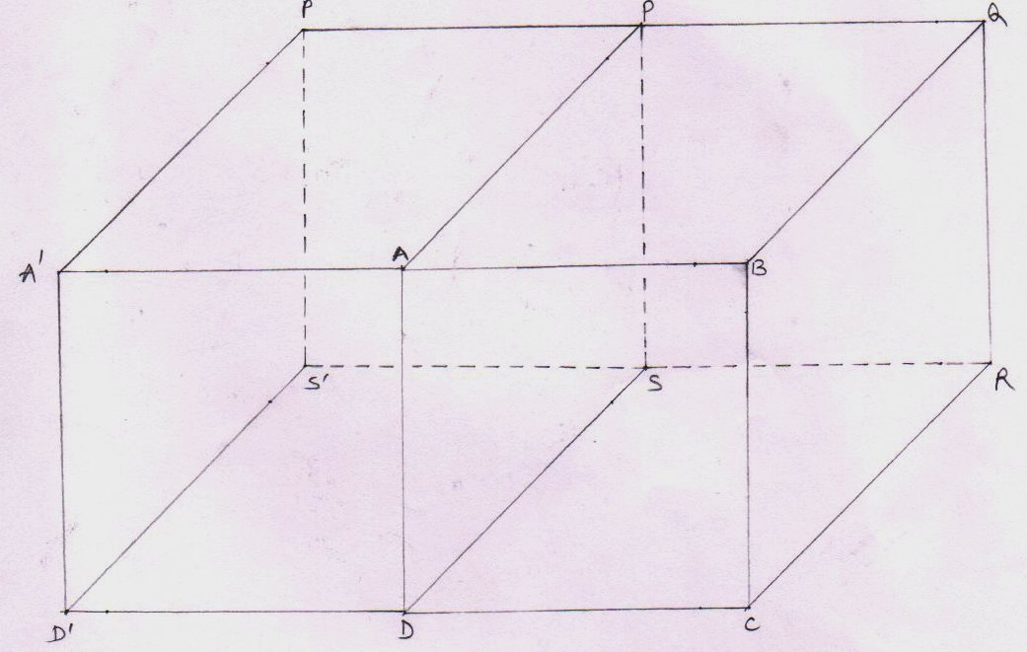
Extended walls of the tokamak The Main tokamak

Fig (2)
- The points A , B, C , D , P , Q , R and S make the main tokamak while all the other points make the arm of the main tokamak ( or the extension of the tokamak ) .
- Where ,
AB = BC =CD = DA = AP =PQ = QB = QR= RS = SP = SD =RC = 1.6 m
And also
The length of each extended wall = 1.6 m
The breadth of the extended wall = 1.6 m

Total surface area of the tokamak
- Surface area of the walls of the main tokamak
- Surface area of the walls
I ABCD = length x breadth = 1.6m x 1.6m = 2.56 m²
Ii PQRS = 1.6m x 1.6m = 2.56 m²
Iii APQB = 1.6m x 1.6m = 2.56 m²
IV DSRC = 1.6m x 1.6m = 2.56 m²
V BQRC = 1.6m x 1.6m = 2.56 m²
- So , the total surface area of the main tokamak = 12.80 m² eq.(9)
- The points APSD do not represent a wall . it is a blank place that allows the injected protons to enter into the main tokamak . (or the region where the magnetic fields are applied .

ii Surface area of the extended walls of the tokamak : -
- The surface area of the each extended wall
= 1.6m x 1.6m =2.56 m²
- Total no of extended walls = 5
- Total surface area of the extended walls
= surface area of the extended wall x total no of extended walls
= 2.56 m² x 5
= 12.80 m² eq.(10)
iii. Total surface area of the tokamak = surface area of the main tokamak + surface area of the extended walls
= 12.80 m² +12.80 m² from eq.(9,and 10) respectively
= 25.6 m²

The location of the point of injection ‘ F ‘ [ or the center of fusion ‘ F’ ]
point of injection is the point ‘ F ‘ through which the injected charged particles enters into the main tokamak which in turn is covered up by the two magnetic fields perpendicular to each other.
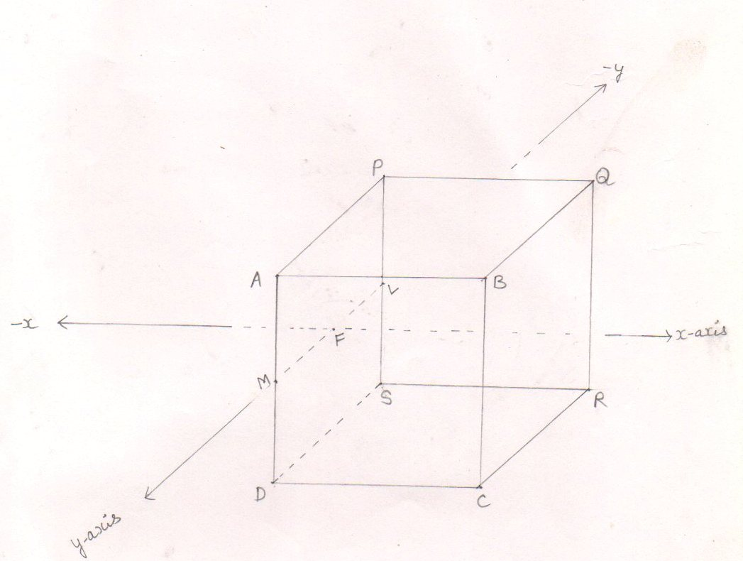
fig (3)
Here MF = 0.80 m and LF = 0.80 m
AM =0.80 m and MD = 0.80 m
PL = 0.80 m and LS =0.80 m
AP = AB = AD = =1.6 m

Magnetic field coils
VBM fusion reactor has two pairs of semicircular magnetic field coils . out of them , one pair of semicircular magnetic field coils is vertically erected while another pair of semicircular magnetic field coils is horizontally lying .
1 Vertically erected magnetic field coils :
In a VBM fusion reactor , there are two vertically erected semicircular magnetic field coils that act as a helmholtz coil.
The distance between the two vertically erected semicircular coils is equal to the radius of any one of the semicircular magnetic field coil .
i.e. d = r = 2.5 m
The vertically erected semicircular magnetic field coils acting as a helmholtz coil produce a uniform magnetic field ( $\overset{→}{By}$ ) parallel to y – axis . [ see fig . (4) ]
- horizontally lying magnetic field coils :
in a VBM fusion reactor , there are two horizontally lying semicircular magnetic field cols that acts as a helmholtz coil .
the distance between the two horizontally lying semicircular magnetic field coils is equal to the radius of any one of the semicircular magnetic field coil .
i.e. d = r = 2.2 m
The horizontally lying semicircular magnetic field coils acting as a helmholtz coil produce a uniform magnetic field ($\overset{→}{Bz}$ ) parallel to z –axis .
[ see fig . (5) ]

Magnetic field due to a semicircular coil at point x is –
B₁ = µ _{o} /4π x πR²ni / (R² + x² ) ^{3/2}

Magnetic fields due to a semicircular coil at the x , If x = R/2

B₁ = µ _{o} /4π x πR²ni / (R² + R² / 4 ) ^{3/2} [ $∴$x = R / 2 ]

= 8 / 5$\sqrt{5 }$ x µ _{o} ni / 4R eq (11)

So, the magnetic field in the mid plane of the two semicircular coils acting as a helmholtz coil is

B_{T} = B₁ + B₂

= 2 B [ $∴$ B₁ = B₂ = B ]

= 16 / 5$\sqrt{5 }$ x µ _{o} ni / 4R from eq. (11)

= 1.43 x µ _{o} ni / 4R
= 1.43 B_{center} [ B_{center} = µ _{o} ni / 4R ] eq.(12)

- Magnetic field (B_{z}) in the mid plane of the two horizontally lying semicircular coils acting as a helmholtz coil is -

B_{z} = 1.43 B from eq.(12)
Centre

B = µ₀ ni
Centre 4 R

Where , µ₀ = 4 π x 10⁻⁷
n = 490 turns
i = 10 KA = 10⁴ Amperes
R = 2.2 m
- B_{centre} = 4 x 3.14 x 10⁻⁷ x490 x 10⁴ Tesla
4 x 2.2
- B_{centre} = 0.69936 Tesla
- B_{Z} = 1.43 B_{centre}
- B_{Z} = 1.43 X 0.69936 Tesla
= 1 Tesla eq.(13)
see fig. (4)

The horizontally lying semicircular magnetic field coils acting as a helmholtz coil.

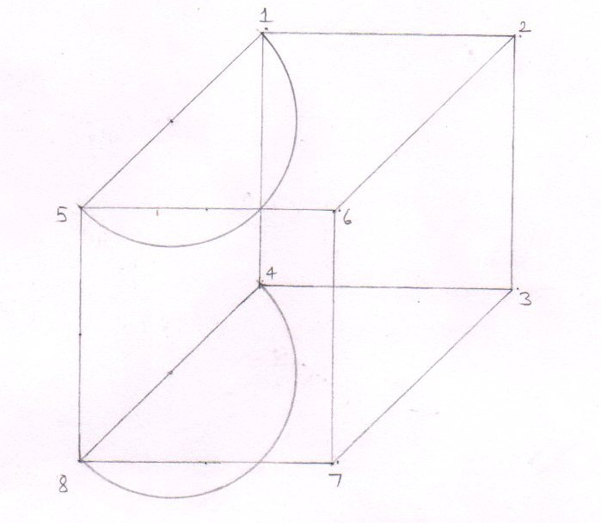

Horizontally lying semicircular coil
fig.(4)

- The magnetic field coils are exterior to the main tokamak so, the area covered up by points 1, 2, 3 ,4 , 5, 6, 7 and 8 is greater than the area covered up by the points A , B, C ,D , P , Q , R and S of the main tokamak .

- Magnetic field ( B_{Y} ) in the mid plane of the two vertically erected semicircular coils acting as a helmholtz coil is –

B_{y} = 1.43 B_{centre} from eq.(12)

B_{centre} = µ₀ nI
4 R
Where ,
n = 557 turns
i = 10 KA = 10⁴ Amperes
R = 2.5 m

B_{centre} = 4 x 3.14 x 10⁻⁷ x 557 x 10⁴ Tesla
4 x 2.5

B_{centre} = 699.592 x 10⁻³ tesla
= 0.699592 Tesla
B_{y} = 1.43 B_{centre}

= 1.43 x 0.699592 Tesla
B_{y} = 1 Tesla eq.(14)
see fig.(5)

The vertically erected semicircular magnetic field coils that act as a helmhotz coil

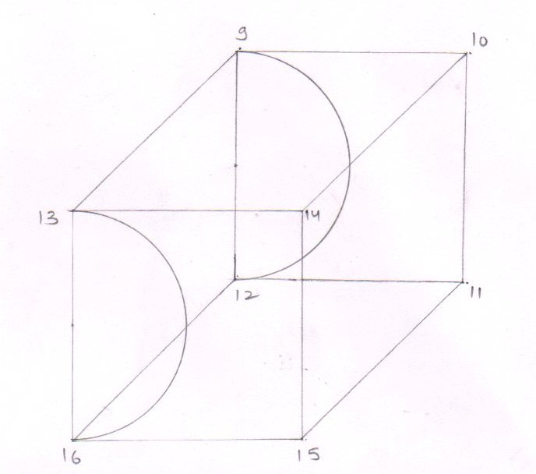

vertically erected semicircular coil

fig(5)

The vertically erected magnetic field coils are exterior to the horizontally lying semicircular magnetic field coils which are in turn exterior to the main tokamak .

The directions of magnetic fields
- The direction of flow of current in the horizontally lying semicircular coils is clockwise so that the direction of the produced magnetic field is according to negative z – axis ( i. e. downward )

As B_{z} = 1 Tesla from eq.(13)

So $\overset{→}{Bz}$ = -1 Tesla eq.(15)
see fig (6)

- The direction of flow of current in the vertically erected magnetic coils is anticlockwise so that the direction of the produced magnetic field is according to positive y – axis .

As B_{y} = 1 Tesla from eq.(14)
So $\overset{→}{By}$ = 1 Tesla eq.(16)
see fig.(6)

The direction of flow of current in the magnetic field coils .
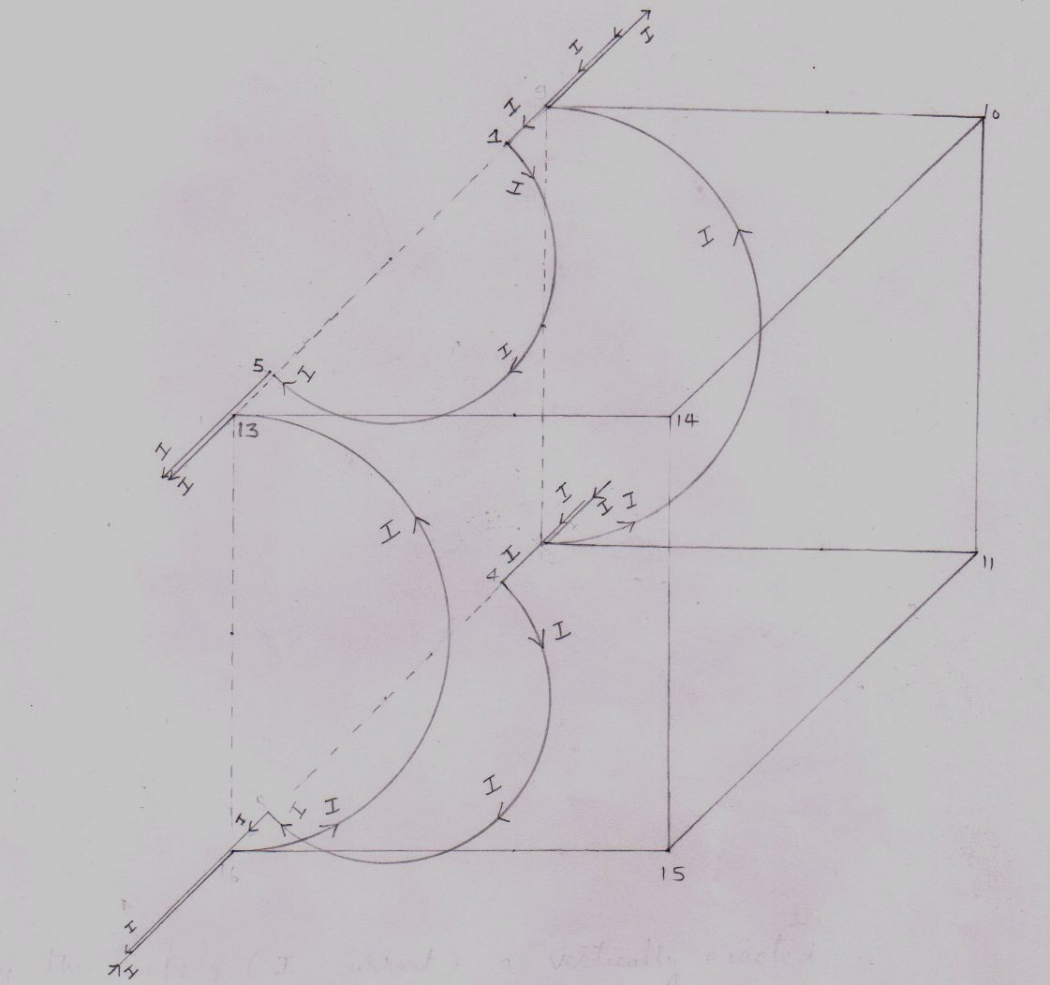
fig.(6)

In the horizontally lying coils the current flows in clockwise direction while in the vertically erected coils the current ( i ) flows in anticlockwise direction .

Magnetic fields within into the main tokamak : -
We have denoted the presence of magnetic fields by the cross [ x ] sign .

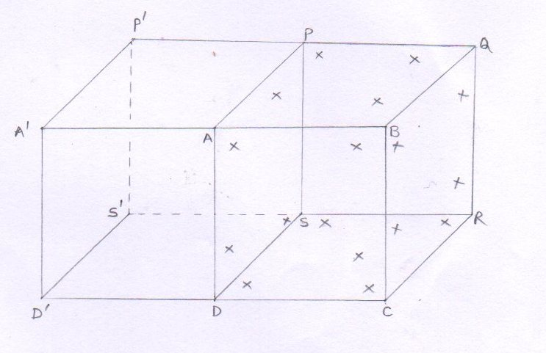
fig(7)
- The uniform magnetic fields [ $\overset{→}{By}$ and $\overset{→}{Bz}$ ] are applied within into the main tokamak only .

- Within into the ‘ extension of the tokamak ‘ there the no any magnetic field is applied . so , that until the injected proton reaches at point ‘ F ‘ [ located within into the ‘ APSD ‘ area of the main tokamak ] the injected proton is not influenced by the magnetic lines of force .

The direction of the applied magnetic fields [$\overset{→}{By}$and $\overset{→}{Bz}$ ] in the main tokamak .
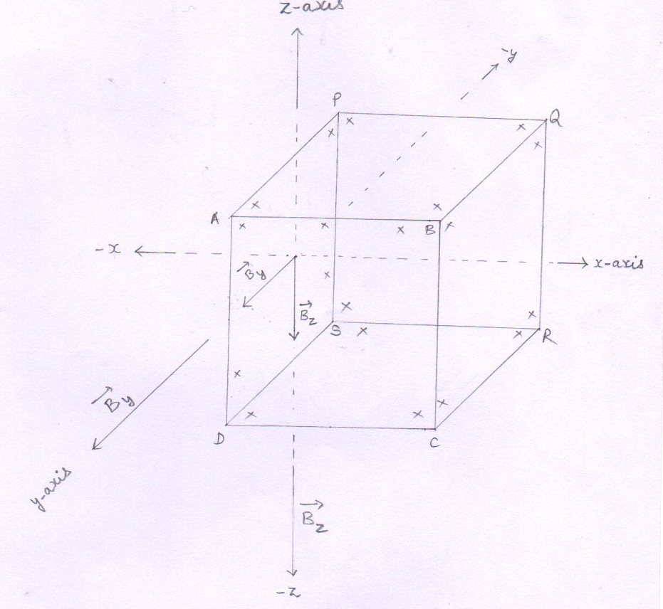
fig.(8)
- Where
$\overset{→}{By}$ = 1 Tesla from eq.(16)
$\overset{→}{Bz}$ = -1 Tesla from eq.(15)
Where, $\overset{→}{By}$ and $\overset{→}{Bz}$ are perpendicular to each other

Center of fusion : -
center of fusion is actually a point where two charged particles fuse .
1. For the VBM fusion reactor –The center of fusion is a point from where a charged particle ( either it is injected or produced ) undergoes to a confined circular path and passes from this point by time and again and thus available for another injected particle (reaching at this point ‘ F ‘ ) for fusion .
2. The location of center of fusion [ or the point of injection ] : The center of fusion is a point located within into the APSD area of the main tokamak where the two magnetic fields perpendicular to each other are applied and where the charged particle is injected to.
within into the tokamak , the center of fusion is the first point from where the injected charged particle experiences magnetic lines of force and starts its circular motion .
thus the center of fusion and the point of injection of charged particle are the same – the point ‘ F ‘
see fig.(3)

3.. Number of centers of fusion : The point ‘ F ‘
[ From where a proton starts it’s circular motion] is acting as a center of fusion .
so, the total number of centers of fusion is equal to the number of protons that contains the bunch.

4..Nature of center of fusion ( F ) : -
As the magnetic field is tangential in nature so the point ‘ F ‘ [ the center of fusion ] that is located within into the magnetic fields is a tangential point of a number of circular orbits ( followed or to be followed by the charged particles ) of different radii .
see fig (10)

5. The circular orbits followed by the confined particles –
The confined proton and the confined deuteron passes through the tangential magnetic field point ‘ F ‘ .

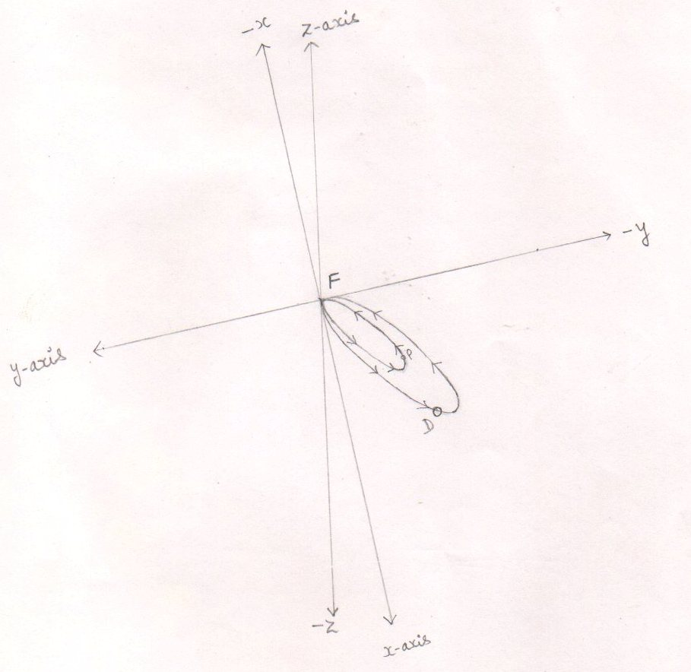
fig (9)
- The outer circular path denotes the circular orbit followed by the confined deuteron
- The inner circular path represents the circular orbit followed by the confined proton .
- Both the circular orbits lies in the plane made up of positive x – axis , negative y-axis and the negative z – axis .

6. Center of fusion ( F ) is a platform where the fusion is a certainty : -
Form the point ‘ F ‘ [ The center of fusion ] the proton (s) of earlier bunch will undergo to confined circular path and will pass through this point ‘ F ‘ by time and again until it fuses with the proton of later injected bunch .
Similarly , the center of fusion [ the point ‘ F ‘ ] also governs the produced charged particle ( the deuteron ) to undergo to a confined circular orbit and pass through this point ‘ F ‘ by time and again and thus tends the produced deuteron to be fused with the proton of later injected bunch .
Thus , the center of fusion [ the point ‘ F ‘ ] avails us a platform where the fusion is a certainty .
Or , within into the tokamak , the center of fusion [ the point ‘ F ‘ ] is the only and only point where the fusion reactions occur .
see fig.(9,10)

7. Center of fusion in the view of magnetic fields : -
By the view of magnetic fields the center of fusion is a point where the two uniform magnetic fields [ $\overset{→}{By}$ and $\overset{→}{Bz}$] are perpendicular . But within into the region covered – up by the main tokamak , at each and every point the ratio of two perpendicular magnetic fields [ $\overset{→}{By}$ and $\overset{→}{Bz}$]is constant . so , the each and every point within into the region covered – up by the main tokamak can act as a center of fusion .

Center of plasma :
The center of plasma [ C_{pm} ] is the center of the circular orbit followed by the charged particle .
Thus the center of plasma [ C_{pm} ] differs particle by particle .
But the center of fusion [ the point ‘ F ‘ ] is a common point that is located on the circumferences of all the circular orbits of different radii followed by the charged particles .

see fig (10)

center of fusion and the center of plasma
the center of fusion [ the point ‘ F ‘ ] is a common tangential magnetic field point of a number of circular orbits followed by the confined particles .
While the center of plasma is the center of the circular orbit followed by the particle .
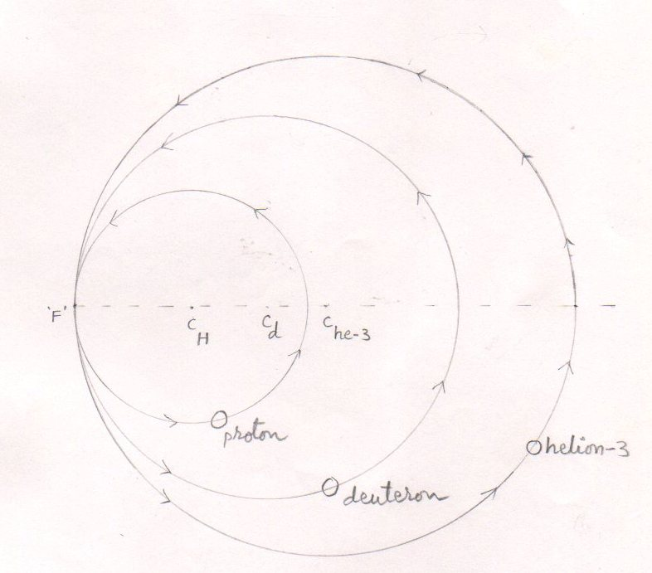
fig (10)
Where ,
C_{H} = Center of the circular orbit followed by the proton .
C_{d} = Center of the circular orbit followed by the deuteron .
C_{he-3} = Center of the circular orbit followed by the helium – 3 nucleus.
F = A tangential point of a number of circular orbits followed by the confined particles or to be followed by the undesired particles ( he – 3 ash ) .
VBM plasma : RF linac injects the bunches of the protons into the tokamak at point F . such that each proton makes angle 30⁰ with the x –axis , 60⁰ angle with the y-axis and the 90⁰ angle with the z-axis . RF linac injects each proton with 102.4 kev energy .

Confinement of protons of 1st bunch : -
As the proton (s) of first bunch reaches at point F into the tokamak , it experiences a centripetal force due to magnetic fields and hence it follows a confined circular orbit passing through the point of injection ( F ) by time and again.
see fig (11,12)

- Injection of the proton

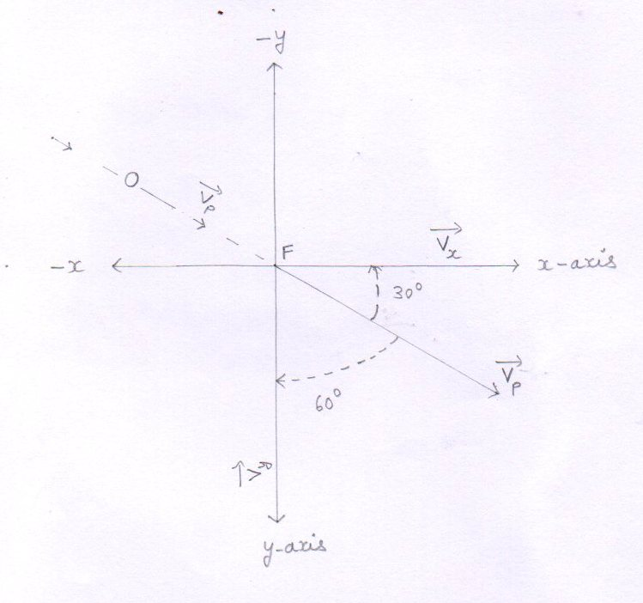
fig(11)
- The injected proton reaches at point ‘ F ‘
- The velocity of the proton make angle 30º with x – axis , 60º angle with y-axis and the 90º angle with z – axis .

- Velocity of the proton

- Each proton is injected into the tokamak with the kinetic energy equal to 0.1024 Mev .
so, the velocity of the proton

V = [ ^{2E}_{Mp} ]^{1/}₂
E = 0.1024x1.6x10⁻¹³ J from eq.(4)
m_{p} = 1.6726x10⁻²⁷ Kg

= 2x0.1024x1.6x10⁻¹³ J ^{1/2}
1.6726x10⁻²⁷ kg

= 0.32768x10¹⁴ ^{1/2} m/s
1.6726

= [ 0.19591055841 x 10¹⁴ ] ^{½} m/s
= 0.4426 x 10⁷ m/s eq.(17)

- 3. Components of the velocity of the proton with which it enters into the tokamak and reaches at point : -
As each proton is injected into the tokamak making angle 30º with x – axis , 60º angle with y-axis and 90º angle with z – axis.
So ,
1 $\overset{→}{Vx}$ = V cos α
V = 0.4426 x 10⁷ m/s from eq.(17)
Cos α = cos 30º = 0.866
- $\overset{→}{Vx}$ = 0.4426 X10⁷ X 0.866 m/s
= 0.3832 x 10⁷ m/s eq.(18)
2 $\overset{→}{Vy}$ = V cosβ
cos β = cos 60º = 0.5
- $\overset{→}{Vy}$ = 0.4426 X10⁷ X ¹/₂ m/s

= 0.2213 x 10⁷ m/s eq.(19)
3 $\overset{→}{Vz}$ = V cos y
cos y = cos 90º = 0
- $\overset{→}{Vz}$ = V x 0 m/s
=0 m/s eq.(20)

4.. Momentum of the proton with which the proton is injected into the tokamak and reaches at point F .
- P = mv
v = 0.4426 x 10⁷ m/s from eq.(17)
m = 1.6726 x 10⁻²⁷ kg
P = 1.6726 x 10⁻²⁷ x 0.4426 x 10⁷ kg m/s
P = 0.7402 x 10⁻²⁰ kg m/s eq.(21)
5.. Component of the momentum of the injected proton with which the proton reaches at point F : -
As each proton is injected into the tokamak making angle 30º
With x-axis , 60º angle with y-axis and 90º angle with z- axis .
So ,
1.. $\overset{→}{Px}$ = P cos α
p= 0.7402 x 10⁻²⁰ kg m/s from eq.(21)
Cos α = cos 30º = $\sqrt{3}$/2 = 0.866
- $\overset{→}{Px}$ = 0.7402 X10⁻²⁰ X 0.866 kgm/s

= 0.6410 x 10⁻²⁰ kgm/s eq.(22)
2 $\overset{→}{Py}$ = P cos β
cos β = cos 60º = 0.5
- $\overset{→}{Py}$ = 0.7402 X10⁻²⁰ X ¹/₂ kgm/s

= 0.3701 x 10⁻²⁰ kgm/s eq (23)
3 $\overset{→}{Pz}$ = P cos y
cos y = cos 90º = 0
- $\overset{→}{Pz}$ = P x 0 kg m/s
=0 kgm/s eq.(24)

6. Forces acting on the particle – proton ( when the proton is at point ‘ F ‘ )
1 F_{y} = q V_{x} B_{z} sin θ
$\overset{→}{Vx}$ = 0.3832 x 10⁷ m/s from eq.(18)
$\overset{→}{Bz}$ = -1 Tesla from eq.(15)
sin θ = sin 90º = 1
q = 1.6 x 10⁻¹⁹ c
- Fy = 1.6 x 10⁻¹⁹ x 0.3832 x 10⁷ x 1 x 1
=0.61312 x 10⁻¹² N
Form the right hand palm rule , the direction of the force $\overset{→}{Fy}$ is according to negative y-axis , so ,
$\overset{→}{Fy}$ = -0.61312 x 10⁻¹² N eq.(25)
2 F_{z} = q V_{x} B_{y} sin θ
$\overset{→}{By}$ = 1 Tesla from eq.(16)
sin θ = sin 90º = 1
- Fz = 1.6 x 10⁻¹⁹ x 0.3832 x 10⁷ x 1 x 1 N
=0.61312 x 10⁻¹² N
Form the right hand palm rule , the direction of the force $\overset{→}{Fz}$ is according to negative Z- axis , so ,
$\overset{→}{Fz}$ = -0.61312 x 10⁻¹² N eq.(26)
3 F_{x} = q V_{y} B_{z} sin θ
$\overset{→}{Vy}$ = 0.2213 x 10⁷ from eq.(19)
$\overset{→}{Bz}$ = -1 Tesla
sin θ = sin 90º = 1
- Fx = 1.6 x 10⁻¹⁹ x 0.2213 x 10⁷ x 1 x 1 N
=0.35408 x 10⁻¹² N
Form the right hand palm rule , the direction of the force $\overset{→}{Fx}$ is according to positive x axis , so ,
$\overset{→}{Fx}$ = 0.35408 x 10⁻¹² N eq.(27)
see fig.(12)

Forces acting on the particle – proton ( when the proton is at point ‘ F ‘ )
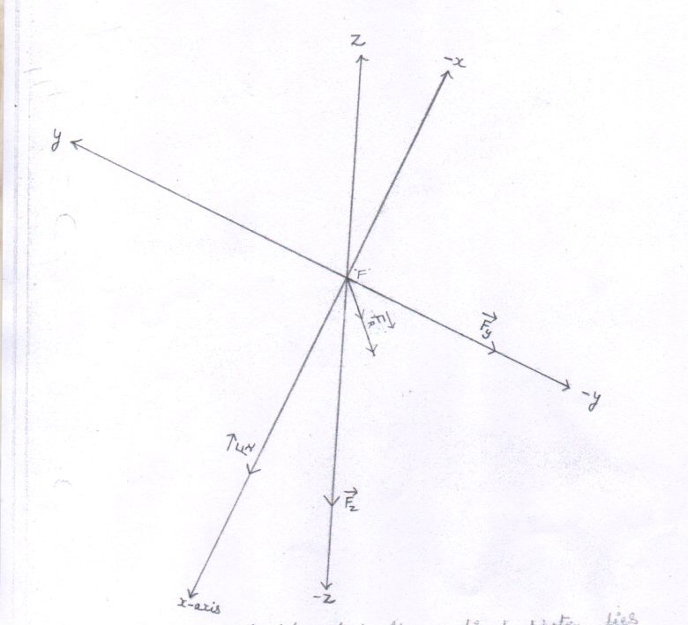
fig (12)
- where the point ‘ F ‘ is the point where all the three axes intersect each other
4.. Resultant force (F_{r} ) acting on the proton :
F_{R}² = F_{x}² + F_{y}² + F_{z}²
F_{z} = F_{y} =F = 0.61312 x 10⁻¹² N from eq.(25,26)
F_{x} = 0.35408 x 10⁻¹² N from eq.(27)
- F_{R}² = 2F² + F_{x}²
- F_{R}² = 2(0.61312 x 10⁻¹² ) + (0.35408 x 10⁻¹² ) ² N²
- F_{R}² = 2 x 0.3759161344 x 10⁻²⁴ + 0.1253726464 x 10⁻²⁴ N²
= 0.7518322688 + 0.125372646 N²
- F_{R}² = 0.7518322688 x 10⁻²⁴ + 0.1253726464 x 10⁻²⁴ N²
- F_{R}² = 0.8772049152 x 10⁻²⁴ N²
- F_{R} = 0.9365 x 10⁻¹² N eq.(28)
see fig.(12)

7.. Radius of the circular orbit followed by the proton .
r = $\frac{mv 2}{Fr}$
E = ½ mv² = 0.1024x 1.6x10⁻¹³ J from eq.(4)
mv² = 0.32768 x 10⁻¹³ J
F_{r} = 0.9365 x 10⁻¹² N from eq.(28)
- r = 0.32768 x10⁻¹³ J
0.9365 x 10⁻¹² N
- r = 0.3498 x 10⁻¹ m
= 3.498 cm = 3.498 x 10⁻² m eq.(29) see fig.(13)
8.. Time period (T) of the proton
T = 2πr / V
r = 3.498 x 10⁻² m from eq.(29)
V = 0.4426 x 10⁷ m/ s from eq.(17)
= 2 x 3.14 x 3.498 x 10⁻² m
0.4426 x 10⁷ m/s
= 21.96744 x 10⁻⁹ s = 49.6327 x 10⁻⁹ s
0.4426
= 4.96 x 10⁻⁸ s eq.(30)
Conclusion : the confined proton passes the point ‘F’ by the after each 4.96 x 10⁻⁸ second.

10. Confinement of the proton: The circular orbit followed by the confined proton
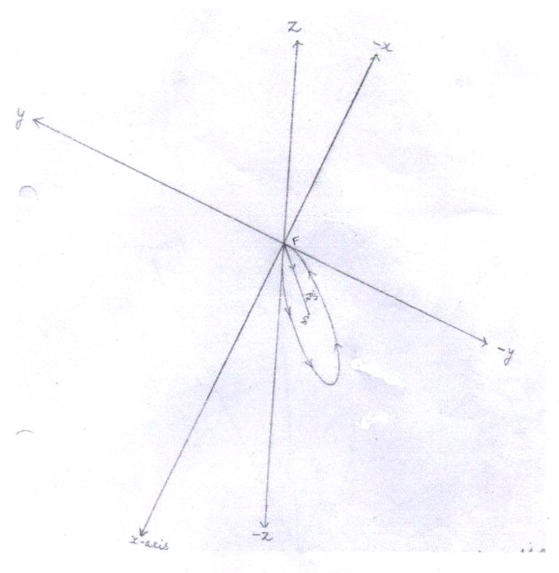

The circular orbit followed by the confined proton
fig.(13)
- By seeing the directions of forces[ $\overset{→}{Fx}$ ,$\overset{→}{Fy} \overset{→}{Fz}$ ] acting on the proton [ when the proton is at point ‘ F ‘ ] , we reach at the conclusion that the circular orbit followed by the confined proton lies in the plane made up of positive x – axis , negative y – axis and the negative z – axis.
- C_{p} = center of the circular path followed by the proton
- ‘ F ‘ is the center of fusion or the point where the proton is injected to. Here ‘ F ‘ is the point where all the three axes intersect each other.
- The line segment $\overset{→}{FCP}$ is the radius of the circular orbit followed by the confined proton and is equal to 3.498 x 10⁻² m.
- $\overset{→}{Fr}$ = the resultant force acting on the particle when the particle is at point F .
It is the resultant force( $\overset{→}{Fr}$ ) By virtue of which the particle starts its circular motion from point F and undergo to a confined circular path
11. Angles that make the resultant force ($\overset{→}{Fr}$) [ acting on the proton when the proton is at point ‘ F ‘ ] with positive x , y and z-axis .
1 with x –axis
Cos α = F_{R} cos α / F_{R} = $\overset{→}{Fx}$ / F_{R}
$\overset{→}{Fx}$ = 0.35408 x 10⁻¹² N from eq.(27)
F_{R} = 0.9365 x 10⁻¹² N from eq.(28)
= 0.35408 x 10⁻¹² N
0.9365 x 10⁻¹² N
- Cos α = 0.3780 eq.(31)
- α = 67.8 degree [ $∴$ cos ( 67.8 ) = 0.3778 ]
2 With y – axis
Cosβ = F_{R} cos β / F_{R} = $\overset{→}{Fy}$ / F_{R}
$\overset{→}{Fy}$ = -0.61312 x 10⁻¹² N from eq.(25)
= - 0.61312 x 10⁻¹² N
0.9365 x 10⁻¹² N
- Cos β = -0.6546 eq.(32)
- β = 130.8 degree [ $∴$ cos ( 130.8 ) = -0.6534 ]
3 with z – axis
Cos y = F_{R} cos y / F_{R} = $\overset{→}{Fz}$ / F_{R}
$\overset{→}{Fz}$ = -0.61312 x 10⁻¹² N from eq.(26)
= -0.61312 x 10⁻¹² N
0.9365 x 10⁻¹² N
- Cos y = -0.6546 eq.(33)
- y = 130.8 degree [ $∴$ cos ( 130.8 ) = -0.6534 ]
see fig (14)
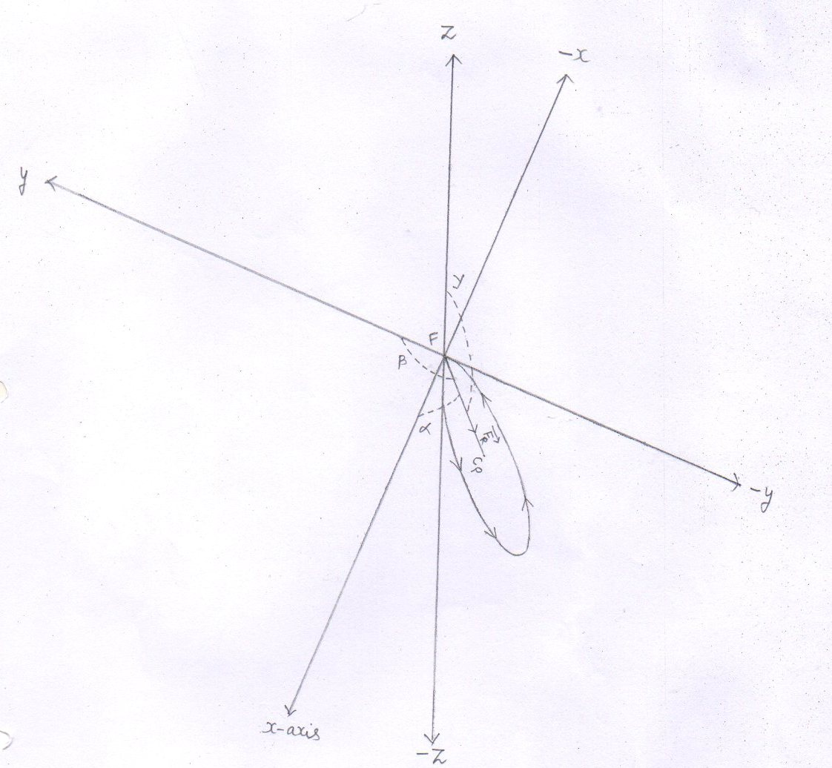

fig.(14)
- Angle that make the resultant force ($\overset{→}{Fr}$) with respect to positive x , y and z axis , when particle – proton is at point F .
Where
α ˜ 67.8 Degree
β ˜ 130.8 Degree
y ˜ 130.8 Degree
The direction cosines of the line P₁ P₂
- The line P₁ P₂ is the diameter of the circle followed ( or to be followed ) by the particle .
- The points P₁ (x₁ y₁ z₁ ) and P₂ (x₂ y₂ z₂ ) make the line P₁ P₂ .

- The particle starts its circular motion from the point ‘F’ (- the center of fusion where the particle is either injected or produced ).
So, we have denoted the Cartesian coordinates for the
Point ‘F’ as (0 ,0 , 0) .
- Here the point F ( 0,0,0 ) and the point P₁ (x₁ y₁ z₁ ) are the same .

- So , the direction cosines of the line P₁ P₂ are : -

- l = cos α = x₂ – x₁ / d
where ,

d = 2 x radius of the circle
cos α = cos component of the angle that make the resultant force ( $\overset{→}{Fr}$ ) [ acting on the particle when the particle is at point F ] with the positive x - axis .
2. m = cos β = y₂ –y₁ / d
Where ,
cos β = cos component of the angle that make the resultant force ($\overset{→}{Fr}$ ) [ acting on the particle when the particle is at point F ] with the positive y - axis .
3. n = cos y = z₂ –z₁ / d
Where ,
cos y = cos component of the angle that make the resultant force ($\overset{→}{Fr}$ ) [ acting on the particle when the particle is at point F ] with the positive z - axis .

12. The cartesian coordinates of the points P₁ ( x₁ , y₁ , z₁ ) and P₂ ( x₂ , y₂ , z₂ ) located on the circumference of the circle obtained by the proton
- cos α = x₂ - x₁
d
d = 2 x r
r=3.498x10⁻² m from eq.(29)
= 2x3.498x10⁻² m
= 6.996 x 10⁻² m
Cos α = 0.37 from eq.(31)
- x₂ - x₁ = d x cos α
- x₂ - x₁ = 6.996x10⁻²x0.37 m
- x₂ - x₁ = 2.5885 x 10⁻² m
- x₂ = 2.5885 x 10⁻² m [ $∴$ x₁ = 0 ] eq(34)
- cos β = y₂ - y₁
d
cos β = -0.65 from eq.(32)
- y₂ - y₁ = d x cos β
- y₂ - y₁ = 6.996x10⁻²x (-0.65) m
- y₂ - y₁ = -4.5474 x 10⁻² m
- y₂ = -4.5474 x 10⁻² m [ $∴$ y₁ , = 0 ] eq(35)

- cos y = z₂ - z₁
d
cos y = -0.65 from eq.(33)
- z₂ - z₁ = d x cos y
- z₂ - z₁ = 6.996x10⁻²x (-0.65) m
- z₂ - z₁ = -4.5474 x 10⁻² m
- z₂ = -4.5474 x 10⁻² m [ $∴$ z₁ , = 0 ] eq(36)
- The point ‘ F ‘ and the point ‘ P₁ ‘ are same . from where each particle starts its circular motion . so , the coordinates of point p₁ ( x₁ , y₁ , z₁ ) are equal to P₁ ( 0 , 0, 0 ) .
see fig.(15)
- The cartesian coordinates of the point p₁ ( x₁ , y₁ , z₁ ) located on the circumference of the circle obtained by the proton. :-
- The line segment ___ is the diameter of the circle followed by the confined proton
P₁P₂

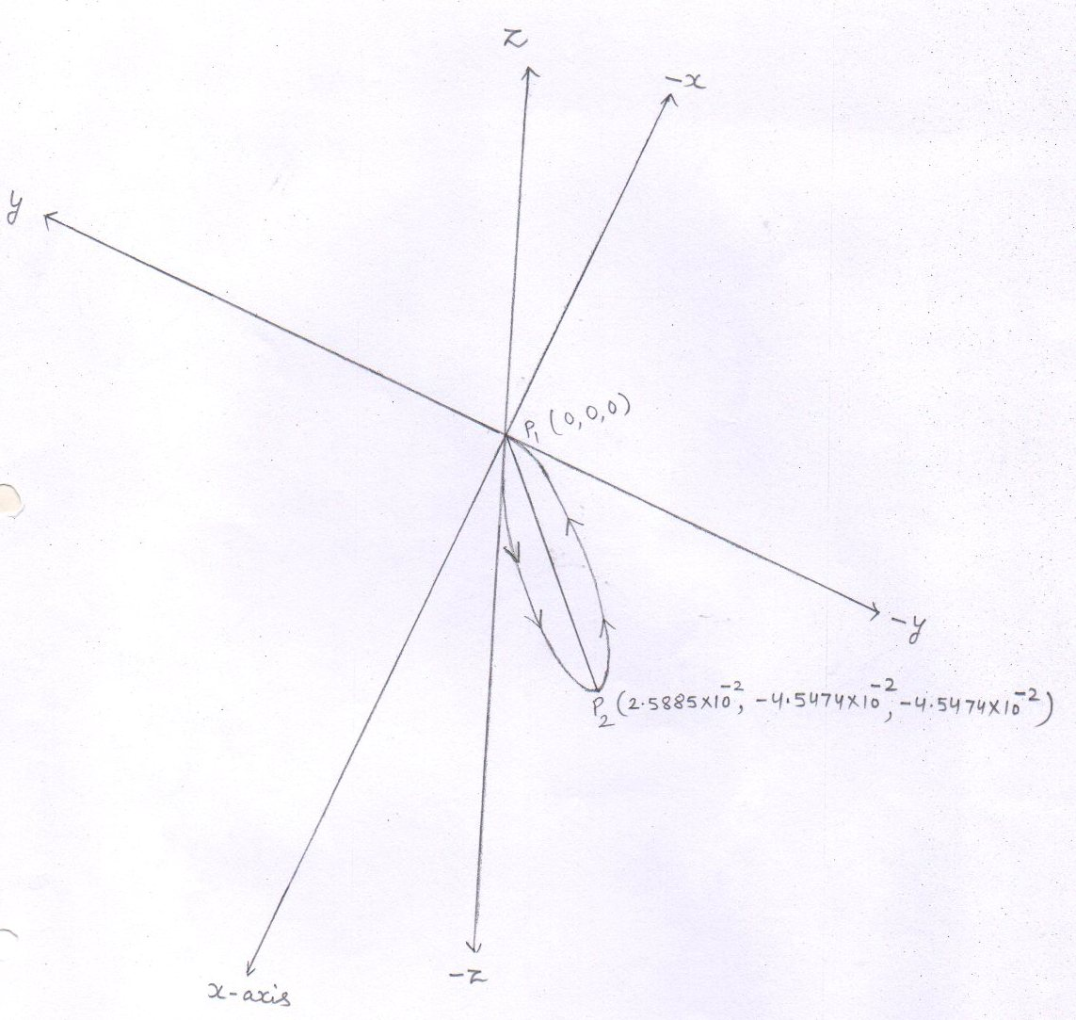
fig.(15)
Conclusion : the proton is confined . The proton starts its circular motion from point p₁ [ or the point ‘ F ‘ ( 0 , 0 , 0) ] and reaches at point p₂ ( x_{2 ,} y₂ , z₂ ) and then again reaches at point p₁ ( x_{1 ,} y₁ , z₁ ) to complete the circle of radius 0.03498 m . the proton keeps on following the confined circular orbit uninterruptedly and pass through this point ‘F’ [ or the point p₁ (0 , 0 ,0 ) by time and again until it fuses with the proton of the later injected bunch reaching at point ‘F ‘ .
The confined proton fuses with the injected proton at only and only point ‘ F ‘ and form the compound nucleus at point ‘ F ‘ .

Fusion reactions
1 Proton - proton fusion
¹₁H + ¹₁ H $→$ ₁² D + Ѵ_{e} + e⁺
[injected ] [ confined ] [ confined ]
2 Annihilation of positron and an electron
e⁺ + e⁻ $→$ у + у rays
- Proton – deuteron fusion
¹₁H + ²₁ D $→$ ₂³ He + y rays
[injected ] [ confined ] [ not confined ]

- Proton – deuteron – proton fusion
¹₁H + ²₁ D + ¹₁H $→$ [ ⁴₃ Li ] $→$ ³₂ He + Δm + ¹₁H
[injected ] [ confined ] [ confined ] [not confined ] [not confined]

How fusion occurs
1 Formation of compound nucleus : -
As the proton of Nth bunch reaches at point ‘ F ‘ , it fuses with the confined proton [ the proton of first bunch that has already confined and passing through the point ‘ F ‘ ] to form a compound nucleus .
2 The splitting of compound nucleus : -
The compound nucleus splits into three particles . out of three particles , two are stable nuclei while the third one ( the reduced mass ) is unstable . By the law of inertia, each particle that has separated from the compound nucleus has an inherited velocity( $\overset{→}{Vinh}$ ) equal to the velocity of the compound nucleus($\overset{→}{Vcn}$ )
- Propulsion of the particles : -
The reduced mass converts into energy and the total energy ( E_{T}) is carried away by the neutrino . The neutrino do not interact with any particle . so , neither the deuteron nor the positron is propelled .

For proton - proton fusion reaction
¹₁H + ¹₁ H $→$ ₁² D + Ѵ_{e} + e⁺
Formation of compound nucleus [ ₁² D ] :
- interaction of nuclei : -
The injected proton as reaches at point F , it interacts [ experiences a repulsive force due to the confined proton passing through the point F ] with the confined proton at point F . the injected proton overcomes the electrostatic repulsive force and – a like two solid spheres join - the injected proton dissimilarly joins with the confined proton .
see fig.(16)

Note : -[ ₁² D ] is a compound nucleus formed due to proton –proton fusion .

Interaction of nuclei
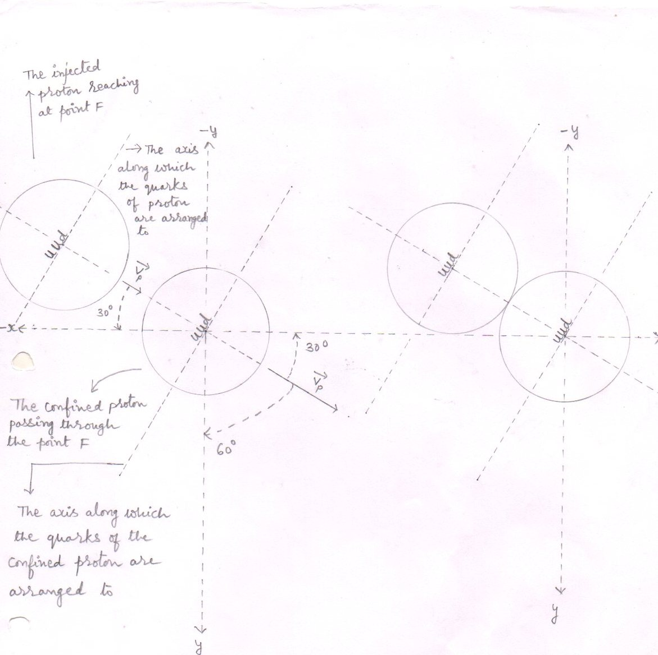
Interaction of nuclei-1 Interaction of nuclei-2
fig.(16)

- Formation of the homogeneous compound nucleus : -
The constituents ( quarks and gluons ) of the dissimilarly joined nuclei ( Protons ) behave like a liquid and form a homogeneous compound nucleus . having similarly distributed groups of quarks with similarly distributed surrounding gluons .
Thus within the homogeneous compound nucleus – each group of quarks is surrounded by the gluons in equal proportion . so, within the homogeneous compound nucleus there are 2 groups of quarks surrounded by the gluons.

see fig.(17)

Homogeneous compound nucleus:
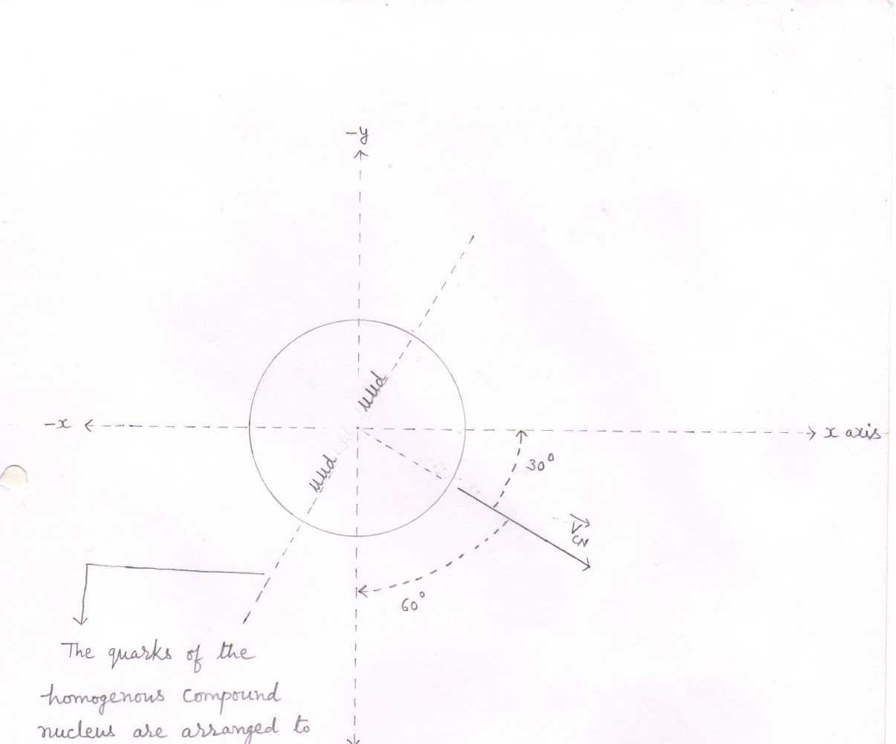
fig.(17)
where , $\overset{→}{Vcn}$ ₌ velocity of the compound nucleus
α = 30⁰ from eq.(53)
β = 60⁰ from eq.(54)
y = 90⁰ from eq.(55)

3 Formation of lobes within into the homogeneous compound nucleus or the transformation of the homogenous compound nucleus into the heterogeneous compound nucleus : -
Emitting a positive charge , an up quark ( u ) of a group of quarks ( uud) converts into a down quark (d ) . Thus the group of quarks ( uud ) that compose the proton converts into a group of quarks (udd) that compose the neutron .
The converted group of quarks (udd) with its surrounding gluons to become a stable and the next higher nucleus (deuteron ) than the reactant one (the Proton ) includes the another group of quarks (uud) with its surrounding gluons and rearrange to form the ‘ A ‘ lobe of the heterogeneous compound nucleus.
While , on the other hand , the emitted positive charge to become a stable nucleus (positron) includes its surrounding gluons or mass [ out of the available mass ( or gluons ) that is not included in the formation of the lobe ‘ A ‘ ] and rearrange to form the ‘B‘ lobe of the heterogeneous compound nucleus .
Thus , due to formation of two dissimilar lobes within into the homogeneous compound nucleus , the homogeneous compound nucleus transforms into the heterogeneous compound nucleus.

see fig.(18,19,20)

The transformation of the homogenous compound nucleus into the heterogeneous compound nucleus : -
Formation of lobes -1

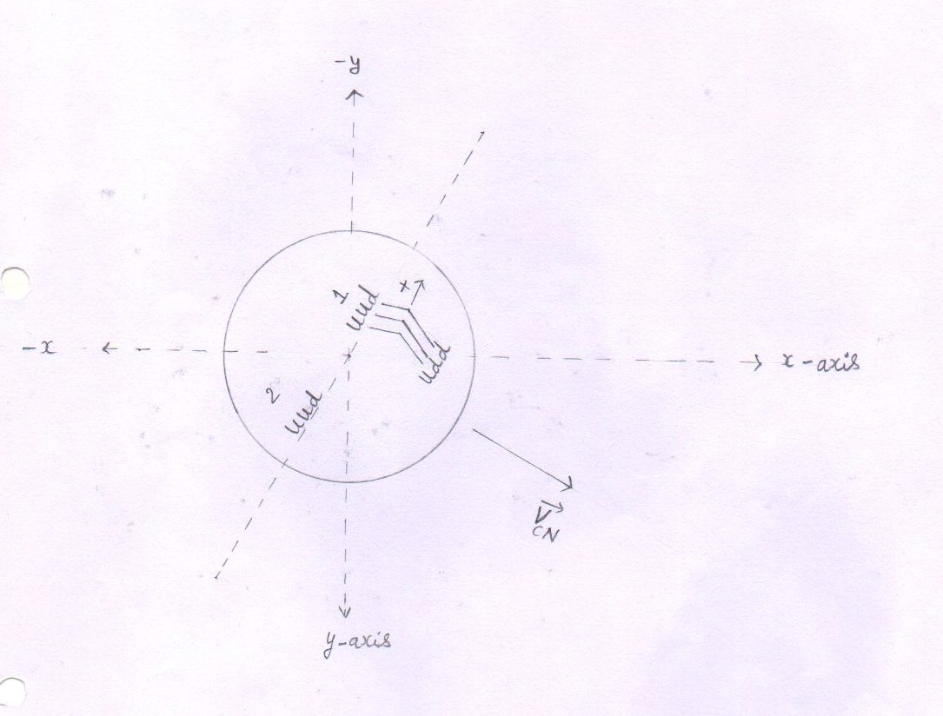

fig.(18)
Heterogeneous compound nucleus – An up quark (u) emits a positive charge and converts into a down quark (d) .

The transformation of the homogenous compound nucleus into the heterogeneous compound nucleus : -
Formation of lobes -2
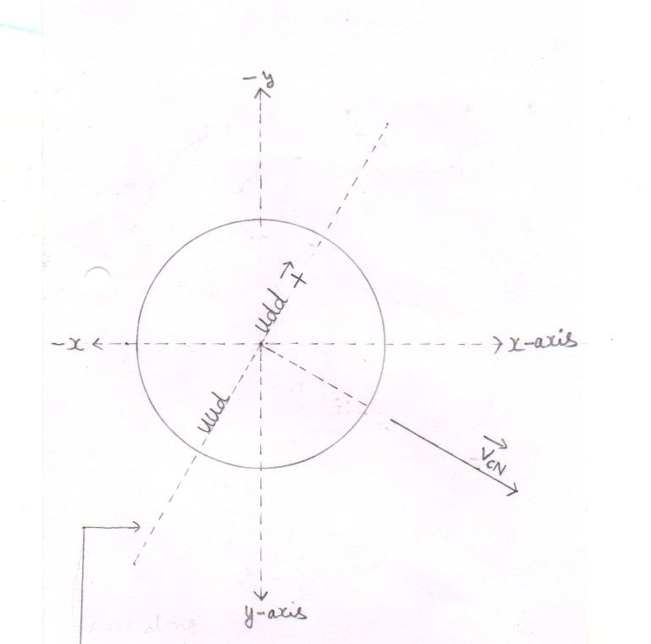
fig.(19)
The axis along which
the groups of quarks are
arranged to

:- The emitted positive
Charge reaches on the other end of the nucleus .

The transformation of the homogenous compound nucleus into the heterogeneous compound nucleus : -
Formation of lobes -3

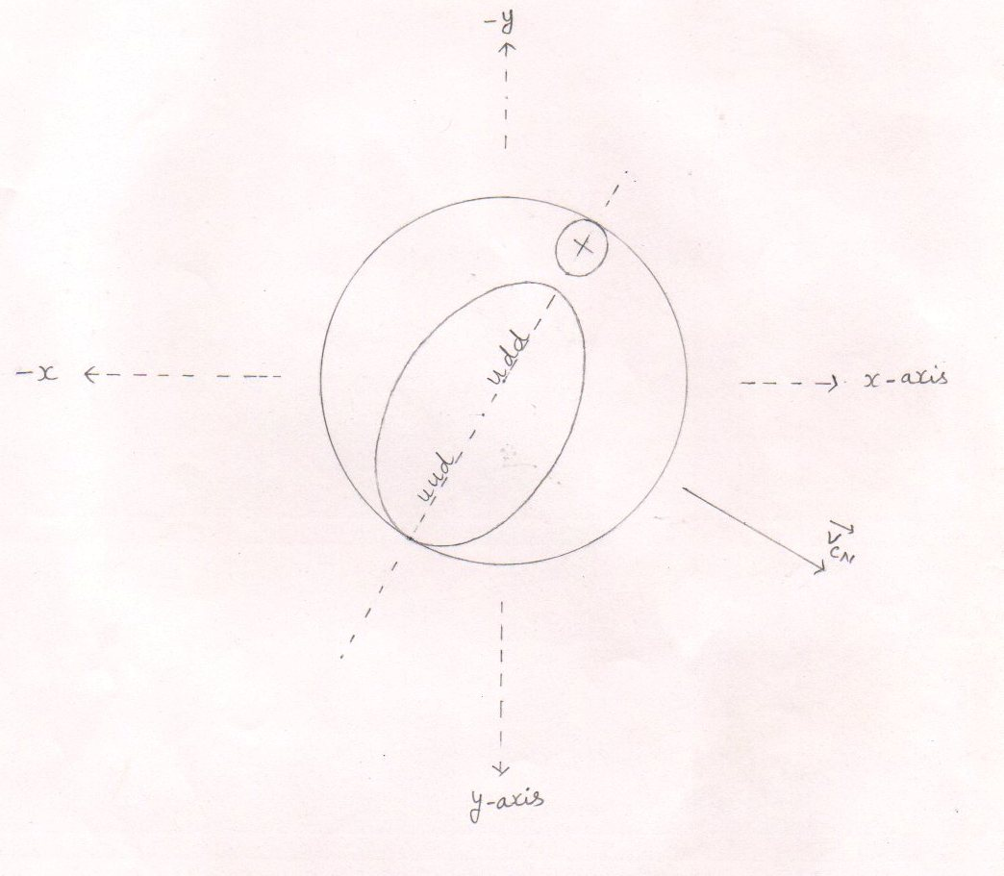
fig.(20)
Formation of lobes
- Within into the homogeneous compound nucleus the greater nucleus is the deuteron and the smaller one is the positron while the remaining space represents the remaining gluons
- The greater nucleus is the lobe ‘A ‘ while the smaller nucleus is the lobe ‘B’ .
- Final stage of the heterogeneous compound nucleus : -
The process of formation of lobes creates void (s) between the lobes . so, the remaining gluons [ the gluons (or the mass ) that are not involved in the formation of any lobe] rearrange to fill the void (s) between the lobes . Thus the remaining gluons form a node between the dissimilar lobes of the heterogeneous compound nucleus .
Thus , the reduced mass ( or the remaining gluons ) keeps both the dissimilar lobes of the heterogeneous compound nucleus joined them together .
So, finally , the heterogeneous compound nucleus becomes like a dumb – bell .

see fig.(21,22)

Final stage of the heterogeneous compound nucleus : -
Final stage - 1

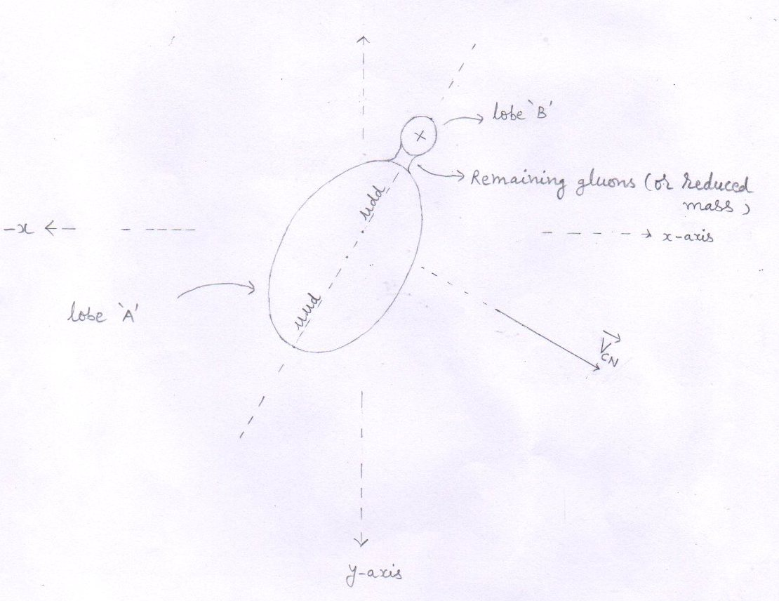

fig.(21)

Final stage of the heterogeneous compound nucleus : -
Final stage -2
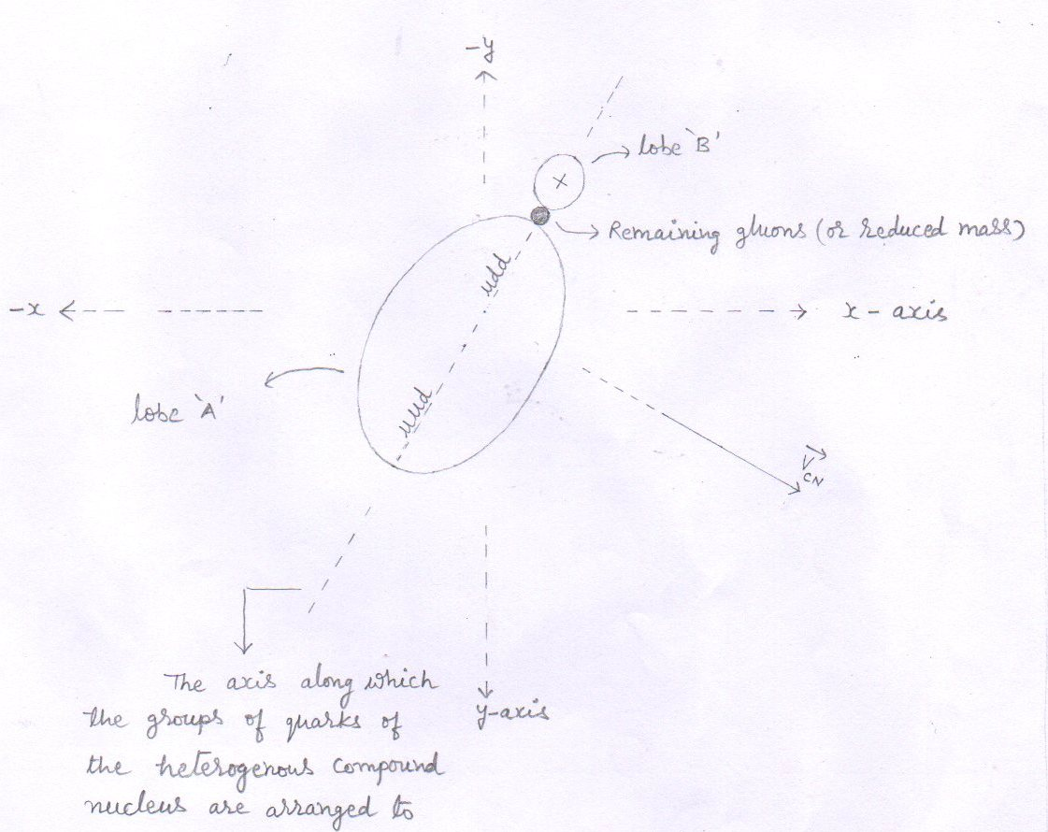

fig.(22)

Calculations for the compound nucleus [ ²₁ D ]:
- Just before fusion , the loss in the kinetic energy of the injected proton
- As the injected proton reaches at point ‘F’ , the injected proton fuses with the confined proton ( passing through the point ‘F’ ) to form the compound nucleus , at point ‘F’ .
- Just before fusion , to overcome the electrostatic repulsive force , the injected proton loses its energy equal to 2.5 Kev. [ from eq.(2) ]
- So, the kinetic energy of the proton just before fusion is -
E_{b} = [ E_{P} - E_{loss}]
E_{P} = 102.4 kev from eq.(4)
E_{loss} = E_{P-P} = 2.5 kev from eq.(2)
E_{b} = [ 102.4 -2.5 ] kev
= 99.9 kev
= 0.0999 Mev
- 2. Velocity of the injected proton just before fusion : -

V_{b} = 2E_{b} ^{½}
Mp E_{b} = 0.0999 Mev
= 0.0999x1.6x10⁻¹³ J
m_{p} =1.6726x10⁻²⁷ kg
= 2x0.0999x1.6x10⁻¹³ J ^{½}
1.6726x10⁻²⁷ kg

= 0.31968x10⁻¹³ ^{½} m/s
1.6726x10⁻²⁷

= [ 0.19112758579x10¹⁴ ] ^{½} m/s

= 0.4371 x 10⁷ m/s eq.(37)

3.. Components of the velocity of the injected proton just before fusion are : -
1 $\overset{→}{Vx}$ = V_{b} cos α
V_{b} = 0.4371 x 10⁷ m/s from eq.(37)
Cosα= cos 30º =$\sqrt{3}$/₂ = 0.866

$\overset{→}{Vx}$ = 0.4371 x 10⁷ x 0.866 m/s
$\overset{→}{Vx}$ = 0.3785 x 10⁷ m/s eq.(38)

2 $\overset{→}{Vy}$ = V_{b} cos β
Cos β = cos 60º = 0.5
$\overset{→}{Vy}$ = 0.4371 x 10⁷ x 0.5 m/s
$\overset{→}{Vy}$ = 0.2185 x 10⁷ m/s eq.(39)

3 $\overset{→}{Vz}$ = V_{b} cos y
Cos y = cos 90º = 0
$\overset{→}{Vz}$ = V_{b} x 0 m/s
$\overset{→}{Vz}$ = 0 m/s eq.(40)

4.. Components of the momentum of the injected proton just before fusion are : -

1 $\overset{→}{Px}$ = P_{b} cos α = mv_{b} cos α
m = 1.6726 x 10⁻²⁷ kg
V_{b} cos α = 0.3785 x 10⁷ m/s from eq.(38)
$\overset{→}{Px}$ = 1.6726 x 10⁻²⁷ x 0.3785 x 10⁷ kgm/s
$\overset{→}{Px}$ = 0.6330 x 10⁻²⁰ kgm/s eq.(41)
2 $\overset{→}{Py}$ = P_{b} cos β = mv_{b} cos β
V_{b} cos β = 0.2185 x 10⁷ m/s from eq.(39)
$\overset{→}{Py}$ = 1.6726 x 10⁻²⁷ x 0.2185 x 10⁷ kgm/s
$\overset{→}{Py}$ = 0.3654 x 10⁻²⁰ kgm/s eq.(42)

3 $\overset{→}{Pz}$ = P_{b} cos y = mv_{b} cos y
V_{b} cos y = 0 m/s from eq.(40)
$\overset{→}{Pz}$ = 1.6726 x 10⁻²⁷ x 0 kgm/s
$\overset{→}{pz}$ = 0 kgm/s eq.(43)

5.. Components of the momentum of the compound nucleus ( P_{CN} ) : -
The injected proton penetrates the confined proton. So , Just before fusion , there is a loss in kinetic energy of the injected proton but the kinetic energy of the confined proton remains same. So, the momentum of the confined proton remains same as with which it was injected to.
- X – component of the momentum of the compound nucleus ( $\overset{→}{Px}$) =

X – component of X – component of the
the momentum momentum of the injected
of the confined proton + Proton just before fusion
at point F at point F

- $\overset{→}{Px}$ = [ 0.6410 x 10⁻²⁰ ] + [ 0.6330 x 10⁻²⁰ ] kgm/s from eq.(22 and 41) respect.
= 1.274 x 10⁻²⁰ kgm/s
- $\overset{→}{Px}$ = P_{CN} cos α = 1.274 x 10⁻²⁰ kgm/s eq.(44)
- y– component of the momentum of the compound nucleus ( $\overset{→}{Py}$ ) =

y – component of y – component of the
the momentum momentum of the injected
of the confined proton + Proton just before fusion
at point’ F ‘ at point ‘F’

- $\overset{→}{Py}$ = [ 0.3701 x 10⁻²⁰ ] + [ 0.3654 x 10⁻²⁰ ] kgm/s from eq.(23 and 42 )
= 0.7355 x 10⁻²⁰ kgm/s
- $\overset{→}{Py}$ = P_{CN} cos β = 0.7355 x 10⁻²⁰ kgm/s eq.(45)

- z – component of the momentum of the compound nucleus ( $\overset{→}{Pz}$ )=

z– component of z – component of the
the momentum momentum of the injected
of the confined proton + Proton just before fusion
at point F at point F

- $\overset{→}{Pz}$ = [ 0 ] + [ 0 ] kgm/s from eq.(24 and 43) respectively
= 0 kgm/s
- $\overset{→}{Pz}$ = P_{CN} cos y = 0 kgm/s eq. (46)

6.. Mass of the compound nucleus (M) :

M = 2m_{p}
= 2 x 1.6726 x 10⁻²⁷ kg
= 3.3452 x 10⁻²⁷ kg eq.(47)

7.. Components of the velocity of the compound nucleus : -

1 $\overset{→}{Vx}$ = V_{CN} cos α = $\overset{→}{Px}$ /M = P_{CN} cos α
M

P_{x} = P_{CN} cos α = 1.274 x 10⁻²⁰ kgm/s from eq. (44)
M = 3.3452 x 10⁻²⁷ kg from eq.(47)

- $\overset{→}{Vx}$ = V_{CN} cos α = 1.274 x 10⁻²⁰ kgm/s
3.3452 x 10⁻²⁷ kg
- $\overset{→}{Vx}$ = V_{CN} cos α = 0.3808 x 10⁷ m/s eq.(48)

2 $\overset{→}{Vy}$ = V_{CN} cos β = = $\overset{→}{Py}$ /M = P_{CN} cos B
M

P_{y} = P_{CN} cos β = 0.7355 x 10⁻²⁰ kgm/s from eq.(45)

- $\overset{→}{Vy}$ = V_{CN} cos β = 0.7355 x 10⁻²⁰ kgm/s
3.3452 x 10⁻²⁷ kg
- $\overset{→}{Vy}$ = V_{CN} cos β = 0.2198 x 10⁷ m/s eq.(49)

3 $\overset{→}{Vz}$ = V_{CN} cos y = = $\overset{→}{Pz}$ /M = P_{CN} cos y
M
P_{z} = P_{CN} cos y = 0 kgm/s from eq.(46)

- $\overset{→}{Vz}$ = V_{CN} cos y = 0 kgm/s
M kg
- $\overset{→}{Vy}$ = V_{CN} cos y = 0 m/s eq.(50)

8.. Velocity of the compound nucleus ( V_{CN} ) : -

V_{CN}² = V_{x}² + V_{y}² + V_{z}²
V_{x} = 0.3808 x 10⁷ m/s from eq.(48)
V_{y} = 0.2198 x 10⁷ m/s from eq.(49)
V_{z} = 0 m/s from eq.(50)
- V_{CN}² = ( 0.3808 x 10⁷ )² + ( 0.2198 x 10⁷ )² + ( 0 )² m²/s²
= (0.14500864 x 10¹⁴ ) + (0.04831204 x 10¹⁴ ) + 0 m²/s²
- V_{CN}² = ( 0.19332068 x 10¹⁴ ) m²/s² eq.(51)

- V_{CN} = 0.4396 x 10⁷ m/s eq.(52)

9..Angles that make the velocity of the compound nucleus ( V_{CN} ) with positive x , y , and z axes at point ‘ F ‘ .
- with x – axis
cos α = $\overset{→}{Vx}$ /V_{CN} = V_{CN} cos α/ V_{CN}

V_{CN} cos α = 0.3808 x 10⁷ m/s from eq.(48)
V_{CN} = 0.4396 x 10⁷ m/s from eq.(52)

- cos α = 0.3808 x 10⁷ m/s = 0.8662 eq.(53)
0.4396 x 10⁷ m/s
- α = 30º [ cos 30º = 0.8660 ]

2 with y– axis
cos β = $\overset{→}{Vy}$ /V_{CN} = V_{CN} cos β / V_{CN}

V_{CN} cos β = 0.2198 x 10⁷ m/s from eq.(49)

cos β = 0.2198x 10⁷ m/s = 0.5
0.4396 x 10⁷ m/s

- β = 60º [ cos 60º = 0.5 ] eq.(54)
3 with z– axis
cos y= $\overset{→}{Vz}$ /V_{CN} = V_{CN} cos y / V_{CN}

V_{CN} cos y = 0 m/s from eq.(50)

cos y = 0 m/s = 0
0.4396 x 10⁷ m/s
- y = 90º eq.(55)

The splitting of the heterogeneous compound nucleus : -

- The heterogeneous compound nucleus , due to its instability , splits according to the lines parallel to the direction of the velocity of the compound nucleus ($\vec{Vcn}$ ) into the three particles – the deuteron , the positron and the reduced mass (Δm) .
Out of them , the two particles (deuteron and positron ) are stable while the third one ( reduced mass ) is unstable .

- According to the law of inertia , each particle that has separated from the compound nucleus , has an inherited velocity ( $\overset{→}{Vinh}$) equal to the velocity of the compound nucleus ($\vec{Vcn}$) .

- So, for conservation of momentum

M$\vec{Vcn}$ = ( m_{d} + Δm +m_{e+} ) $\vec{Vcn}$ eq.(56)

Where ,
M = mass of the compound nucleus
$\vec{Vcn}$ = velocity of the compound nucleus
m_{d} = mass of the deuteron
Δm = reduced mass
m_{e+} = mass of the positron
see fig.(23)

The splitting of the heterogeneous compound nucleus
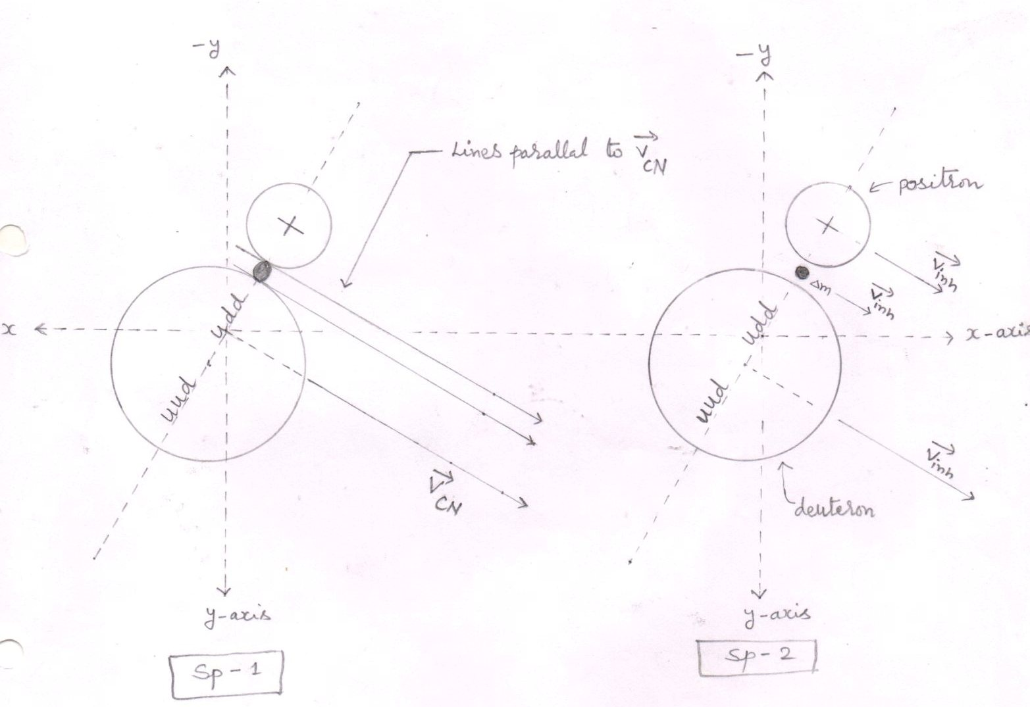
splitting -1 splitting -2
The compound nucleus (before splitting ) ( The particles produced after splitting)
fig.(23)
- The heterogeneous compound nucleus splits into three particles – the deuteron , the reduced mass (Δm) and the positron.
- $\overset{→}{Vinh}$ = inherited velocity of the particle
- $\overset{→}{Vcn}$ = velocity of the compound nucleus
- Positron is a stable particle in the presence of the magnetic field .

Inherited velocity ($\overset{→}{Vinh}$ ) of the particles
- Each particle that has separated from the compound nucleus has an inherited velocity ($\overset{→}{Vinh}$ ) equal to the velocity of the compound nucleus .
1 The inherited velocity of deuteron
- $\overset{→}{Vinh }$ = $\overset{→}{Vcn }$ = 0.4396 x 10⁷ m/s form eq.(52)

- Components of the inherited velocity of the deuteron

- $\overset{→}{Vx}$ = V_{inh} cos α = V_{CN} cos α = 0.3808 x 10⁷ m/s from eq.(48) eq.(57)
- $\overset{→}{Vy}$ = V_{inh} cos β = V_{CN} cos β = 0.2198 x 10⁷ m/s from eq.(49) eq.(58)
- $\overset{→}{Vz}$ = V_{inh} cos y = V_{CN} cos y = 0 m/s from eq.(50) eq.(59)
2 The inherited velocity for the positron
- $\overset{→}{Vinh}$ = $\overset{→}{Vcn }$ = 0.4396 x 10⁷ m/s

- Components of the inherited velocity of the positron

- $\overset{→}{Vx}$ = V_{inh} cos α = V_{CN} cos α = 0.3808 x 10⁷ m/s from eq.(48) eq.(60)
- $\overset{→}{Vy}$ = V_{inh} cos β = V_{CN} cos β = 0.2198 x 10⁷ m/s from eq.(49) eq.(61)
- $\overset{→}{Vz}$ = V_{inh} cos y = V_{CN} cos y = 0 m/s from eq.(50) eq.(62)

3.. The inherited velocity of the reduced mass
- $\overset{→}{Vinh }$ = $\overset{→}{Vcn }$ = 0.4396 x 10⁷ m/s

Propulsion of the particles
The total energy (E_{T}) is carried away by the neutrino . the produced neutrino does not interact with any produced nucleus . so, neither the deuteron nor the positron is propelled by the neutrino .
- Reduced mass
Δm = [ 2m_{p} ] – [ m_{d} +m_{e+} ]
m_{p} = 1.00727 amu
m_{d} = 2.01355 amu
m_{e+} = 0.00054 amu
Δm = [ 2x1.00727 ] – [ 2.01355 + 0.00054 ] amu

Δm = [ 2.01454 ] – [ 2.01409 ] amu
Δm = 0.00045 amu

Δm = 0.00045 x 1.6605 x 10⁻²⁷ kg [ 1amu = 1.6605 x 10⁻²⁷ kg ]

Δm = 0.000747225 x 10⁻²⁷ kg
i.e. = 0.00045 amu = 0.000747225 x 10⁻²⁷ kg eq.(63)
- Inherited kinetic energy of the reduced mass .

- E_{inh} = Δm V² _{inh} = Δm V² _{CN}
2 2 V² _{CN} = 0.19332068 x 10¹⁴ m²/s² from eq.(51)
Δm = 0.000747225 x 10⁻²⁷ kg from eq.(63)
- E_{inh} = _{½} x 0.000747225 x 10⁻²⁷ x 0.19332068 x 10¹⁴ J

- E_{inh} = 0.00007222702 x 10⁻¹³ J

E_{inh} = 0.000045 Mev [ 1Mev = 1.6 x 10⁻¹³ J ] eq.(64)

- Released energy ( E_{R} )

E_{R} = Δmc ²
Δm = 0.00045 amu from eq.(63)
E_{R} = 0.00045 x 931 Mev

E_{R} = 0.41895 Mev eq. (65)

- Total energy ( E _{T} )
E _{T} = E_{inh} + E_{R} from eq. (64 and 65 )
E _{T} = ( 0.000045 ) + ( 0.41895 ) Mev from eq. (58)
E _{T} = 0.418995 Mev eq.(66)
Conclusion : -
The total energy (E_{T}) is carried away by the neutrino . the produced neutrino does not interact with any produced nucleus . so, neither the deuteron nor the positron is propelled by the neutrino .

see fig. (24)

Propulsion of the particles

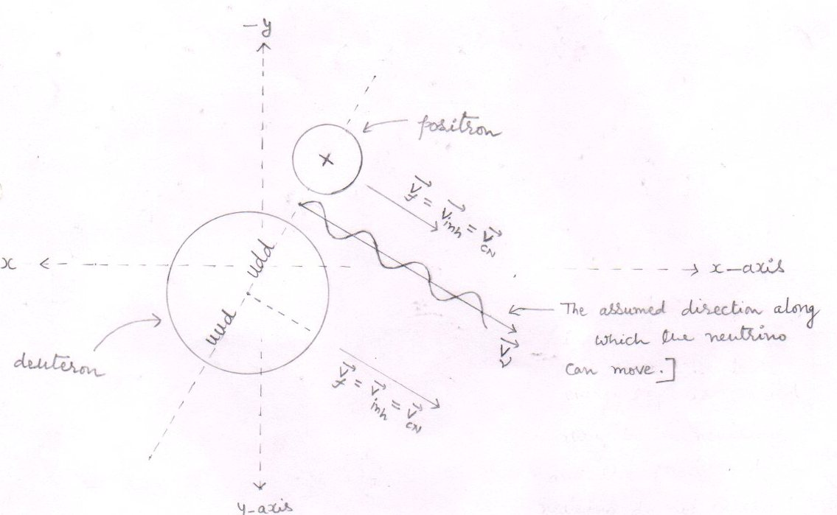

fig.(24)
- As the neutrino does not interact with any particle , so we have shown the direction of the velocity of the produced neutrino in such a way that it seems that neutrino does not interact with any particle .
V_{Ѵ} = Final velocity of the neutrino .
- The total energy E_{T} is carried away by the neutrino and the produced neutrino does not interact with any particle and hence neither the deuteron nor the positron is propelled .
- it is the inherited velocity ($\overset{→}{Vinh}$ ) of the reduced mass by virtue of which the produced neutrino can exceed the speed of light .

5.. Increased energy ( E_{inc}) of the particles :-
- As the reduced mass converts into energy . the total energy ( E_{T} ) is carried away by the particle – neutrino .
- The produced neutrino does not interact with any of the stable nuclei ( deuteron and the positron )
- Hence the increased energy ( E_{inc}) of the each final nucleus ( the deuteron and the positron ) is zero . or
E_{inc} = 0 J eq.(67)
Increased velocity of the particles
- As the increased energy (E_{inc} ) of the each particle ( the deuteron and the positron ) is equal to zero. that is
E_{inc} = 0 J
So, the increased velocity (V_{inc} ) of the each particle ( the deuteron and the position ) is also equal to zero . or

V_{inc} = 0 m/s eq.(68)

6.. Components of the increased velocity (V_{inc} ) of the particle – the deuteron : -
As the V_{inc} = 0 m/s
So,
1 $\overset{→}{Vx}$ = V_{inc} cos α = 0 m/s eq.(69)
2 $\overset{→}{Vy}$ = V_{inc} cos β = 0 m/s eq.(70)
3 $\overset{→}{Vz}$ = V_{inc} cos y= 0 m/s eq.(71)
7 Components of the increased velocity (V_{inc} ) of the particle – the positron: -
As the V_{inc} = 0 m/s
So,
1 $\overset{→}{Vx}$ = V_{inc} cos α = 0 m/s eq.(72)
2 $\overset{→}{Vy}$ = V_{inc} cos β = 0 m/s eq.(73)
3 $\overset{→}{Vz}$ = V_{inc} cos y= 0 m/s eq.(74)

8..Components of the final velocity of the particles

- For the deuteron

According  To - | Inherited  Velocity ( $\overset{→}{Vinh}$) | Increased  Velocity ( $\overset{→}{Vinc}$) | Final velocity  $\overset{→}{Vf}$ = $\overset{→}{Vinh}$ + $\overset{→}{Vinc}$
X – axis | $\overset{→}{Vx}$ = 0.3808x10⁷m/s | $\overset{→}{Vx}$ = 0 m/s | $\overset{→}{Vx}$ =0.3808x10⁷m/s  eq.(75)
y – axis | $\overset{→}{Vy}$ = 0.2198x10⁷m/s | $\overset{→}{Vy}$ = 0 m/s | $\overset{→}{Vy}$ =0.2198x10⁷m/s  eq.(76)
z – axis | $\overset{→}{Vz}$ = 0 m/s | $\overset{→}{Vz}$ = 0 m/s | $\overset{→}{Vz}$ =0 m/s  eq.(77)
from eq.(57,58,59) from eq.(69,70,71)
respectively respectively

- For the positron

According  To - | Inherited  Velocity ( $\overset{→}{Vinh}$) | Increased  Velocity ( $\overset{→}{Vinc}$) | Final velocity  $\overset{→}{Vf}$ = $\overset{→}{Vinh}$ + $\overset{→}{Vinc}$
X – axis | $\overset{→}{Vx}$ = 0.3808x10⁷m/s | $\overset{→}{Vx}$ = 0 m/s | $\overset{→}{Vx}$ =0.3808x10⁷m/s  eq.(78)
y – axis | $\overset{→}{Vy}$ = 0.2198x10⁷m/s | $\overset{→}{Vy}$ = 0 m/s | $\overset{→}{Vy}$ =0.2198x10⁷m/s  eq.(79)
z – axis | $\overset{→}{Vz}$ = 0 m/s | $\overset{→}{Vz}$ = 0 m/s | $\overset{→}{Vz}$ =0 m/s  eq.(80)
from eq.(60,61,62) from eq.(72,73,74)
respectively respectively

9 Components of the final momentum of the deuteron : -

1 $\overset{→}{Px}$ = m_{d} $\overset{→}{Vx}$
m_{d} = 3.3434 x 10⁻²⁷ kg
$\overset{→}{Vx}$ = 0.3808 x10⁷ m/s from eq.(75)

- $\overset{→}{Px}$ = 3.3434 x 10⁻²⁷ x 0.3808 x 10⁷ kgm/s
= 1.2731 x10⁻²⁰ kgm/s eq.(81)

2 $\overset{→}{Py}$ = m_{d} $\overset{→}{Vy}$
$\overset{→}{Vy}$ = 0.2198 x10⁷ m/s from eq.(76)

- $\overset{→}{Py}$ = 3.3434 x 10⁻²⁷ x 0.2198 x 10⁷ kgm/s
= 0.7348 x10⁻²⁰ kgm/s eq.(82)
3 $\overset{→}{Pz}$ = m_{d} $\overset{→}{Vz}$
$\overset{→}{Vz}$ = 0 m/s from eq.(77)
= m_{d} x 0 kgm/s

- $\overset{→}{Pz}$ = 0 kgm/s eq.(83)

10..Final velocity ( V_{f} ) of the deuteron
V_{f}² = V_{x}² + V_{Y}² +V_{Z}²
V_{x}= 0.3808X10⁷ m/s from eq.(75)
V_{y}= 0.2198X10⁷ m/s from eq.(76)
V_{z}= 0 m/s from eq.(77)
- V_{f}² = (0.3808X10⁷)² + (0.2198X10⁷)+(0)² m²/S²
- V_{f}² = (0.14500864X10¹⁴)+(0.04831204X10¹⁴)+0 m²/S²
- V_{f}² =0.19332068X10¹⁴ m²/S² eq.(84)
- V_{f} =0.4396x10⁷ m/s eq.(85)
Final kinetic energy of the deuteron
E= ½ m_{d} V_{f}²
V_{f}²=0.19332068x10¹⁴ m²/s² from eq.(84)
E = ½ X3.3434X10⁻²⁷ X 0.19332068X10¹⁴ J
E = 0.32317418075X10⁻¹³ J
- E = 0.3231X10⁻¹³ J eq.(86)
E = 0.2019 Mev
- E = ½ m_{d} V_{f} ² =0.3231 X 10⁻¹³ J from eq.(86)
= m_{d} V_{f} ² =2 X 0.3231X10⁻¹³ J
= m_{d} V_{f}² =0.6462X10⁻¹³ J eq.(87)

11.. Forces acting on the particle – deuteron [ when the deuteron is at point ‘ F ‘]
1 F_{y} = q V_{x} B_{Z} sin θ
q = 1.6 x 10⁻¹⁹
$\overset{→}{Vx}$ = 0.3808 x 10⁷ m/s from eq.(75)
$\overset{→}{Bz}$ = - 1 Tesla from eq.(15)
sin θ = sin 90º = 1
- F_{Y} = 1.6 x 10⁻¹⁹ x 0.3808 x 10⁷ x 1 x 1 N
= 0.60928 x 10⁻¹² N

Form the right hand palm rule , the direction of force $\vec{Fy }$ is according to negative y axis .
So, $\vec{Fy}$ = - 0.60928 x 10⁻¹² N eq.(88)
2 F_{z} = q V_{x} B_{y} sin θ
$\overset{→}{By}$ = 1 Tesla from eq.(16)
sin θ = sin 90º = 1
- F_{z} = 1.6 x 10⁻¹⁹ x 0.3808 x 10⁷ x 1 x 1 N
= 0.60928 x 10⁻¹² N
Form the right hand palm rule , the direction of force $\vec{Fz}$ is according to negative z axis .
So, $\vec{Fz}$ = - 0.60928 x 10⁻¹² N eq.(89)
3 F_{x} = q V_{y} B_{Z} sin θ
$\overset{→}{Vy}$ = 0.2198 x 10⁷ m/s from eq.(76)
$\overset{→}{Bz}$ = -1 Tesla
sin θ = sin 90º = 1
- F_{x} = 1.6 x 10⁻¹⁹ x 0.2198 x 10⁷ x 1 x 1 N
= 0.35168 x 10⁻¹² N

Form the right hand palm rule , the direction of force $\vec{Fx}$ is according to positive x axis .
So, $\vec{Fx}$ = 0.35168 x 10⁻¹² N eq.(90)
see fig. (25)
Forces acting on the particle – deuteron [ when the deuteron is at point ‘ F ‘]

fig.(25)
4.. Resultant force ( F_{R} ) acting on the deuteron
F_{R}² = F_{x}² + F_{Y}² +F_{Z}²
F_{y} = F_{z} = F = 0.60928 x 10⁻¹² N from eq.(88 and 89)
F_{x} = 0.35168 x 10⁻¹² N from eq.(90)
F_{R}² = 2F² + F_{x}²
F_{R}² = 2 x (0.60928 x 10⁻¹² )² + (0.35168 x 10⁻¹² )² N²
= 2 x (0.3712221184 x 10⁻²⁴ ) + (0.1236788224 x 10⁻²⁴ ) N²
F_{R}² = (0.7424442368 x 10⁻²⁴ + 0.1236788224 x 10⁻²⁴ ) N²
F_{R}² = 0.8661230592 x 10⁻²⁴ N²
F_{R} = 0.9306 x 10⁻¹² N eq.(91)
see fig.(25)

12.. Radius of the circular orbit followed by the deuteron :

R = mv²/ F_{R}
mv² = 0.6462 x 10⁻¹³ J from eq.(87)
F_{R} = 0.9306 x 10⁻¹² N from eq.(91)
- R = 0.6462 x 10⁻¹³ J
0.9306 x 10⁻¹² N

R = 0.6943 x 10⁻¹ m
R = 6.943 cm = 0.6943 x 10⁻² m eq.(92)
see fig.(26)
13..Time period (T) of the confined deuteron :-
T = 2πr / V
r = 6.943 x 10⁻² m from eq.(92)
V = 0.4396 x 10⁷ m/ s from eq.(85)
T = 2 x 3.14 x 6.943 x 10⁻² m
0.4396 x 10⁷ m/s
T = 43.60204 x 10⁻⁹ s = 99.1857 x 10⁻⁹ s
0.4396
T = 9.9185 x 10⁻⁸ s eq.(93)
Conclusion : the confined deuteron passes the point ‘F’ by the after each 9.9185 x 10⁻⁸ second.

Confinement of deuteron : The circular orbit followed by the confined deuteron

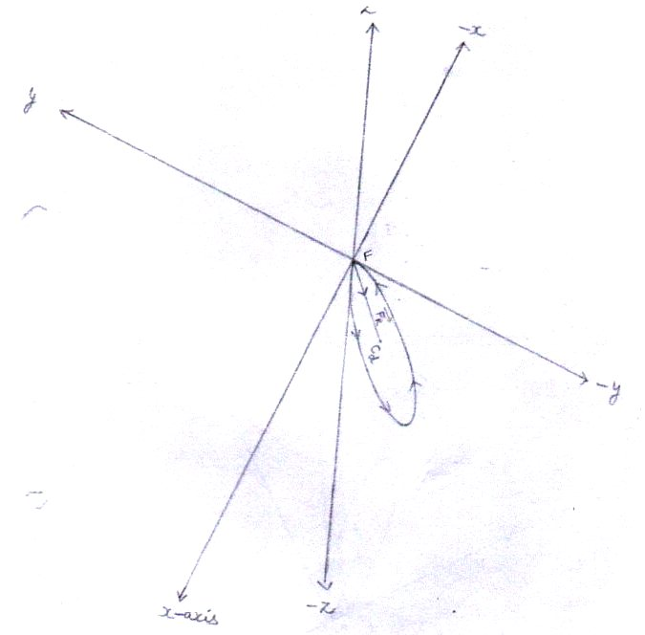
The circular orbit followed
fig.(26) by the confined deuteron
Where ,
C_{d} = center of the circular orbit followed by the confined deuteron
$\vec{Fr}$ = Resultant force
F = the center of fusion or the point where deuteron is produced.
- By seeing the directions of forces[ $\overset{→}{Fx}$ ,$\overset{→}{Fy} \overset{→}{Fz}$ ] acting on the deuteron [ when the deuteron is at point ‘ F ‘ ] , we reach at the conclusion that the circular orbit followed by the confined deuteron lies in the plane made up of positive x – axis , negative y – axis and the negative z – axis.
- The deuteron is confined .
- The line segment $\overset{→}{FCd}$ is the radius of the circular orbit followed by the confined deuteron and is equal to 6.943 x 10⁻² m.
14..Angles that make the resultant force ( F_{R} ) [ acting on the deuteron when the deuteron is at point ‘ F ‘ ] with positive x , y and z-axes .
1 with x- axis
Cos α = F_{R} cos α / F_{r} = $\overset{→}{Fx}$ / F_{r}
$\overset{→}{Fx}$ = 0.35168 x 10⁻¹² N from eq.(90)
F_{r} = 0.9306 x 10⁻¹² N from eq.(91)
Cos α = 0.35168 x 10⁻¹² N
0.9306 x 10⁻¹² N
Cos α = 0.3779 eq.(94)
- α = 67.8 degree [ $∴$ cos ( 67.8 ) = 0.3778 ]
2 with y- axis
Cos β = F_{R} cos β / F_{r} = $\overset{→}{Fy}$ / F_{r}
$\overset{→}{Fy}$ = -0.60928 x 10⁻¹² N from eq.(88)
F_{r} = 0.9306 x 10⁻¹² N from eq.(91)
Cos β = -0.60928 x 10⁻¹² N
0.9306 x 10⁻¹² N
Cos β = - 0.6547 eq.(95)
- β = 130.8 degree [ $∴$ cos ( 130.8 ) = - 0.6534 ]
3 with y- axis
Cos y = F_{R} cos y / F_{r} = $\overset{→}{Fz}$ / F_{r}
$\overset{→}{Fz}$ = -0.60928 x 10⁻¹² N from eq.(89)
Cos y = -0.60928 x 10⁻¹² N
0.9306 x 10⁻¹² N
- Cos y = -0.6547 eq.(96)
- y = 130.8 degree
see fig.(27)
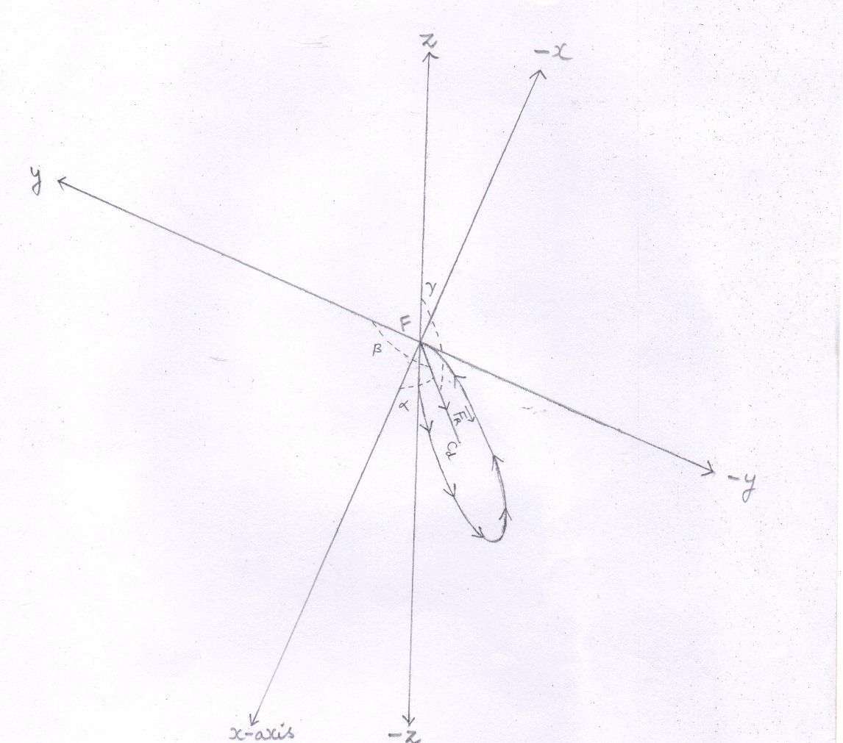

fig.(27)
- Angles that make the resultant force ($\overset{→}{Fr}$ ) [ acting on the particle, when the deuteron is at point ‘F’] with respect to positive x , y , and z- axes .
Where,
α = 67.8 degree from eq.(94)
β = 130.8 degree from eq.(95)
Y = 130.8 degree from eq.(96)

- ‘ F ‘ is the point where all the three axes meet or intersect each other .
15..The cartesian coordinates of the points P₁ ( x₁ , y₁ , z₁ ) and P₂ ( x₂ , y₂ , z₂ ) located on the circumference of the circle obtained by the deuteron
- cos α = x₂ - x₁
d
d = 2 x r
r = 6.943x10⁻² m from eq.(92)
d = 2x6.943x10⁻² m
d = 13.886 x 10⁻² m
Cos α = 0.37 from eq.(94)
- x₂ - x₁ = d x cos α
- x₂ - x₁ = 13.886 x10⁻²x0.37 m
- x₂ - x₁ = 5.1378 x 10⁻² m
- x₂ = 5.1378 x 10⁻² m [ $∴$ x₁ = 0 ] eq.(97)
2 cos β = y₂ - y₁
d
cos β = -0.65 from eq.(95)
- y₂ - y₁ = d x cos β
- y₂ - y₁ = 13.886 x10⁻²x (-0.65) m
- y₂ - y₁ = -9.0259 x 10⁻² m
- y₂ = -9.0259x 10⁻² m [ $∴$ y₁ , = 0 ] eq.(98)

- cos y = z₂ - z₁
d
cos y = -0.65 from eq.(96)
- z₂ - z₁ = d x cos y
- z₂ - z₁ = 13.886 x10⁻²x (-0.65) m
- z₂ - z₁ = -9.0259 x 10⁻² m
- z₂ = -9.0259 x 10⁻² m [ $∴$ z₁ , = 0 ] eq.(99)

- The cartesian coordinates of the points P₁ ( x , y , z ) and P₂ ( x₂ , y₂ , z₂ ) located on the circumference of the circle obtained by the deuteron :-
- The line P₁P₂ is the diameter of the circle .

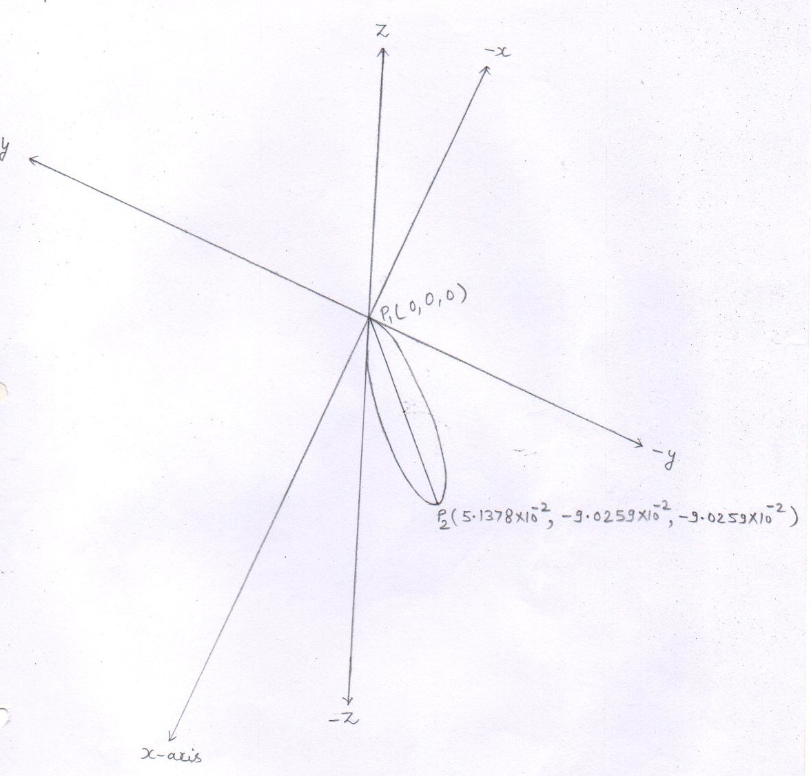
fig.(28 )
- Conclusion : the deuteron is confined . The deuteron starts its circular motion from . point p₁ [ or the point ‘ F ‘ ( 0 , 0 , 0) ] and reaches at point p₂ ( x_{2 ,} y₂ , z₂ ) and then again reaches at point p₁ ( x_{1 ,} y₁ , z₁ ) to complete the circle of radius 0.06943 m . the deuteron keeps on following the confined circular orbit uninterruptedly and pass through this point ‘F’ [ or the point p₁ (0 , 0 ,0 ) by time and again until it fuses with the proton of the later injected bunch reaching at point ‘F ‘ .
- The confined deuteron fuses with the injected proton at only and only point ‘ F ‘ and form the compound nucleus at point ‘ F ‘ .
Final kinetic energy of the positron
E = _{½} m_{e+} V_{f}² = ½ m_{e+} V²_{inh} = ½ m_{e+} V²_{CN}
m_{e+} = 9.1 x 10⁻³¹ kg
V²_{CN} = 0.19332068 x 10¹⁴ from eq.(84)
E = ½ x 9.1 x 10⁻³¹ x ( 0.19332068 x 10¹⁴ ) J

- E = 0.879609094 x 10⁻¹⁷ J
= 0.5497 x 10⁻⁴ Mev

- m_{e+} V_{f}² = m_{e+} V²_{inh} = m_{e+} V²_{CN}
V²_{CN} = (0.19332068 x 10¹⁴ ) m²/s² from eq.(84)
- m_{e+} V_{f}² = 9.1 x 10⁻³¹ x 0.19332068 x 10¹⁴ J
= 1.7592 x 10⁻¹⁷ J eq.(100)

17 Forces acting on the particle – Positron
1 F_{y} = q V_{x} B_{Z} sin θ
q = 1.6 x 10⁻¹⁹
$\overset{→}{Vx}$ = 0.3808 x 10⁷ m/s from eq.(78)
$\vec{Bz}$ = - 1 Tesla from eq.(15)
sin θ = sin 90º = 1
- F_{Y} = 1.6 x 10⁻¹⁹ x 0.3808 x 10⁷ x 1 x 1 N
= 0.60928 x 10⁻¹² N
Form the right hand palm rule , the direction of force $\vec{Fy}$ is according to negative y axis .
So, $\vec{Fy}$ = - 0.60928 x 10⁻¹² N eq.(101)
2 F_{z} = q V_{x} B_{y} sin θ
$\vec{By}$ = 1 Tesla from eq.(16)
sin θ = sin 90º = 1
- F_{Y} = 1.6 x 10⁻¹⁹ x 0.3808 x 10⁷ x 1 x 1 N
= 0.60928 x 10⁻¹² N

Form the right hand palm rule , the direction of force $\vec{Fz}$ is according to negative z axis .
So, $\vec{Fz}$ = - 0.60928 x 10⁻¹² N eq.(102)

3 F_{x} = q V_{y} B_{Z} sin θ
$\overset{→}{Vy}$ = 0.2198 x 10⁷ m/s from eq.(79)
$\vec{Bz}$ = -1 Tesla
sin θ = sin 90º = 1
- F_{x} = 1.6 x 10⁻¹⁹ x 0.2198 x 10⁷ x 1 x 1 N
= 0.35168 x 10⁻¹² N

Form the right hand palm rule , the direction of force $\vec{Fx}$ is according to positive x axis .
So. $\vec{Fx}$ = 0.35168 x 10⁻¹² N eq.(103)
See fig.(29)
Forces acting on the particle – Positron
fig.(29)
4 Resultant force ( F_{R} ) acting on the positron
F_{R}² = F_{x}² + F_{Y}² +F_{Z}²
F_{x} = 0.35168 x 10⁻¹² N from eq.(103)
F = F_{y} = F_{z} = 0.60928 x 10⁻¹² N from eq.(101 and 102)
F_{R}² = F_{x} ² + 2F²
- F_{R}² = (0.35168 x 10⁻¹² )² + 2(0.60928 x 10⁻¹² )² N²
= (0.1236788224 x 10⁻²⁴ ) + 2(0.3712221184 x 10⁻²⁴ ) N²
F_{R}² = (0. 1236788224 x 10⁻²⁴ ) + (0. 7424442368x 10⁻²⁴ ) N²
F_{R}² = 0.8661230592 x 10⁻²⁴ N²
F_{R} = 0.9306 x 10⁻¹² N eq.(104)

- 18 Radius of the circular orbit followed by the Positron :

R = mv²/ F_{R}
mv² = 1.7592 x 10⁻¹⁷ J from eq.(100)
F_{R} = 0.9306 x 10⁻¹² J from eq.(104)

- R = 1.7592 x 10⁻¹⁷ m
0.9306 x 10⁻¹²

- R = 1.89039 x 10⁻⁵ m
- R = 18.9039 x 10⁻⁶ m eq.(105)
Conclusion :
Confinement of positron
The positron is confined due to the forces acting on it . By seeing the directions of forces acting on the positron , we reach at the conclusion that the circular orbit followed by the confined positron lies in the plane made up of positive x – axis , negative y- axis and negative z – axis .

Electron gun : - electron gun injects the electron into the the tokamak at point ‘ F ‘ . The each electron is injected into the tokamak with 10 ev energy making angle 30º with the x-axis , 120º angle with the y-axis and 90º angle with the z-axis .

Injection of the electron : -

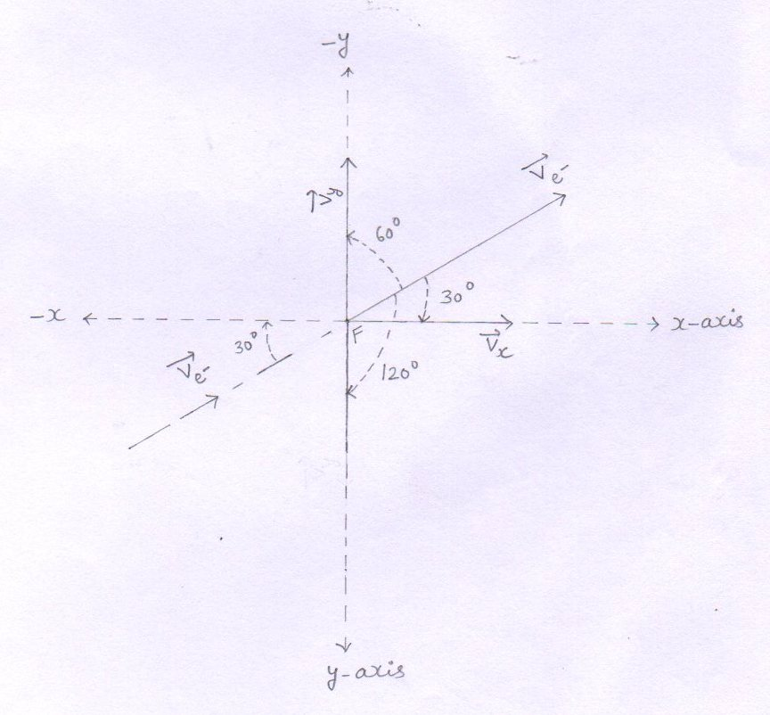
fig.(30)

Annihilation of the positron
- The injected electron reaches at point ‘ F ‘ and collides with the positron passing through it. The result of the collision is the annihilation of the positron and the electron and is the creation of a pair of gamma ray photons .
The positron annihilates with an electron and their mass
Energy [ m_{e+} c² + m_{e-} c² ] and their kinetic energy [ ½ m_{e+} V²_{CN} + ½ m_{e-} V² _{injected} ] is carried away by the two gamma ray photons .

- So , at point ‘ F ‘ annihilation is as :-
e⁺ + e⁻ $→$ 2 y photons

- The produced gamma ray photons strike to the wall of the tokamak.
- The positron (s) that do not collide with electron (s) continue follow the confined circular orbit until they annihilate with electron (s) .
- The injected electron (s) that reaches at point ‘F ‘ but does not collide with any positron , due to presence of magnetic fields , undergo to a circular orbit .

Confinement of the injected electron
1 Velocity of the electron

V = 2E ½ m/s
m_{e-} E_{e} = 10 ev
m_{e-} = 9.1 x 10⁻³¹ J
V = 2x10x1.6x10⁻¹⁹ ½ m/s
9.1 x 10⁻³¹
V = 3.51648351648 x 10¹² ½ m/s

V = 1.8752 x 10⁶ m/s eq.(106)

- Components of the velocity of the election
Each electron is injected into the tokamak making angle 30º with the x-axis , 120º angle with y-axis and 90º angle with the z-axis .
So, the components of the velocity of the electron at point ‘ F ‘ are –
1 $\overset{→}{Vx}$ = V cos α
V = 1.8752 x 10⁶ m/s from eq.(106)
cos α = cos 30º =0.866
$\overset{→}{Vx}$ = 1.8752 x 10⁶ x 0.866 m/s
$\overset{→}{Vx}$ = 1.6239 x 10⁶ m/s eq.(107)
2 $\overset{→}{Vy}$ = V cos β
cos β = cos 120º = -0.5
$\overset{→}{Vy}$ = 1.8752 x 10⁶ x (-0.5) m/s from eq.(106)
$\overset{→}{Vy}$ = -0.9376 x 10⁶ m/s eq.(108)

3 $\overset{→}{Vz}$ = V cos y
cos y = cos 90º = 0

$\overset{→}{Vz}$ = 1.8752 x 10⁶ x 0 m/s
$\overset{→}{Vz}$ = 0 m/s eq.(109)

3..Forces acting on the particle – electron
1 F_{y} = q V_{x} B_{Z} sin θ
$\overset{→}{Vx}$ = 1.6239 x 10⁶ m/s from eq.(107)
$\vec{Bz}$ = - 1 Tesla from eq.(15)
sin θ = sin 90º = 1
q = 1.6 x 10⁻¹⁹ C
- F_{Y} = 1.6 x 10⁻¹⁹ x 1.6239 x 10⁶ x 1 x 1 N
= 2.5982 x 10⁻¹³ N

Form the right hand palm rule , the direction of force $\vec{Fy}$ is according to negative y-axis .
So, $\vec{Fy}$ = - 2.5982 x 10⁻¹³ N eq.(110)
2 F_{z} = q V_{x} B_{y} sin θ
$\vec{By}$ = 1 Tesla from eq.(16)
sin θ = sin 90º = 1
- F_{z} = 1.6 x 10⁻¹⁹ x 1.6239 x 10⁶ x 1 x 1 N
= 2.5982 x 10⁻¹³ N

Form the right hand palm rule , the direction of force $\vec{Fz}$ is according to negative z- axis .
So,$\vec{Fz}$ = - 2.5982 x 10⁻¹³ N eq.(111)
3 F_{x} = q V_{y} B_{Z} sin θ
$\vec{Vy}$ = -0.9376 x 10⁶ m/s from eq.(108)
$\vec{Bz}$ = -1 Tesla
sin θ = sin 90º = 1
- F_{x} = 1.6 x 10⁻¹⁹ x 0.9376 x 10⁶ x 1 x 1 N
= 1.5001x 10⁻¹³ N

Form the right hand palm rule , the direction of force $\vec{Fx}$ is according to negative x- axis .
So, $\vec{Fx}$ = - 1.5001x 10⁻¹³ N eq.(112)

4 Resultant force ( F_{R} ) acting on the electron
F_{R}² = F_{x}² + F_{Y}² +F_{Z}²
F_{x} = 1.5001 x 10⁻¹³ N from eq.(112)
F = F_{y} = F_{z} = 2.5982 x 10⁻¹³ N from eq.(110,111)

F_{R}² = F_{x}² + 2F²
- F_{R}² = (1.5001 x 10⁻¹³ )² + 2(2.5982 x 10⁻¹³ )² N²
= (2.25030001 x 10⁻²⁶ ) + 2( 6.75064324 x 10⁻²⁶ ) N²
- F_{R}² = ( 2.25030001 x 10⁻²⁶ ) + (13.50128648x 10⁻²⁶ ) N²

- F_{R}² = 15.75158649 x 10⁻²⁶ N²

- F_{R} = 3.9688 x 10⁻¹³ N eq.(113)

- 4. Radius of the circular orbit followed by the electron :

R = mv²/ F_{R}
½ mv² = 10 ev
mv² = 2x10x1.6 x 10⁻¹⁹ J
=32x10⁻¹⁹ J
F_{R} = 3.9688 x 10⁻¹³ N from eq.(113)

- R = 32x10⁻¹⁹ m
3.9688 x 10⁻¹³

- R = 8.0628 x 10⁻⁶ m eq.(114)

Conclusion : - The electron that does not collide with positron is not confined . By seeing the direction of forces acting on the electron we reach at the conclusion that the circular orbit to be followed by the electron lies in the plane made up of negative x-axis , negative y-axis and negative z-axis where the magnetic fields are not applied. so , In trying to follow a confined circular orbit , the electron starts its circular motion from point ‘ F ‘ and reaches in a region made up of negative x-axis , negative y-axis and negative z- axis where the magnetic fields are not applied .
So, as the electron get rid of the magnetic fields , it starts its linear motion leaving the circular motion.
Firstly , the electron starts circular motion from point ‘ F ‘ then it give up its circular motion and starts its linear motion towards the downward to strike the base wall of the tokamak .

For fusion reaction (3) :-
¹₁H + ²₁ H $→$ ₂³ He + y rays
Formation of compound nucleus [₂³ He ] :-
1 interaction of nuclei : -
The injected proton as reaches at point ‘ F ‘, it interacts [ experiences a repulsive force due to the confined deuteron passing through the point F ] with the confined deuteron at point F . the injected proton overcomes the electrostatic repulsive force and – a like two solid spheres join - the injected proton dissimilarly joins with the confined deuteron .
see fig (31)

where ,[ ₂³ He ] is a compound nucleus formed due to proton and deuteron fusion.

Interaction of nuclei

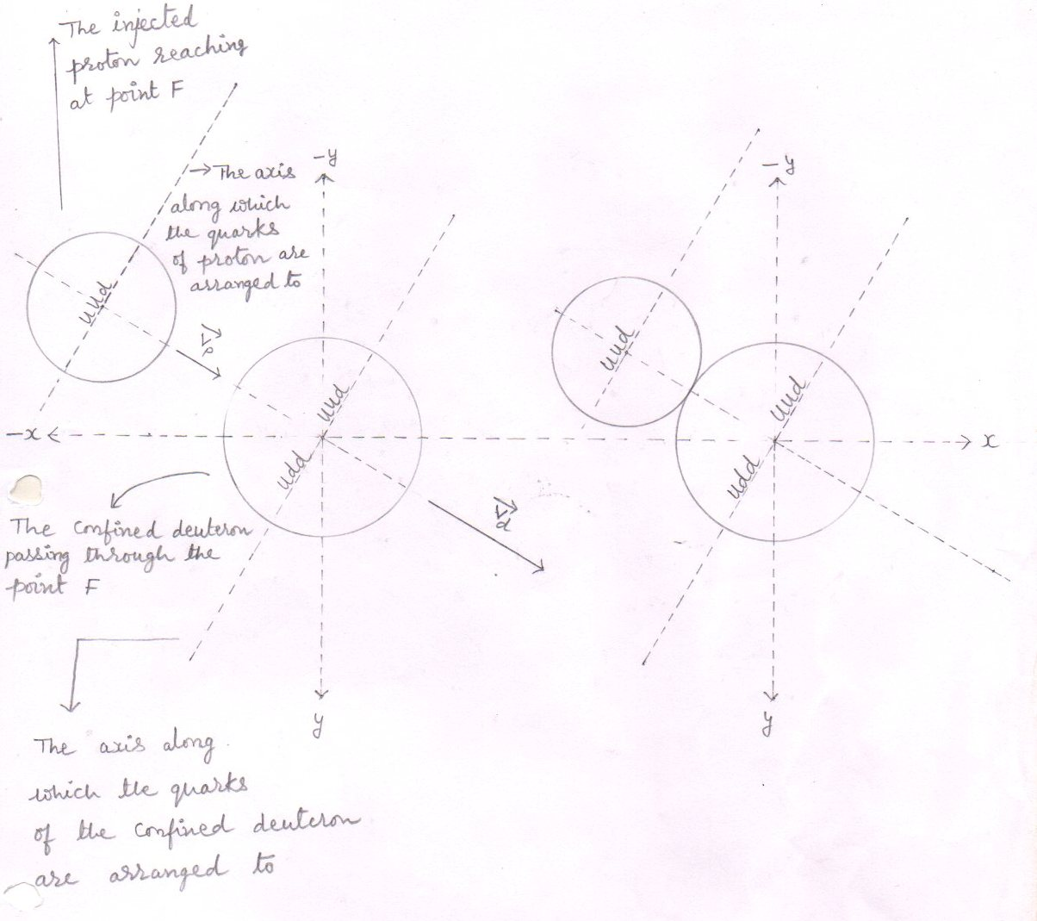
interaction (1) interaction (2)

fig(31)

2..Formation of the homogeneous compound nucleus : -
The constituents ( quarks and gluons ) of the dissimilarly joined nuclei ( the proton and the deuteron ) behave like a liquid and form a homogeneous compound nucleus having similarly distributed groups of quarks with similarly distributed surrounding gluons .
Thus within the homogeneous compound nucleus – each group of quarks is surrounded by the gluons in equal proportion. so, within the homogeneous compound nucleus there are 3 groups of quarks surrounded by the gluons.

see fig(32)

Homogeneous compound nucleus
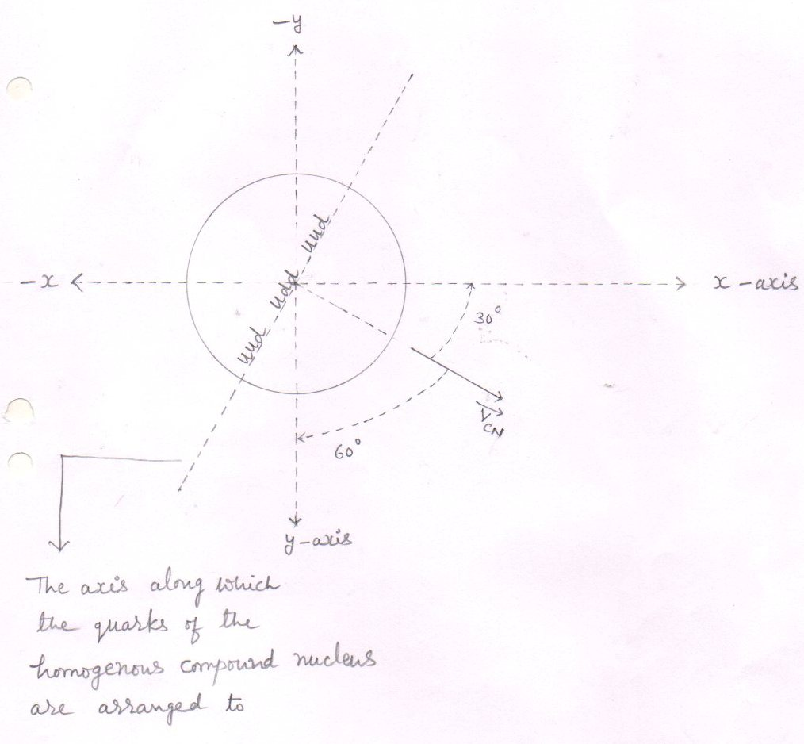
fig(32)
where,
$\overset{→}{Vcn}$ = velocity of the compound nucleus
and
α = 30⁰ [ from eq(132)]
β = 60⁰ [ from eq(133)]
y = 90⁰ [ from eq(134)]

2..Formation of lobes within into the homogeneous compound nucleus or the transformation of the homogeneous compound nucleus into the heterogeneous compound nucleus : -
The central group of quarks with its surrounding gluons to become a stable and the next higher nucleus ( the hellion – 3 ) than the reactant one ( the deuteron) includes the other two ( nearby located ) groups of quarks with their surrounding gluons and rearrange to form the ‘ A ‘ lobe of the heterogeneous compound nucleus.
While the remaining gluons [ the gluons or the mass that is not included in the formation of the lobe ‘ A ‘ ] rearrange to form the ‘ B ‘ lobe of the heterogeneous compound nucleus .
Due to formation of two dissimilar lobes within into the homogeneous compound nucleus , the homogeneous compound nucleus transforms into the heterogeneous compound nucleus.

see fig(33)

Formation of lobes within into the homogeneous compound nucleus : -
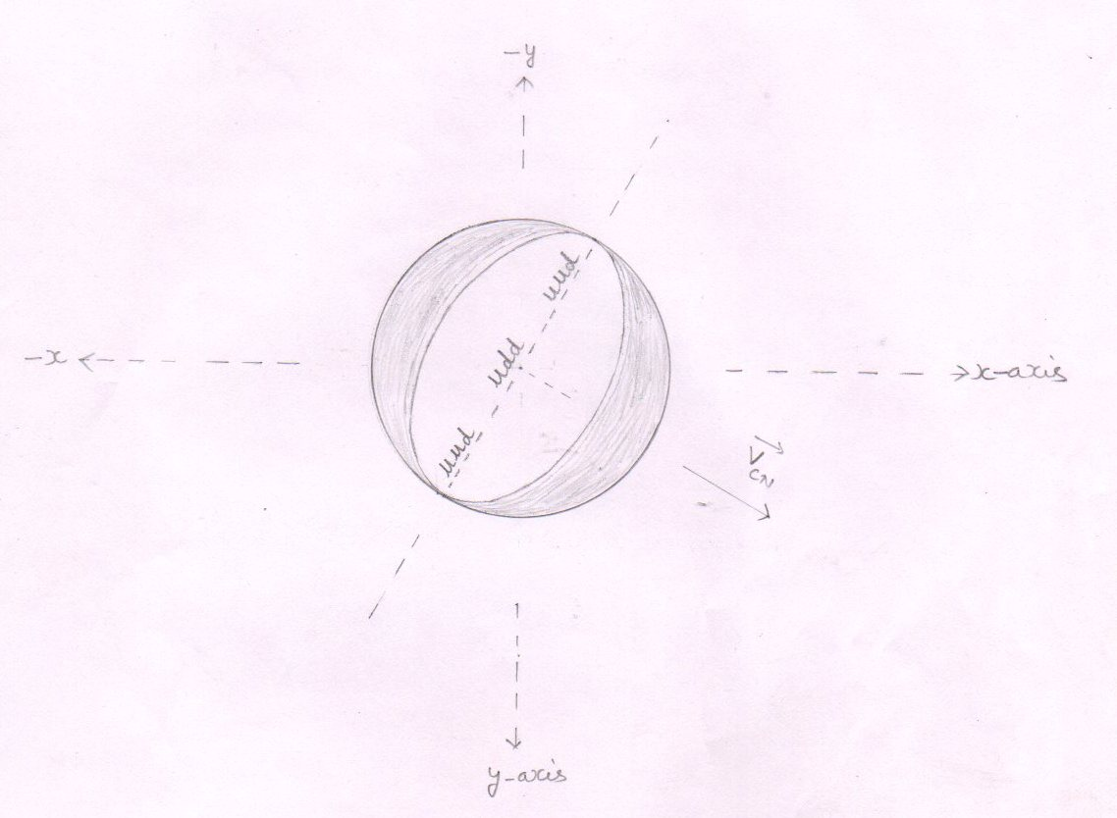
fig(33)

- Where ,
1 Inner side - lobe ‘ A ‘ is formed . [ The is the helium – 3 nucleus is formed ]
2 Outer side - The remaining gluons [ or the reduced mass ] form the ‘ B ‘ lobe of the heterogeneous compound nucleus ] .

4 Final stage of the heterogeneous compound nucleus : -
The remaining gluons [ That compose the ‘ B ‘ lobe of the heterogeneous compound nucleus ] remains loosely bonded to the helium – 3 nucleus [ that compose the ‘ A ‘ lobe of the heterogeneous compound nucleus ] . Thus , the heterogeneous compound nucleus , finally , becomes like a coconut into which the remaining gluons represent the outer shield while the helium – 3 nucleus represent the inner part of the coconut .

see fig.(34)

Final stage of the heterogeneous compound nucleus : -

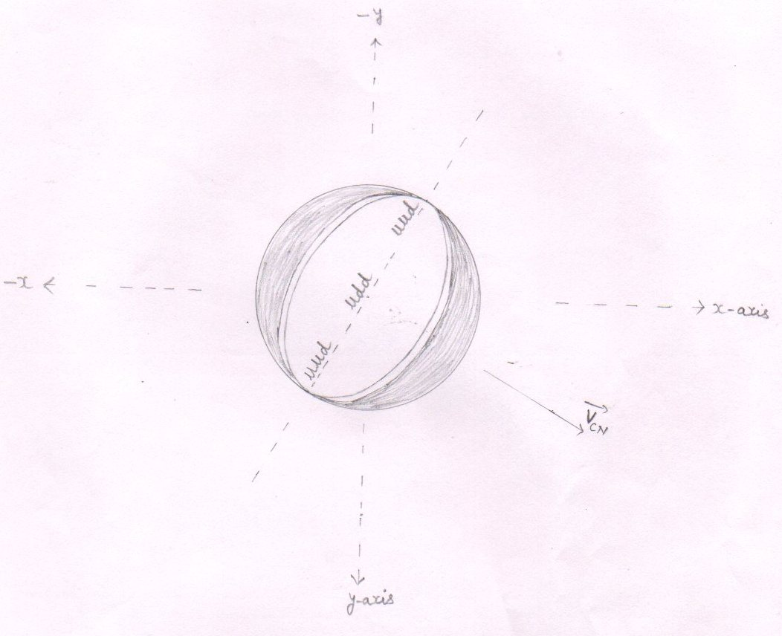

fig(34)

Calculations for the compound nucleus [ ³₂ He ]
1..Just before fusion , the loss in the kinetic energy of the injected proton
- As the injected proton reaches at point F , the injected proton fuses with the confined deuteron ( passing through the point F ) to form the compound nucleus at point F .
- Just before fusion , to overcome the electrostatic repulsive force , the injected proton loses its energy equal to 2.5 kev.
- So, the kinetic energy of the proton just before fusion is [ E_{b} ] -
E_{b} = [E_{P}- E_{loss} ]
E_{P} = 102.4 kev from eq. (4)
E_{loss} = E_{P-D} = 2.5 kev from eq. (3)
E_{b} = [ 102.4 -2.5 ] kev
= 99.9 kev
= 0.0999 Mev eq. ( 115 )
- The Velocity of injected proton just before fusion is [ V_{b} ]: -

V_{b} = 0.4371 x 10⁷ m/s from eq. (37) ………. eq.(116)

- The Components of the velocity of the proton just before fusion are : -
(1) $\overset{→}{Vx}$ = V_{b} cos α = 0.3785 x 10⁷ m/s from eq.(38) …… eq.(117)

(2) $\overset{→}{Vy}$ = V_{b} cos β = 0.2185 x 10⁷ m/s from eq.(39)……. eq.(118)

(3) $\overset{→}{Vz}$ = V_{b} cos y = 0 m/s from eq.(40)……. eq.(119)

3.. Components of the momentum of the injected proton just before fusion are : -
1 $\overset{→}{Px}$ = P_{b} cos α = 0.6330 x 10⁻²⁰ from eq.(41)……… eq.(120)

2 $\overset{→}{Py}$ = P_{b} cos β = 0.3654 x 10⁻²⁰ kgm/s from eq.(42) …eq.(121)

3 $\overset{→}{Pz}$ = P_{b} cos y = 0 kgm/s from eq.(43)….. eq.(122)

4.. Components of the momentum of the compound nucleus : -
The injected proton penetrates the confined proton. So , Just before fusion , there is a loss in kinetic energy of the injected proton but the kinetic energy of the confined deuteron remains same. So, the momentum of the confined deuteron remains same as with which it was produced .
- X – component of the momentum of the compound nucleus $(\overset{→}{Px} )$ =

X – component of X – component of the
the momentum momentum of the injected
of the confined deuteron + Proton just before fusion
at point ‘ F’ at point ‘F’

$\overset{→}{Px}$ = [ 1.2731 x 10⁻²⁰ ] + [ 0.6330 x 10⁻²⁰ ] kgm/s from eq.(81 and 120)
= 1.9061 x 10⁻²⁰ kgm/s
$\overset{→}{Px}$ = P_{CN} cos α = 1.9061 x 10⁻²⁰ kgm/s eq.(123)

- Y– component of the momentum of the compound nucleus( $\overset{→}{Py}$ ) =

y – component of y – component of the
the momentum momentum of the injected
of the confined deuteron + Proton just before fusion
at point ‘F ‘ at point ‘F’

- $\overset{→}{Py}$ = [ 0.7348 x 10⁻²⁰ ] + [ 0.3654 x 10⁻²⁰ ] kgm/s from eq.(82 and 121)
- $\overset{→}{Py}$ = 1.1002 x 10⁻²⁰ kgm/s
- $\overset{→}{Py}$ = P_{CN} cos β = 1.1002 x 10⁻²⁰ kgm/s from eq.(124)

- z – component of the momentum of the compound nucleus ($\overset{→}{Pz}$ ) =

z– component of z – component of the
the momentum momentum of the injected
of the confined deuteron + Proton just before fusion
at point ‘F’ at point ‘F’

- $\overset{→}{Pz}$ = [ 0 ] + [ 0 ] kgm/s from eq.(83 and 122)
- $\overset{→}{Pz}$ = 0 kgm/s
- $\overset{→}{Pz}$ = P_{CN} cos y = 0 kgm/s eq.(125)

5..Mass of the compound nucleus :

- M = m_{d} + m_{p}
= [ 3.3434 x 10⁻²⁷ ] + [1.6726 x 10⁻²⁷ ] kg
= 5.016 x 10⁻²⁷ kg eq.(126)

- 6..Components of the velocity of the compound nucleus : -

- $\overset{→}{Vx}$ = V_{CN} cos α = $\overset{→}{Px}$ / M = P_{CN} cos α
M

P_{CN} cos α = 1.9061 x 10⁻²⁰ kgm/s from eq.(123)
M = 5.016 x 10⁻²⁷ kg from eq.(126)

- $\overset{→}{Vx}$ = V_{CN} cos α = 1.9061 x 10⁻²⁰ kgm/s
5.016 x 10⁻²⁷ kg
- $\overset{→}{Vx}$ = V_{CN} cos α = 0.3800 x 10⁷ m/s eq.(127)

- $\overset{→}{Vy}$ = V_{CN} cos β = = $\overset{→}{Py}$ / M = P_{CN} cos β
M

P_{CN} cos β = 1.1002 x 10⁻²⁰ kgm/s from eq.(124)

- $\overset{→}{Vy}$ = V_{CN} cos β = 1.1002 x 10⁻²⁰ kgm/s
5.016 x 10⁻²⁷ kg
- $\overset{→}{Vy}$ = V_{CN} cos β = 0.2193 x 10⁷ m/s eq.(128)

- $\overset{→}{Vz}$ = V_{CN} cos y = = $\overset{→}{Pz}$ /M = P_{CN} cos y
M
P_{CN} cos y = 0 kgm/s from eq.(125)

- $\overset{→}{Vz}$ = 0 kgm/s
M kg
- $\overset{→}{Vz}$ = V_{CN} cos y = 0 m/s eq.(129)

- 7.. Velocity of the compound nucleus ( V_{CN} ) : -

- V² _{CN} = V_{x}² + V_{y}² + V_{z}²
V_{x} = 0.38 x 10⁷ m/s from eq.(127) V_{y} = 0.2193 x 10⁷ m/s from eq.(128)
V_{z} = 0 m/s from eq.(129)

- V²_{CN} = ( 0.38 x 10⁷ )² + ( 0.2193 x 10⁷ )² + ( 0 )² m²/s²
= (0.1444 x 10¹⁴ ) + (0.04809249 x 10¹⁴ ) + 0 m²/s²
- V²_{CN} = 0.19249249 x 10¹⁴ m²/s² eq.(130)

- V_{CN} = 0.4387 x 10⁷ m/s eq.(131)

8.. Angles that make the velocity of the compound nucleus ( V_{CN} ) with positive x , y , and z axes at point ‘ F ‘ .
- with x – axis
cos α = $\vec{Vx}$ /V_{CN} = V_{CN} cos α/ V_{CN}

V_{CN} cos α = 0.38 x 10⁷ m/s from eq.(127)
V_{CN} = 0.4387 x 10⁷ m/s from eq.(131)

- cos α = 0.38 x 10⁷ m/s = 0.8661
0.4387 x 10⁷ m/s
- α = 30º eq.(132) [ cos 30º = 0.8660 ]

- with y– axis
cos β = $\vec{Vy}$ /V_{CN} = V_{CN} cos β / V_{CN}

V_{CN} cos β = 0.2193 x 10⁷ m/s from eq.(128)

cos β = 0.2193x 10⁷ m/s
0.4387 x 10⁷ m/s
Cos β = 0.4998
- β = 60º eq.(133) [ cos 60º = 0.5 ]
- with z– axis
cos y= $\vec{Vz}$ /V_{CN} = V_{CN} cos y / V_{CN}

V_{CN} cos y = 0 m/s from eq.(129)

cos y = 0 m/s = 0
0.4387 x 10⁷ m/s
y = 90º eq.(134)

The splitting of the heterogeneous compound nucleus : -
- The remaining gluons are loosely bonded to the helium – 3 nucleus .

- At the poles of the helium – 3 nucleus , the remaining gluons are lesser in amount than at the equator

- So, during the rearrangement of the remaining gluons [ or during the formation of the ‘ B ‘ lobe of the heterogeneous compound nucleus ] , the remaining gluons to be homogeneously distributed all around , rush from the equator to the poles .
In this way , the loosely bonded remaining gluons separates from the helium – 3 nucleus and also divides itself into two parts giving us three particles – the first one is the one – half of the reduced mass , second one is the helium -3 nucleus and the third one is the one – half of the reduced mass .

- Thus , the heterogeneous compound nucleus splits according to the lines parallel to the velocity of the compound nucleus into three particles – the first one is the one – half of the reduced mass ( Δm/2 ) , the second one is the helium -3 nucleus and the third one is the another one – half of the reduced mass (Δm/2 ) .

- By the law of inertia , each particle that has separated from the compound nucleus has an inherited velocity ( $\overset{→}{Vinh }$ ) equal to the velocity of the compound nucleus ($\vec{Vcn}$ ) .

- So , for the conservation of momentum

M $\vec{Vcn}$ = ( Δm/2 + m_{he-3} +Δm/2 ) $\vec{Vcn}$

Where ,
M = mass of the compound nucleus
$\vec{Vcn}$ = velocity of the compound nucleus
Δm/2 = one – half of the reduced mass
m_{he-3} = mass of the helium -3 nucleus

see fig (35) and (36)

The splitting of the heterogeneous compound nucleus
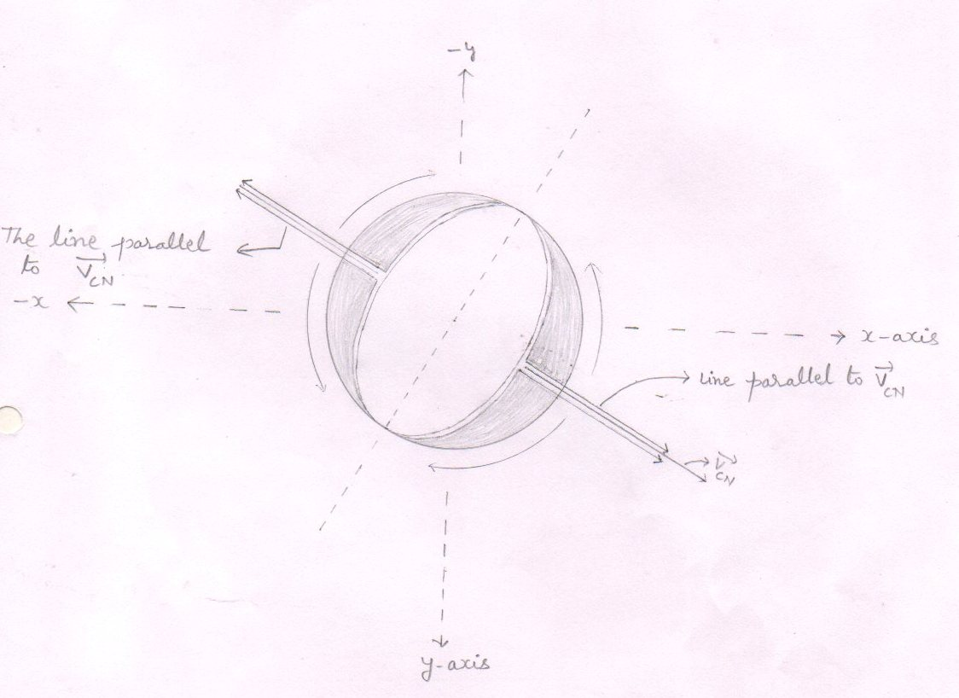
splitting -1
fig (35)
- The loosely bonded remaining gluons rush from equator to the poles , but before they reach at the equator, it breaks up.
- Thus the heterogeneous compound nucleus splits according to the lines parallel to the velocity of the compound nucleus ($\vec{Vcn}$ ) into three particles – one is the half of the reduced mass (Δm/2 ) the second is the helium -3 nucleus and the third is the one – half of the reduced mass (Δm/2 ) .

The spitting of the heterogeneous compound nucleus
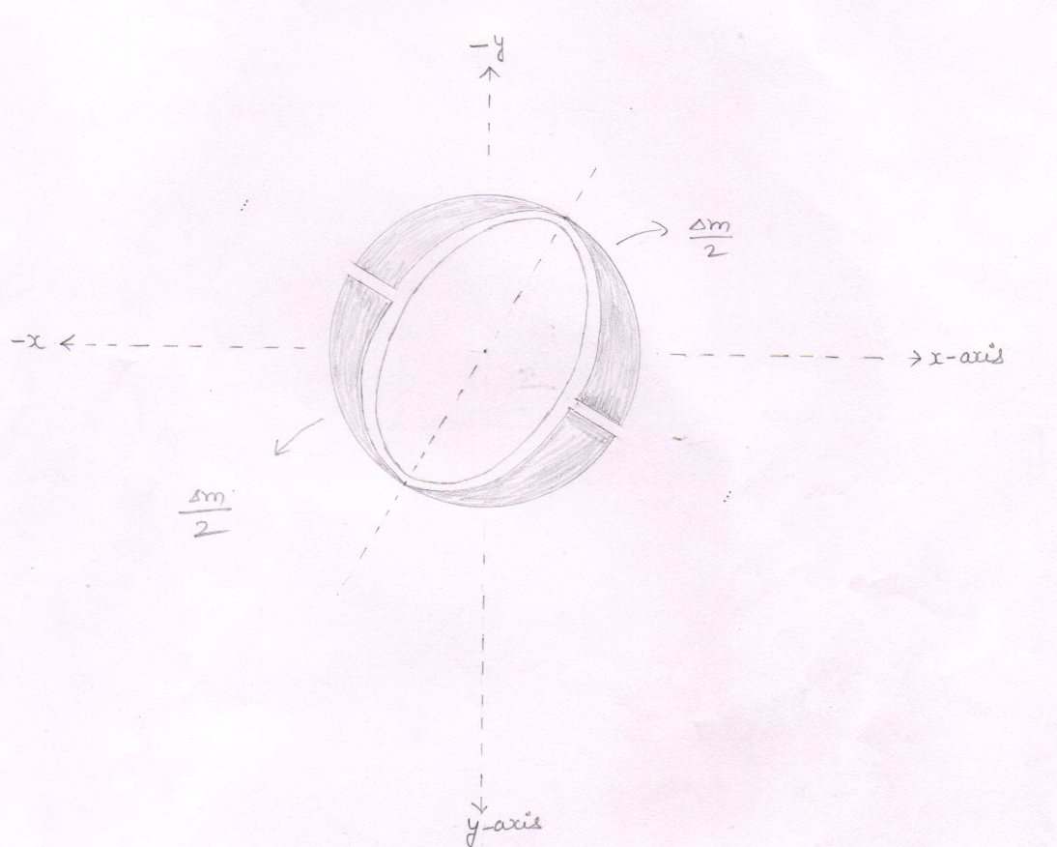
splitting -2
fig (36)

- The heterogeneous compound nucleus splits into three particles – The one – half of the reduced mass ,the helium – 3 nucleus and the one – half of the reduced mass .

- Inherited velocity of the particles : -
Each particles that has separated from the compound nucleus has an inherited velocity ( $\overset{→}{Vinh }$) equal to the velocity of the compound nucleus ($\overset{→}{Vcn }$) .

I . inherited velocity ( $\overset{→}{Vinh }$) the particle hellion – 3

V_{inh} = V_{CN} = 0.4387 x 10⁷ m/s from eq.( 131)

- Components of the inherited velocity of the hellion – 3

1 $\overset{→}{Vx}$ = V_{inh} cos α = V_{CN} cos α = 0.38 x 10⁷ m/s from eq.( 127)……eq.( 135)

2 $\overset{→}{Vy}$ = V_{inh} cos β = V_{CN} cos β = 0.2193 x 10⁷ m/s from eq.( 128) …. eq.( 136)

3 $\overset{→}{Vz}$ = V_{inh} cos y = V_{CN} cos y = 0 m/s from eq.( 129) …. eq.( 137)

II . For the each one – half of the reduced mass (Δm/2 ) :-

- V_{inh} = V_{CN} = 0.4387 x 10⁷ m/s from eq.( 131)

- Propulsion of the particles
- Reduced mass
Δm = [ m_{d} +m_{p} ] - [ m_{He-3} ]
m_{d} = 2.01355 amu
m_{p} = 1.00727 amu
m_{He-3} = 3.01493 amu
Δm = [ 2.01355+1.00727 ] – [ 3.01493 ] amu

Δm = [ 3.02082 ] – [ 3.01493 ] amu
Δm = 0.00589 amu

Δm = 0.00589 x 1.6605 x 10⁻²⁷ kg

Δm = 0.009780345 x 10⁻²⁷ kg
i.e. Δm = 0.00589 amu = Δm = 0.009780345 x 10⁻²⁷ kg eq.(138)

- The Inherited kinetic energy of the total reduced mass (Δm ) .

- E_{inh} = _{½} Δm V² _{inh} = _{½} Δm V²_{CN}
Δm = 0.009780345 x 10⁻²⁷ from eq.(138)
V²_{CN} = 0.19249249 x 10¹⁴ m²/s² from eq.(130)
- E_{inh} = _{½} x 0.009780345 x 10⁻²⁷ x 0.19249249 x 10¹⁴ J

- E_{inh} = 0.00094132148 x 10⁻¹³ J

- E_{inh} = 0.000588 Mev eq.(139)

- Released energy ( E_{R} )

E_{R} = Δmc ²
Δm = 0.00589 amu from eq.(138)

E_{R} = 0.00589 x 931 Mev

E_{R} = 5.48359 Mev eq.(140)

- Total energy ( E _{T} )
E _{T} = E_{inh} + E_{R}
E _{T} = ( 0.000588 ) + ( 5.48359 ) Mev from eq.(139 and 140)
E _{T} = 5.484178 Mev eq.(141)

5 Propulsion of the helium – 3 nucleus : -
- 5(i) The each one – half of the reduced mass (Δm/2 ) converts into energy . so , the energy ( E ) carried by the produced pairs of gamma ray photons is –

E = E_{T}/ 2

E_{T} = 5.4841 Mev from eq.(141)

- E = 5.4841/2 Mev

- E = 2.7420 Mev eq.(142)

- When a pair of gamma ray photon make a head – on collision with a nucleus , it imparts its extra energy to the nucleus by a pair production [ that is producing a positron and an electron ] .

So , for pair production each pair of gamma ray photon carrying high energy must have an energy ( 1.02 Mev ) equal to or greater than the sum of the energies – the energy equal to the rest mass of the positron ( m_{e+} c² ) and the energy equal to the rest mass of electron ( m_{e-} c² ) .

5(ii) Number of pairs of gamma ray photons ( N _{y} ) : -
- When one – half of the reduced mass (Δm/2 ) converts into energy , the energy ( E ) carried by the pairs of gamma ray photons is 2.7420 Mev .

- Each pair of gamma ray photon that carry a part of energy ( E ) must have an energy equal to or more than 1.02 Mev .

- So ,

Number of pairs of = Energy (E) produced due to Δm/2
gamma ray photos Energy that must carried by a pair of g.r. photon

E = 2.7420 Mev from eq.(142)
- N_{y} = 2.7420 Mev
1.02 Mev
- N_{y} = 2.6882

- Taking the whole digit , we may say that there are 2 pairs of gamma ray photons that carry the energy 2.7420 Mev .

- Thus , there are the 4 pairs of gamma ray photons that carry the total energy ( E_{T} ) equal to 5.4841 Mev

5(iii) Energy carried by the each pair of gamma ray photon [ E_{y} ] : -

- Energy carried by the each pair of gamma ray photon is equal to the energy (E ) produced due to one – half of the reduced mass (Δm/2 ) divided by the total number of pairs of gamma ray photons that carry the energy ( E ) .

- E_{y} = energy (E) produced due to Δm/2
Total number of pairs of g.r. photons that carry energy ( E )

E = 2.7420 Mev from eq.(142)

- E_{y} = 2.7420 Mev
2
- E_{y} = 1.3710 Mev

6.. Propulsion of particle : -
As the reduced mass converts into energy , the total energy (E_{T} ) is carried away by the gamma ray photons .

6(i) conservation of momentum : -
we know that the reduced mass has separated from the compound nucleus with an inherited velocity ($\vec{Vinh}$) equal to the velocity of the compound nucleus ($\vec{Vcn}$ ) .
so , for conservation of momentum , if we sum up the momenta of all the produced gamma ray photons , we will again get the total momentum equal to the reduced mass multiplied by the velocity of the compound nucleus (ΔmV_{CN} ) .

Now , if we denote the momentum of a gamma ray photon by P_{y} then,

The total momenta of all the produced four gamma ray photons will be equal to ΔmV_{CN} .
Or

P_{y} ₍ ₁ ₎ + P_{y} ₍ ₂ ₎ + P_{y} ₍ ₃ + P_{y} ₍ ₄ ₎ = ΔmV_{CN}

see fig ( 37,39,40)

6..(ii) We know that the inherited kinetic energy of the reduced mass is negligible . so . we can take the inherited momentum of the reduced mass (Δm$\vec{Vcn}$ ) is equal to zero .
If we take the inherited momentum of the reduced mass (Δm$\vec{Vcn}$ ) is equal to zero then the sum of the momenta of all the produced 4 gamma ray photons will also be equal to zero .
That is –

P_{y} ₍ ₁ ₎ + P_{y} ₍ ₂ ₎ + P_{y} ₍ ₃ + P_{y} ₍ ₄ ₎ = 0

So, we reach at this conclusion that out of 4 gamma ray photons , the sum of momenta of 2 gamma ray photons is equal and opposite to the sum of momenta of rest 2 gamma ray photons .
Or we may say that there is a photon having equal and opposite momentum to the another photon .

see fig (38,39,40)

6..(iii)when one – half of the reduced mass (Δm/2 ) converts into energy , the one – half of the total energy ( E_{T} / 2 ) is carried away by the 2 pairs of gamma say photons .
The pair of gamma ray photon numbered as ‘ 1 ‘ travelling in 1st quadrant has equal and opposite momentum to the pair of gamma ray photon numbered as ‘ 3 ‘ travelling in the 3rd quadrant .
Similarly , the pair of gamma ray photon numbered as ‘ 2 ‘ travelling in the 2nd quadrant has equal and opposite momentum to the pair of gamma ray photon numbered as ‘ 4 ‘ travelling in the 4th quadrant .

That is ,
P_{y} ₍ ₁ ₎ = - P_{y} ₍ ₃ ₎

Similarly
P_{y} ₍ ₂ ₎ = - P_{y} ₍ ₄ ₎

see fig (37,38,39,40)

6.. (iv) The sum of the momenta of the pairs of gamma ray photons travelling in the I quadrant is equal and opposite to the sum of the momenta of the pairs of gamma ray photons travelling in the III quadrant .
Similarly , the sum of the momenta of the pairs of gamma ray photons travelling in the II quadrant is equal and opposite to the sum of the momenta of the pairs of gamma ray photons travelling in the IV quadrant .

Conclusion : Increased kinetic energy of helion -3.
For conservation of momentum there the three conditions arise -
- All the four pairs of gamma ray photons strike to the helium -3 nucleus where a pair of gamma ray photon has equal and momentum to another . so, the net change in momentum of the helium -3 nucleus is zero . As the momentum of helion -3 is not increased ( changed ) the increament in the kinetic energy of the helion -3 is zero see fig (37,38)
- All the four pairs of gamma ray photons move outward and no any pair strike to the nucleus . In this condition also, the change in momentum of the helium -3 nucleus is zero . And so the increased kinetic energy of the helion -3 is zero . see fig.(39)
- only two pairs strike to the nucleus with equal and opposite momentum . so that the net change [ increatment ] in the momentum of the helium -3 is zero or we may say that the increased kinetic energy of the helion-3 is zero . see fig.(40)

For the 1st condition : All the four pairs of gamma ray photon strike to the helium -3 nucleus .
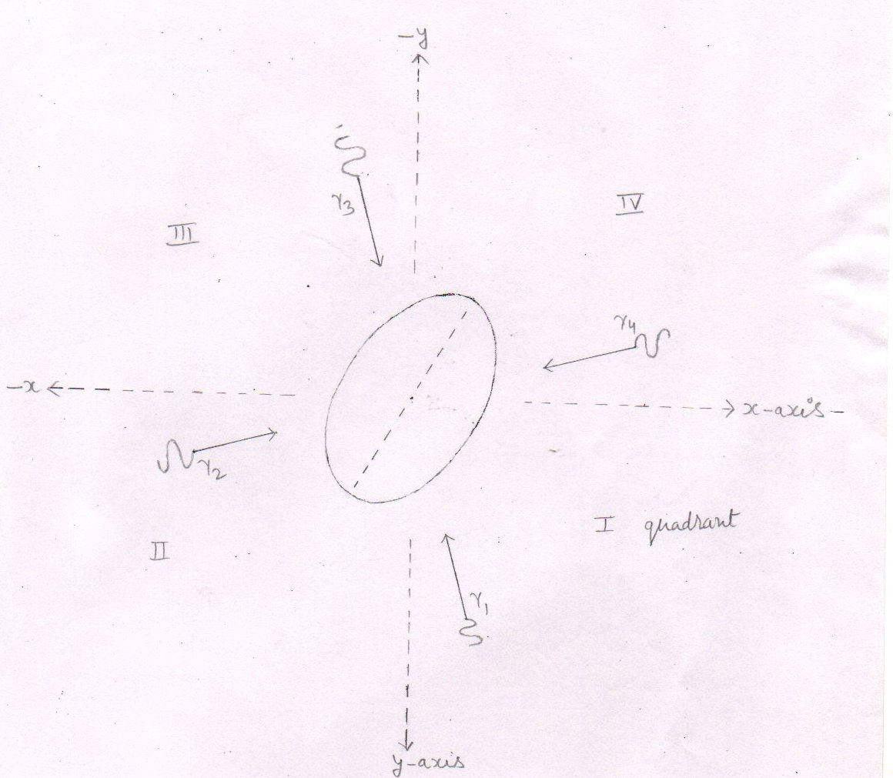
fig (37)
- Each pair of gamma ray photon travel towards the nucleus to make a head – on collision with the nucleus .
- Each photon carry 1.3710 Mev energy .
- The pair of gamma ray photon that has numbered as ‘ 1 ‘ travelling in the `I quadrant has equal and opposite momentum to the pair of gamma ray photon that has numbered as ‘ 3 ‘ travelling in the III quadrant . And same condition is applicable for the pairs of gamma ray photons numbered as ‘ 2 ‘ and ‘ 4 ‘

I . e P_{y} ₍ ₁ ₎ = -P_{y} ₍ ₃ ₎ and P_{y} ₍ ₂₎ = -P_{y} ₍ ₄ ₎
For the 1st condition : Collision between a pair of gamma ray photon and the helium -3 nucleus .
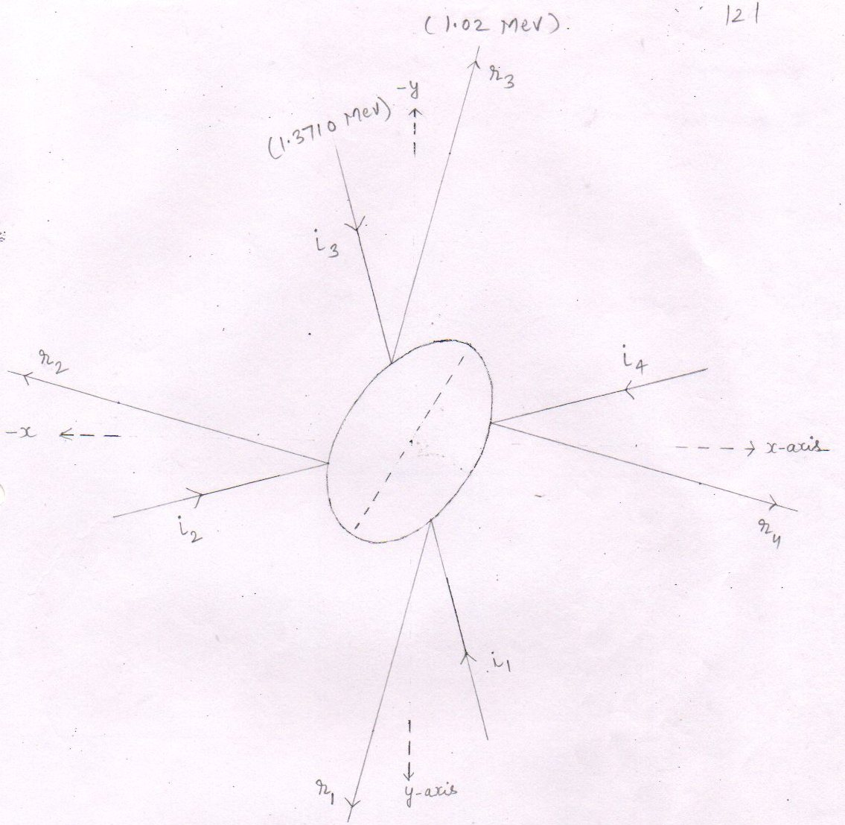
fig.( 38)
- Each incident photon carry 1.3710 Mev .
- Each incident photon make head – on collision with the helium – 3
- The angle of incidence is equal to the angle of reflection
- Where ,
i₁ = The incident photon numbered as ‘ 1 ‘
r₁ ₌ The reflected photon numbered as ‘ 1 ‘
- The helium – 3 nucleus is energised by the 1.404 Mev energy .
- Conclusion : Four pairs of gamma ray photon strike to the helium -3 nucleus where one pair has a momentum equal and opposite to the another . so, the net change in momentum of the helion -3 is zero . so, though , there is a loss in the energy of pairs of gamma ray photons , the net increased energy of the helion -3 is zero .
For the second condition : No any pair of gamma ray photon strike to the helium -3 nucleus .
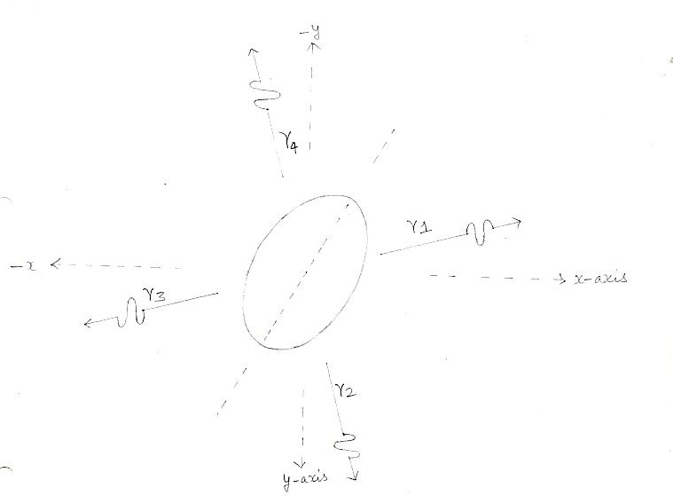
fig.(39)
- Each gamma ray photon carry 1.3710 Mev
- The gamma ray photon that is numbered as ‘ 1 ‘ travelling in the first quadrant has equal and opposite momentum to the photon numbered as ‘ 3 ‘ travelling in the III quadrant
Similarly 2nd and 4th photon also have equal and opposite momenta
- Conclusion : No any gamma ray photon make a head –on collision with the helium -3 nucleus . so, the net change in momentum of helium -3 is zero . so, the increased kinetic energy of the helium -3 nucleus is zero .

For 3rd condition : only two pairs of gamma ray photons strike to the helium-3 nucleus.

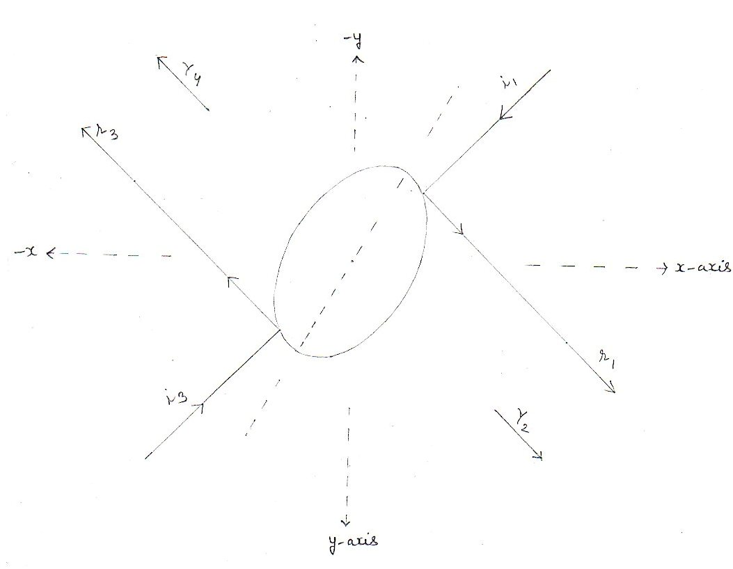
fig.(40)
- In the third condition, only half number of the produced gamma ray photons [ that is equal to 2 ] strike to the helium-3 nucleus.
While the other two pairs of gamma ray photons do not strike to the helium-3 nucleus.
Conclusion : two pairs of gamma ray photons strike to the helium-3 nucleus where each pair has equal and opposite momentum to the other one . so, the net increased momentum of the helion-3 is zero and hence the net increased kinetic energy of the helion-3 is zero .

- Increased kinetic energy of the helium -3 nucleus
in each condition, either the gamma ray photons strike to the helium-3 nucleus or not , the net change in momentum of the helium-3 nucleus is zero. so, the net change [ increament in the kinetic energy] . in energy of the helium-3 nucleus is zero.
or we say , the increased kinetic energy of the helium-3 nucleus is zero i.e.
E_{inc} = 0 eq.(143)
- Increased velocity ( V_{inc} ) of the helium-3 nucleus : -
As the increased kinetic energy ( E_{inc} ) of the helium-3 nucleus is equal to zero . so, the increased velocity ( V_{inc} ) of the helium-3 nucleus is also equal to zero .
that is –
V_{inc} = 0 eq.(144)
- Components of the increase velocity ( $\overset{→}{Vinc}$ ) of the helium-3 nucleus : -
As , V_{inc} = 0

So, the components of the increased velocity
are –
- $\overset{→}{Vx}$ = V_{inc} Cos α = 0 m/s eq.(145)
- $\overset{→}{Vy}$ = V_{inc} Cos β = 0 m/s eq.(146)
- $\overset{→}{Vz}$ = V_{inc} Cos y = 0 m/s eq.(147)

Components of the final velocity ($\vec{Vf}$) of the helium – 3 nucleus

According  to - | Inherited  Velocity ( $\overset{→}{Vinh}$ | Increased  Velocity ( $\overset{→}{Vinc}$) | Final velocity  $\vec{Vf}$ = $\overset{→}{Vinh}$ + $\overset{→}{Vinc}$
X – axis | $\overset{→}{Vx}$ = 0.38x10⁷m/s | $\overset{→}{Vx}$ = 0 m/s | $\overset{→}{Vx}$ = 0.38x10⁷m/s eq.(148)
y – axis | $\overset{→}{Vy}$ = 0.2193x10⁷m/s | $\overset{→}{Vy}$ = 0 m/s | $\overset{→}{Vy}$ = 0.2193x10⁷m/s eq.(149)
z – axis | $\overset{→}{Vz}$ = 0 m/s | $\overset{→}{Vz}$ = 0 m/s | $\overset{→}{Vz}$ = 0 m/s eq.(150)
from eq.135,136,137 from eq.145,146,147
respectively respectively
- Thus the final velocity ($\vec{Vf}$) of the helion -3 is equal to the inherited velocity ($\vec{Vinh}$) of the particle.
$\vec{Vf}$ = $\overset{→}{Vinh}$ = $\vec{Vcn}$ = 0.4387 x 10⁷ m/s from eq.(131)

Final kinetic energy of the helium – 3 nucleus
E_{K} = _{½} m_{he-3} V_{f}²
V_{f}² = 0.19249249 x10¹⁴ m² /s² from eq.(130)
m_{he-3} = 5.00629 x 10⁻²⁷ kg
E_{k} = _{½ x} 5.00629 x 10⁻²⁷ x 0.19249249 x10¹⁴ J
E_{k} = 0.48183661388 x 10⁻¹³ J eq.(151)
E_{k} = 0.3011 Mev

m_{he-3} V_{f}² = 2 E_{k} = 2x0.4818 x 10⁻¹³ J from eq.(151)

m_{he-3} V_{f}² = 0.9636 x 10⁻¹³ J eq.(152)

Forces acting on the helium – 3 Nucleus
1 F_{y} = q V_{x} B_{Z} sin θ
$\vec{Vx}$ = 0.38 x 10⁷ m/s from eq.(148)
$\vec{Bz}$ = - 1 Tesla from eq.(15)
q = 2 x 1.6 x 10⁻¹⁹ C
sin θ = sin 90º = 1
- F_{Y} = 2 x1.6 x 10⁻¹⁹ x 0.38 x 10⁷ x 1 x 1 N
= 1.216 x 10⁻¹² N

Form the right hand palm rule , the direction of force $\vec{Fy}$ is according to negative y axis .
So,
$\vec{Fy}$ = - 1.216 x 10⁻¹² N eq.(153)
2 F_{z} = q V_{x} B_{y} sin θ
$\vec{By}$ = 1 Tesla from eq.(16)
sin θ = sin 90º = 1
- Fz = 2 x 1.6 x 10⁻¹⁹ x 0.38 x 10⁷ x 1 x 1 N
= 1.216 x 10⁻¹² N

Form the right hand palm rule , the direction of force $\vec{Fz}$ is according to negative z - axis .
So,
$\vec{Fz}$ = - 1.216 x 10⁻¹² N eq.(154)
3 F_{x} = q V_{y} B_{Z} sin θ
$\vec{Vy}$ = 0.2193 x 10⁷ m/s from eq.(149)
$\vec{Bz}$ = -1 Tesla
sin θ = sin 90º = 1
- F_{x} = 2 x1.6 x 10⁻¹⁹ x 0.2193 x 10⁷ x 1 x 1 N
= 0.70176 x 10⁻¹² N
Form the right hand palm rule , the direction of force $\vec{Fx}$ is according to positive x axis .
So,
$\vec{Fx}$ = 0.70176 x 10⁻¹² N eq.(155)
see fig (41)

Forces acting on the helium – 3 Nucleus
fig.(41)
Resultant force ( F_{R} ) acting on the helium – 3 nucleus : -
F_{R}² = F_{x}² + F_{Y}² +F_{Z}²
F_{x} = 0.70176 x 10⁻¹² N from eq.(155)
F = F_{y} = F_{z} = 1.216 x 10⁻¹² N from eq.(153,154)

F_{R}² = F_{x} ² + 2F²
- F_{R}² = (0.70176 x 10⁻¹² )² + 2( 1.216 x 10⁻¹² )² N²
- F_{R}² = (0.4924670976 x 10⁻²⁴ ) + 2( 1.478656 x 10⁻²⁴ ) N²
- F_{R}² = ( 0.4924670976 x 10⁻²⁴ ) + (2.957312x 10⁻²⁴ ) N²

- F_{R}² = 3.4497790976 x 10⁻²⁴ N²
- F_{R} = 1.8573 x 10⁻¹² N eq.(156)
see fig (41)

Radius of the circular orbit followed by the helion – 3

r = mv² / F_{R}
mv² = 0.9636 x 10⁻¹³ J from eq.(152)
F_{R} = 1.8573 x 10⁻¹² N from eq.(156)
r = 0.9636 x 10⁻¹³ J
1.8573 x 10⁻¹² N
R = 0.5188 x 10⁻¹ m
r = 5.188 cm = 0.5188 x 10⁻² m eq.(157)
see fig.(42)

The circular orbit to be followed by the helion-3
- The line segment FC he-3 is the radius of the circular orbit to be followed by the helion-3 and is equal to 5.188 x 10⁻² m.
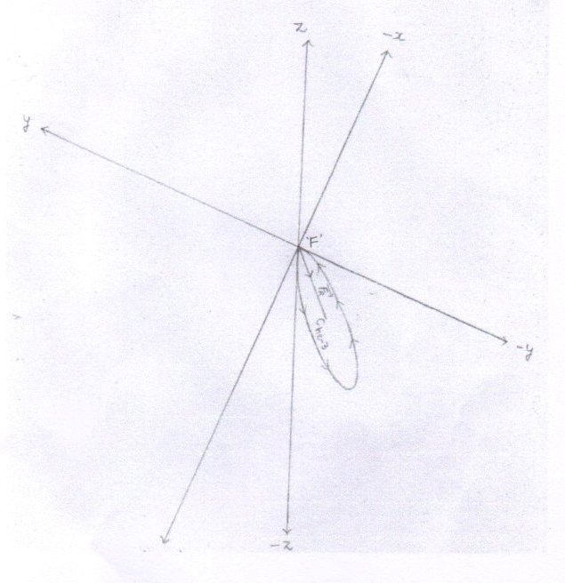
fig.(42)
- The circular orbit to be followed by the hellion -3 lies in the plane made up of positive x-axis , negative y-axis and negative z-axis .
- ‘ F ‘ is the center of fusion or the point where the he-3 nucleus is produced .
- C_{H-3} = center of the circular orbit to be followed by the hellion – 3 .
- F_{R} = Resultant force acting on the hellion – 3 .
- By seeing the directions of forces [ $\overset{→}{Fx}$ , $\overset{→}{Fy}$ ,$\overset{→}{Fz}$ ] acting on the helium-3 nucleus [when the helium -3 nucleus is at point ‘ F ‘ ] , we reach at the conclusira that the circular orbit to be followed by the helion-3 lines in the plane made up of positive x-axis , negative y-axis , and negative z- axis.
Angles that make the resultant force ( F_{R} ) [ acting on the particle when the helium - 3 is at point ‘ F ‘ ] with respect to positive x , y and z-axes .
1 with x- axis
Cos α = F_{R} cos α / F_{R} = $\overset{→}{Fx}$ / F_{R}
$\overset{→}{Fx}$ = 0.70176 x 10⁻¹² from eq.(155)
F_{R} =1.8573 x 10⁻¹² from eq.(156)
Cos α = 0.70176 x 10⁻¹² N
1.8573 x 10⁻¹² N
- Cos α = 0.3778 eq.(158)
- α = 67.8 degree [ $∴$ cos ( 67.8 ) = 0.3778 ]
2 with y- axis
Cos β = F_{R} cos B / F_{R} = $\overset{→}{Fy}$ / F_{R}
$\overset{→}{Fy}$ = -1.216 x 10⁻¹² from eq.(153)
Cos β = -1.216 x 10⁻¹² N
1.8573 x 10⁻¹² N
Cos β = -0.6547 eq.(159)
- β = 130.8 degree [ $∴$ cos ( 130.8 ) = - 0.6534 ]
3 with z- axis
Cos y = F_{R} cos y / F_{R} = $\overset{→}{Fz}$ / F_{R}
$\overset{→}{Fz}$ = -1.216 x 10⁻¹² from eq.(154)
Cos y = -1.216 x 10⁻¹² N
1.8573 x 10⁻¹² N
Cos y = -0.6547 eq.(160)
- y = 130.8 degree
[ $∴$ cos ( 130.8 ) = - 0.6534 ]
see fig.(43)
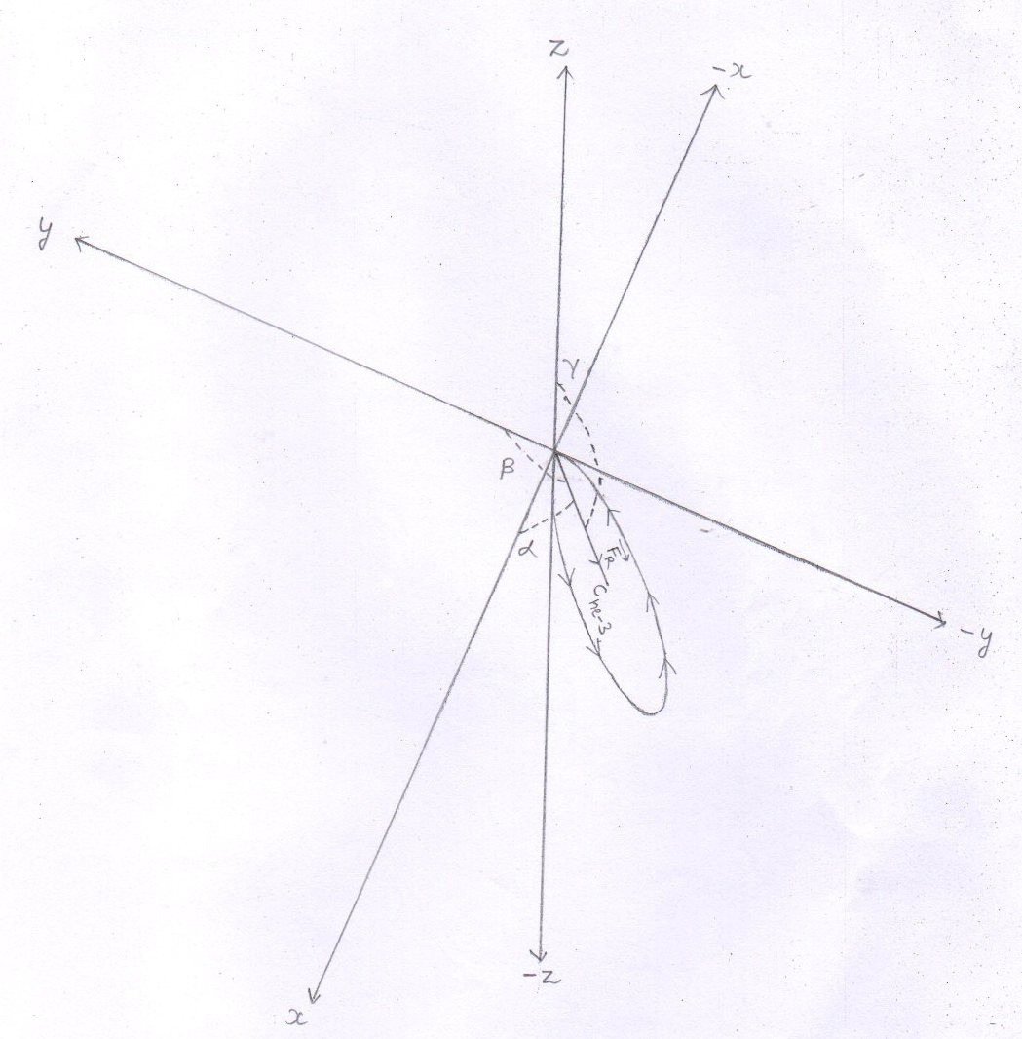
fig.(43)
- Angles that make the resultant force ( F_{R} ) [ acting on the helion – 3 when the hellion -3 is at point ‘F’ ] with respect to positive x , y , and z- axes .
Where,
α = 67.8 degree from eq.(158)
β = 130.8 degree from eq.(159)
Y = 130.8 degree from eq.(160)

The cartesian coordinates of the points P₁ ( x₁ , y₁ , z₁ ) and P₂ ( x₂ , y₂ , z₂ ) located on the circumference of the circle obtained by the helium – 3 nucleus
1 cos α = x₂ - x₁
d
d = 2 x r
r = 5.188x10⁻² m from eq.(157)
d = 2 x 5.188x10⁻² m
d = 10.376 x 10⁻² m
Cos α = 0.37 from eq.(158)
- x₂ - x₁ = d x cos α
- x₂ - x₁ = 10.376 x 10⁻² x 0.37 m
- x₂ - x₁ = 3.8391 x 10⁻² m
- x₂ = 3.8391 x 10⁻² m [ $∴$ x₁ = 0 ] eq.(161)
- cos β = y₂ - y₁
d
cos β = -0.65 from eq.(159)
- y₂ - y₁ = d x cos β
- y₂ - y₁ = 10.376 x10⁻²x (-0.65) m
- y₂ - y₁ = -6.7444 x 10⁻² m
- y₂ = -6.7444x 10⁻² m [ $∴$ y₁ , = 0 ] eq.(162)

- cos y = Z₂ - Z₁
d
cos y = -0.65 from eq.(160)
- z₂ - z₁ = d x cos y
- z₂ - z₁ = 10.376 x10⁻²x (-0.65) m
- z₂ - z₁ = -6.7444 x 10⁻² m
- z₂ = -6.7444 x 10⁻² m [ $∴$ z₁ , = 0 ] eq.(163)
see fig.(44)

- The cartesian coordinates of the points P₁ ( x₁ , y₁ , z₁ ) and the P₂ ( x₂ , y₂ , z₂ ) located on the circumference of the circle obtained by the hellion- 3 :-
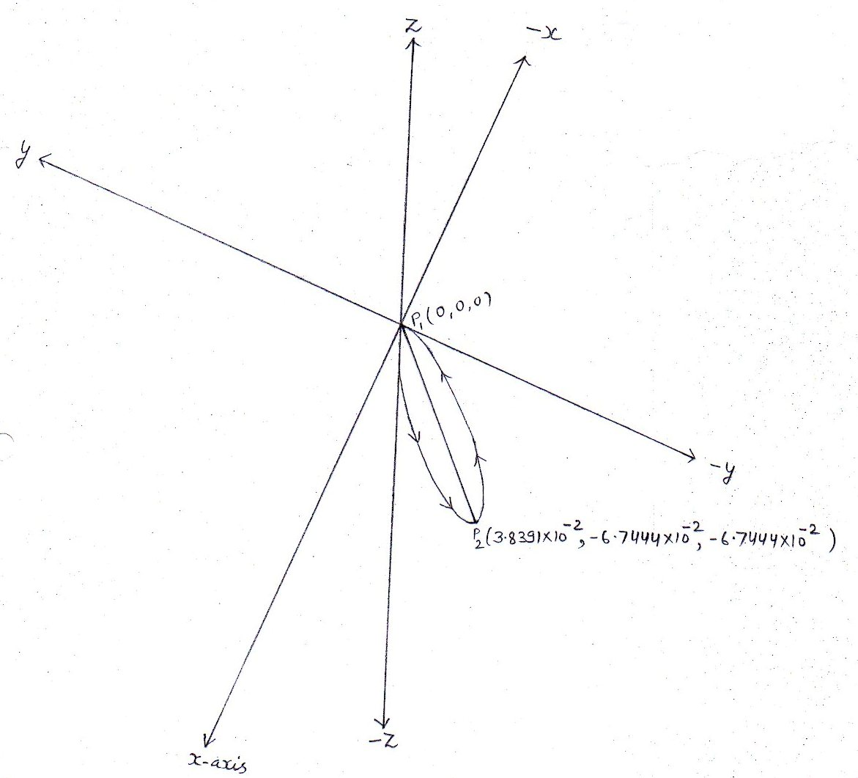
fig.(44)
- The line P₁P₂ is the diameter of the circle .

Conclusion : At point ‘ F ‘ the proton fuses with the deuteron to produce helium-3 nucleus . the produced helium-3 nucleus under the influence of the magnetic lines of force undergo to a circular orbit .
It starts its circular motion from point p₁ ( x₁ , y₁ , z₁ ) [ or the point ‘ F ‘ ] and reaches at point p₂ ( x₂ , y₂ , z₂ )
As the helium -3 nucleus reaches at point p₂ ( x₂ , y₂ , z₂ ), it enters into the mouth of the horse pipe located at the point p₂ ( x₂ , y₂ , z₂ ) . so, the helium-3 nucleus attains gaseous state and then be extracted out from the tokamak with help of vacuum pump attached to the another end of the horse pipe .

Thus , the helium-3 nucleus is not confined .

For fusion reaction (4) :-
¹₁H + ²₁ H +¹₁H $→$ [ ⁴₃Li ] $→$ ₂³ He +¹₁H + Energy
Formation of compound nucleus [ ⁴₃Li ] :-
1 Interaction of nuclei : -
The injected proton reaches at point ‘ F ‘ and interacts [ experiences a repulsive force due to the confined deuteron and also due to the confined proton that are passing through the point F ] with the confined deuteron as well as confined proton that are passing through the point ‘ F ‘ .The injected proton overcomes the electrostatic repulsive force and dissimilarly joins with the confined deuteron .
Similarly , as the confined proton reaches at point ‘ F ‘ , it interacts [ experiences a repulsive force due to the injected proton reaching at point ‘ F ‘ and also due to the confined deuteron passing through the point ‘ F ‘ ] with the injected proton as well as the confined deuteron at point ‘ F ‘.
The confined proton overcomes the electrostatic repulsive force and dissimilarly joins with the confined deuteron .
so, at point ‘F’ , two protons reach and dissimilarly join with the deuteron .
Thus , at point F , all the three nuclei dissimilarly join with each other .
see fig.(45 and 46)

Interaction of nuclei

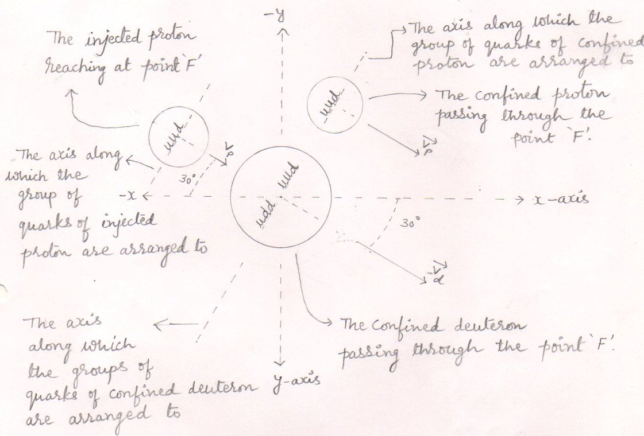
interaction (1)
fig.45
- Here , to overcome the electrostatic repulsive force , the loss in kinetic energy of the confined proton is equal to the loss in kinetic energy of the injected proton .
- Here, the two protons overcome the electrostatic repulsive force and join with deuteron as well as with each other . so, just before fusion , the loss in kinetic energy of the deuteron is taken as zero.
- So,the confined deuteron passes through the point ‘ F ‘ with the same momentum with which it was produced .

Interaction of nuclei
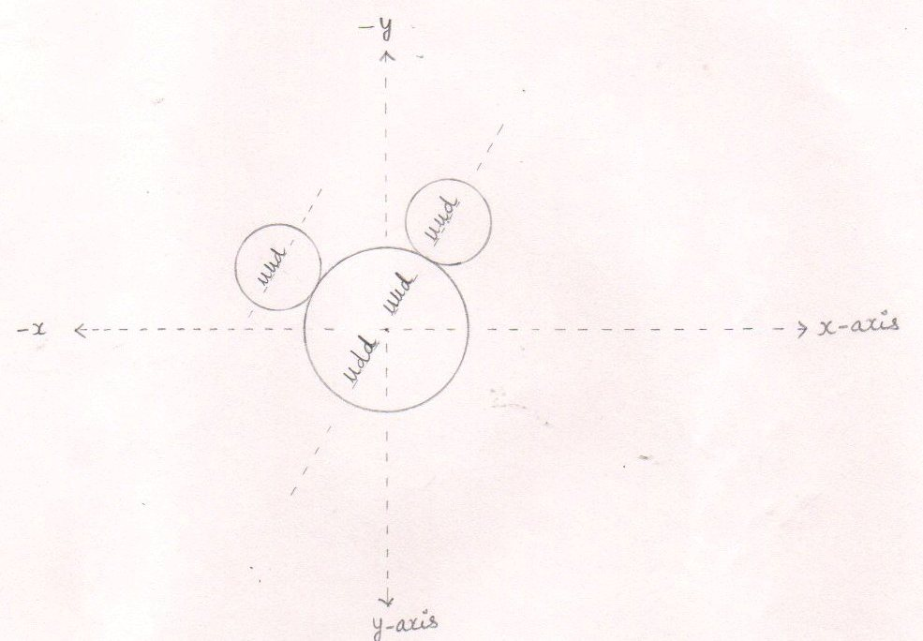

interaction -2
fig.(46)
- All the three nuclei dissimilarly join with each other . or both the protons dissimilarly join to the deuteron one.

2 Formation of the homogeneous compound nucleus : -

The constituents ( quarks and gluons ) of the dissimilarly joined nuclei ( The Protons, the deuteron and the proton ) behave like a liquid and form a homogeneous compound nucleus having similarly distributed groups of quarks with similarly distributed surrounding gluons .
Thus within the homogeneous compound nucleus – each group of quarks is surrounded by the gluons in equal proportion . so, within the homogeneous compound nucleus there are 4 groups of quarks surrounded by the gluons.

see fig.(47)

The homogeneous compound nucleus
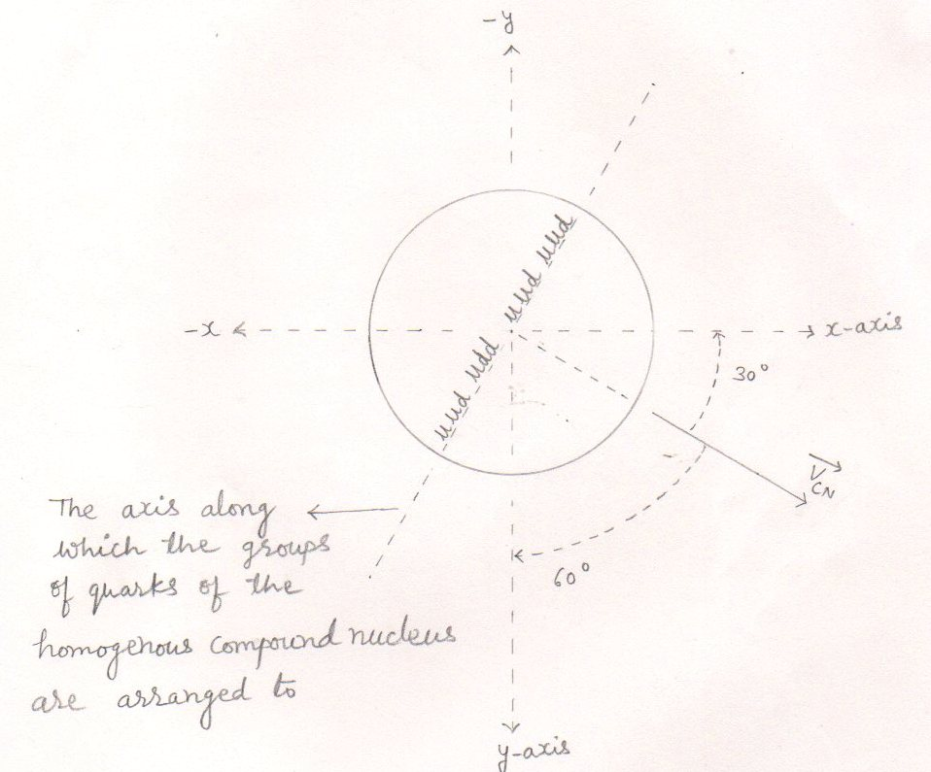
fig.(47)
Where ,
$\vec{Vcn }$ = velocity of the compound nucleus
α = 30º from eq.(179)
β = 60º from eq.(180)
y = 90º from eq.(181)
- The z-axis is perpendicular to both the axes ‘ x ‘ and ‘ y ‘ as well as to the velocity of the compound nucleus ($\vec{Vcn }$) .
3.. Formation of lobes within into the homogeneous compound nucleus or the transformation of the homogeneous compound nucleus into the heterogeneous compound nucleus : -
The central group of quarks with its surrounding gluons to become a stable and the next higher nucleus ( the helion – 3 ) than the reactant one ( the deuteron) includes the other two ( nearby located ) groups of quarks with their surrounding gluons and rearrange to form the ‘ A ‘ lobe of the heterogeneous compound nucleus.
While the remaining groups of quarks to become a stable nucleus ( the proton ) includes its surrounding gluons or mass [ out of available mass ( or gluons ) that is not included in the formation of the lobe ‘ A ‘ ] and rearrange to form the ‘ B ‘ lobe of the heterogeneous compound nucleus .
Thus, Due to formation of two dissimilar lobes within into the homogeneous compound nucleus , the homogeneous compound nucleus transforms into the heterogeneous compound nucleus.

see fig.(48)

Formation of lobes within into the homogeneous compound nucleus : - 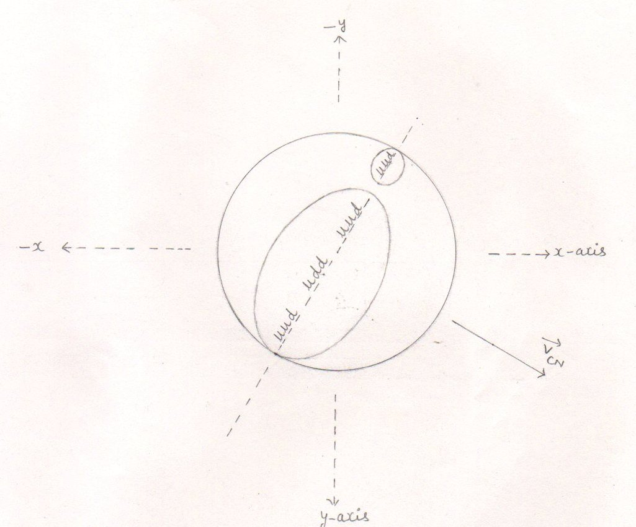

fig.(48)

- The greater one is the lobe ‘ A ‘ and the smaller one is the lobe ‘ B ‘ while the remaining space represents the remaining gluons.
- Within into the homogeneous compound nucleus , the greater lobe [ lobe ‘ A ‘ ] represents the helium – 3 nucleus while the smaller lobe [ the lobe ‘ B ‘ ] represents the proton .

4.. Final stage of the heterogeneous compound nucleus : -
The process of formation of lobes creates void (s) between the lobes . so, the remaining gluons [ the mass that is not involved in the formation of any lobe ] rearrange to fill the void ( s) between the lobes and thus the remaining gluons form a node between the dissimilar lobes of the heterogeneous compound nucleus .
Thus , the reduced mass ( or the remaining gluons ) keeps both the dissimilar lobes of the heterogeneous compound nucleus joined them together
So, finally the heterogeneous compound nucleus becomes like a dumb – bell .

see fig.(49 and 50)

Final stage of the heterogeneous compound nucleus : -
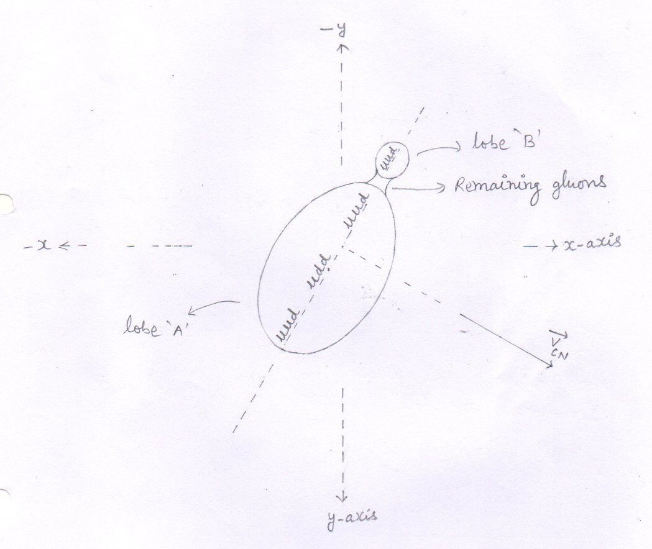

final stage (1)
fig.(49)

Final stage of the heterogeneous compound nucleus : -
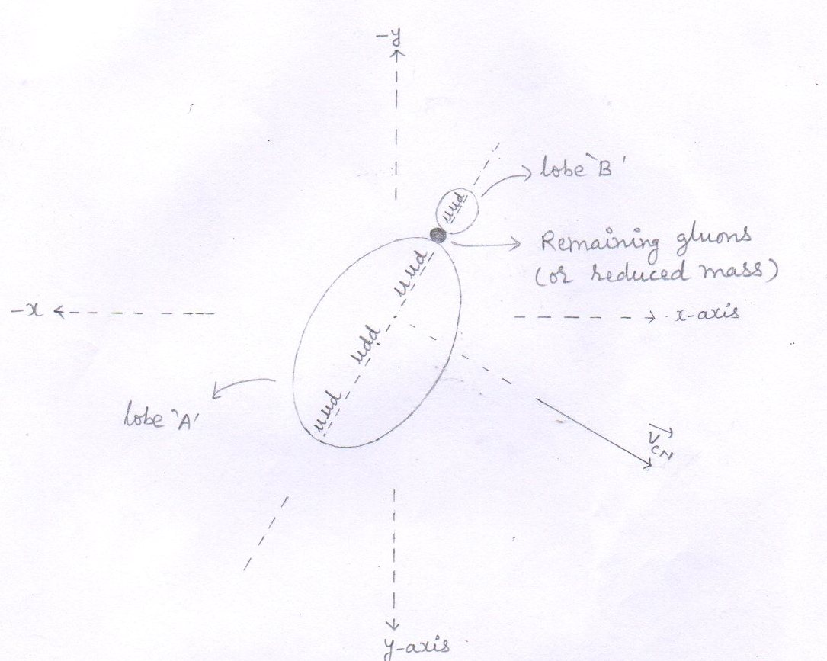

final stage (2)
fig.(50)

calculation for the compound nucleus [ ⁴₃ Li ]
For fusion reaction (4) is :-
¹₁H + ²₁ D +¹₁H $→$ [ ⁴₃Li ] $→$ ₂³ He +Δm + ¹₁H
1 The minimum kinetic energy ( E_{m} ) required by a proton :
In this case, the two protons reach at point ‘ F ‘ and fuse with the deuteron one so, there is a loss in kinetic energy of both the protons but the loss in kinetic energy of hte deuteron is zero. so, just before fusion, there is a same change in momentum of both the protons but the momentum of the confined deuteron remains same as with which it was produced ( and then confined to ) . for the above described fusion reaction , a proton has to overcome the electrostatic repulsive force exerted by the other two positive charges . so ,

E_{m} = E_{p-}3 _{he} = E_{p-p} x Z₂²
E_{p-p} = 2.5 kev from eq.(2)
Z₂ = 2
- E_{m} = 2.5kev x 2²

E_{m} = 10.0 Kev eq.(164)

Note : - Even though , the confined proton and the confined deuteron have the different time periods , they may pass through the point ‘ F’ at a same time and fuse . meanwhile, if the injected proton also reach at point ‘ F’ , then the above fusion reaction is likely to happen.

2.Just before fusion , the kinetic energy of the proton [ either it is injected or confined ] : -
Just before fusion , the proton [ either it is injected or confined ] to overcome the electrostatic repulsive force , loses its energy equal to 10.0 Kev . from eq.(164)
So, just before fusion , the kinetic energy ( E_{b} ) of the proton is –
E_{b} = E_{injected} - E_{loss}
E_{injected} = E_{P} =102.4 kev from eq.(4)
E_{loss} = E_{m} = 10.0 kev from eq.(164)

E_{b} = [ 102.4 - Kev ] – [ 10.0 kev]
E_{b} = 92.4 kev
E_{b} = 0.0924 Mev eq.(165)
3.. just before fusion, the momentum of the proton [ either it is injected or confined ] is : -

P_{b} = [ 2m_{p} x E_{b} ] ^{½}
E_{b} = 0.0924 Mev from eq.(165)
=0.0924 x 1.6 x10⁻¹³ J

P_{b} = [ 2 x 1.6726 x 10⁻²⁷ kg x 0.0924 x 1.6 x 10⁻¹³ J ] ^{½}

P_{b} = [ 0.494554368 x 10⁻⁴⁰ ] ^{½} kgm/s
P_{b} = 0.7032 x 10⁻²⁰ kgm/s eq.(166)

4.. just before fusion , the components of the momentum ( P_{b} ) of the proton [ either it is injected or confined ] .
Each proton [ either it is injected or confined
when reaches at point ‘ F ‘ makes angle 30º with the x-axis , 60º angle with the y- axis and 90º angle with the z-axis . so,
- Just before fusion , the x- component of momentum ( p_{b} ) of the proton is –
$\overset{→}{Px}$ = P_{b} cos α
P_{b} = 0.7032 x 10⁻²⁰ kgm/s from eq.(166)
Cos α = cos 30º =0.8660

- $\overset{→}{Px}$ = 0.7032 x 10⁻²⁰ x 0.866 kgm/s
- =0.6089 x 10⁻²⁰ kgm/s eq.(167)

- Just before fusion , the y- component of momentum ( P_{b} ) of the proton is -
$\overset{→}{Py}$ = P_{b} cos β
Cos β = cos 60º = 0.5
$\overset{→}{Py}$ = 0.7032 x 10⁻²⁰ x 0.5 kgm/s
= 0.3516 x 10⁻²⁰ kgm/s eq.(168)

- Just before fusion , the z - component of momentum ( P_{b} ) of the proton is -
$\overset{→}{Pz}$ = P_{b} cos y
Cos y = cos 90º = 0
$\overset{→}{Pz}$ = 0.7032 x 10⁻²⁰ x 0 kgm/s
= 0 kgm/s eq.(169)

5.. Final momentum of the compound nucleus ( P_{CN} ) : -
According  to - | Just before  Fusion , the momentum $\overset{→}{Pb}$ of the injected proton | Just before  Fusion , the momentum of the confined deuteron | Just before  Fusion , the momentum ($\overset{→}{Pb}$) of the confined proton | Final  Momentum of the compound nucleus  ($\overset{→}{Pcn}$ )
0 | 1 | 2 | 3 | 4 = 1+2+3
X – axis | $\overset{→}{Px}$ = 0.6089x10⁻²⁰ kgm/s | $\overset{→}{Px}$ = 1.2731x10⁻²⁰ kgm/s | $\overset{→}{Px}$ = 0.6089x10⁻²⁰  kgm/s | $\overset{→}{Px}$ = 2.4909x10⁻²⁰ kgm/s  eq.(170)
y – axis | $\overset{→}{Py}$ = 0.3516x10⁻²⁰ kgm/s | $\overset{→}{Py}$ = 0.7348x10⁻²⁰ kgm/s | $\overset{→}{Py}$ = 0.3516x10⁻²⁰ kgm/s | $\overset{→}{Py}$ = 1.438x10⁻²⁰ kgm/s  eq.(171)
z – axis | $\overset{→}{Pz}$ = 0 kgm/s | $\overset{→}{Pz}$ = 0 kgm/s | $\overset{→}{Pz}$ = 0 kgm/s | $\overset{→}{Pz}$ = 0 kgm/s  eq.(172)
from eq.(167,168,169) from eq.(81,82,83) from eq.(167,168,169)
respectively respectively respectively
In this case there is a same loss in kinetic energy of both the protons ( either it is injected or confined ) but the loss in kinetic energy of the deuteron is zero. so, the momentum of the confined deuteron remains same as with which it was produced to .

Mass of the compound nucleus ( M ) :
6.. M = m_{p} + m_{d} + m_{p}

= [ 1.6726 x 10⁻²⁷ + 3.3434 x 10⁻²⁷ + 1.6726 x 10⁻²⁷ ] kg
= 6.6886 x 10⁻²⁷ kg eq.(173)

7.. The components of the velocity of the compound nucleus ($\overset{→}{Vcn}$ ): -
  - x – component of the velocity of the compound nucleus :-
- $\overset{→}{Vx}$ = V_{CN} cos α = P_{CN} cos α / M = MV_{CN} cos α / M = $\overset{→}{Px}$ / M
$\overset{→}{Px}$ = 2.4909 x 10⁻²⁰ kgm/s from eq.(170)
M = 6.6886 x 10⁻²⁷ kgm/s from eq.(173)
- $\overset{→}{Vx}$ = 2.4909 x10⁻²⁰ kgm/s = 0.3724 x 10⁷ m/s eq.(174)
  - 0⁻²⁷ kg

  - y– component of the velocity of the compound nucleus :-
- $\overset{→}{Vy}$ = V_{CN} cos β= P_{CN} cos β / M = MV_{CN} cos β/M = $\overset{→}{Py}$ / M
$\overset{→}{Py}$ = 1.438 x 10⁻²⁰ kgm/s from eq.(171)
M = 6.6886 x 10⁻²⁷ kgm/s
- $\overset{→}{Vy}$ = 1.438 x10⁻²⁰ kgm/s = 0.2149 x 10⁷ m/s eq.(175)
  - 0⁻²⁷ kg

  - z - component of the velocity of the compound nucleus :-
- $\overset{→}{Vz}$ = V_{CN} cos y = MV_{CN} cos y / M = P_{CN} cos y / M = $\overset{→}{Pz}$ / M
$\overset{→}{Pz}$ = 0 kgm/s from eq.(172)
M = 6.6886 x 10⁻²⁷ kgm/s
- $\overset{→}{Vz}$ = 0 . kgm/s = 0 m/s eq.(176)
6.6886 x 10⁻²⁷ kg

8.. Velocity of the compound nucleus ( V_{CN} ) : -

V²_{CN} = V_{x}² + V_{y}² + V_{z}²
V_{x} = 0.3724 x 10⁷ m/s from eq.(174)
V_{y} = 0.2149 x 10⁷ m/s from eq.(175)
V_{z} = 0 m/s from eq.(176)

- V²_{CN} = ( 0.3724 x 10⁷ )² + ( 0.2149 x 10⁷ )² + ( 0 )² m²/s²
= (0.13868176 x 10¹⁴ ) + (0.04618201 x 10¹⁴ ) + 0 m²/s²
- V²_{CN} = 0.18486377 x 10¹⁴ m²/s² eq.(177)

- V_{CN} = 0.4299 x 10⁷ m/s eq.(178)

9.. Angles that make the velocity of the compound nucleus ( V_{CN} ) with respect to positive x , y , and z axes .
- with x – axis
cos α = V_{CN} cos α/ V_{CN} = $\overset{→}{Vx}$ /V_{CN}

$\overset{→}{Vx}$ = 0.3724 x 10⁷ m/s from eq.(174)
V_{CN} = 0.4299 x 10⁷ m/s from eq.(178)

- cos α = 0.3724 x 10⁷ m/s = 0.8662
0.4299 x 10⁷ m/s
- α = 30º eq.(179)

2 with y– axis
cos β = V_{CN} cos β / V_{CN} = $\overset{→}{Vy}$ / V_{CN}

$\overset{→}{Vy}$ = 0.2149 x 10⁷ m/s from eq.(175)

cos β = 0.2149x 10⁷ m/s = 0.4998
0.4299 x 10⁷ m/s

- β = 60º eq.(180)
3 with z– axis
cos y= = V_{CN} cos y / V_{CN} = $\overset{→}{Vz}$ /V_{CN}

$\overset{→}{Vz}$ = 0 m/s from eq.(176)

cos y = 0 m/s = 0
0.4299 x 10⁷ m/s
y = 90º eq.(181)

The splitting of heterogeneous compound nucleus :
- The heterogeneous compound nucleus , due to its instability , splits according to the lines parallel to the direction of the velocity of the compound nucleus ($\overset{→}{Vcn}$ ) into three particles – the helium -3 nucleus , the proton and the reduced mass ( Δm )
Out of them , the two particles ( helion – 3 and the proton ) are stable while the third one ( reduced mass ) is unstable .

- According to the law of inertia , each particle that has separated from the compound nucleus , has an inherited velocity ($\overset{→}{Vinh}$ ) equal to the velocity of the compound nucleus ($\overset{→}{Vcn}$ ) .

- So, for conservation of momentum

M$\vec{Vcn}$ = ( m_{he-3} + Δm + m_{p} ) $\vec{Vcn}$

Where ,
M = mass of the compound nucleus
$\vec{Vcn}$ =velocity of the compound nucleus
m_{he-3} = mass of the helium- 3 nucleus
m_{p} = mass of the proton
Δm = reduced mass

see fig.(51,52)

The splitting of the heterogeneous compound nucleus : -
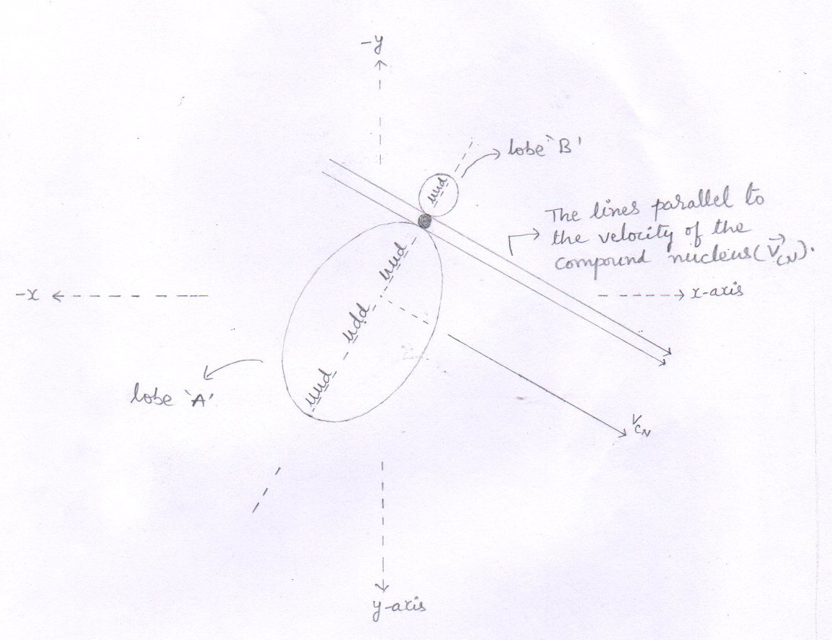

Splitting -1
fig.(51)
- The heterogeneous compound nucleus splits according to the lines parallel to the velocity of the compound nucleus ($\vec{Vcn}$ ) .

The splitting of the heterogeneous compound nucleus : -
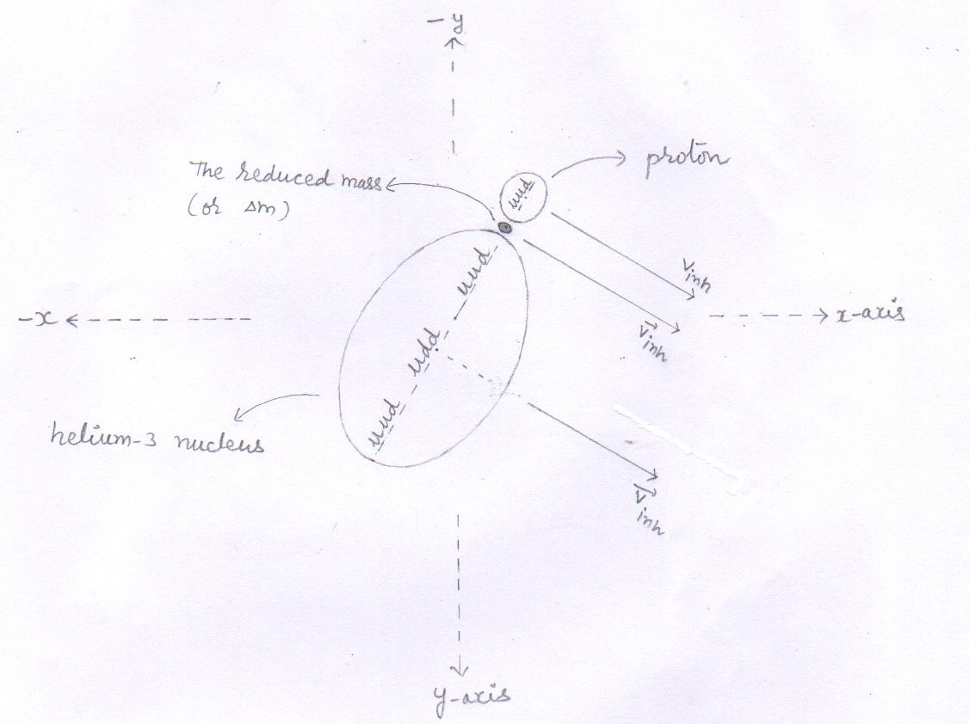

Splitting – 2
fig.(52)
- The heterogeneous compound nucleus splits into three particles –The helium-3 nucleus , the reduced mass (Δm ) and the proton .
- $\overset{→}{Vinh}$ = inherited velocity of the particle with which it has separated from the compound nucleus .

- Inherited velocity ($\overset{→}{Vinh}$ ) of the particles : -
Each particles that has separated from the compound nucleus has an inherited velocity ($\overset{→}{Vinh}$ ) equal to the velocity of the compound nucleus ($\vec{Vcn}$ ) .

I . inherited velocity of the helium – 3 nucleus

V_{inh} = V_{CN} = 0.4299 x 10⁷ m/s from eq.(178)

- Components of the inherited velocity of the helium – 3 nucleus
1 $\overset{→}{Vx}$ = V_{inh} cos α = V_{CN} cos α = 0.3724 x 10⁷ m/s from eq.(174) eq.(182)

2 $\overset{→}{Vy}$ = V_{inh} cos β = V_{CN} cos β = 0.2149 x 10⁷ m/s from eq.(175) eq.(183)

3 $\overset{→}{Vz}$ = V_{inh} cos y = V_{CN} cos y = 0 m/s from eq.(176) eq.(184)
II . Inherited velocity of the proton
- V_{inh} = V_{CN} = 0.4299 x 10⁷ m/s

- Components of the inherited velocity of the proton
1 $\overset{→}{Vx}$ = V_{inh} cos α = V_{CN} cos α = 0.3724 x 10⁷ m/s from eq.(174) eq.(185)

2 $\overset{→}{Vy}$ = V_{inh} cos β = V_{CN} cos β = 0.2149 x 10⁷ m/s from eq.(175) eq.(186)

3 $\overset{→}{Vz}$ = V_{inh} cos y = V_{CN} cos y = 0 m/s from eq.(176) eq.(187)

III inherited velocity ( V_{inh} ) of the reduced mass (Δm) : -
- V_{inh} = V_{CN} = 0.4299 x 10⁷ m/s

Propulsion of the particles
The reduced mass converts into energy and the total energy ( E_{T} ) is divided between the produced particles [ the helion-3 and the proton] according to their inverse mass ratio .
The total energy propel both the particles with equal and opposite momentum according to a ray ( line ) perpendicular to the direction ( line ) of the velocity of the compound nucleus see fig.(53)
1 Reduced mass is equal to the subtraction of the sum of the masses of the reactant nuclei and the sum of the masses of the product nuclei .
Δm = [ m_{p} +m_{d} + m_{p} ] - [ m_{He-3} + m_{p} ]
m_{He-3} = 3.01493 amu
m_{p} = 1.00727 amu
m_{d} = 2.01355 amu
Δm = [ 1.00727+2.01355 +1.00727 ] – [ 3.01493 +1.00727 ] amu

Δm = [ 4.02809 ] – [ 4.0222 ] amu
Δm = 0.00589 amu eq.(188)

Δm = 0.00589 x 1.6605 x 10⁻²⁷ kg

Δm = 0.009780345 x 10⁻²⁷ kg eq.(189)

- Inherited kinetic energy (E_{inh} )of the reduced mass .

- E_{inh} = _{½} Δm V²_{inh} = _{½} Δm V² _{CN}
Δm = 0.009780345 x 10⁻²⁷ kg from eq.(189)
V ²_{inh} =V² _{CN} = 0.18486377 x 10¹⁴ m²/s² from eq.(177)
- E_{inh} = _{½} x 0.009780345 x 10⁻²⁷ x 0.18486377 x 10¹⁴ J

E_{inh} = 0.00090401572 x 10⁻¹³ J

E_{inh} = 0.0005650 Mev eq.(190)

3 Released energy ( E_{R} )

E_{R} = Δmc ²
Δm = 0.00589 amu from eq.(188)
E_{R} = 0.00589 x 931 Mev

E_{R} = 5.48359 Mev eq.(191)

- Total energy ( E _{T} )
E _{T} = E_{inh} + E_{R}
E _{T} = ( 0.000565 Mev ) + ( 5.48359 Mev ) from eq.(190 and 191) resp.
E _{T} = 5.484155 Mev eq.(192)

5.. Increased kinetic energy of the particles : -
The total energy ( E_{T} ) is divided between the particles according to their inverse mass ratio . so,
- The increased kinetic energy ( E_{inc} ) of the helion – 3 :-
E_{inc} = m_{p} x E_{T}
m_{he-3} + m_{p}
m_{p} = 1.00727 amu
m_{he-3} = 3.01493 amu
E_{T} = 5.484155 Mev from eq.(192)
- E_{inc} = 1.00727 x 5.484155 Mev
3.01493 + 1.00727
- E_{inc} = 1.00727 x 5.484155 Mev
4.0222
- E_{inc} = 0.25042762667 x 5.484155 Mev

E_{inc} = 1.373383 Mev eq.(193)

- Increased kinetic energy of the proton

E_{inc} = E_{T} - [ increased kinetic energy of the helion -3 ]
E_{T} = 5.484155 Mev from eq.(192)
E_{inc} of helion -3 = 1.373383 Mev from eq.(193)

- E_{inc} = [ 5.484155 Mev ] - [ 1.373383 Mev ]

- E_{inc} = 4.110772 Mev eq.(194)

6..Increased velocity ( V_{inc} ) of the helium – 3 nucleus .
(1) Increased velocity ( V_{inc} ) of the helium – 3 nucleus .
V_{inc} = [ ^{2E}_{inc} / m_{he-3} ]^{1/}₂
E_{inc} = 1.373383 Mev from eq.(193)
E_{inc} = 1.373383x1.6x10⁻¹³ J
m_{he-3} = 5.00629x10⁻²⁷ kg
- V_{inc} = 2x1.373383x1.6x10⁻¹³ J ^{½}
5.00629x10⁻²⁷ kg
- V_{inc} = 4.3948256x10⁻¹³ ^{½} m/s
5.00629x10⁻²⁷
- V_{inc} = [ 0.87786077114 x 10¹⁴ ] ^{½} m/s

- V_{inc} = 0.9369 x 10⁷ m/s eq.(195)
- Increased velocity ( V_{inc} ) of the proton .

V_{inc} = [ ^{2E}_{inc} / m_{p} ] ^{½}
E_{inc} = 4.110772 Mev from eq.(194)
E_{inc} = 4.110772x1.6x10⁻¹³ J
- V_{inc} = 2x4.110772x1.6x10⁻¹³ J ^{½}
1.6726x10⁻²⁷ kg
- V_{inc} = 13.1544704x10⁻¹³ ^{½} m/s
1.6726x10⁻²⁷
- V_{inc} = [ 7.86468396508 x 10¹⁴ ] ^{½} m/s

- V_{inc} = 2.8044 x 10⁷ m/s eq.(196)
7 Angle of propulsion

1 As the reduced mass converts into energy , the total energy ( E_{T} ) propel both the particles with equal and opposite momentum according to a ray ( line ) perpendicular to the direction ( line ) of the velocity of the compound nucleus ($\vec{Vcn}$ ) .

2. We know that when there a fusion process occurs , then we find the lighter nucleus in the forward direction [ or in the direction of ion beam or in the direction of the velocity of the compound nucleus ($\vec{Vcn}$ ) .]
Now,
- At point ‘ F ‘ , as V_{CN} makes 30º angle with x-axis , 60º angle with y-axis and 90º angle with z-axis .
- so, the proton is propelled making 60º angle with x-axis , 150º angle with y-axis and 90º angle with z-axis .
- While the helium -3 nucleus is propelled making 120º angle with x-axis , 30º angle with y-axis and 90º angle with z-axis .

see fig (53)

Propulsion of the particles : -

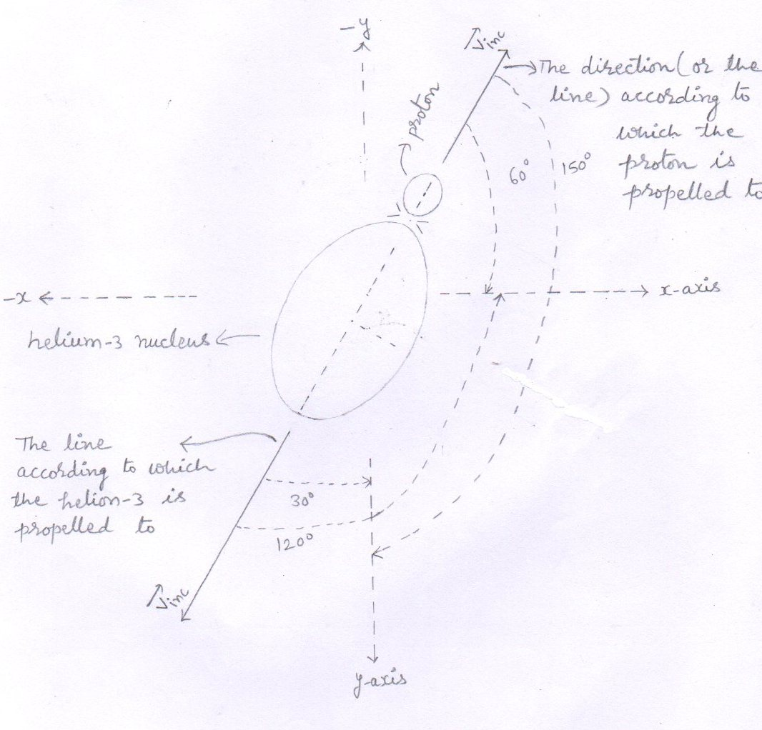
fig.(53)
- $\overset{→}{Vinc}$ = The direction of the increased velocity ($\overset{→}{Vinc}$ ) .
- The reduced mass converts into energy and propel both the particles according to a ray ( line ) perpendicular to the direction ( line ) of the velocity of the compound nucleus ($\vec{Vcn}$ ).
- $\overset{→}{Vinc}$ is perpendicular to z- axis .

8.. Components of the increased velocity $\overset{→}{Vinc}$ ) of particles.
(i) Components of the increased velocity ($\overset{→}{Vinc}$ ) of helium -3 nucleus
1 $\overset{→}{Vx}$ = V_{inc} cos α
V_{inc} = 0.9369 x 10⁷ m/s from eq.(195)
cos α = cos 120º = -0.5 use fig.(53)
$\overset{→}{Vx}$ = 0.9369 x 10⁷ x (- 0.5) m/s
= -0.4684 x 10⁷ m/s eq.(197)
2 $\overset{→}{Vy}$ = V_{inc} cos β
cos β = cos 30º = 0.8660 use fig.(53)
$\overset{→}{Vy}$ = 0.9369 x 10⁷ x 0.866 m/s
= 0.8113 x 10⁷ m/s eq.(198)
3 $\overset{→}{Vz}$ = V_{inc} cos y
Cos y = cos 90º = 0 use fig.(53)
$\overset{→}{Vz}$ = 0.9369 x 10⁷ x 0 m/s = 0 m/s eq.(199)
(ii).. Components of the increased velocity ($\overset{→}{Vinc}$) of protons
1 $\overset{→}{Vx}$ = V_{inc} cos α
V_{inc} = 2.8044 x 10⁷ m/s from eq.(196)
cos α = cos 60º = 0.5 use fig.(53)
$\overset{→}{Vx}$ = 2.8044 x 10⁷ x 0.5 m/s
= 1.4022 x 10⁷ m/s eq.(200)
2 $\overset{→}{Vy}$ = V_{inc} cos β
cos β = cos 150º =- cos 30º = -0.8660 use fig.(53)
$\overset{→}{Vy}$ = 2.8044 x 10⁷ x ( - 0.866 ) m/s
= -2.4286 x 10⁷ m/s eq.(201)

3 $\overset{→}{Vz}$ = V_{inc} cos y
cos y = cos 90º = 0 use fig.(53)
$\overset{→}{Vz}$ = 2.8044 x 10⁷ x 0 m/s = 0 m/s eq.(202)

9.. Components of the final velocity ($\vec{Vf}$) of the particles
I For helium – 3 nucleus

According  to - | Inherited  Velocity ($\overset{→}{Vinh}$) | Increased  Velocity ($\overset{→}{Vinc}$) | Final velocity  ($\vec{Vf}$) = ($\overset{→}{Vinh}$+ ($\overset{→}{Vinc}$)
X – axis | $\overset{→}{Vx}$ = 0.3724x10⁷m/s | $\overset{→}{Vx}$ = -0.4684x10⁷m/s | $\overset{→}{Vx}$ = - 0.096x10⁷m/s  eq.(203)
y – axis | $\overset{→}{Vy}$ = 0.2149x10⁷m/s | $\overset{→}{Vy}$ = 0.8113x10⁷m/s | $\overset{→}{Vy}$ = 1.0262x10⁷m/s  eq.(204)
z – axis | $\overset{→}{Vz}$ = 0 m/s | $\overset{→}{Vz}$ = 0 m/s | $\overset{→}{Vz}$ = 0 m/s  eq.(205)
from eq.(182,183,184) from eq.(197,198,199)
resp. resp.
- For Proton
According  to - | Inherited  Velocity ($\overset{→}{Vinh}$) | Increased  Velocity ($\overset{→}{Vinc}$) | Final velocity  ($\vec{Vf}$) = ($\overset{→}{Vinh}$) + ($\overset{→}{Vinc}$)
X – axis | $\overset{→}{Vx}$ = 0.3724x10⁷m/s | $\overset{→}{Vx}$ = 1.4022x10⁷m/s | $\overset{→}{Vx}$ = 1.7746x10⁷m/s  eq.(206)
y – axis | $\overset{→}{Vy}$ = 0.2149x10⁷m/s | $\overset{→}{Vy}$ = -2.4286x10⁷m/s | $\overset{→}{Vy}$ = -2.2137x10⁷m/s  eq.(207)
z – axis | $\overset{→}{Vz}$ = 0 m/s | $\overset{→}{Vz}$ = 0 m/s | $\overset{→}{Vz}$ =0 m/s  eq.(208)
from eq.(185,186,187) from eq.(200,201,202)
resp. resp.

10.. Final velocity ( V_{f} ) of the helium – 3 nucleus
V_{f}² = V_{x}² + V_{Y}² +V_{Z}²
V_{x}= 0.096X10⁷ m/s from eq.(203)
V_{y}= 1.0262X10⁷ m/s from eq.(204)
V_{z}= 0 m/s from eq.(205)
- V_{f}²= (0.096X10⁷)² + (1.0262X10⁷)² +(0)² m²/s²
- V_{f}²= (0.009216X10¹⁴)+(1.05308644X10¹⁴)+0 m²/s²
- V_{f}²=1.06230244X10¹⁴ m²/s² eq.(209)
- V_{f}= 1.0306x10⁷ m/s eq.(210)
Final kinetic energy ( E_{f} ) of the helium – 3 nucleus
E_{f} = ½ m_{he-3} V_{f}²
m_{he-3} = 5.00629X10⁻²⁷ kg
V_{f}²= 1.06230244x10¹⁴ m²/s² from eq.(209)
E_{f} = ½ X 5.00629X10⁻²⁷ X 1.06230244X10¹⁴ J
= 2.65909704117X10⁻¹³ J
= 1.6619 Mev
- m_{he-3} V_{f}² = 5.00629X10⁻²⁷ x 1.06230244 x 10¹⁴ J
=5.3181X10⁻¹³ J eq.(211)

Forces acting on the helium – 3 nucleus
1 F_{y} = q V_{x} B_{Z} sin θ
q = 2 x 1.6 x 10⁻¹⁹ C
$\overset{→}{Vx}$ = -0.096 x 10⁷ m/s from eq.(203)
$\overset{→}{Bz}$ = - 1 Tesla from eq.(15)
sin θ = sin 90º = 1
- F_{Y} = 2 x1.6 x 10⁻¹⁹ x 0.096 x 10⁷ x 1 x 1 N
= 0.3072 x 10⁻¹² N
Form the right hand palm rule , the direction of force $\overset{→}{Fy}$ is according to positive y axis .
So, $\overset{→}{Fy}$ = 0.3072 x 10⁻¹² N eq.(212)
2 F_{z} = q V_{x} B_{y} sin θ
$\overset{→}{By}$ = 1 Tesla from eq.(16)
sin θ = sin 90º = 1
- Fz = 2 x1.6 x 10⁻¹⁹ x 0.096 x 10⁷ x 1 x 1 N
= 0.3072 x 10⁻¹² N
Form the right hand palm rule , the direction of force $\overset{→}{Fz}$ is according to positive z- axis . ( that is upward )
So, $\overset{→}{Fz}$ = 0.3072 x 10⁻¹² N eq.(213)
3 F_{x} = q V_{y} B_{Z} sin θ
$\overset{→}{Vy}$ = 1.0262 x 10⁷ m/s from eq.(204)
$\overset{→}{Bz}$ = -1 Tesla
sin θ = sin 90º = 1
- F_{x} = 2 x 1.6 x 10⁻¹⁹ x 1.0262 x 10⁷ x 1 x 1 N
= 3.2838 x 10⁻¹² N

Form the right hand palm rule , the direction of force $\overset{→}{Fx}$ is according to positive x- axis .
So, $\overset{→}{Fx}$ = 3.2838 x 10⁻¹² N eq.(214)
see fig (54)
Forces acting on the helium – 3 nucleus
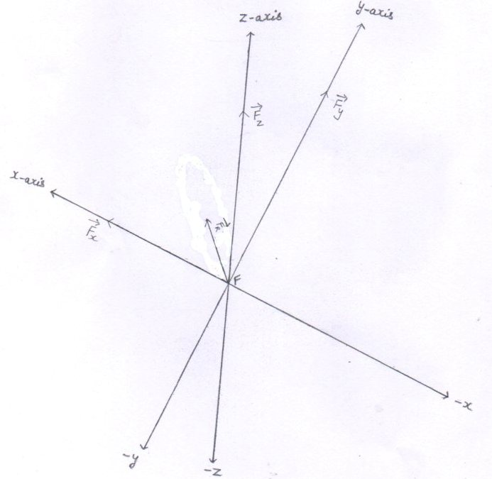
fig(54)
4.. Resultant force ( F_{R} ) acting on the particle [ when particle helium – 3 is at point ‘ F ‘ ] .
F_{R}² = F_{x}² + F_{Y}² +F_{Z}²
F_{x} = 3.2838 x 10⁻¹² N from eq.(214)
F = F_{y} = F_{z} = 0.3072 x 10⁻¹² N from eq.(212,213)
F_{R}² = F_{x}² + 2F²
F_{R}² = (3.2838 x 10⁻¹² )² + 2 (0.3072 x 10⁻¹² )² N²
F_{R}² = (10.78334244 x 10⁻²⁴ ) + 2 (0.09437184 x 10⁻²⁴ ) N²
F_{R}² = (10.78334244 x 10⁻²⁴ )+ ( 0.18874368 x 10⁻²⁴ ) N²
F_{R}² = 10.97208612 x 10⁻²⁴ N²
F_{R} = 3.3124 x 10⁻¹² N eq.(215)
see fig(54)
5.. Radius of the circular orbit to be followed by the helium – 3 nucleus :-

r = mv²/ F_{R}
mv² = 5.3181 x 10⁻¹³ J from eq.(211)
F_{R} = 3.3124 x 10⁻¹² N from eq.(215)

- r = 5.3181 x 10⁻¹³ J
3.3124 x 10⁻¹² N

- r = 1.60551 x 10⁻¹ m
- r = 16.0551 x 10⁻² m eq.(216)

see fig.(55)

6.. The circular orbit to be followed by the helium-3 nucleus :-
- By seeing the directions of forces[ $\overset{→}{Fx}$ ,$\overset{→}{Fy} \overset{→}{Fz}$ ] acting on the helium-3 [ when the helium-3 is at point ‘ F ‘ ] , we reach at the conclusion that the the confined circular orbit to be followed by the helium-3 nucleus lies in the region made up of positive x-axis , positive y-axis and the positive z-axis .
Where ,
- C_{he-3} = center of the circular orbit followed by hellion -3
- $\overset{→}{Fr}$ = The direction of the resultant force acting on the hellion -3 , when the hellion -3 is at point ‘ F ‘ .
- ‘ F ‘ is the point where helion-3 is produced .
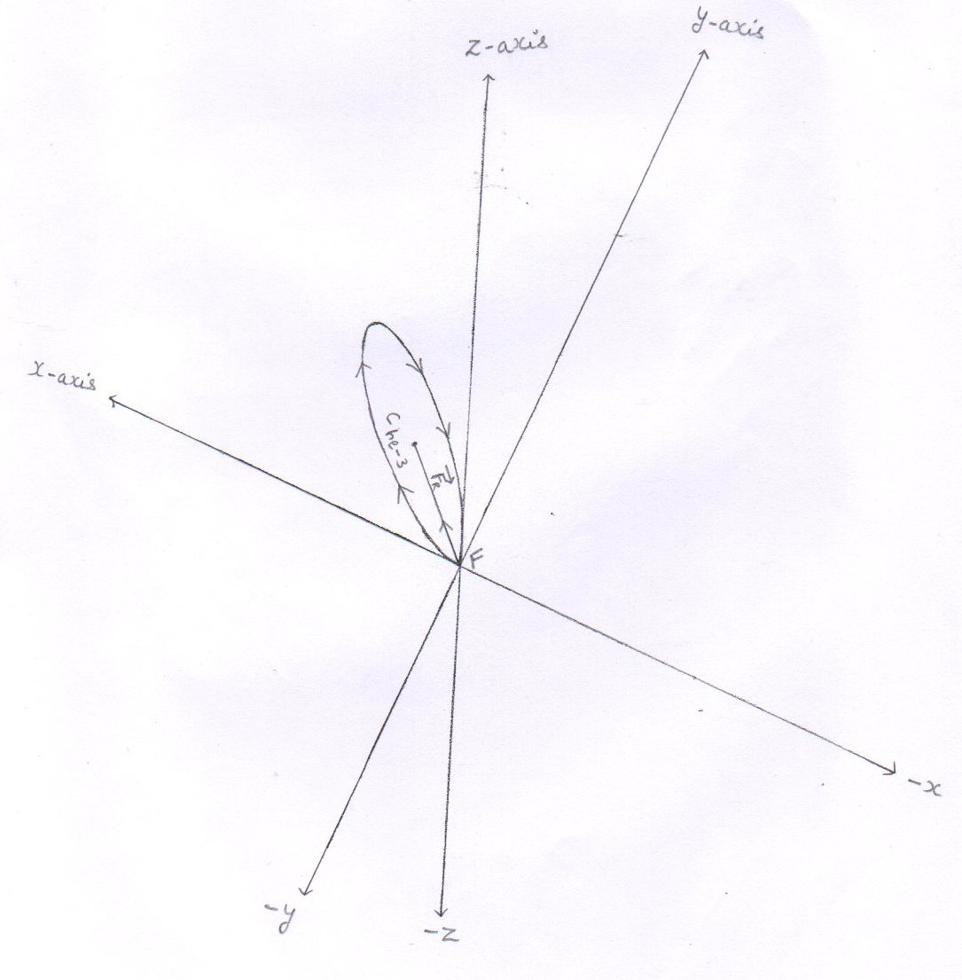
fig.(55)
7.. Angles that make the resultant force ($\overset{→}{Fr}$) [ acting on the particle when the particle is at point ‘ F ‘ ] with positive x , y and z-axes respectively .
I For helium- 3 nucleus
1 with x- axis
Cos α = F_{R} cos α / F_{R} = $\overset{→}{Fx}$ / F_{r}
$\overset{→}{Fx}$ = 3.2838 x 10⁻¹² N from eq.(214)
F_{r} = 3.3124 x 10⁻¹² N from eq.(215)
Cos α = 3.2838 x 10⁻¹² N
3.3124 x 10⁻¹² N
- Cos α = 0.9913 eq.(217)
- α = 7.4 degree
2 with y- axis
Cos β = F_{R} cos β / F_{R} = $\overset{→}{Fy}$ / F_{r}
$\overset{→}{Fy}$ = 0.3072 x 10⁻¹² N from eq.(212)
Cos β = 0.3072 x 10⁻¹² N
3.3124 x 10⁻¹² N
- Cos β = 0.0927 eq.(218)
- β = 84.7 degree
3 with z- axis
Cos y = F_{R} cos y / F_{R} = $\overset{→}{Fz}$ / F_{r}
$\overset{→}{Fz}$ = 0.3072 x 10⁻¹² N from eq.(213)
Cos y = 0.3072 x 10⁻¹² N
3.3124 x 10⁻¹² N
- Cos y = 0.0927 eq.(219)
- y = 84.7 degree
see fig.(56)

The resultant force ($\overset{→}{Fr}$ ) makes angle α, β , y with positive x , y ,z –axes respectively .
Where ,
α = 7.4 degree from eq.(217)
β = 84.7 degree from eq.(218)
y = 84.7 degree from eq.(219)
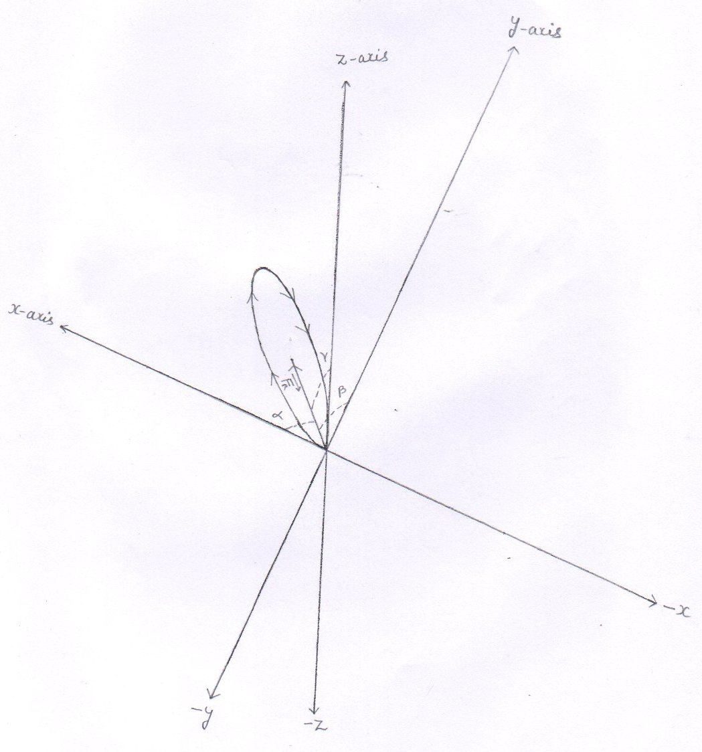

fig.(56)
8.. The cartesian coordinates of the points P₁ ( x₁ , y₁ , z₁ ) and P₂ ( x₂ , y₂ , z₂ ) located on the circumference of the circle obtained by the helium-3 nucleus.
- cos α = x₂ - x₁
d
d = 2 x r
r = 16.0551x10⁻² m from eq.(216)
= 2x16.0551x10⁻² m
= 32.1102 x 10⁻² m
Cos α = 0.9913 from eq.(217)
- x₂ - x₁ = d x cos α
- x₂ - x₁ = 32.1102 x10⁻²x0.9913 m
- x₂ - x₁ = 31.8308 x 10⁻² m
- x₂ = 31.8308 x 10⁻² m [ $∴$ x₁ = 0 ] eq.(220)
2 cos β = y₂ - y₁
d
cos β = 0.0927 from eq.(218)
- y₂ - y₁ = d x cos β
- y₂ - y₁ = 32.1102 x10⁻²x 0.0927 m
- y₂ - y₁ = 2.9766 x 10⁻² m
- y₂ = 2.9766x 10⁻² m [ $∴$ y₁ , = 0 ] eq.(221)

3 cos y = z₂ - z₁
d
cos y = 0.0927 from eq.(219)
- z₂ - z₁ = d x cos y
- z₂ - z₁ = 32.1102 x10⁻²x 0.0927 m
- z₂ - z₁ = 2.9766 x 10⁻² m
- z₂ = 2.9766 x 10⁻² m [ $∴$ z₁ , = 0 ] eq.(222)

see fig.(57)
- The cartesian coordinates of the points P₁ ( x₁ , y₁ , z₁ ) and P₂ ( x₂ , y₂ , z₂ ) located on the circumference of the circle to be followed by the helium-3 .
- Where , the line P₁ P₂ is the diameter of the circle .
- Unit of distance is in meter .

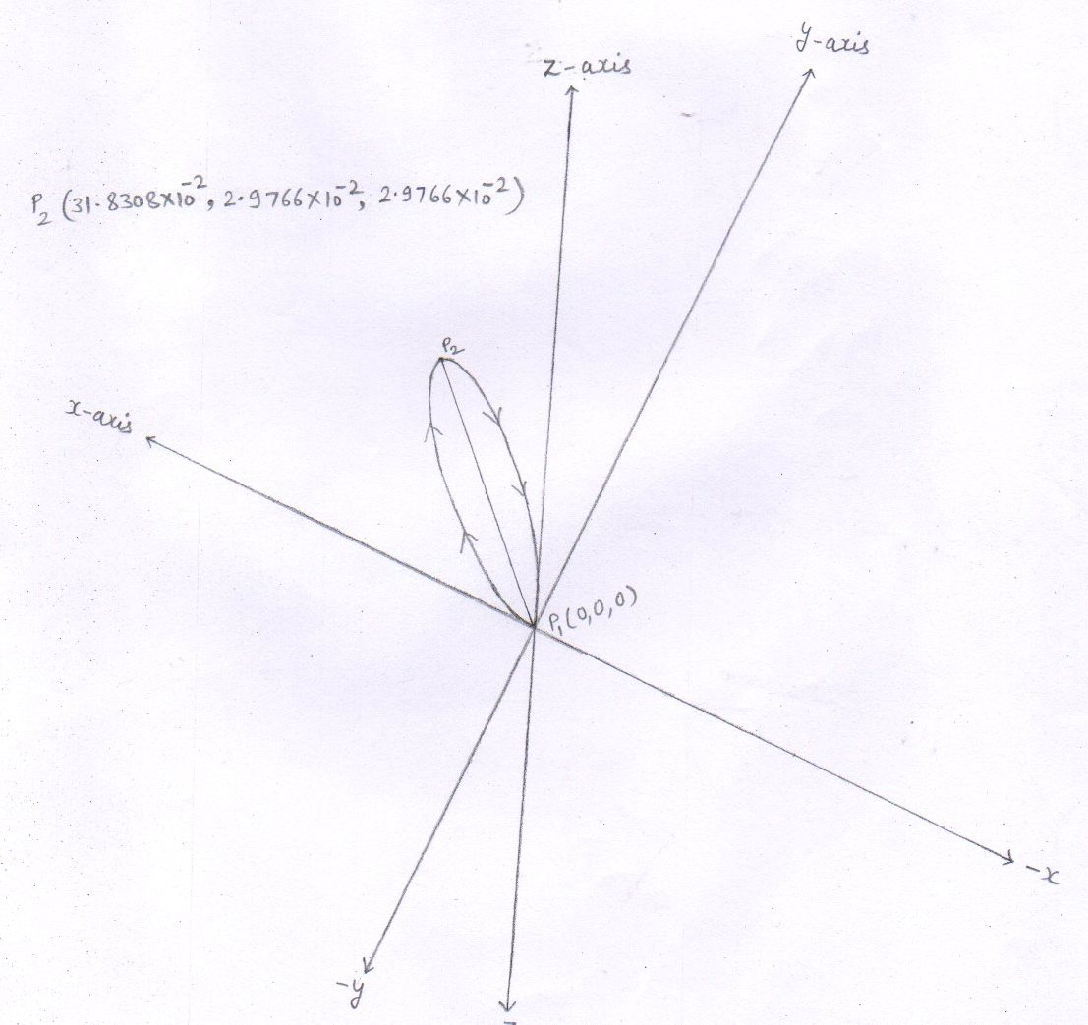

fig.(57)

Conclusion :
Two protons [ one is injected and the another is confined ] and confined deuteron fuse to form an unstable homogeneous compound nucleus – the lithion -4 .
The lithion -4 splits to produce two stable particles – one is helium -3 and the other is proton .
As soon as the helium-3 nucleus is produced at point ‘ F ‘ , under the influence of magnetic lines of force , it undergo to a circular orbit .
It starts its circular motion from point p₁ [ or F(0,0,0,) ] and reaches at point p₂ (x₂, y₂ , z₂ ).
As it reaches at point p₂ (x₂, y₂ , z₂ ) , in spite of completing its circle , it enters into the mouth of the horse pipe which is located at the point p₂ (x₂, y₂ , z₂ ).
Then it attains the gaseous state in the horse pipe and thus be extracted out of the tokamak with the help of vacuum pumps attached to the another end of the horse pipe.

Confinement of the produced proton :-
1.. Final velocity of the produced proton
V_{f}² = V_{x}² + V_{Y}² +V_{Z}²
V_{x}= 1.7746X10⁷ m/s from eq.(206)
V_{y}= 2.2137X10⁷ m/s from eq.(207)
V_{z}= 0 m/s from eq.(208)
- V_{f} ² = (1.7746X10⁷)² + (2.2137X10⁷)+(0)² m²/s²
- V_{f}² = (3.14920516X10¹⁴)+(4.90046769X10¹⁴)+0 m²/s²
- V_{f}² = 8.04967285X10¹⁴ m²/s² eq.(223)
- V_{f} = 2.8371x10⁷ m/s eq.(224)
2..Final kinetic energy (E_{f} ) of the proton
E= ½ m_{P} V_{f}²
m_{P} = 1.6726X10⁻²⁷ kg
V_{f}²= 8.04967285x10¹⁴ m²/s² from eq.(223)
E = ½ X1.6726X10⁻²⁷ X 8.04967285X10¹⁴ J
E = 6.73194140445X10⁻¹³ J
E = 4.2074 Mev
- M_{p} V_{f}² = 1.6726X10⁻²⁷ x 8.04967285 x 10¹⁴ J
= 13.4638X10⁻¹³ J eq.(225)

3..Forces acting on the proton
1 F_{y} = q V_{x} B_{Z} sin θ
q = 1.6 x 10⁻¹⁹ C
$\overset{→}{Vx}$ = 1.7746 x 10⁷ m/s from eq.(206)
$\overset{→}{Bz}$ = - 1 Tesla from eq.(15)
sin θ = sin 90º = 1
- F_{Y} = 1.6 x 10⁻¹⁹ x 1.7746 x 10⁷ x 1 x 1 N
= 2.8393 x 10⁻¹² N
Form the right hand palm rule , the direction of force $\overset{→}{Fy}$ is according to nagative y axis .
So, $\overset{→}{Fy}$ = -2.8393 x 10⁻¹² N eq.(226)
2 F_{z} = q V_{x} B_{y} sin θ
$\overset{→}{By}$ = 1 Tesla from eq.(16)
sin θ = sin 90º = 1
- F_{z} = 1.6 x 10⁻¹⁹ x 1.7746 x 10⁷ x 1 x 1 N
= 2.8393 x 10⁻¹² N

Form the right hand palm rule , the direction of force $\overset{→}{Fz}$ is according to negative z- axis . [ That is downward ] .
So, $\overset{→}{Fz}$= -2.8393 x 10⁻¹² N eq.(227)
3 F_{x} = q V_{y} B_{Z} sin θ
$\overset{→}{Vy}$ = -2.2137 x 10⁷ m/s from eq.(207)
$\overset{→}{Bz}$ = -1 Tesla
sin θ = sin 90º = 1
- F_{x} = 1.6 x 10⁻¹⁹ x 2.2137 x 10⁷ x 1 x 1 N
= 3.5419 x 10⁻¹² N

Form the right hand palm rule , the direction of force$\overset{→}{Fx}$ is according to negative x- axis .
So, $\overset{→}{Fx}$ = -3.519 x 10⁻¹² N eq.(228)

see fig.(58)
4.. Resultant force ( F_{R} ) acting on the proton [ when the proton is at point ‘ F ‘ ] .
F_{R}² = F_{x}² + F_{Y}² +F_{Z}²
F_{x} = 3.5419 x 10⁻¹² N from eq.(228)
F = F_{y} = F_{z} = 2.8393 x 10⁻¹² N from eq.(226,227)
F_{R}² = F_{x}² + 2F²
F_{R}² = (3.5419 x 10⁻¹² )² + 2 (2.8393 x 10⁻¹² )² N²
F_{R}² = (12.54505561 x 10⁻²⁴ ) + 2 (8.06162449 x 10⁻²⁴ ) N²
F_{R}² = (12.54505561 x 10⁻²⁴ )+ ( 16.12324898 x 10⁻²⁴ ) N²
F_{R}² = 28.66830459 x 10⁻²⁴ N²
F_{R} = 5.3542 x 10⁻¹² N eq.(229)

5..Radius of the circular orbit to be followed by the proton :-

r = mv²/ F_{R}
mv² = 13.4638 x 10⁻¹³ J from eq.(225)
F_{R} = 5.3542 x 10⁻¹² N from eq.(229)

- r = 13.4638 x 10⁻¹³ J
5.3542 x 10⁻¹² N

- r = 2.51462 x 10⁻¹ m
- r = 25.1462 x 10⁻² m eq.(230)

see fig.(58)

6.. Conclusion :- For proton that has produced
Conclusion : - By seeing the directions of the forces [ $\overset{→}{Fx}$ ,$\overset{→}{Fy}$ , $\overset{→}{Fz}$ ] being applied on the proton, we reach at the conclusion that the confined circular orbit to be followed by the proton lies in the region made up of negative x – axis , negative y- axis and negative z – axis where the magnetic fields are not applied .
In trying to follow the confined circular orbit , the proton reaches in the region where the magnetic fields are not applied . so as soon as the proton gets rid of the magnetic fields , it starts its linear motion.
So, the proton starts its circular motion from the point ‘ F ‘ and after travelling a negligible circular path , it give up the circular motion and then travel downward to strike to the base wall of the tokamak .
Thus the produced proton is not confined
see fig.(58)

The confinement of the produced proton :-
- The produced proton is not confined : -
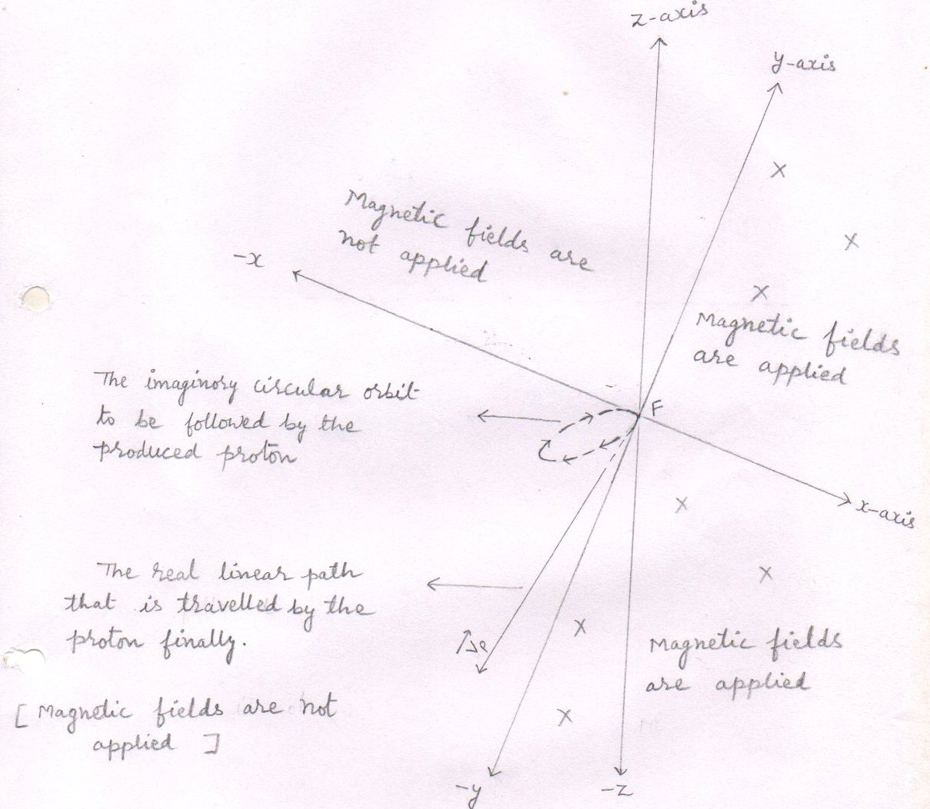
fig.(58)
- By the directions of the components of the resultant force [$\overset{→}{Fx}$ , $\overset{→}{Fy}$ , $\overset{→}{Fz}$ ] acting on the proton , we have come to know that the circular orbit to be followed by the proton lies in a region that is made by negative x , negative y and negative z-axis where the magnetic fields are not applied .
So, the proton starts its circular motion from point ‘ F ‘ and reaches in a region where the magnetic fields are not applied . Thus , the proton gets rid of the magnetic fields and hence finally moves downward to strike to the base wall of the tokamak .
Thus , the produced proton is not confined .
The power produced
To calculate the heat energy produced, we will consider the main fusion reactions only.
1 ₁¹ H + ₁¹ H $→$ ₁² H + e⁺ + ν_{e}
[ E_{injected} ] [ E_{injected} ] [ E_{inh} ] [ E_{inh} ] [ 0.4189 Mev ]

2 ₁¹ H + ₁² H $→$ ₂³ He + y rays + 5.4841 Mev
[ E_{injected} ] [ E_{inh} ]

ignoring the inherited kinetic energy of positron and the energy carried away by the neutrino , the energy produced is –

E _{produced} = 3 ₁¹ H $→$ ₂³ He + y rays + 5.4841 Mev eq.(231)

Conclusion : 3 protons fuse to form a Helium-3 nucleus and to produce 5.4841 Mev .

Total input energy
- Each proton is injected with 0.1024 Mev energy . from eq.(4)
- So, the total input energy carried by the 3 injected protons is –

E_{input} = 3x 0.1024 Mev

- E _{input} = 0.3072 Mev eq.(232)

Net yield energy
Net yield = E_{produced} - E_{input}

- Net yield = 5.4841 Mev - 0.3072 Mev from eq.(231,232) resp.

- Net yield = 5.1769 Mev eq.(233)

Conclusion : The 3 protons fuse and give us the net yield 5.1769 Mev .

VBM fusion reactor and the power produced

- The 3 protons fuse to yield 5.1769 Mev. from eq.(233)
Or the 3 protons fuse to yield 5.1769 x 1.6 x 10⁻¹³ J
- Then , if the 3 x 10¹⁹ protons fuse per second then the power produced is-

P = 5.1769 x 1.6 x 10⁻¹³ x 3 x 10¹⁹ J/s
3
- P = 8.2830 x 10⁶ J/s
- P = 8.2830 MW

Horse pipe and the extraction of the undesired charged particles : -

A horse pope is a hollow cylindrical pipe that allows the gaseous atoms to pass through it.
The one end ( mouth ) of the horse pipe is located in the main tokamak at the point P₂ ( x₂ , y₂ , z₂ ) where the Confined charged particle ( s ) reaches . while the another end is located outside the main tokamak .
Now as the confined charged particle, to follow the circular orbit, reaches from point P₁ ( 0 , 0, 0 ) to point P₂ ( x₂ , y₂ , z₂ ) , it enters into the mouth of the horse pipe . so, the charged particle at point ‘ P₂ ‘ , in spite of completing its circle, strike to the horse pipe . thus the confined charged particle imparts its all the heat energy to the horse pipe which in turn transfers this heat energy to the tokamak .
The slowed charged particle gets free electron ( s ) and become a gaseous atom .
With the help of vacuum pumps, attached to the another end of horse pipe, we can get the undesired gaseous atoms (helion -3 or helium - 4 gas ) on the another end of the horse pipe which is located at the outside of the main tokamak .

Summary
Either the charged particles are confined or not confined, the cartesian coordinates of the charged particles and the extraction of the undesired charged particles ( the helium -3 ) with the help of horse pipe : -
- The injected proton remains confined within into the tokamak .
( i).. The radius of the circular orbit followed by the confined proton is 3.498 x 10⁻² m.
(ii).. The Cartesian coordinates achieved by the confined proton are –
P₁ ( 0 , 0 , 0 ) and P₂ ( 2.58 x 10⁻² m , - 4.54 x 10⁻² m , -4.54 x 10⁻² m)

- For fusion reaction
₁¹ H + ₁¹ H $→$ ₁² H + e⁺ + ν_{e}
[ injected ] [ confined ]

I For the deuteron
- The deuteron remains confined within into the tokamak .

- The radius of the circular orbit followed by the confined deuteron is 6.943 x 10⁻² m.

- The Cartesian coordinates achieved by the confined deuteron are –

P₁ ( 0 , 0 , 0 ) and P₂ ( 5.13 x 10⁻² m , - 9.02 x 10⁻² m , -9.02 x 10⁻² m)
II For the positron
- The positron annihilates with the free electron to produce a pair of gamma ray photon.
III For the neutrino
- The produced neutrino does not interact with any particle and pass out from the tokamak .

- For fusion reaction
₁¹ H + ₁²H $→$ ₂³ He + gamma rays
[ injected ] [ confined ]

I For the helium – 3 nucleus
- The helium -3 nucleus is not confined .
- The radius of the circular orbit to be followed by the helium -3 nucleus is 5.188x10⁻² m .
- The Cartesian coordinates achieved by the helium -3 nucleus are –
P₁ ( 0 , 0 , 0 ) and P₂ ( 3.8391 x 10⁻² m , - 6.7444 x 10⁻² m , -6.7444 x 10⁻² m)
- The helium -3 nucleus starts its circular motion from point P₁ ( x₁ , y₁ ,z₁ ) and reaches at point P₂ ( x₂ , y₂ ,z₂ ).
As the helium – 3 nucleus reaches at point P₂ ( x₂ , y₂ ,z₂ ) , it
enters into the mouth of the horse pipe and thus be extracted out of the tokamak .

Where ,

P₁ ( x₁ , y₁ ,z₁ ) = P₁ ( 0 , 0 , 0 )
And P₂ ( x₂ , y₂ ,z₂ ) = P₂ ( 3.8391 x 10⁻² m , - 6.7444 x 10⁻² m , -6.7444 x 10⁻² m)

II For the gamma rays
- The gamma rays heats the tokamak .

- For the fusion reaction
₁¹ H + ₁²H + ₁¹ H $→$ ₂³ He + ₁¹ H
[ injected ] [ confined ] [ confined ]

I For the helium – 3 nucleus
- The helium -3 nucleus is not confined within into the tokamak .
- The radius of the circular orbit to be followed by the helium – 3 nucleus is 16.0551 x 10⁻² m.
- The Cartesian coordinates achieved by the helium – 3 nucleus are –

P₁ ( 0 , 0 , 0 ) and P₂ ( 31.83 x 10⁻² m , 2.97 x 10⁻² m , 2.97 x 10⁻² m)

- The helium – 3 nucleus starts its circular motion from point P₁ ( x₁ , y₁ ,z₁ ) and reaches at point P₂ ( x₂ , y₂ ,z₂ ).
As the helium – 3 nucleus reaches at point
P₂ ( x₂ , y₂ ,z₂ ) , it enters into the mouth of the horse pipe and thus be extracted out of the tokamak.
Where ,

P₁ ( x₁ , y₁ ,z₁ ) = P₁ ( 0 , 0 , 0 )
And P₂ ( x₂ , y₂ ,z₂ ) = P₂ ( 31.83x 10⁻² m , 2.97 x 10⁻² m , 2.97 x 10⁻² m)

II For the proton

- The produced proton is not confined within into the tokamak .
- The produced proton starts its circular motion form point ‘ F ‘ [ or the point P₁ ( 0 , 0 , 0 ) ] and then reaches in a region where the magnetic fields are not applied . so , the proton give up its circular motion and then travel downward to strike to the base wall of the tokamak .

VBM fusion reactor and the lawson’s criterion :

VBM fusion reactor has a particular point – the center of fusion ( or the point ‘ F ‘ ) that governs all the fusion reactions . so, the VBM fusion reactor exceeds the value of Lawson ‘s criterion [ n_{e} t_{e} or n_{e} T t_{e} ] while in any other thermonuclear fusion reactor , to achieve the Lawson’s criterion is still a challenge .

Mode of output

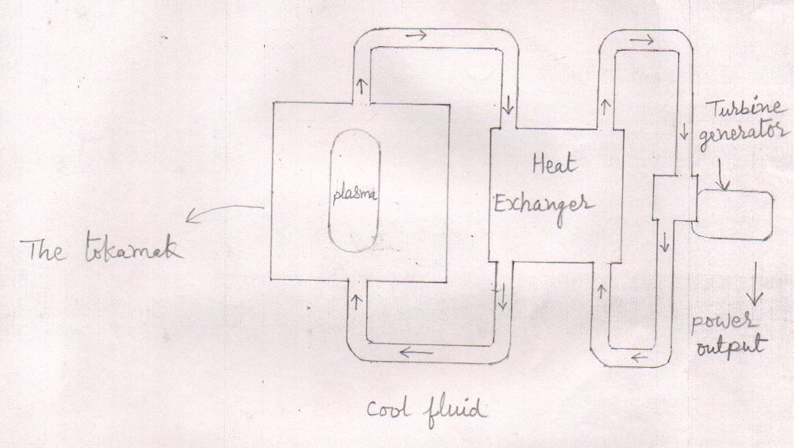

fig.(59)
- The heat is transferred by a water – cooling loop from the tokamak to a heat exchanger to make steam .

- The steam will drive electrical turbines to produce electricity .

- The steam will be condensed back into water to absorb more heat from the tokamak .

