Effects of mixed fermentation of bio-control microorganisms treatment on the postharvest quality of grape and kiwifruit
Yunzhe Cong, School of Life Science, Shandong University, Jinan 250100, PR China
Kaoshan Chen, PhD, School of Life Science, Shandong University, Jinan 250100, PR China

Abstract (300 word limit)
Postharvest diseases of fruits cause major losses, these diseases are primarily controlled by application of synthetic chemicals.The studies of the new and safer creature preservatives have been researched during the process of the restraint of the fruits and vegetables postharvest disease. Microorganisms and secondary metabolites can be used for the preservation of post-harvest fruits and vegetables to reduce the pollution of chemical pesticides. This study used a new type treating agent made by mixed fermentation of bio-control microorganisms, including Trichoderma pseudokoningii, Rhizopus nigricans, Bacillus amyloliquefaciens, to sprinkle on the vines and kiwifruit trees and irrigating the roots, the fruits were studied during storage and the subsequent shelf time. The results showed that the incidence of post-harvest disease is significantly reduced after treatment. After 18 days, disease index of grape treatment group (28.43%) was significantly lower than the control group (75.57%). In kiwifruit groups, disease index reduced from 82.12% to 57.67%. Moreover, the fruit flesh firmness and the contents of titratable acid, total soluble solids, total sugar and reducing sugar were higher than the control group. In addition mixed fermentation treatment induced the production of resistance enzymes of fruits, including polyphenol oxidase (PPO) and peroxidase (POD) and enhancing the resistance activity of fruits to pathogens. In conclusion, mixed fermentation treating agent could significantly increase quality of fruits and commercial value and benefit the preservation of kiwifruits quality and the extension of storage life under the room conditions, and this agent has the potential for commercial applications．

Image
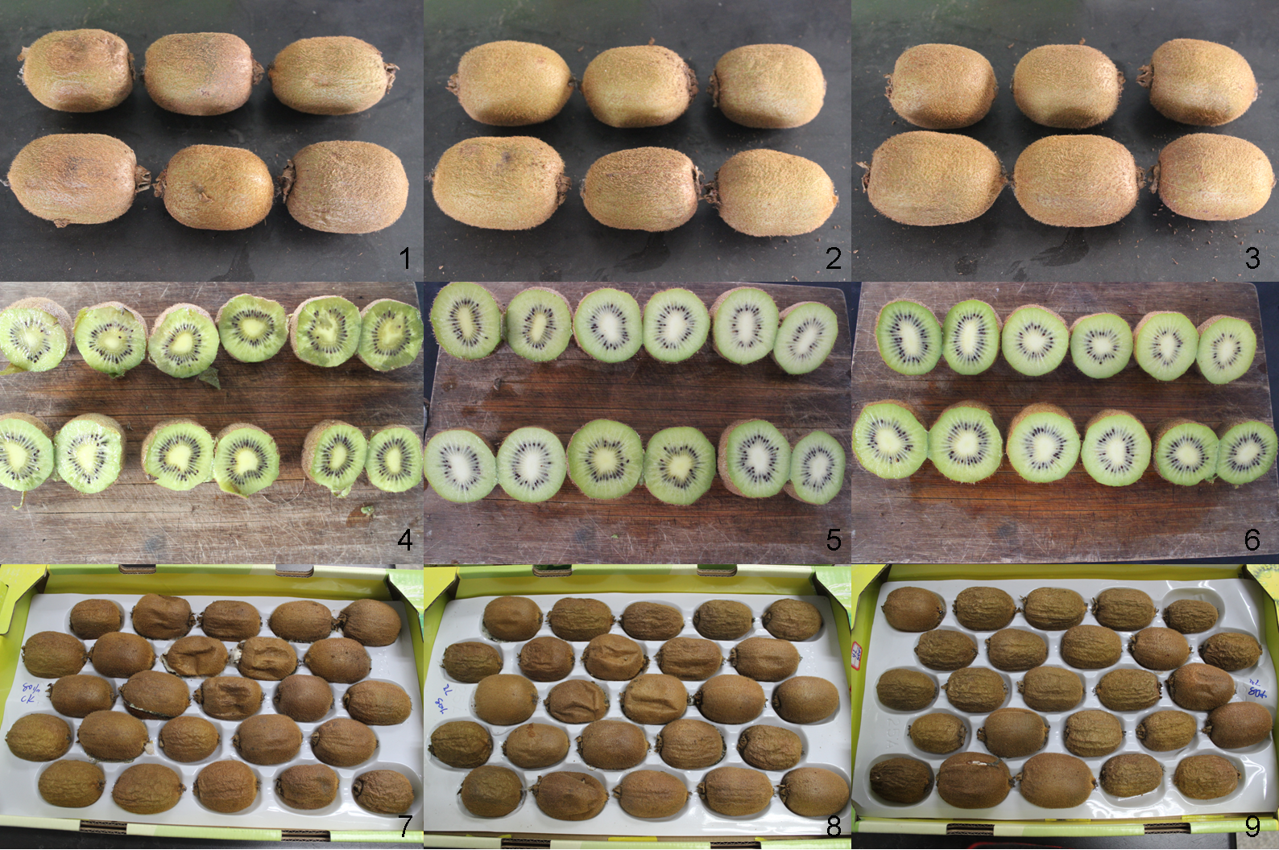
Fig.1 Effects on the preservation of post-harvest kiwifruits after different preharvest treatment
(left: Control group; middle: 2L/m² group; right: 4L/m² group)
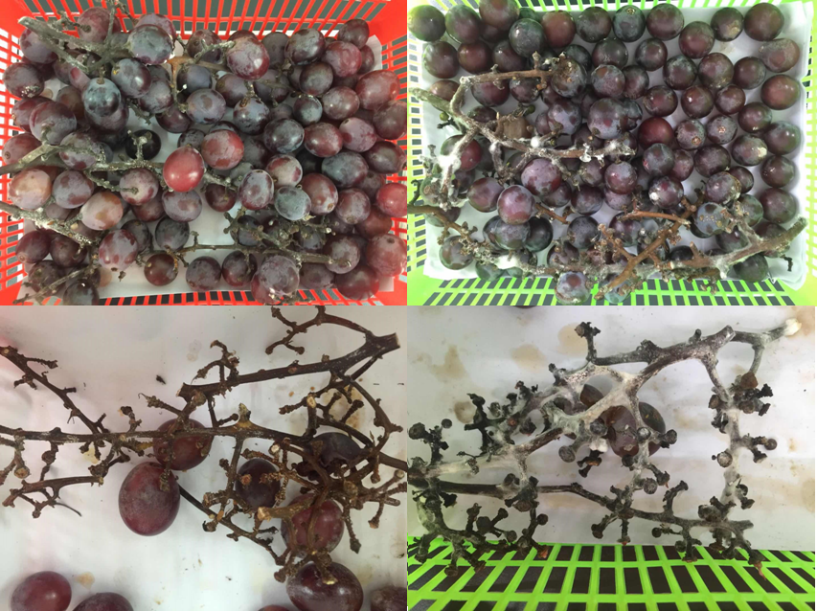
Fig.2 Fruit drop and postharvest diseases of grape 18 days after harvest (left: Treatment group; right: Control group)
Recent Publications (minimum 5)
- Postharvest diseases control effect in different fruits with Burdock Fructooligosaccharide and the mechanism in grape against Botrytis cinerea. Food Chemistry, 2013, 138(1): 539-546.
- Postharvest treatment with trans-2-hexenal induced resistance against Botrytis cinerea in tomato fruit. Australasian Plant Pathol, 2015, 44:121–128.
- Exopolysaccharide of Antarctic bacterium Pseudoaltermonas sp. S-5 induces apoptosis in K562 cells. Carbohydrate Polymers, 2015, 121:107-114.
- Immune-enhancing activity of extracellular polysaccharides isolated from Rhizopus nigricans. Carbohydrate Polymers，2016, 148:318-325.

Biography (150 word limit)
Kaoshan Chen, Ph.D. Professor
Professor of Shandong University, School of Life Science and National Glycoengineering Research Center, State Key Laboratory of Microbial Technology, Shandong University.
Address: No. 27 Shanda Nan Road, Jinan 250100, Shandong Province, P.R. China.
Email: ksc313@126.com
Work experience
2001.9-now, Professor, Life Science School, Shandong University. PRC
2005,3-now, Part-time Professor, Department of Pharmacy, Wannan Medical Collge
2002,2-2005, Professor, 1st Institute of SOA, Qingdao
2001.6-2001.9, Postdoctoral Rearcher, Agricultural Research Organization Volcani Center, Israel
2001.1-2001.5, Visiting Scholar, Institut für Zellbiologie of Max Planck, Germany.
1997.7-2001.9, Associate Professor, Life Science School, Shandong University
1995.7-1997.9, Lecturer, Life Science School, Shandong University
Research interest key words
biocontrol, phytophysiology, polysaccharide, immunomodulatory

Yunzhe Cong, Ph.D.
2014.9-now, Ph.D., Biochemistry and Molecular Biology, Shandong University

Email: ksc313@126.com
congyunzhe@foxmail.com

Notes/Comments:

