Novel mixed fermentation of bio-control microorganisms treatment agent for suppressing kiwifruit bacterial canker disease associated with soil microflora alterations
Yunzhe Cong, School of Life Science, Shandong University, Jinan 250100, PR China
Kaoshan Chen, PhD, School of Life Science, Shandong University, Jinan 250100, PR China

Abstract (300 word limit)
Bacterial canker of kiwifruit, caused by Pseudomonas syringae pv. actinidiae (Psa), is a devastating disease of kiwifruit production due to its fast spread，strong pathogenicity and difficult to control, the disease has seriously hampered the development of kiwifruit industry. The application of a novel treatment agent based on mixed fermentation of bio-control microorganisms, including Trichoderma pseudokoningii, Rhizopus nigricans, Bacillus amyloliquefaciens, as a strategy for controlling bacterial canker and its effects on soil microflora was investigated in a field with serious disease incidence in this study. The results showed that the pH value of the soil by the treatment (5.42) of mixed fermented liquid was lower than the control group (6.53) and the soil bulk density reduce from 1.52g/cm³ to 1.46 g/cm³ after processing. Real-Time PCR results showed that the total bacterial and fungal numbers were significantly decreased after treatment and that significantly fewer pathogens were observed. The next-generation sequencing of the 16S rRNA and internal transcribed spacer (ITS) genes using HiSeq platform showed that the soil bacterial and fungal community structures in the treatment were significantly different from the control without treatment. Compared to the control, higher abundances of Ascomycota and Basidiomycota, and lower abundance of Glomeromycota and Neocallimastigomycota were observed in the processed soils. While, we also found the relative abundance of Proteobacteria and Firmicutes were higher in the processed soils and the Acidobacteria, Planctomycetes and Nitrospirae were lower. Most importantly, the abundance of Pseudomonas syringae, which includes the pathogen potentially responsible for bacterial canker of kiwifruit, was significantly lower in the fumigated soils after harvest. In conclusion, the observed disease suppression due to the novel mixed fermentation treatment strategy may be attributed to general suppression resulting from altered soil properties and the alteration of the disturbed soil microflora in a kiwifruit monoculture system.

Image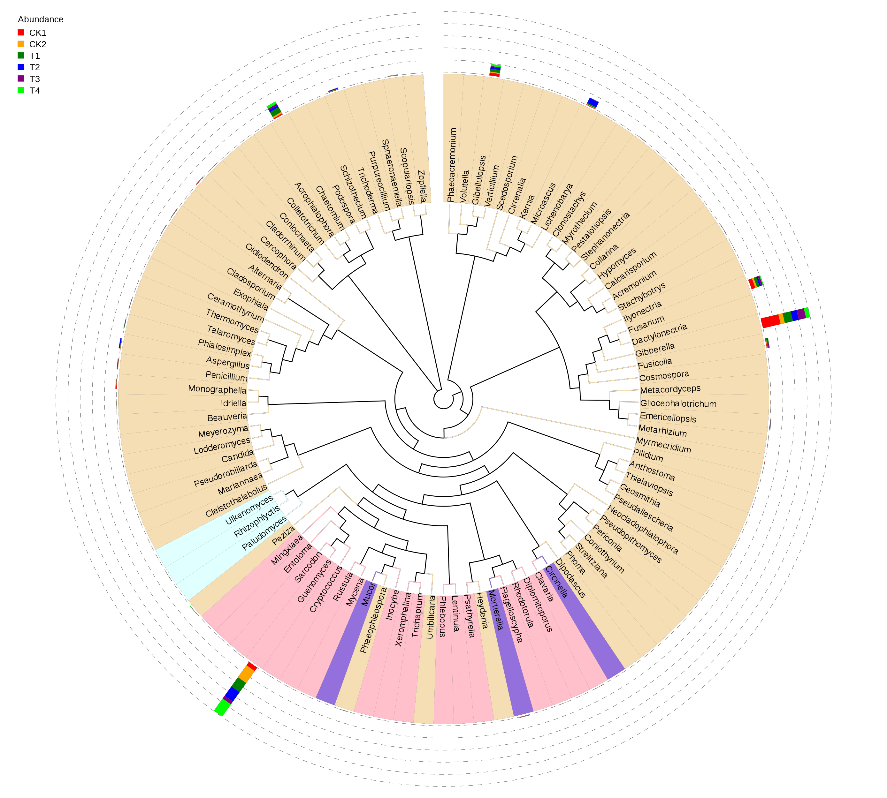
Fig. 1 The phylogenetic relations of different groups at genus level

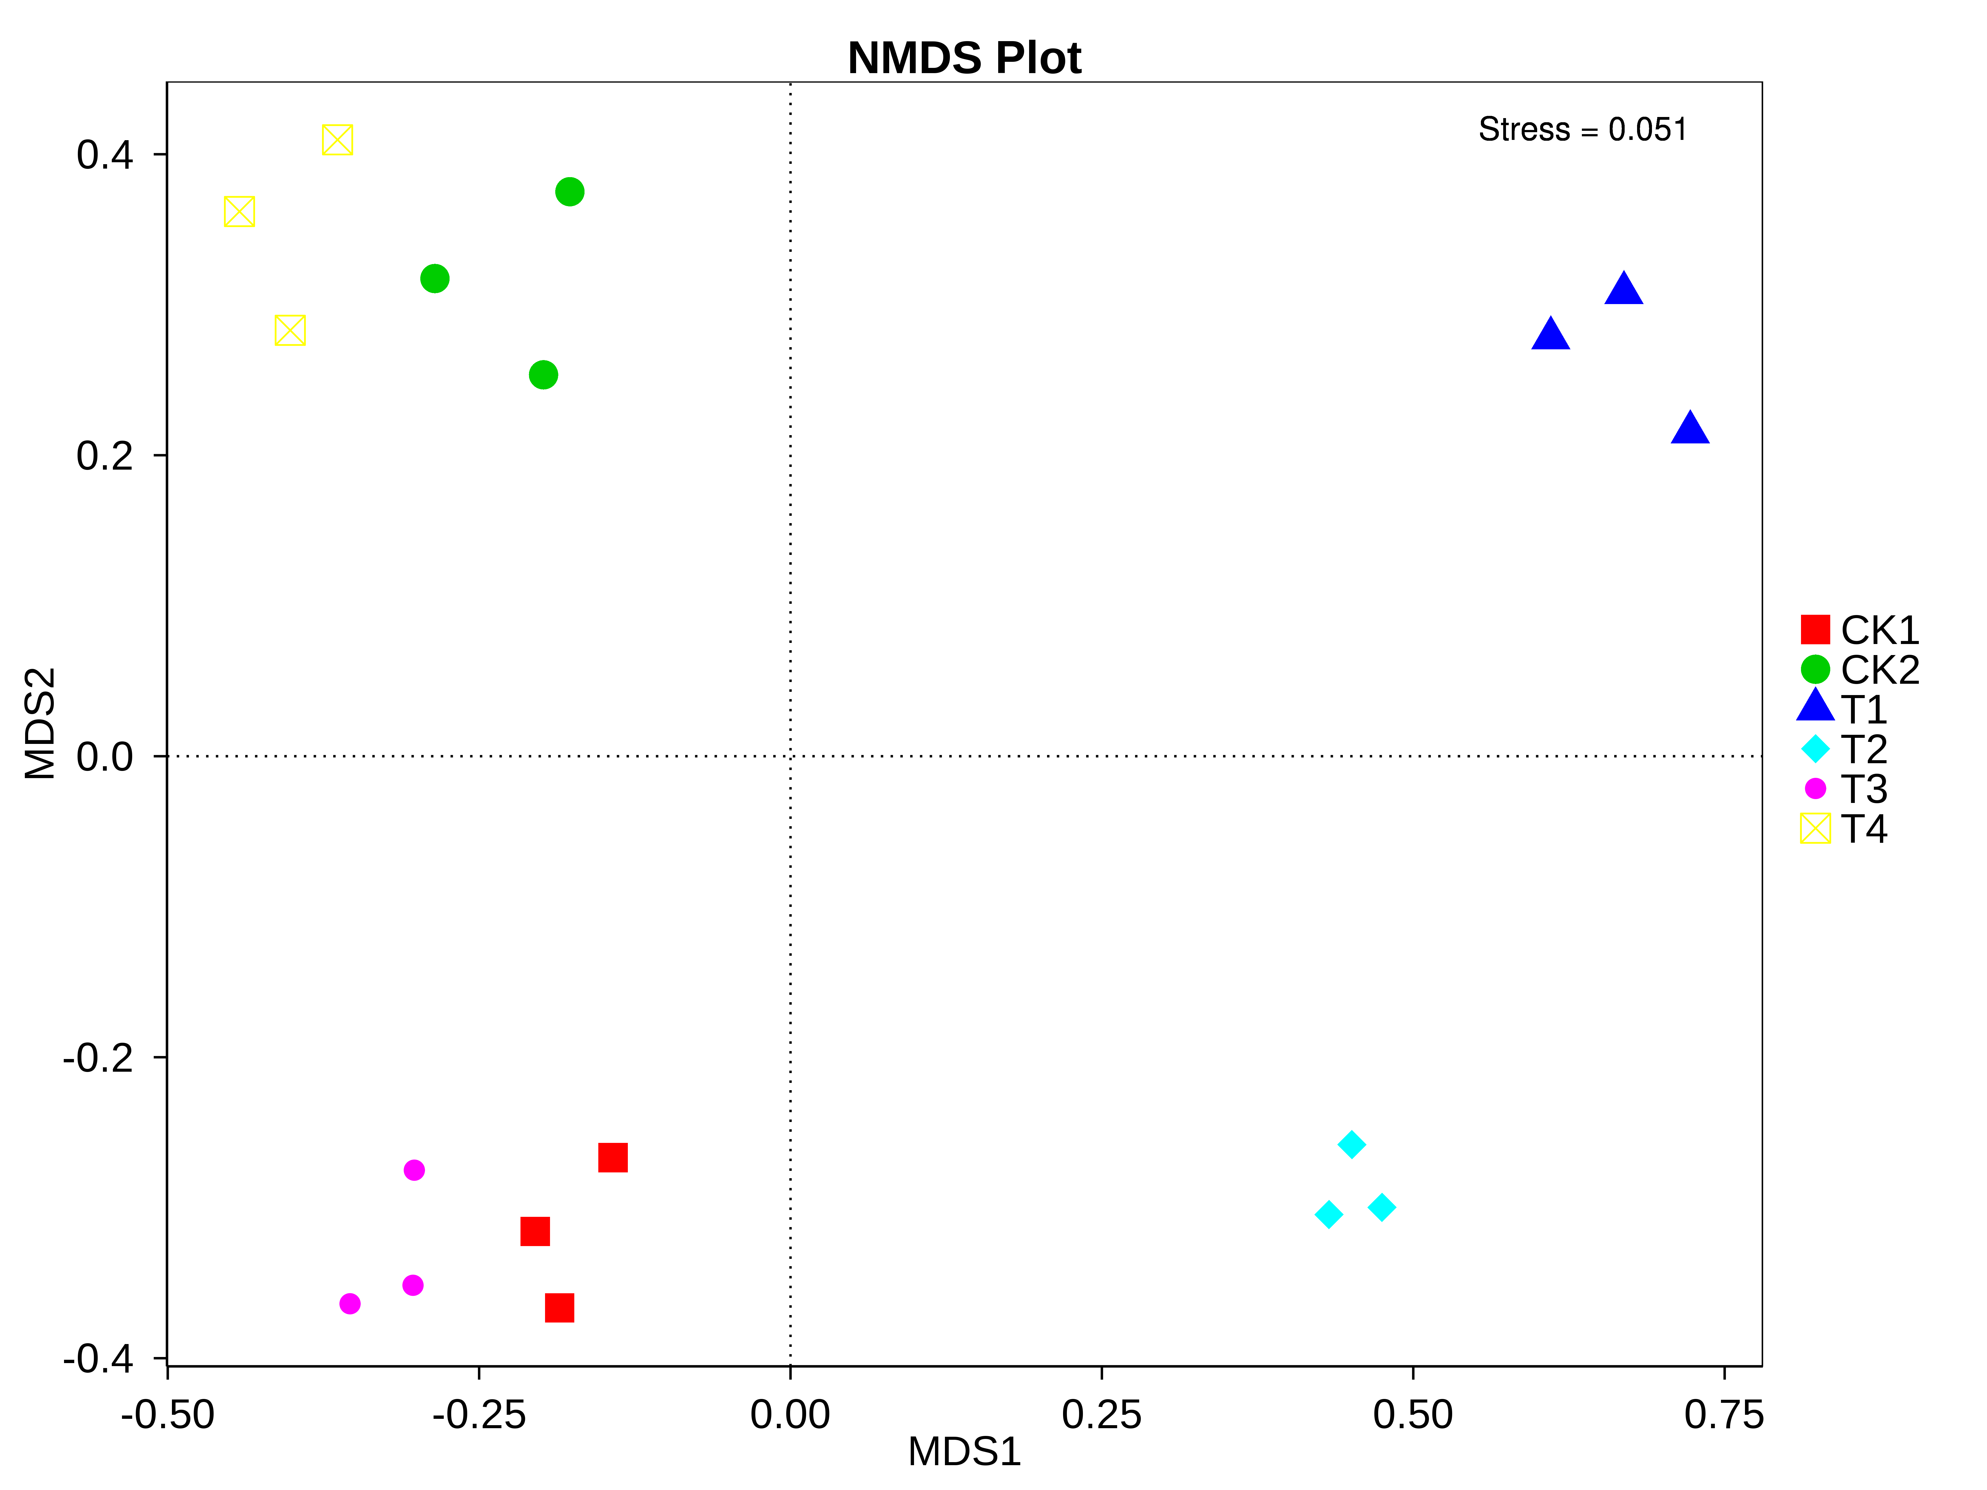
Fig.2 non-metric multi-dimensional scaling (NMDS）analysis
Recent Publications (minimum 5)
- Postharvest treatment with trans-2-hexenal induced resistance against Botrytis cinerea in tomato fruit. Australasian Plant Pathol, 2015, 44:121–128.
- Exopolysaccharide of Antarctic bacterium Pseudoaltermonas sp. S-5 induces apoptosis in K562 cells. Carbohydrate Polymers, 2015, 121:107-114.
- Immune-enhancing activity of extracellular polysaccharides isolated from Rhizopus nigricans. Carbohydrate Polymers，2016, 148:318-325.

Biography (150 word limit)
Kaoshan Chen, Ph.D. Professor
Professor of Shandong University, School of Life Science and National Glycoengineering Research Center, State Key Laboratory of Microbial Technology, Shandong University.
Address: No. 72 Binhai Road, Tsingtao Jimo 250100, Shandong Province, P.R. China.
Email: ksc313@126.com
Work experience
2001.9-now, Professor, Life Science School, Shandong University. PRC
2005,3-now, Part-time Professor, Department of Pharmacy, Wannan Medical Collge
2002,2-2005, Professor, 1st Institute of SOA, Qingdao
2001.6-2001.9, Postdoctoral Rearcher, Agricultural Research Organization Volcani Center, Israel
2001.1-2001.5, Visiting Scholar, Institut für Zellbiologie of Max Planck, Germany.
1997.7-2001.9, Associate Professor, Life Science School, Shandong University
1995.7-1997.9, Lecturer, Life Science School, Shandong University
Research interest key words
biocontrol, phytophysiology, polysaccharide, immunomodulatory

Yunzhe Cong, Ph.D.
2014.9-now, Ph.D., Biochemistry and Molecular Biology, Shandong University

Email: ksc313@126.com
congyunzhe@foxmail.com

Notes/Comments:

