Maize-Soybean Relay Strip Intercropping Systems in China: Nutrient Acquisition, Light Utilization and Productivity of Component Crops
SAJAD HUSSAIN¹, PANG TING¹, MUHAMMAD NAEEM KHAN², MUHAMMAD IJAZ², SAMI ULLAH², MUBSHAR HUSSAIN², WEIGUO LIU^{1*}, WENYU YANG^{1*}
¹College of Agronomy, Sichuan Agricultural University, 211-Huimin Road, Wenjiang District, Chengdu 611130, P.R. China.
(²College of Agriculture, Bahauddin Zakrya University, Bahadur Sub-Campus layyah, Punjab, Pakistan.
*Correspondence: lwgsy@126.com (L.W), mssiyangwy@sicau.edu.cn (W.Y)
Tel: +86-28-86290960; Fax: +86-28-86290870

Abstract
The efficient capture and utilization of resources in any cropping system are considered as fundamentals of productive agriculture. Soybean (Glycine max L.) has traditionally been grown in intercropping with maize in China. In China, domestic production does not meet the country’s requirement. Moreover, the traditional maize-soybean intercropping systems have not been adapted to modern agriculture. Therefore, a model mechanized based maize-soybean relay strip intercropping system has been developed, which is practicing widely in the southwestern China since last over than a decade. Recently, soybean-strip intercropping has been recommended as a major technology by the Ministry of Agriculture of China. The key technologies of this system are: rows spacing expansion, inter-plant spacing reduction, and optimal cultivar screening. This intercropping system ensures the three main paradigms of modern agriculture such as food security, sustainability, and environmental safety. The two core objectives of this review were to bring across the concept that how this novel intercropping system can increase the nutrients acquisition, light utilization, and the total yields for the component crops, and highlight the need and importance of the mechanized based maize-soybean relay strip intercropping systems in the modern agriculture.
Keywords: environmental safety, Intercropping, resource utilization, sustainability, total yield,
1. Introduction:
The current world population is around 7 billion and it is estimated to be 9 billion by the end of 2050. With the bulk of this growth providing food for the 9 billion people in the future would be a big challenge. China will have to face the largest challenge of this century to increase in cereal production up to 600 Mt by 2030 (Miao et al., 2010). Different strategies have been practiced such as crop rotations, high rate of fertilizer application and intercropping by Chinese farmers in traditional farming systems. It is obvious the crop yield also increased because of increased rate of fertilizer application. In addition, inappropriate application of fertilizers is also contributing to boost the environmental hazards. Phosphorus accumulation and nitrogen leaching, and over use of pesticides have been increased severely, about 67% of phosphorus source resulting in water pollution (Zhou et al., 2016, Constantin et al., 2010, Aktar et al., 2009).
The abuse of nitrogen (N) fertilizer and traditional farming systems have been leading to emission of greenhouse gas and input losses, respectively (Dyer et al., 2012; Qiao et al., 2014). However, several studies reported that inclusion of soybean with maize regulates the internal nitrogen cycle through nitrogen fixation process and minimizes the fertilizer requirements. Keeping in view the benefits of intercropping such as complementary use of resource in time and space, we can minimize the soil nitrogen and carbon losses (Prasad et al., 2005). Furthermore, intercropping systems provide 15-20% of the world’s food supply (Lithourgidis et al., 2011). Traditional maize-soybean intercropping has been practiced in different countries (Jun-Bo et al., 2018). In traditional intercropping systems, one of the major limitations is lack of technological intervention such as mechanized sowing, fertilization and harvesting. The other thing in traditional intercropping is incompatible crop combinations without considering the crop traits for intercropping (Aziz et al., 2015) such as degree of relativeness, standardized plant spacing, plants height, phenology stages, type of canopy, leaves and roots architecture. In traditional intercropping, the partitioning of resources is imprecise because of uneven distribution of plants. Furthermore, in traditional intercropping systems the associated crop suffers from stresses specifically nutrients and light. The chances of lodging increase owing to severe light stress results in poor growth, vigor and ultimately low yield (Liu et al., 2016). However, these traditional intercropping practices seem not capable of providing food for the alarmingly increasing human population in the future due to low resource use efficiencies and productivity. The efficient utilization of resources is indispensable to achieve optimum crop yield. Inappropriate intercropping systems such as in traditional intercropping depletion of natural resources, inefficient utilization of nutrients and imbalanced distribution of nutrients are the disappointing shortcomings (Rahman et al., 2013). Therefore, it is of dire importance to introduce a type of cropping system that could ensure sustainability, mitigate the environmental foe impacts, and improve the efficiency of abiotic resources such as light and nutrients.
The comparative analysis of various crops intercropped with soybean has indicated that maize is the best partner of soybean under intercropping conditions, because of the complementary characteristics possessed by both species (Chen et al., 2017). Maize is a nitrogen-consuming C4 crop that occupies a relatively higher ecological niche and high photosynthetic efficiency (Calderon et al., 2012), while soybean is a nitrogen-fixing C3 crop (Qin et al., 2013) that occupies a relatively lower ecological niche. Maize has large cylindrical leaves, whereas soybean has small round leaves, which are good for light utilization within the spaces (Yang et al., 2015). Maize is enriched with starch (Zhang et al., 2008), whereas soybean in high protein crop, which satisfy the need of food for humans and fodder for animals (Rossi et al., 2016). Additionally, maize and soybean both are thermophilic plants and having same habits for temperature, light, and water (Kocsy et al., 2001). Moreover, both are seeded crops, and share the same sowing season making them fit for the mechanized cultivation and harvesting (Yang et al., 2014). These characteristics enable them to coexist harmoniously. Therefore, the maize-soybean relay strip intercropping system can be practiced in any region worldwide, where either maize or soybean can grow.
In recent years, a new maize-soybean relay strip intercropping system has been developed and popularized in the southwestern china (Liu et al., 2017, Fan et al., 2018). This intercropping system is being practiced on approximately 667 thousands hacters in southwestern China and the area is still increasing due to growing demand for protein rich food (Liu et al., 2017; Yang et al., 2014; Yan et al 2010). The pivotal focus of this system is on three critical strategies including: row spacing expansion, inter-plant spacing reduction, and optimal cultivar screening (Yang et al., 2018, Yang et al., 2015, Ren et al., 2016). Changing the hierarchies and spatial patterns in plant populations may influence the productivity of the intercropping system (Oseni and Aliyu, 2010). Planting maize and soybean in 2:2 or 1:2 row arrangements can maximize the optimum crop yield in intercropping conditions (Undie et al., 2012). Some studies elaborated the soybean response to shading and the most suitable planting pattern (2:2) in maize-soybean strip intercropping (Yang et al., 2014; Yang et al., 2015; Rahman et al., 2016). Several studies have been carried out on the critical aspects of intercropping such as varietal breeding and screening, planting pattern (Yang et al., 2015) lodging resistance (Luo et al., 2015), fertilizer management (Yong et al., 2014) water use efficiency and water distribution (Rahman et al., 2016), microbial activity (Yu et al., 2014), relative crowding coefficient, competitive ratio, actual yield loss, aggressivity, intercropping advantage indices (Yang et al., 2016), growth improvement and light irradiance (Yang et al., 2014). Through agronomic practices our systems of intercropping maintained the proper competitiveness between two intercropped species and achieved higher yield. The technological advancement such as mechanized cultivation and harvesting of crops is the key to the success of this system (Jun-Bo et al., 2018). In our research team, a wide range of research has previously been reported to suggest the appropriate planting geometry that can ensure high yield, nutrient acquisition, and light interception in maize-soybean intercropping systems (Yang et al., 2015; Zhang et al., 2015) for success of this system.
According to mechanized based maize-soybean intercropping systems, the resource utilization is highly efficient as compared to the traditional intercropping systems. Therefore, the current review was generated in order to summarize the efficient utilization of nutrient and light in maize-soybean intercropping system and its ultimate yield potential.

2. Nutrient Acquisition, Light Utilization, and Yield Potential of Maize-Soybean Intercropping
2.1 Nutrient Use Efficiency
The excessive fertilization and inadequate application of fertilizers not only causes environmental risks but also reduces the crop productivity e.g. leading to water eutrophication, soil acidification and air pollution (Erisman et al., 2007, Guo et al., 2010)(Le et al., 2010; Vitousek et al., 2009). The success of intercropping system is profoundly depends on the temporal and spatial complementarity of resource utilization (Xue et al., 2016). This maize-soybean relay strip intercropping not only decreases nitrogen losses but also reduces the requirement of the fertilizers by providing soil nitrogen through soybean nitrogen fixation (Chen et al., 2017). In maize-soybean relay strip intercropping followed by 2:2 maize-to-soybean rows (Figure 1), the reduced application of nitrogen fertilizer increase the component yield for the maize and soybean crop, and the total yield by 4.95%, 7.07% and 5.35%, respectively through the separation of the root ecological niche contributed to a positive interspecific facilitation, which increased the land productivity (Chen et al., 2017)(Dong et al., 2014).
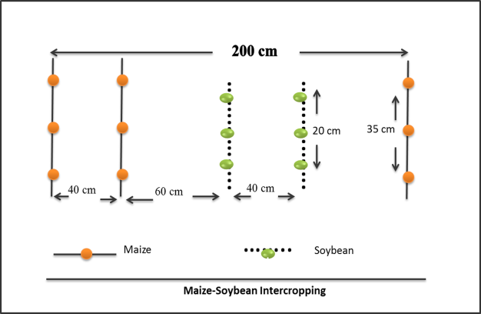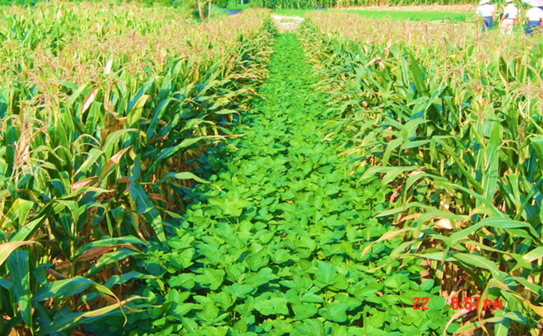
Figure 1. Planting geometry of maize-soybean intercropping; the green circles indicate soybean plants and the orange circles indicate maize plants.
In traditional intercropping system, the application rate of fertilizer is much higher than our mechanized based maize-soybean relay strip intercropping system. Apart from this, it is reported that nodules per plant, nitrogen fixation potential, and ultimately nitrogen uptake can be improved by reducing nitrogen application rate from 240 kg ha⁻¹ to 180kg ha⁻¹ (Yong et al., 2014). Former studies have shown that increased rate of nitrogen application (240 kg ha⁻¹) weaken the excellence of maize- soybean relay strip intercropping (Yang et al., 2014; Yong et al., 2014). However, grain yield, harvest index, and NPK uptake efficiency for the intercropped maize and soybean were higher than that of respective monocultures at the 180 kg ha⁻¹ reduced rate of nitrogen. Another study reported on the rational application of phosphorus demonstrated that a rational application of P at the rate of 72 kg ha⁻¹ can enhance the phosphorus uptake, and increase yield for maize-soybean relay strip intercropping. The onset of efficiently functional nodule system is important for nitrogen fixation, and nitrate leaching can be minimized by intercropping (Graham, 2008). A previous study have shown 20.2% higher nitrogen uptake for maize in maize-soybean relay strip intercropping (Yong et al., 2014). Root interaction plays a vital role in nutrient immobilization and acquisition (Li et al., 2003). The interspecific competition for nutrients in maize and soybean is clearly weak due to the existence of the roots of both crops at different soil depth (Gao et al., 2010). The root length density and distribution can enhance the nutrient acquisition efficiency in this intercropping system. Considering the key technologies of our novel intercropping system maize and soybean crop attain their required space equally. The complementarity and facilitation characteristics are impeccable in our intercropping system. As the plants have different behavior according to the degree of relativeness of the other plant. The higher interspecific interaction at the border rows, favorable microenvironment and kin recognition behavior of plants might be the possible reason of efficient utilization of nutrient. Therefore, by adopting this specific crop combination and spatial arrangement, we can reduce nutrient run off losses and enhance soil fertility, which increases the overall yield in intercropping systems.
2.2 Light Use Efficiency
The interception of light and light use efficiency describes the resource capture efficiency of a cropping system. There is a linear relationship between photosynthetic active radiation (PAR) and biomass accumulation (Behling et al., 2015). The slope of this relationship named as light use efficiency (Zhang J. et al., 2008). Intercropping is an applicable technique to capture the above and below ground resources effectively. The better use of above ground resource, for example high interception of sunlight, and efficient conversion of intercepted radiation within time and space are attributed as the fundamental features of maize-soybean intercropping. However, compare to maize, soybean often suffers from the shading effect caused by the tall maize plants during the co-growth period. Shading by the maize crop changes the light environment of soybean in terms of both red far red ratio and PAR (Liu et al., 2017). Another study found (17-21%) reduction in red far red ratio on top of the soybean canopy in intercropping systems (Liu et al., 2017). A recent study showed that after co-existence period, the recovery response of soybean to shade is very significant in maize-soybean relay strip intercropping (Wu et al., 2015). In addition, the space between maize and soybean plants not only affects the PAR efficiency, but also influences canopy structure for the intercropped soybean (Tsubo and Walker, 2002; Zhang J. et al., 2008; Munz et al., 2014). Therefore, it is important to explore an optimum spatial-temporal configuration of intercropping systems. After a collaborative research on space deployment, it was evaluated that increase in the distance between soybean and maize rows and decrease in the spacing of maize narrow rows might be useful for the high light interception for the soybean (Yang et al., 2015), moreover the 40 cm distance between soybean rows and 60cm between soybean and maize rows increase the photosynthesis. Furthermore, due to shading effect caused by maize, the morphological changes in soybean plants were observed such as soybean stem elongation, reduction in leaf size (Page et al., 2011; Yang et al., 2014; Gong et al., 2015), and ultimately lodging of the soybeans. Keeping in view this problem, the shade susceptible and shade insensitive genotypes have been screened out in our system (Liu et al., 2015; Liu et al., 2016). It seems that the cultivation of semi-dwarf and shade tolerant soybean cultivars in maize-soybean mechanized based intercropping could be helpful in minimizing the influence of shade. By cultivating shade resistance cultivars in this system, photosynthetic productivity can be enhanced.
2.3 Yield Potential
Intercropping yield potential is assessed by calculating the land equivalent ratio (LER) (Zhang et al., 2011). LER is used to assess the performance of intercropped plants relative to that of the corresponding sole crops.
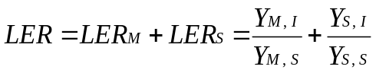
LER_{M} and LER_{S} are the relative yield of maize and soybean in intercropping. YM, S and YM, I are the sole and intercropped maize yield, whereas YS, S and YS, I are the sole and intercropped soybean yield, respectively. Intercropping favors the growth and yield of the species when LER is > 1 (Nassab et al., 2011). In china, previous research on traditionally sown maize-soybean intercropping revealed that the maximum LER did not exceed than 1.2, and the average grain yield of maize and soybean can reach up to 7,300 kg ha⁻¹ and 1,045 kg ha⁻¹, respectively. Several indices including relative crowing coefficient, aggressivity, competitive ratio, actual yield loss and intercropping advantage have been used to determine the beneficial effects regarding different planting patterns. These indices indicate that narrow wide row planting pattern increase the intercropping advantage, LER, monetary advantage as compared to sole cropping (Yang et al., 2016). By comparing the mechanized based maize-soybean strip intercropping system with the other intercropping systems practicing across the world, it is clear that our maize-soybean intercropping practice is more efficient in terms of LER. In our maize-soybean intercropping systems, we have multifold and convincing results of LER (1.8) and average optimum yield (Liu et al., 2017). The LER typically ranges between 1.64 and 2.28 (Table 1). Moreover, the corresponding average grain yield is approximately 6,790-11,475 kg ha⁻¹ for maize and 1,510-2,364 kg ha⁻¹ for soybean (Cui et al., 2014; Deng et al., 2013; Liu et al., 2014), which indicates much higher values than those obtained using the previous traditional models (Lv et al., 2014). The grain yield obtained in a recent two-year experiment in Shandong province using our intercropping system was 9,765-11,710 kg ha⁻¹ for maize and 1,527-1,538 kg ha⁻¹ for soybean, with a LER of 1.4. The grain yield reached as high as 12,750 kg ha⁻¹ for maize and 1,650 kg ha⁻¹ for soybean in a regular strip-intercropping system in Ningxia Hui Autonomous Region in 2014. These results reveal that yield potential in our intercropping system is much higher than that of previous maize-soybean intercropping systems (Lv et al., 2014; Verdelli et al., 2012).
Table 1. The maximum LER achieved by different countries through intercropping.
Country LER Reference
China 2.2 (Yong et al., 2014)
Nigeria 1.87 (Ijoyah et al., 2002)
Kenya 1.81 (Matusso et al., 2014)
Iran 1.67 (Mahmoudi et al., 2013)
Pakistan 1.78 (khan et al., 2014)
India 1.54 (Yogesh et al., 2014)
Nepal 1.45 (Prasad et al., 2005)

Previous studies have demonstrated that legume cropping increases the retention of soil carbon and nitrogen through the maize-soybean rotation system. Our recent study also showed that maize yields in a two and three year maize-soybean alternative rotation were 9.4% and 12.6% higher, respectively, compared with maize-sweet potato rotation systems, indicating that soybean improved soil fertility and indirectly production (Wang et al., 2012). Strip-intercropping is an environmental friendly strategy, which is highly efficient in nutrient utilization, and light interception. This intercropping system can be a remarkable breakthrough for high output in the field of agriculture. It is worth noting that formerly Sichuan province was not a major soybean production area. But now due to the popularization of our strip-intercropping system, this province occupied 6th position in terms of area and 5th position in terms of production in the major soybean producing provinces in China (http://www.moa.gov.cn). Recently, soybean-strip intercropping has been recommended as a major technology by the Ministry of Agriculture of China to farmers in maize and soybean planting regions. Combined with compact-planting strategies, the crop density of strip-intercropping is increased. As a result, the yield of maize can be maintained at a higher level and extra soybean production can be obtained, providing additional benefits compared with maize monoculture. Another important revolution in our intercropping systems is the mechanized sowing; fertilizing and harvesting have developed (Figure 2). This machinery can even be used in the hilly areas in Southwestern China.
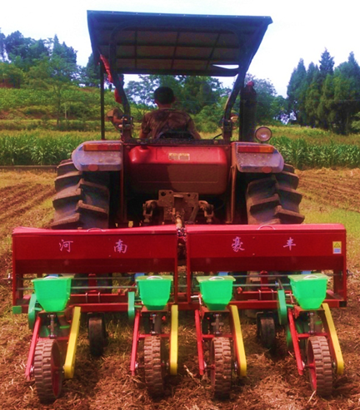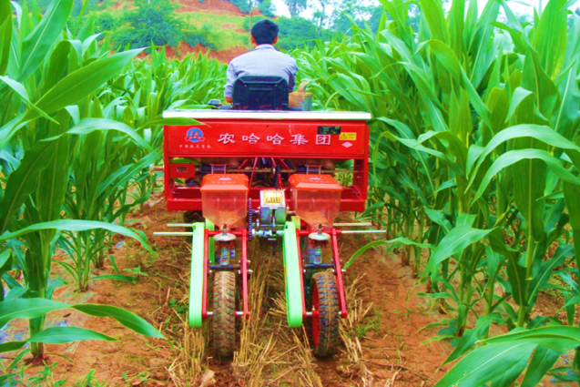
- Maize-soybean intercropping b) Maize-soybean relay strip intercropping
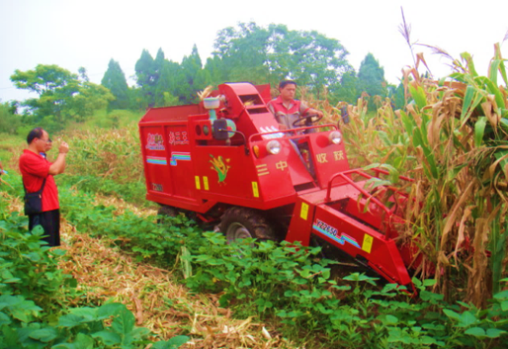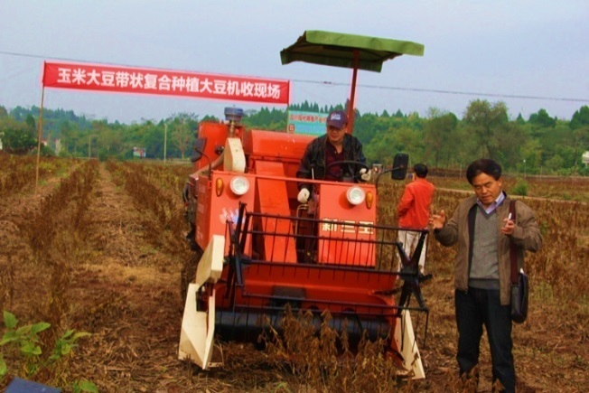
c) Maize harvesting machine d) Soybean harvesting machine
Figure 2. The machinery for sowing, harvesting in maize-soybean maize and soybean.

Due to technical advancement in the system, it can play a pivotal role to boost domestic soybean production in China. The FAO statistical data (2009-2013) show that on an annual basis, croplands are covered by approximately 56.53 million hectares of maize and 19.12 million hectares of soybean in developing Asian countries (Jun-Bo et al., 2018), and approximately 8.2 million hectares of soybean in China (Yin et al., 2017). If this maize-soybean strip-intercropping practice is applied in all of these regions, at least 15.458 billion tons of extra maize grains and 14.933 billion tons of extra soybean grains would be obtained annually, indicating that it has great potential for current soybean intercropping systems to prevent future food crises in developing countries.
3. Conclusion
This review highlights the efficient utilizations of light and nutrients are the basis can lead the agriculture systems to sustainability. The maize-soybean intercropping system ensures the sustainability without pressing the environment, and disturbing the soil fertility level. In addition, this system can improve the soil health, and ensure efficient crops performance such as nutrient, and light use efficiency. Maize-soybean mechanized based intercropping system fulfills the conditions of triple bottom line such as, economic prosperity, environmental stewardship, and social responsibility. The implementation of such cropping system could be a breakthrough in food crisis issues. The advances in agronomy and physiology can give us the better understanding of interactive mechanisms between crop genotypes, and species in intercropping, whereas ecological advances can help in better perception of mechanisms behind pests, and disease avoidance in below and above ground spaces.
Author Contribution
All authors contributed to this study. Sajad Hussain and Nasir Iqbal wrote this review, and Weiguo Liu and Wenyu Yang revised and approved for the submission.
Conflicts of Interest
The authors declare no conflict of interest.
Abbreviation Used
LER: Land Equivalent Ratio, NPK: Nitrogen Phosphorus Potassium and PAR: Photosynthetic Active Radiation.

References
Aktar, M.W., Sengupta, D. & Chowdhury, A. 2009. Impact of pesticides use in agriculture: their benefits and hazards. Interdisciplinary Toxicology, 2, 1-12.
Aziz, M., A. Mahmood, M. Asif and A. Ali. 2015. Wheat-based intercropping: a review. J. Anim. Plant. Sci. 25: 896-904.
Behling, A., C.R. Sanquetta, A.P. Dalla Corte, B. Caron, A.A. Simon, M. Behling and D. Schmidt. 2015. Conversion efficiency of photosynthetically active radiation intercepted in biomass in stands of black wattle in Brazil. Bosque. 36: 61-69.
Calderón, F., M. Vigil, D. Nielsen, J. Benjamin and D. Poss. 2012. Water use and yields of no-till managed dryland grasspea and yellow pea under different planting configurations. Field Crops Res. 125: 179-185.
Chen, P., Du, Q., Liu, X., Zhou, L., Hussain, S., Lei, L., Song, C., Wang, X., Liu, W. & Yang, F. 2017. Effects of reduced nitrogen inputs on crop yield and nitrogen use efficiency in a long-term maize-soybean relay strip intercropping system. Plos One, 12, e0184503.
Constantin, J., Mary, B., Laurent, F., Aubrion, G., Fontaine, A., Kerveillant, P. & Beaudoin, N. 2010. Effects of catch crops, no till and reduced nitrogen fertilization on nitrogen leaching and balance in three long-term experiments. Agriculture Ecosystems & Environment, 135, 268-278.
Cui, L., B. Su, F. Yang and W. Yang. 2014. Effects of photo-synthetically active radiation on photosynthetic characteristics and yield of soybean in different maize/soybean relay strip intercropping systems. Sci. Agric. Sin. 47:1489-1501.
Deng, X., X. Wang, W.Y. Yang, C. Song, X. Wen, Q. Zang and S. Mao. 2013. Phosphorus uptake and utilization of maize and interspecies interactions in maize/soybean and maize/sweet potato relay intercropping systems. Acta. Agron. Sin. 39:1891-1898.
Dong, Q., Y. Tai-Wen, L. Xiao-Ming, L. Wen-Yu, X. Ting, S. Chun, . . . Y. Wen-Yu. 2014. Effect of Nitrogen Application Methods on Crop Yield and Grain Filling Characteristics of Maize in Maize-Soybean Relay Strip Intercropping System. Acta. Agron. Sin. 40: 2028-2039.
Dyer, L., M. Oelbermann and L. Echarte. 2012. Soil carbon dioxide and nitrous oxide emissions during the growing season from temperate maize‐soybean intercrops. J. Plant Nutr. Soil Sci. 175: 394-400.
Erisman, J. W., Bleeker, A., Galloway, J. & Sutton, M. S. 2007. Reduced nitrogen in ecology and the environment. Environmental Pollution, 150, 140-149.
Fan, Y., Chen, J., Cheng, Y., Raza, M. A., Wu, X., Wang, Z., Liu, Q., Wang, R., Wang, X., Yong, T., Liu, W., Liu, J., Du, J., Shu, K., Yang, W. & Yang, F. 2018. Effect of shading and light recovery on the growth, leaf structure, and photosynthetic performance of soybean in a maize-soybean relay-strip intercropping system. PLOS ONE, 13, e0198159.
Gao, Y., A. Duan, X. Qiu, Z. Liu, J. Sun, J. Zhang and H. Wang. 2010. Distribution of roots and root length density in a maize/soybean strip intercropping system. Agric. Water Manage. 98:199-212.
Gong, W. Z., C.D. Jiang, Y.S. Wu, H.H. Chen, W.Y. Liu and W.Y. Yang. 2015. Tolerance vs. avoidance: two strategies of soybean (Glycine max) seedlings in response to shade in intercropping. Photosynthetica 53: 259–268.
Graham, P.H. 2008. Ecology of the root-nodule bacteria of legumes Nitrogen-fixing leguminous symbioses. Springer. 23-58.
Guo, J. H., Liu, X. J., Zhang, Y., Shen, J. L., Han, W. X., Zhang, W. F., Christie, P., Goulding, K. W. T., Vitousek, P. M. & Zhang, F. S. 2010. Significant Acidification in Major Chinese Croplands. Science, 327, 1008-1010.
Ijoyah, M. and F. Fanen. 2002. Effects of different cropping pattern on performance of maize-soybean mixture in Makurdi, Nigeria. Sci. J. Crop. Sci. 1: 39-47.
Jun-Bo, D. U., Han, T. F., Gai, J. Y., Yong, T. W., Sun, X., Wang, X. C., Yang, F., Liu, J., Shu, K. & Liu, W. G. 2018. Maize-soybean strip intercropping: Achieved a balance between high productivity and sustainability. Journal of Integrative Agriculture, 17, 747-754.
Khan, S., M. A. Khan, M. Akmal, M. Ahmad, M. Zafar and A. Jabeen. 2014. Efficiency of wheat brassica mixtures with different seed rates in rain fed areas of potohar-pakistan. Pak. J. Bot. 46: 759-766.
Kocsy, G., B. Tóth, T. Berzy, G. Szalai, A. Jednákovits and G. Galiba. 2001. Glutathione reductase activity and chilling tolerance are induced by a hydroxylamine derivative BRX-156 in maize and soybean. Plant Sci. 160: 943-950.
Le, C., Y. Zha, Y. Li, D. Sun, H. Lu and B. Yin. 2010. Eutrophication of lake waters in China: cost, causes, and control. Environ. Manage. 45: 662-668.
Li, L., F. Zhang, X. Li, P. Christie, J. Sun, S. Yang and C. Tang. 2003. Interspecific facilitation of nutrient uptake by intercropped maize and faba bean. Nutri. Cycl. Agroecosys. 65: 61-71.
Lithourgidis, A. S., C. A. Dordas, C. A.Damalas and D. Vlachostergios. 2011. Annual intercrops: an alternative pathway for sustainable agriculture. Aust. J Crop Sci. 5: 396.
Liu, W., J. Zou, J. Zhang, F. Yang, Y. Wan and W. Yang. 2015. Evaluation of Soybean (Glycine max) Stem Vining in Maize-Soybean Relay Strip Intercropping System. Plant Prod. Sci. 18: 69-75.
Liu, W., Y. Deng, S. Hussain, J. Zou, J. Yuan, L. Luo, . . . W. Yang. 2016. Relationship between cellulose accumulation and lodging resistance in the stem of relay intercropped soybean [Glycine max (L.) Merr.]. Field Crops Res. 196:261-267.
Liu, X., Rahman, T., Song, C., Su, B., Yang, F., Yong, T., Wu, Y., Zhang, C. & Yang, W. 2017. Changes in light environment, morphology, growth and yield of soybean in maize-soybean intercropping systems. Field Crop Res. 200, 38-46.
Liu, X., T. Rahman, C. Song, B. Su, F. Yang, T. Yong and W. Yang. 2017. Changes in light environment, morphology, growth and yield of soybean in maize-soybean intercropping systems. Field Crop Res. 200:38-46.
Liu, X., T. Yong, B. Su, W. Liu, L. S. Zhou and W. Yang. 2014. Effect of reduced N application on crop yield in maize-soybean intercropping system. Acta. Agron. Sin. 40: 1629-1638.
Luo, L., Y. Xiao-bo, W. Yan, , J. Tao, D. Jun-bo, Z. Jun-lin, . . . L. Wei-guo. 2015. The Relationship between Lodging and Stem Endogenous Gibberellins Metabolism Pathway of Relay Intercropping Soybean at Seedling Stage. Sci. Agric. Sin. 48: 2528-2537.
Lv, Y., C. Francis, P. Wu, X. Chen and X. Zhao. 2014. Maize–Soybean Intercropping Interactions Above and Below Ground. Crop Sci. 54: 914-922.
Mahmoudi, R., Jamshidi, K., & Pouryousef, M. (2013). Evaluation of Grain Yield of Maize (Zea mays L.) and Soybean (Glycine max L.) In strip Intercropping. Int. J. Agron. Plant Prod. 4: 2388-2392.
Matusso, J. M. M., Mugwe, J. N., & Mucheru-Muna, M. (2014). Potential role of cereal-legume intercropping systems in integrated soil fertility management in smallholder farming systems of sub-Saharan Africa. J. Agric. Environ. Manage. 3: 162-174.
Miao, Y., B.A. Stewart and F. Zhang. 2010. Long-term experiments for sustainable nutrient management in China. A review. Agron. Sustainable Dev.
Mu, X., F. Chen, Q. Wu, Q. Chen, J. Wang, L. Yuan and G.H. Mi. 2015. Genetic improvement of root growth increases maize yield via enhanced post-silking nitrogen uptake. Eur. J. Agron. 63:55-61.
Munz, S., Graeff-Hönninger, S., Lizaso, J. I., Chen, Q., & Claupein, W. (2014). Modeling light availability for a subordinate crop within a strip–intercropping system. Field Crops Res. 155: 77-89.
Nassab, A. D. M., T. Amon and H.P. Kaul. 2011. Competition and yield in intercrops of maize and sunflower for biogas. Indus. Crops Prod. 34:1203-1211.
Ofori, F. and W. Stern. 1987. Cereal–legume intercropping systems. Adv. Agron. 41:41-90.
Oseni, T.O. 2010. Evaluation of sorghum-cowpea intercrop productivity in savanna agro-ecology using competition indices. J. Agric. Sci. 2: 229–234.
Page, E.R., W. Liu, D. Cerrudo, E.A. Lee and C.J. Swanton. 2011. Shade avoidance influences stress tolerance in maize. Weed Sci. 59:326–334.
Prasad, R. B., & Brook, R. M. (2005). Effect of varying maize densities on intercropped maize and soybean in Nepal. Exp. Agr. 41: 365-382.
Qiao, Y., S. Miao, X. Han, M. You, X. Zhu and W.R. Horwath 2014. The effect of fertilizer practices on N balance and global warming potential of maize–soybean–wheat rotations in Northeastern China. Field Crops Res. 161:98-106.
Qin, A.Z., G.B. Huang, Q. Chai, A.Z. Yu and P. Huang. 2013. Grain yield and soil respiratory response to intercropping systems on arid land. Field Crops Res. 144:1-10.
Rahman, T., L. Ye, X. Liu, N. Iqbal, J. Du, R. Gao, . . . W. Yang. 2016. Water use efficiency and water distribution response to different planting patterns in maize–soybean relay strip intercropping systems. Exp. Agr. 1-19.
Rehman, A., A. Mahmood, Z. Iqbal, Z. Ahmed, A. Zeb and K. Ahmed. 2013. Growth and yield performance of maize (zea mays l.) as affected by planting methods and NPK level. Pak. J. Agri. Sci. 50: 329-335.
Ren, M., Liu, W., Liu, X., Fang, P., Yang, W. 2016. Effect of shading signal on growth and photosynthetic characteristics of soybean seedlings. Chinese J Eco-Agric.
Rossi, W., M. Newcomb and D. M. Gatlin. 2016. Assessing the nutritional value of an enzymatically processed soybean meal in early juvenile red drum, Sciaenops ocellatus L. Aquaculture.
Tsubo, M. and S. Walker. 2002. A model of radiation interception and use by a maize-bean intercrop canopy. Agr. Forest. Meteorol. 110:203–215.
Undie, U.L., D.F. Uwah, E.E. Attoe. 2012. Effect of intercropping and croparrangement on yield and productivity of late season maize/soybean mixturesin the humid environment of south southern Nigeria. J. Agric. Sci. 4: 37–50.
Verdelli, D., H.A. Acciaresi and E.S. Leguizamón. 2012. Corn and soybeans in a strip intercropping system: crop growth rates, Radiation interception, and grain yield components. Int. J. Agron. 2012.
Vitousek, P. M., R. Naylor, T. Crews, M. David, L. Drinkwater, E. Holland . . . P. Matson. 2009. Nutrient imbalances in agricultural development. Sci. 324: 1519-1520.
Wang, X., W. Yang, W. Ren, X. Deng, Q. Zhang, D. Xiang and T. Yong. 2012. Study on yield and differences of nutrient absorptions of maize in wheat/maize/soybean and wheat/maize/sweet potato relay intercropping systems. Plant Nutr. Fert. Sci. 18:803-812.
Wen-yu, L., Y. Tai-wen, L. Xiao-ming, C. Peng, D. Qian, X. Ting and Y. wen-yu. 2014. Effect of Reduced N Application on Nodule N Fixation, N Uptake and Utilization of Soybean in Maize-Soybean Relay Strip Intercropping System. Soy. Sci. 33.
Wu, Y., W. Gong, F. Yang, X. Wang, T. Yong and W. Yang. 2015. Responses to shade and subsequent recovery of soybean in maize-soybean relay strip intercropping. Plant Prod. Sci. 19:206-214.
Xue, Y., H. Xia, P. Christie, Z. Zhang, L. Li and C. Tang. 2016. Crop acquisition of phosphorus, iron and zinc from soil in cereal/legume intercropping systems: a critical review. Ann. Bot,mcv182.
Yan, Y., W. Gong, W. Yang, Y. Wan, X. Chen, Z. Chen and L. Wang. 2010. Seed treatment with uniconazole powder improves soybean seedling growth under shading by corn in relay strip intercropping system. Plant Prod. Sci. 13 (4):367-374.
YANG, F., FAN, Y., WU, X., CHENG, Y., LIU, Q., FENG, L., CHEN, J., WANG, Z., WANG, X. & YONG, T. 2018. Auxin-to-Gibberellin Ratio as a Signal for Light Intensity and Quality in Regulating Soybean Growth and Matter Partitioning. Front. Plant Sci. 9.
Yang, F., Liao, D., Fan, Y., Gao, R., Wu, X., Rahman, T., ... & Shu, K. (2016). Effect of narrow-row planting patterns on crop competitive and economic advantage in maize–soybean relay strip intercropping system. Plant Prod. Sci. 1-11.
Yang, F., S. Huang, R. Gao, W. Liu, T. Yong, X. Wang, . . . W. Yang. 2014. Growth of soybean seedlings in relay strip intercropping systems in relation to light quantity and red: far-red ratio. Field Crops Res. 155:245-253.
YANG, F., WANG, X., LIAO, D., LU, F., GAO, R., LIU, W., YONG, T., WU, X., DU, J. & LIU, J. 2015. Yield Response to Different Planting Geometries in Maize–Soybean Relay Strip Intercropping Systems. Agron. J, 107, 296.
Yang, F., X. Wang, D. Liao, F. Lu, R. Gao, W. Liu . . . J. Liu. 2015. Yield response to different planting geometries in maize–soybean relay strip intercropping systems. Agron. J. 107: 296-304.
Yin, R., Feng, X. & Zhang, Z. 2017. Changes of Soybean Planting Area in Northeast China and the Huang-Huai Region in 2017 and Its Production Outlook. Agricultural Outlook.
Yogesh, S., Halikatti, S., Hiremath, S., Potdar, M., Harlapur, S., Venkatesh, H. (2014). Light use efficiency, productivity and profitability of maize and soybean intercropping as influenced by planting geometry and row proportion. K. J. Agric. Sci. 27(1).
Yong, T., X. Liu, L. Wen-Yu, B. Su, C. Song, F. Yang, . . . W. Yang. 2014. Effects of reduced N application rate on yield and nutrient uptake and utilization in maize-soybean relay strip intercropping system. Chin. J. Appl. Ecol. 25: 474-482.
Yu, X. B., B. Y. Su, W. Z. Gong, L. Luo, W. Liu, W. Yang . . . X. T. Zeng. 2014. The Nodule Characteristics and Nitrogen Fixation of Soybean in Maize-Soybean Relay Strip Intercropping. Sci. Agric. Sin. 47: 1743-1753.
Zhang, G., Z. Yang and S. Dong. 2011. Interspecific competitiveness affects the total biomass yield in an alfalfa and corn intercropping system. Field Crops Res. 124:66-73.
Zhang, J., X. Lu, X. Song, J. Yan, T. Song, J. Dai . . . J. Li. 2008. Mapping quantitative trait loci for oil, starch, and protein concentrations in grain with high-oil maize by SSR markers. Euphytica. 162:335-344.
Zhang, L.Z., W. van der Werf, L. Bastiaans, S. Zhang, B. Li, J.H.J. Spiertz. 2008. Light interception and utilization in relay intercrops of wheat and cotton. Field Crop Res. 107: 29–42.
Zhang, Y., Liu, J., Zhang, J., Liu, H., Liu, S., Zhai, L., Wang, H., Lei, Q., Ren, T., Yin, C., 2015. Row ratios of intercropping maize and soybean can affect agronomic efficiency of the system and subsequent wheat. PloS one 10. e0129245.
Zhong, X., X. Zhao, H. Bao, H. Li, G. Li and Q. Lin. 2003. The evaluation of phosphorus leaching risk of 23 Chinese soils Ⅰ. Leaching criterion. Acta Ecol. Sin. 24: 2275-2280.
Zhou, T., Du, Y., Ahmed, S., Liu, T., Ren, M., Liu, W. Yang, W. 2016. Genotypic Differences in Phosphorus Efficiency and the Performance of Physiological Characteristics in Response to Low Phosphorus Stress of Soybean in Southwest of China. Frontiers in Plant Science, 7.
Zhu, X., F. Song and H. Xu. 2010. Influence of arbuscular mycorrhiza on lipid peroxidation and antioxidant enzyme activity of maize plants under temperature stress. Mycorrhiza. 20: 325-332.

