BIO-HERBICIDAL POTENTIAL OF LANTANA CAMARA L. ON THE GROWTH AND PHYSIOLOGICAL PARAMETERS OF TRITICUM AESTIVUM L. AND ITS MAJOR WEEDS
TAUSEEF ANWAR¹*, NOSHIN ILYAS¹*, RAHMATULLAH QURESHI¹, MUHAMMAD AZEEM MALIK² AND MARIA KHAN PANNI³

¹Department of Botany, Pir Mehr Ali Shah - Arid Agriculture University, Murree Road, Shamsabad, Rawalpindi, Pakistan.
²Department of Agronomy, Pir Mehr Ali Shah - Arid Agriculture University, Murree Road, Shamsabad, Rawalpindi, Pakistan.
³IBGE, The University of Agriculture Peshawar, Peshawar, Pakistan.
*Corresponding author’s e-mail: drtauseefanwar@hotmail.com.

ABSTRACT
Statement of the problem: Plant species contain different allelochemicals that may have inhibitory effect against weeds” This research work carried out at Plant Physiology Laboratory, Department of Botany, Pir Mehr Ali Shah - Arid Agriculture University, Rawalpindi, Pakistan and at Bioactive Natural Products and Phytoceuticals (BNPP) Laboratory, Department of Horticulture, Michigan State University, Michigan, USA to screen out Lantana camara for its allelopathic activity against major weeds viz. Phalaris minor, Avena fatua, Chenopodium album, Euphorbia helioscopia and Rumex dentatus of wheat crop. Preliminary screening of selected species was carried out in laboratory on filter paper, soil and agar by extraction method (aqueous, hexane and methanolic) and plant sandwich method. L. camara methanolic extract significantly suppressed germination percentage of E. helioscopia, P. minor R. dentatus and A. fatua measuring 65%, 63%, 61% and 60% respectively, whereas no substantial effect on germination percentage of T. aestivum and C. album. L. camara significantly suppressed radical length (cm) of A. fatua, P. minor and C. album 54%, 53% and 52% respectively. There was no substantial effect on radical length (cm) of T. aestivum, R. dentatus and E. helioscopia. L. camara suggestively repressed plumule length (cm) of E. helioscopia, C. album, R. dentatus and A. fatua 56%, 55%, 53% and 53% respectively. Three fractions from L. camara leaf methanolic extract obtained by combiflash. Fraction 2 exhibited significant inhibitory potential against test weeds while wheat crop remains unaffected. Assessment of physiological effects on weed species by fraction 2 significantly suppressed chlorophyll, superoxide dismutase, peroxidase and protein contents of all the weed. The GC-MS and NMR (Proton and Carbon) analysis of L. camara methanolic fraction 2 showed it possess four active compounds (Methyl linoleate, Methyl palmitate, Methyl stearate and Methyl oleate). This is the first report on the identification of potential allelopathic compounds from the active fraction against selected weeds of wheat crop. Allelopathic potential of these four active compounds was not reported previously against selected weeds of wheat crop.
1

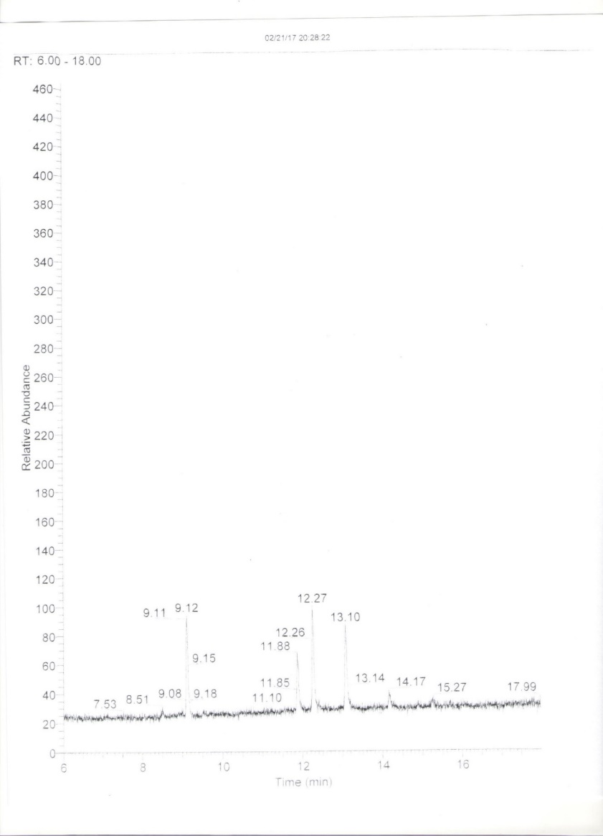
Figure 4.24: GC-MS profile of L. camara methanolic fraction 2.
RESEARCH MANUSCRIPTS:
- Anwar, T., S. Khalid, Y. Arafat, S. Sadia and S. Riaz. 2013. Allelopathic suppression of Avena fatua and Rumex dentatus in associated crop. Pak. J. Weed Sci. Res. 19(1): 31-43.
- Anwar, T., S. Khalid, M. Saeed, R. Mazhar, H. Qureshi and M. Rashid. 2016. Allelopathic interference of leaf powder and aqueous extracts of hostile weed: Parthenium hysterophorus (Asteraceae). Sci. Int., 4: 86-93.
- Anwar, T., S. Khalid, R. Mazhar, H. Qureshi and M. Rashid. 2017. Herbicidal potential of selected species to overcome weed infestation in Triticum aestivum, Zea mays and Helianthus annuus. Pak. J. Weed Sci. Res. 23(1): 49-63.
- Anwar, T., S. Khalid, M.K. Panni, H. Qureshi and M. Rashid. 2017. Allelopathic effect of Euphorbia helioscopia on Avena fatua, Rumex dentatus, Helianthus annuus, Zea mays and Triticum aestivum. Pak. J. Weed Sci. Res. 23(2): 165-177.

Tauseef Anwar has submitted his Research Thesis for the award of PhD degree at PMAS Arid Agriculture University, Rawalpindi, Punjab, Pakistan under the supervision of Dr. Noshin Ilyas. He has worked as a visiting PhD scholar for a period of 6 months (December 29, 2016 to June 28, 2017) at Bioactive Natural Products and Phytoceuticals Laboratory, Michigan State University, Michigan, USA, under the supervision of Prof. Dr. Muraleedharan G. Nair (nairm@msu.edu) based on the award of Scholarship under “International Research Support Initiative Program” funded by Higher Education Commission (HEC) of Pakistan. Research involve extraction, bioassay directed isolation, fractionation, chromatographic purification, structure elucidation of bioactive natural products. He has completed his M.Phil. and M.Sc. from The University of Agriculture, Peshawar and The Islamia University, Bahawalpur, Pakistan. He has Published 8 research papers in Nation and International journals. He has participated in different National Conferences. The latest one “Train the Trainer Workshop” conducted by Pakistan Biological Safety Association in collaboration with Fogarty International Centre, National Institute of Health, USA and safer behavior, USA, March 23-29, 2018, at Islamabad, Pakistan.

