In Vitro: Phytochemical Screening of San Francisco Leaf Extract (Codieaum variegatum) Against Plant Pathogenic Fungi Phytophthora palmivora,
Fusarium oxysporum f.sp cubense, and
Colletotrichum gloeosporioides

An entry of Asuncion National High School
To the 2017 Regional Science and Technology Fair
Cluster 1 Life Science
Individual Category

PROPONENTS:
Jeremiah P. Malalis

Zeniffer S. Otig
Adviser

Arnel A. Servino
Principal III

ABSTRACT

Black Pod Rot, Fusarium Wilt, and Anthracnose are the major cause of loss in Cacao, Banana, and Mango production which is damaging hectare of farms in the Philippines. Today, with the worldwide trend using organic fungicides it is essential and less in chemical products for agricultural settings.
Hence this study was conducted to test the potential of San Francisco Leaf Extract in controlling Black Pod Rot, Fusarium Wilt, and Anthracnose.
The study used a Complete Randomized Design (CRD) using five treatments: T0- Potato Dextrose Agar (PDA), T1- 25% San Francisco solution, T2- 50% San Francisco solution, T3- 75% San Francisco solution T4- Benzalkonium Chloride and replicated five times.
The experimental phase used Poisoned Food Technique and seven days of observation was done. Data for radial growth were collected. Least Significance Difference (LSD) was used to determine its significance.
The result showed that San Francisco Leaves Extract is an effective organic-based fungicide against the radial growth of three different fungi. 25% and 50% concentrations significantly decreased radial growth but 75% concentration of San Francisco yielded the most effective treatment. The study indicates that San Francisco could be a promising organic-based fungicide because the results of the experiment demonstrated antifungal activity against the radial growth of Black Pod Rot, Fusarium Wilt, and Anthracnose.

INTRODUCTION

Banana (Musa acuminata), Cacao (Theobroma cacao), and Mango (Mangifera indica) are among the top selling fruit crops grown in the Philippines. In terms of production and hectarage, banana tops the production specifically in Davao Region which is the reason why it is known as the “Banana Capital” (Valino, 2006).
Growth in banana production this year helped the Philippine crops sub-sector expands by 5.18 percent during 2017’s third quarter (Teves, 2017). Nationwide production of banana increased by 3.45% accounting to almost 2.4 million metric tons in 2017 from 2.30 million metric tons in 2016 (PSA, 2017).
Conversely, Cacao has also been considered an important cash crop in producing countries and a key export for processing and consuming to other countries (Boquiren, 2014). In the Philippines cacao had high demands owing to its nutritive and cancer-fighting capabilities (Renter, 2013) and being an important ingredient in making chocolates and many more. Moreover the demands of cacao beans are increasing at a rate of 3% per annum both domestic and foreign markets (Bacongco, 2011). Cacao production in Davao Region reached to 3,844.30 thousand metric tons in 2013. These comprise 80% of the total cacao production in the Philippines (Tacio, 2014).
Mango also is one of the most top selling fruit crop in the Philippines, with more than 607.87 thousand metric tons in 2016, and already reaches its total production by up to 546.28 thousand metric tons last June 2017 (PSA, 2017).
There are also several researches, that there are nutrients from mangoes which can help our body. They fight cancer, alkalize the body, aid in weight loss, regulate diabetes, help digestion, and clean your skin (Chan, 2017).
On the other hand, because of the proliferation of different pathogens that attacks and kills the fruits which leave the farmers lead to a great loss of its production. Black Pod Rot which is caused by Phytophthora palmivora, Fusarium Wilt caused by (Fusarium oxysporum f.sp cubense) and Anthracnose caused by (Colletotrichum gloeosporioides). It is considered the most important disease in fruit crops in the humid tropics that contribute significantly to preharvest and postharvest losses in Cacao, Banana and Mango (Lakshmi, 2011).
There are three known fungal species namely: P. palmivora, P. megakarya and P. capsici. These are identified based on the rotting or necrosis of pods.The P. palmivora causes global yield loss of 20-30% and tree deaths of 10% annually. P. megakarya is the most important pathogen in Central and West Africa, known as the most aggressive of the Black Pod Rot pathogens. P.capsici is widespread in Central and South America, causing significant losses in favorable environments (ICO, 2015).
Among the production constrains, Black Pod Rot caused by the fungus Phytophthora palmivora is the most devastating disease affecting commercial and domestic cacao production throughout the cacao-producing areas of the world (Britannica, 2015). Recently, severe infections were reported not only in Cacao plantations but also in jack fruit, durian, papaya, pineapple, and palm plantations in the Philippines (Padilla, 2013).
Also, Cavendish bananas are increasingly falling victim to the soil borne fungus Fusarium wilt tropical race 4 (TR4), also known as Panama disease (Staff, 2017). It is a lethal fungal disease caused by the soil-borne fungus Fusarium oxysporum f. sp. cubense (Foc). The fungus enters the plant through the roots and colonizes the xylem vessels thereby blocking the flow of water and nutrients (ProMusa, 2013).
The disease progression result in the collapse of leaves at the petiole, the splitting of the pseudostem base and eventually plant death. Fusarium is a soil-inhabiting filamentous fungus that belongs to the sections Elegans in the fungus Fusarium (Agrios, 2005). The fungus is characterized by micro and macro-conidia that are produced on branched and unbranched monophialides.
Chlamydospores are usually globose and are formed singly or in pairs in hyphae or conidia. They resistant to desiccation and unfavorable environmental conditions, and enable the fungus to survive for more than 30 years in the soil after hosts have been removed (Agrios, 2005).
It is also found out that there are four known races of Fusarium oxysporum f.sp cubense (Foc), namely: race 1, race 2, race 3, and race 4. These are identified and based on the reaction to specific hosts. In the Philippines occurrence of the disease is caused by races 1 and 2, recently, by Tropical Race 4 (TR4). In fact, (Sudarma, 2011) reported that this notorious pathogen damaged 634.70 hectares in Region XI alone, particularly in Davao del Norte. The presence of TR4 was detected in the Middle East in 2012 and appeared in Mozambique a year later (Stokstard, 2017).
Meanwhile, Anthracnose caused by the fungus (Colletotrichum gloeosporioides) belongs to order affects mango crop as the most threatening malady that results in huge economic losses melanoconiales. C. gloeosporioides (Kamle, 2016). It also attacks guava, custard apple, pomegranate and other subtropical fruit crops.
The ubiquitous fungus Colletotrichum gloeosporioides Penz and Sacc. is the anamorph stage (asexual stage of the pathogenic fungus). C. gloeosporioides is responsible for many diseases, also referred to as “anthracnose,” on many tropical fruits including banana, avocado, papaya, coffee, passion fruit, and others (Nelson, 2008).
Most visible symptoms of Anthracnose are black spots on the leaves. At first they are very small. With time, the spots get bigger and create holes in the leaf and eventually parts of the leaf die off. Damage on leaves does not directly affect your mango, but it is the starting point. Anthracnose will spread: it starts from the leaves, spreads over the panicles to the flowers, to finally attack the fruit (Schuetz, 2015).
Many microbial agents and organic fertilizers had recently received much attention since many products were out in the market claiming for sustainable management of the disease. Hence, there is a need to explore different plant based products which can help the small scale farmers.
San Francisco, scientifically called Codiaeum variegatum, is known as an ornamental plant and abundant in the Philippines. It is a low fanning bush with appealing and variedly formed and shaded foliage. Leaves are thick and weathered, praise, oval to straight, and the edges whole, lobed or spirally turned. Youthful leaves are typically green, yellow or red, later changing to single shading or variegation of gold cream, white, red, maroon, purple, dark or darker. A smooth sap seeps from cut stems. Blossoms are little, long, axillary, normally unisexual racemes (Stuart, 2015).
Aside from its fundamental reason in filling in as an ornamental, the root decoction of C. variegatum is utilized to treat gastric ulcers (Maundipa, 2005). The leaves have antibacterial and anti-amoebic properties and can be crushed and drunk to cure diarrhea. Anim (2016) reported that San Francisco leaves contain several phytochemicals such as glycosides, anthracene, saponins, tannins, alkaloids, flavonoids, sterols and triterpenoids.
With its antimicrobial properties, this study aims to evaluate the effect of San Francisco leaf extract against several important plant pathogens such as Phytopthora palmivora, Fusarium oxysporum f.sp. cubense and Colletotrichum gloeosporioides.
METHODOLGY
Location and Duration of the Study
The study was conducted at the Plant Pathology Laboratory at Marsman Estate Plantation, Inc., Sto. Tomas, Davao del Norte from October to November 2017.

Experimental Design and Treatment
The experiment was laid out in a Complete Randomized Design (CRD) using 3 different fungi, with five (5) treatments and replicated five (5) times. The treatments were as follows:
T0- Inoculated Fungus (Negative Control)
T1- 25% San Francisco Leaf Extract
T2- 50% San Francisco Leaf Extract
T3- 75% San Francisco Leaf Extract
T4- Benzalkonium Chloride (Positive Control)

Preparation of Culture Media
Potato Dextrose Agar (PDA) was used as a culture medium and prepared following the Standard Operating Procedure (SOP). Two hundred fifty grams of potato were chopped and boiled for about 30minutes (Figure 1a) with 1000ml of distilled water. The chopped potato was then removed after, 20 grams of dextrose, and 20 grams of agar were added and simmered for about 30minutes. It was then placed in a flask (Figure 1b) and sterilized in an auto-clave (Figure 1c) at 15psi for 30minutes. Afterwards, it was placed in each petri dish (Figure 1d) (10ml/petri dish) and set aside to cool down, and under goes in Ultraviolet Light (UVL) sterilization for 15minutes, to insure that culture media are free from contamination.
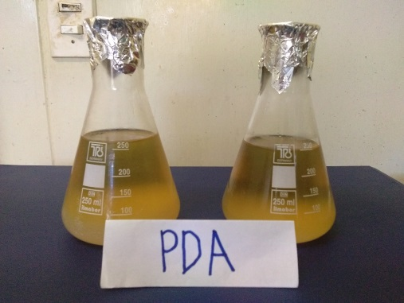
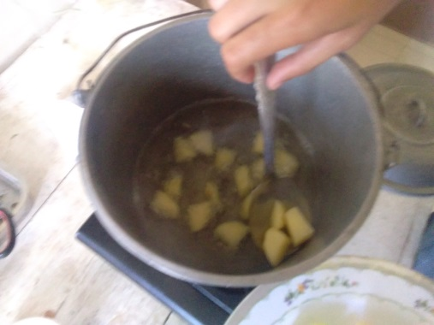

1b
1a

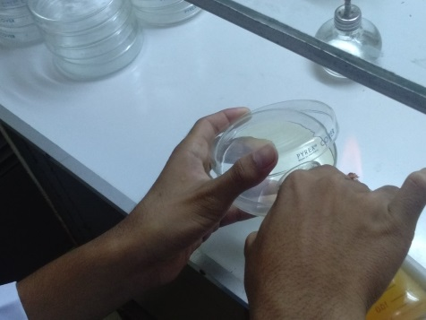
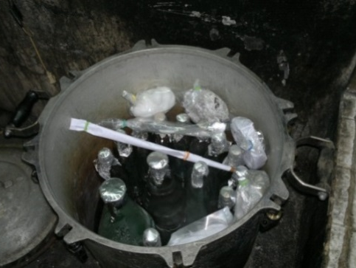

1d
1c
Figure 1. Preparation and sterilization of the PDA and other materials.

Preparation and Isolation of Fungus
The infected fruits were collected (Figure 2a), washed, and blot dried. The pathologist determines the spots of the infected fruit and placed marks for the isolation. Scalpel, wire loop, and forceps were sterilized. The marked areas on the fruits were sliced into smaller pieces (Figure 2b) using sterile-scalpel and placed in a sterile-tissue (Figure 2c). The infected area to be isolated must have dead and live tissues. Using flame-sterilized forceps (Figure 2d), the cut pieces were surface sterilized by immersion sequence in sterile distilled water (SDW) for 30 seconds, 5% chlorine solution for 1 minute and in SDW two times for 30 seconds each (Figure 2e). Transferred in a sterile tissue (Figure 2f), and was then blot dried using a sterile tissue paper (Figure 2g) before placing into the culture media. The mouth of the petri plate of culture media was directed with fire (Figure 2h) as well as the sterile-wire (Figure 2i) to avoid any form of contamination during the transfer of the infected part inside the culture media. Using sterile-wire (Figure 2j) the sliced part were placed inside (Figure 2k) the culture media in the middle of the plate (Figure 2l), and set aside horizontally. Five replicates per fungus were isolated.
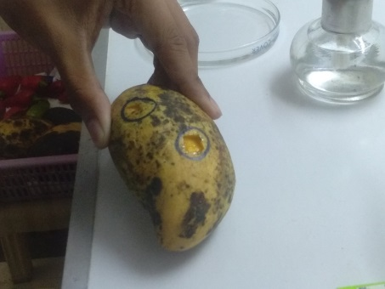
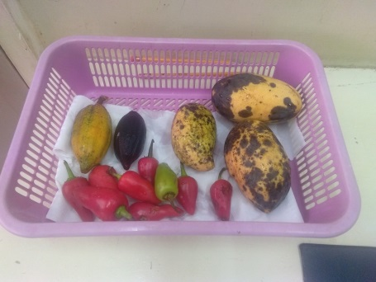
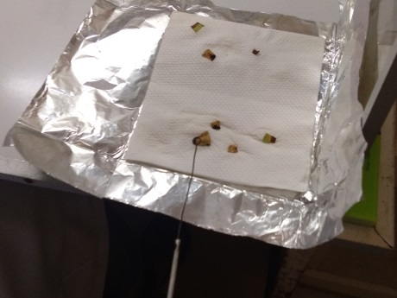

2c
2b
2a
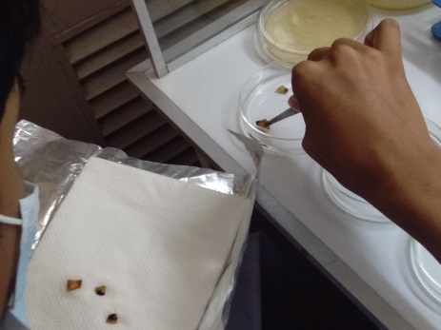
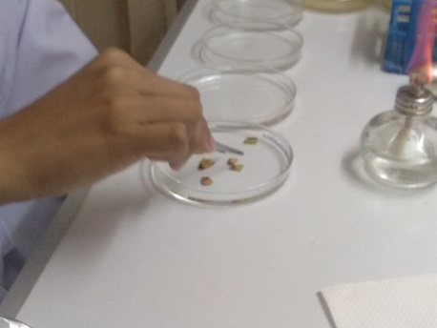
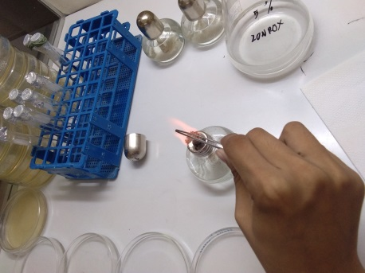

2e
2f
2d
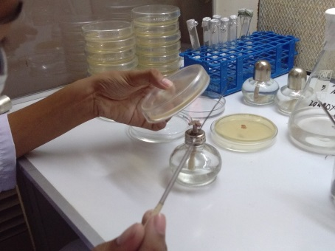
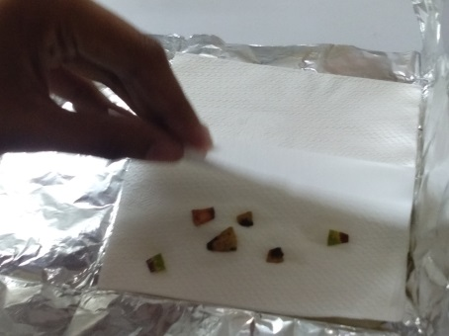
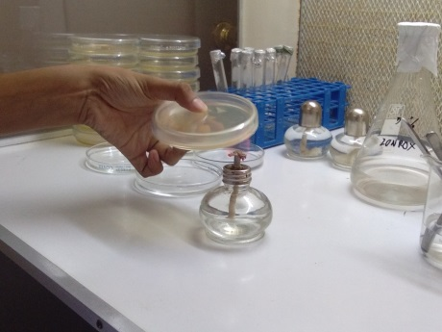

2i
2h
2g

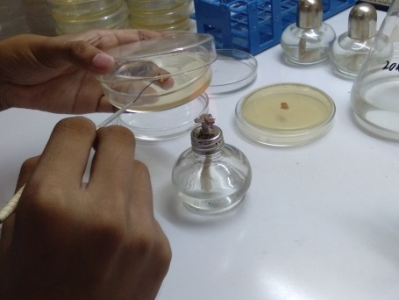
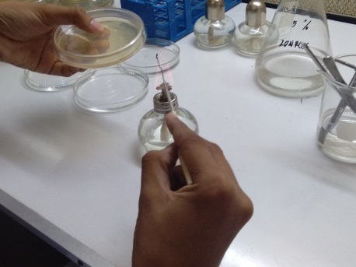
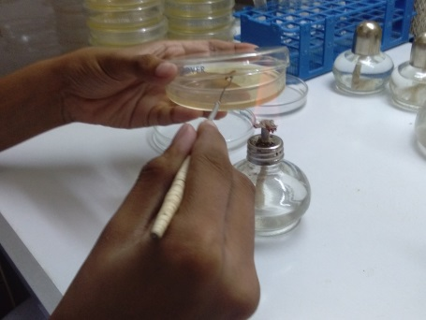

2l
2k
2j

Figure 2.Isolation of the fungus.

Pure culture of Phytophthora palmivora (Figure 3a), Fusarium oxysporum f.sp cubense (Figure 3b), and Colletotrichum gloeosporioides (Figure 3c) was acquired and mass produced at the Plant Pathology Laboratory of Marsman Estate Plantation, Inc., Sto. Tomas, Davao del Norte. Seven day old pure cultures were used for inoculation.
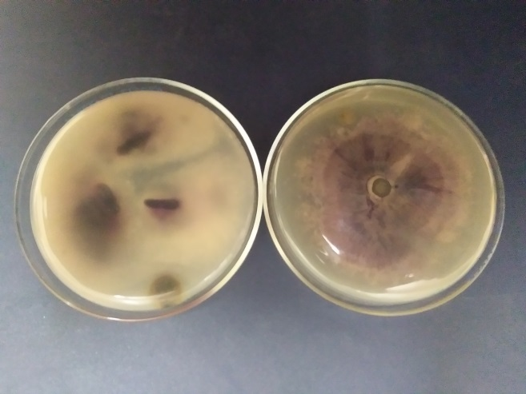
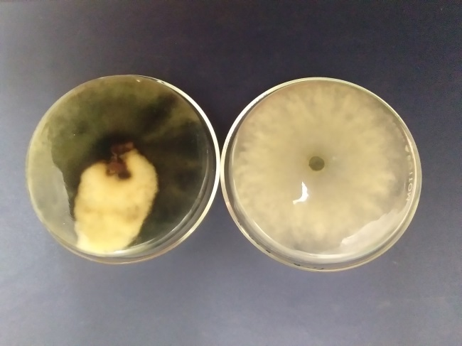
Pure Culture
Isolated Fungus
Pure Culture
Isolated Fungus

3b
3a

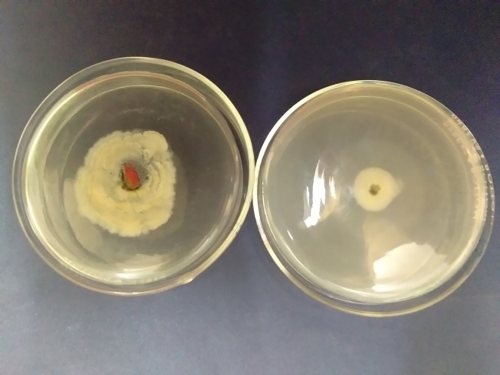
Isolated Fungus
Pure Culture

3c

Plant Collection and Processing
Fully matured dark leaves of Codiaeum variegatum (San Francisco) were collected around the vicinity of Asuncion National High School, Asuncion, Davao del Norte. Plant species was identified by verifying the color pictures for identification (Figure 4a). The plant leaves were thoroughly washed with distilled water to avoid dusts and other unwanted materials accumulated on the leaves from their natural environment (Figure 4b). It was weighed and gets a total of 400grams (Figure 4c). The leaves were soaked with 70% ethyl alcohol for 30minutes to remove leaf pigments (Figure 4d). After soaking, the leaves were cut into smaller pieces (Figure 4e), and placed in a blender (Figure 4f). A ratio of 1:1 is applied in blending the leaves (Figure 4g) with distilled water (400grams of leaves and 400grams of distilled water). The mixture was filtered (Figure 4h) and extracted (Figure 4i) until all the remaining leaves were all blended. After, all the mixtures were filtered again (Figure 4j) to ensure that only aqueous solution were obtain and then placed in a flask (Figure 4k) covered with foil (Figure 4l) and set aside.
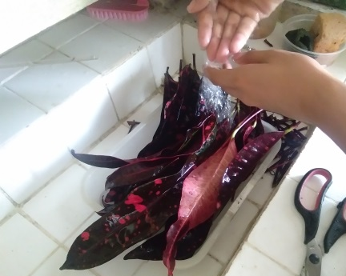
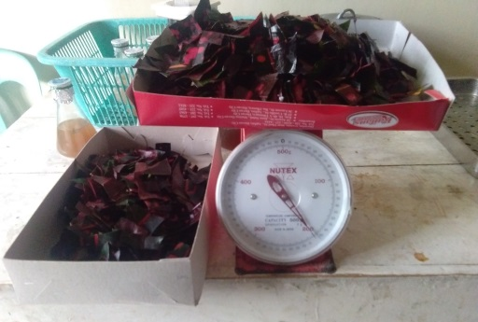
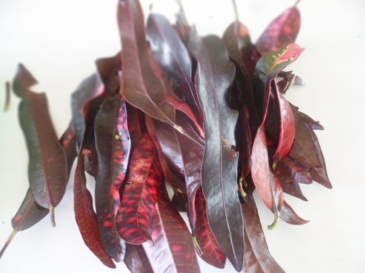

4c
4b
4a

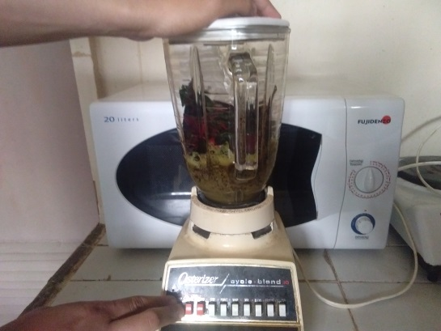
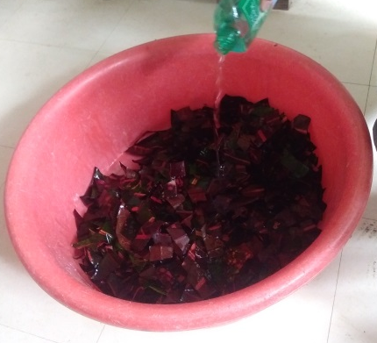
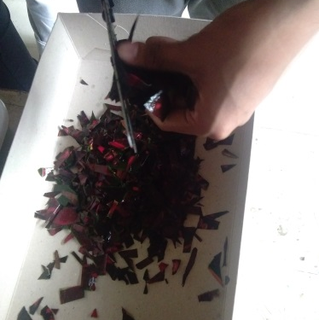

4d
4d
4d

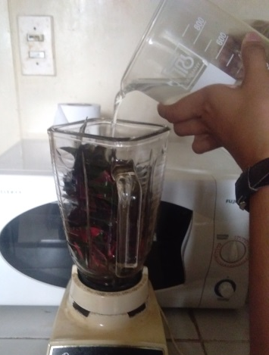
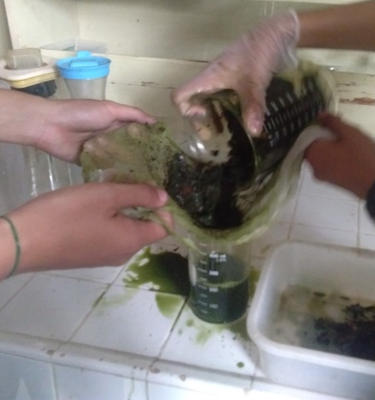
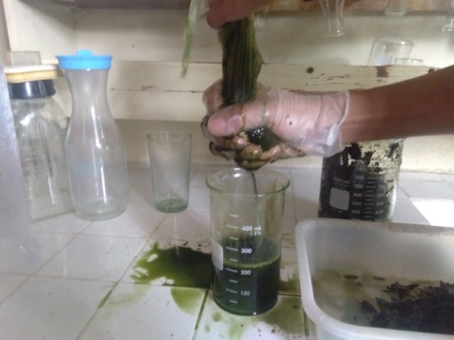

4d
4d
4d
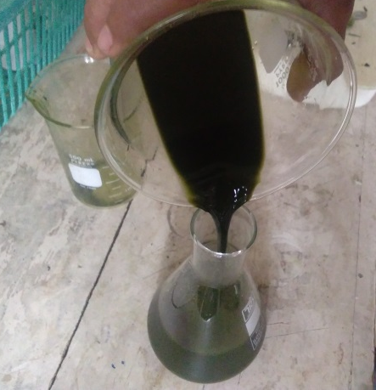
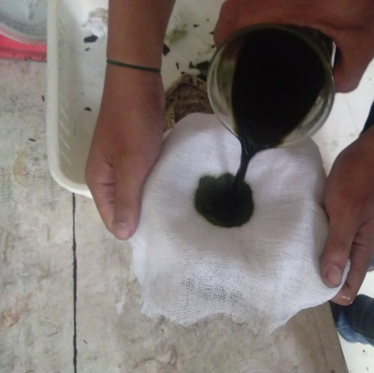
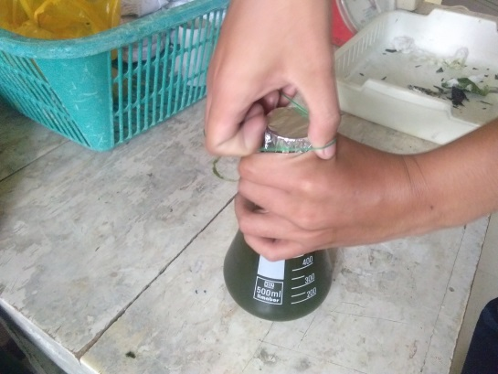

4d
4d
4d
Figure 4. Preparation of the Treatment

Preparation of the Treatment
The extracted San Francisco Leaves were mixed with PDA depending on its concentration as follows: 50ml of San Francisco extract and 150ml of PDA were mixed to obtain 25%; 100ml of San Francisco extract and 100ml of PDA were mixed to obtain 50%; and 150ml of San Francisco extract and 50ml of PDA were mixed to obtain 75%.
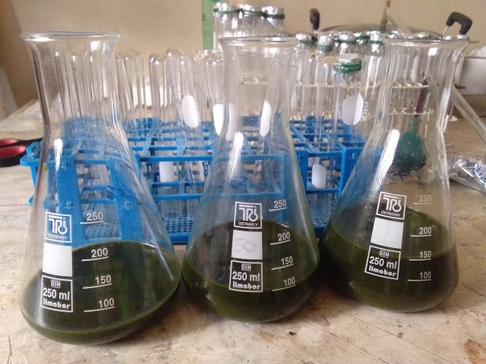
Figure 5.San Francisco Extract

Preparation of the Commercial Fungicide
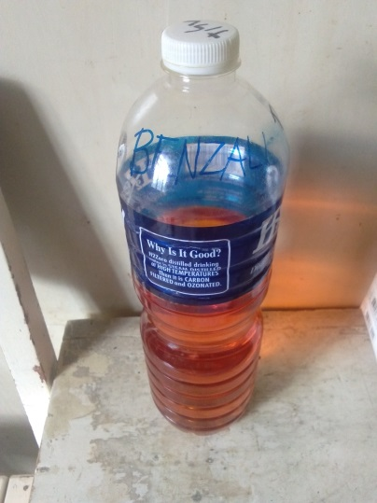
Four milliliters of Benzalkonium chloride were mixed with 200ml of PDA and set aside for the positive control.

Figure 6. Benzalkonium Chloride

Preparation and Inoculation for the Treatments
Food Poisoning Technique (FPT) was used in treating the fungus; it determines if the treatments are positive or negative. In performing the Food Poisoning Technique, 10ml of each solution were placed in separate petri plates (Figure 7a), set aside horizontally and wait to cool down and solidify. Using a flame-sterilized cork-borer with a 0.8cm in diameter (Figure 7b), agar discs with the cultured fungi was made. Agar discs were transferred in the middle of the solidified agar (Figure 7c) amended with the respective treatments using a flame-sterilized wire loop, and incubated (Figure 7d).

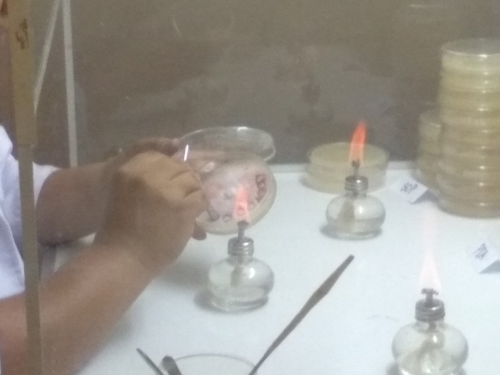
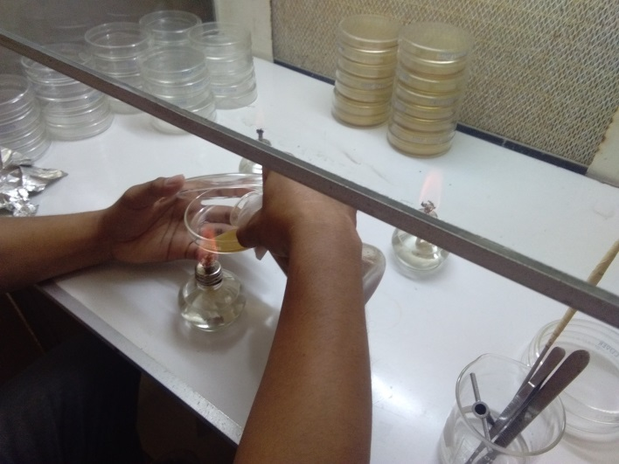

7b
7a

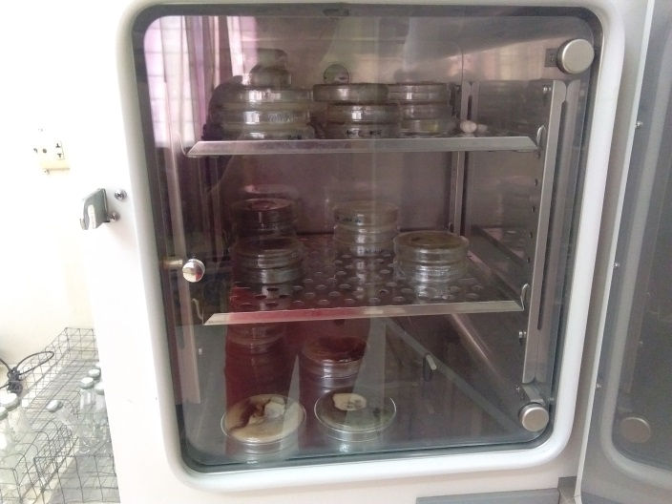
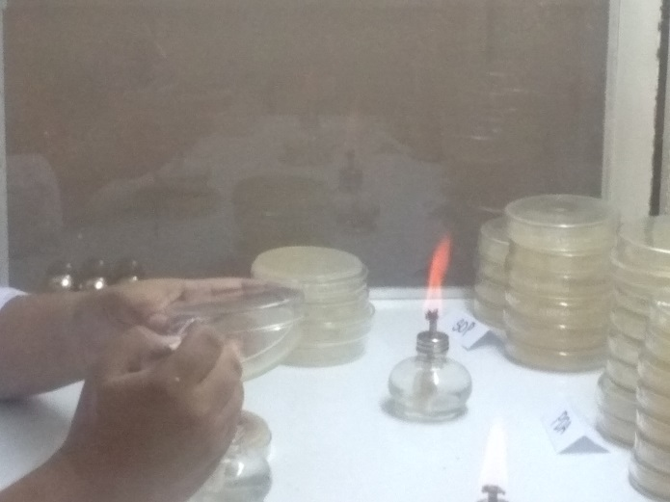

7d
7c

Figure 7. Inoculation of the Treatment

Extraction Procedure for Phytochemical Analysis
Fifty (50) grams of powdered San Francisco (Figure 8a) was kept in 500 mL beaker (Figure 8b) and 250 mL of ethanol (Figure 8c) was added to the powdered plant (Figure 8d). It was then stir using a glass stirring rod to mix (Figure 8e) with the ethanol. Then, the mixture was extracted using cloth (Figure 8f). It was then filtered again using a cloth (Figure 8g). The solvent was set aside for the analysis of its chemical compound.
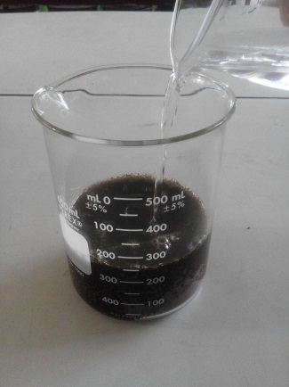
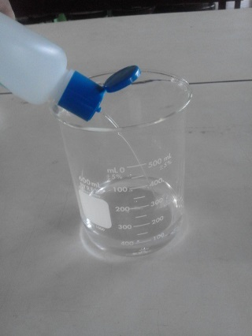
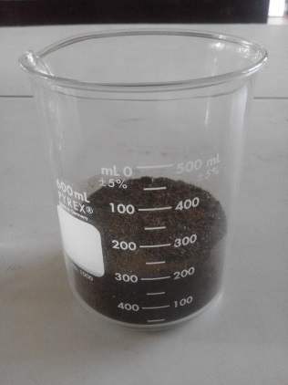
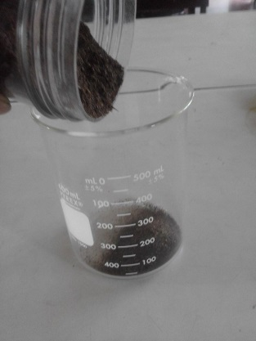

8d
8c
8b
8a
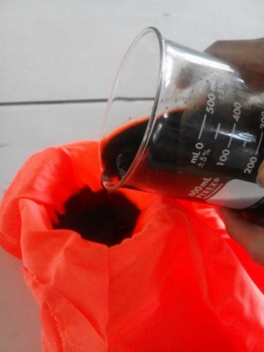
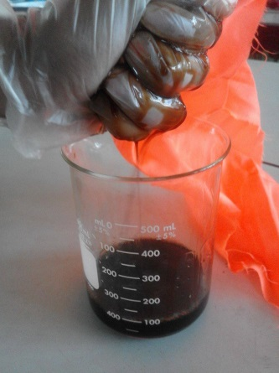
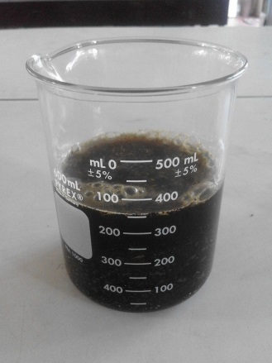

8e
8f
8g

Statistical Analysis
The data obtained were subjected to Analysis of Variance (ANOVA) using the Statistical Package for the Social Science (SPSS) and the mean difference in each treatment was determined using Least Significance Difference (LSD).

Disposal
The culture media and the petri plates and other materials used in the study were decontaminated and sterilized in a pressure cooker at 15 PSI for 30 minutes.

RESULT
Agronomic Characteristic
Growth of Fungus (cm)
The average growth of the fungus treated with San Francisco Leaves Extract were computed by adding its growth in x and y axis and divided by (2) two.
Table 1.
Treatments | P. palmivora | C. gloeosporioides | F. oxysporum
TO | 3.58 a | 1.2 a | 0.88 a
T1 | 3.31b | 1.19 a | 0.93a
T2 | 2.48 c | 1.14 a | .9 a
T3 | 1.04 d | 0 b | 0 b
T4 | 0 e | 0 b | 0 b
Legend: * - significant at 5% level of significance means with the same letter are not significantly different

Twenty-four hours after incubation, it was observed that the radial growths of the three test fungi were significantly affected by the treatment application. Among all the treatments, T4 had the best result with 0 radial growths in all test fungi. The 75% San Francisco leaf extract (T3) had comparable result to T4 with 0 radial growths for C. gloeosporioides and F. oxysporum.
DISCUSSION
The introduction of the fungus in the PDA was done through the use of Poisoned Food Technique, a new method of detecting microorganism, which is faster in speed detection of bacteria and also specific (Hallerman, 2002)
Anim (2016) reported that San Francisco leaves contain several phytochemicals such as glycosides, anthracene, saponins, tannins, alkaloids, flavonoids, sterols and triterpenoids.
According to the phytochemical analysis of San Francisco Leaf Extract that was tested at the University of Immaculate Conception last October 21, 2017, the following chemical compounds are: Flavonoids, Saponins, and Tannins are present (Appendix Figure 9).
Base on the result among the fungus P. palmivora is the fastest growing fungus compared to the other two remaining fungus, and it is observed that per treatment it has a mean of 1cm to 1.3cm.
The result of F. Oxysporum, treated with 75% extract T3, showed no significant difference with commercial one T4 garnering a complete 0 growth. Compared to T0, T1 and T2, which is also, do not have significant difference with each other.
C. gloeosporioides also displayed a great result in T3 which is the 75% extract, which is also having a comparable result with the commercial fungicide, the remaining treatments T0, T1, and T2 also showed no significant difference with each other.
It is concluding that it is the cause of the where the treatments were able to suppress the radial growth of the fungus and showed a significant effect on its first 24 hours.
It is also observed that the growth of the treatments treated with San Francisco Leaves Extract goes up instead of scattering in the surface (Appendix Figure 10).
Since San Francisco Extract solution is a little bit dark green, a light is place in the bottom of the petri plates while getting its radial growth (Appendix Figure 11).

CONCLUSION
The experimental phase T1 (25% San Francisco Extract), and T2 (50% San Francisco Extract) showed a good result. However T3 (75% San Francisco Extract), showed significant result, and were able to control the growth of P. palmivora, C. gloeosporioides, and F. oxysporum.
The study revealed that San Francisco Extract is a potential agent in controlling P. palmivora, C. gloeosporioides, and F. oxysporum under Laboratory Condition.
RECOMMENDATION
The researchers would like to recommend further study to evaluate San Francisco Leaf Extract under field conditions.

