Viral Satellite RNA as a Biological Control Agent Against Viral Diseases

Abstract (300 word limit)
A naturally occurring satellite RNA possessed by the CMV strain was first characterized and then used as a biological control agent to protect tomato plants against the disease induced by another severe strain. Viability and infectivity of the virus in extracted nucleic acid inoculums was further proved using mechanical transmission method. Tomato plants were pre inoculated or “vaccinated” with the strain containing viral satellite RNA, and then challenge inoculated with the severe strain at different time intervals. All plants challenged three weeks after vaccination showed nearly complete protection from subsequent infection by the severe strain. This biological control technology of plant viruses was effective and could be successfully used as biological control agent at the molecular level.

Image
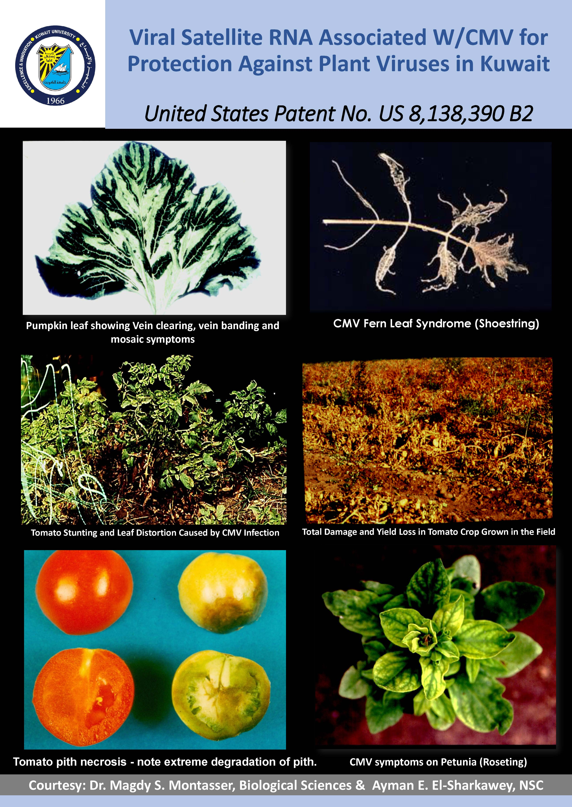
Recent Publications (minimum 5)
- Magdy S. Montasser, Muhammad M. Hegazi, Ashraf M. Younes, Narjes H. Dashti & Ayman E. El-Sharkawey, (2017). Effect of Gold Chloride Concentration and Volume on Size and Shape of Biological Synthesized Gold Nanoparticles (AuNPs) using Red Algae. Science of Advanced Materials 9 (7), 1105-1113.
- Montasser MS, El-Sharkawey AE (2017) Histopathology of Chloroplast Ultrastructure and Inclusion Bodies in CMV-Infected Plant Tissues Using Electron Microscopic Examination and ImageJ Analysis. Vegetos 30:3. doi: 10.4172/2229-4473.1000266
- Magdy. S. Montasser, Narjes H. Dashti, Nedaa Y. Ali & Vineetha M. Cherian. (2017) Biological Control of a severe viral strain of Cucumber Mosaic Virus(CMV) using a mild strain of CMV associated with viral satRNA combined with a mixture of plant growth promoting rhizobacteria (PGPRs). Int J biotech & bioeng 3.5, 126-134
- Montasser MS, Younes AM, Hegazi MM, Dashti NH, El-Sharkawey AE, et al. (2016) A Novel Eco-friendly Method of Using Red Algae (Laurencia papillosa) to Synthesize Gold Nanoprisms. J Nanomed Nanotechnol 7: 383. doi:10.4172/2157- 7439.1000383
- Dashti, N. H., Montasser, M.S., Ali, N.Y.A. and Cherian, V. M. 2014. Influence of plant growth promoting rhizobacteria (PGPR) on fruit yield, pomological characteristics and chemical contents in cucumber mosaic virus (CMV)-infected tomato plants. Kuwait J. Sci. 41 (2) pp. 205-220.

- Montasser, M. S. 2012. Biological Control Agent for Plants, US Patent No.: US 2012/8138390B2 Mar. 20, 2012



Biography (150 word limit)
Magdy Montasser has his expertise in Molecular Virology and Plant Pathology over the last 30 years of experience in research, evaluation, teaching and supervising graduate students towards M.Sc. He optained his Ph.D. degree from Rutgers University, New Jersey, USA in 1988, and Post Doctor at the University of Maryland. Currently working as an Associate Professor at the University of Kuwait, Biological Science
Email: magdy.montasser@ku.edu.kw

