In vitro propagation and DNA profiling of Acorus calamus Linn.

G. J. Sharma PhD, Department of Life Sciences, Manipur University, Imphal 795003, India

Abstract

Sweet flag (Acorus calamus Linn.) is an important littoral plant widely used in traditional medicine since times immemorial. Four cytotypes, viz., diploid, triploid, tetraploid and hexaploid are found world-wide. Two cytotypes, viz., diploid and triploid are found in Manipur, India. Different cytotypes show wide variations in morphology and chemical composition of essential oils in rhizomes and leaves. The plants is used for anti-spasmodic, anti-diarrhoeic, carminative, anti-helminthic, anti-depressant and CNS anxiolytic properties, as tonic, stimulant and aphrodisiac, for treating rheumatism, toothache and respiratory ailments. The aromatic oils are used for flavoring alcoholic beverages and as fragrances in perfumes and sacred oils. The crude extract can prevent acrylamide-induced limb paralysis and increase dopamine receptor in corpus striatum, prevent noise stress-induced changes in rat brain and significant hypolipidemic activities. Bioactive molecules present are acorin, α- and β-asarone, asaryldehyde, caryophylene, isoasarone, methyl isoeugenol and safrol. β-asarone content varies with ploidy level. Triploids contain 7-7.8% β-asarone as against 73-88% in tetraploids. Diploids do not contain β-asarone which is known carcinogen. Chinese medicine suggests its beneficial effects on memory disorder, learning performance and senescence. Clonal propagation of diploid and triploid cytotypes have been developed using dual-phase culture. Microrhizome induction for propagation has significance in conservational and sustainable development priorities. Accessions across nineteen different populations have been investigated. RAPD and ISSR markers have been employed for understanding genetic variabilities of the species. Amplification of genomic DNAs reveals 35.3% polymorphism. Marker indices and resolving powers indicate that ISSR markers are more efficient. Similarity matrix has been used to construct dendrogram based on UPGMA analysis and grouped accessions into two clusters in tune with ploidy level.

Image

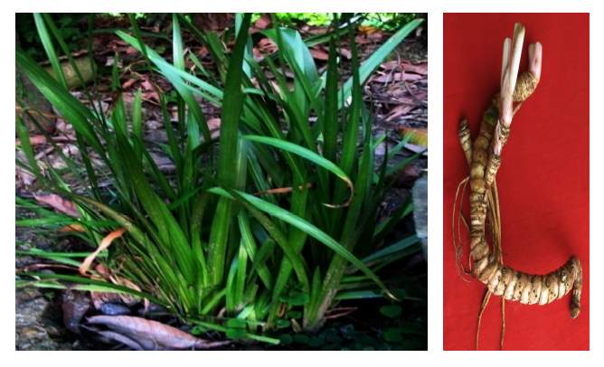
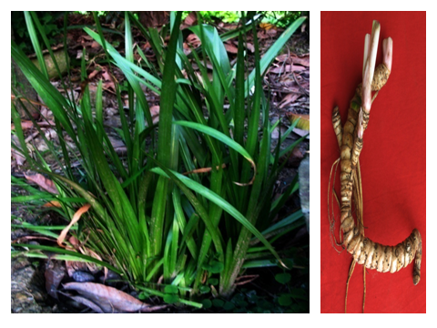 Figure showing Acorus calamus in wild habitat (Left) and rhizome (right)

Recent Publications
- NS Devi, R Kishor, GJ Sharma (2012) Microrhizome induction in Acorus calamus Linn.- an important medicinal and aromatic plant. Horticultural and Environmental Biotechnology 53(5): 410-414.
- N Sandhyarani, R Kishor, GJ Sharma (2011) Clonal propagation of triploid Acorus calamus Linn. using dual-phase culture system. Journal of Crop Science and Biotechnology 14(3): 85-95.
- A Ahlawat, M Katoch, G Ram, A Ahuja (2010) Genetic diversity in Acorus calamus L. as revealed by RAPD markers and its relationship with ß-asarone content and ploidy level. Scientia Horticulturae 124: 294-297.
4. KB Dusvek, EB Galambosi, KK Hethelyi, K Kartova (2007) Morphological and chemical variations of sweet flag (Acorus calamus L.) in the Czech and Finnish gene bank collection. Horticultural Science (Prague) 34: 17-25.
5. CM Bertea, CMM Azzolin, S Bossi, G Doglia, ME Maffer (2005) Identification of an E. coRI restriction site for a rapid and precise determination of ß-asarone free Acorus calamus cytotypes. Phytochemistry 66: 507-514.

Prof Sharma had PhD (Radiation Biology) from Jawaharlal Nehru University, New Delhi and Post-Doctoral Research from Department of Biochemistry, Brunel University, London. He was a Visiting Professor at National Institute of Food and Nutrition Research, Rome. Recently retired as Professor (HAG), he continues as UGC-BSR Faculty Fellow (Life Sciences) at Manipur University. He has 88 publications in international journals, supervised 20 PhDs, participated in over 75 conferences and delivered 24 invited lectures in conferences held in USA, UK, France, China, Netherlands, Italy, Singapore, Thailand and India. He is a reviewer of 12 international journals of repute. His research areas are plant biotechnology, food irradiation, free radicals and dietary antioxidants. He is a Member, Scientific Panel on GMOs and Foods, Food Safety & Standard Authority of India, Government of India.
E-mail: gjs1951@rediffmail.com



