Seed priming with Selenium improves growth, yield and anti-oxidative machinery in salt-stressed mungbean (Vigna radiata L.Wilczek) plants

Simranjeet Kaur, Assistant Professor, Akal University, Talwandi Sabo, Bathinda

Abstract
Salt stress is one of the vital reasons that adversely affect the productivity of crops; hence suitable strategies are required to mitigate its adverse effects on plants. Exogenous selenium (Se) has been reported to mitigate the salinity effects under lab conditions, but its effects in soil-grown salt-stressed mungbean plants with seed-priming technique have not been reported as yet. In a preliminary experiment, the comparative response of mungbean plants to different salt stress levels (applied with NaCl) revealed nearly 70% reduction in pod number and seed yield per plant at 100 mM concentration. Subsequent studies showed that 100 mM NaCl caused substantial damage to membranes, chlorophyll, photosynthetic ability, stomatal conductance and leaf water status. Se seed priming at 1 and 2.5 ppm to salt-stressed plants revealed significant alleviation of stress damage. With 1 ppm Se concentration, resulting in enhanced plant biomass (12%) and seed yield/plant (22%) as compared to salt-treated plants. These plants accumulated significantly less Na⁺ (42%) in their leaves but Cl⁻ accumulation was not affected. The oxidative damage, measured as lipid peroxidation and hydrogen peroxide, was considerably lower in Se-primed salt-stressed plants. The activity of antioxidants such as catalase, ascorbate peroxidase, glutathione reductase and glutathione peroxidase was significantly improved with 1 ppm Se application to salt-stressed plants. These findings indicated that Se seed-soaking at low concentration increased Se uptake but reduced the Na⁺ uptake and, consequently improved the plant function in mungbean plants growing under salt stress.
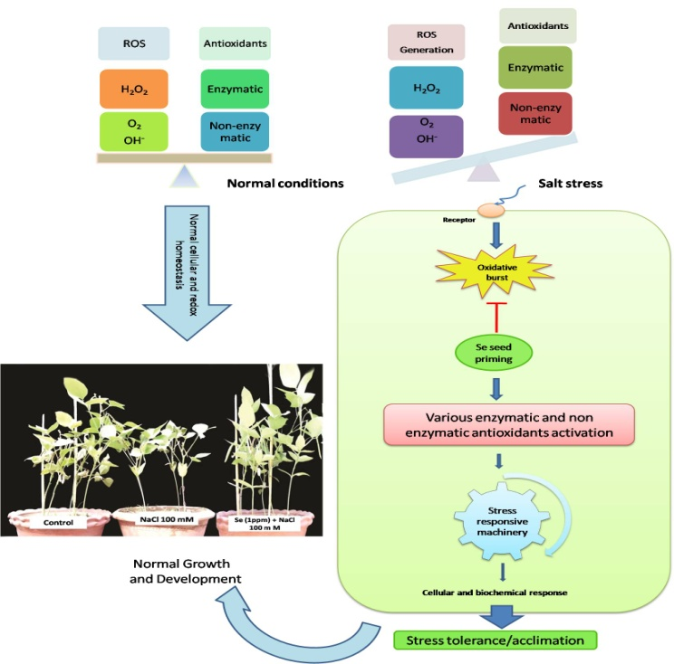
Fig: Role of Selenium in regulating the plant homeostasis under salt-stressed conditions.

References

Mozafariyan, M., Kamelmanesh, M. M., & Hawrylak-Nowak, B. (2016). Ameliorative effect of selenium on tomato plants grown under salinity stress. Archives of Agronomy and Soil Science, 62(10), 1368-1380.

Jiang, C., Zu, C., Lu, D., Zheng, Q., Shen, J., Wang, H., & Li, D. (2017). Effect of exogenous selenium supply on photosynthesis, Na+ accumulation and antioxidative capacity of maize (Zea mays L.) under salinity stress. Scientific Reports, 7.

El-Ramady, H., Abdalla, N., Alshaal, T., El-Henawy, A., Salah, E. D. F., Shams, M. S., ... & Sztrik, A. (2015). Selenium and its role in higher plants. In Pollutants in Buildings, Water and Living Organisms (pp. 235-296). Springer International Publishing.

Parihar, P., Singh, S., Singh, R., Singh, V. P., & Prasad, S. M. (2015). Effect of salinity stress on plants and its tolerance strategies: a review. Environmental Science and Pollution Research, 22(6), 4056-4075.

Khaliq, A., Aslam, F., Matloob, A., Hussain, S., Geng, M., Wahid, A., & ur Rehman, H. (2015). Seed priming with selenium: consequences for emergence, seedling growth, and biochemical attributes of rice. Biological trace element research, 166(2), 236-244.

Nawaz, F., Ashraf, M. Y., Ahmad, R., Waraich, E. A., Shabbir, R. N., & Bukhari, M. A. (2015). Supplemental selenium improves wheat grain yield and quality through alterations in biochemical processes under normal and water deficit conditions. Food chemistry, 175, 350-357.

Biography
My expertise is in Plant Physiology. My research is about the Interactive effects of Selenium and salt stress on growth and physiology of Mungbean (Phaseolus aureus Roxb.).

