Productivity of cells from shoot cultures of Aronia species cultivated in different in vitro systems

Agnieszka Szopa, Paweł Kubica, Adam Setkiewicz, Halina Ekiert
Chair and Department of Pharmaceutical Botany, Jagiellonian University-Collegium Medicum, Kraków, Poland

Abstract
Statement of the problem: Different plant in vitro systems (e.g. stationary and agitated cultures) have a great influence on the accumulation of bioactive metabolites in the cultivated biomass. The level of the organogenesis affects the accumulation of secondary metabolites, too. The aim of the study was to compare the productivity of cells from shoot cultures of Aronia sp. (A. melanocarpa, A. arbutifolia and A. x prunifolia) cultivated as stationary and agitated cultures. The object of interest were phenolic acids, the metabolites with anticancer, anti-inflammatory and other activities important in therapy and cosmetology. Methodology: Stationary and agitated shoot cultures were cultivated on three variants of Murashige-Skoog medium (MS) supplemented with cytokinin (BA) and auxin (NAA) in following concentrations [mg/l]: variant I - 0.5 and 2.0; variant II - 2.0 and 2.0; variant III - 3.0 and 1.0. In the methanolic extracts from biomasses 19 compounds (derivatives of cinnamic acid, benzoic acid and depsides) were estimated by LC-DAD method. Findings: Cells of all studied in vitro cultures produced as main metabolites three depsides: neochlorogenic acid, chlorogenic acid and rosmarinic acid. Their maximal amounts were higher in shoots cultivated as agitated cultures and riched respectively: 82.00, 105.45 and 134.24 mg/100g DW (A. melanocarpa) and 25.49, 175.94 and 132.49 mg/100g DW (A. arbutifolia), and 70.91, 260.34 and 225.26 mg/100g DW (A. prunifolia). The best “productive” media were MS variants: variant II for A. melanocarpa and A. arbutifolia in vitro cultures and variant III for A. prunifolia, respectively. Conclusions & Significance: The optimization of in vitro cultures conditions (type of culture, concentrations of plant growth regulators) lead to the potentially applicable results. The obtained amounts of depsides are higher than in fruits of soil-growth plants. After the optimization of in vitro cultures conditions it is possible to obtain, high amounts of biologically active depsides.

Image
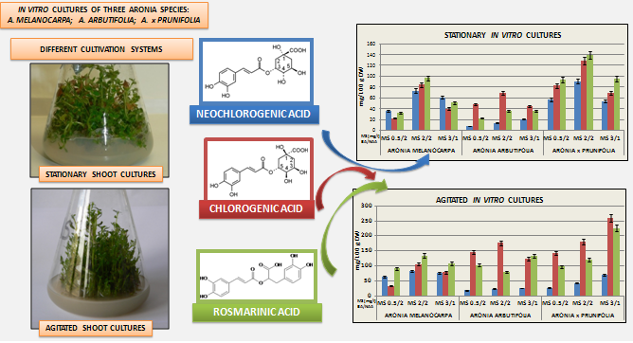

Recent publications
- Kokotkiewicz A, Jaremicz Z, Łuczkiewicz M (2010) Aronia plants: a review of traditional use, biological activities, and perspectives for modern medicine. Journal of Medicinal Food 13:255-269.
- Matkowski A (2008) Plant in vitro culture for the production of antioxidants a review. Biotechnology Advances 26:548-560.
- Ramawat KG, Mathur M (2007) Factors affecting the production of secondary metabolites. In: Biotechnology – Secondary metabolites. Plants and Microbes. Eds. Ramawat KG, Merillon JM, Sciences Publishing, Enfield, USA, 59-102.
- Steingroewer J, Bley T Georgiev V, Ivanov I, Lenk F, Marchev A, Pavlov A (2013) Bioprocessing of differentiated plant in vitro systems. Engineering in Life Sciences 13:26–38.
- Szopa A, Kubica P, Kokotkiewicz A, Banaszczak P, Wojtanowska-Krośniak A, Krośniak M, Marzec-Wróblewska U, Badura A, Zagrodzki P, Bucinski A, Luczkiewicz M, Ekiert H (2017) Comparative analysis of different groups of phenolic compounds in fruit and leaf extracts of Aronia sp.: A. melanocarpa, A. arbutifolia and A. x prunifolia, and their antioxidant activities. European Food Research and Technology – after review.


Biography
Halina Ekiert, professor of pharmaceutical sciences is a specialist in the field of plant biotechnology, biotechnology of higher fungi, mycochemistry and phytochemistry. She has special interest in biotechnology of medicinal plants. Her main investigations are connected with endogenic accumulation of plant secondary metabolites important in therapy, food industry and cosmetology (e.g. coumarins, phenolic acids, flavonoids, lignans) in established in vitro cultures. Some investigations are connected with biotransformation of exogenous substrates (simple phenolic compounds) into important products (e.g. arbutin). Comparative phytochemical studies of soil-growth plants are the next research areas. Some investigations are connected with mycochemistry of higher fungi (Macromycetes) and biotechnology of higher fungi with special interest e.g. in accumulation of nonhallucinogenic indole compounds, phenolic acids, sterols, fatty acids and polysaccharides.
Email: mfekiert@cyf-kr.edu.pl

