Healthy soils with
conservation agriculture
systems
Mohammad Esmaeil Asadi, PhD, Golestan Agricultural Research Center, Iran

Abstract (300 word limit)

Soil is the network of interacting living organisms within the earth's surface layer, which support life above ground – plants and animals, including humans. Soil filters the rainwater and regulates the discharge of excess rainwater, preventing flooding; it is capable of storing large amounts of organic carbon; it buffers against pollutants, including CO₂. Many people don’t realize that soil, especially healthy soil, is full of life. Bacteria, algae, microscopic insects, earthworms, beetles, ants, mites, and fungi are among them. Altogether, their value has been estimated at $1.5 trillion a year worldwide.

The healthiest soils are those with a diversity and abundance of life. Farmers who adapted conservation agriculture (CA) approach understand that tillage, the turning of the soil that has been the standard for growing crops for years and years, is disruptive to soil microbes and destructive to the soil system and its very structure. CA farmers grow a diversity of living plants in the soil as much of the time as practical, covering the soil and offering food to soil microbes through living roots. Those soil organisms, in turn, cycle nutrients back to the plant.

CA-farming practices that involve minimal soil disturbance, permanent soil cover and the use of crop rotation to simultaneously maintain and boost yields, reduce costs for farmers – especially by saving fuel for the soil tillage – increase soil quality, reduce soil erosion and improve biological activity, all while increasing agricultural productivity, especially by increasing resilience to drought and climate change.

Studies show a producer can save at least 30% of water consumption per hectare by changing from conventional tillage to CA.

In this paper we will provide some examples and case studies from adoption and practices of CA in developed and developing countries especially Asian countries who got good results in terms of healthy soils.

Image
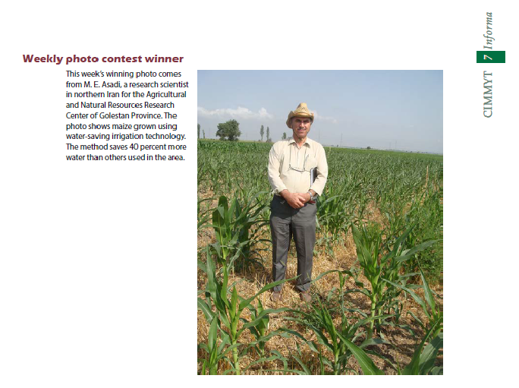
Recent Publications (minimum 5)
- Ebrahimi, M., M. E. Asadi., M. Manshori., F. Kaveh and A. Afrous. 2011. Effect of nitrogen fertigation via two methods of sprinkler and furrow irrigation under different levels of fertilizers on yield and yield components of sweet corn. World Applied Sciences Journal 13 (4): 706-711.
- Feyzbakhsh, M.T., Kamkar, B., Mokhtarpour, H., and Asadi, M. E. 2015. Effect of soil water management and different sowing dates on maize yield and water use efficiency under drip irrigation system. Archives of Agronomy and Soil Science. Vol. 61(11): 1581-1592.
- Shahrinezhad, S., Asadi, M. E., and Tohidloo, G. 2015. Effect of Various Tillage Systems on Viability, Germination, Establishment and Yield of Wheat. Journal of Research in Applied sciences. Vol. 2(4): 108-118.
- Arabi, Z., Homaee, M., Asadi, M. E., and Asadi Kapourchal, S. 2017. Cadmium removal from Cd-contaminated soils using some natural and synthetic chelates for enhancing phytoextraction. Chemistry and Ecology.
- Sedghi Marjan., Mohammadi Torkashvand Ali., Asadi Mohammad Esmaeil., and Pazira Ebarahim. 2018. Evaluation of contamination of some heavy metals in the soils around ShahidSalimipowerplant, Neka, Mazandaran province, Iran. Journal of Soil and Nature (JSN). Volume 10 Issue 1.

Biography (150 word limit)
Mr.Mohammad Esmaeil Asadi, an Iranian citizen, finished his Ph.D degree in Integrated Water Resources Management, at Asian Institute of Technology (AIT), Thailand in Aug 2001. Currently he is working as a principle research scientist in Golestan Agricultural and Natural Resources Research and Education Center (GANRREC) that is governmental center which is situated in Golestan Province north part of Iran near Caspian Sea. His research interests are as follows: 1-Irrigation/drainage systems design, development and performance evaluation 2- Conservation Agriculture (CA), Soil and water management of upland crops

Email: iwc977127@yahoo.com

