P. nodorum effectors resistance among Polish wheat and triticale germplasm
Jakub Walczewski, MSc, IHAR, Poland
Piotr Ochodzki, PhD, IHAR, Poland
Edward Arseniuk, D.Sc., IHAR, Poland
Tan Kar-Chun, Ph.D., Curtin University, Australia

Statement of the Problem:
Parastagonospora nodorum is a necrotrophic pathogen of all assimilative green plant parts of wheat and triticale as well as of other cereals and grasses. Necrotic tissue is essential for fungal growth and reproduction. Destruction of green plant parts affects adversely photosynthesis, what results in grain yield loss, quantitative and qualitative in nature. Fungus is causing necrosis by production of several host-selective necrotrophic effectors proteinaceous in nature. Positive recognition with dominant allele in host plant, leads to necrosis induction, while absence of dominant allele causes effector insensitivity. Several breading lines of wheat and triticale were tested on Tox1, Tox3, Tox5 and ToxA resistance. Data were correlated with phenotypic resistance in adult and seedling stage to determine effector with largest impact on disease severity in Polish wheat and triticale germplasm.
Methodology & Theoretical Orientation:
Effectors used in this study were purified and checked on differential lines to ensure purity, and compared with samples of effectors provided by associated laboratories. Seedlings were tested by infiltrate fully expanded second leaves. Reactions were scored after 5 days as a susceptible or resistant.
Field and fitotron trials conducted to score phenotypic resistance, were inoculated with mix of pycnidiospores derived from 11 isolates representative for Polish P. nodorum population. Field trials scores were done weekly on 3 replications and average scores were used for correlation. In control environment trials average % of affected tissue of sixteen second leafs were calculated 7 days after inoculation.
Conclusion & Significance:
Among tested breeding lines only minority was susceptible to ToxA and Tox1, susceptibility on Tox3 and Tox5 was far more frequent. The largest positive correlation between insensitivities and phenotypic resistance of adult and seedling stages was observed between Tox3 and Tox5. Therefore it seems notably important to focus on excluding Snn3 and Snn5 dominant alleles from Polish wheat and triticale germplasm.
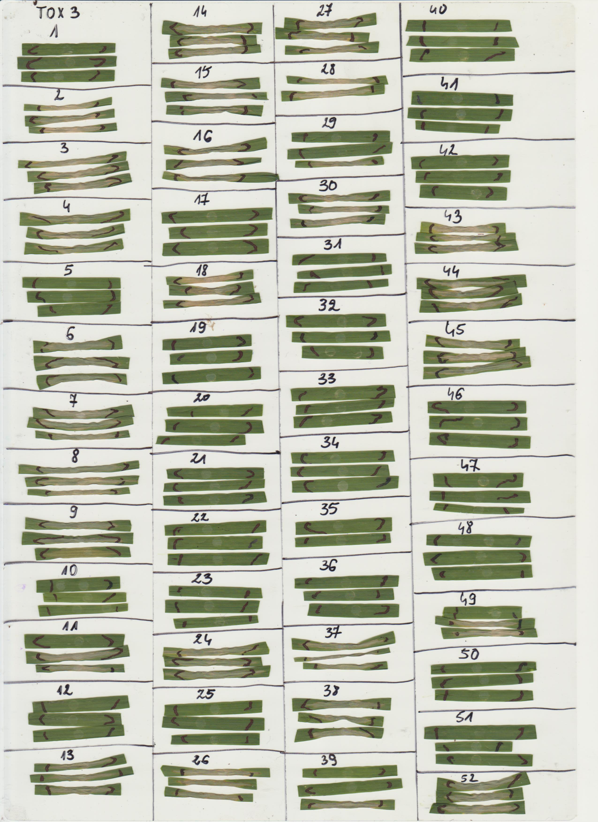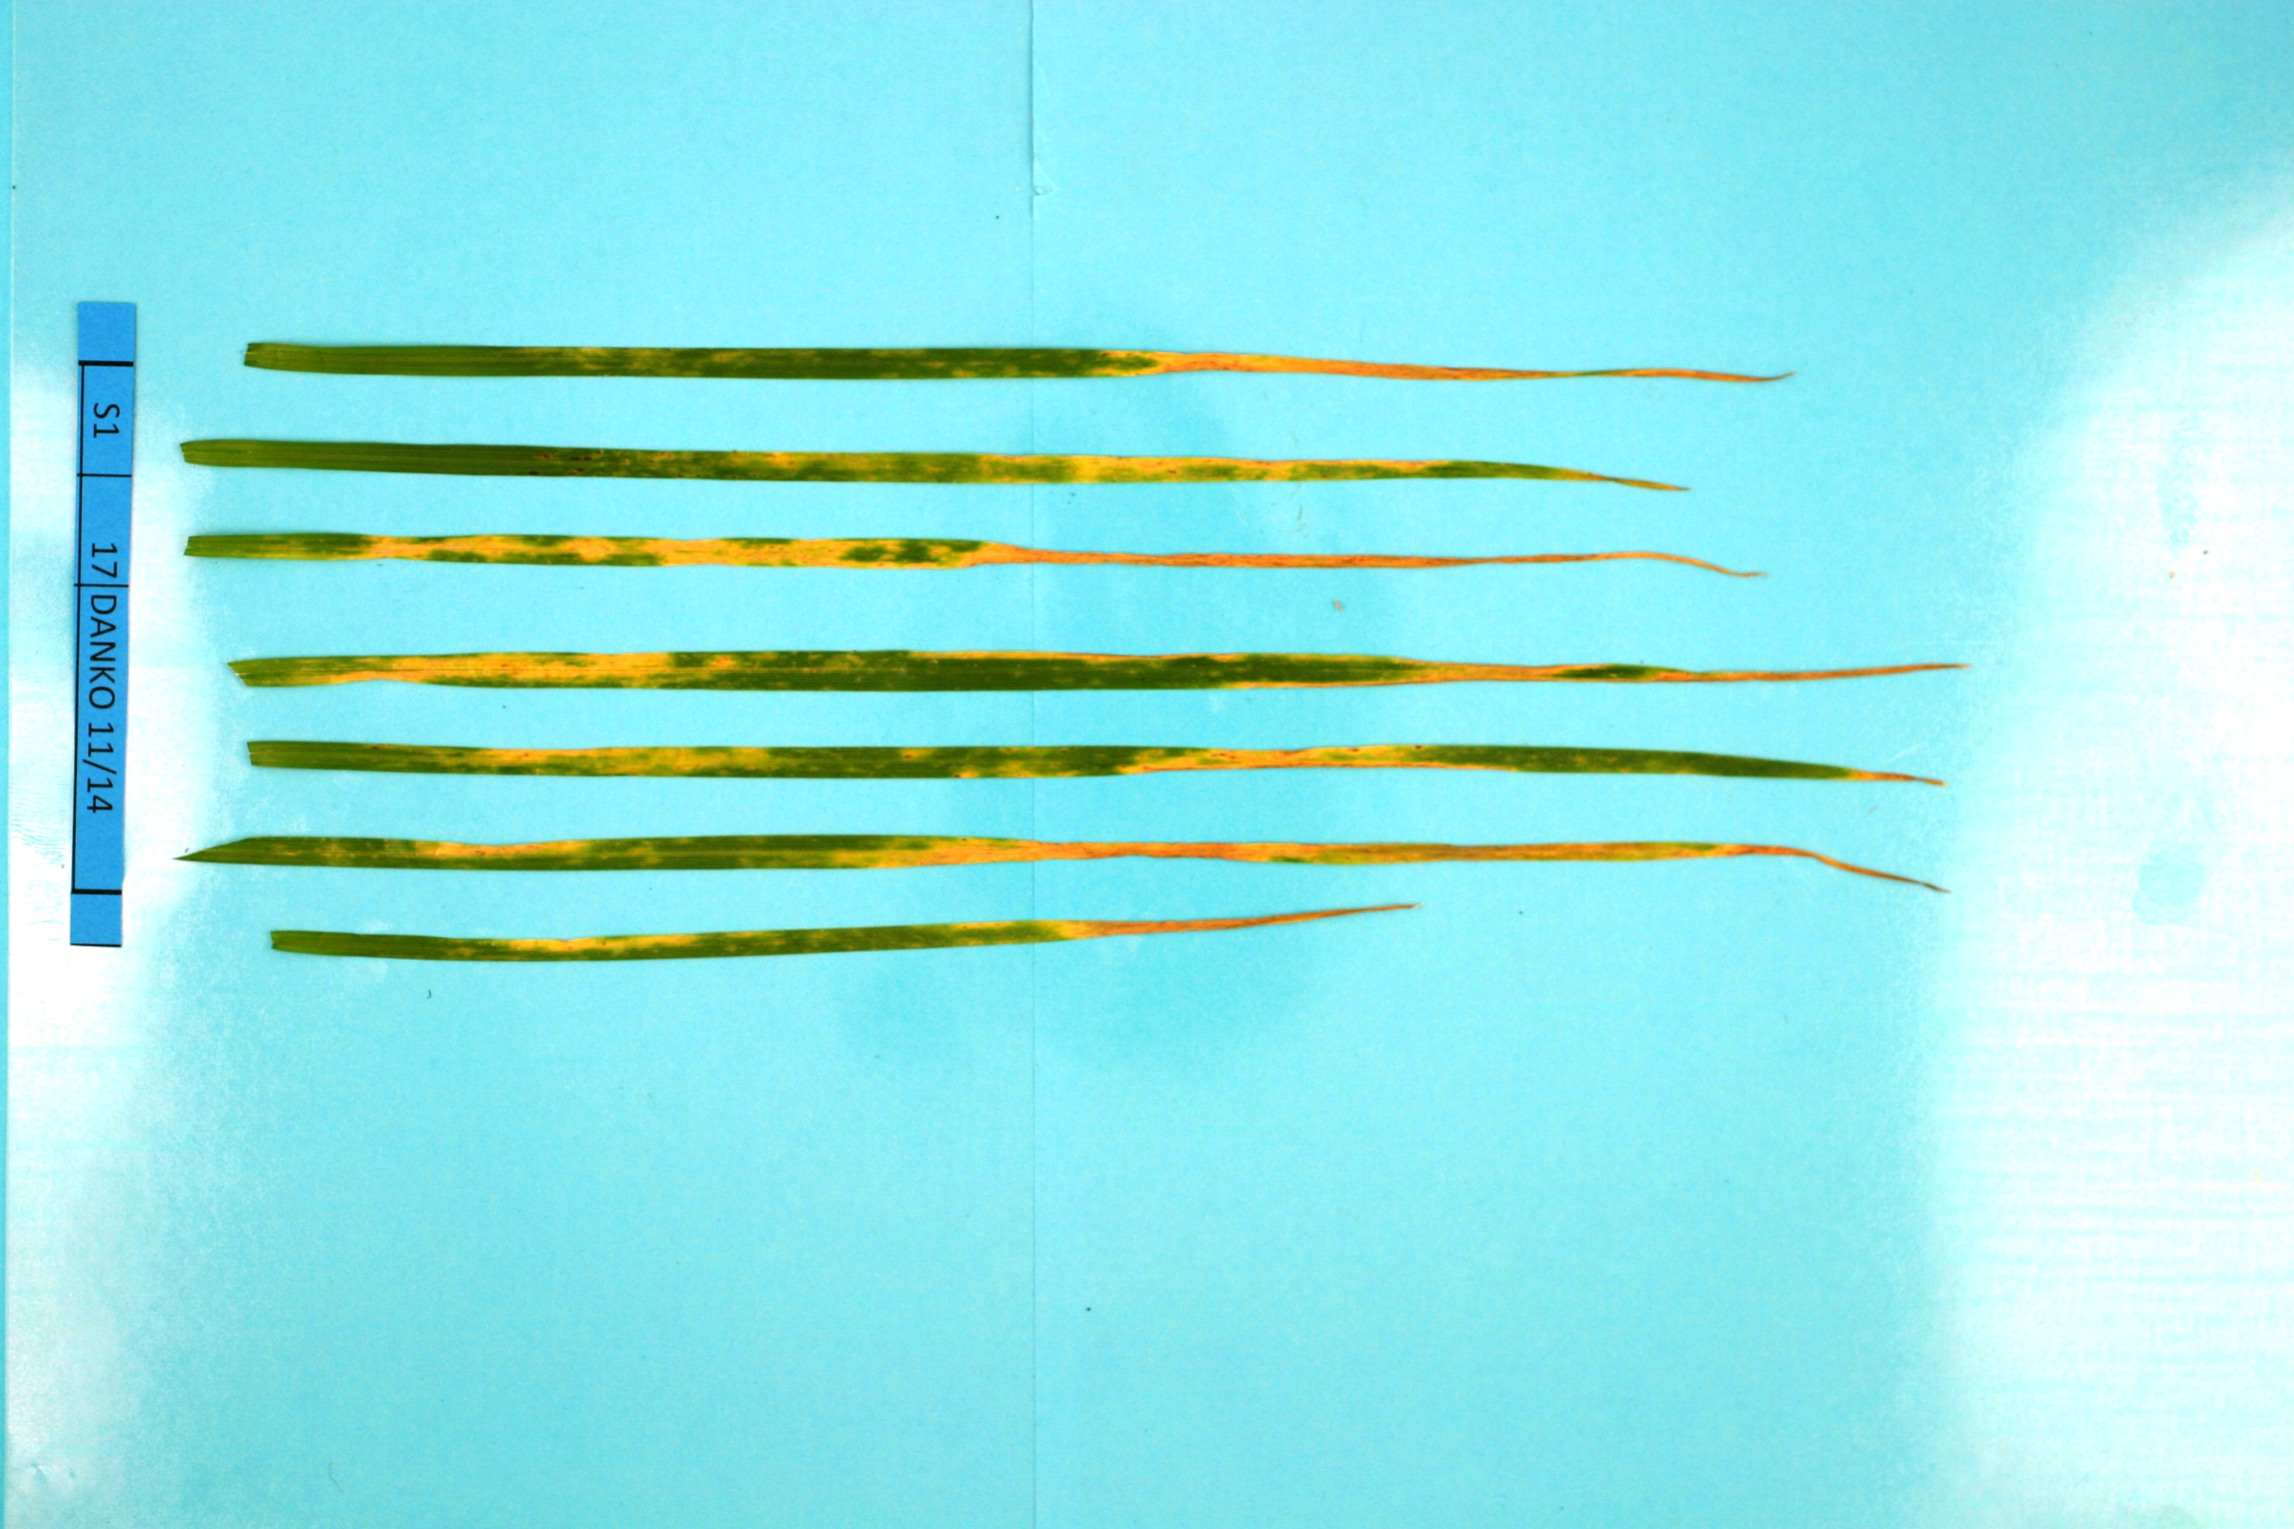
A
B
Figure 1: A) Example of effector sensitive or insensitive breeding lines. B) Example of disease in seedling stage of development

- Friesen TL, Faris JD, Solomon P, Oliver RP (2008) Host-specific toxins: effectors of necrotrophic pathogenicity. Cell Microbiol. 10:1421-8.
- Oliver RP, Lichtenzveig J, Tan KC, Waters O, Rybak K, Lawrence J, Friesen TL, Burgess P (2014) Absence of detectable yield penalty associated with insensitivity to Pleosporales necrotrophic effectors in wheat grown in the West Australian wheat belt. Plant Pathology 63: 1027–1032
- Friesen TL, Chu CG , Liu ZL, Xu SS, Halley S, Faris JD (2009) Host-selective toxins produced by Stagonospora nodorum confer disease susceptibility in adult wheat plants under Weld conditions. Theor Appl Genet 118:1489–1497
- Friesen TL, Chu CG, Xu SS, Faris JD (2012) SnTox5–Snn5: a novel Stagonospora nodorum effector–wheat gene interaction and its relationship with the SnToxA–Tsn1 and SnTox3–Snn3–B1 interactions. MOLECULAR PLANT PATHOLOGY 13(9), 1101–1109
- Liu Z, Faris JD, Oliver RP, Tan K-C, Solomon PS, Megan C. McDonald MC, McDonald B, Nunez A, Lu S, Rasmussen JB, Friesen JB (2009) SnTox3 Acts in Effector Triggered Susceptibility to Induce Disease on Wheat Carrying the Snn3 Gene. PLoS Pathog 5(9): e1000581.

 Biography:
Jakub Walczewski is bound with Plant Breeding and Acclimatization Institute (IHAR) - National Research Institute in Radzikow (Poland) for eight years. His main field of activity is participating in multiannual efforts in order to enhance Parastagonospora nodorum resistance in wheat and triticale.
Email: J.walczewski@ihar.edu.pl

Notes/Comments:

