Title: Effect of rolC expression on biochemical composition and pathogen resistance in Nicotiana tabacum
Tatiana V. Matveeva*, Irina Isaeva, Sofie V. Sokornova, St. Petersburg State University, Russia

Abstract
Statement of the Problem: Plant genetic engineering mostly uses Agrobacterium-mediated transformation to introduce novel genes. In nature, insertion of T-DNA into the plant genome and its subsequent transfer via sexual reproduction has been shown for several species of Nicotiana, Ipomoea, and Linaria. Such T-DNA was named “cellular T-DNA” (cT-DNA). One of the most conserved genes in cT-DNA is rolC. Its expression has been shown in Nicotiana and Linaria.[1-2]. To investigate the rolC functions, we compared the biochemical composition of tobacco plants, differing in expression of the gene. Methodology & Theoretical Orientation: Transgenic N. tabacum plants, containing rolC under dexamethasone-inducible promoter and control non-transgenic plants [3] were cultivated for 7 days on MS media supplied with 10 µM of dexamethasone and MS0 media [4]. The experiment was done in three replicates. The plant materials were ground in liquid nitrogen, methanol-extracted and analyzed by HPTLC/AMD and GC-MS. The antimicrobe activities of the extracts (50 μg/disc) were tested against Bacillus subtilis, Escherichia coli, Candida tropicalis, fungistatic activity was tested against Alternaria alternate, Boeremia exigua, Fusarium proliferatum. Findings: The major component identified in plant extracts was dioctanoyl sucrose ester (RT 35.2). Transgenic plant extracts (TPE) show an increased level of nornicotine, sucrose and sucrose esters (RT 40.75, 40.98). Since it is known that alkaloids have antimicrobial activity [5], we evaluated the effect of TPE on the vitality of bacteria and fungi. The TPE in the cultural media inhibits growth of F. proliferatum and A. alternate (fig.1) and shows antibiotic activity against E. coli, C. tropicalis. Conclusion & Significance: Expression of the rolС leads to an increase in the content of sucrose, sucrose esters, nornicotine and increases resistance to microorganisms. This study was supported by a grant to TM from the RFBR 18-016-00118. Authors thank Professor Otten (IBMP, France) for transgenic plants.

Image
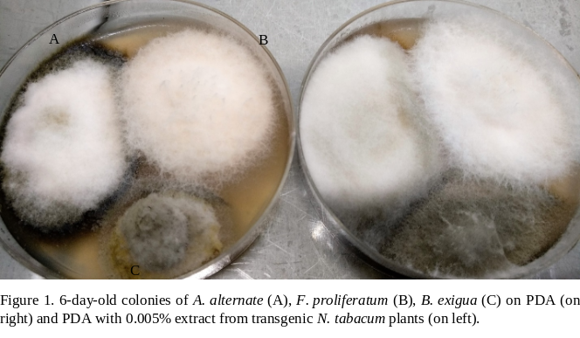
Recent Publications
- Matveeva T (2018) Agrobacterium-Mediated Transformation in the Evolution of Plants. Curr Top Microbiol Immunol DOI https://doi.org/10.1007/82_2018_80

Matveeva T & Sokornova S (2017) Biological traits of naturally transgenic plants and their evolutional roles. Russ J Plant Physiol. 64(5): 635-64

Mohajjel-Shoja H et al. (2011) Biological Activity of the Agrobacterium rhizogenes–Derived trolC Gene of Nicotiana tabacum and Its Functional Relation to Other plast Genes. MPMI 24(1): 44-53
- Murashige T & Skoog F (1962) A revised medium for rapid growth and bioassay with tobacco tissue culture. Physiol. Plant. 15: 165–170.
- Bailey JA et al (1975) Capsidiol: an antifungal compound produced in Nicotiana tabacum and Nicotiana clevelandii following infection with tobacco necrosis virus Phytochem 14: 597−582



Biography
Tatiana V. Matveeva graduated from St.Petersburg State University in 1996, got her PhD in 2000 and became a Doctor of Science in 2013. Now she is a Professor of the Department of Genetics and Biotechnology of the St.Petersburg State University. Her research is devoted to horizontal gene transfer from Agrobacterium to plants. Under her leadership, T-DNA was first discovered and characterized in plants of the genus Linaria. Now her research team is studying biodiversity of T-DNA-like sequences in plants and possible functions of genes obtained by plants from Agrobacterium
Email:radishlet@gmail.com
Full Name: Tatiana V. Matveeva
Personal Email: radishlet@gmail.com
Mobile Number: +79045154005
Linked In:
Facebook:
Session Name/ number: Plant Biotechnology
Category: Poster presentation
Date of Birth: 10/11/1974
Postal Address: Department of Genetics and Biotechnology, St. Petersburg State University, University emb., 7/9, St. Petersburg, 199034, Russia

Notes or Comments:

