Manipulation of a bHLH transcription factor to generate male sterility line in rice
Dr. Rachel Swee-Suak Ko
Academia Sinica, Agricultural Biotechnology Research Center/BCST

Abstract (300 word limit)
Hybrid rice is a promising strategy to increase grain yield by 15-20%. Stable male sterility line is important for pure F1 hybrid seed production. We identified a male-sterile TRIM mutant without pollen development in rice. Southern blot indicated that this mutant is single T-DNA insertion even. Heterozygous mutant is fertile and homozygous line is male sterile. Our genetic analyses confirmed that the male sterility in this mutant is controlled by a single recessive locus. Knockout mutant cannot enter meiosis, defects in tapetal programmed cell death and hypertrophy tapetal cells, consequently lead to no pollen development. To know more about the molecular function of bHLH142, we overexpressed bHLH142. Surprisingly, OE lines also showed male sterility. OE caused premature onset of tapetal PCD, defective in ROS scavenging in the anther. Altered expression of several key regulatory transcription factors such as UDT1, GAMYB, TDR1, and EAT1 were found upregulated in OE anther. Our detail molecular study demonstrated that bHLH142 and TDR1 form protein-protein interaction and co-modulate transactivation of EAT1. Either knockout or OE of bHLH142 both lead to defect or premature PCD, eventually all turn out to be sterile. Indicating that homeostatic and tightly control of bHLH142 expression is essential for normal pollen development. This study provides a new method to generate genic male sterility in rice and possibly in other cereal crops too. Moreover, exploitation of this novel functionality of bHLH142 would confer a big advantage to hybrid seed production.

Image
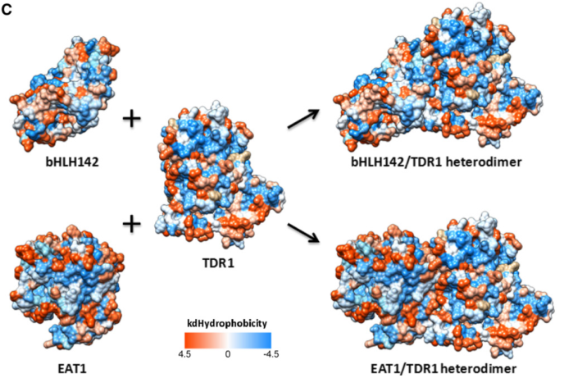
Recent Publications (minimum 5)
- Ko, S.S.*, Li, M.J., Sun-Ben Ku, M., Ho, Y.C., Lin, Y.J., Chuang, M.H., Hsing, H.X., Lien, Y.C., Yang, H.T., Chang, H.C., and Chan, M.T. (2014). The bHLH142 Transcription Factor Coordinates with TDR1 to Modulate the Expression of EAT1 and Regulate Pollen Development in Rice. Plant Cell 26, 2486-2504.
- Hsing, H.X., Lin, Y.J., Tong, C.G., Li, M.J., Lin, Y.J., S.S. Ko*. 2016. Stable Agrobacterium-mediated tramsformatiom of Phalaenopsis orchids. Botanical Studies 50:37
- Chen, T.K., Yang, H.T., Fang, S.C., Lien, Y.C., Yang, T.T., Ko, S.S.* (2016). Hybrid-Cut: An Improved Sectioning Method for Recalcitrant Plant Tissue Samples. J. Vis. Exp. 117, e54754, doi:10.3791/54754.
- Lin, C.S., Hsu, C.T., Liao, D.C., Chang, W.J., Chou, M.L., Huang, Y.T., Chen, J.J., Ko, S.S., Chan, M.T., and Shih, M.C. (2016). Transcriptome-wide analysis of the MADS-box gene family in the orchid Erycina pusilla. Plant Biotechnol J 14, 284-298.
- Shih, M.C., Chou, M.L., Yue, J.J., Hsu, C.T., Chang, W.J., Ko, S.S., Liao, D.C., Huang, Y.T., Chen, J.J., Yuan, J.L., Gu, X.P., and Lin, C.S. (2014). BeMADS1 is a key to delivery MADSs into nucleus in reproductive tissues-De novo characterization of Bambusa edulis transcriptome and study of MADS genes in bamboo floral development. BMC Plant Biol 14, 179.
- Lin, H.Y., Chen, J.C., Wei, M.J., Lien, Y.C., Li, H.H., Ko, S.S., Liu, Z.H., and Fang, S.C. (2014). Genome-wide annotation, expression profiling, and protein interaction studies of the core cell-cycle genes in Phalaenopsis aphrodite. Plant Mol Biol 84, 203-226.

Biography (150 word limit)
Rachel SS Ko devotes herself in functional genomics studies in rice and orchid. She identified a key bHLH transcription factor in rice that is essential in rice pollen development. She is interested to carry out detail study on the molecular mechanism underlying pollen development to improve agriculture application of male sterility line for hybrid rice yield improvement.
Email: sweesuak@gate.sinica.edu.tw

Notes/Comments:

