Lagenaria siceraria Ring Zinc Finger 1(LsRZF1)-antisense expression of transgenic watermelon rootstock improves drought stress tolerance in Citrullus lanatus
Ji Hyeon Min, Assistant Researcher
Department of Plant Biotechnology, Chonnam National University, Gwangju 61186, Republic of Korea

Abstract

Watermelon is a major fruit vegetable around the world. Drought is an abiotic stress factor that affects the productivity and growth of crop plants. To enhance the tolerance of watermelon to drought stress, it is important to isolate stress tolerance-related genes. Recently, we characterized the gene for ubiquitin E3 ligase protein named Lagenaria siceraria RING Zinc Finger 1 (LsRZF1). In Arabidopsis, LsRZF1 is involved in the drought response through the proline metabolism-mediated pathway. In this study, we identified and characterized a watermelon (Citrullus lanatus cv. Gongdae) homolog of LsRZF1, designated GdRZF1. LsRZF1 antisense (lsrzf1) transgenic watermelon lines showed decreased GdRZF1 expression, and were in sensitive to drought stress than the wild type. Decreased expression of GdRZF1 was also significantly influential in changes in drought-sensitive parameters including relative water content, ion leakage, chlorophyll content, malondialdehyde levels, proline content, and the expression of drought stress- responsive genes. Additionally, grafted plants showed more health leaves and larger leaf area as compared with the control during drought condition. Taken together, these findings results that GdRZF1 is important for water deficit tolerance in watermelon. This is the report of the development by genetic engineering of watermelon tolerance to drought response.

Image
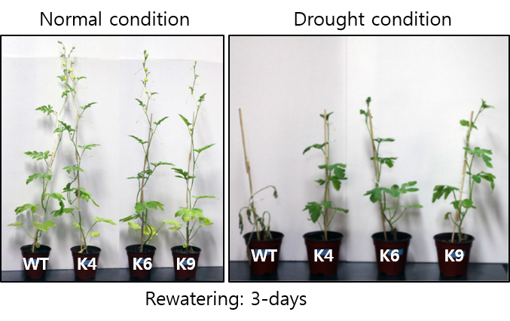
Recent Publications
- Ju HW, Min JH, Chung MS, Kim CS (2013) The atrzf1 mutation of the novel RING-type E3 ubiquitin ligase increases proline contents and enhances drought tolerance in Arabidopsis. Plant Sci 203:1-7.
- 11. Min JH, Ju HW, Yang KY, Chung JS, Cho BH, Kim CS (2014) Heterologous expression of the gourd E3 ubiquitin ligase gene LsRZF1 compromises the drought stress tolerance in Arabidopsis thaliana. Plant Physiol Biochem 77:7-14.
- Shi H, Ye T, Chan Z (2014) Comparative proteomic responses of two bermudagrass (Cynodon dactylon (L). Pers.) varieties contrasting in drought stress resistance. Plant Physiol Biochem 82:218-228.
- Smirnova OG, Stepanenko IL, Shumnyi VK (2011) The role of the COP1, SPA, and PIF proteins in plant photomorphogenesis. Biol Bull Rev 1:314-324.
- Zhang L, Zhao G, Xia C, Jia J, Liu X, Kong X (2012) A wheat R2R3-MYB gene, TaMYB30-B, improves drought stress tolerance in transgenic Arabidopsis. J Exp Bot 63:5873-5885.

Biography
Ji Hyeon Min is an assistant researcher in Cheol Soo Kim’s laboratory at the Chonnam National University in South Korea. Min focuses on researching crop development via CRISPR-Cas9 system to increase drought stress tolerance.

Email: gmleodml4389@naver.com
Notes/Comment

