Identification of Proline Content Alterative 13 (PCA13) as the Arabidopsis thaliana RING Zinc Finger 1 suppressor in plant environmental stress response
Cheol Soo Kim, Professor, Department of Plant Biotechnology, Chonnam National University, Gwangju 61186, Republic of Korea

Abstract

Proline (Pro) metabolism is important for environmental responses, plant development and growth. However, the mechanism of Pro in abiotic and biotic stress processes are unclear. Using the atrzf1 (Arabidopsis thaliana ring zinc finger 1) mutant as a parental line for T-DNA tagging mutagenesis, we identified a suppressor mutant, designated proline content alterative 13 (pca13) that suppressed the insensitivity of atrzf1 to abiotic stresses during early seedling growth. Pro content of pca13 was lower than in atrzf1, while the complementary lines were less sensitive to abscisic acid (ABA) and abiotic stresses compared to WT. Through the TAIL-PCR of pca13, it was shown that T-DNA inserted at site chromosome 2 which encodes cell wall enzyme. Under condition of biotic stress, pathogen resistance were significantly higher in pca13 compared to WT and atrzf1. Moreover, pca13 mutant was significantly higher in several important drought parameters including malondialdehyde level, ion leakage and water loss. The fluorescence signal of the green fluorescent protein (GFP)-tagged PCA13 was quite strong in the cell wall of the root cells of the transgenic seedlings. Additionally, the PCA13 promoter-β-glucuronidase (GUS) construct revealed substantial gene expression in the root tissues and apical meristem. Collectively, these findings prove that pca13 acts as a suppressor mutant of atrzf1 in the abiotic and biotic stress responses through the Pro metabolism.

Image
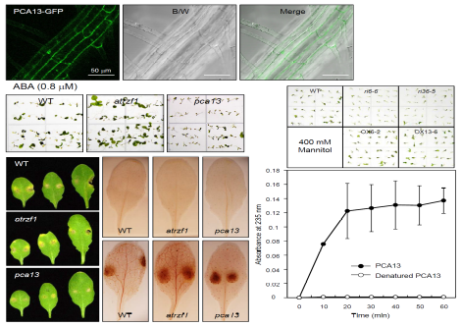
Recent Publications
- Ji-Hee Min et al. (2017) Arabidopsis basic Helix-Loop-Helix 34 (bHLH34) is involved in glucose signaling through binding to a GAGA cis-element. Frontiers in Plant Science 8:2100.
- Ah-Reum Kim et al. (2017) PCA22 acts as a suppressor of atrzf1 to mediate proline accumulation in response to abiotic stress in Arabidopsis. Journal of Experimental Botany 68:1797-1809.
- Moon-Soo Chung et al. (2016) Regulation of AtPGR expression by AtSTKL modulates glucose response in Arabidopsis. Plant Physiology and Biochemistry 104:155-164.
- Ji-Hee Min et al. (2015) The B-box zinc finger family AtCOL4 is a positive regulator of abiotic stress tolerance through the ABA-dependent manner in Arabidopsis. Journal of Integrative Plant Biology 57:313-324.
5. Hyun-Woo Ju et al. (2013) The atrzf1 mutation of the novel RING-type E3 ubiquitin ligase increases proline contents and enhances drought tolerance in Arabidopsis. Plant Science 203-204:1-7.

 Biography
Cheol Soo Kim is a faculty member in the Department of Plant Biotechnology at the Chonnam National University of South Korea. Kim focuses on researching the molecular genetic mechanisms underlying plant responses to adverse environments such as osmotic stress, drought and biotic stress. His work has led to the identification of genes for modifying the responses of crops to environmental stresses, which will ultimately lead to major contributions to agriculture and the environment. Kim and his colleagues have used the model plant Arabidopsis to create mutants that are “proline content alterative” (PCA). By characterizing the PCA genes, they have been able to describe a proline metabolism pathway that mediates the response of Arabidopsis to drought. Recently, the Kim lab has focused on the mechanisms of post-translational ubiquitination in environmental stress adaptation.
Email: cskim626@jnu.ac.kr

