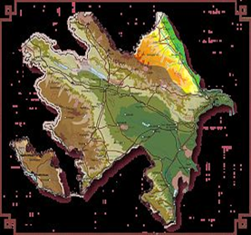

3.Budagov B.A. - Geomorphology of the northern slope of the southeastern Caucasus. Tr. Institute of Geography, Academy of Sciences of Azerbaijan SSR.

