A contradiction for law of energy conservation
M. Yusefzad, Amirkabir University of technology, 424 Hafez Ave, Tehran, Iran

Abstract
Statement of the Problem:
The term energy is so broad that a clear definition is difficult to write. Energy can be transformed from one type to another and transferred from one object to another, but the total amount is always the same (energy is conserved). However, in present paper it will be shown that there is a serious contradiction for law of energy conservation and mathematically, it will proof.
It is assumed that an electromagnetic wave with Eq. (1) and Fig. (1), which is a solution to Maxwell’s Equations [3].
(1) | $$E\left(x,t\right)={\vec{y}E}_{0}\cos\left(kx-ωt\right)$$  $$B(x,t)={\vec{z}B}_{0}cos(kx-ωt)$$
Where $E_{0}$ and $B_{0}$ are amplitude of electric and magnetic field respectively, k=2π/λ is the wavenumber, $ω$=2πƒ is the angular frequency, λ is the wavelength and ƒ is the frequency of the wave. Also, it is assumed that wave Eq. (1) is placed inside a frictionless ring Fig. (2) with cross-section A $A$. The characteristic of this ring is that the wave interference with itself each time it spins.
Consequently, the electromagnetic wave that is produced by the n interferences with previous waves in the ring with length L=mλ $L=mλ$, where m $m$ is an integer, is:
$${E\left(x,t\right)}_{n}={\vec{y}nE}_{0}\cos\left(kx-ωt\right)$$  $${B(x,t)}_{n}={\vec{z}nB}_{0}cos(kx-ωt)$$ | (2)
After n times, that n≫1, the amplified wave inside the ring can be represented as Eq.2. Therefore, the power of amplified wave inside the ring can be written as bellow [2]:

(3) | $$P_{circle}=Kn^{2}E_{0}^{2}{cos\left(kx-ωt\right)}^{2}{}$$

Where ${K=ε}_{0}Ac$.
The time required to exit the wave from the ring is t=L/c. With regarding that the amount of power and the applying time is given, it is possible to calculate output energy from system that is shown in Fig.2 [3].

$$E_{out}=\int_{0}^{\frac{L}{c}}{P_{circle}dt}=\int_{0}^{\frac{L}{c}}{Kn^{2}E_{0}^{2}{cos\left(kx-ωt\right)}^{2}{dt}}=\frac{Kn^{2}E_{0}^{2}}{2}\frac{L}{c}$$ | (4)

The amount of input energy $E_{in}$ to the system for the duration $T=\frac{nL}{c}$ is expressed as follows:
(5) | $$E_{in}=\int_{0}^{\frac{nL}{c}}{Pdt}=\int_{0}^{\frac{nL}{c}}{KE_{0}^{2}{cos\left(kx-ωt\right)}^{2}{dt}}=\frac{KE_{0}^{2}}{2}\frac{nL}{c}$$

By rewriting the law of energy conservation for system Fig. 2.

(6) | $$E_{out}=E_{in}⇒n=1$$

The result obtained in Eq. (6) absolutely is false, because, at first, it was assumed that n≫1.
Findings: - According to Eq. (6), one of the three following results can be extracted:
1- The energy conservation law is wrong and the amount of energy of a given wave, depending on the path in which it is located, can be increased over the time. This can be shown as follows.
(7) | $$E_{T}=nE$$
Where in Eq. (7), E is the energy of a moving wave in a non-repeat path and n is the number of interferences of a wave in the ring. Therefore, the total energy of a particle can be expressed as follows:
(8) | $$E_{T}=nmc^{2}$$
2- The wave speed is not constant and is linearly proportional to the number of interferences in the ring. This means that the wave speed increases at each interference and can be expressed as follows:
(9) | $$c_{n}=nc^{}$$

Image
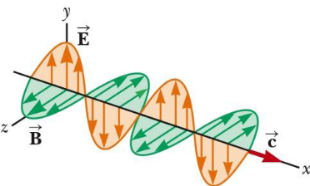
Fig1. An electromagnetic wave
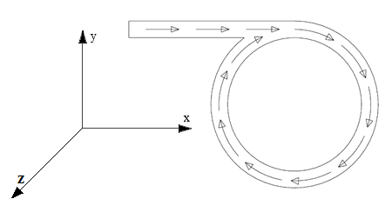
Fig. 2. Circular path for interference a wave with itself

Biography
Master of Science in Mechanical Engineering  Amirkabir University of Technology, Tehran, Iran. | 
Bachelor of Science in Mechanical Engineering
Science & Technology University, Tehran, Iran.
I am working in the field of laser and optic for more than two recent years. The result of these years is a patent that is called “Laser Resonance Amplifier”. This idea is registered in State Organization for Registration of Deeds and Properties (Intellectual Property Center) in Iran. Also the method is submitting for USPTO.

Email: yusefzadib@gmail.com

DETAILS OF PRESENTING AUTHOR
Full name: Mahdi Yusefzad
University/Industry/Organization name: Amirkabir University of technology
Designation: Researcher
Country: Iran
Electronic address: yusefzadib@gmail.com
Contact number: +989126952692
Alternate contact number: +982144515222
Twitter account: -
Linked In account: Mahdi Yusefzad
Track name: Track 12-2 (Collider Physics)
Presentation: Oral
Research interest:
- Laser amplifiers; optical circuit to amplify laser beams; optical elements.
- Laser machining of super alloy; analyzing beam profile; pulse duration; power & pulse optimization.
- MSC level mechanical engineer with academic background in mechanical vibration, dynamics, dynamic structure and modal analysis.

