A culturally adapted and language specific pain management programnme
Mohammad Shoiab BSc MCSP (Pain Specialist Physiotherapist), Dr Romy Sherlock (Clinical Psychologist), Dr Razia Bhatti Ali (Clinical Psychologist), Dr Asim Suleman (GPwSI) & Mohammed Arshad (Chaplaincy Manager)
Bradford Teaching Hospitals NHS Foundation Trust (Bradford, West Yorkshire) – United Kingdom

Abstract (300 word limit)
Statement of the Problem: Some patients are unable to sufficiently comprehend the Pain Management Programme (PMP) in English, not only due to language, but cultural differences. Some have a belief that long term pain is the result of punishment from Allah (God), or that it should be endured and not relieved. One of the cultural values dictate that the sufferer should be looked after by family members, further reinforcing a dependence and physical deconditoning¹. Acceptance is the main obstacle in engaging with this patient group, utilising cultural/religious awareness as a way of breaking down barriers, increasing patient compliance and engaging patients with long term self-management of living with pain². Methodology & Theoretical Orientation: 6 patients started the 8 session PMP (1 male, 5 female). The PMP included an overview from the Trust's Muslim Chaplain of his role on the PMP, and how Islamic teachings promote self-management, compassion, physical activity and dispelling of cultural myths. The GP discusses pain medication management within holistic care, the physiotherapist emphasises the biopsychosocial approach of the PMP. SEQ and HADS outcome measures were administered pre and post PMP. Findings: Patients made improvements in self-efficacy, anxiety and depression following the programme. There was a statistically significant change in anxiety (t(3)=4.7, p< 0.01), depression (t(3)=5, p< 0.01), and self-efficacy (t(3)=-8.18, p< 0.001) following the programme
The Reliable Change Index (RCI) was used, and this found that 25% of patients made a reliable change in anxiety
and 75% of patients made a reliable change in depression. Conclusion & Significance: Preliminary results suggest there is value in delivering a language specific and culturally adapted MDT led PMP for the South Asian community. It has been able to engage patients to break down cultural barriers but also increase awareness of the cultural perception and experience of persistent pain.
Image
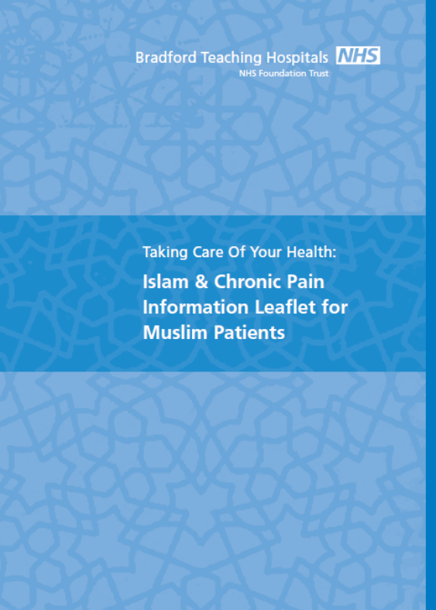
References
¹ Fletcher, G (2006) Enhancing care for Muslim patients in Bradford. Diversity in Health & Social Care, 3 (2), pp. 154-­‐15
² Maki, D., Critchley, D., Watson, P., and Lempp, H (2014) An exploration of Arab patients' experiences and beliefs of long-­‐term lower back pain in Bahrain. British Society for Rheumatology and British Health Professionals in Rheumatology Annual Meeting April 2014 Liverpool, UK
Publications
Shoiab, M., Sherlock, R., Ali, R.B., Suleman, A. and Arshad, M (2016) A language specific and culturally adapted pain management programme. Physiotherapy ,102 (Suppl 1) , e197 - e198
Shoiab, M., Sherlock, R., Ali, R.B., Suleman, A. and Arshad, M (2016) A Pilot Study of an Urdu Speaking Culturally Adapted Multi-Disciplinary Pain Management Programme. British Journal of Pain, 10(2), Suppl1, p.58-59
Shoiab, M. (2016) Found in Translation. Pain Matters, Issue 65, p.13, Pain Concern: Edinburgh



Biography
Mohammad Shoiab completed his undergraduate physiotherapy training at the University of Bradford in 2009. He has spent several years gaining experience within a number of specialties within Bradford Teaching Hospitals NHS Foundation Trust. He began to develop a clinical interest in the field of pain management, particularly, how persistent pain patients of different cultural backgrounds responded differently to the concepts of pain self-management, despite accounting for language barriers alone. Mr. Shoiab established the UK’s first multi-disciplinary culturally adapted and language specific pain management programmer. He teaches to junior clinicians within his service and nationally. In addition, this includes lectures at an undergraduate and postgraduate across the UK

Email: shoiab@hotmail.co.uk
Mobile: +447902 116222
Twitter: https://twitter.com/shoiab1
Linkedin: https://uk.linkedin.com/in/mohammad-shoiab-925b3b108

