

The explaining of “magic” nuclear numbers by a
quasi-crystalline nuclear model, of possible cold genesis
PhD. Marius Arghirescu* *State Office for Inventions and Trademarks, OSIM, RO

Abstract
Statement of the Problem: The paper is based on a cold genesis theory of the author, (CGT), in which the proton results as formed by a neutral N^{p} cluster of degenerate electrons and an attached positron with degenerate spin and magnetic moment. Also, the neutron results in a “dynamide” model, as formed by a proton and a degenerate electron with degenerate spin and magnetic moment, with its centroid incorporated in the proton quantum volume and rotated around the proton center.
In the paper is shown that the stable nuclei with "magic" or semi-“magic” number of protons or and neutrons: 2; 8; 20; 28; (32, 36, 40); 50; 82; 126, are retrieved by a quasi-crystalline nuclear model of ground state T→0K, as sum of quasi-crystalline forms with integer number of alpha particles: A= Σ(4n²), with 4n² nucleons and 2n² protons- for the double magic nuclei, having small deformation parameter, the nucleus ²⁰⁸Pb₈₂ corresponding to an initial form: ²⁰⁸N₁₀₄ (A = 4x(4² + 6²)) in which 22 attracted α⁰-clusters were transformed into α⁺ clusters, by β⁻ radiation emission. This possibility may be explained by the dynamide model of neutron of CGT by the hypothesis of α⁰- neutron clusters cold forming at T→0K and the generating of small square forms of neutral α⁰-particles which are transformed into nuclei by α⁰-particles transforming into α⁺ and α²⁺ particles which attract new α⁰-particles, the process being repeated until the forming of double magic nuclei or of nuclei with “magic” mass number, which may attract nucleons or α⁰-clusters transformed thereafter into α⁺ clusters.
The correspondence of the binding energy with the ‘drop’ nuclear model may be explained by a binding energy value of the quasi-crystal nucleus close to those of a ‘drop’ form at the ‘melting’ nuclear temperature, resulted as consequence of the nucleons vibrations and of the nucleus’ vibrations/oscillations, higher to the deformed nuclei.
The proposed model predicts that the nuclei with A = 4(5² + 7²) = 296, A = 4x(6² + 2x4² + 2x2² = 304) nucleons and Z = 114÷120 are more stable in the ground state than the forms: 114/184, 120/182 predicted with the “nuclear shells” model. Also, it results as possible the forming of cold semi-“magic” nuclei with hexagonal symmetry, with the mass number A = Σ(3x4n²), (n= 1…5).
Keywords: crystalline nuclear model; magic nuclei; dynamide neutron model; tetra-neutron; cold genesis

Images
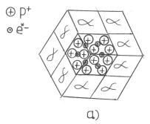
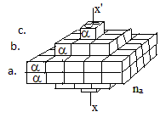

Fig.1, a, b
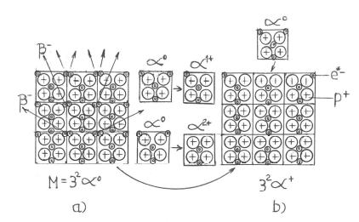 Fig.2, a, b

Figure 1,a, b, –“Magic” forms of a quasi-crystal nucleus
Figure 2-The forming of a nuclear quasi-crystalline form of α⁰ -clusters by the forming of a first square form of α⁰ –clusters a) and its transforming into a nuclear square form b) in accordance with the “dynamide” neutron m.

Recent Publications (minimum 5)

1. M. Arghirescu, A Quasi-Unitary Pre-Quantum Theory of Particles
and Fields and Some Theoretical Implications, IJHEP, July,
80-103, (2015)
2. M. Arghirescu, “, ‘The Cold Genesis- A New Scenario of Particles
Forming’ , PAIJ, Vol.1 Issue 5 – 2017, pp. 1-5
3. M. Arghirescu, “, The nuclear force explaining by a bag model
resulted from a vortexial, cold genesis model of nucleon”,
Phys.&Astron. Internat. Journ., Vol. 2(4),( 2018), pp. 349-358
4. M. Arghirescu, ‘The Explaining of the Elementary Particles Cold
Genesis by a Preonic Quasi-Crystal Model of Quarks and a Pre-
Quantum Theory of Fields’, IJHEP, Vol.5(1), (2018),12-22
5. M. Arghirescu , „Observations Concerning the Mass Variation in
a Galilean–Type Relativity”, International Journal of High Energy
Physics, IJHEP, 5(1): (2018), pp. 44–54.
6. M. Arghirescu, ‘The Possibility of Particles Forming from a Bose-
Einstein Condensate, in an Intense Magnetic or Gravitational
Field’, IJHEP, Vol. 5, No. 1, (2018), pp. 55-62.

Biography
Marius Arghirescu is an independent scientist in physics and inventor and has a doctorate in science and engineering of materials, from Politechnica University- Bucharest. He works as patent examiner at State Office for Inventions and Trademarks in Romania. He has published three books and more than 30 papers as single author in national and international reviews and has more than 30 patented inventions. He is associate member of GCI-DLMFS of Romanian Academy and the author of a cold genesis theory of matter, published in the book: “The Cold Genesis of Matter and Fields” and in some additional papers.

Presenting author details
Full name (As per the passport): Arghirescu S. Marius
Organization name: State Office for Inventions and Trademarks, OSIM, RO
Country: Romania ; Mobile number: +40745795507 ; Email: maris3a@yahoo.com
Session name /number: 5-nth Internat. Congress on Physics , Paris 2022 / track 5 ;
Category : Poster presentation
Your profile page URL in your department: www.osim.ro ; Year of birth: 1959 ; Linked In/Facebook/twitter account:

