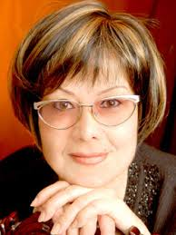
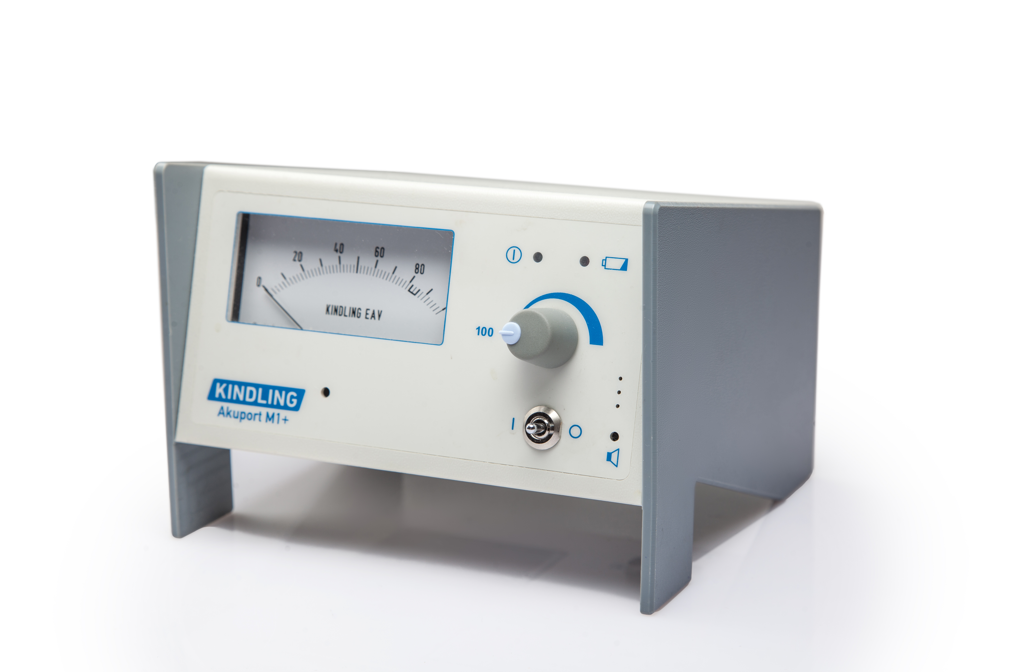

Paste your Logo here

APPLICATION OF UNUSUAL PROPERTIES OF LOW LEVEL LASER RADIATION FOR TRANSFER INFORMATION FROM MEDICINE TO PATIENT'S BODY IN THERAPY OF PATIENTS WITH SOME VIRAL DISEASES

Research Institute of Virology, Tashkent, Uzbekistan

This poster presents the results of study of torsion field application in medicine Torsion fields were used with the aim to transfer information from the medicine to the patient’s body. The group of patients with different chronic conditions such as chronic hepatitis B and C virus infections, patients with cytomegalovirus infection, patient with Epstein- Barra infection were treated with application of laser light guide, where the source of light was low level laser radiation.The patients were under the observation in the Out-Patients department of Research Institute ( Uzbekistan) and the approach to therapy towards the patients was the same: torsion fields formed by the radiation of low level laser therapy device. Into the field of radiation, the medicine was placed with the aim to be transmitted to the patient‘s body. Our approach of the therapy has patented The obtained results has shown that under the torsion field, formed with the help of laser light guide, the distant transmission information from medicine to human body occurred. The method of therapy is safe and might be used to treat patients with chronic viral diseases. In some cases, it results in complete elimination of the virus infection( hepatitis C virus infection). In patients with a virus pathology of the liver, this therapy leads to improvement of quality of their life and contributes to prevention of development of such terrible complications of chronic viral such as cirrhosis of liver and cancer of the liver.

Biography

Naylya Djumaeva has completed her Phd at the age 40 years from Institute for Epidemiology, Microbiology and Infectious Diseases (Uzbekistan) Naylya works as the Consultant – Neurologist at the Research Institute of Virology(Uzbekistan) She is the author of 36 papers including reputed journals and she has 2 patents.

