DESIGN AND PRODUCTION OF A COOKER WITH PHOTOVOLTAIC ENERGY
I. Atmane¹, S. Talbi¹, K. Kassmi^{1,3*}, O. Deblecker², N. Bachiri³

¹Mohamed First University, Faculty of Science, Department of Physics, Laboratory of Electromagnetic, Signal Processing & Renewable Energy LESPRE, Team Electronic Materials & Renewable Energy EMRE, Oujda, Morocco.
² University of Mons (UMONS), Faculty of Engineering, Electrical Power Engineering Unit, Mons, Belgium
³Association Humain and Environnement of Berkane (AHEB), Berkane, Morocco.
*Corresponding: khkassmi@yahoo.fr
Abstract:
Currently, the problem of deforestation and the degradation of the environment is very worried. To mitigate and limit the resulting effects, governments and NGO organizations, which fight for the protection of the environment, have set up awareness and promotion programs to use green solar energy (photovoltaic and thermal) for cooking in homes. Solar thermal ovens have been proposed, but their performances and performances do not meet the needs of users (rural or urban).
In this context, in collaboration with the Polytechnic Faculty of MONS (Belgium) (project: Wallonia-Brussels International WBI, 2018-2022, N ° 4.2), socioeconomic sectors and civil society (National Initiative for Human Development INDH (N ° 29 / 2017) from the province of Berkane, Association AHEB), we are conducting research to propose innovative solar cookers (ovens and hotplates) equipped with remote control and supervision equipment, using photovoltaic energy (Figure 1).
In this paper, we present the results of the progress of the work on the prototype (Figure 1) powred by photovoltaic energy. The main results show:
- 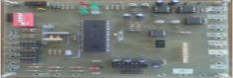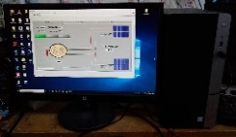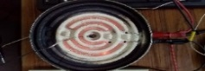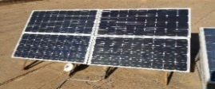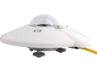In the case of hot plates: we have sized, according to the nature of the PV panels and the thermal resistance used, a heating plate, powered by a power of 230 W, to heat 1 liter of water and 0.33 liter of the oil . The prototype set up provides for an illumination of 730W / m², a temperature of 500 °C after 30 seconds, a rapid rise in the temperature of water and oil of 10 °C / min, a temperature of baking greater than 200 °C and a thermal efficiency greater than 70%. Comparing these results compared to those obtained on conventional solar furnaces of the thermal box type, we deduce very interesting performances on our prototype: improvement of the climbs of temperature of 75%, improvement of temperatures of cooking of 164% and the thermal efficiencies 16%.
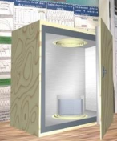
- In the case of furnaces of the box type: The results obtained show, under an illumination of 770 W/m², ambient temperature of 18 °C and electrical power of 340 W, temperatures of the thermal resistance of 686 °C, temperatures and thermal efficiencies of the oven respectively 200 °C and 77%. Heating one liter of water indicates a boiling time of 50 minutes and a complete evaporation of the order of 3 hours. The comparison between the experimental results and the simulated results shows a good agreement and consequently the validation of the operation of the thermoelectric model of the box-type furnace proposed, operating with photovoltaic energy inside the hearths.
Figure 1: Prototype of the oven and heating plate with photovoltaic energy.

Keywords : Box cooker; Solar energy; Heating temperature; Electric power ; Thermal efficiency.

