Tuning Interdependence in Human-Machine Systems to Produce Autonomy
W.F. Lawless, Paine College, USA

Abstract (300 word limit)
Closed-system models are logical, relatively easy to build and operate, and generate the results desired (e.g., game theory); but only uncertainty intrinsic to these models can be studied; and the data from closed-system models consists of independent actions or observations that do not aggregate to replicate social effects (viz., with i.i.d. data), precluding the derivation of autonomous teams or systems. In contrast, open-system models are not intuitive, difficult to manage, and cannot disentangle action and observation except, characteristically, when measuring social effects. However, interdependence theory has guided us to the following findings: that the best teams are highly interdependent; that the best teams of interdependent individuals outperform the best teams composed of the same individuals acting independently; that tradeoffs between structure and performance determine the entropy production of a team’s structure (e.g., structural entropy production, or SEP) and its performance (e.g., maximum entropy production, or MEP). Tradeoffs lead to several results; e.g., that the more dependent are the members of a team on their team’s performance, the greater the potential sum of the whole; that suppressing information in a system can deceive observers into believing that an organization is well-run, but rendering it unable to innovate, motivating its need to steal secrets; that competition between teams exposes vulnerabilities in an opponent’s team; that the best teams are constituted of orthogonal roles; that deception is a major factor across all aspects of social autonomy, compromising even machine learning algorithms; and that structures of the most successful, resilient and adaptive systems tune themselves to produce minimum SEP and maximum MEP, motivating trial-and-error mergers, alliances, spin-offs, and divorces autonomously. We review these aspects of theory, results and future research, including value (bistable) information.

Image

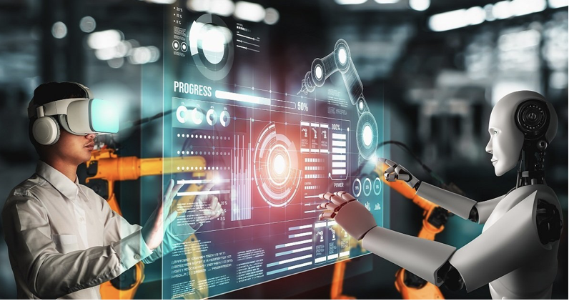

Figure 1. Special Call in Entropy: "An Entropy Approach to Structure & Performance of Interdependent Auton. Human Machine Teams & Systems”; www.mdpi.com/journal/entropy/special_issues/Human_Machine_Teams
Recent Publications (minimum 5)
- Lawless, W.F. (2017), The entangled nature of interdependence. Bistability, irreproducibility and uncertainty, Journal of Mathematical Psychology, 78: 51-64.
- Lawless, W.F. (2017), The physics of teams: Interdependence, measurable entropy and computational emotion, Frontiers of physics. 5:30. doi: 10.3389/fphy.2017.00030.
- Lawless, W.F. (2019), Interd. Autonomous Human-Machine Teams: The Entropy of Teams, Not Individuals, Advances Sci., Entropy, 21(12), 1195; https://doi.org/10.3390/e21121195
- Lawless, W.F. (2020), Quantum-Like Interdependence Theory Advances Autonomous Human–Machine Teams (A-HMTs, Entropy, 22(11), 1227; https://doi.org/10.3390/e22111227
- Lawless, W.F., Mittu, R., Sofge, D.A., Shortell, T. & McDermott, T.A. (2021). Systems Engineering and Artificial Intelligence. Springer. https://link.springer.com/book/10.1007/978-3-030-77283-3
- Lawless, W.F., Llinas, J., Sofge, D.A. & Mittu, R. (2021). Engineering Artificially Intelligent Systems. Springer LNCS. https://link.springer.com/book/10.1007/978-3-030-89385-9


Biography (150 word limit)
W.F. Lawless blew the whistle on Department of Energy’s mismanagement of military radioactive wastes. DOE invited him onto its Savannah River Site citizens advisory board where he sponsored closing the first two high-level radioactive waste tanks. He is the lead editor of seven books (Springer 2016; 2017; 2021; CRC 2018; Elsevier 2019; 2020 [Elsevier nominated the latter to ASIS&T for Information Science book of the year in 2020]; LNCS, 2021). His special issue on “human-machine teams and explainable AI” was published in AI Magazine (2019). He organized twelve AAAI symposia at Stanford. He is on Office of Naval Research's Boards for Science of AI and Command DM. He is lead editor: Frontiers in Physics Interdisciplinary Approaches to the Structure and Performance of Interdependent Autonomous Human Machine Teams; and Entropy’s An Entropy Approach to the Structure and Performance of Interdependent Autonomous Human Machine Teams and Systems.

Email: w.lawless@icloud.com

Notes/Comments:

