STEM Students’ Perceptions on On-Line Teaching and Learning During the COVID-19 Pandemic: Challenges and Successes
Jodye I. Selco, Cal Poly Pomona, California, USA
Mariam Habbak, Cal Poly Pomona, California, USA

Abstract (300 word limit)
Statement of the Problem: The rapid switch to emergency on-line instruction during the pandemic changed life in many ways. For STEM students, there were many hurdles to overcome and some unintended helpful side effects. To discover STEM students’ perceptions to the changes in their university education, they were surveyed in Fall of 2020 to ask about their initial and ongoing challenges and successes. Findings: Students reported that they felt disconnected from learning and the academic community, had difficulties in adjusting to the “new normal”, and that the quality of their education had diminished. On the other hand, most students benefited from the flexibility and convenience of online instruction such as the availability of course resources including recorded class sessions, which increased their academic productivity. Student responses along with some problem-solving suggestions will be discussed.

Image
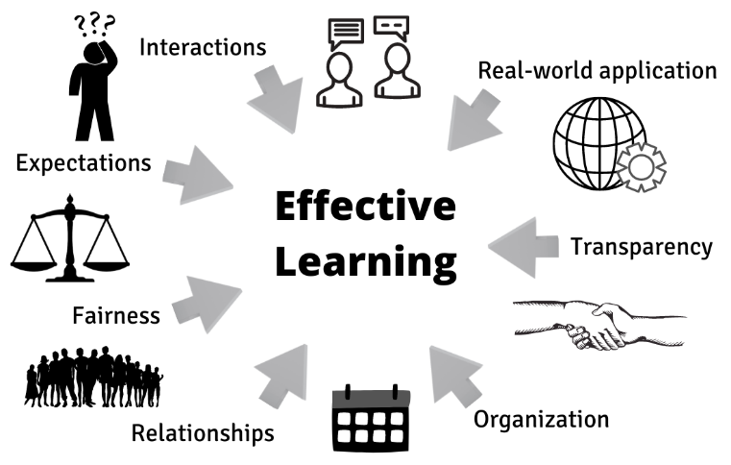
Figure 1: A synthesis of the results of the survey showing that students requested transparency about course objectives and deadlines, organization of Learning Management System site, fairness in grading, reasonable expectations, increased human interactions, the loss of relationships, and the need for real-world applications for the topics being presented.
Recent Publications (minimum 5)
- SelcoJI, HabbakM (2021) STEM Students’ Perceptions on Emergency Online Learning during the COVID-19 Pandemic: Challenges and Successes. Education Sciences 11:799.
- SelcoJ (2020) Chemistry Experiments at Home – Acid-Base Reactions. California Classroom Science, a publication of the California Association of Science Educators
- SelcoJI (2020) Using Hands-On Chemistry Experiments While Teaching Online. Journal of Chemical Education. 97:2617-2623.
- MuljanaPS. SelcoJ, FeldmanR, GastonT, ChoiB (2020) When Chemical Bonding is Perceived Simple and Interesting: The Design and Development of a Learning Object. International Journal of Designs for Learning, 11(3):148-161.
- SelcoJI (2021) Can Cheating Be Reduced In a Take-Home Exam in Chemistry? CASE California Classroom Science 33:Issue 5.

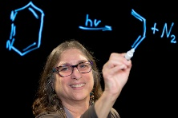Biography (150 word limit)
Paste your Logo here
Jodye I. Selco is a Professor at California State Polytechnic University, Pomona (Cal Poly Pomona) in the Center for Excellence in Mathematics and Science Teaching (CEMaST) and teaches in the Department of Chemistry and Biochemistry. She has a Ph.D. in chemistry from Rice University (1983) and a B.S. in chemistry from University of California, Irvine. Her research interests are in science education K-20. Professor Selco has developed laboratory experiments and studied their effectiveness on student learning.
Email: jiselco@cpp.edu

Notes/Comments:

Presenting author details
Full name: Jodye Selco
Contact number: 1-562-696-7639 or on campus: 1-909-869-4552
Twitter account: @drselco
Linked In account: Jodye Selco
Session name/ number: Applied Science
Category: (Oral presentation/ Poster pesentation

