Putative Martian Microbes Formed Plentiful Ooids on Mars.
Last updated on March 14, 2018
Abstract
NASA’s Mars Rover Curiosity discovered plentiful indigenous spherical ooids at High Dune and Namib Dune in Bagnold dune field, Gale Crater, Mars. The spherical Martian ooids contain nuclei and range from around 0.15 mm to 0.5 mm in diameter. Colors of the spherical Martian ooids are various, including white, yellow translucent, green, gray, and yellow. The spherical Martian ooids should have been formed by microbes, because ooids of Earth have recently been found to be formed by microbes and microbial borings are found in ooids of Earth and of Mars. There is no evidence that proves ooids are formed by agitated water.
Keywords: Martian microbes; Martian ooids; Past life on Mars

Introduction
NASA’s Mars Rover Curiosity visited Bagnold dune field in Gale Crater, Mars, to study sands there from December 2015 to February 2016 (from Sol 1182 to Sol 1260) (See Figure 1 and http://www.hou.usra.edu/meetings/lpsc2016/pdf/2298.pdf ).

Figure 1: Route map of Mars Rover Curiosity from Sol 1172 to Sol 1260

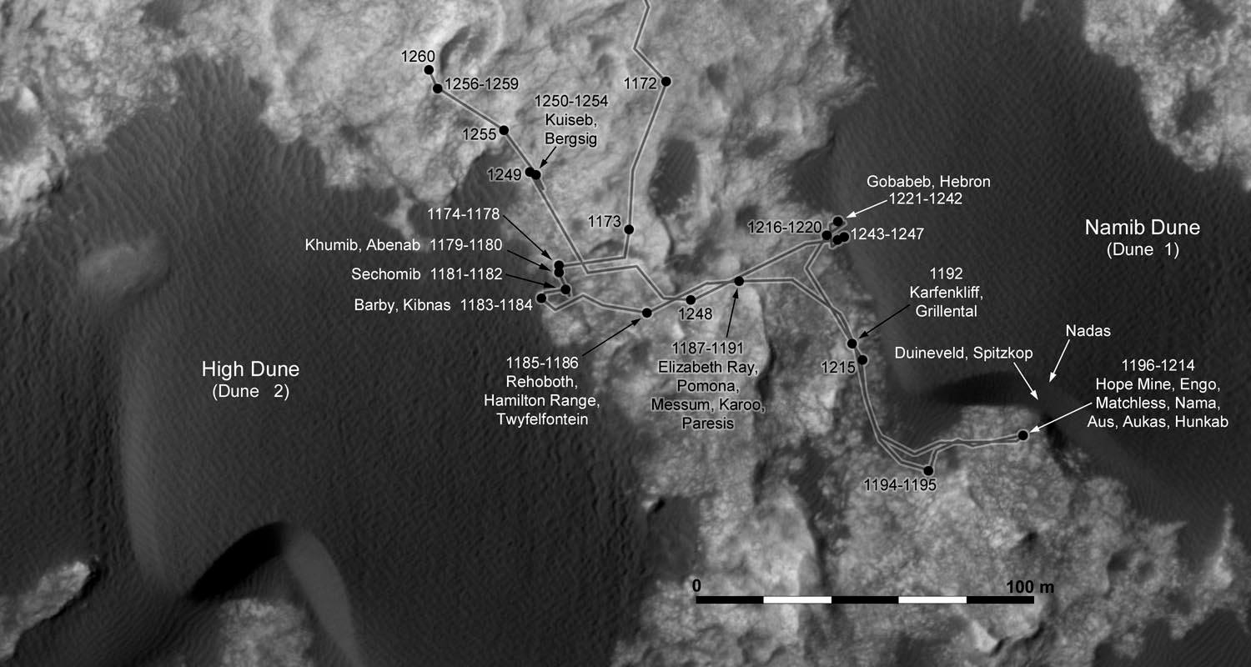

Geological context of Bagnold Dune is seen in these three photos: http://mars.jpl.nasa.gov/msl/multimedia/images/?ImageID=7658
http://mars.nasa.gov/msl/multimedia/images/?ImageID=7640
http://photojournal.jpl.nasa.gov/catalog/PIA16064

During its visit there, Curiosity Rover did a lot of science on Martian sands there, including the morphology, mineralogy, and chemistry of the sands. This article focuses on the rover’s discovery of putative ooid sand there. Curiosity rover used its Mars Hand Lens Imager (MAHLI) to acquire a lot of microscopic images of the sands there. Many of the microscopic images show ooids, some of which are marked in the following figures in the result section below.

Result

Figure 2: Martian ooids at High Dune

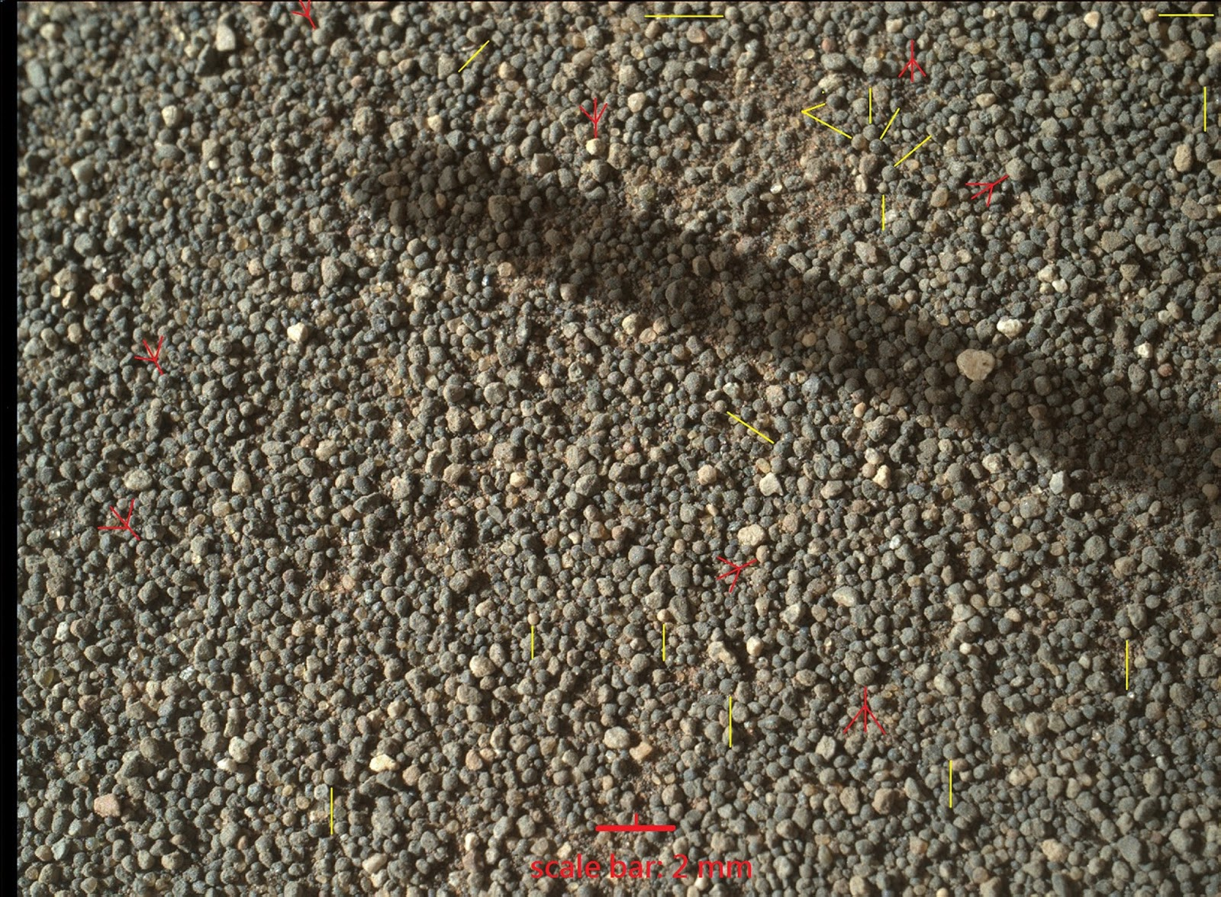

Figure 2 was acquired by NASA's Mars rover Curiosity on Dec. 3, 2015 (Sol 1182) near High Dune, Gale Crater, Mars. Eight red arrows and 17 yellow lines mark ooids. They are about 0.5 mm in diameter. Scale bar: 2 mm. Image width: ~3.3 cm. Above figure in the largest size:

https://www.flickr.com/photos/fossil_lin/30445874575/sizes/o/
Image Credit: NASA/JPL-Caltech/MSSS

Image source: mars.nasa.gov/msl/multimedia/raw/?rawid=1182MH00036500104...

Location: at the lower left in http://i.imgur.com/VK79Uz2.jpg

For comparison with ooids of Earth that resemble Martian ooids, see Figure 8 and photos in http://wretchfossil.blogspot.tw/2016/01/earthly-ooids-for-comparison.html .

Figure 3: Well-preserved ooids at Namib Dune

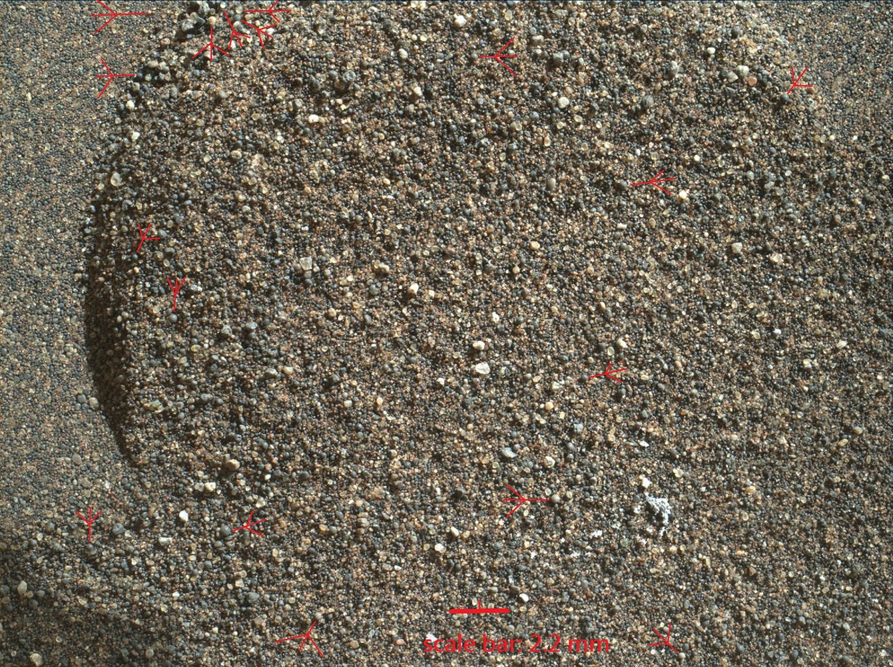

NASA's Mars Rover Curiosity acquired the above microscopic image (Figure 3) on Jan. 19, 2016 (Sol 1228) at Gobabeb in Namib Dune in Bagnold dune field, Gale Crater, Mars. Seventeen red arrows point to well-preserved ooids. The ooids measure roughly about 0.2 mm to 0.5 mm in diameter. Scale bar: 2.2 mm. Image width: ~3.5 cm. Above figure in the largest size:
https://www.flickr.com/photos/fossil_lin/30409147796/sizes/o/

Image Credit: NASA/JPL-Caltech/MSSS

Image source: mars.nasa.gov/msl/multimedia/raw/?rawid=1228MH00016300004...

Context: beside the scoop trench in

http://mars.jpl.nasa.gov/msl/multimedia/images/?ImageID=7658

Figure 4: Well-preserved ooids in sieved sample

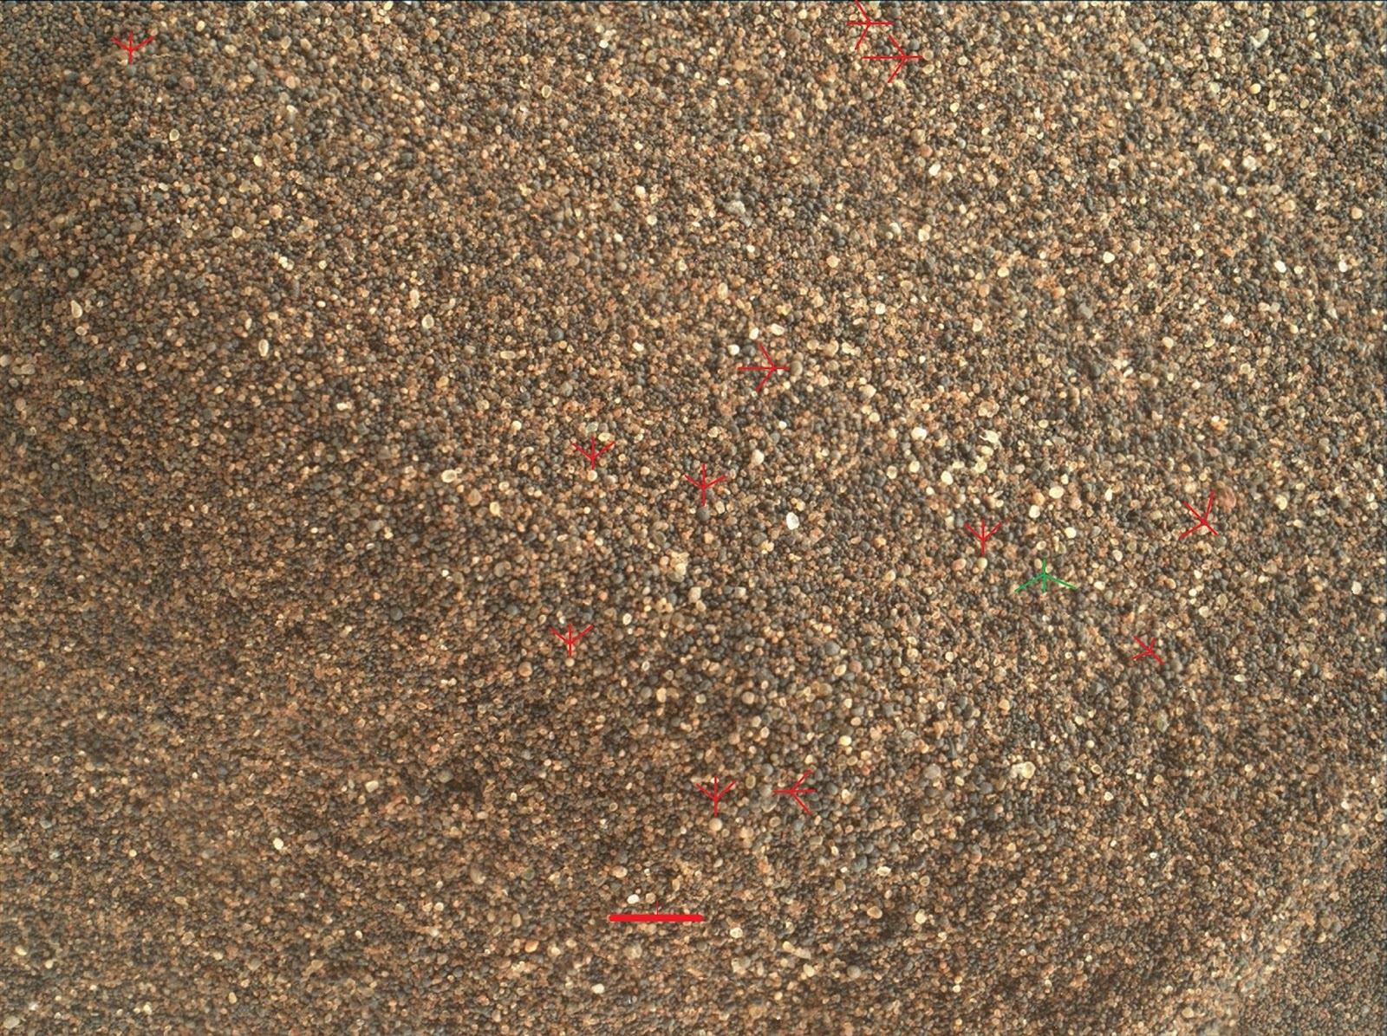

Above figure (Figure 4) in the largest size:
https://www.flickr.com/photos/fossil_lin/30445873175/sizes/o/
NASA’s Mars Rover Curiosity acquired the above microscopic image on Jan. 19, 2016 (Sol 1228) at Gobabeb in Namib Dune in Bagnold dune field, Gale Crater, Mars. Twelve red arrows point to well-preserved ooids. These ooids are around 0.15 mm in diameter, as they have been sieved with a mesh of 0.15 mm holes. Scale bar: 1.8 mm. Image width: ~2.8 cm. The rover dumped the scooped and sieved particles onto the ground after analyzing similar particles for their chemistry and mineralogy in its laboratory instruments. Image Credit: NASA/JPL-Caltech/MSSS

Image source:
mars.nasa.gov/msl/multimedia/raw/rawid=1228MH00017000004...

Context: Dump Pile A in http://planetary.s3.amazonaws.com/assets/images/4-mars/2016/20160210_MAHLI_1241_Namib_sample_area.jpg

Additional images of well-preserved ooids at Namib Dune:

http://wretchfossil.blogspot.tw/2016/02/really-great-science-at-namib-dune-mars.html

http://wretchfossil.blogspot.tw/2016/02/mars-rover-dumped-ooids-onto-rock.html

Figure 5: Most particles in this photo are ooids.

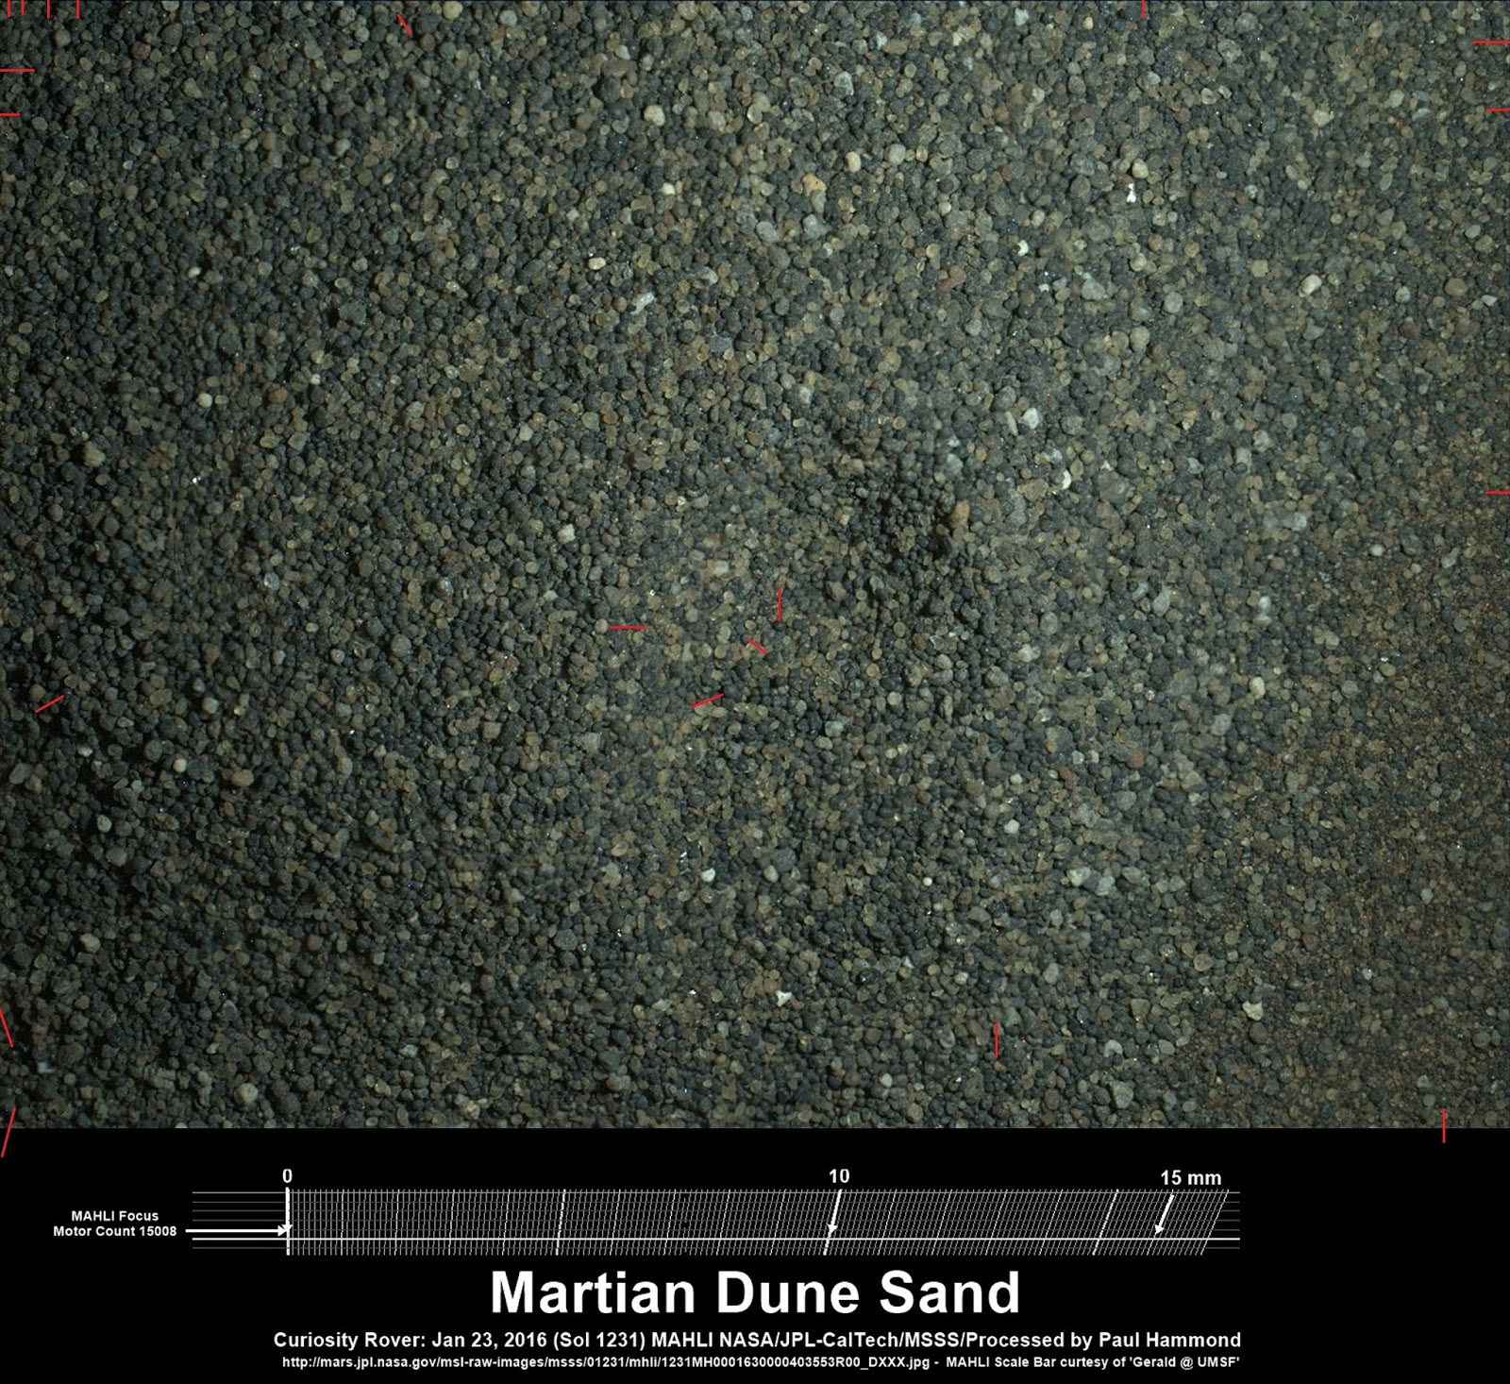

NASA's Mars Rover Curiosity acquired the above image (Figure 5) with Mars Hand Lens Imager (MAHLI) on Jan. 23, 2016 (Sol 1231) at Gobabeb in Namib Dune in Bagnold dune field, Gale Crater, Mars. Most of the particles in this image are eroded ooids. Red lines mark some of the ooids. They measure roughly 0.2 mm to 0.4 mm across. Image width: ~2.8 cm. Largest-sized figure:

https://www.flickr.com/photos/fossil_lin/30445875115/sizes/o/
Image Credit: NASA/JPL-Caltech/MSSS

Image source: www.flickr.com/photos/105796482@N04/24483811912/

NASA's image: http://mars.jpl.nasa.gov/msl/multimedia/images/?ImageID=7659

Context: Dump Pile B in http://planetary.s3.amazonaws.com/assets/images/4-mars/2016/20160210_MAHLI_1241_Namib_sample_area.jpg

Figure 6: Geological Context for Ooids at Namib Dune

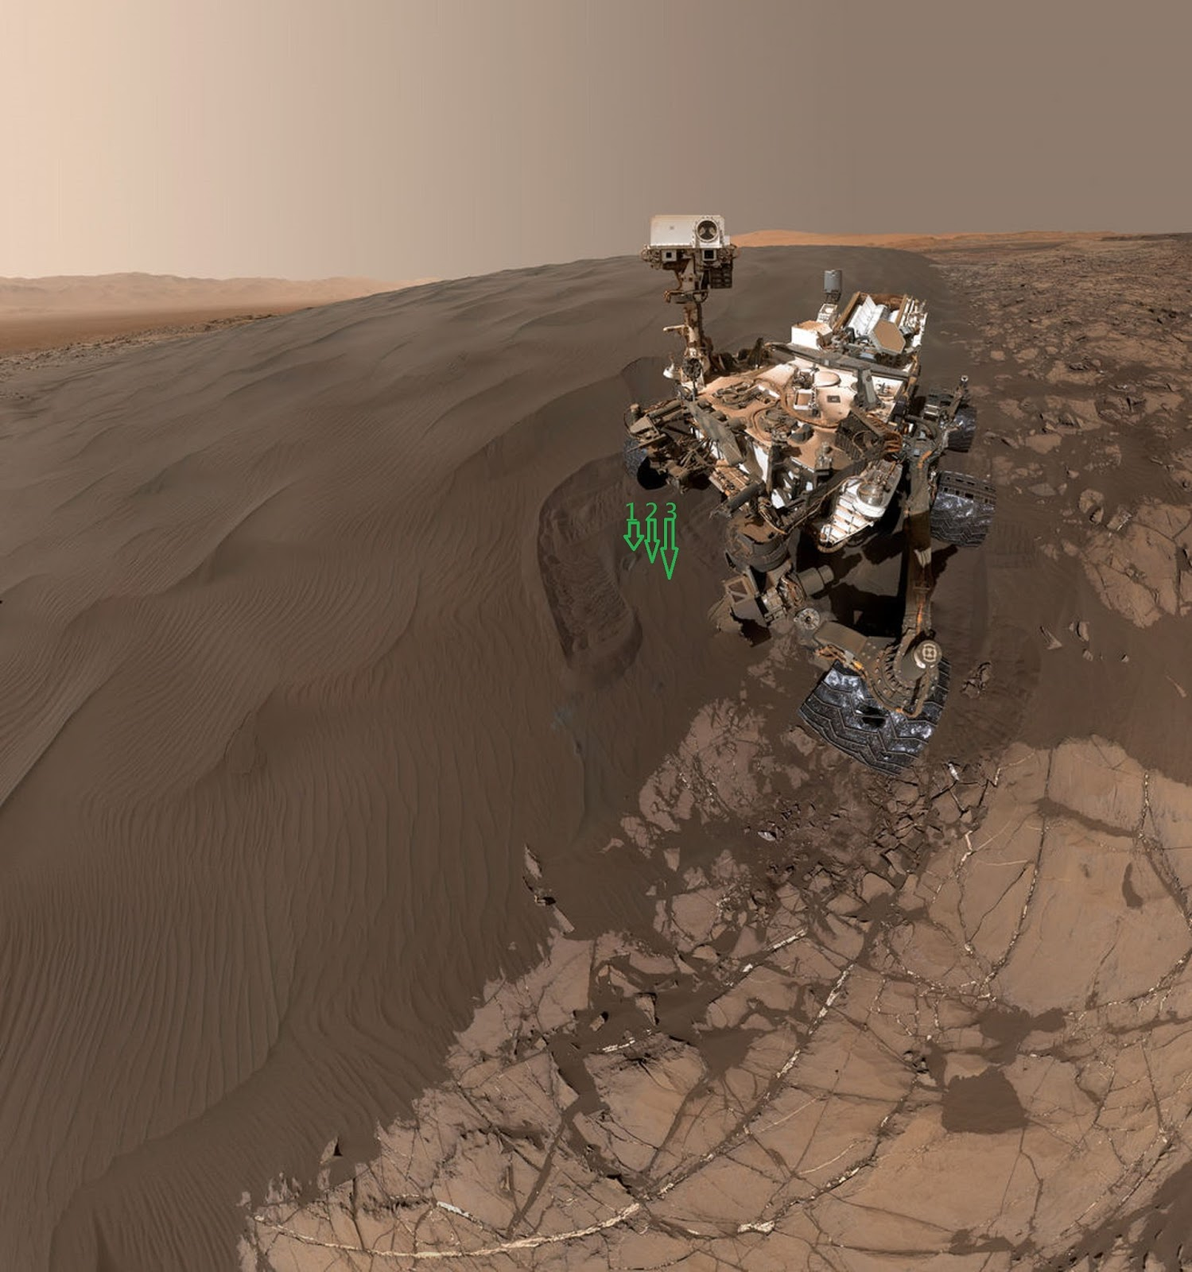

Figure 6. Three green arrows point to three spots at Gobabeb, where Mars Rover Curiosity scooped samples for chemical and mineralogical analyses with onboard instruments SAM and CheMin. After analyses, some samples were dumped onto ground and imaged with Mars Hand Lens Imager. The material imaged in Figures 3, 4, and 5 are from arrow 1 (Figures 4 & 5) and arrow 2 (Figure 3). Image Credit: NASA/JPL-Caltech/MSSS
NASA’s full-sized image with description:
http://mars.jpl.nasa.gov/msl/multimedia/images/?ImageID=7658

Figure 7: Microbes bored holes in these ooids.

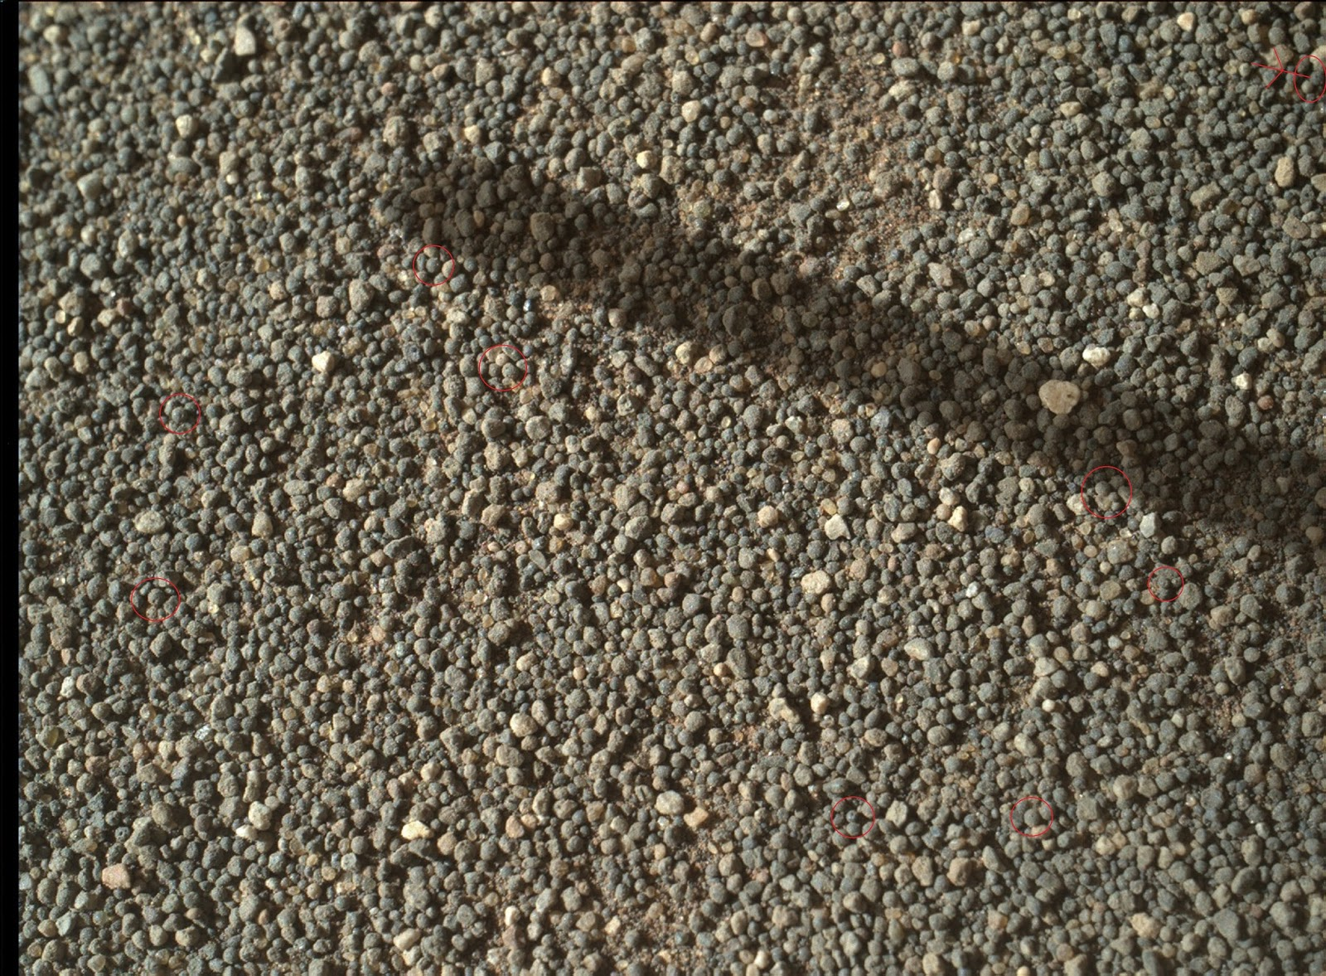

Figure 7. Microbes of Earth often bore holes in ooids (Ref. 1, notes 1, 2, 3). Microbes on Mars did the same thing in this figure (Figure 7), which is the same as Figure 2 above. In the red circles are Martian ooids with holes bored by Martian microbes. Such borings prove indirectly the existence of microbes. Image width: ~3.3 cm. The largest-sized figure:
https://www.flickr.com/photos/fossil_lin/24749890260/sizes/o/

Context: the left side in http://i.imgur.com/VK79Uz2.jpg

Image Credit: NASA/JPL-Caltech/MSSS

Image source: http://mars.nasa.gov/msl/multimedia/raw/?rawid=1182MH0003650010402637C00_DXXX&s=1182

More evidence for microbial borings:
http://wretchfossil.blogspot.tw/2016/04/more-martian-microbes-boring-holes-in.html

Note 1: “The ooids have the same pattern of microboring alteration across the region. The surface and outer cortex of the ooids are punctuated with unfilled microborings, whereas the inner cortex contains two morphologies of aragonite cement filling the microborings.” (quoted from the abstract of article in Ref. 1)

Note 2: “Examination of such micritic ooids by scanning electron microscopy often shows evidence of microbial borings later filled by fine cement.” (quoted from Wikipedia article on ooids)

Note 3: Example of Earthly microbes boring holes in ooids:

http://wretchfossil.blogspot.tw/2016/09/microbial-borings-differentiate-ooids.html

Figure 8: Earthly ooids identified during field trip

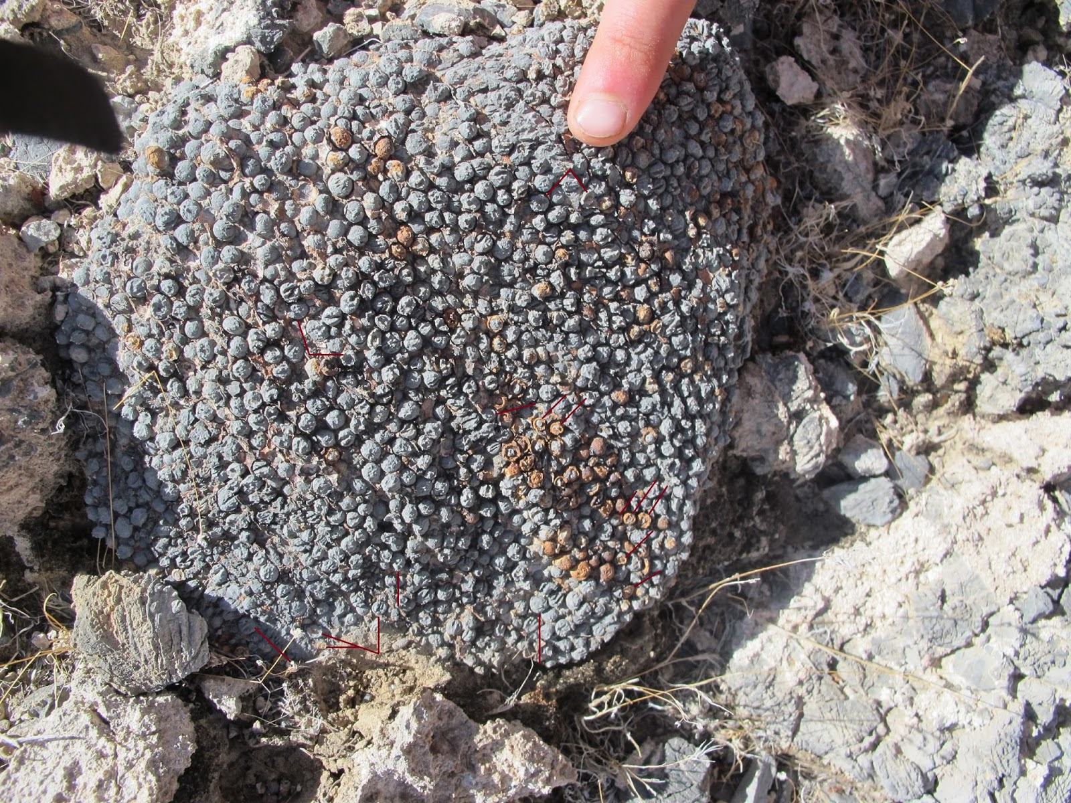

Figure 8. Original description: "Mega ooids! Dave's finger for scale." The above photo (Figure 8) shows ooids in China Ranch, California, USA. Red lines in the photo mark ooids that have been eroded into hemispheres. Image source: the last fifth photo in http://daveandiztakeonthewest.blogspot.tw/2012/11/china-ranch-and-stretchoween.html

Figure 9: These spheres differ from ooid spheres.

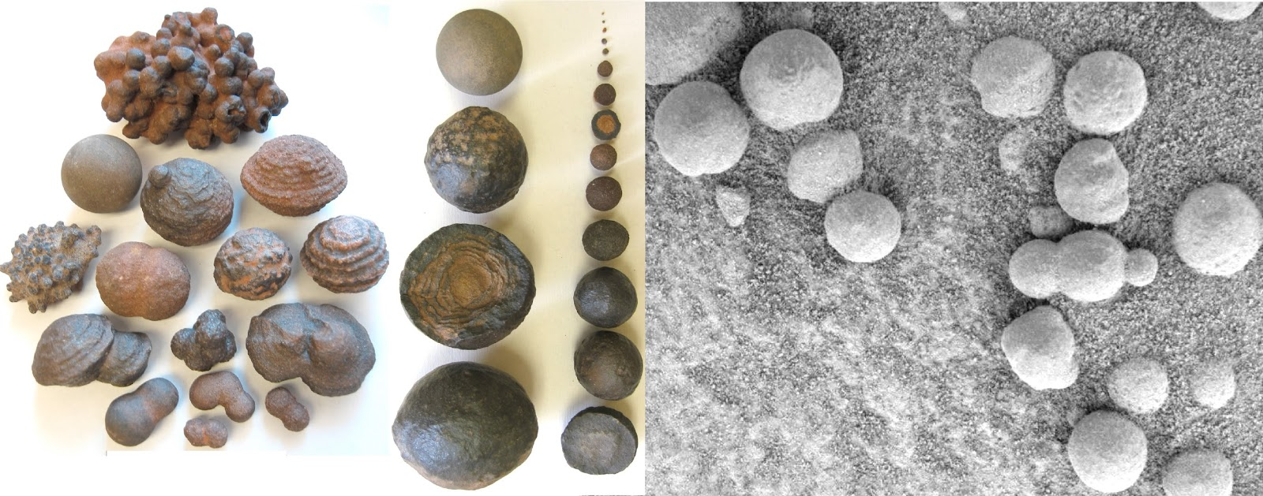

Figure 9 shows spheres that are different from ooids. Original description: "The Utah concretions shown on the left range in diameter from one twenty-fifth of an inch to 2 inches (1 mm to 50 mm), while the Martian versions on the right all measure less than one-fifth of an inch (5 mm) in diameter. (Scale of photos is different.)" (Quoted from http://www.innovations-report.com/html/reports/earth-sciences/report-30313.html )

Image source:
http://www.bev.ba/MOMARAFO/ET/krater/blueberries/usa_stone_balls1.html

Figure 10: Eroded Martian ooids expose characteristic interior.

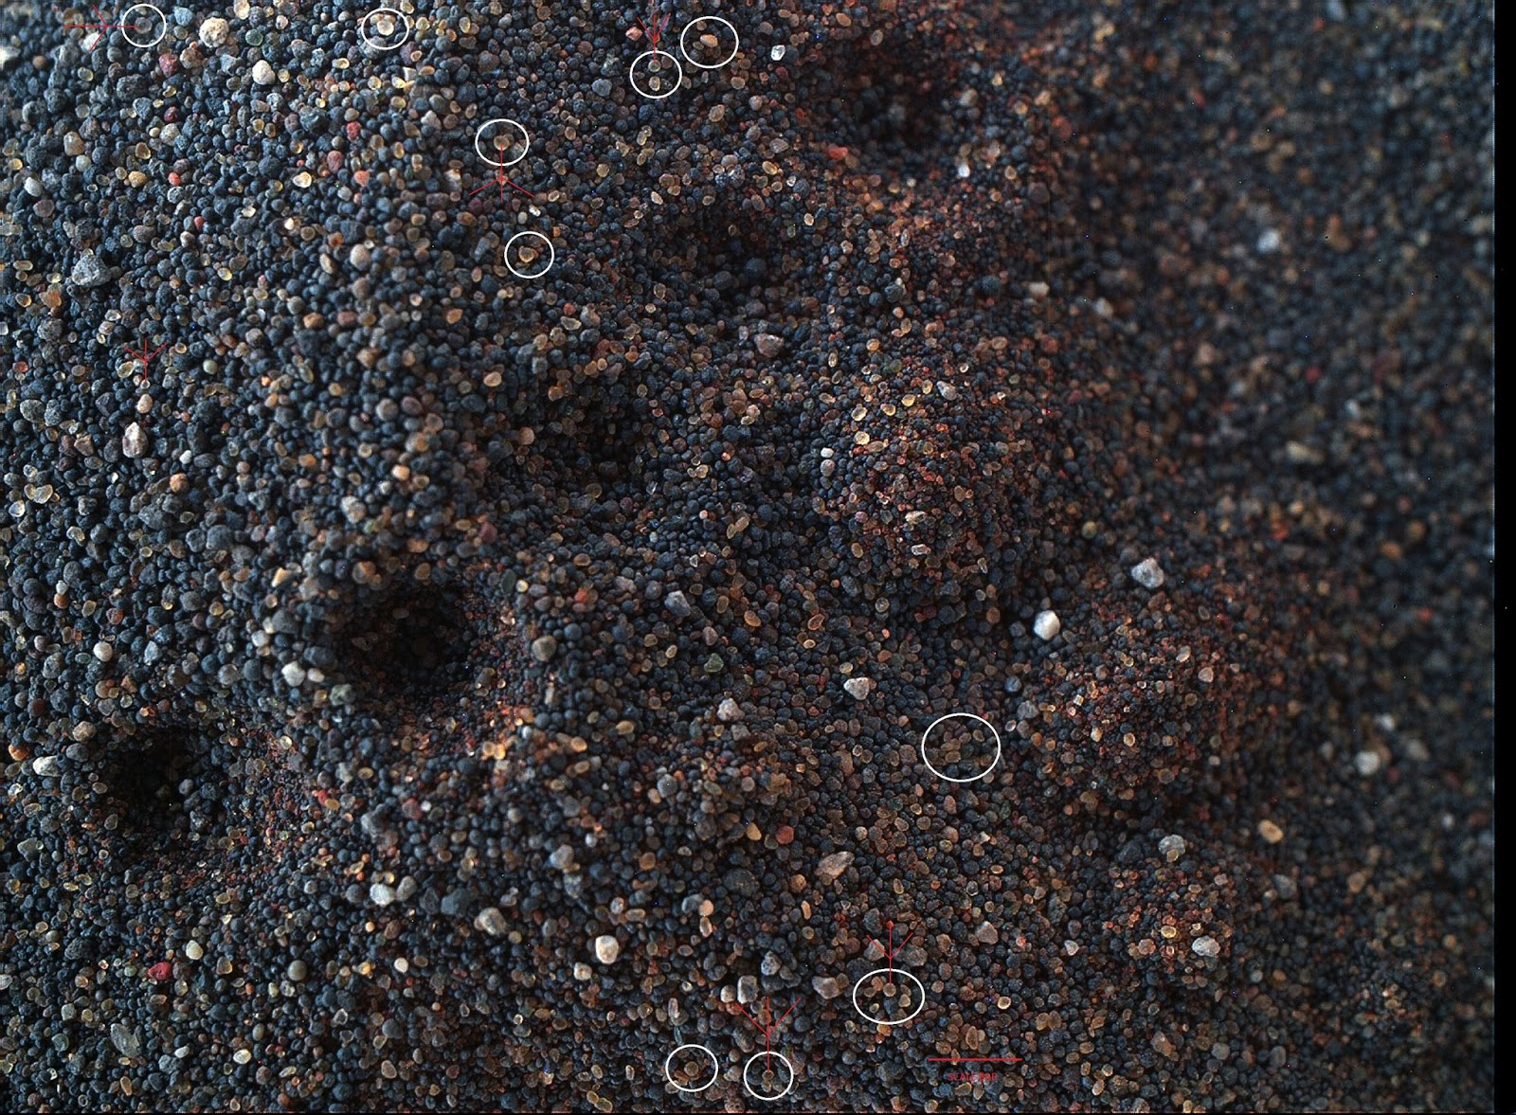

Figure 10 is a microscopic image taken at Gobabeb in Namib Dune in Bagnold dune field, Gale Crater, Mars. In the white circles are ooids that have been eroded into hemispheres. Red arrows point to nucleus of ooids. The ooid at top left exposes its concentric layers and nucleus. The hemispheres measure 0.2 mm to 0.4 mm across. Scale bar: 1.6 mm. Image width: ~2.7 cm. For comparison with Earthly ooids that have been eroded into hemispheres, see Figure 8 above. Above figure in the largest size:
https://www.flickr.com/photos/fossil_lin/30445874495/sizes/o/

Above image is enlarged from
https://www.flickr.com/photos/lunexit/24626790060/in/dateposted/
Image Credit: NASA/JPL-Caltech/MSSS/2di7 & titanio44
NASA's original raw image: http://mars.nasa.gov/msl/multimedia/raw/?rawid=1242MH0005620020403663C00_DXXX&s=1242 (flipped 180 degrees into the above image)

History of the material: from scoop 2 in
http://planetary.s3.amazonaws.com/assets/images/4-mars/2016/20160210_MAHLI_1241_Namib_sample_area.jpg,
then transported to Dump Pile D in the same photo.

See additional image of nuclei in Martian ooids:

http://wretchfossil.blogspot.tw/2016/10/nucleus-of-ooids-on-mars.html

Discussion

In paragraphs A to E below, this article discusses putative ooids discovered on Mars and their possible formation by microorganisms.

A. Are they ooids?

A1. Putative Martian ooids match ooids of Earth. An ooid consists of a nucleus (a fragment of shell, a grain of sand, etc.) around which material is deposited in concentric layers to form roughly spherical or oval grains. A website named Sandatlas has the following webpage for 20 types of sand on Earth: http://www.sandatlas.org/sand-types/

Of the 20 types of sand on Earth, only ooid sand matches the material described in Figures 2 to 5, because those Martian ooids are unique for their combination of spherical shape, similar size of ~0.15 mm to 0.5 mm in diameter, and various colors that include white, yellow translucent, green, grey, and yellow. These features can be seen by comparing Figures 2 to 5 with the 20 types of sand on Earth. The combination of these features is also seen in nearly every Focus Merge Data Product at

http://mars.nasa.gov/msl/multimedia/raw/?s=1231&camera=MAHLI and http://mars.nasa.gov/msl/multimedia/raw/?s=1228&camera=MAHLI

Such shape, size, and color are characteristic of ooid sand.
A2. Putative Martian ooids are seen not only at High Dune (Figure 2) and Namib Dune (Figures 3, 4, 5) but also seen at 15 other places in Gale Crater. (see http://wretchfossil.blogspot.tw/2016/06/numerous-martian-microbes-produced.html). Some of the ooids are still embedded in oolite and many others were drilled out of rocks in 2016.
The environment of Gale Crater over 3.5 billion years ago was a freshwater lake near the Martian equator (see http://authors.library.caltech.edu/60940/). Such concentration, distribution, and environment fit those of ooid sand on Earth. Regarding the geological context of Martian ooids, Martian wind had blown the ooids in the above figures away from the site where they were originally formed (see the third paragraph inhttp://mars.jpl.nasa.gov/msl/multimedia/images/?ImageID=7658). Anyway, geologists do not need geological context in order to correctly identify ooids (see Figure 8).
A3. Ooid spheres differ from other kinds of spheres in sizes, colors, and internal structures. Ooids of Earth are mostly 0.25 mm to 1 mm in diameter (note 1). Martian ooids at Bagnold Dune measure ~0.15 mm to 0.5 mm in diameter (Figures 2 to 5).
However, “On Mars, most of the hematite rocks (“blueberries”) are about 0.16 inches (4 millimeters) in diameter, and no larger than 0.24 inches (6.2 millimeters). By contrast, Earth spherules exhibit a large range of sizes, not limited to only a quarter of an inch.” (Quoted from the ninth paragraph in http://news.nationalgeographic.com/news/2014/02/140224-mars-blueberries-water-meteorite-space-science/ )
The colors of Martian ooids include white, yellow translucent, green, grey, and yellow as shown in figures above. Other kinds of spheres do not show all of these colors.
Regarding internal structures, ooids contain nuclei and concentric layers (Figure 10), which are usually lacking in spherical look-alikes, such as chondrules, Martian Blueberries, Utah's Moqui marbles, etc. Ooids are not "impact spherules" because no mechanisms allow meteor impacts to form spherules with nuclei and concentric layers. Nothing matches the spherical “ooids” on Mars except ooids of Earth.
In view of the above, yes, they are ooids.
Note 1: See the third paragraph in https://en.wikibooks.org/wiki/Historical_Geology/Ooids_and_oolite and the first paragraph in http://www.sandatlas.org/ooid-sand/.
B. Were the ooids on Mars formed by microbes?
Regarding the formation of ooids, there are non-biological hypotheses, in which ooids get their spherical shape owing to highly agitated water (Ref. 3), such as sea waves pounding on the beaches, that rolls the ooids into the spherical shape. However, there is no highly agitated water in lakes. The spherical ooids at Bagnold Dune are unlikely to have been formed by the non-biological mechanisms because the Martian ooids are in a former lake and there is no evidence that proves ooids are formed by agitated water. On the other hand, there is ample evidence for the biological formation of ooids. Some of the evidence are listed below in B1, B2, and Ref. 3 to Ref. 15. In view of the above and the microbial borings in Martian ooids (Figure 7), the Martian ooids should have been formed by microbes.
B1. Microbes of Earth form ooids in the freshwater lake. Evidence: "Here, we show that photosynthetic microbes not only enhance early carbonate precipitation around the ooid nucleus but also control the formation of the entire cortex in freshwater ooids from Lake Geneva, Switzerland.” (Quoted from the abstract of the article in Ref. 4: "Going nano: A new step toward understanding the processes governing freshwater ooid formation", displayed at http://geology.gsapubs.org/content/40/6/547.abstract)
The water in Gale Crater of Mars was once fresh water in a lake as mentioned in paragraph A2 above.
B2. Recent research confirms that microbes of Earth form ooids in seawater, as reported in the abstract of Ref. 5:
http://www.hou.usra.edu/meetings/abscicon2015/pdf/7317.pdf
More evidence for microbes forming ooids are listed in Ref. 3 to Ref. 15 below.
C. Ooids Prove Microbial Activities.
Microbes of Earth bore holes in ooids and Martian microbes did the same thing (see Figure 7). Microbial borings in Figure 7 prove indirectly the existence of Martian microbes. Ooids are not only formed by microbes (see paragraph B) but also contain high organic matter content (Ref. 5).

D. Can the ooids and the microbes be contaminants?

The ooids and the microbes should be indigenous, not contaminants from meteorites or other planets, because
1. Meteorites have never been proven to contain ooids or living microbes;
2. Gale Crater of Mars has 15 other places that produce countless ooids (see http://wretchfossil.blogspot.tw/2016/06/numerous-martian-microbes-produced.html). Some of the ooids are still embedded in oolite and many others were drilled out of rocks in 2016.

E. Are chemistry and mineralogy necessary for identifying ooids on Mars?

No, chemical and mineralogical measurement results are not necessary for definitively identifying ooids on Mars. Geologists usually identify ooids with visual observation (See Figure 8 and http://wretchfossil.blogspot.tw/2016/11/geologists-identify-ooids-with-visual.html ), because ooids possess unique morphology and unique internal structures of concentric layers and nucleus.
The Martian sand grains are mixtures of different types of sands blown there by the wind, so ooids sometimes may not be included in samples analyzed by the rover's instruments CheMin and SAM. The Martian ooids are often 0.15 mm to 0.5 mm in diameter, so they sometimes cannot pass the sieve holes to get into the instruments. The omnipresent perchlorate on Mars can decompose heated carbonates into CO2 in the SAM instrument (Ref. 16). Moreover, photosynthetic microbes can use different kinds of material to build their dwellings. Some ooids may even be made of volcanic ash (see http://jsedres.geoscienceworld.org/content/62/6/1084).

In such cases, non-detection of carbonates (CO3) does not mean non-existence of ooids at the Bagnold Dune. Conversely, if minerals of aragonite or calcite are found, they may have nothing to do with life. Even if laboratory results contain the chemistry and mineralogy of ooids, such results may not be interpreted as coming from ooids (for example, see Fig.1 in http://aem.asm.org/content/68/8/3663/F1.expansion.html). Lastly, Curiosity rover has no means by which to link sample chemistry or mineralogy to the morphology of the sand grains. So, visual observation by experienced people is sufficient in identifying ooids.

Conclusion

Nothing matches the spherical "ooids" on Mars except ooids of Earth. No evidence proves ooids are formed by agitated water. Ample evidence proves microbes form ooids on Earth. The "ooids" found on Mars should have been formed by microbes, as there is no other proven way for forming such spheres. So, ooids are an apparent and widespread biosignature on Mars.

References

1. Duguid SMA, Kyser TK, James NP, Rankey EC (2010) Microbes and Ooids. Journal of Sedimentary Research 80: 236–251.

2. Levin GV, Straat PA (1976) Viking Labeled Release Biology Experiment: Interim Results. Science 194: 1322-1329.

3. Tang D, Shi X, Shi Q, Wu J, Song G, et al. (2015) Organomineralization in Mesoproterozoic giant ooids. Journal of Asian Earth Sciences 107: 195-211.

4. Pacton M, Ariztegui D, Wacey D, Kilburn M R, Rollion-Bard C, et al. (2012) Going nano: a new step toward understanding the processes governing freshwater ooid formation. Geology 40: 547-550.

5. O’Reilly SS, Klepac-Ceraj V, Winter AR, Bosak T, McDermott F, et al. (2015) Molecular evidence for a microbial role in modern ooid formation and implications for their occurrence and meaning in the geological record. Astrobiology Science Conference.

6. Plee K, Ariztegui D, Martini R, Davaud E (2008) Unravelling the microbial role in ooid formation - results of an in situ experiment in modern freshwater Lake Geneva in Switzerland. Geobiology 6: 341-350.

7. Summons RE, Bird LR, Gillespie AL, Pruss SB, Roberts M, et al. (2013) Lipid biomarkers in ooids from different locations and ages: Evidence for a common bacterial flora. Geobiology 11: 420-436.

8. Miller CR, James NP (2012) Autogenic Microbial Genesis of Middle Miocene Palustrine Ooids; Nullarbor Plain, Australia. Journal of Sedimentary Research 82: 633–647.

9. Rehm UB, Rumbein WEK (2004) Laboratory cultures of calcifying biomicrospheres generate ooids - A contribution to the origin of oolites. Carnets de Géologie 3: 1-6.

10. Woods AD (2013) Microbial ooids and cortoids from the Lower Triassic (Spathian) Virgin Limestone, Nevada, USA: Evidence for an Early Triassic microbial bloom in shallow depositional environments. Global and Planetary Change 105: 91-101.

11. Duan Xiong, Shi Zhiqiang, Jin Xin, Fan Hong, Ji Guofeng, et al. (2015) Microbial cause for giant ooids: Evidence from the Lower Cambrian in Shizhu area, Chongqing. Journal of Palaeogeography 17: 241-248.

12. Kahle CFJ (2007) Proposed origin of aragonite Bahaman and some Pleistocene marine ooids involving bacteria, nannobacteria(?), and biofilms. Carbonates and Evaporites 22: 10–22.

13. Folk RL, Lynch FL (2001) Organic matter, putative nannobacteria and the formation of ooids and hardgrounds. Sedimentology 48: 215–229.
14. Thompson JB, Huber JA (1997) Microbe and ooid associations; a possible microbial role in the origin of ooids. Abstracts with Programs - Geological Society of America 29: 130.

15. Diaz MR, Swart PK, Eberli GP, Oehlert AM, Devlin Q, et al. (2015) Geochemical evidence of microbial activity within ooids. Sedimentology 62: 2090-2112.
16. Cannon KM, Sutter B, Ming DW, Boynton WV, and Quinn R. (2012) Perchlorate induced low temperature carbonate decomposition in the Mars Phoenix Thermal and Evolved Gas Analyzer (TEGA)

