INVESTIGATIONS OF ELECTRONIC AND OPTICAL PROPERTIES OF NITROGEN, COPPER, AND SULFUR DOPED TiO₂
Haseeb Ahmad¹, Matiullah Khan^{1, 2}*

Abstract
Recently, environmental pollution and energy crises are taking increasing attention from researchers. Doped TiO₂ is widely used to deal with the environmental pollution and energy crises in an environmental friendly way. For the cleaning up of environmental pollution, the DFT based computations were implemented to examine impact of Cu, N and S doping on the electronic and optical properties of anatase TiO₂. Cupper in anatase TiO₂ decreased the band gap of unadulterated TiO₂ from 2.17 eV to 1.85 eV by presenting Cu 3d locals over the valance band. Isolated N 2p state was introduced over the highest point of the valence which would annihilate the electron–hole sets and restrict the efﬁciency of N@TiO₂. Sulfur doping decreased the band width of TiO₂ to 1.89 eV. The codoping of Cu as well as S decreased the band gap of TiO₂ to 1.86 eV. Tri-doping of Cu, N and S induced a synergistic effect restricting the gap to 1.80 eV. The creation of Cu 3d, N 2p and S 3p drastically reduced the band gap which would improve the light absorbing and photocatalytic activity of TiO₂. The optical absorption coefﬁcient depicts that CuNS@TiO₂ display noticeable absorption among the developed models. Moreover, the suitable band structure of the tri-doped system would diminish the recombination sites. This would help in increasing the application spectrum of TiO₂ in photo electrochemical applications.

Image
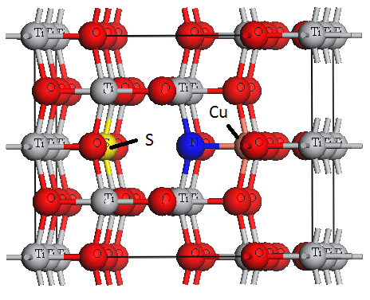
Fig. 1 Model of tri-doped TiO₂ having Cu on Ti location and S as well as N at O location.
Recent Publications (minimum 5)
- Ahmad, Abdullah Saghir, et al. "Molecular occurrence of canine babesiosis in rural dog population in Pakistan." Trop Biomed 35.3 (2018): 593-603..
- Tan, Kheng-Lin, et al. "Synthesis and evaluation of bisbenzylidenedioxotetrahydrothiopranones as activators of endoplasmic reticulum (ER) stress signaling pathways and apoptotic cell death in acute promyelocytic leukemic cells." Journal of medicinal chemistry 57.14 (2014): 5904-5918.
- Fawad, U., et al. "Proton, UV, and X-ray Induced Luminescence in Tb3+ Doped LuGd2Ga2Al3O12 Phosphors." Crystals 10.9 (2020): 844.
- Hu, Ningning, et al. "Effect of microstructure on the thermal conductivity of plasma sprayed Y2O3 stabilized zirconia (8% YSZ)." Coatings 7.11 (2017): 198.
- Fawad, U., et al. "Proton, UV, and X-ray Induced Luminescence in [Tb. sup. 3+] Doped Lu [Gd. sub. 2][Ga. sub. 2][Al. sub. 3][O. sub. 12] Phosphors." Crystals 10.9 (2020).


Biography

Haseeb Ahmad Born in Lakki Marwat KPK Pakistan. Done His schooling and college from Lakki marwat after that he went to Bannu University of science and technology (BUST) for completing his sixteen year of education in Physics. He got admission in Kohat University of Science and Technology (KUST) for getting his MS degree. He is currently working in Material studio and Simulation Under the supervision of Dr Matiullah Khan (Associate professor) in the department of physics
Email: khanhaseebahmad98@gmail.com, : matiullahustb@gmail.com, dr.matiullah@kust.edu.pk

Presenting author details
Full name: Haseeb Ahmad & Dr Matiullah khan
Contact number: +92313 9346669/+ 92 335 5037658
Twitter account:
Linked In account:
Session name/ number:
Category: (Oral presentation)

