Coarse-grained simulations of
DNA-Polyethyleneimine complex formation
Titus Adrian Beu, Department of Biomolecular Physics, University Babeș-Bolyai, Cluj-Napoca, Romania

Abstract

The formation of DNA-polycation complexes, able to enter cells via endocytosis, is a topic of high current medical and fundamental interest, which requires advanced computational modeling. Due to its remarkable buffering capacity, polyethyleneimine (PEI) is a genetic vector widely in use to condense DNA into polyplexes. With a view to developing a high-quality coarse-grained (CG) force-field for modeling DNA-PEI complexes, we performed extensive atomistic (AA) simulations based on our recently developed AA FF for PEI [1,2] and applied Boltzmann inversion techniques to extract the detailed CG FF parameters (including bonds, angles, and dihedrals) [3]. Combining our FF with the Martini FF for DNA of Marrink et al. [4], we carried out CG molecular dynamics simulations of DNA-PEI polyplexes. In order to accurately account for the significant electrostatic interactions between the protonated PEI beads and the negative phosphate groups of DNA, we employed a polarizable water model [5]. To characterize the mainly electrostatic attachment of PEI to DNA, we studied the distance distributions between the mentioned DNA and PEI sites in dependence on the number of polymer chains, as well as on their length and protonation fractions. Besides providing essential insights into the formation of the DNA-PEI polyplexes, our simulations enable predictions for efficient practical realizations of DNA-PEI condensation.

Recent Publications

- Beu T A, Ailenei A E, Farcaş A (2018) Atomistic and Coarse-Grained Modeling of Polyethyleneimine. Chemical Physics Letters 714: 94-98.
- Beu T A, Ailenei A E, Farcaş A (2018) CHARMM Force Field for Protonated Polyethyleneimine. Journal of Computational Chemistry 39: 2564-2575.
- Beu T A, Farcaş A (2017) CHARMM force field and molecular dynamics simulations of protonated polyethylenimine. Journal of Computational Chemistry 38(27): 2335-2348.
- Uusitalo J J, Ingólfsson H I, Akhshi P, Tieleman D P, Marrink S J (2015) Martini Coarse-Grained Force Field: Extension to DNA. Journal of Chemical Theory and Computation 11 (8): 3932-3945.
- Yesylevskyy S O, Schäfer L V, Sengupta D, Marrink S J (2010) Polarizable Water Model for the Coarse-Grained MARTINI Force Field. PLoS Computational Biology 6: e1000810.

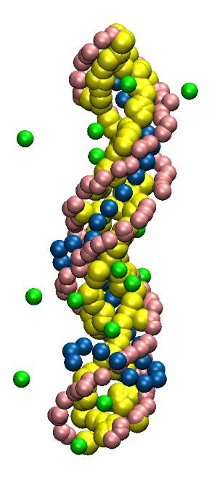
Figure 1: Snapshot of a coarse-grain DNA-PEI polyplex trajectory
(water is omitted).

 Biography

Titus Adrian Beu is professor of theoretical and computational physics and has a long-standing research experience in various fields of computational physics. His research concerned modelling of diffusion in fission nuclear reactors and tokamak plasmas in the 1980s, vibrational spectroscopy and collisions of molecular clusters in the 1990s, expanding to vibrational spectroscopy of fullerenes and nanofluidics in carbon nanotubes in the 2000s. His current theoretical and computational work focuses on soft matter, and in particular on complex biomolecular systems. Over the course of his career, he has delivered courses on quantum mechanics, molecular dynamics, and numerical methods. He has recently published a well-received book – “Introduction to Numerical Programming: A Practical Guide for Scientists and Engineers Using Python and C/C++” (CRC Press / Taylor & Francis, 2014).

Email: titus.beu@phys.ubbcluj.ro

