Tuning the spin-state of iron(II) phthalocyanine (FePc) molecules via non-covalent interaction by positioning on functionalized graphene
Bruno de la Torre, PhD, Institute of Physics (CAS), Cukrovarnická 10, 16200 Prague 6, Czech Republic; RCPTM, Palacký University, Šlechtitelů 27, 78371 Olomouc, Czech Republic.
Martin Švec, PhD, Institute of Physics (CAS), Cukrovarnická 10, 16200 Prague 6, Czech Republic; RCPTM, Palacký University, Šlechtitelů 27, 78371 Olomouc, Czech Republic.
Prokop Hapala, PhD, Institute of Physics (CAS), Cukrovarnická 10, 16200 Prague 6, Czech Republic.
Jesus Redondo, PhD, Institute of Physics (CAS), Cukrovarnická 10, 16200 Prague 6, Czech Republic.
Ondřej Krejčí, PhD, Institute of Physics (CAS), Cukrovarnická 10, 16200 Prague 6, Czech Republic.
Rabindranath Lo, PhD, IOCB (CAS), Flemingovo nám. 2, 16610 Prague 6, Czech Republic
Debashree Manna, PhD, IOCB (CAS), Flemingovo nám. 2, 16610 Prague 6, Czech Republic; RCPTM, Palacký University, Šlechtitelů 27, 78371 Olomouc, Czech Republic.
Amrit Sarmah, PhD, IOCB (CAS), Flemingovo nám. 2, 16610 Prague 6, Czech Republic; RCPTM, Palacký University, Šlechtitelů 27, 78371 Olomouc, Czech Republic.
Dana Nachtigallová, PhD, IOCB (CAS), Flemingovo nám. 2, 16610 Prague 6, Czech Republic; RCPTM, Palacký University, Šlechtitelů 27, 78371 Olomouc, Czech Republic.
Jiří Tuček, PhD, RCPTM, Palacký University, Šlechtitelů 27, 78371 Olomouc, Czech Republic.
Piotr Błoński, PhD, RCPTM, Palacký University, Šlechtitelů 27, 78371 Olomouc, Czech Republic.
Michal Otyepka, PhD, RCPTM, Palacký University, Šlechtitelů 27, 78371 Olomouc, Czech Republic.
Radek Zbořil, PhD, RCPTM, Palacký University, Šlechtitelů 27, 78371 Olomouc, Czech Republic.
Pavel Hobza, PhD, IOCB (CAS), Flemingovo nám. 2, 16610 Prague 6, Czech Republic; RCPTM, Palacký University, Šlechtitelů 27, 78371 Olomouc, Czech Republic.
Pavel Jelínek, PhD, Institute of Physics (CAS), Cukrovarnická 10, 16200 Prague 6, Czech Republic; RCPTM, Palacký University, Šlechtitelů 27, 78371 Olomouc, Czech Republic.
These authors contributed equally: Bruno de la Torre, Martin Švec, Rabindranath Lo.

Abstract
Statement of the Problem: Very recent work using scanning probe microscopy (SPM) imaging techniques has demonstrated that N-doping of graphene can even tune the physicochemical properties of molecules adsorbed on its surface.¹ Moreover, N-doped graphene offered a multitude of applications in the fields like spintronics, energy generation/storage and nanoelectronics.²⁻⁵ Here we investigate the possibility of tuning the electronic and magnetic properties of iron(II) phthalocyanine (FePc) molecules via non-covalent interaction by its positioning on N-doped graphene.
Methodology & Theoretical Orientation: Geometries were optimized at the DFT-D3/B97D/TZVPP level of theory with the TURBOMOLE 6.6 suite of programs. Spin-unrestricted DFT was used for the open shell systems. Grimme’s advanced dispersion-corrected approach⁶ (DFT-D3) with the TZVPP basis set is considered. Multi configurational self-consistent field calculations have been carried out using Molpro 2010.1 version and with active space (8, 10). Scanning probe microscopy measurements were performed in ultra-high vacuum conditions at cryogenic temperatures for FePc molecule located on pristine graphene and in the vicinity of nitrogen defects. The electron density accompanying the spin transition was detected in high-resolution atomic force microscopy (AFM) images (acquired with functionalized carbon monoxide tip)
Findings: In the present work,⁷ we show the unique capability of N-doped graphene to behave as a non-covalent tuner of the electronic and spin properties of molecules. The STM images of FePc molecules adsorbed at either graphene or N-dopants showed a different contrast and number of lobes. High-resolution atomic force microscopy imaging with a CO-functionalized tip showed that the transition can be characterized by a distinct sub-molecular contrast over molecules located on pristine graphene and near to the N-dopant for the triplet and singlet spin states, respectively. The spin transition was driven by weak intermixing between orbitals with z-component of N-dopant (pz of N-dopant) and molecule (d_{xz}, d_{yz}, d_{z}²) with subsequent reordering of the Fe d-orbitals. This demonstrates the unique capability of the high-resolution imaging technique to discriminate between different spin states of single molecules.
Conclusion & Significance: The electronic states of FePc molecules on graphene can be tuned locally by means of weak non-covalent interaction with N-dopants causing reordering of the selected iron d-orbitals. This offers a way for controlling the spin state of a molecular system by simple positioning of the molecule onto a suitably functionalized graphene substrate.

(a) (b)
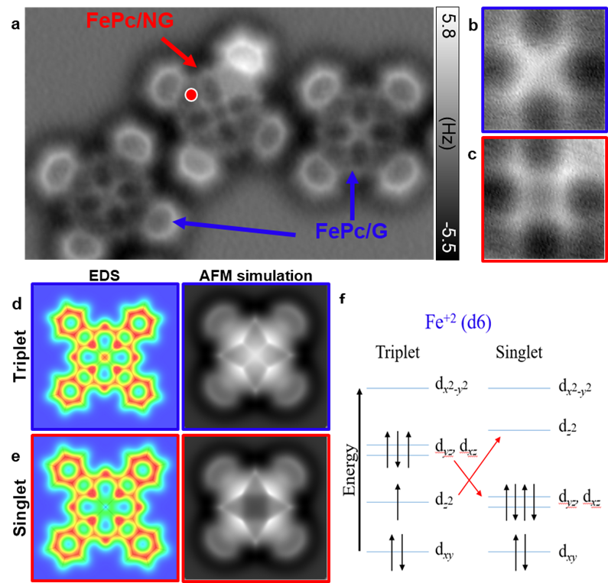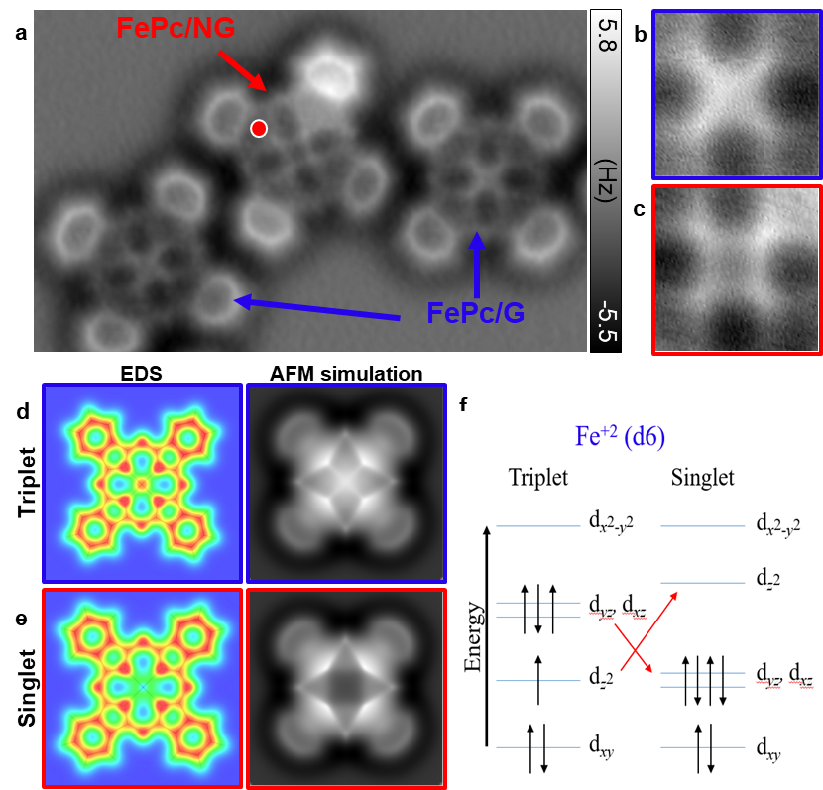
a
b
Fig. (a) Calculated electron density (EDS) from MCSCF calculations and simulated AFM image of FePc when the Fe atom is in the triplet and singlet spin state, respectively. (b) Upward energy shift of the d_{z}² orbital which promotes electron transfer from d_{z}² to (d_{yz}, d_{xz}), leaving the d_{z}² orbital empty with a closed shell electron configuration for singlet.

Recent Publications:
- V. D. Pham, J. Lagoute, O. Mouhoub, F. Joucken, V. Repain, C. Chacon, A. Bellec, Y. Girard, S. Rousset, ACS Nano 8, 9403 (2014).
- Z. Yang, J. Ren, Z. Zhang, X. Chen, G. Guan, L. Qiu, Y. Zhang, H. Peng, Chem. Rev. 115, 5159 (2015).
- D. W. Boukhvalov, M. I. Katsnelson, Nano Lett. 8, 4373 (2008).
- W. Han, R. K. Kawakami, M. Gmitra, J. Fabian, Nat. Nanotechnol. 9, 794 (2014).
- P. Błoński, J. Tuček, Z. Sofer, V. Mazánek, M. Petr, M. Pumera, M. Otyepka, R. Zbořil, J. Am. Chem. Soc. 139, 3171 (2017).
- S. Grimme, J. Antony, S. Ehrlich, H. Krieg, J. Chem. Phys., 132, 154104 (2010).
- B. D. L. Torre, M. Švec, P. Hapala, J. Redondo, O. Krejčí, R. Lo, D. Manna, A. Sarmah, D. Nachtigallová, J. Tucek, P. Blonski, M. Otyepka, R. Zboril, P. Hobza, P. Jelinek, Nat. Commun. 9, 2831 (2018).

Keywords: Iron(II) phthalocyanine, N-doped graphene, Non-covalent interaction, Density functional theory, Multi-configurational self-consistent field, Atomic force microscopy imaging, Scanning tunneling microscope image

Biography (150 word limit)
Debashree Manna has her expertise in computational theoretical chemistry for materials. She is currently doing her postdoc research in the group of Prof. Pavel Hobza at Institute of organic chemistry and bio-chemistry, Prague, Czech Republic. Currently she is focused on the importance of non-covalent interactions for designing and application of different materials. Her PhD was from Bhabha Atomic Research Centre, Mumbai, India, where she was involved in designing novel actinide selective ligands for the separation of trivalent lathanides and actinides, which is highly challenging and crucial for management of nuclear wastes. There she proposed a new concept, “Intra-ligand Synergism” for selective separation of actinides. Her first postdoc was from Weizmann Institute of Science, Israel, where she worked on performance of optimally tuned range separated hybrid functional on determining electronic coupling matrix element of small organic dimer cations and on theoretical benchmark study on smaller fullerenes and water clusters.
Email: mannadebashree2014@gmail.com

Presenting author details Debashree Manna
Full name: Debashree Manna
Contact number: +420777534393
Linked In account:
Twitter account:
Session name/ number:

Category: (Poster Presentation)
Speaker Suggestions:
Notes/Comments:

