Non-covalently Functionalized Novel Stable Complexes of Graphene and Small Molecules.
VIJAY MADHAV MIRIYALA, PhD, IOCB AS CZ, CZ
RABINDRANATH LO, PhD, IOCB AS CZ, CZ
AMRIT SARMAH, PhD, IOCB AS CZ, CZ
SUSANTA HALDAR, PhD, UNIVERSITY OF BRISTOL, UK
PAVEL HOBZA, RN PhD, IOCB AS CZ, CZ

Abstract
Graphene, due to its special honey comb like structure possesses some very special properties such as intersection of the valence band and the conduction band at the Dirac point where the energy momentum dispersion is linear and hence known to be a very good charge carrier. The interactions between graphene and different chemical species like electro-active molecules such as electron donors and electron acceptors have been well known for many potential applications in the field of graphene based potential devices. Intensive investigations are ongoing both experimentally and theoretically to assess the interaction between graphene and different molecules on the electronic properties of the graphene.
A huge number of adsorption studies have been carried out so far on the graphene surface where the adsorbate particles spanned in the range from small organic molecules, to biomacromolecules such as proteins, amino acids, ss-RNA, ds-DNA, inorganic molecules and also monovalent and divalent ions. In many of those adsorption studies, the focus was mainly given to the adsorption pattern, stability and at the end to the origin of the stability. It was confirmed that in most of the cases the binding is non-covalent, mainly via stacking. Adsorption of a conjugated electro-active donor or acceptor on the graphene surface has been a promising way for designing new functionalized nanostructures. Among the various molecules studied for adsorption on the graphene surface, conjugated organic donors and acceptors are the most important, which are used to functionalize graphene due to compatibility and binding ability via π-π stacking, electrostatic forces, and hydrogen bonds. With the experience of our previous work on adsorption of small to medium sized molecules on graphene, we attempt to build unique double and triple layer donor-acceptor-complexes on graphene surface that show changes in electronic properties of graphene using different molecules that non-covalently functionalize graphene via charge transfer interactions calculated from QM and MM methods.
Recent Publications
- Chen L, Wang L, Shuai Z, Beljonne D (2013) Energy Level Alignment and Charge Carrier Mobility in Noncovalently Functionalized Graphene. The Jouranl of Physical Chemistry Letters 4:2158-2165.
- Novoselov K. S, Geim A. K, Morozov S. V, Jiang D, Zhang Y, Dubonos S. V, Grigorieva I. V, Firsov A. A (2004) Electric Field Effect in Atomically Thin Carbon Films. Science 306 :666−669.
- Morozov S. V, Novoselov K. S, Katsnelson M. I, Schedin F, Elias D. C, Jaszczak J. A, Geim A. K (2008) Giant Intrinsic Carrier Mobilities in Graphene and Its Bilayer. Physical Review Letters 100:016602.
- Haldar S, Spiwok V, Hobza P (2013) On the Association of the Base Pairs on the Silica Surface Based on Free Energy Biased Molecular Dynamics Simulation and Quantum Mechanical Calculations. The Journal of Physical Chemistry C 117:11066–11075.
- Haldar S, Kolář M. H, Sedlak R, Hobza P (2012) Adsorption of Organic Electron Acceptors on Graphene-like Molecules: Quantum Chemical and Molecular Mechanical Study. The Journal of Physical Chemistry C 116:25328-25336.
- Miriyala V. M, Lo R, Haldar S, Sarmah A, Hobza P (2018) Non-covalently functionalized novel three layered stable tower complexes of graphene and small donor-acceptor molecules. Manuscript under preparation.

Keywords:
Graphene, Non-covalent interactions, Functionalization, charge-transfer, donor-acceptor complex.

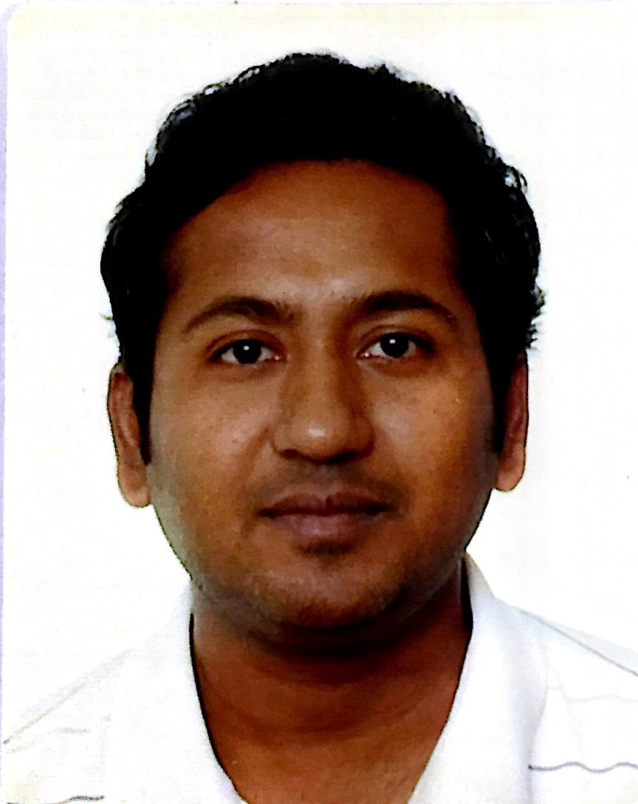
Biography
Dr. Vijay Miriyala received his PhD in Theoretical and Computational Chemistry from the Indian Institute of Technology, Kanpur in July 2013. From June 2012 to February 2014 he worked as a Postdoctoral researcher at the Center for Superfunctional Materials, Pohang University of Science and Technology (POSTECH), South Korea with Prof. Kwang. S. Kim . From April 2014 to December 2015 he worked as Postdoctoral Researcher at the Department of Chemistry, University of Johannesburg, South Africa. Since January 2016 he has been working at the Institute for organic and biochemistry, Czech Academy of Sciences, Prague with Prof. Pavel Hobza. His previous projects involve research on Vibrational Spectroscopy, Force fields and Compliance constants during his PhD and study of interactions between biomolecules and organic supramolecules used to sense them via excimer formations (π-π, H- π stacking interactions) during his postdoctoral studies. Currently his research involves developing advanced corrections and parameters for semiempirical methods such as DFTB and PM6 and studies on non-covalent interactions.
Email: vijay.miriyala@uochb.cas.cz

Presenting author details
Full name: Vijay Madhav Miriyala
Contact number: +420-778026581
Linked In account: https://www.linkedin.com/in/dr-vijay-miriyala-49b4a426/
Twitter account: https://twitter.com/mvmadhav
Session name/ number:
Category: Poster Presentation
Speaker Suggestions:
Notes/Comments:

