Spin prohibition in the long-lived negative ions of tetracyanoquinodimethane (TCNQ)
Olga G Khvostenko, Russian Federation
Vladimir G Lukin, Russian Federation
Laysan Z Khatymova, Russian Federation

Abstract
Negative ion mass spectrometry (NIMS) is one of the most powerful methods for investigation of negative ions in the gas phase. With this method, negative molecular ions are formed at certain energies of the captured electrons (E_{el}) (at certain resonant maxima) when E_{el} is varied from 0 eV to 15 eV, and each resonance gives a definite electronic state of the ions. The challenge is then to determine the ion state at a given resonance. This problem can be solved by obtaining additional data for the molecule of interest using photoelectron spectroscopy, UV absorption spectroscopy, and or other methods. We applied this approach to TCNQ and found that a series of the electronically excited Feshbach resonances are formed in this compound over the entire E_{el} range of 0 – 15 eV, some of which produce unusually long-lived ions. With UV absorption spectroscopy, we also determined previously the first triplet of TCNQ at 1.96 eV, which enabled us to elucidate two mechanisms providing the high lifetime for these ions. The first of these mechanisms is of a practical interest and presents intersystem crossing with transformation into the ion-quartet (⁴M⁻) of the “initial” Feshbach ion-doublet (²M⁻) formed below the first triplet (T₁). Such ion-quartet can decay to the ground state of the neutral molecule only via inversion of the spin of one of the electrons, and, as a result, such ion holds an additional electron for a relatively long time. We suggest that the analogous ion-quartets may also be formed in condensed medium, such as in the organic photovoltaic cell. If the electron acceptor in the voltaic cell forms it, this can reduce the probability of exciton recombination and improve the efficiency of the device. Our detailed research on the possibility of this phenomenon in the device is scheduled for the foreseeable future.

Image
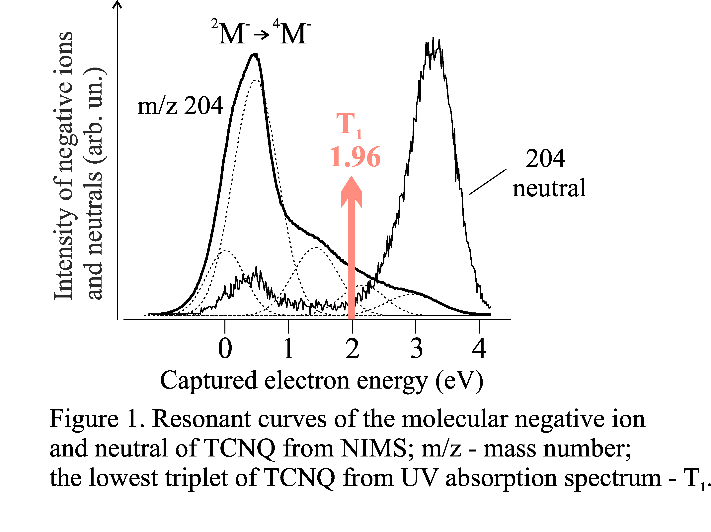
Recent Publications
- Khvostenko OG, Tuimedov GM (2006) doublet - quartet conversion in negative ions as a possible mechanism of the electron autodetachment delay. Rapid Comm. Mass Spectrom. 20:3699-3708.
- Khvostenko OG, Lukin VG, Tseplin EE (2012) anomalously long-lived molecular negative ions of duroquinone. Rapid Comm. Mass Spectrom. 26:2535-2547.
- Khvostenko OG, Lukin VG, Tuimedov GM, Khatymova LZ, Kinzyabulatov RR, Tseplin EE (2015) electronically excited negative ion resonant states in chloroethylenes. Electr. Spectr. Rel. Phenom. 199:1–9.
- Lukin VG, Khvostenko OG (2017) influence upon the ion lifetime measurement results of the negative ion surface adsorption which occurs in the ion source. Uspekhi Fizicheskikh Nauk (UFN) DOI: org/10.3367/UFNe.2017.01.038045)
- Khvostenko OG, Kinzyabulatov RR, Khatymova LZ, Tseplin EE (2017) the lowest triplet of tetracyanoquinodimethane via uv-vis absorption spectroscopy with br-containing solvents. J. Phys. Chem. A. http://dx.doi.org/10.1021/acs.jpca.7b05623

 Biography
Olga Khvostenko has her expertise in the experimental recording and assignment of the resonant states of the negative molecular ions formed at the resonant electron capture by molecules in the gas phase. Her approach to solve the problem of the resonance assignment is to use a complex of several experimental methods with the currently available quantum-chemical calculations, where the main one is the mass spectrometry of the resonant electron capture aimed at recording of the ions themselves, and the additional ones are the photoelectron spectroscopy and UV absorption spectroscopy directed to investigation of the neutral parent molecules. This approach made it possible to see the formation in molecules of the electronically-excited Feshbach and inter-shell resonances and to obtain the exact electron configurations of the corresponding ions. It also provided the finding of the intersystem crossing in the ions, which gives the long-lived negative molecular ions at the nonzero electron capture.
Email: khv@mail.ru

Presenting author details
Full name:Olga G. Khvostenko
Contact number: +7(347)292-14-17
Linked In account:
Session name/ number:
Category: Oral Presentation

