Theoretical study of magnetic properties in redox-active ruthenium complexes
Corentin BOILLEAU, Dr, IFPAN, Poland Karine COSTUAS, Prof., ISCR Rennes 1, France

Abstract
Due to the slowdown of the information technology development, a great challenge of present-day applied science is to develop new electronic devices at the molecular scale. Indeed, molecular spintronic offers great potential multifunctional molecules performing new properties or operations unreachable by conventional semi-conductor technology. This project takes place in this quest of tomorrow's technologies conquest in the new field of Molecular Spintronic. The goal is to provide multifunctional compounds made from bricks with remarkable properties, for storage or manipulation of information across a single molecule. This work use an uncommon strategy based on redox properties of Ruthenium compounds associated with magnetic centers in order to obtain a device allowing a modulation of the magnetic properties. The aim is to study the inter-molecular interactions, to understand the interplay of the components in view of obtaining their synergistic working mode.
Considering the crucial role of the electronic correlation in magnetic systems and the strong geometrical and electronic coupling existing between the different functional elements, modelling of such systems is a tough task. A correct description of these systems requires to take into account the couplings between the subunits. The nature of the interactions studied, the presence of transition metals and the need for investigation of both ground and excited states suggest the use of Post Hartree Fock methods. But, considering their computational cost and the size of our systems, they are here prohibited. Therefore, the use of DFT with hybrid functionals is suitable. Standard and Broken Symmetry calculations have been performed to determine the magnetic coupling.
The supramolecular assembly proposed present efficient switching properties allowing the realization of logical functions. Depending on their composition, shape, physical and chemical properties they can be used as data processing devices (molecular wires, transistors, circuits) as information storage devices (molecular switchers) or as molecular machines.

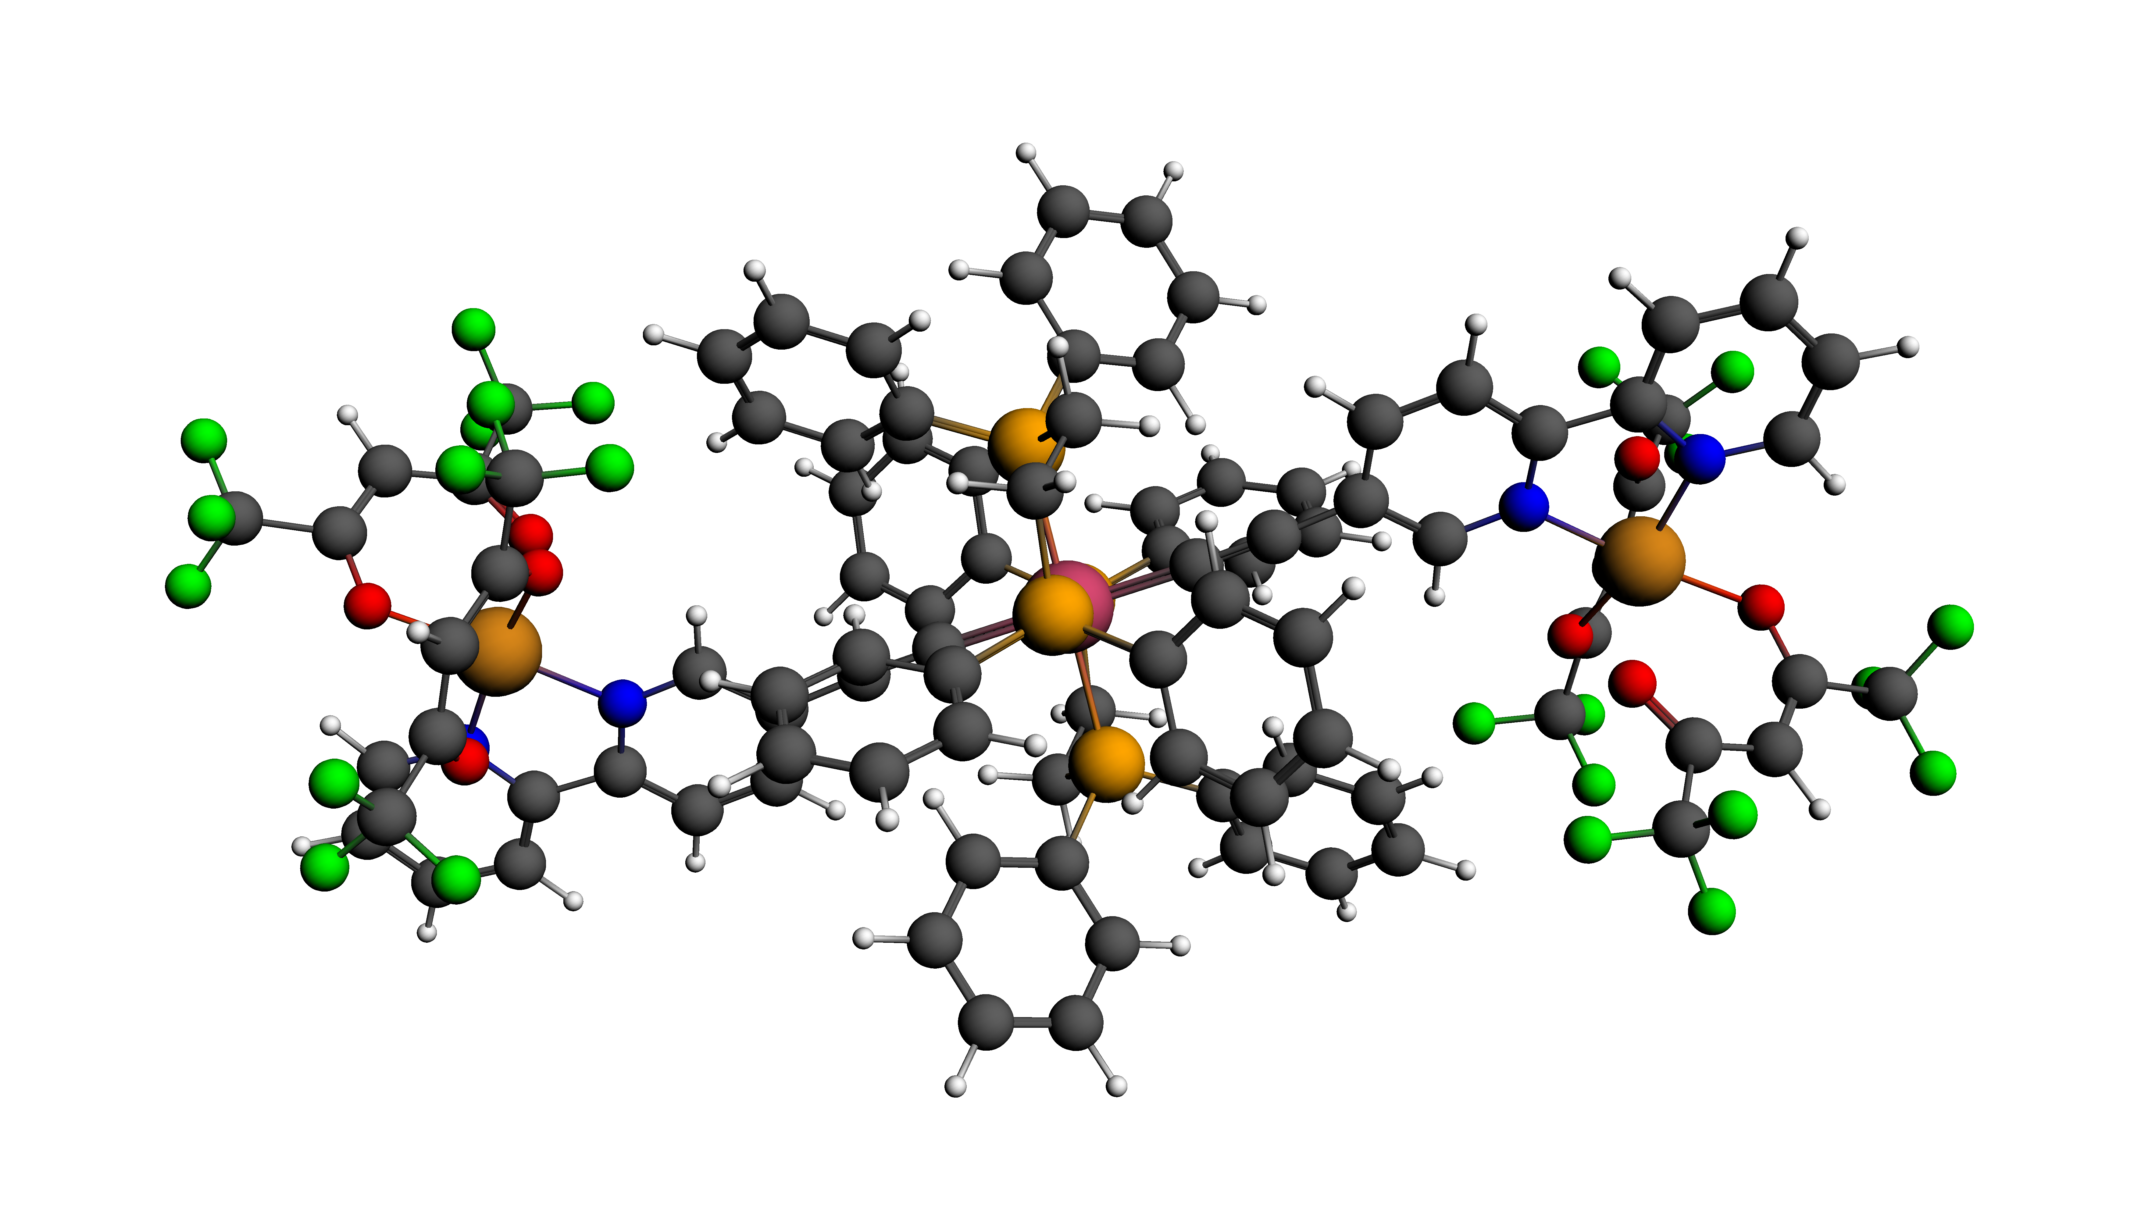
Recent Publications (minimum 5)
- K. Ridier , A. Mondal , C. Boilleau , O. Cador , B. Gillon, G. Chaboussant, B. Le Guennic, K. Costuas, R. Lescouëzec (2016) Polarized Neutron Diffraction to Probe Local Magnetic Anisotropy of a Low-Spin Fe(III) Complex, Angewandte, 128, 12, 4171.
- V. Barone, C. Boilleau, I. Cacelli, A. Ferretti, G. Prampolini (2013) Conformational effects on the magnetic properties of an organic diradicals : a computational study, J. Chem. Theo. Comp., 9, 1958-1963.
- V. Barone, C. Boilleau, I. Cacelli, A. Ferretti, S. Monti, G. Prampolini (2013) Structure-properties relationships in triplet ground state organic diradicals : a computational study, J. Chem. Theo. Comp., 9, 300-307.
- C. Boilleau, N. Suaud and N. Guihéry. (2012) Ab initio study of the influence of structural parameters on the potential energy surfaces of spin crossover Fe(II) model compounds, J. Chem. Phys., 137, 224304.
5. M. Kepenekian, V. Robert, C. Boilleau, J.-P. Malrieu (2012) A bottom-up Valence Bond derivation of excitation energies in 1D-like delocalized systems, Phys. Chem. Chem. Phys., 14, 4, 1381- 1388.

Biography
Corentin BOILLEAU has his expertise in electronic structures and magnetic properties. He built his professional experience by first realizing his thesis in Toulouse under the supervision of Nathalie GUIHERY and Nicolas SUAUD, studying molecular magnetism through ab initio calculations. After his PhD, He joined for 2 years Vincenzo BARONE's laboratory in Pisa to participate to the development of BALOO, a post hartree fock method. Then, Corentin BOILLEAU joined Karine COSTUAS in Rennes for one in order to study ruthenium based compounds using DFT methods and model Hamiltonians. Today, he works at the Institute of Physics in Warsaw where he obtained a grant for 3 years to carry out a study on multifunctional compounds allowing a modulation of their magnetic properties.
Email: boilleau@ifpan.edu.pl

Presenting author details
Full name: Corentin BOILLEAU
Contact number: +48 22 116 2202
Session name/ number:
Category: Oral presentation

Notes/Comments:

