Photoinduced Electron Transfer Through Silicon Bridge:
the Source for Blue-Green Emission
Malgorzata Bayda, Dr., AMU / CAT, Poland
Gonzalo Angulo, Dr., PAS, Poland
Gordon L. Hug, Dr., NDRL, USA
Monika Ludwiczak, Dr., AMU / CAT, Poland
Jerzy Karolczak, Dr., AMU, Poland
Jacek Koput, Prof., AMU, Poland
Jacek Dobkowski, Dr., PAS, Poland
Bronislaw Marciniak, Prof., AMU / CAT, Poland

Abstract
There are still few examples of materials emitting blue and green light. Coming forward to meet these needs we proposed silicon-bridged chromophores as sources for blue-green emission. Although the individual chromophores chosen (N-isopropylcarbazole (CBL) and 1,4-divinylbenzene (DVB)) emit in the UV range, linking them through the silylene bridge ‘switches on’ the coloured emission which originates from an intramolecular charge transfer reaction (ICT). This phenomenon was observed not only for the polymer but also for its bichromophoric model compound representing the repeating unit of the polymer. This finding indicates that the ICT occurs between adjacent chromophores through the silylene bridge. If so, it was justified to use a model to describe in detail excited-state processes in this kind of substances to give rise to rational molecular design of new light-emitting materials. The questions raised in this work are: what are the nuclear motions essential to intramolecular charge transfer? Is the ICT process solvent-controlled or is the driving force some geometric change of a solute in the excited state? To answer these questions, we studied ICT on a model compound. We found that in nonpolar solvents, emission arises from the local excited state (LE) of carbazole whereas in more polar solvents dual emission was detected (LE+ICT). The CT character of the additional emission band was concluded from the linear dependence of the fluorescence maxima on solvent polarity. Electron transfer from CBL to DVB resulted in a large excited-state dipole moment (37.3 D) as determined from a solvatochromic plot and DFT calculations. Steady-state and picosecond time-resolved fluorescence experiments performed in butyronitrile (293-173 K) showed that the ICT excited state arises from the LE state of carbazole. These results were analyzed and found to consistent with an adiabatic version of Marcus theory including solvent relaxation.

Image
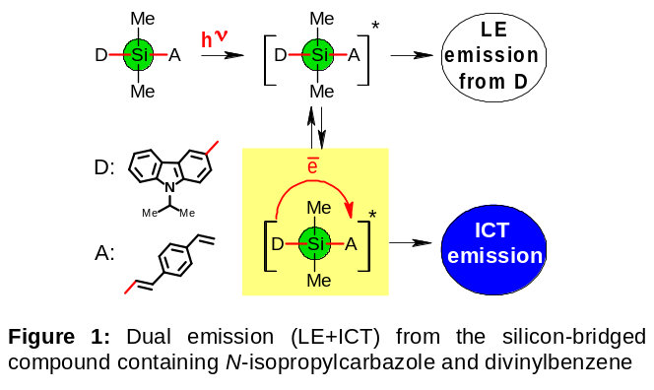
Recent Publications
- Bayda M, Angulo G, Hug GL, Ludwiczak M, Karolczak J, Koput J, Dobkowski J, Marciniak B (2017) Electron Transfer in Silicon-Bridged Adjacent Chromophores: the Source for Blue-Green Emission. Phys. Chem. Chem. Phys. DOI: 10.1039/C7CP00590C
- Bayda M, Ludwiczak M, Hug GL, Majchrzak M, Marciniec B, Marciniak B (2014) Intramolecular Charge Transfer Photoemission of a Silicon-Based Copolymer Containing Carbazole and Divinylbenzene Chromophores. Electron Transfer across Silicon Bridges. J. Phys. Chem. A 118:4750-4758.
- Ludwiczak M, Majchrzak M, Bayda M, Marciniak B, Kubicki M, Marciniec B (2014) J. Organomet. Chem. 750:150-161.
- Rachuta K, Bayda M, Majchrzak M, Koput J, Marciniak B (2017) Phys. Chem. Chem. Phys. DOI: 10.1039/C7CP01292F
- Bayda M, Hug GL, Lukaszewicz J, Majchrzak M, Marciniec B, Marciniak B (2009) Photochem. Photobiol. Sci. 8:1667-1675.

Biography
Malgorzata Bayda received her Ph.D. in chemistry from the Adam Mickiewicz University, Poznan, Poland (2009) working under supervision of Prof. Bronislaw Marciniak. She had 4 external positions: short-term research positions at Radiation Laboratory, University of Notre Dame, USA working with Dr. Gordon L. Hug (2008, 2015) and postdoctoral associate positions in Professor Jack Saltiel’s research laboratory at the Florida State University, USA (2010-2011, 2012). Since 2009 she works as associate professor (teaching and research) at AMU. She has her expertise in photophysics and photochemistry of organosilicon compounds using steady-state and time-resolved absorption and emission spectroscopy. Her earlier work was focused on a cis/trans photoisomerization of p-phenylene-silylene-vinylene polymers. Recently, her scientific interest turned toward searching for an attractive organosilicon light-emitting materials. To improve performance of such materials through rational molecular design she investigates excited-state processes between silylene-bridged chromophores focussing on a role of silicon atom in these processes.
Email: mbayda@amu.edu.pl
Presenting author details
Full name: Malgorzata Bayda
Contact number: +48 61 8291740
Session name/ number: Track 10-5 (Photochemistry- Fluorescence and Phosphorescence); Category: Oral/Poster presentation
Notes/Comments:
AMU: Adam Mickiewicz University; CAT: Center of Advanced Technologies; PAS: Polish Academy of Sciences; NDRL: Radiation Laboratory, University of Notre Dame;

