Topotactic synthesis of mixed-anion oxide epitaxial thin films
Akira Chikamatsu, PhD, Department of Chemistry, The University of Tokyo, Japan
Tetsuya Hasegawa, PhD, Department of Chemistry, The University of Tokyo, Japan

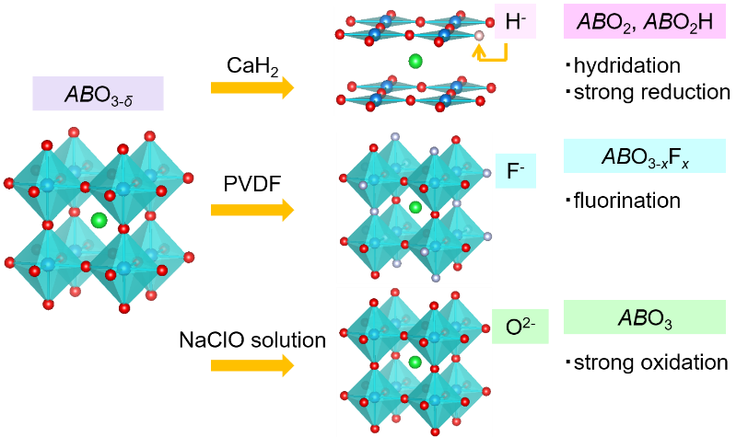
Abstract (300 word limit)
Transition metal oxides exhibit fascinating physical and chemical properties, including superconductivity, colossal magnetoresistance, ferroelectricity, and photocatalytic abilities. Since these properties are strongly affected by bonding interactions between the d orbital of transition metal cations and the p orbital of oxide anions, moderate replacement of O²⁻ by H⁻ or F⁻ can drastically change the characters. One of the most excellent methods to obtain oxyhydrides and oxyfluorides is topotactic synthesis using reagents, where guest species can be introduced into a host crystalline structure without destroying the initial crystalline matrix. For example, insulating BaTiO₃ changes into oxide hydride BaTiO_{2.4}H_{0.6} with metallic nature by CaH₂ treatment [1], and bulk crystal of SrFeO_{3-δ} changes into SrFeO₂F by annealing with poly-CH₂CF₂ (PVDF) at 400°C [2]. Though this method has mainly been applied to powder bulk samples, the reaction on thin-film samples is expected to have several advantages over bulk: considerably higher reactivity owing to the larger surface area/volume ratio, stabilization of the crystal framework by epitaxial effect, and modification of physical properties by epitaxial strain. In this study, we examined four types of topotactic reactions for various transition-metal oxide epitaxial thin films, i.e., hydridation and strong reduction using CaH₂, fluorination using PVDF, and strong oxidation using NaClO solution, as schematically illustrated in Figure 1. Furthermore, we found interesting electronic properties in the obtained mixed-anion oxide thin films, such as ferromagnetic metal to antiferromagnetic insulator transition. These reactions will be useful for designing and synthesizing novel mixed-anion compounds in epitaxial thin film form.
[1] Y. Kobayashi et al., Nature Mater. 11, 507 (2012).
[2] F. J. Berry et al., Solid State Commun. 134, 621 (2005).

Image
Figure 1. Schematic image of the topotactic reactions of hydridation and strong reduction using CaH₂, fluorination using PVDF, and strong oxidation using NaClO solution.

Recent Publications (minimum 5)
- T. Onozuka, A. Chikamatsu, T. Hasegawa et al., “Reversible Changes in Resistance of Perovskite Nickelate NdNiO₃ Thin Films Induced by Fluorine Substitution”, ACS Appl. Mater. Interfaces 9, 10882 (2017).
- K. Kawahara, A. Chikamatsu, T. Hasegawa et al., “Topotactic fluorination of perovskite strontium ruthenate thin films using polyvinylidene fluoride”, CrystEngComm 19, 313 (2017).
- T. Katayama, A. Chikamatsu, T. Hasegawa et al., “Epitaxial growth and electronic structure of oxyhydride SrVO₂H thin films”, J. Appl. Phys. 120, 85305 (2016).
- T. Onozuka, A. Chikamatsu, T. Hasegawa et al., “Formation of defect-fluorite structured NdNiO_{x}H_{y} epitaxial thin films via a soft chemical route from NdNiO₃ precursors”, Dalt. Trans. 45, 12114 (2016).
- T. Katayama, A. Chikamatsu, T. Hasegawa et al., “Experimental and theoretical investigation of electronic structure of SrFeO_{3-x}F_{x} epitaxial thin films prepared via topotactic reaction”, Appl. Phys. Express 9, 25801 (2016).

Biography (150 word limit)
Akira Chikamatsu holds a Ph.D. from the University of Tokyo in 2008, and currently works on the University of Tokyo as an assistant professor. He is an expert in solid-state chemistry and physics, thin-film growth, and electron spectroscopy. He developed new thin-film growth techniques of mixed-anion transition metal oxides, and succeeded in creating some new materials by these methods. His current research interests in searching for new functionalities and new phenomena in mixed-anion transition metal oxides by using layer-by-layer thin film growth and topotactic reaction technologies.
Email: chikamatsu@chem.s.u-tokyo.ac.jp
Presenting author details
Full name: Akira Chikamatsu
Contact number:
Twitter account: None
Linked In account: none
Session name/ number:
Category: Oral presentation
Notes/Comments

