APOD based evaluation of drug safety and prioritization of investigational drugs
Chaitanya N. Hiremath, Ph.D.
APODvision, Inc., Massachusetts, USA

Abstract
Abbreviated Profile of Drugs (APOD) is a simple, instantaneous, and empowering prediction method for drug discovery. It facilitates decision-making and prioritization of the investigational treatments. The laboratory techniques used to determine drug safety are time-consuming. The tell-tale signs of drug safety are in the actual makeup of the drug itself. APOD uses the drug’s chemical properties for a mathematical model to predict its pharmacokinetic properties. In this approach, the drugs are classified as: strong, moderate, and weak. It is done using the APOD score which is a pair of numbers that represents benefit and risk presented by a drug. Drugs with only strong and moderate safety profiles can be repurposed for COVID-19 or any other disease targets. The existing effective drugs with weak safety profiles can be modified into effective drugs with moderate/strong profiles through the insights from the APOD fingerprint and difference APOD, even before the molecule is synthesized. The APOD method provides an advancement in the field of drug discovery by unifying all properties in the fingerprint, making any property comparisons possible with uniform representation, and integrating pharmacokinetic insights into drug design.

Image
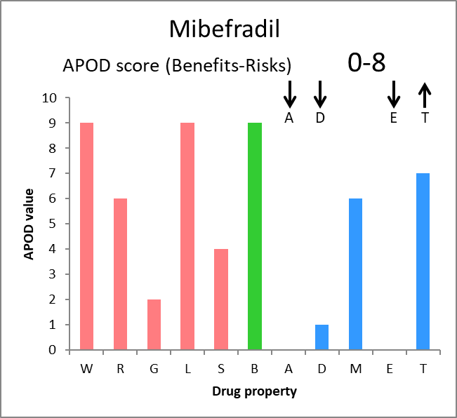

Figure 1: Graphical-APOD representation of a recalled drug
Recent Publications
- C.N. Hiremath, R.A. Grant, D.J. Filman and J.M. Hogle. The Binding of the Antiviral Drug WIN51711 to the Sabin Strain of Type 3 Poliovirus: Structural Comparison with Drug Binding in Rhinovirus 14. Acta Cryst. (1995) D51: 473-489.
- C.N. Hiremath, D.J. Filman, R.A. Grant and J.M. Hogle. Ligand-induced Conformational changes in Poliovirus-Antiviral Drugs Complexes. Acta Cryst. (1997) D53: 558-570.
- C.N. Hiremath. Abbreviated Profile of Drugs (A-POD): A unique numerical and graphical representation for compound properties and its use in ADMET prediction. International Journal of Integrative Biology (2007). 1(1): 44-50.
- C.N. Hiremath. Let Your Success be BIIG: A New Paradigm for Problem-Solving in Science. International Journal of Physics (2015), 3(3), 113-119.
- Hiremath C. N. (2021). Abbreviated Profile of Drugs (APOD): modeling drug safety profiles to prioritize investigational COVID-19 treatments. Heliyon, 7(8), e07666.



Biography
Dr. Chaitanya Hiremath is a distinguished drug discovery scientist, educator, advisor, mentor, reviewer, founder, and inventor, specializing in Bioinformatics and Cheminformatics. He was a senior fellow at Harvard Medical School and a visiting scientist at Massachusetts Institute of Technology. As a former associate-professor of bioinformatics, apart from research, mentoring, and teaching, he has served as a Chief-Coordinator of Bioinformatics Program at a national level, managing all aspects of this program across five centers. Dr. Hiremath has developed the BIIG problem-solving method with a goal of improving science education worldwide. Dr. Hiremath has designed the World Flag and is the founder of a non-profit organization SEALOEarth.
ORCID: https://orcid.org/0000-0001-6116-0727

Notes/Comments:

Presenting author details
Full name: Dr. Chaitanya N. Hiremath
Contact number: +1 978-692-1658
Mail id: cnhiremath@apodvision.com
Category: Oral presentation

