Self-medication practices among parents who attend to a private pediatric clinic
Lopez Ruiz, MA MD, PhD, CEU Cardenal Herrera University, Spain

Abstract (300 word limit)

Self-medication is a common practice and an important problem of public health between the pediatric patients. The total number of patients who attended to the Accident and Emergencies Department during 1 year (from February 2017 to February 2018) was 2388. A total of 1538 patients attended to the private pediatric clinic taking some medication before the visit. The majority of drugs consumed by these patients (self-medication provided by parents or caregivers of children) were pain-killers and antipyretics (64.8%), followed by drugs for the respiratory system (20.1%) and drugs for the digestive system (11.2%) and antibiotics in a minority form (3.9%).

The 1538 self-medicated patients, 143 had some adverse drug reaction due to the medication they were taking; and 35 of these reactions were due to self-medication. The patients from 1 to 4 years were the most self-medicated group (65.1%), followed by the group of 5 to 14 years (22.8%) and those under one year (12.1%). Self-medication among pediatric patients is common; and the most often with pain-killers and antipyretics underdosing leading to ineffectiveness and adverse reactions that could be prevented with proper use of drugs. Regarding the analysis of the dosage of pain-killers and antipyretics: ibuprofen recorded 343 cases of undertreatment (54.6%), 28 cases of overtreatment (4.9%) and 251 cases of correct dosing (40.5%). While paracetamol recorded 200 cases of undertreatment (35.9%), 32 cases of overtreatment (5.8%) and 331 cases of correct dosing (58.3%). The most frequent adverse drug reactions observed with self-medication were: vomiting (77.3%), skin rashes (12.5%) and diarrhea (10.2%). None of the adverse drug reactions was serious, and could be solved without requiring hospital admission. Although it should be noted that such adverse reactions could have been avoided if they had not made an inappropriate use of the drugs, due in large part to their own lack of knowledge of the indications of the same.

Image
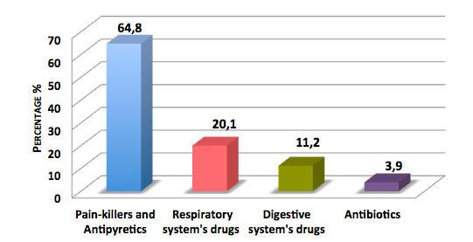
Fig. Percentages of self-medication drugs provided by parents or caregivers

Recent Publications (minimum 5)
- López-Ruiz MA, Bendala-Tufanisco E, Muedra V, Moreno L. Single Oral Ibuprofen Overdose as Cause of Gastric Hemorrhagic Ulcer: A Medication Error in Children. Med Sci Case Rep, 2016; 3: 86-90.
- López-Ruiz MA, Bendala-Tufanisco E, Muedra V, Moreno L. Neuroleptic-Induced Oral-Facial Tardive Dyskinesia in a Prepuberal Boy with an Attention-Deficit Hyperactivity Disorder. Pediatrics & Therapeutics 2015; 5 (3):47-248.
- López-Ruiz MA, López-Peña R, Rojas-Otero LI, Moreno-Royo L. Self-medication between patients who come to a paediatric accident and emergencies unit. Aten Farm 2012; 14 (6):441-445.

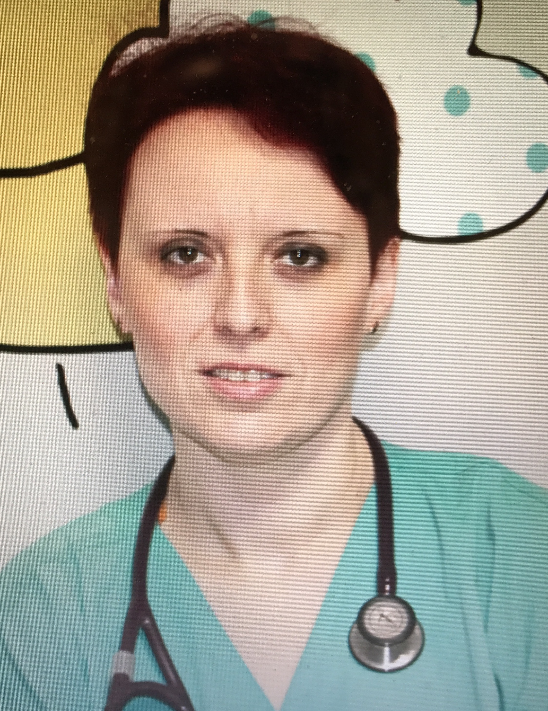 Biography (150 word limit)
Dr. Lopez-Ruiz has completed his PhD from Valencia University and postdoctoral studies from CEU Cardenal Herrera Health Sciences Faculty. She obtained her doctorate in Medicine with the doctoral thesis on “Analysis of the use of medication in the paediatric population that visit accident and emergency department” with summa cum laude. She has achieved the qualification of “University Expert in Neonatology” from the Catholic University in Valencia and “Master’s Degree in Neonatology (from de SENeo -Neonatology Spanish Society-)”. She is Medicine Degree Coordinator in CEU Cardenal Herrera University since 2015. She is the director of the “Master’s degree in Neonatal Intensive care and Neonatal Nursing”. She has attended to International Congresses of Pediatrics as a keynote speaker and she has been part of the Organizing Committee member for the 12th International Conference on Pediatric Pathology and Laboratory Medicine, and she has published in reputed international journals..
Email: maria.lopez5@uchceu.es

Notes/Comments:

