Immunohistochemistry study of testis tissue to investigate the effect of vitamin E on the proliferation and apoptosis induced by diazinon
Mohammad Reza Nikravesh, Mehdi Jalali, Fatemeh Rahimi Anbarkeh
Department of Anatomy and cell biology, Mashhad University of Medical Sciences, Mashhad, Iran.
Background: Diazinon (DZ) is an organophosphate pesticide and today this insecticide is mostly used in agriculture in developing countries. The main effect of these pesticides which affects the human body systems consists of: blocking the acetylcholinesterase activity, oxidative stress and apoptosis. Although the antioxidant system of body is the most powerful defense against the changes caused by diazinon, sometimes it is not enough and the need to use antioxidants is to improve the changes. In this study we analyzed the effects of diazinon and vitamin E on apoptosis and the proliferation of germ cells in adult rat gonad.
Methods: 30 male wistar rats, were divided into five groups (N=6). Control group (No intervention), sham group (got pure olive oil into the peritoneum), Experimental group 1 (got 60 mg/kg diazinon, by intraperitoneal injection) Experimental group 2 (received 60 mg /kg diazinon by intraperitoneal injection and 200 mg/kg vitamin E by gavage) The vitamin receiving group (received 200 mg/kg vitamin E by gavage daily). animals were scarified after six weeks and left testis were removed for immunohistochemistry study (TUNEL and PCNA).
Results: compared to control group, diazinon in the experimental group 1 decreased the number of positive PCNA cells significantly (p< 0.001) and increased the number of TUNEL positive cells significantly (p< 0.001). and vitamin E in the experimental group 2 caused the decrease in the number of TUNEL positive cells and increase in PCNA positive cells compared to experimental group 1 (p< 0.001).
Conclusion: vitamin E can decrease the number of TUNEL positive cells and increase the number of PCNA positive cells by overcoming the poison cause by diazinon in the gonad.
Keywords: Apoptosis, proliferation, Diazinon, Testis, Vitamin E.

Introduction
The pesticides are used all over the world to control the pests in agriculture, veterinary, insects in houses and the insects which cause disease and to increase the production of foodstuffs and Keep up human and animal health. The wide usage of pesticides in agriculture and general hygiene cause serious problems in ecosystem and hygiene risks including crucial, pre crucial and chronic human and animal poisoning and is therefore an important concern (1,2). Organophosphate pesticides have been used instead of chlorine poisons during the four current decades and they are the most common pesticide. The main advantage of organophosphate compounds is their short sustainability and their low aggregation in ecosystem (3).
Because of non-polar and fat friendly structure of the organophosphates, they are absorbed quickly after eating or breathing, and after the absorption they aggregate in fat, kidney, liver and salivary glands. Their long contact with the skin can cause intense poisoning. Organophosphates are affected by different metabolism reaction and finally their metabolites are egested by urine, faeces and expiration. Some of these poisons are accumulated in fat and their excretion takes days because on aggregating in fat (4). The common structure of pesticides is as below:
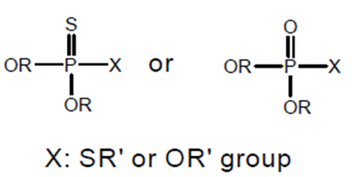
In this structure X is the leaving group which is variable. And most of the alkoxy groups are placed in R1 and R2. And oxygen or sulfur is placed in the other stand which can connect to another phosphor and create dual band. Based on these chemical differences, the organophosphates are divided to some subgroups. phosphates and phosphorothionates are the main which are the most common organophosphate pesticides. Phosphorothionates are like parathion, diazinon, malathion and clorpirifos and phosphorothionates are more common compared to phosphates (6,5). Diazinon is one of the most well-known organophosphate pesticides which is synthetic and does not exist naturally in the environment. It is more common for paddies, fruit trees and to control the ectoparasites of the livestock. Diazinon activity is like the other organophosphates, which is to block the acetylcholinesterase enzyme. These compounds are connected to some enzymes in the body but its effect on acetylcholinesterase has clinically important (7, 6). Diazinon creates pathological changes in body like hematology disorders, kidney, liver, cardiac and nervous toxicity and reproductive disorders in male and female, by creating oxidative stress and free radicals (8, 9). Most of the findings and statements show that organophosphate poisoning is more than blocking acetylcholinesterase enzymes and is related to the ability of these compounds to create low amount of apoptosis by activating internal and external directions (10). So that in several studies, induction of apoptosis in various tissues of the body was observed by activating the pathways of caspases by organophosphates (11, 12). Spermatogenesis is a process in which the immature germ cells change in to mature germ cells in the testicular tubes (13). Apoptosis and cell proliferation are two important cellular processes in the normal activity of male germ cells and the normal homeostasis of sperm tubes epithelium is dependent on these two processes (14). Apoptosis has two main roles in the normal spermatogenesis: 1) decreasing the germ cells to the number which can be supported by sertoli cells. 2) the manual omission of abnormal sperms, during which most of the ineffective cells like old, immature or hurt cells are omitted (14-16). Diazinon through loosening the connective tissue and the muscles around the sperm tube, changes its diameter. The size of the germinal cells will also change and the size of these cells is smaller than normal (17). The antioxidant enzymes are responsible of detoxification of free radicals. Catalase and superoxide dismutase are the main enzymes in this system. Glutathione solves the toxins and exerts it from the kidney (18). Vitamin E as a fat soluble antioxidant, blocks the release of lipid peroxidation in cell membrane and therefore keeps the sustainability of the membrane and membrane processes. Different studies show that vitamin E has an important role in blocking oxidative stress and lipid peroxidation induced by organophosphate pesticides in laboratory animals (19).
Although the antioxidant and anti-apoptotic effect of vitamin E is shown in a vast number of studies, but we found no study which have analyzed the effect of this vitamin on testicle changes made by diazinon (including proliferation and apoptotic changes), so in this study the apoptotic changes and the proliferation of germ cells in the testicle of male rats after using diazinon with vitamin E is analyzed.

Methods and materials
Animals
In this study 30 adult male rats of wistar race with the weight of 200 to 250 gr. were taken from the Animal House in the Medical University of Mashhad. They were taken care of in standard situation (temperature of 22±2 ℃ and light/ darkness cycle of 12 hours) and during the examination they had free access to water and food.
The rats were divided to 5 groups randomly (n=6) and their condition was as below:
Control group, received no material.
Sham group got pure olive oil into the peritoneum
Experimental group 1 got 60 mg/kg diazinon soluble in olive oil into the peritoneum daily
Experimental group 2 got 60 mg/kg diazinon and 200 mg/kg vitamin E by gavage
The vitamin group got 200 mg/kg vitamin E by gavage daily.
After the treatment period (after 6 weeks) all group were anesthetized. After perfusion with normal saline and paraformaldehyde 4% the left testicle was removed and fixed in fixative solution (paraformaldehyde 4%) for histology protocols. This study was done in the histology laboratory of medical university of Mashhad and was approved by the Ethics Committee of Mashhad University of Medical Sciences
Testicle tissue perfusion:
Tissue perfusion is necessary to omit the blood, reduce the background color and increase the quality of colors.
To do the perfusion, first the animals were anesthetized by ether and their chest were opened with a surgical incision and the rinse solution and fixative solution perfusion was done by a 10 or 20 CC syringe through the left ventricle and perforated atrium.
During the opening of the chest we tried to do the incision in the middle line so that the wall veins had the lowest damage and therefore we had the minimum bleeding and rupture of the vessels. Then we separated the joints of the heart and its coatings from the bone. We perforated the right atrium with a needle while we entered another syringe needle to the left ventricle and did the injection of rinse solution until the solution coming out from the right atrium hole got bright. Then the fixative solution was injected promptly and this continued until the animal’s hands and legs whitened and started to shake. After these signs the left testicle was removed to do the preparations. (Figure 1and 2).

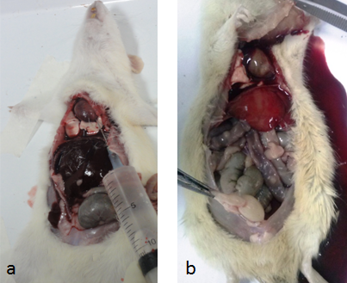

Figure 1. perfusion phase through the left ventricle: the left figure (a) is the start of perfusion and all the internal guts have a normal color, but the right figure (b) is after the perfusion and as you can see the color change of the internal guts including the liver and testicles which shows that the perfusion was successful and then the initial fixation happens.
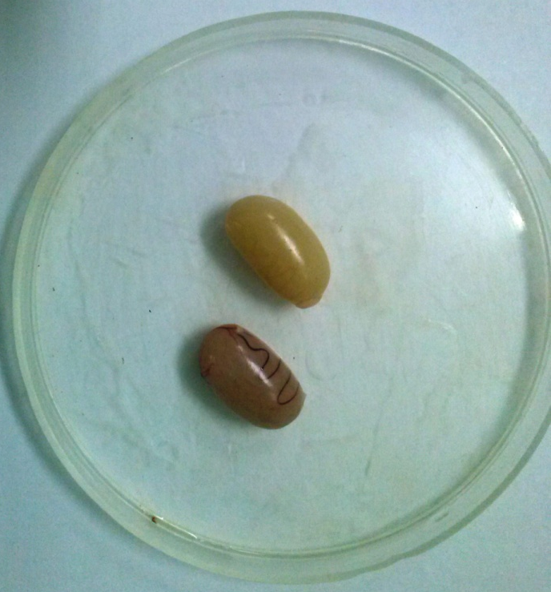
Figure 2. the testicle color change after the perfusion while the fixative solution replaced the vessels blood, and it is bright.

Preparation of the samples
To prevent the autolysis by lysosomal enzymes and tissue damage by bacteria and keeping the shape and the ingredient volume of the tissues, the testicles are fixed by paraformaldehyde 4% solution in 72 hours (considering the size, type of samples and the fixative quality). After the fixation to prepare the tissue for the examination by optical microscope, the tissue processing was done. Finally, the samples were embedded by paraffin. Then the samples were cut by microtome with the diameter of 5 µm and the pieces were placed on poly L-lysine lams. After deparaffinization and hydration by alcohol with descending rates, the samples were examined by PCNA and TUNEL immunohistochemical techniques with optical microscope.
Cell proliferation examination method
The coloring is done using PCNA kit and based on the related protocol in these steps respectively (20, 21): deparaffinization of the pieces with xylol in two steps (5 minutes for each step). Placing in absolute ethanol in two steps (5 minutes for each step), 95%, 80% and 70% alcohols (3 minutes each). Tree times washing with PBS each time 2 minutes. Blocking the peroxidase activity inside the tissue with hydrogen peroxide 3% in methyl alcohol for 10 minutes. Three washing with PBS, each time for two minutes. pouring a few drops of blocking solution (100μl) on the samples and incubating them for 10 minutes in room temperature. Cleaning the blocking solution from the pieces without washing. Incubating the samples with the initial anti-PCNA biotin antibody for 30 to 60 minutes in the humid environment and the room temperature. Three time washing with PBS, each time for two minutes. Incubating the samples with chromogenic Diaminobenzidine (DAB) for 2 to 5 minutes in the room temperature. Three time washing with PBS, each one for two minutes. Incubating the samples with Alcine blue for maximum of 10 minutes. Rinsing with running water for 5 minutes and then rinsing with distilled water. Dehydration with increasing levels of Ethyl alcohol, transparency with xylene in two steps and montage using special glue.
Control lams: some positive control lams (existing in the kit) are colored with the tested slides and some negative control lams are also colored after the omission of antibody.
Cellular apoptosis examination method
The coloring was done based on the TUNEL kit and coloring protocols as below (22): in this technique the methods are like PCNA until blocking the peroxidase activity and after washing three times with PBS, the cuts are incubated for 20 minutes in the room temperature and humid environment with 50 µL protein kinase K. three times washing by PBS (each time for two minutes). The pieces with TUNEL reaction mixture containing terminal deoxynucleotidyl transferase incubate about 24 hours in 4 ° C. three times rinsing with PBS (each time for 2 minutes). Dioxygen peroxidase (Converter-POD) was added to the samples and the lams were incubated for 30 minutes in 37 ° C. three times rinsing with PBS (each time for 2 minutes). Incubating the samples with chromogenic Diaminobenzidine (DAB) for 2 to 5 minutes in room temperature. Three times rinsing with PBS (each time for two minutes). Incubating the samples with hematoxylin for 20 seconds. Rinsing with running water for 5 minutes and then rinsing with distilled water. Dehydration with increasing levels of ethyl alcohol, transparency with xylene in two steps and montage using special glue.
Control lams: a few lams have been incubated with DNase I solution in the room temperature for 10 minutes and after rinsing with PBS the lams pass other steps of coloring. Since this enzyme cause the DNA fragmentation, the colored lams are positive control lams. The negative control lams are colored with the omission of terminal transferase.
The stereology method:
The numerical density of positive PCNA cells and positive TUNEL is calculated in the unit of surface by unbiased frames grades. To this end the testicular sections from different groups are shot by Olympus optical microscope model BX51. Then the numerical density of the positive TUNEL and PCNA cells are calculated in the unit of surface. The average cells in the unit of surface of the rats’ testicles in different groups is calculated based on this formula (23):
N_{a=}$\frac{\sum{Q}}{a/f\sum{P }}$
In this formula ΣQ is the number of calculated cells, a/f is the area of each frame, ΣP is the number of clash points in the frame area.
The statistical analysis method:
In this study SPSS version 16 is used to present the results, ANOVA test is used to analyze the immunohistochemical data of the apoptosis and proliferation, and next Tukey’s test is used to compare the differences between pairs of means. The statistical difference was P<0.05 which is significant and the results were presented based on the Mean ±SD.
Results:
Analyzing the proliferation of the spermatogonium cells and the primary spermatocytes.
In this study the PCNA method is used to examine the amount of the primary spermatocytes and spermatogonium cells proliferation and the results are as below:
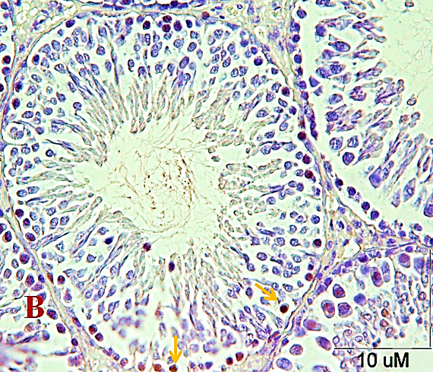
Based on figure 3 and 4, analyzing the cell proliferation by PCNA method shows that the spermatogonium cells and the primary spermatocytes which are proliferating in diazinon group decreased significantly compared to the control group (p<0.001) and therefore this group has the lowest amount of cell proliferation. Vitamin E in the experimental group 2 caused the proliferation of spermatogonium cells and the primary spermatocytes to improve compared to the experimental group 1 (p<0.001). As you can see in chart number 1 and 2, the amount of cell proliferation in control, sham and vitamin E receiving groups did not vary significantly (p>0.05).
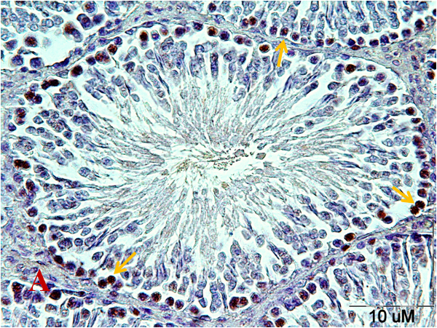

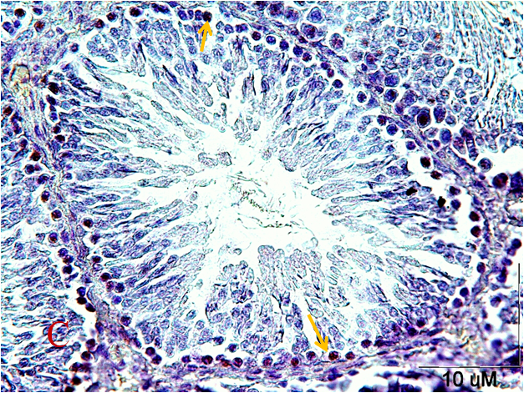

Figure 3. Testis tissue sections after the PCNA technique. Control group (a). Most of the spermatogonium cells are proliferating. In the experimental group 1 (B) diazinon (DZN) caused the decrease in the proliferating spermatogonium cells. In the experimental group 2 (C) which is taking DZN and vitamin E together the number of proliferating spermatogonium increased compared to DZN receiving group. PCNA positive cells are determined by arrow.
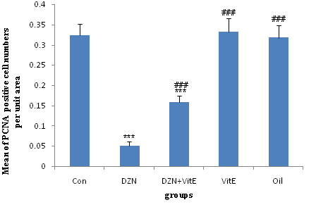

Chart 1. The effect of diazinon (DZN) and vitamin E on the proliferation of spermatogonium cells in the seminiferous tubes. In the groups of this study, DZN and olive oil (oil) are prescribed inside the peritoneum and vitamin E (VitE) is prescribed by gavage one time a day for six weeks. (mean±SEM) *** Comparing to control group (P<0.001), ### comparing to DZN group (p<0.001)

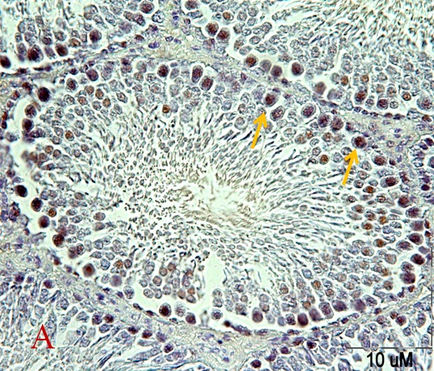
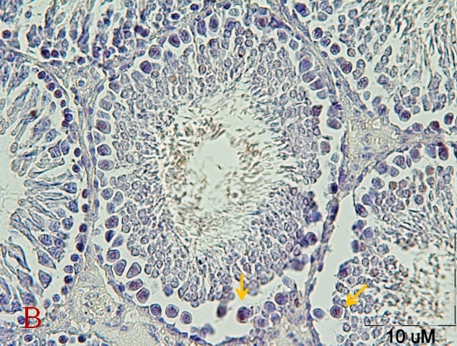

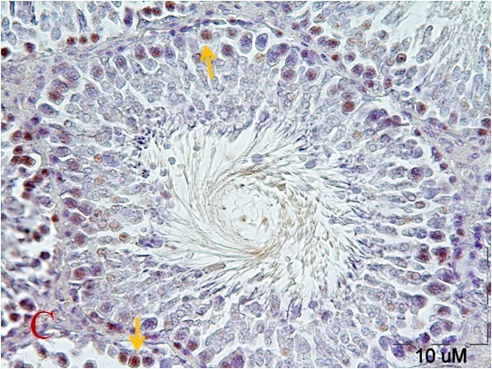

Figure 4. Testis tissue sections after the PCNA technique. Control group (a). Most of the primary spermatocytes are proliferating. In the experimental group 1 (B) DZN caused the decrease in the proliferating primary spermatocytes. In the experimental group 2 (C) which is taking DZN and vitamin E together the number of proliferating primary spermatocytes increased compared to DZN receiving group. PCNA positive cells are determined by arrow.

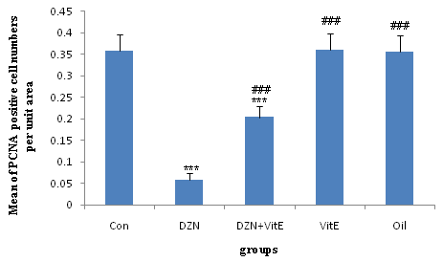

Chart 2. The effect of diazinon and vitamin E on the proliferation of primary spermatocytes in the seminiferous tubes. In the groups of this study, DZN and olive oil are prescribed inside the peritoneum and VitE is prescribed by gavage one time a day for six weeks. (mean±SEM) *** Comparing to control group (P<0.001), ### comparing to DZN group (p<0.001)

The examination of spermatogonium cells and the primary spermatocytes apoptosis
The results of the Immunohistochemistry study of seminiferous tubes using TUNEL technique to examine the amount of these two cells apoptosis is as bellow:
The histological study using TUNEL technique showed that diazinon in the experimental group 1 increased the spermatogonium cells and the primary spermatocytes apoptosis compared to the experimental group 1 (p<0.001), which shows the protective role of vitamin E. the sham and vitamin E receiving groups in the number of apoptotic cells were similar to the control group and most of their seminiferous tubes did not have apoptotic cells and one or two apoptotic cell is observed in some of the tubes (p>0.05) (figure 5 and 6).

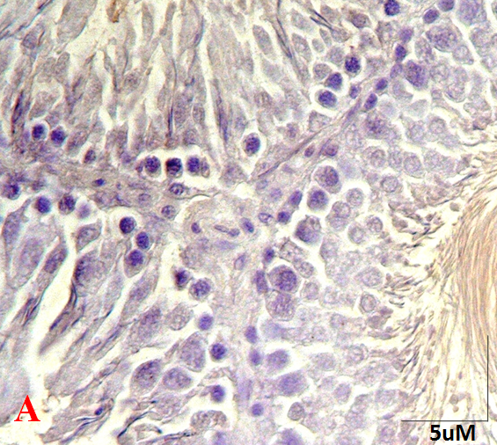
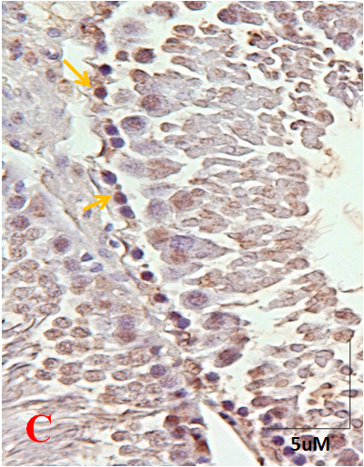
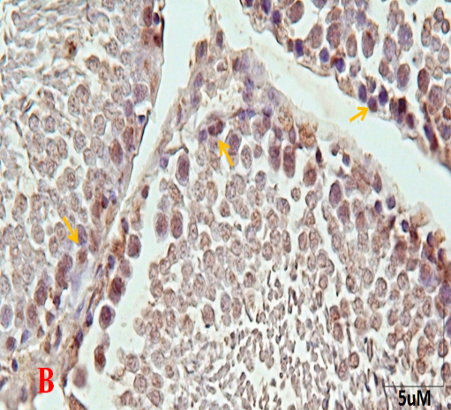
Figure 5. Testis tissue sections after the TUNEL technique for the apoptosis of spermatogonium cells: control group (A). Most of the seminiferous tubes do not have apoptotic cells. In the experimental group 1 (B) DZN caused the increase in the apoptotic cells compared to the control group. In the experimental group 2, vitamin E decreases the number of apoptotic cells compared to the experimental group 1. The TUNEL positive cells are marked by an arrow.
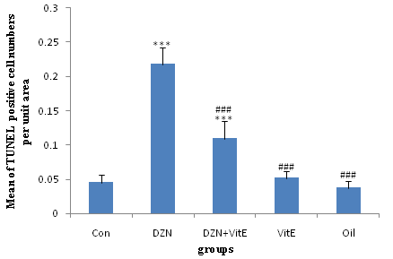

Chart 3. The effect of DZN and Vit.E on the apoptosis of the spermatogonium cell in the seminiferous cell. The results are presented in the form of the mean± the standard error. *** Comparing to control group (P<0.001), ### comparing to DZN group (p<0.001).

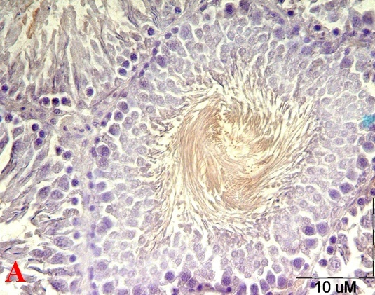
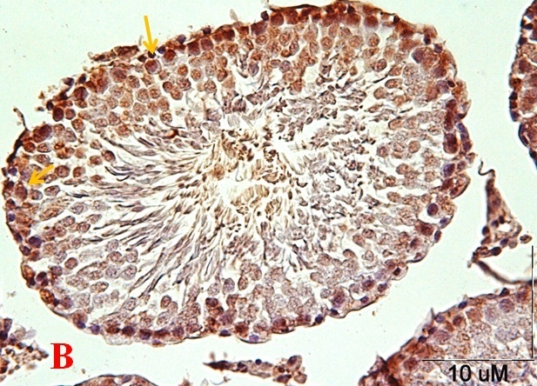
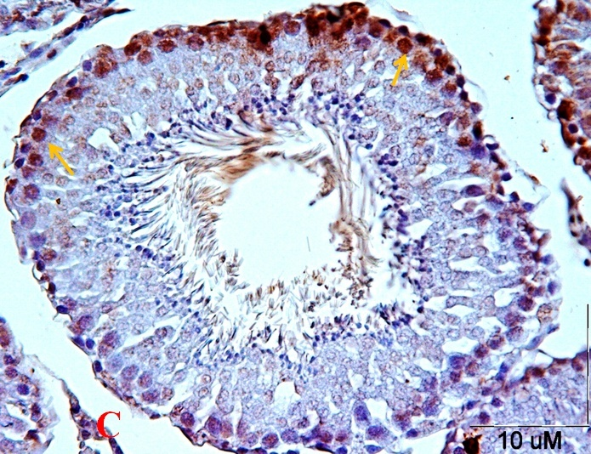

Figure 6. Testis tissue sections after the TUNEL technique for the apoptosis of primary spermatocyte cells: control group (A). Most of the seminiferous tubes do not have apoptotic cells. In the experimental group 1 (B) DZN caused the increase in the apoptotic cells compared to the control group. In the experimental group 2, vitamin E decreases the number of apoptotic cells compared to the experimental group 1. The TUNEL positive cells are marked by an arrow.

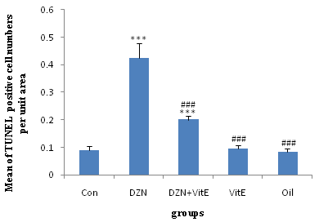

Chart 4. The effect of DZN and Vit.E on the apoptosis of the primary spermatocyte cells in the seminiferous cell. The results are presented in the form of the mean± the standard error. *** Comparing to control group (P<0.001), ### comparing to DZN group (p<0.001).
Discussion
Although most of the toxins in the body excrete after the detoxication in the liver, but part of it is possible aggregate in different body tissues like gonads and affect the germ cells which can cause weakness and decrease the reproduction of the animals (24). Considering the studies about different organophosphates, oxidative stress, lipid peroxidation and the increase in ROS production creates apoptosis. In this study considered the effect of diazinon on the apoptosis of the spermatogonial cells and primitive spermatocyte using TUNEL technique. Histological studies after using this technique, showed that diazinon increases the apoptosis of spermatogonial cells and the primitive spermatocyte. Using vitamin E along with diazinon also reduced the number of apoptotic cells. Another study showed that diazinon increase the number of apoptotic cells in the secondary follicles and graph in diazinon group compared to the control group and using vitamin E along with diazinon decreases the number of apoptotic cells in this follicles compared to diazinon group (25). In their study Bustos et al. showed that malathion creates apoptosis in A and B spermatogonia, spermatocyte and spermatid. Malathion also decreases the activity of serum acetylcholinesterase significantly (26). Razavi et al. reported that diazinon in sub chronic prescribing induced the significant increase in the MDA in the heart and aorta and decrease in serum acetylcholinesterase and pathologic harms in the heart tissue compared to the control group. It is also reported that diazinon caused to the apoptosis in the intracellular direction or the mitochondria dependent direction in heart and aorta. In this study it is shown that prescribing crocin and vitamin E together with diazinon reduces this damages to control group level and causes the recovery of toxic effects created by diazinon in heart and vessels (27). It is also reported that methyl parathion and dichlorvos and chlorpyrifos increases 3 and 9 caspases in tissues like endometrium and retina and the consumption of vitamin C and E together reduces the pathological and apoptosis induced by these pesticides (12, 28 and 29). Apoptosis or planned death is a normal process that keeps the homeostasis. Apoptosis is an energy- dependent process that causes the group activation of proteases named caspases. Apoptosis has special chemical characteristics. The transfer of phosphatidyl serine to the outside of plasma membrane, changes in the permeability of mitochondrial membrane, activating the caspases and finally the transfer of caspases to the core and fragmentation of DNA are the characteristics of apoptosis (30). Also based on several studies organophosphates change the gene expression level related to apoptosis like pro apoptotic Bax genes and anti-apoptotic Bcl-2 genes (31, 32). Therefore, organophosphates create apoptosis by activating the interior and exterior directions. Apoptosis in different tissues of the body is created through activating the caspases direction by organophosphates (10,11 and 33-35)
As mentioned previously the cellular damages created by organophosphate toxins have different reasons but these effects are mainly by affecting the structure and the performance of DNA. Pina-Guzman et al. confirm that the toxicity of most of the organophosphates is because of phosphorylation of some proteins like core proteins. Organophosphates have alkylation characteristics which can affect DNA. They also have electrophilic characteristics which can affect core proteins (36,37). Therefore, organophosphates including diazinon make changes in the chromatin structure and sperm DNA in the spermatogenesis phases by phosphorylation of core proteins (protamine) and also infiltrate in the testicle tissue and cause weight loss and makes the testicle diameter smaller, decreases the diameter of the semen tube and decreases the movement and survival of the sperm, germinal cell, leydig, sertoli and changes the quality of semen. It finally lowers the sperm production and increases abnormal sperms (38). In this way they can affect the normal characteristics of germ cells and their core (39). Therefore, the free radicals produced in the metabolism of diazinon toxin in liver can reduce the efficiency of the testicles in hormone synthesis and producing high quality germ cells by creating lipid peroxidation and damaging the cellular membrane of the testicle cells (17). And vitamin E can prevent the peroxidation in biological systems by blocking the free radicals and the difference of the kind of compound and the examined spices, the amount and time are the different factors considered.
One of the known performances of cell proliferator nuclear antigen is the processing of delta and epsilon polymerase DNA. PCNA also interact with the proteins in the cellular cycle. And by interaction with complex cyclin CDK affects the cellular cycle. Testicle includes the spermatogenetic epithelium in which the germ cells transfer from margin to the lumen and from develop spermatogonium to sperm. PCNA expression has direct relation to the mitosis activity and because the spermatogonium cells and the initial spermatocyte are mitosing in the seminiferous tubes, we can use it as a cellular proliferation marker for mitotic cells of the seminiferous tubes (40-44). Using PCNA method in this article shows the maximum spermatogonium proliferation activity and the initial spermatocyte in the control group, sham and the vitamin E receiving group, while diazinon causes a significant reduction in these cells proliferation. Also consuming vitamin E together with diazinon increases the number of spermatogonia and initial proliferating spermatocyte significantly. Sargazi et al. showed that the number of proliferating cells in the secondary follicles and graph in diazinon group decreased significantly compared to the control group, and vitamin E together with diazinon increases the number of proliferating cells in these follicles significantly compared to diazinon group. In most of the studies the examination of organophosphate in vitro and their metabolites effects on the survival and the proliferation of nerve cells and glia shows that these effects are seen in the micro molar concentrations which also blocks the DNA synthesis (46). The reduction of cell proliferation due to diazinon shows that organophosphates affect the cellular responses to cytokine set up and the ability of cellular proliferation and gene expression by creating free radicals. MDA increase also makes cellular changes and apoptosis (47). In Mirjana et al. study diazinon with different doses decrease the proliferation of blood lymphocytes and the fibroblasts of human skin in the culture medium and this decrease was dependent on the dose, and diazinon blocked the AChE activity and increased the MDA level (48). Videau et al. reported that one dose of malathion creates vacuole in sertoli cells and germ cells, increases the apoptosis of germ cells in seminiferous tubes and decreases the activity of cholinesterase plasma. Damage of spermatids at the time of the evolution of the flagella causes the immaturity of gamete in changing to sperm; it can also reduce the number of sperms, increase the number of abnormal shapes or change the sperm movement (49).
Therefore, diazinon and other organophosphate compounds can harm the testicle by affecting the different cellular steps like DNA transcription and the changes in DNA or the bond proteins and decrease the cells proliferation and eventually change the sperm by spermatocyte mutation (50, 51). Vitamin E can restrict the free radical’s activity, block the reaction of lipid peroxidation in cell membrane and therefore protect the cell membrane. This vitamin has antioxidant characteristic in blocking the harmful effects of free radicals in the testicle and sperm (19).
Conclusion:
The results of our study shows that diazinon makes the testicle toxic by increasing the apoptosis and decreasing the proliferation of testicle germ cells and vitamin E decrease this toxicity. Therefore, considering the importance of the quality of agricultural products, organophosphate toxins are more common in agriculture and this is inevitable until being replaced by biological techniques, so we should use antioxidant for people who contact these toxins.
Declaration of conflict of interest
The authors declare that there is no conflict of interests.
Acknowledgements
This project was funded by a grant from Research Council of Mashhad University of Medical Sciences. It was conducted under contract NO.911096.
References
- Ranjbar, A., Pasalar, P., Abdollahi, M., 2002. Induction of oxidative stress and acetylcholinesterase inhibition in organophosphorous pesticide manufacturing workers. Hum Exp Toxicol. 21,179–182.
- Abdel‐Daim, M., Halawa, S., 2014. Synergistic hepatocardioprotective and antioxidant effects of myrrh and ascorbic acid against diazinon‐induced toxicity in rabbits. Int Res J Humanit Eng Pharm Sci. 1,1–7.
- Zavon M.R. 1971. Treatment of organophosphorus and chlorinated hydrocarbon insecticide intoxications. Mod Treat. 8,503–510.
- Brent, J., Wallance, K.L., Burkhart, K.K., Phillips, S.D., Donovan, J.W., 2005. Critical care toxicology- diagnosis and management of the critically poisoned patient. Philadelphia, Elsevier Mosby, pp. 937-42.
- Carr, R.L., Richardson, J.R., Guarisco, J.A., Kachroo, A., Chambers, J.E., Couch, T.A., et al, 2002. Effects of PCB exposure on the toxic impact of organophosphorus insecticides. Toxicol Sci. 67(2), 311‐321.
- Storm, J.E., Rozman, K.K., Doull, J., 2000. Occupational exposure limits for 30 organophosphate pesticides based on inhibition of red blood cell acetylcholinesterase. Toxicology. 150(1‐3), 1‐29.
- Karalliedde, L., 1999. Organophosphorus poisoning and anaesthesia. Anaesthesia. 54(11), 1073‐1088.
- Elmazoudy, R.H., Attia, A.A., 2012. Endocrinedisrupting and cytotoxic potential of anticholinesterase insecticide, diazinon in reproductive toxicity of male mice. J Hazard Mater. 209–210, 111–120.
- Razavi, B.M., Hosseinzadeh, H., Movassaghi, A.R., Imenshahidim M., Abnous, K., 2013. Protective effect of crocin on diazinon induced cardiotoxicity in rats in subchronic exposure. Chemicobiological interactions. 203(3), 547‐55.
- Kumar, P., Radotra, B., 2007. Impaire mitochondrial energy metabolism and neural apoptotic cell death after chronic dichlirvos (OP) exposure in rat brain. NeuroToxicol. 28, 1208-19.
- Saulsbury, M.D., Heyliger, S.O., Wang, K., Johnson, D.J., 2009. Chlorpyrifos induces oxidative stress in oligodendrocyte progenitor cells. Toxicology. 259(1-2), 1-9.
- Oral, B., Guney, M., Demirin, H., Ozguner, M., Giray, S.G., Take, G., et al, 2006. Endometrial damage and apoptosis in rats induced by dichlorvos and ameliorating effect of antioxidant vitamins E and C. Reprod Toxicol. 22(4), 783-90.
- Hess, R.A., de Franca, L.R., 2009. Spermatogenesis and cycle of the seminiferous epithelium. Molecular mechanisms in spermatogenesis.8rd ed., USA, Springer. 1-15.
- Dadhich, R.K., Real, F.M., Zurita, F., Barrionuevo, F.J., Burgos, M., Jimenez, R., 2010. Role of apoptosis and cell proliferation in the testicular dynamics of seasonal breeding mammals: a study in the Iberian mole, Talpa occidentalis. Biol Reprod. 83(1), 83-91.
- Angelopoulou, R., Plastira, K., Msaouel, P., 2007. Spermatozoal sensitive biomarkers to defective protaminosis and fragmented DNA. Reprod Biol Endocrinol. 5(1), 36-41.
- Guneli, E., Tugyan, K., Ozturk, H., Gumustekin, M., Cilaker, S., Uysal, N., 2008. Effect of melatonin on testicular damage in streptozotocin-induced diabetes rats. Eur Surg Res. 40(4), 354-60.
- Dutta, H.M., Meijer, H.J., 2003. Sublethal effects of diazinon on the structure of the testis of bluegill, Lepomis macrochirus: a microscopic analysis. Enviromental pollution. 125, 355-60.
- Nordberg, J., Arner, E.S., 2001. Reactive oxygen species, antioxidants, and the mammalian thioredoxin system. Free Radic Biol Med. 31(11), 1287-312.
- John, S., Kale, M., Rathore, N., Bhatnagar, D., 2001. Protective effect of vitamin E in dimethoate and malathion induced oxidative stress in rat erythrocytes. The Journal of nutritional biochemistry. 12(9), 500-504.
- Hall, P.A. L.D., Woods, A.L., Yu, C.C., Kellock, D.B., Watkins, J.A., et al, 1990. PCNA immunolocalizationin paraffin sections: an index of cell proliferation with evidence of deregulated expression in some neoplasms. J Pathol. 162(4),285-94.
- Bravo, R. M.-B.H., 1987. Existence of two populations of cyclin proliferating cell nuclear antigen during the cell-cycle-association with DNAreplication sites. J Cell Biol.;105(4):1549-54.
- Moghaddam-Dorafshani M., Nikravesh, M.R., Ebrahimzadeh, A.R., 2013. Study of the Effect of Hypothyroidism on the Apoptotic Index in Rat Ovarian Follicles, Using the TUNEL Technique. Iranian society anatomical sciences.10(1), 25-35.
- Rajabzadeh, A.A., Ebrahimzadeh-Bideskan, A.R., Haghir, H., Fazel, A.R., 2011. Morphometrical study of polysialylated neural cell adhesion molecule positive cells in rat pups’ hippocampus following induction of seizure during pregnancy. Iran Biomed J.15(4), 157–63.
- Abd e-A.M., Sahlab, A., Abd e-K.M., 1994. Influence of diazinon and deltamethrin on reproductive organs and fertility of male rats. DTW Deutsche tierarztliche Wochenschrift. 101(6), 230-32.
- Sargazi, Z., Nikravesh, M.R., Jalali, M., Sadeghnia, H.R., Rahimi-Anbarkeh, F., 2016. Apoptotic effect of organophosphorus insecticide diazinon on rat ovary and protective effect of vitamin E. Iranian Journal of Toxicology. 10(2), 37-44.
- Bustos-Obregon, E., Gonzalez-Hormazábal, P., 2003. Mice testicular damage elicited by Malathion. Int J Morphol. 21(2), 155-59.
- Razavi, M., Hosseinzadeh, H., Movassaghi, A.R., Imenshahidi, M., Abnous, K. 2013. Protective effect of crocin on diazinon induced cardiotoxicity in rats in subchronic exposure. Chem Biol Interact. 203(3), 547-55.
- Guney, M., Oral, B., Demirin, H., zguner, M., Take, G., Mungan, T., et al, 2007. Evaluation of caspase-dependent apoptosis during methyl parathion-induced endometrial damage in rats: Ameliorating effect of Vitamins E and C. Env Toxicol Pharmacol. 23(2), 221-27.
- Yu, F., Wang, Z., Ju, B., Wang, Y., Wang, J., Bai, D., 2008. Apoptotic effect of organophosphorus insecticide chlorpyrifos on mouse retina in vivo via oxidative stress and protection of combination of vitamins C and E. Experimental and Toxicologic Pathology. 59, 415–23.
- Crompton, M., 2000. Bax, Bid and the permeabilization of the mitochondrial outer membrane in apoptosis. Curr Opin Cell Biol. 12, 414-19.
- Geng, X., Shao, H., Zhang, Z., Ng, J.C., Peng, C., 2015. Malathion-induced testicular toxicity is associated with spermatogenic apoptosis and alterations in testicular enzymes and hormone levels in male Wistar rats. Environmental toxicology and pharmacology. 39(2), 659-67.
- Yu, K., Li, G., Feng, W., Liu, L., Zhang, J., Wu, W., et al, 2015. Chlorpyrifos is estrogenic and alters embryonic hatching, cell proliferation and apoptosis in zebrafish. Chemico-biological interactions. 239, 26-33.
- Saleh, A.M., Vijayasarathy, C., Masoud, L., Kumar, L., Shahin, A., Kambal, A., 2003. Paraoxon induces apoptosis in EL4 cells via activation of mitochondrial pathways. Toxicol Appl Pharmacol. 190(1), 47-57.
- Kaur, P., Radotra, B., Minz, R.W., Gill, K.D., 2007. Impaired mitochondrial energy metabolism and neuronal apoptotic cell death after chronic dichlorvos (OP) exposure in rat brain. Neuro Toxicol. 28(6), 1208-19.
- , Guida, M.G., Falugi, C., 2010. Apoptosis as a specific biomarker of diazinon toxicity in NTera2-D1 cells. Chem Biol Interact. 187, 293-303.
- Maxwell, L.B., Dutta, H., 2005. Diazinon-induced endocrine disruption in bluegill sunfish, Lepomis macrochirus. Ecotoxicology and environmental safety. 60(1), 21-27.
- Pina-Guzman, B., Solis-Heredia, M., Quintanilla-Vega, B. 2005. Diazinon alters sperm chromatin structure in mice by phosphorylating nuclear protamines. Toxicology and applied pharmacology. 202(2), 189-98.
- Fattahi, F., parivar, K., Jorsaraei, S.G.A., Moghadamnia, A.A., 2010. The Effects of a Single Dosage of Diazinon and Hinosan on the Structure of Testis Tissue and Sexual Hormones in Mice. Yakhteh Medical Journal. 12(3), 405-10.
- Mohseni-Kouchesfahani, H., Parivar, K., Tahamtani, Y., 2008. Effect of diazinon as a pesticide on oogenesis and ovary structure of balb/c mice strain. Journal of Science (Kharazmi University). 8(2), 143-52.
- Chieffi, P., Franco, R., Fulgione, D., Staibano, S., 2000. PCNA in the Testis of the Frog, Rana esculenta: A Molecular Marker of the Mitotic Testicular Epithelium Proliferation. General and comparative endocrinology. 119(1),11-6.
- Hirshfield, A.N., 1986. Patterns of [3H] thymidine incorporation differ in immature rats and mature,cycling rats. Biol Reprod. 34(1), 229-35.
- Chang, C.D., Ottavio, L., Travalli, S., Lipson, K.E., Baserga, R., 1990. Transcriptional and posttranscriptional regulation of the proliferating cell nuclear antigen. Mol Cell Biol. 10(7), 3289-96.
- Unek, G., Ozmen, A., Kipmen-Korgun, D., Korgun, E.T., 2012. Immunolocalization of PCNA, Ki67, p27 and p57 in normal and dexamethasone-induced intrauterine growth restriction placental development in rat. Acta Histochem. 114(1), 31-40.
- Jasku, D., Gatti, C., Travali, S., Calabretta, B., Baserga, R., Regulation of the proliferating cell nuclear antigen cyclin and thymidine kinase mRNA levels by growth factors. J Biol Chem. 1988;263(21):10175-79.
- Sargazi Z." Effects of diazinon on biochemical parameters and morphological changes of apoptosis and proliferation of ovarian follicles in adult rats and the protective effect of vitamin E." Master Thesis, Mashad University of Medical Sciences, 2014.
- Guizzetti M, Pathak S, Giordano G, Costa LG. Effect of organophosphorus insecticides and their metabolites on astroglial cell proliferation. Toxicology. 2005;215(3):182-90.
- Jia Z, Misra, PH. Reactive oxygen species in in vitro pesticide induced neuronal cell (SH-SY5Y) cytotoxicity: Role of NF_B and caspase-3. Free Radical Biology and Medicine. 2007;42 (2):288–98.
- Colovic M, Krstić D, Petrović S, Leskovac A, Joksic G, Savic J, et al. Toxic effects of diazinon and its photodegradation products. Toxicology letters. 2010;193(1):9-18
- Penna-Videau S, Bustos-Obregn E, Cermeo-Vivas J, Chirino D. Malathion affects spermatogenic proliferation in mouse. Int J Morphol. 2012;30(4):1399-407.
- Sarabia L, Maurer I, Bustos-Obregon E. Melatonin prevents damage elicited by the organophosphorous pesticide diazinon on mouse sperm DNA. Ecotoxicology and Environmental Safety. 2009;72(2):663-68.
- Wyrobek A, Bruce W. Chemical induction of sperm abnormalities in mice. Proceedings of the National Academy of Sciences. 1975;72(11):4425-29.

