The role of folic acid targeting on nanotechnology based cancer photothermal therapy
Ali Shakeri-Zadeh, PhD, Iran University of Medical Sciences (IUMS), Tehran, Iran
Habib Ghaznavi, MD-PhD, Zahedan University of Medical Sciences (ZaUMS), Tehran, Iran

Abstract
Nano-Photothermal therapy (NPTT) is a nanotechnology assisted cancer hyperthermia approach in which the interaction between laser light and plasmonic nanoparticles generates a considerable localized heating. Exploitation of plasmonic nanoparticles in association with active targeting moieties causes the preferential accumulation of nanoparticles inside the cancer cells, providing a targeted photothermal therapy. We herein evaluate the effect of folic acid (FA) as an active targeting agent on enhancing the NPTT efficiency of multifunctional Fe3O4@Au core-shell nanoparticles. Fe3O4@Au core-shell nanoparticles were firstly synthesized and characterized. The temperature rise profiles of nasopharyngeal KB cancer cells treated with different concentrations of FA-targeted Fe3O4@Au nanoparticles were measured upon administration of near infrared (NIR) laser and compared with non-targeted Fe3O4@Au. Aside from that, the recorded temperature profiles of the cells were used for thermal dose calculation.
The presence of the nanoparticles resulted in increased temperature elevation rate of the KB cells in a concentration-dependent manner. However, the higher heating rate and then the higher thermal dose were obtained for the cells exposed to FA- targeted Fe3O4@Au nanoparticles rather than non-targeted Fe3O4@Au. These findings support the potential of FA targeting to improve the efficiency of laser hyperthermia through reducing the administrated concentration of nanoparticles, power density of the laser and the time needed for a NPTT operation procedure.
Image
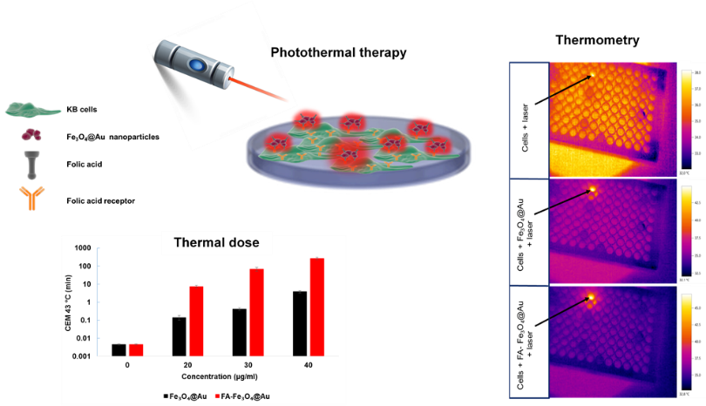
Recent Publications (minimum 5)
- Shakeri-Zadeh A, Mansoori GA, Hashemian AR, Eshghi H, Sazgarnia A, Montazerabadi AR. Cancerous cells targeting and destruction using folate conjugated gold nanoparticles. Dyn Biochem Process Biotechnol Mol Biol. 2010;4(1):06-12.
- Khoei S, Mahdavi SR, Fakhimikabir H, Shakeri-Zadeh A, Hashemian A. The role of iron oxide nanoparticles in the radiosensitization of human prostate carcinoma cell line DU145 at megavoltage radiation energies. International journal of radiation biology. 2014;90(5):351-6.
- Montazerabadi AR, Oghabian MA, Irajirad R, Muhammadnejad S, Ahmadvand D, Delavari H H, et al. Development of Gold-Coated Magnetic Nanoparticles as a Potential MRI Contrast Agent. NANO. 2015;10(04):1550048.
- Beik J, Abed Z, Ghoreishi FS, Hosseini-Nami S, Mehrzadi S, Shakeri-Zadeh A, et al. Nanotechnology in hyperthermia cancer therapy: From fundamental principles to advanced applications. Journal of Controlled Release. 2016;235:205-21.
- Samadian H, Hosseini-Nami S, Kamrava SK, Ghaznavi H, Shakeri-Zadeh A. Folate-conjugated gold nanoparticle as a new nanoplatform for targeted cancer therapy. Journal of cancer research and clinical oncology. 2016:1-13.

Biography
Habib Ghaznavi has got his MD degree from Zahedan University of Medical Sciences (ZaUMS), Iran in 2005, and his PhD degree in Pharmacology from Iran University of Medical Sciences (IUMS), Iran in 2014. He is now an assistant professor working at the Department of Pharmacology of the Faculty of ZaUMS.
Email: ghaznavih@yahoo.com
Notes/Comments:

