Role of Biobanking in Discovering Pharmacologic Biomarker Targets for the Practice of Precision Medicine
Stephanie C. Tanner, MD and Richard L. Summers, MD
University of Mississippi Medical Center, USA

Abstract

Statement of the Problem: Clinical studies that examine the outcomes of different treatments have guided the development of standards of care for the practice of medicine. While the evidences of these clinical trials has informed an improved practice of medicine, they focus on the outcome likelihoods for the population of patients as a whole and therefore treatment guidelines have evolved into a one-size-fits-all methodology. Recently, the modern methods of precision/personalized medicine have emerged as the course of medical practice for the future. The discovery of biomarker targets for the pharmacologic strategies of precision medicine will be critical to the development of this practice.

Methodology: Developing precision/personalized medicine systems will require an improved capacity to link biologic biomarkers with basic clinical, demographic and socioeconomic phenotypes. Such biomarkers can then be used as targets for patient-specific pharmacologic treatment strategies. A process that back tracks clinical treatment outcomes or adverse events to biologic materials banked in a prospectively instituted biorepository system can be used in the discovery of these potential biomarker targets.

Results: A software interface was used to link information from the electronic health record (Epic) and other salient data contained within the enterprise data warehouse with samples in the biobank at the University of Mississippi Medical Center. Researchers analyzing the epidemiologic characteristics of the data warehouse can identify cohorts of patients with specific responses to prescribed pharmacologic treatments. The biobanked biologic specimens that are associated with the individuals in these cohorts can then be recovered for an analysis of their pharmacogenetics and other omics as potential biomarker targets.

Conclusion: The new precision medicine approach to clinical practice represents a shift in the philosophy of treatment schemes that will require a greater focus on the translation of basic biomedical research to practical patient applications. Linking biobanked specimens to observed outcomes in clinical cohorts will be critical to the discovery of biomarker targets that facilitate decisions regarding precision pharmacologic strategies.

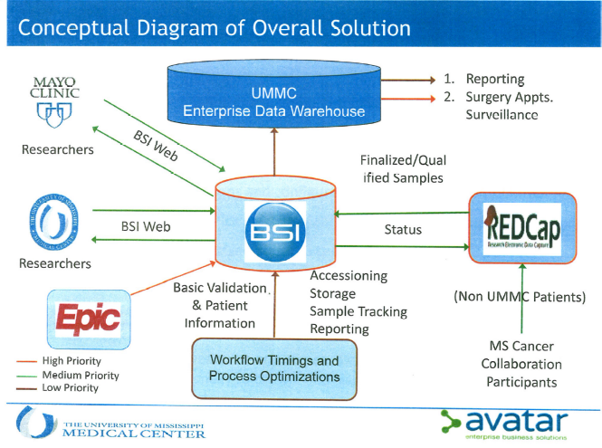
Recent Publications
- Somiari SB, Somiari RI. The Future of Biobanking: A Conceptual Look at How Biobanks Can Respond to the Growing Human Biospecimen Needs of Researchers. Adv Exp Med Biol. 2015;864:11-27.
- Ostrom QT, Devine K, Fulop J, Wolinsky Y, Liao P, Stetson L, Couce M, Sloan AE, Barnholtz-Sloan JS. Brain tumor biobanking in the precision medicine era: building a high-quality resource for translational research in neuro-oncology. Neurooncol Pract. 2017; 4(4):220-228.
- Vaught J. Biobanking Comes of Age: The Transition to Biospecimen Science. Annu Rev Pharmacol Toxicol. 2016;56:211-28.
- Pauli C, Moch H, Rubin MA. Establishment of a living biobank : Improved guidance of precision cancer care with in vitro and in vivo cancer models. Pathologe. 2017;38(Suppl 2):160-168.
- Check W. http://www.captodayonline.com/pharmacogenomics-advocates-make-case-wider-use/.

Biography
Stephanie C. Tanner, MD is a board certified pathologist and Medical Director of the Biobank at the University of Mississippi Medical Center. She is also a faculty member in the Department of Cell and Molecular Biology .
Email: rsummers@umc.edu

