Downregulation of Antimicrobial Peptides and Cytokines Increases Survival Rate of Gut-Damaged Drosophila by fed with Dextran Sodium Sulfate
Tae-Won Goo¹, Eun-Young Yun^{2,*}
¹Department of Biochemistry, School of Medicine, Dongguk University, Gyeongju, South Korea
²Graduate School of Integrated Bioindustry, Sejong University, Seoul 05006, Korea

*Corresponding author E-mail: yuney@sejong.ac.kr (E-Y.Y)

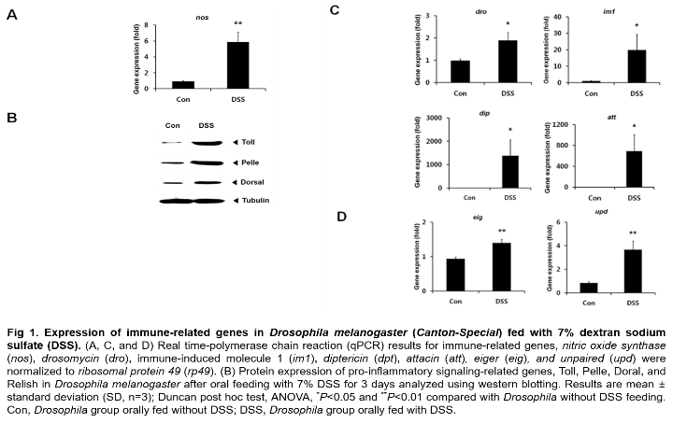
Abstract

The cause of inflammatory bowel disease (IBD), a chronic inflammatory disorder has not been fully elucidated. In this study, we found that in Drosophila melanogaster fed with dextran sodium sulfate (DSS), apoptosis in gut cells were very increased. At that time, antimicrobial peptides (AMPs), pro-inflammatory cytokines (Eiger [Eig] and Unpaired [Upd]), and nitric oxide synthase (NOS) were overexpressed by activation of immune-related signaling, Toll, immune deficiency (Imd), c-Jun N-terminal kinase (JNK), and Janus kinase (JAK)/signal transducer and activator of transcription (STAT) . Accordingly, we supposed that overexpressed AMPs and cytokines were causes of gut damage. Consistent with this conjecture, downregulation of AMPs, Eig, and Upd using RNA interference (RNAi) increased the survival rate of flies compared with wild-type flies after feeding with DSS. In addition, feeding with antibodies against the immune-related proteins (Dorsal, Toll, Pelle, and Relish) affecting the expression of AMPs, also raised the survival rate of flies. Treatment of flies with immune-related antibodies also downregulated AMP gene expression. Therefore, we suggest that overexpression of AMPs and cytokines induced by harmful stimuli in the gut may be the cause of the intestinal damage associated with IBD.

This research was supported by Basic Science Research Program through the National Research Foundation of Korea (NRF) funded by the Ministry of Science and ICT (NRF-2017R1A2B4002411)

Image

Recent Publications (minimum 5)
- Seo M, Goo TW, Chung MY, Baek M, Hwang JS, Kim MA, Yun EY (2017) Tenebrio molitor larvae inhibit adipogenesis through AMPK and MAPKs signaling in 3T3-L1 adipocytes and obesity in high-fat diet-induced obese Mice. International Journal of Molecular Sciences 18(3):518.
- Kim J, Yun EY, Park SW, Goo TW, Seo M (2016) Allomyrina Dichotoma larvae regulate food intake and body weight in high fat diet-induced obese mice through mTOR and Mapk signaling pathways. Nutrients 8(2):100.
- Yoon YI, Chung MY, Hwang JS, Han MS, Goo TW, Yun EY (2015) Allomyrina dichotoma (Arthropoda: Insecta) larvae confer resistance to obesity in mice fed a high-fat diet. Nutrients 7(3):1978-1991.
- Ren F, Wang B, Yue T, Yun EY, Ip YT, Jiang J (2010) Hippo signaling regulates Drosophila intestine stem cell proliferation through multiple pathways. Proc. Natl. Acad. Sci. USA 107(49): 21064-21069.
5. Tanji T, Yun EY, Ip YT (2010) Heterodimers of NF-kappaB transcription factors DIF and Relish regulate antimicrobial peptide genes in Drosophila. Proc. Natl. Acad. Sci. USA 107(33):14715-14720.

 Biography
Eun-Young Yun has her expertise in innate immunity using insects, and functional analysis for materials isolated from various insects. Recently, she was interested in entomophage, and registered three kinds of insects as novel foods on Korean Food Standards Codex through evaluation of toxicity and nutritional components. And then, she has analyzed their function, anti-obesity, anti-diabetes, anti-dementia, and so on for materials from insects using various cell lines, mice, and transgenic flies.
Email: yuney@sejong.ac.kr

