Bisphosphonates are Novel Inhibitors of hFPPS Synthase
and their Role in Oncology

Wafaa M. Abdou
Chemical Industries Division, National Research Centre, Elbohouth St., Dokki, Cairo, Egypt;
* e-mail: wabdou@link.net

Abstract (300 word limit)
In addition to inhibiting bone resorption, and chronic arthritis, bisphosphonates (BPs) have also been shown to exhibit anti-tumor effects. In vitro, BPs inhibit proliferation and induce apoptosis in cultured human breast cancer cells. There is now a much greater appreciation of the benefits of introduction of BPs in oncology, which has dramatically changed the management of patients with metastatic bone disease. Recently, BPs have been, however, proven to be the drugs of choice to: i- Decrease in bone resorption in tumor bone disease. ii- Decrease in hypocalcemia as a result of diminution of bone resorption that leads to a big decrease of new osteolytic lesions, and iii- Decease of fractures, which results in amelioration of pain and an improvement of the quality of life [1]. This antitumor potency of BPs, particularly N-BPs was attributed to the differences of their molecular mechanism of action. Thus, BPs can be grouped in two main different classes: first-generation is non-N-BPs and the second generation is N-BPs. First-generation of BPs, such as clodronate and etidronate, are metabolized intracellular to analogues of ATP by inhibiting ATP-dependent enzymes. In contrast, second- N-BPs, generation such as pamidronate and zoledronate, interfere with mevalonate biosynthetic pathway, by inhibiting farnesyl diphosphate (FPP) synthase [2]. Our recent [3-5], and present work considered an elaboration of a novel series of nitrogen and/or sulfur containing BPs. Several of these N-BPs reflected remarkable antitumor activity against breast, ovarian, and prostate carcinoma cell lines.

Image
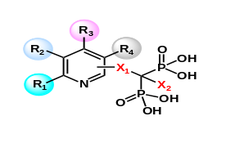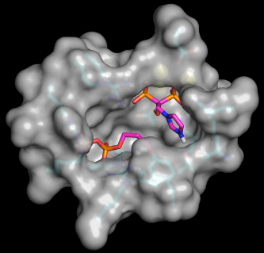
Mechanism of action of N-BPs

Recent Publications (minimum 5)
- Abdou W.M., Barghash, R.F., Bekheit M.S. Geronikaki, A. Cytotoxicity and Anti-inflammation Profiles of Synthesized Thiazoles-Based N-Bisphosphonates and Relevant Bisphosphonic acids. ChemistrySelect. 2016, 1 (13), 3797-3803.
- Barghash, R.F. Abdou W.M. Pathophysiology of metastatic bone disease and the role of the second generation of bisphosphonates: from basic science to medicine. Current Pharmaceutical Design, 2016, 22, 1546-1557.
- Abdou W.M., Barghash, R.F., Bekheit M.S. Geronikaki, A. Cytotoxicity and Anti-inflammation Profiles of Synthesized Thiazoles-Based N-Bisphosphonates and Relevant Bisphosphonic acids. ChemistrySelect. 2016, 1 (13), 3797-3803.
- Abdou W.M., Bekheit M.S. One pot three-component synthesis of peptidomimics for investigation of antibacterial and antineoplastic properties. Arabian J. Chemistry, 2016, DOI:10.1016/j.arabjc.2015.04.014.
- Abdou W.M., Ganoub N.A., Sabry E. Spiro- and substituted hexylthiophene-triazaphospholes and phosphoramidates as potent antineoplastic agents: synthesis, biological evaluation and SAR studies. Monatsh. Chem.2016, 147, 619–626: Doi: 10.1007/s00706-015-1542-4.

 Biography (150 word limit)
Dr. Wafaa Abdou is a Professor of Applied Organic Chemistry Since 1986; and D. Sc. Professor: 2003/RSC, U.K. She is a Principal Investigator of a Research Group working on biophosphorus chemistry at National Research Centre (NRC), Cairo, Egypt. She has been awarded several research grants from USA, Germany, Britain and Poland. The most important awards and prizes: NRC’s Scientific Appreciation Award, 2010; Scientific Supremacy Prize NRC, 1998; State's Medal of Science and Art of the First Rank, 1995; State’s Prize of Chemistry in 1992; Encouragement Prize, NRC, 1986; and Bestowed the title: Woman of the Year 2004 (in Chemistry). She has >167-Publications have been published in International Scientific Journals, generally deals with organophosphorus chemistry, heterocyclic chemistry and photochemistry. These publications are cited >1650 times by others in the International Journals; Supervised or shared in the supervision of > 40 graduate degrees.
Email: wafaaabdou04@gmail.com

Notes/Comments: Plz send me the acceptance as soon as you can. The acceptance should be ORAL, so I can get a financial support. Thanks

