Multiple D2 heteroreceptor complexes in the ventral striatum: Relevance for schizophrenia and cocaine use disorder and their treatments
Kjell Fuxe, MD, PhD and Dasiel Borroto-Escuela, PhD, Department of Neuroscience, Karolinska Institutet, Stockholm, Sweden

Abstract
The discovery of allosteric receptor-receptor interactions in GPCR heteroreceptor complexes in the plasma membrane of nerve cells in the CNS gave a new dimension to brain integration, plasticity and neuropsychopharmacology. Statement of the Problem: To test the hypothesis that the different types of D2 heteroreceptor complexes are new targets in the treatment of schizophrenia and cocaine use disorder. D2 receptors in the complexes can also interact with ion channel receptors, receptor tyrosine kinases and/or adapter proteins. Disturbances in the D2 complexes can contribute to schizophrenia development and cocaine use disorder through changes in the balance of the activity of diverse D2 homo-and heteroreceptor complexes of the ventral striato-pallidal GABA anti-reward pathway regulating salience. Methodology & Theoretical Orientation: Proximity ligation assays and biochemical binding techniques were used with behavioral correlates. Findings: Agonist activation of the A2A protomer in the A2A–D2 heteroreceptor complex inhibits D2 Gi/o mediated signaling but increases the D2 β-arrestin2 mediated signaling. Through this allosteric receptor–receptor interaction, the A2A agonist becomes a biased inhibitory modulator of the Gi/o mediated D2 signaling, which may be the main mechanism for its atypical antipsychotic properties. The dopamine (DA) and glutamate hypotheses of schizophrenia come together in the signal integration in D2–NMDAR and A2A–D2–mGluR5 heteroreceptor complexes, especially in the ventral striatum. Cocaine self-administration differentially affected allosteric A2A-D2 receptor-receptor interactions in the ventral vs the dorsal striatum Conclusion & Significance: 1. Dysregulation of the meso-limbic DA neurons and their postjunctional D2 heteroreceptor targets may be involved in producing the symptoms of schizophrenia. 2. Potential differences in the composition and stoichiometry of the A2A-D2 heteroreceptor complexes, including differential recruitment of sigma 1 receptor, to the ventral vs dorsal striatum may explain the selective antagonistic A2A-D2 receptor interactions observed after cocaine self-administration in nuc accumbens explaining the anti-cocaine actions of A2A agonists

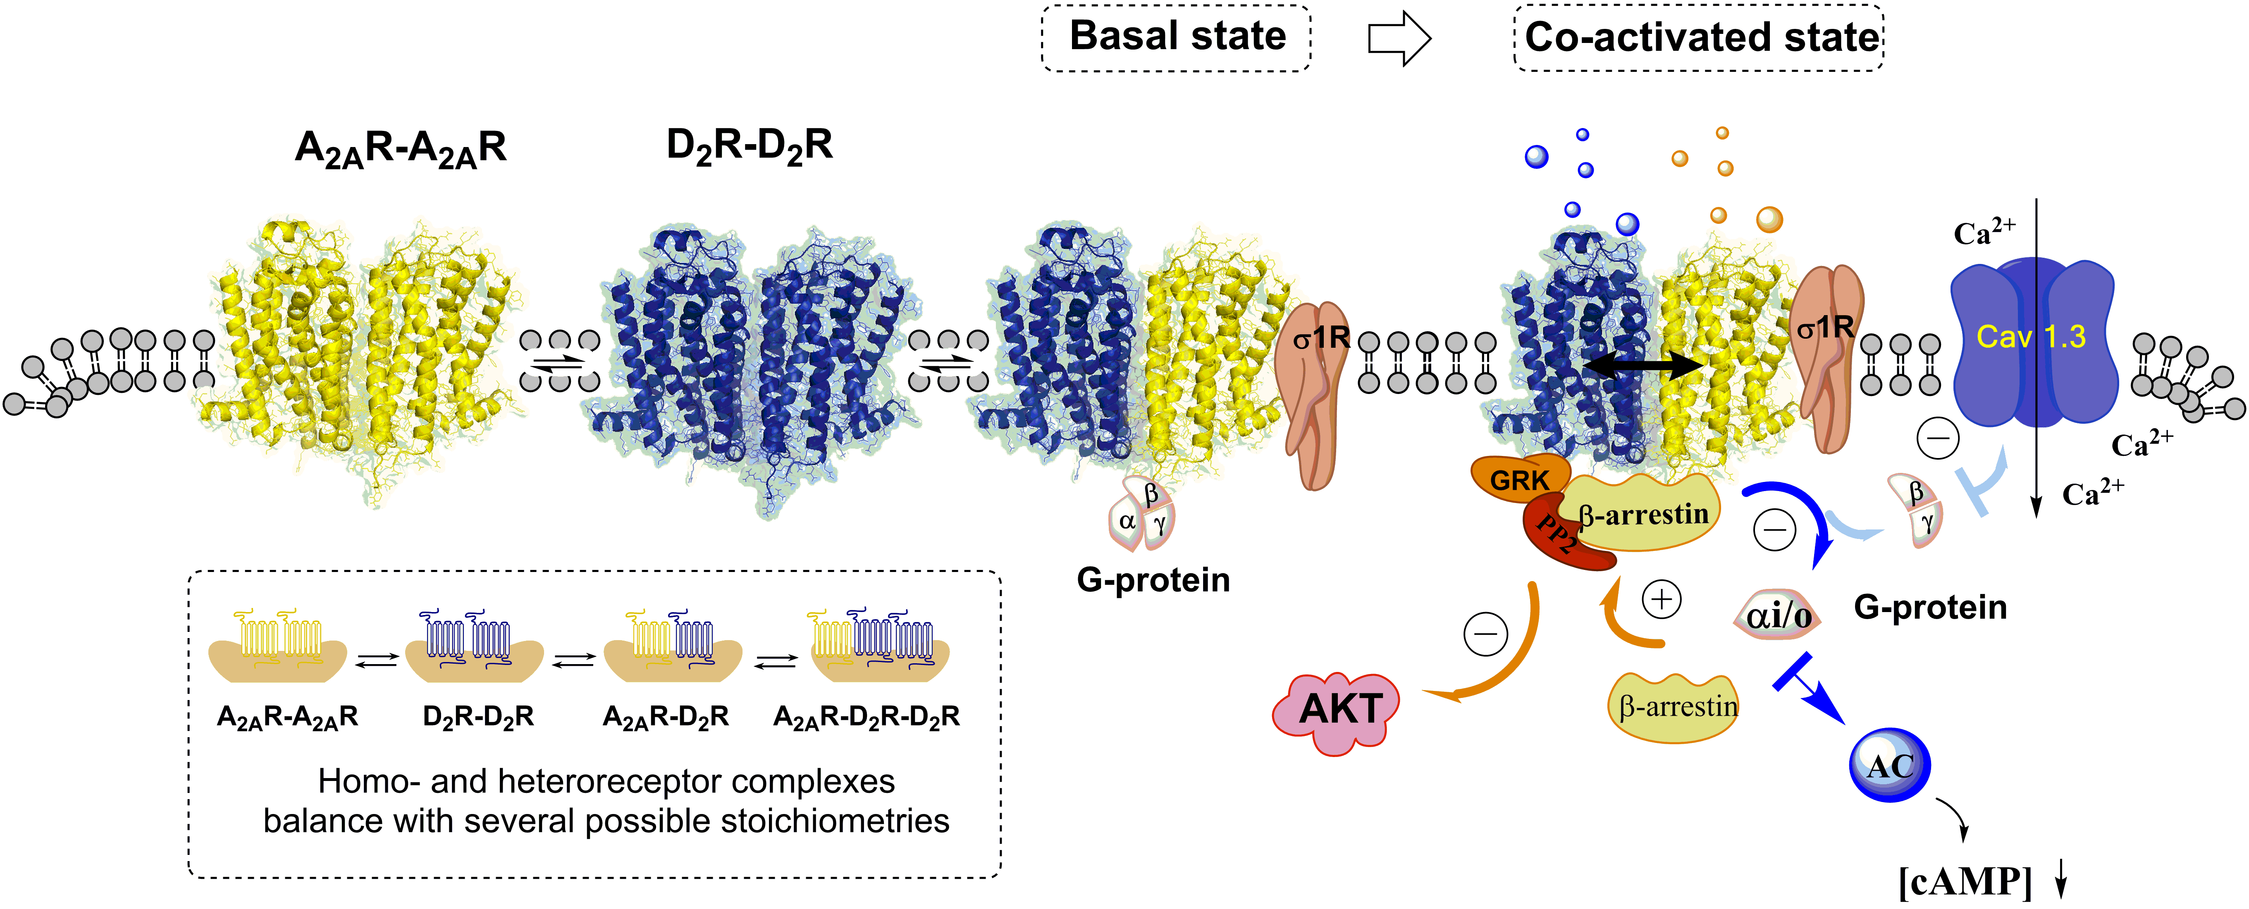
Recent Publications
- Borroto-Escuela DO, Wydra K, Pintsuk J, Narvaez M, Corrales F, Zaniewska M, Agnati LF, Franco R, Tanganelli S, Ferraro L, Filip M, Fuxe K. (2016) Understanding the Functional Plasticity in Neural Networks of the Basal Ganglia in Cocaine Use Disorder: A Role for Allosteric Receptor-Receptor Interactions in A2A-D2 Heteroreceptor Complexes. Neural Plast. 4827268.
- Borroto-Escuela DO, Pintsuk J, Schäfer T, Friedland K, Ferraro L, Tanganelli S, Liu F, Fuxe K. (2016) Multiple D2 heteroreceptor complexes: new targets for treatment of schizophrenia. Ther Adv Psychopharmacol. 6(2):77-94.
- Fuxe K, Borroto-Escuela DO, Tarakanov AO, Romero-Fernandez W, Ferraro L, Tanganelli S, Perez-Alea M, Di Palma M, Agnati LF. (2014) Dopamine D2 heteroreceptor complexes and their receptor-receptor interactions in ventral striatum: novel targets for antipsychotic drugs. Prog Brain Res. 211:113-39.
- Fuxe K, Borroto-Escuela DO. (2016) Heteroreceptor Complexes and their Allosteric Receptor-Receptor Interactions as a Novel Biological Principle for Integration of Communication in the CNS: Targets for Drug Development. Neuropsychopharmacology 41(1):380-382.
- Pintsuk J, Borroto-Escuela DO, Pomierny B, Wydra K, Zaniewska M, Filip M, Fuxe K. (2016) Cocaine self-administration differentially affects allosteric A2A-D2 receptor-receptor interactions in the striatum. Relevance for cocaine use disorder. Pharmacol Biochem Behav. 144:85-91.

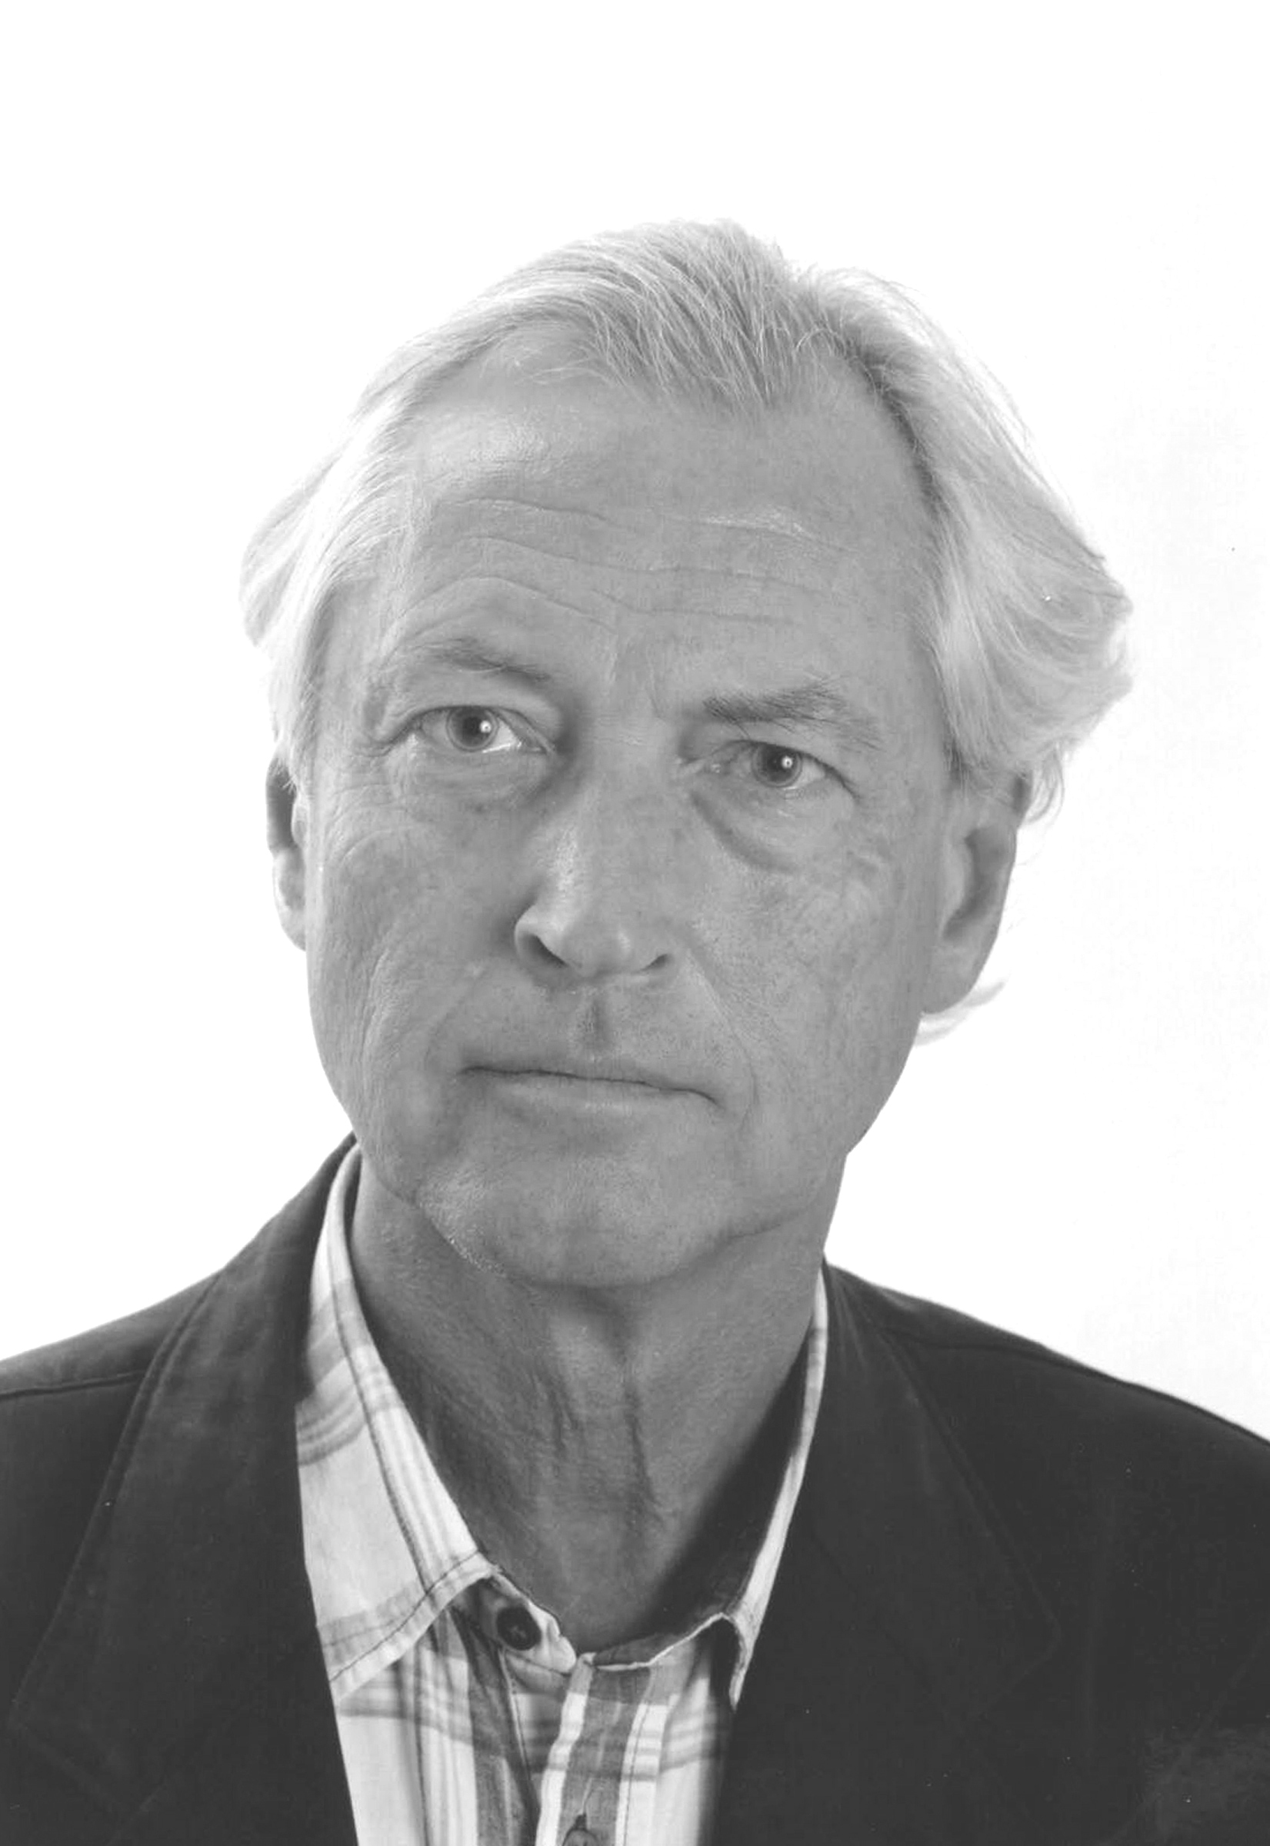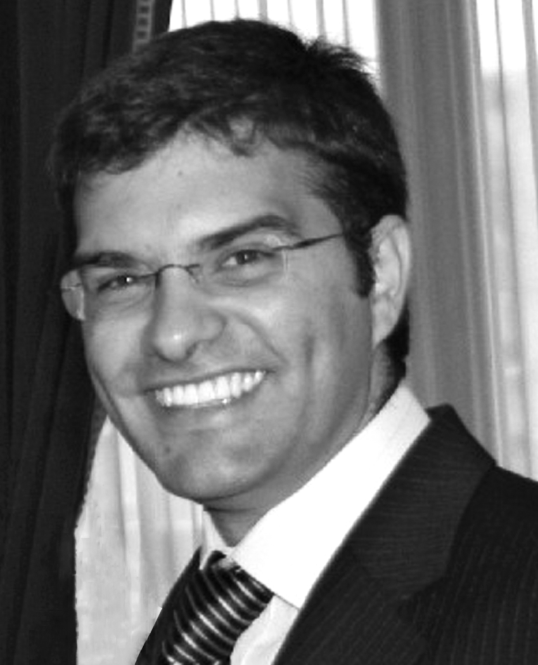
Kjell Fuxe has worked at the Karolinska Institutet since 1960, became prosektor in 1968 and professor in 1979. Since 2005 Fuxe is a professor emeritus at the Department of Neuroscience. He published over 1589 papers.He is a member Royal Swedish Academy of Sciences and foreign member of the Mexican Academy of Sciences and was a member of the Nobel Assembly. He is mainly known for his work on central monoamine neurons, volume transmission and its different forms, receptor-receptor interactions in the CNS and neuropsychopharmacology.
Dasiel Borroto-Escuela is a contracted Postdoctoral Researcher and Senior Lab Manager at the Department of Neuroscience, Karolinska Institutet since 2009. He is focused on understanding whether alterations in specific heteroreceptor complexes are associated with and/or play a role in pathogenic mechanisms contributing to brain disease development, inter alia schizophrenia, addiction and depression. He has received the UPC Excellence Thesis Award, the FEBS-YSF 2013, the ECNP 2014 Fellow Award and published over 90 papers in neuroscience in the last five years.

Emails: kjell.fuxe@ki.se and dasiel.borroto.escuela@ki.se

