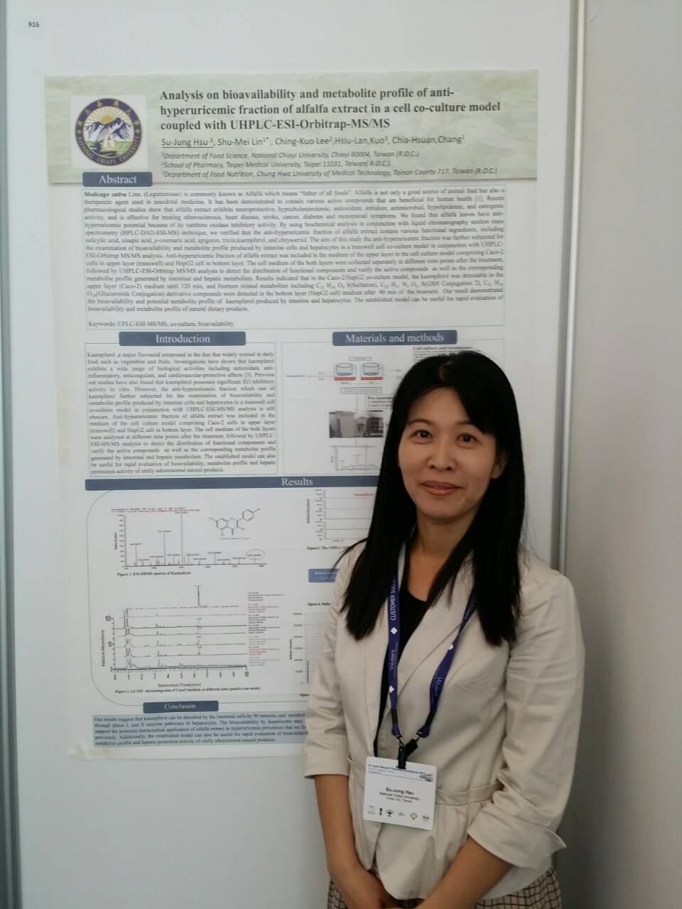
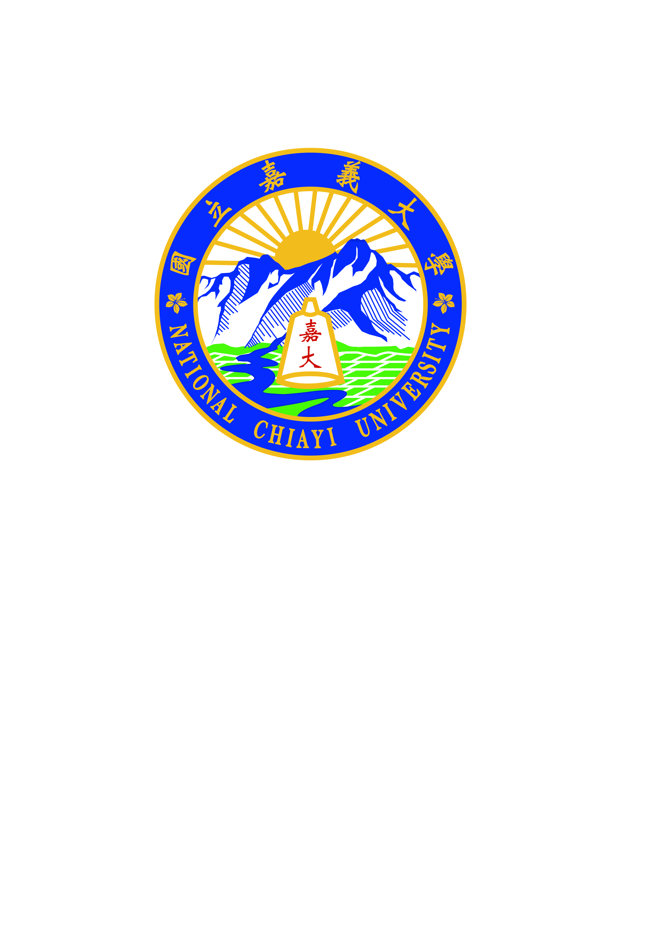

Paste your Logo here

Rapid identification of natural hypouricemic compounds from alfalfa extract using UPLC-MS/MS coupled with Molecular Docking
Su-Jung Hsu ¹, Shu-Mei Lin^{1*}, Ching-Kuo Lee^{2*}

¹Department of Food Science National Chiayi University, Taiwan R.O.C.
²School of Pharmacy, Taipei Medical University, Taiwan R.O.C.
Xanthine oxidase (XO) is a key enzyme that catalyzes the oxidation of xanthine and hypoxanthine to the end product (uric acid) in purine metabolism and is the major target enzyme for the hyperuricemia treatment and gout arthritis prevention. For the past five decades, allopurinol is the only available XO inhibitor for hyperuricemia treatment. It is of great interest to search for other natural XO inhibitors. Recent pharmacological studies demonstrated that alfalfa extract exhibits a variety of bioactivities, including neuroprotective, hypocholesterolemic, antioxidant, antiulcer, antimicrobial, hypolipidemic, and estrogenic activity. It has been shown to be effective for treating atherosclerosis, heart disease, stroke, cancer, diabetes and menopausal symptoms. The aims of our study were to investigate the XO inhibiting potential and to identify the corresponding active components in alfalfa extract. The alfalfa extract was first combined with xanthine oxidase before applying to UPLC-ESI-Q-TOF-MS / MS for fingerprint analysis and structure identification of active compounds. The potential XO inhibitors from alfalfa extract were identified, including tricin and chrysoeriol. The XO inhibition and antioxidant activities of these compounds were further predicted using molecular docking software. The results revealed that tricin showed the lowest inhibition constant value (Ki) which means that this compound was predicted as the strongest inhibitor of XO. The method established in this study, LC-MS technique combined with Molecular Docking, might be also applied to rapid identification of anti-oxidative compounds and enzyme inhibiting agents from other natural resources in addition to alfalfa.
Biography：
Su-Jung is a ph. D. candidate from the Department of Food Science, National Chiayi University, co-advised by Professor Ching-Kuo Lee, School of Pharmacy, Taipei Medical University. Her research works in doctoral dissertation are focused on nutraceutical properties of alfalfa, including bioactive components purification, structure identification and bio-function evaluation. Under supervision of Professor Lee, Su-Jung acquires expertise in purification and chemical structure identification of natural products. She has purified and identified numbers of biologically functional components, especially compounds possessing tyrosinase and xanthine oxidase inhibition activity, from a variety of natural resources. She also conducted studies to investigate bioavailability of the active compounds from alfalfa extract in Dr. Lin’s laboratory. Her recent research interest is to study metabolomics of Alfalfa extract, using in vitro cell co-culture model comprising enterocytes and hepatocytes in tandem with UPLC-ESI-Q-TOF-MS / MS technology.

Presenting author details
Full name: SU-JUNG,HSU
Contact number: 886-5-271-7625, 886-2-2736-1661＊6150
Session name/ number: Analytical techniques in phytochemistry
Category: Poster presentation

