Knowledge Attitude and Practice of Thirty-third Village Citizens toward Asbestos

Tagwa Omer1 , Salih Boushra 1, Rogaia Hassab alrasol 1, Ali Elzain 1 ,shiraz Noor 1 , Raheeg Bashir1, Amal Abdallah1, Tanzil Yousif 1 ,gadeer Tarig1, Hassan ElShami 1, Sozan Ahmed 1,Mosab Abass1
1 Omdurman Islamic university

Supervisied by: Mahboub EL Hashemi 2

Abstract

Objectives: Our aims in this is to improve the knowledge ,attitude ,and practice level of people in order to protect people from asbestos and asbestos–related diseases and to determine the sources of exposure to asbestos and to determine knowledge attitude and practice level in relation to age , Methods: The study was Cross-sectional descriptive study. A questionnaire, interviewer–administered, that included 18 items was employed on a convenient sample consisting of 384 participants from thirty third village citizens in Halfa Aljadida . Results: Vast majority of the participants 286 (74.22%) knows asbestos and it's usage in their village such as usage of it in building, water supply and its hazards and 98 (25.78%) don't know it. 78.9 of participants exposed to asbestos,(48.7%) were exposure at home , exposure were from houses roofs 142 (36.98%) , water pipes 3 (0.78%) and from both sources 144 (37.50%) , 2 (0.5%) were exposure at work . 81 (21.1%) were not exposed to it. 279 (72.7%) exposed to it for more than one year, 7 (1.8%) exposed to it for more than one month and 3 (0.8%) for more than one day. 378 (97.66%) of participants don't use any safety equipment regarding their exposure to asbestos and only 9 (2.24%) use safety equipments like gloves1 (0.3%) and masks 5 (1.3%). Conclusion: Asbestos is widely use in Thirty Third village in Halfa Aljadida and more effort should be done to eliminate asbestos containing houses and water supplies.

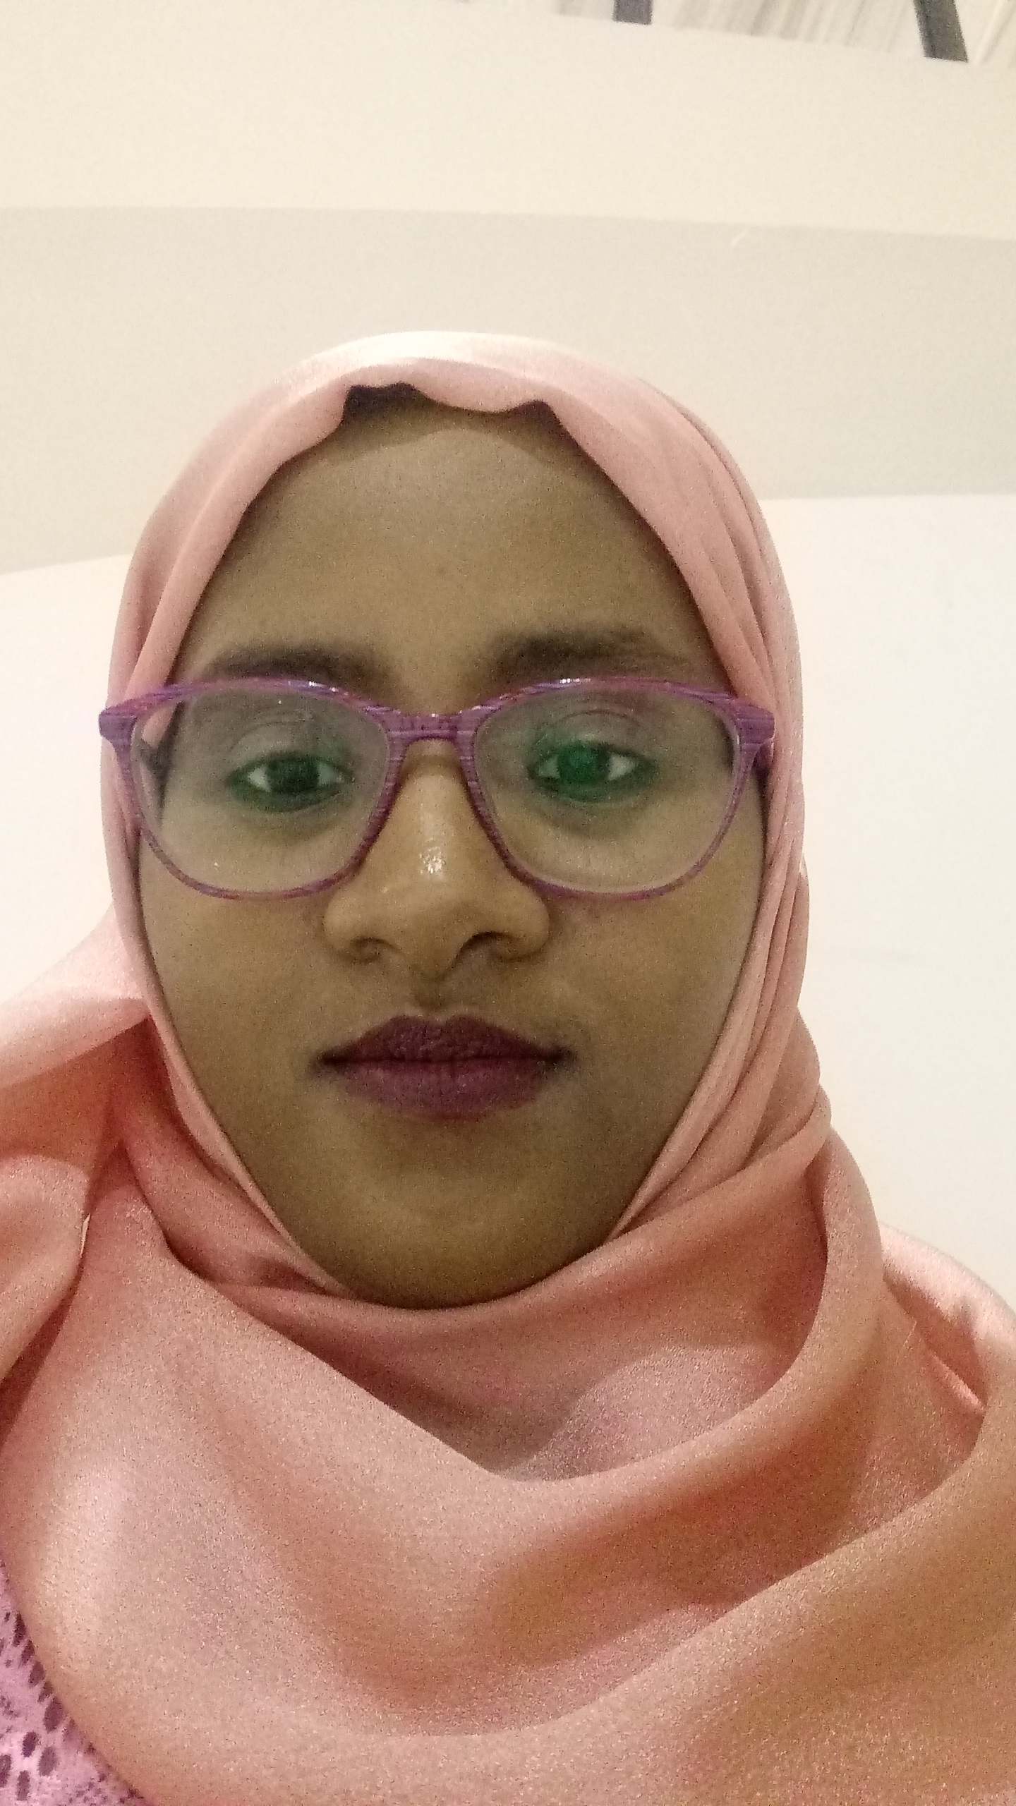 BIOGRAPHY:

Tagwa Omer is graduated from faculty of medicine and health sciences, OIU, working as house officer at ministry of health, interested in research , attend several conference and workshops in different aspects .

tagwa97@hotmail.com
+249997103723

