Formulation, Development & Evaluation of Prepared Ointment for Treatment of Piles
ABSTRACT:
Name : Dr.P.B.Cholke
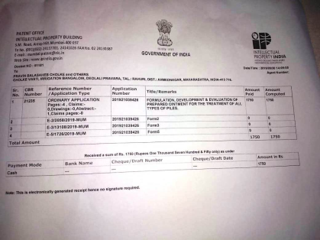
Savitribai phule Pune University,Maharashtra,India

This research work aimed to development of formulation containing
herbal ingredients in ointment dosage form for use in the cases
of piles & evaluation of prepared herbal ointment for
antimicrobial & laxative activities. This prepared ointment
contains Brimstone, Camphor, Coconut oil, Chloramphenicol
& Lidocaine 3% (as per give Master Formula) which is effective
in the treatments of all types of piles. For the preparation of this
ointment all ingredients are obtained from the natural sources. Fig : Provisional patent

Recent Publication:
Development and Validation of Spectrophotometric Method for Clopidogrel bisulfate in pure and in film coated tablet dosage form
PB Cholke, R Ahmed, SZ Chemate, KR JadhavArch. Appl. Sci. Res 4 (1), 59-64
Extraction and GC-Ms Analysis of Orange (Citrus sinensis) Peel Oil
PB Cholke, AK Bhor, AM Shete, RK Sonawane Res J Agri Bio Sci 2 (5), 41-51
Development and validation of UV-Visible Spectroscopy method for simultaneous estimation of Saxagliptin hydrochoride and Metformin Hydrochoride in tablet dosage form
pravin cholke
international journal of research in pharmacy and pharmaceutical Sciences 3 …
Development and Validation of Spectrophotometric Method for Clopidogrel Bisulfate in Bulk and Formulations
P Cholke, YN Ingale, AS Gopale, K Jadhav, SZ Chemate
Int. J. Chem. Sci 10, 449-456
In vivo and In vitro Evaluation of antimicrobial activity of peel extracts of red dragon fruit (Hylocereus polyrhizus)
Y Temak, P Cholke, A Mule, A Shingade, S Narote, A Kagde, R Lagad, ...
International Journal of Research in Pharmacy and Pharmaceutical Sciences 3 (5)

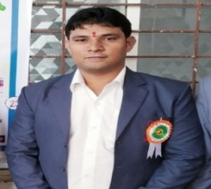
Dr.P.B.Cholke (Ph.D.Pursuing) is currently working as Assistant Professor & HOD of Pharmaceutics Department, Shri Wagheshwar Gramvikas Pratishthan Sanchalit, Loknete Shri Dadapatil Pharate College of Pharmacy, Madavgoan Pharata, Shirur, Pune, sciences last two year. He has more than 10 years of teaching experiences in Pratibhatai Pawar College of Pharmacy, Shrirampur & one year industry

experiences in Lupin ltd Mumbai. He completed his graduation (B.Pharmacy) from NGSPM’s COP, Anjeneri, Trimakeswar, Nashik & Post graduation (M.pharmacy) from PDVVP COP, Vilad Ghat, Ahemadnagar. He has handled various portfolios like representation of Pharmacy Colleges in front of AICTE, PCI, DTE & MSBTE visiting committee. He has many research paper publications in international & national journals of repute to his credit along with that he published three book of medicinal chemistry- I theory and practical textbook of pharmaceutical organic chemistry III in 2018. He is associated with APTI, APP &IPA as life member ship. Recently he filled an Indian Patent on his name. He is awarded as a Best Performer of the Year: 2017. (Administrative Work)

Presenting Author: Dr.Pravin Balasaheb Cholke
Contact Detail: 7745038402
Session name/number: R&D Advancemant:Road to new medicine
Category: Oral Presentaion
Email : pravincholke03@gmail.com

