Formulation, Development & Evaluation of Prepared Ointment for Treatment of Piles

ABSTRACT:
Name : Dr.P.B.Cholke
Savitribai phule Pune University,Maharashtra,India
This research work aimed to development of formulation containing herbal ingredients in ointment dosage form for use in the cases of piles & evaluation of prepared herbal ointment for antimicrobial & laxative activities. This prepared ointment contains Brimstone, Camphor, Coconut oil, Chloramphenicol & Lidocaine 3% (as per give Master Formula) which is effective in the treatments of all types of piles. For the preparation of this ointment all ingredients are obtained from the natural sources.

Biography
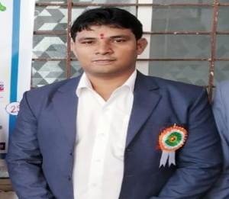
Dr.P.B.Cholke (Ph.D.Pursuing) is currently working as Assistant Professor & HOD of Pharmaceutics Department, Shri Wagheshwar Gramvikas Pratishthan Sanchalit, Loknete Shri Dadapatil Pharate College of Pharmacy, Madavgoan Pharata, Shirur, Pune, sciences last two year. He has more than 10 years of teaching experiences in Pratibhatai Pawar College of Pharmacy, Shrirampur & one year industry experiences in Lupin ltd Mumbai. He completed his graduation (B.Pharmacy) from NGSPM’s COP, Anjeneri, Trimakeswar, Nashik & Post graduation (M.pharmacy) from PDVVP COP, Vilad Ghat, Ahemadnagar. He has handled various portfolios like representation of Pharmacy Colleges in front of AICTE, PCI, DTE & MSBTE visiting committee. He has many research paper publications in international & national journals of repute to his credit along with that he published Three book of medicinal chemistry- I Theoy and Practical Textbook of pharmaceutical Organic Chemistry III in 2018. He is associated with APTI, APP &IPA as life member ship. Recently he filled an Indian Patent on his name. He is awarded as a Best Performer of the Year: 2017. (Administrative Work)
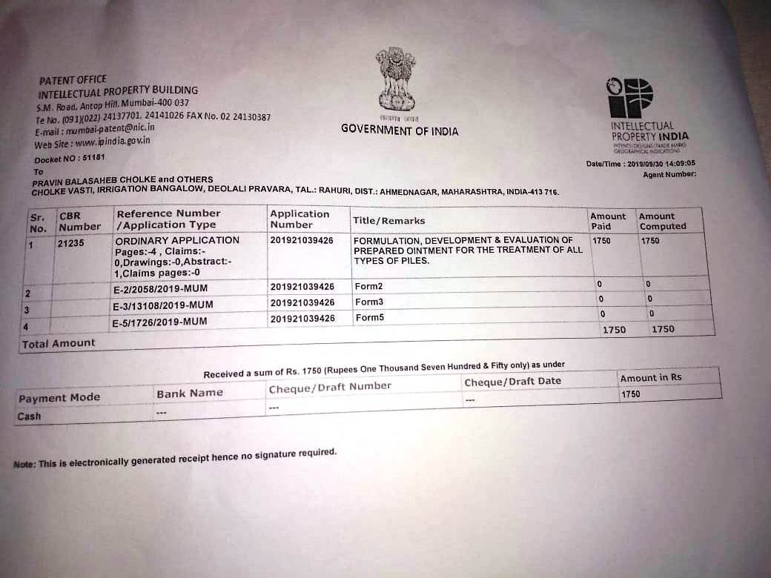

Fig: The above receipt is provisional patent receipt of the research.

Presenting Author: Chandan .R.Kale
Contact Detail:8652282376
Session name/number:R&D Advancement .New road to Medicine
Category: Oral presentation

