CHPTER 3
DEVELOPMENT OF A NOVEL SPORE
CLONING SYSTEM

3.1 Introduction
Bacillus endospores or spores are non-reproductive, enzymatically inert and dormant entities with well-known resistance properties including heat stability, exposure to noxious chemicals and desiccation (Nicholson, Munakata et al. 2000). During harsh condition such as starvation, heat, dissection or radiation, the bacterium (vegetative cells) will start to divide asymmetrically to form endospore that can be resistance to all these environmental factors (Tan and Ramamurthi 2014). Genetic manipulation of bacterial spores of the genus Bacillus has shown potential for vaccination and for delivery of drugs or enzymes (Potot, Serra et al. 2010, Ning, Leng et al. 2011, Nguyen, Huynh et al. 2013). Remarkably, proteins displayed on the spore surface retain activity and generally are not degraded.

Despite the potential utility of Bacillus spores for industrial applications, there remain a number of obstacles regarding the deliberate release of genetically modified Bacillus. First is the use of antibiotic resistance (Ab^{R}) genes used in the engineering of stable recombinant strains. Regarding Ab^{R} the majority of procedures requiring insertion of heterologous DNA into B. subtilis require ectopic insertion using an Ab^{R} gene for positive selection (Shimotsu and Henner 1986). Plasmid vectors carrying chloramphenicol or erythromycin resistance genes are typically used for ectopic insertion at a genetic locus that is redundant for cell growth, typically the amylase E (amyE) or threonine C (thrC) genes (Guerout-Fleury, Frandsen et al. 1996). For instance, pDG364 (6257 bp) is a suicide vector that has been designed to integrate a clone inserts into the amyE locus of B. subtilis 168 chromosome. It contains the left and right homology arm for amyE, interrupted in between the two arms, a multiple cloning site and a chloramphenicol resistance gene (Figure 1). Once the plasmid linearized, it enables the insertion of cloned DNA, in trans, via double-crossover, at the amyE locus. The chloramphenicol resistance gene is used as a selection marker. Also, the insertion at the amyE locus creates an Amy⁻ phenotype (Hoa, Brannigan et al. 2002).

The discovery of antibiotic was a major step forward for treatment against infectious agents. However, the inappropriate and excessive use of the antibiotic can spread a large scale of antibiotic in the environment. Therefore, the use of antibiotic for the treatment of some infectious disease and their use in plasmid vector as a selection marker gene can have various consequences such as spreading in the environment, causing the spread of resistant bacteria and emergence of new resistances or multi-resistance pathogenic bacterial strains. (Mignon, Sodoyer et al. 2015). The potential risk of Ab^{R} gene transfer following release is recognized and at least two systems in B. subtilis have now been described that enable insertion of heterologous genes without the introduction of an Ab^{R} gene (Bloor and Cranenburgh 2006, Iwanicki, Piatek et al. 2014).
The second, and most challenging, hurdle is the ultimate fate of recombinant spores once

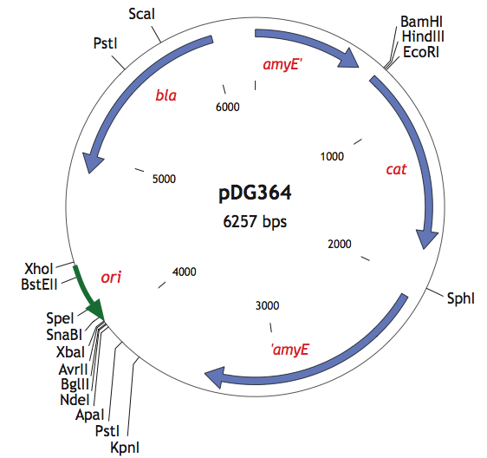

Figure 1. Suicide plasmid DG364 (pDG364)
The two amyE are the left and right homology arm of complete amyE. The cat and bla represent are the chloramphenicol and ampicillin resistance gene respectively. Multiple cloning site (MCS) consist of BamHI, EcoRI and HinDIII is located in between the left homology arm of amyE and the chloramphenicol resistance gene. ori is the origin of replication. this plasmid consists of 6257 bp. (Image is from Bacillus Genetics Stock Centre website, http://www.bgsc.org)

released since spores have been shown to survive for millions of years as viable entities (Cano and Borucki 1995). The soil is normally enriched with dormant spores (Nicholson 2002) and their robustness makes it difficult to argue that they would not persist after deliberate release. One approach might be to construct germination deficient spores but, at best, the germination rate can be reduced to 0.0015% (Mauriello, Cangiano et al. 2007) which is unlikely to satisfy regulatory authorities. Another approach that could be considered is that of thymine starvation since prokaryotes carrying a mutated thymidylate synthase gene are unable to grow in low concentrations of thymidine or thymine resulting in cell death. This Phenomenon is first discovered about five decades ago (JUN 1965). Thymine also referred as 5-methyluracil, is a pyrimidine found in the nucleic acid of DNA along with adenine, guanine, and cytosine. Since thymine (or thymidine) is not readily found in nature other than in the DNA of living cells this would result in what is known as a ‘thymineless death’ (Goulian, Bleile et al. 1986, Ahmad, Kirk et al. 1998). Thymineless death has been documented for B. subtilis (Rolfe 1967) and the bacterium carries two thymidylate synthase enzymes encoded by the thyA and thyB genes. Mutating thy genes make the strain resistant to antibiotic TMP that enabling positive selection on successively higher levels of TMP but without the introduction of any antibiotic resistance genes.(Neuhard, Price et al. 1978).

Therefore, the principles of a thymineless death to exploit Bacillus for the introduction of heterologous genes without the introduction of antibiotic genes can be adopted. As recombinant spores, should they released and germinate, they would exhibit a thymine-less death due to rapid cessation of metabolism and fail to survive in the environment. The method described in this chapter has been validated using a number of exemplars and solves a problem for containing spore GMOs in the environment.

3.2 Aim
The aim of this chapter was to design and develop a newly system in B. subtilis which can be used to present chimeric protein on its spore surface but also has an additional antibiotic selectivity marker without introducing any antibiotic resistant gene.

3.3 Results
3.3.1 Construction of B. subtilis strains that display chimeric proteins on
its spore surfaces.
Two genes of B. subtilis, thyA and thyB, are both encoding thymidylate synthase (TSase) enzyme that are responsible for the production of pyrimidine. Mutation of both these genes lead to a strain that lacks TSase and as a result it becomes thymine auxotroph. Also, deactivation of thyA and thyB will enable the strain to become TMP resistant (TMP^{R}). TMP can also disrupt the folate pathway by deactivation dihydrofolate reductase enzyme, which leads to blocking purine and pyrimidine as well as some key amino acids synthesis (Figure 2) (Neuhard, Price et al. 1978).

If both thy genes are mutated by insertion of a chimeric gene that is fused to B. subtilis spore coat protein such as CotB, then the outcome will be a strain of B. subtilis strain that is thymine auxotroph and display chimeric protein on its spore surface. To construct a strain of B. subtilis that display chimeric protein on its spore surface and is thymine auxotroph, an E. coli plasmid (pMA) was used to produce two plasmids, pThyA and pThyB (Figure 3). These plasmids possess sequences homologous to the proximal and distal fragments of thyA or thyB genes interrupted midpoint with a multiple cloning site (MCS), targeting a ‘cargo’ DNA sequence for integration into those genes (Appendix A, Figure 3). Approximately 900 bp long proximal and distal fragments of thyA or thyB were used in the integration plasmids to ensure sufficient homology with target regions and to ensure efficient integration.
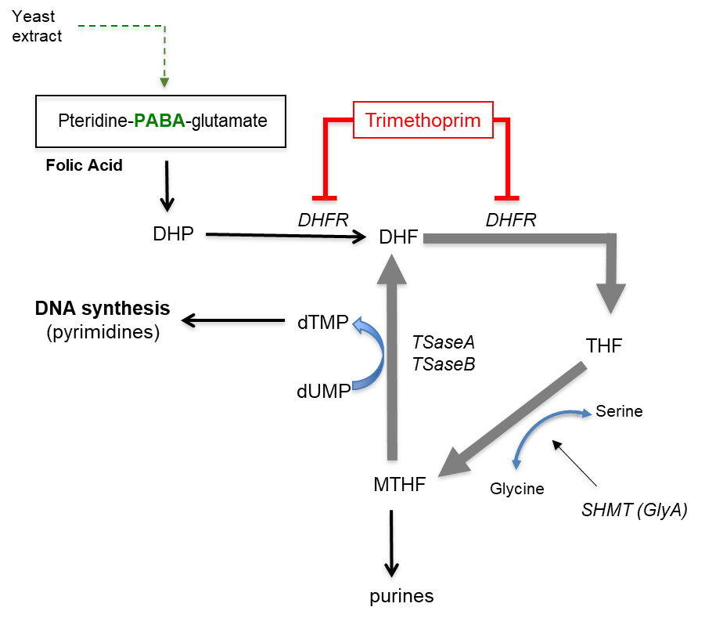

Figure 2: The Action of TMP on the Folate Pathway.
TMP inhibits the enzyme dihydrofolic acid (DHFR) which is required for production of dihyrofolate (DHF) from dihydropterate (DHP) as well as for synthesis of tetrahydrofolic acid (THF). This prevents synthesis of methyleneterahydrofolic acid (MTHF) and synthesis of both purines and pyrimidines. In B. subtilis, TSase , TSase A and TSase B use MTHF to produce the pyrimidines thymidine and thymine. Inactivation of both TS enzymes is lethal unless exogenous thymine (or thymidine) is supplied. Also shown is para-aminobenzoic acid (PABA) which is a component of folic acid and SHMT (serine hydroxymethyltransferase).

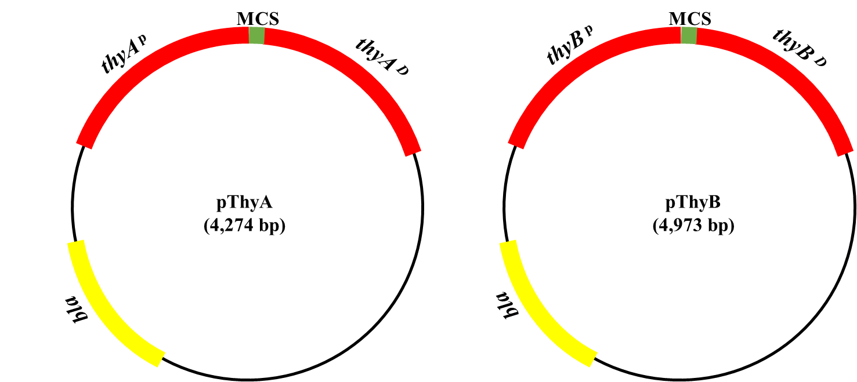

Figure 3: Schematic figure of pThyA and pThyB.
A total of ~900 bp proximal and distal of both thyA and thyB has been synthesized in an E.coli plasmid, pMA. Both thyA and thyB are interrupted in the midpoint with a multiple cloning site (MCS). pThyA and pThyB have a total of 4,274bp and 4,973bp respectively. The antibiotic resistance gene on these plasmid is ampicillin (bla).

In frame fusions of the cotB and cotC genes (encoding the spore coat anchors required for display of heterologous proteins) to the following ORFs: vp26 and vp28 (white spot virus envelope proteins), tcdA₂₆₋₃₉ (a segment of C-terminal toxin A from C. difficile), SA, amyE (α-amylase enzyme from B. amyloliquefaciens) and aprE (subtilisin E enzyme from B. subtilis) were then cloned into the appropriate pThyA or pThyB vectors via restriction sites, BamHI and EcoRI (Appendix B). The construction of these recombinant plasmids was transformed into E.coli DH5-alpha. Subsequently, the purified plasmids were transformed into PY79, a derivative of B.subtilis 168.

To mutate the thyA by inserting the chimeric gene, the purified pThyA plasmids were linearized either by ApaLI or ScaI and used to transform into competent cells of PY79 with selection for 3 μg/ml TMP^{R} on SMM agar plates supplemented with thymine (50 μg/ml) at 37ºC. Colonies were re-streaked on two SMM agar plates supplemented with TMP, one of which contained thymine and the other one didn’t. Transformants carrying thyA insertions were not able to grow without thymine at 46ºC. Typically, transformation frequencies were about 2 x 10³/μg of competent cells with about 15-20% of colonies carrying the correct insertion.

For the introduction of insertions at the thyB locus classical DNA-mediated transformation of competent cells with the pThyB plasmid proved inefficient (with low levels of transformation). Instead, an electroporation method was developed that reliably and reproducibly enabled the introduction of pThyB plasmids at the thyB locus in thyA strains. After introducing pThyB into thyA strain via electroporation, transformants were plated on SMM supplemented with 0.2% casamino acid (CAA), thymine and TMP (6 μg/ml), and strains carrying insertions at thyA and thyB were identified by their failure to grow at both 37ºC and 46ºC in the absence of thymine. Figure 2 shows the schematic diagram of two-step, ectopic cloning system (Figure 4).

Using this two-step process, different strains carrying insertions at the thyA and thyB loci were constructed (Table 4). This included strains carrying insertions of one or two different proteins on the spore surface by fusion to different spore coat anchors (cotB and cotC). For each strain constructed in Table 4, using nucleotide sequence analysis, the integrity of the thyA or thyB insertion was confirmed.

Since inactivation of thy genes will render the strain resistance to TMP (Neuhard, Price et al. 1978), the level of resistance of thyA and thyA thyB insertional mutant to TMP relative to wildtype PY79 was evaluated. For that purpose, minimal inhibitory concentrations (MIC) for TMP of the mutant strains were determined. It was done by a method of serial dilutions of TMP in the SOC2 broth supplemented with thymine. The determined MIC value for PY79 was 0.25 μg/ml whereas thyA and thyA thyB insertional mutants had 16 μg/ml and >64 μg/ml respectively (Table 4).

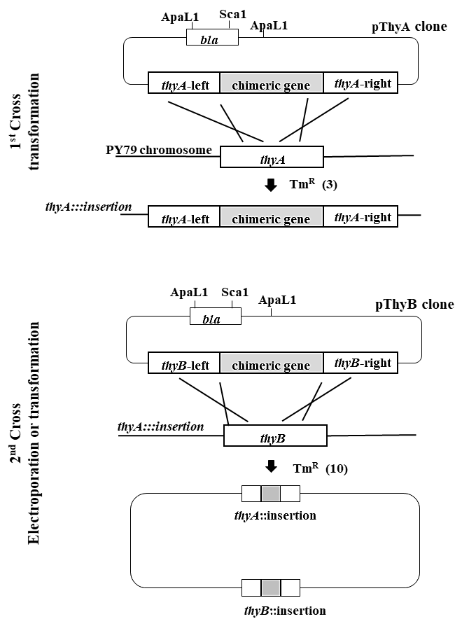

Figure 4: Strain constructions
To construct ectopic insertions at the thyA and thyB loci of B. subtilis two steps are required. In step 1 a pThyA plasmid carrying a chimeric gene is, linearized (ApaII digestion) and introduced into cells of a wild type B. subtilis strain (in this case strain PY79) by DNA-mediated transformation. TMP^{R} transformants are selected on SMM agar containing TMP (3 mg/ml) and thymine (50 mg/ml) and carry an insertion of homologous thyA DNA together with the chimeric gene, by marker replacement, as shown. In the second step linearized plasmid DNA of a pThyB vector carrying the same or a different chimeric gene is introduced by electroporation into cells of the thyA insertion strain created in the 1st step. Selection for TMP^{R} is made on SMM + CAA agar containing TMP (> 6 mg/ml) and thymine (50 mg/ml).

Table 4: Phenotypes of B. subtilis recombinant strains.

Strain | Genotype | 37ºC¹ |  | 46ºC¹ |  | TMP, MIC²  (μg/ml)
Strain | Genotype | - thy | + thy | - thy | + thy | TMP, MIC²  (μg/ml)
PY79 | thyA⁺ thyB⁺ | + | + | + | + | 0.25
SH11 | thyA::cotC-vp26 | + | + | + | - | 16
SH12 | thyA::cotC-vp26 thyB::cotB-vp28 | + | - | + | - | >64
AC01 | thyA::cotB-vp28 | + | + | + | - | 16
AC02 | thyA::cotB-vp28 thyB::cotB-vp28 | + | - | + | - | >64
SH13 | thyA::cotB-tcdA₂₆₋₃₉ | + | + | + | - | 16
SH14 | thyA::cotB-tcdA₂₆₋₃₉ thyB::cotC-tcdA₂₆₋₃₉ | + | - | + | - | >64
SH15 | thyA::cotB-SA | + | + | + | - | 16
SH16 | thyA::cotB-SA  thyB::cotB-SA | + | - | + | - | >64
SH17 | thyA::cotB-amyE | + | + | + | - | 16
SH18 | thyA::cotB-amyE thyB::cotB-MCS³ | + | - | + | - | >64
SH19 | thyA::cotB-aprE | + | + | + | - | 16
SH20 | thyA::cotB-aprE  thyB::cotB-MCS | + | - | + | - | >64
¹ Growth (+) or no growth (-) on SMM agar with or without thymine (50 μg/ml)
² Minimal inhibitory concentration (MIC; μg/ml) of TMP determined using a microdilution method (CLSI 2010).
³ Multiple Cloning Site

Western blotting was performed by using spore coat extracts, to confirm that chimeric proteins were produced and displayed on the spore surface. When extracted spore coat proteins from purified spores were subjected to western blot, immunoreactive bands of the expected molecular weight were seen (Figure 5). As a further verification, whole-spore ELISA was performed for the confirmation of presence of chimeric proteins on the spore surface (Figure 6). Figure 6A and figure 6B show surface detection of the TcdA₂₆₋₃₉ antigen and VP28 respectively by whole-spore ELISA. Production of the TcdA₂₆₋₃₉ antigen at both the thyA and thyB loci (SH14 in Figure 6A) was greater than expression at one locus (i.e., thyA, SH13). Using a rabbit PAb to detect VP28, expression levels of strains carrying cotB-vp28 inserted at thyA (AC01) or at both thyA and thyB (AC02) was examined (Figure 6B). The ELISA result shows that the expression of VP28 antigen at both the thyA and thyB loci was greater than expression at one locus.

Therefore, it is confirmed that the new system was successfully cloned and is presenting chimeric proteins on its spore surface as expected.

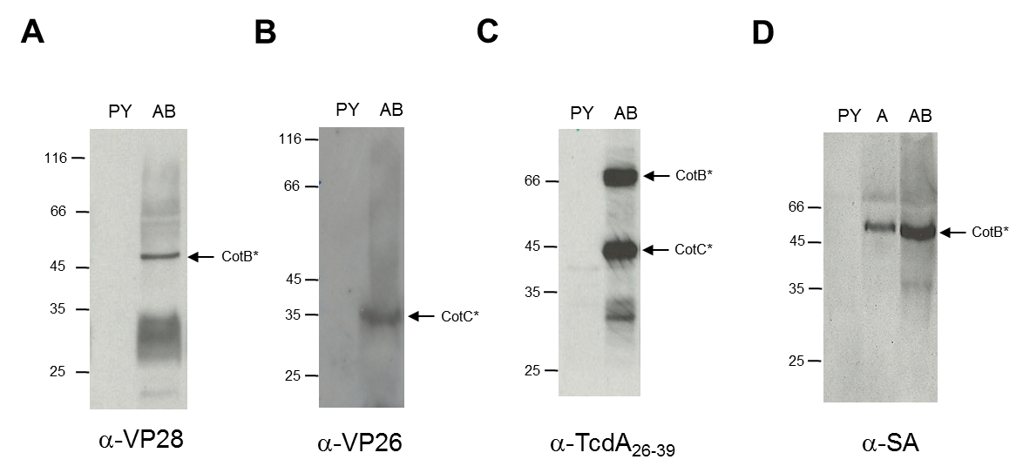
Figure 5: Spore coat expression
B. subtilis strains carrying insertions at the thyA and thyB loci were examined by Western blotting of spore coat proteins extracted from preparations of pure spores. Each figure shows bands obtained in extracts of wild type spores (PY79) or spores carrying thyA and thyB insertions (AB) or in figure 5D spores carrying only a thyA insertion (A). Figure 5A and 5B show analysis of SH12 (thyA::cotB-vp28 thyB::cotC-vp26) with anti-VP28 (Figure 5A) and anti-VP26 (Figure 5B) antibodies. Figure 5C shows analysis of SH14 (thyA::cotB-tcdA₂₆₋₃₉ thyB::cotC-tcdA₂₆₋₃₉). Figure 5D, SH16 (thyA::cotB-SA thyB::cotB-SA). The size of each band is: CotC-VP26, 31 kDa; CotB-VP28, 63 kDa; CotC-TcdA₂₆₋₃₉, 49 kDa; CotB- TcdA₂₆₋₃₉, 69 kDa; and CotB-SA, 56 kDa.
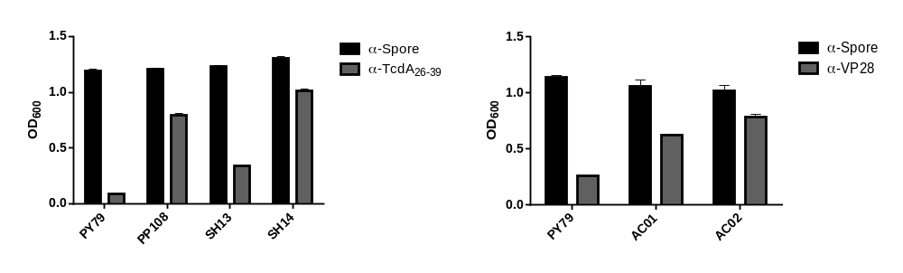
B
A

Figure 6: Surface Expression Determined by “Whole Spore ELISA”.
Figure 6A; Microtiter plates were coated with spores (2 X 10⁸/well) of PY79 (spo⁺), PP108 (amyE::cotC-tcdA₂₆₋₃₉ thrC::cotB-tcdA₂₆₋₃₉), SH13 (thyA::cotB-tcdA₂₆₋₃₉) and SH14 (thyA::cotB-tcdA₂₆₋₃₉ thyB::cotC-tcdA₂₆₋₃₉) and then probed with either anti-spore (1:1,000) or anti-TcdA₂₆₋₃₉ (1:500) rabbit PAbs. Secondary PAbs were 1:5000 and naive serum was used for comparison, and basal levels were subtracted. Figure 6B; same as for figure 6A but using spores of PY79, AC01 (thyA::cotB-vp28) and AC02 (thyA::cotB-vp28 thyB::cotB-vp28) probed with either anti-spore (1:1000) or anti-VP28 (1:300) rabbit PAbs. Black bars represent the detection of spores and grey bars represent the detection of the chimeric proteins.

3.3.2 Characterizing the growth of thyA thyB insertional mutants in different media
3.3.2.1 Growth in minimal media
Since both thy gene are important to maintain the folate cycle responsible for synthesis and also critical for cell survival (Neuhard, Price et al. 1978), it is possible that mutating one or both thy genes could render the growth of these strain compare to wildtype, although supplementing with thymine. For that purpose, the growth of the insertional mutants in minimal SMM medium at 37ºC has been examined. Figure 7 shows examples of strains (SH14) carrying cotB-tcdA and cotC-tcdA insertions at the thyA and thyB loci (Figure 7). The thyA insertion strain grew normally with or without supplementing with thymine (Figure 7B) and was indistinguishable from wild type PY79 (Figure 7A). By contrast, the thyA thyB insertion strain was thymine dependent but in the presence of thymine had reduced fitness as shown from the lower maximal OD (Figure 7C). Since by supplementing thymine to SMM, the growth of thyA thyB insertional mutant didn’t reach the saturation, this suggest that other pathway/molecules could have been affected by the absence of a functional TSase. To aim this question, more growth experiment in SMM was performed, using additional supplements.
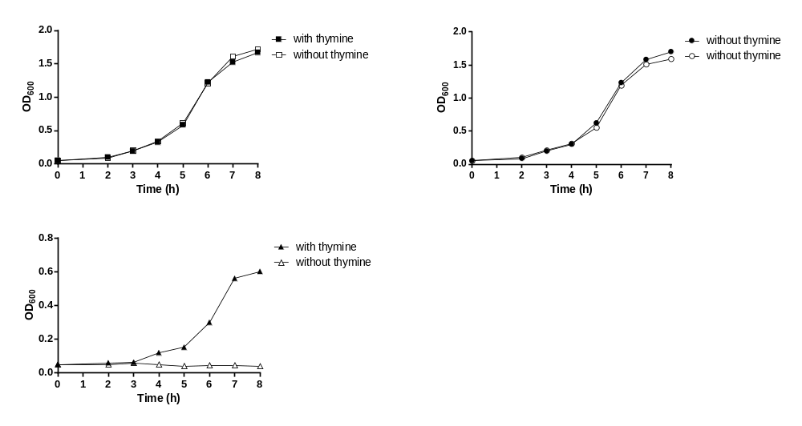
B
A

C

Figure 7: Growth of PY79, thyA and thyA thyB strains in minimal media.
Wild type PY79 (Figure 7A), SH13 thyA::cotB-tcdA (Figure 7B) and SH14 thyA::cotB-tcdA thyB::cotC-tcdA (Figure 7C) were grown in SMM medium at 37ºC with or without thymine supplementation (50 μg/ml); The starting OD₆₀₀ of each culture was 0.05.

Mutating the thy genes, not only it abolishes thymine by stopping the expression of TSase, but it can also result in disruption of glycine and purine production, and since the folate pathway is also connected to the salvage cycle, the production of methionine will also be affected (Kwon, Higgins et al. 2010, Nixon, Saionz et al. 2014). The purine that is affected by disruption of folate pathway in E.coli is adenine. It has been shown that supplementing the minimal media with casamino acid (CAA) and adenine can restore the growth of thymineless E. coli to full saturation (Amyes and Smith 1974). Therefore, the growth of double thy insertional mutants in SMM supplemented with CAA, adenine, and thymine with and without TMP was measured (Figure 8). In the presence of TMP, growth was optimal reaching a maximal OD₆₀₀ of ~2 in SMM containing either CAA and thymine or CAA, adenine and thymine. The growth was suppressed/slowed in medium supplemented with only thymine and adenine. This indicates that supplementing CAA can full restore the growth of thyA thyB in minimal media.

To further investigate the effect of the double thy mutation on amino acid synthesis in the folate and salvage pathway (responsible for glycine and methionine synthesis) and to check whether by supplementing these amino acids (glycine and methionine) full growth could be restored, the growth of a thyA thyB insertion strain (SH14) in SMM supplemented with thymine and either, methionine, serine, glycine or a mixture of these supplements with or without TMP was measured. SH14 in SMM supplemented with thymine and CAA with or without TMP was used as a control for optimum growth. The results indicated that the growth of SH14 with different supplements (no CAA) was, more or less, the same as SH14 which was only supplemented with thymine, suggesting that other amino acids or molecules might have been affected (Figure 9).

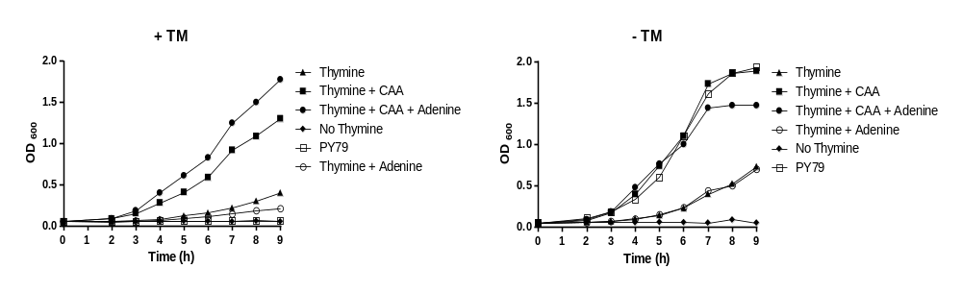
A
B

Figure 8: Growth of thyA thyB insertion strain in SMM media.
Growth at 37ºC of SH14 in SMM medium using different supplements as indicated (thymine 50 μg/ml, CAA (0.2% w/v,) Adenine (20μg/ml). Media was supplemented with TMP (3μg/ml) in figure 8A and no TMP in figure 8B. As a control B. subtilis strain PY79 was also evaluated for growth in SMM with no supplements.

B
A
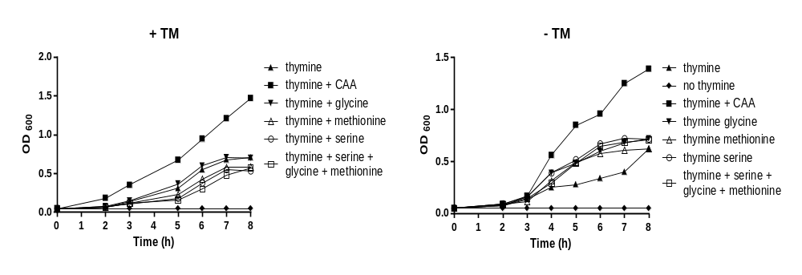

Figure 8: Growth of thyA thyB insertion strain in SMM media with different amino acids.
Growth at 37ºC of SH14 in SMM medium with different supplements as indicated thymine (50 μg/ml), CAA (0.2% w/v), glycine (50μg/ml), serine (50μg/ml) and methionine (50μg/ml). Media in figure 8A were supplemented with TMP (6μg/ml) and figure 8B were without TMP.

b) Growth in rich media
The growth of thyA and thyA thyB insertional mutant strains at 37ºC in LB and DSM medium was assessed, to check if the rich media would affect the growth of the mutant differently than that of. PY79 (wildtype) (Figure 9). Without thymine, in both LB and DSM, strain carrying the insertion in both thyA thyB showed no growth while the strain carrying the insertion in thyA only grew normally (Figure 9B and 9D). In the presence of thymine strains carrying insertions at the thyA locus grew normally yet unexpectedly strain carrying thyA thyB insertions were severely affected. In LB plus thymine, cells of a thyA thyB insertion strain showed no growth (Figure 9A) while in DSM growth was markedly reduced with a reduced OD (Figure 9C).
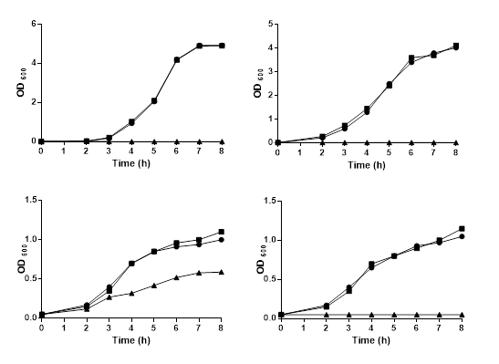
Figure 9: Growth of strains in rich media.
Growth at 37oC of PY79 (■), SH13 (●) and SH14 (▲) were made in: figure 9A, LB with thymine (50 μg/ml); figure 9B, LB without thymine; figure 9C, DSM with thymine (50 μg/ml) and figure 9D, DSM without thymine (50μg/ml) and TMP (3μg/ml).

■ PY79
● SH13
▲ SH14
C
D
B
A

Since thyA thyB insertion mutant strains were not growing in LB supplemented with thymine, it seemed possible that one or more component of LB was inhibiting the growth. Thus, the growth of strain thyA thyB in LB medium supplemented with thymine and with varying levels of yeast extract (YE), a component of LB, was assessed. The optimal growth of thyA thyB was noted in the media containing 0 and 1 mg/ml of YE and growth would reduce as the concentration of YE was increasing. Concentration of 3, 4 and 5 mg/ml of YE have completely abolished the growth of thyA thyB mutant. However, increasing concentration of YE has increased the growth of wild type PY79. These results indicate that the presence of ≥2 mg/ml of YE in LB inhibited growth of strains carrying two thyA thyB insertions (Figure 10).
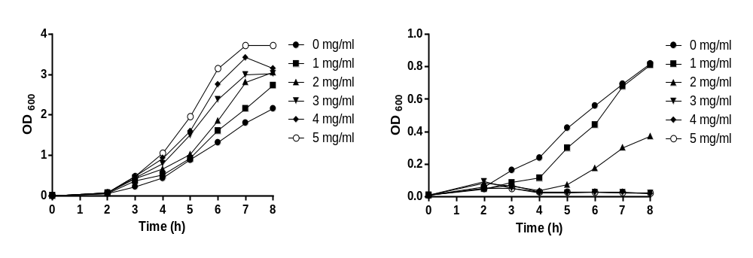
A
B

Figure 10: Growth of strains in rich media
Growth at 37ºC of PY79 (Figure 10A), and SH14 (Figure 10B) were made in LB with different concentrations of YE, (●) 0 mg/ml, (■) 1 mg/ml, (▲) 2 mg/ml, (▼) 3 mg/ml, (♦) 4 mg/ml and (○) 5 mg/ml.

To determine whether tryptone (another component of LB) also has an inhibitory effect on thyA thyB, the use of a growth medium other than LB was necessary. Since SOC2 media contain tryptone and no YE, then the growth of thyA thyB mutant with different concentrations of tryptone in SOC2 was measured. Increasing the concentration of tryptone leads to higher growth of thyA thyB, with a similar benefit as for PY79 (Figure 9). This observation indicates that tryptone had no inhibitory effect on thyA thyB mutant growth.
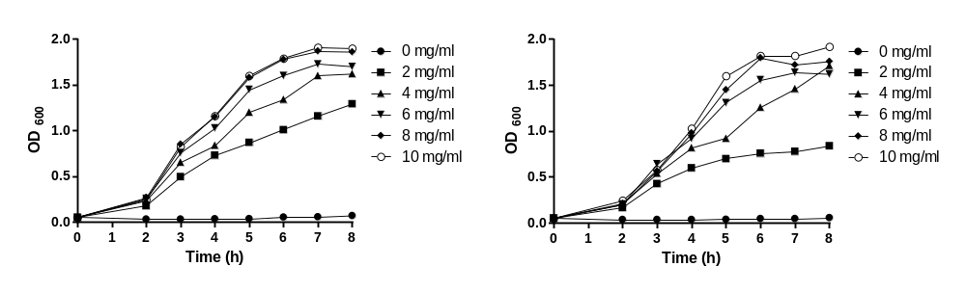
B
A

Figure 11: Growth of strains in rich media
Growth at 37ºC of PY79 (figure 11A), and SH14 (figure 11B) were made in SOC2 supplemented thymine (50μg/ml) and different concentrations of tryptone, (●) 0mg/ml, (■) 2mg/ml, (▲) 4mg/ml, (▼) 6mg/ml, (♦) 8mg/ml and (○) 10 mg/ml.

The inhibitory activity of YE could, therefore, explain why in the LB medium the thyA thyB insertion strain failed to grow even in the presence of thymine (Figure 8B). This inhibitory effect of YE could be due to adenosine, component of YE. It has been previously shown that adenosine causes death of thyminless Ecoli (Kinoshita, Akiyoshi et al. 1969). Therefore, the effect of adenosine on the thyA thyB insertion strain (SH14) were investigated using an agar well diffusion assay (Figure 12). No inhibitory zone by different concentration of adenosine around the well was observed suggesting that adenosine alone had no inhibitory effect on SH14.
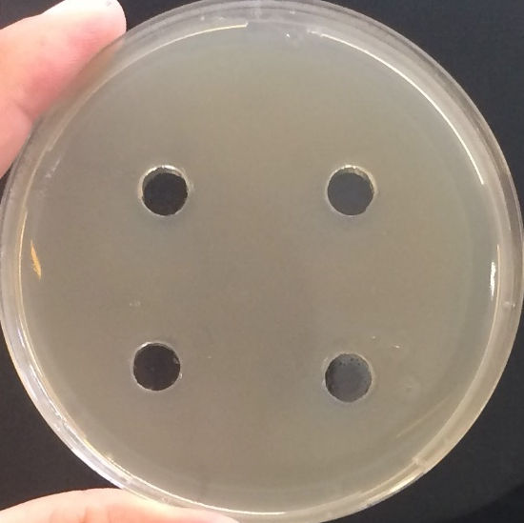

Figure 12: effect of adenosine on the growth of SH14.
An SMM agar plate supplemented with thymine (50μg/ml) and 0.2% CAA was flooded with 8h SH14 culture in SOC2 medium. Wells in agar was made and into each well, a different concentration of adenosine ranging from 0 to 500 mg/ml was added. SMM plates were incubated for 48h at 37ºC.

3.2.3 A choice of better media for sporulation
Since the goal of these cloning is to produce spores that display chimeric protein on their spore surfaces, sporulation becomes an important aspect. To check whether by mutating both thy gene sporulation would be affected, sporulation of thyA and thyA thyB insertional mutants relative to PY79, in DSM, was measured. In comparison to PY79, thyA had similar percentage of sporulation whereas the percentage sporulation of thyA thyB has reduced (Table 5).

Strain | Genotype | Total Count | Heat count | % Sporulation
PY79 | thyA⁺ thyB⁺ | 2.8 x 10⁸ | 2.4 x10⁸ | 85.7
SH11 | thyA::cotC-vp26 | 1.9 x 10⁸ | 1.6 x10⁸ | 82
SH12 | thyA::cotC-vp26 thyB::cotB-vp28 | 2 x 10⁸ | 1.5 x 10⁸ | 75
AC01 | thyA::cotB-vp28 | 2.6 x 10⁸ | 2.2 x 10⁸ | 85
AC02 | thyA::cotB-vp28 thyB::cotB-vp28 | 1.9 x10⁸ | 1.5 x 10⁸ | 78.6
SH13 | thyA::cotB-tcdA₂₆₋₃₉ | 2.2 x10⁸ | 1.8 x 10⁸ | 85
SH14 | thyA::cotB-tcdA₂₆₋₃₉ thyB::cotC-tcdA₂₆₋₃₉ | 2.5 x10⁸ | 1.9 x10⁸ | 77.2
SH15 | thyA::cotB-SA | 2.8 x 10⁸ | 2.3 x 10⁸ | 82
SH16 | thyA::cotB-SA  thyB::cotB-SA | 3.1 x 10⁸ | 2.4 x 10⁸ | 77.4
SH17 | thyA::cotB-amyE | 7.4 x 10⁸ | 6.1 x 10⁸ | 82.5
SH18 | thyA::cotB-amyE thyB::cotB-MCS | 1.28 x 10⁸ | 9.8 x 10⁷ | 76.5
SH19 | thyA::cotB-aprE | 4.1 x 10⁸ | 3.7 x 10⁸ | 90
SH20 | thyA::cotB-aprE  thyB::cotB-MCS | 8.1 x 10⁷ | 6.8 x 10⁷ | 83.9
Table 5. Percentage sporulation of PY79, thyA and thyA thyB insertional mutants.
Different strains were grown for 24h in DSM supplemented with thymine (50 μg/ml). After 24h, untreated and heated (65ºC, 1h) culture were plated on appropriated plates.

Thus, a need for a media for better sporulation of thyA thyB insertion becomes necessary. A BTC medium derived from rice that could provide high levels of sporulation with the thyA thyB insertion strains was developed. Using BTC medium with 4 mg/ml of YE, it was noted that the sporulation of PY79 has increased in-comparison to DSM media. However, high concentration of YE has inhibitory effect on thyA thyB insertion growth (Figure 10). Therefore, the growth of thyA thyB insertion in rice medium using different concentration of YE was measured. The results show that higher or lower concentration than 2 mg/ml of YE give rise to lower growth of thyA thyB insertion. (Figure 13).
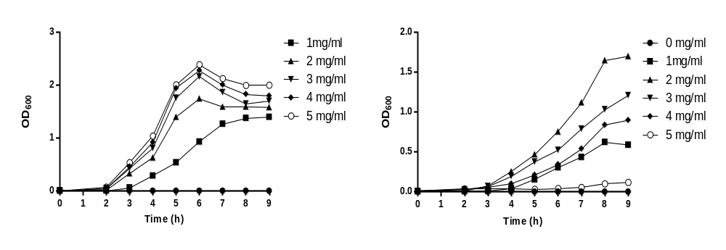
B
A

Figure 13: Growth of PY79 and SH14 in Rice media
Growth at 37ºC of PY79 (Figure 13A), and SH14 (Figure 13B) were made in Rice media with different concentrations of YE (mg/ml). Increasing YE concentration lead to higher growth of PY79. Higher or lower than 2 mg/ml of YE lead to a reduce growth.

Therefore, rice media containing 2 mg/ml of YE was used to measure the sporulation of thyA thyB insertion. Using the rice media in comparison to DSM the percentage of sporulation of thyA thyB has increased by 10% (Table 6).

strain | Non-heated count | Heated count | % sporulation
PY79 | 7.6 * 10⁸ | 7.3 * 10⁸ | 96.1
SH14 | 1.6 * 10⁸ | 1.41 * 10⁸ | 88.1

Table 6: Sporulation in Rice media
Growth at 37ºC of PY79 and SH14 were made in Rice with YE (2 mg/ml). Cells were plated on DSM or DSM supplemented with thymine (50 μg/ml) for PY79 and SH14 respectively. Percentage sporulation was determined by counting the cfu from untreated and heat (65ºC, 1h) spores on the agar plate after 48h.

3.2.4 Different types of colony after transformation
Following the 1st genetic cross (thyA insertional mutation) two colony types were apparent on SMM supplemented with thymine (50 μg/ml) and TMP (3 μg/ml) plates (Figure 14). Type 1 were large opaque colonies (2-3mm) and carried the correct insertion at thyA locus as confirmed both by PCR (see methods shapter 2.) and sequencing. Type 2 colonies were translucent and smaller (1mm) and grew slowly. The type 2 colonies after 96h represented approximately 2/3 of all colonies present on the plate. When investigated by PCR, it was confirmed that some of type 2 colonies carried the thyA insertion while most had no insertion. However, upon restreaking the correct band (indicating the presence of the insertion) was lost and PCR profile of those colonies showed only the wildtype band. Therefore, only type 1 colonies were used for the second step.

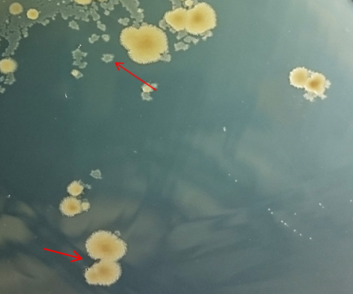
cotB-tcdA₂₆₋₃₉

Figure 14. Different types of 1st crossover.
The growth of two types of colony on SMM supplemented with 3μg/ml of TMP and 50 μg/ml of thymine. Type 1, large opaque, and type 2 colonies are small translucent colonies. Only type 1 colonies were transformable to create double thy mutant.

3.2.5 Thymine and Thymidine titration

Boyle et al. showed that as well as thymine, thymidine could be used for growth of thyminless Ecoli (Boyle and Jones 1970). To assess the lowest concentration of both thymine and thymidine for optimal growth of thyA thyB mutant, an end-point titer test using SH14 was performed with PY79 as control. Also, SH14 in SMM supplementing with 0.2% CAA, thymine (50μg/ml) or thymidine (50μg/ml) was used as positive control. SH14 was allowed to grow for 16h at 37ºC in SMM supplementing with CAA and different concentration of thymine and thymidine. The OD₆₀₀ was measured and the results indicates that for optimal growth of SH14, 15 μg/ml of thymine or 20 μg/ml of thymidine was required (Figure 15C and 15D). Supplementing media with different concentration of thymine and thymidine didn’t affect the PY79 growth (Figure 15A and 15B).
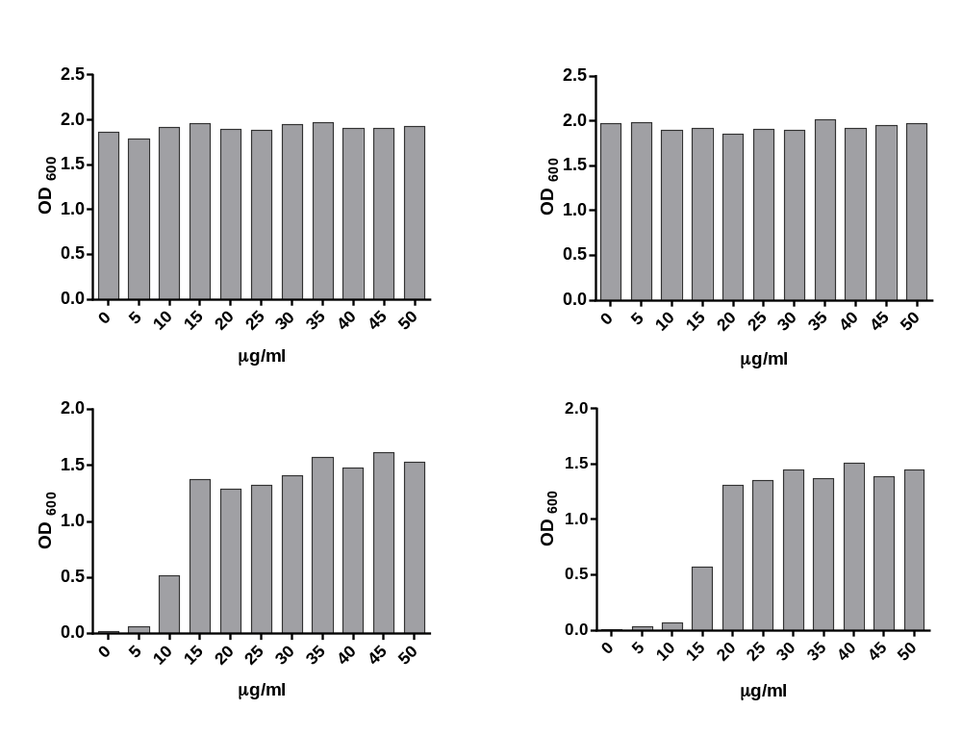
B
A

D
C

Figure 15: Growth of PY79 and SH14 in medium containing thymine (Figure 15A and 15C) or thymidine (Figure 15B and 15D).
PY79 and SH14 was grown in SMM containing 0.2% CAA with different concentrations of thymine or thymidine. Cultures incubated 16h at 37ºC after which OD₆₀₀ were determined. Figure 15A, PY79 + thymine; Figure 15B, PY79 + thymidine; Figure 15C, SH14 + thymine; and Figure 15D shows SH14 + thymidine.

3.2.6 Survival of thyA thyB insertion after elimination of thymine

Elimination of thymine in minimal media will lead to loss of viability of thyminless E.coli (Amyes and Smith 1974). To test the viability of SH14 after thymine elimination, SH14 was grown to the middle of log phase (OD₆₀₀ of 0.5-0.6) in SOC2 supplemented with thymine before eliminating thymine. Thymine was eliminated by centrifugation of the cells and washing the pellete (3x) with PBS. At different time point thereafter 1 ml of cells were removed and plated. Result shows that the CFU count of SH14 after eliminating thymine has greatly reduced compared to the control (+thymine) (Figure 16). This indicates that elimination of thymine has bactericidal effect on thyA thyB insertional mutant.
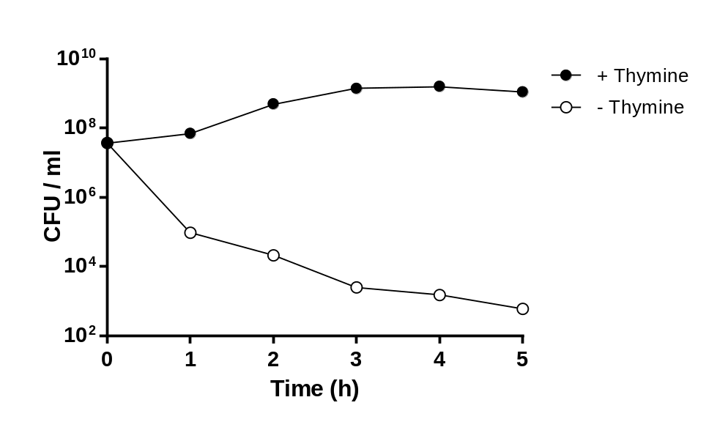

Figure 16. Viability of SH14 after thymine elimination.
SH14 culture was allowed to grow in SOC2 media to OD₆₀₀ 0.5-0.6 before eliminating thymine. Cells were spun down, washed 3 times with PBS (pH 7.4) before resuspending in the same volume of medium as before centrifuging. At different time point, 1 ml of culture was removed, serially diluted and plated on DSM supplemented with thymine (50 μg/ml) ●, growth of SH14 in SOC2 supplemented with thymine (50μg/ml); ○, growth of SH14 in SOC2 without thymine.

3.2.7 Reversion
Although a mutation that occurs by a double cross-over recombinational event is stable there exists the possibility of acquisition of a compensatory suppressor or bypass mutation (Comas, Borrell et al. 2012). Thus, an experiment to test the stability of the inserts in thyAthyB was conducted by growing thyAthyB in DSM which is supplemented with thymine followed by subculture 5 times every 24h into two new DSM broth, one of which supplemented with thymine and the other without. At each time point, 1 ml of the culture was removed and plated on DSM agar with or without thymine. No growth was seen in both subcultures in DSM broth and on agar plates that didn’t have thymine supplemented (Table 6). This result indicates that the double cross-over mutation (upon 5 times subculturing) is stable.

Sub-culture | CFU Culture 1 |  | CFU Culture 2
Sub-culture | DSM + thymine | DSM | DSM + thymine | DSM
1st | 2.8 x 10⁸ | 0 | 2.1 x 10⁸ | 0
2nd | 1.8 x 10⁸ | 0 | 3.4 x 10⁸ | 0
3rd | 1.85 x 10⁸ | 0 | 1.73 x 10⁸ | 0
4th | 1.82 x 10⁸ | 0 | 1.6 x 10⁸ | 0
5th | 1.54 x 10⁸ | 0 | 2.4 x 10⁸ | 0
Table 6. Reversion of SH14 upon subculture in DSM.
SH14 culture in DSM supplemented with thymine (50 μg/ml) were subcultured after 24h growth into fresh DSM supplemented with thymine. At each timepoint (every 24h) 2ml of the culture was removed. 1ml of the culture used to subculture and the other ml was serial diluted and plated on both DSM and DSM supplemented with thymine.

3.2.8 In vitro germination
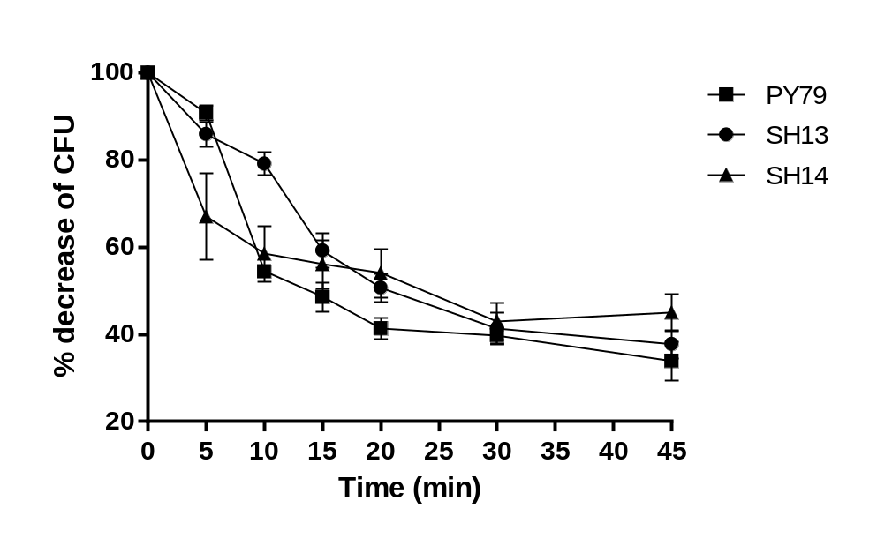Since different proteins (CotB/CotC fused to different proteins) will be displayed on spore coat of PY79 after the double cross-over occurred, it is possible that this might affect the germination relative to the wildtype. Thus, thyA and thyA thyB insertions were examined for their germination phenotypes in parallel with the isogenic spo+ parent strain, PY79. Figure 17 shows the % decrease of CFU of PY79, thyA and thyAthyB insertion strains (Figure 17). This result shows that there was no significant difference between PY79, thyA, and thyA thyB insertion for germination.

Figure 17. Germination of PY79, SH13 and SH14.
Purified spores were resuspended in distilled water to OD₆₀₀ of 3. Spore were heat activated and diluted in 10mM Tris-HCl, pH 8.4. After 15 min incubation at 37ºC, germination was initiated by the addition of L-alanine. At t₀ and different time point, 0.1 ml of the spore suspension was diluted in 10ml of distilled water at and were incubated at 70ºC for 30 min. Spores were then serially diluted spores and plated on DSM and DSM supplemented with thymine (50mg/ml) and TMP (6mg/ml). ■, PY79; ●, SH13; and ▲ shows the cfu count of SH14.

3.2.9 In vivo Fate of thyA thyB insertion mutant spores in the GI-tract
The presence of low level of thymidine in GI-tract might permit limited proliferation of B. subtilis carrying the thyA thyB mutant alleles. An experiment to address this issue was designed. A single dose of 2 X 10¹⁰ spores of SH250 (spo⁺) or SH14 (thyA::cotB-tcdA₂₆₋₃₉ thyA::cotC-tcdA₂₆₋₃₉) spores were given to mice orally. The subsequent shedding of heat-resistant spores in freshly voided feces was determined. The results showed that after 240h the levels of wild type PY79 and spores had reached the threshold level of detection (Figure 18A). This result indicates that SH14 spores can survive similar to SH250 (wild type), despite low concentration of thymine. To confirm that the spores shedding from feces are PY79 and SH14, PCR performed on 20 random selection of colonies at every time point (Figure 18B). This confirmed that the counted CFU were both PY79 and SH14.

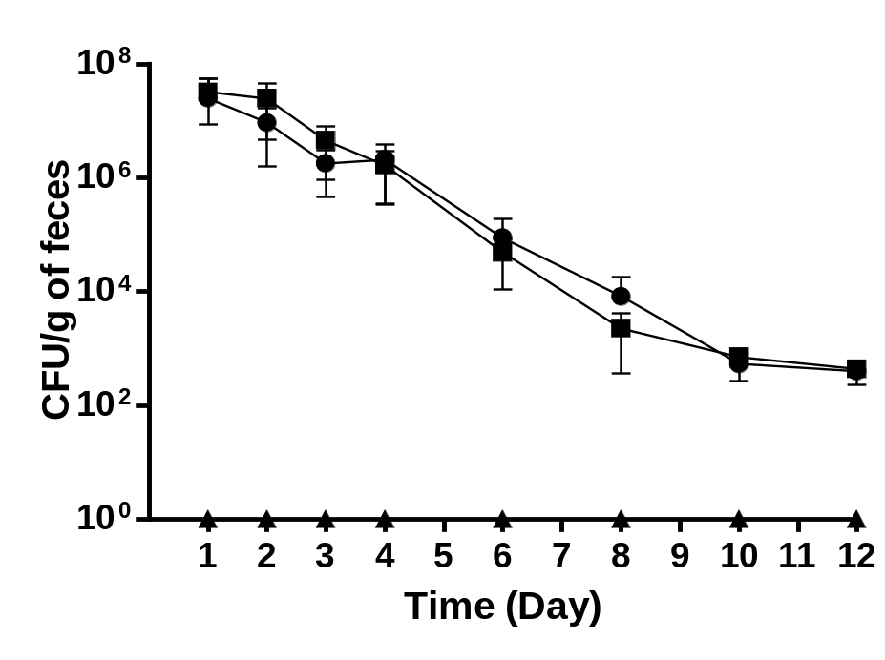
A
SH14
PY79
B
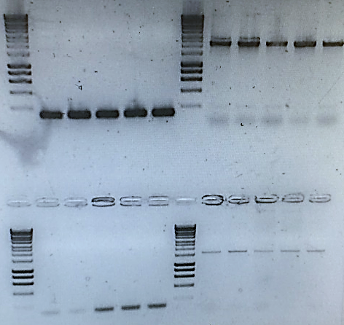
thyA
(cotB-tcdA)
thyA
(no insertion)

thyB
(cotC-tcdA)
thyB
(no insertion)

Figure 18. survival in murine GI-truct.
Groups of 5 mice were administered a single dose of pure spores (2 X 10⁹) by oral gavage. Freshly voided feces were collected (3-4 pellets) at different days, homogenized and serial dilutions plated on (i) DSM, (ii) DSM + chloramphenicol (5 mg/ml) and (iii) DSM + TMP (3 mg/ml) + thymine (50 mg/ml) agar plates. Figure 18A shows the CFU count of heat treated (65ºC for 1h) at different time points. ■ represents; PY79 CFU plated on DSM supplemented with choloramphnicol, ●; SH14 CFU plated on DSM supplemented with thymine, and ▲; is SH14 plated on DSM only. Figure 18B shows the PCR profile of a random selection of colonies that were counted on different plates. that the counted cfu were both PY79 and SH14.

3.3 Discussions
This study has provided a new method for making recombinant spores that display protein on their spore surface without using Ab^{R}. Also, should these spores germinate, in environments where thymine (or thymidine) is absence, cells will die since they have a strict dependence on thymine (or thymidine).

3.3.1 Rationale
An absolute requirement for thymine in B. subtilis requires two thymidylate synthetases (TSase) encoded by the unlinked thyA (TSaseA) and thyB (TSaseB) gene (Neuhard, Price et al. 1978). These genes are linked to the folate pathway and provide pyrimidines for cell growth (Figure 1). TSaseB is thermo-sensitive and retains only ~5-8% activity at a restrictive temperature of 46ºC. Thus, inactivation of the thyA locus requires supplementation with thymine (or thymidine) for growth at 46ºC. TSaseA is not thermo-sensitive and so inactivation of thyB allows cells to grow at an elevated temperature. Inactivation of both thyA and thyB however, produces an absolute requirement on thymine for growth at both 37ºC and 46ºC. As shown by Neuhard et al (Neuhard, Price et al. 1978) inactivation of thy genes produces resistance to the anti-folate drug TMP (or aminopterin) since the need for dihydrofolate reductase (DHFR), the target for TMP, is dispensed with. However, the level of resistance differs, with insertion at thyA producing a lower level of resistance than that found in a thyA thyB mutant (Neuhard, Price et al. 1978). This then enables a two-step ectopic cloning system to be considered (Figure 2) where, in the first step, a gene is introduced at the thyA locus followed, in the second step, by insertion at thyB.
To demonstrate proof of concept for ectopic cloning at thy loci a number of heterologous genes whose gene products had previously been expressed on the spore surface was chosen. In each case, the expression had been achieved by chimeric fusion to a B. subtilis gene encoding a surface expressed spore coat protein (either CotB or CotC). VP26 and VP28 are capsid proteins of the shrimp virus WSSV and when displayed on B. subtilis spores and incorporated in feed have been shown to confer protection to shrimps challenged with WSSV (Ning, Leng et al. 2011, Nguyen, Pham et al. 2014, Valdez, Yepiz‐Plascencia et al. 2014). TcdA₂₆₋₃₉, is a C-terminal domain of Clostridium difficile toxin A and when expressed on the spore surface has been shown to confer protection to C. difficile infection (CDI) in hamsters (Permpoonpattana, Hong et al. 2011, Hong, Hitri et al. 2017). Streptavidin (SA) which when expressed on spores can be conjugated to the monoclonal antibody Cetuximab enabling targeting to colon cancer cells (Nguyen, Huynh et al. 2013). Finally, subtilisin E and amylase E enzyme were displayed on spores surface.
Using the two-step method for ectopic gene insertion different clones diplay the proteins mentioned above was constructed and using whole genome sequencing for strain SH12 (thyA::cotC-vp26 thyB::cotB-vp28) and SH14 (thyA::cotB-tcdA₂₆₋₃₉ thyA::cotC-tcdA₂₆₋₃₉) the presence of chimeric gene inserted at the thy loci without any chromosomal aberrations was confirmed. Expression of chimeric proteins was confirmed by both Western blotting (using purified spores extract) and ELISA. As expected, expression of the chimeric protein at both the thyA and thyB loci was greater than expression at one locus. Measuring the expression of TcdA₂₆₋₃₉ in spores of PP108 that expresses the same antigen fused to CotB and CotC but inserted at the thrC and amyE loci respectively (Permpoonpattana, Hong et al. 2011). Expression levels were somewhat lower, but it should be noted that using an anti-spore PAb to measure levels of spore coat proteins expression levels were correspondingly reduced.
The growth of thyA and thyA thyB insertional mutant in both minimal medium, SMM, was assessed. Surprisingly, the thyA insertion strain grew normally with or without thymine and was indistinguishable from wild type PY79. This illustrate that the level of expression of TS via thyB only is enough for thyA mutant to grow similar to PY79. By contrast the thyA thyB insertion strain was thymine dependent but in the presence of thymine had reduced fitness.
Both thymine and thymidine could be used for growth of strains carrying insertions in the thyA and thyB loci (Boyle and Jones 1970). However, the concentration of thymine and thymidine needed for the growth of thyA thyB were significantly less than the 50g/ml reported before (Neuhard, Price et al. 1978) and most probably reflects differences in strain backgrounds used.
Cell carrying insertions at the thyA and thyB loci although able to grow in media supplemented with thymine rapidly underwent a massive loss in cell viability when thymine was removed. When growing cells were suspended in medium devoid of thymine a ~5-log reduction in cfu was observed in just 5h. Similar effect has been shown previously with thymineless E. coli (Amyes and Smith 1974).

3.3.3.1 Experimental considerations for use of ectopic insertion at the thy loci
As expected, in rich medium single thyA insertion strain was able to grow without thymine supplementation. Interestingly, thyA thyB mutant failed to restore the normal levels of growth once supplemented with thymine in DSM and a limited growth was observed, but in LB it completely failed to grow.
Since the thyA thyB insertion strain could grow, albeit with reduced fitness, in minimal medium supplemented, a simple explanation for it not to grow in LB or limited growth in DSM with thymine supplementation is that one or more components of the rich medium might inhibit growth potentially by interfering with the folate pathway. A prime candidate was yeast extract (YE) that is present in LB and DSM medium at 5 mg/ml and 2 mg/ml respectively and absent in SMM medium. YE has been shown to inhibit thymine-less E. coli strains where the active bactericidal ingredient has been identified as adenosine (Kinoshita, Akiyoshi et al. 1969). YE concentrations of ≥2 mg/ml inhibited growth of strains carrying two thy (thyA + thyB) insertions. Tryptone is also present in LB. Knowing that YE has inhibitory effect on the growth of thyA thyB, SOC2 medium was used to test whether tryptone has inhibitory effect on thyA thyB. Using different concentration of tryptone, no inhibitory effect on growth was observed. The inhibitory activity of YE could therefore explain why in LB medium the thyA thyB double insertion strain failed to grow in the presence of thymine. Similarly, in DSM where YE is present at a lower concentration reduced growth was observed. Finally, the inhibitory action of YE required the need for a modified growth medium (SOC2) lacking YE for preparation of cells for the electroporation step used in the strain constructions (see Method section 2.).
As mentioned earlier DNA-mediated transformation of competent cells could be used to introduce plasmid DNA into B. subtilis cells. However, for introducing DNA into thyA cells in the 2nd, for introduction of insertions at the thyB locus classical DNA-mediated transformation of competent cells with the pThyB plasmid proved inefficient with low integration frequencies and thus, electroporation using a SOC2 medium lacking YE yielded higher frequencies of integration.
following the 1st genetic cross two colony types, in equal proportion, were apparent on SMM agar supplemented with thymine and TMP. Type 1 were large opaque colonies and Type 2 colonies were translucent, smaller and grew slowly. All colonies showed the correct phenotype. When investigated, about one third of type 1 colonies were found to carry stable thyA insertions while no type 2 colonies carried insertions. We assume that

these colonies able to grow on TMP plates must carry some form of compensatory, yet unstable, mutation/s allowing growth in the presence of the antibiotic.
A second important observation was that for the 2nd genetic transfer recombinants could only be selected on SMM minimal media supplemented with thymine, TMP (6 g/ml) and CAA. If plated directly onto agar lacking CAA small (<1mm), slow growing colonies would result but after reculture these were found to have lost the thyB insertion as determined by colony PCR. Even in the presence of CAA all colonies were small and only about 20% that grew on TMP (6 g/ml) carried a stable thyB insertion. Work in E. coli as well as B. subtilis has shown that disruption of the folate pathway can lead to depletion of key amino acids as well as purines and pyrimidines (40, 41). TMP-mediated inactivation of DHFR would deplete intracellular levels of THF, MTHF as well as DHF. In turn this would affect the reversible interconversion of serine and glycine with tetrahydrofolic acid (THF), a vital reaction in the synthesis of purines and catalysed by a serine hydroxymethyltransferase (SHMT or GlyA, (42, 43)). MTHF is also utilised in the final step of the biosynthetic pathways of cysteine and methionine (44) and disruption of the pathway by the thyA thyB alleles could introduce a requirement for methionine.

In thymineless E.coli supplementing CAA and adenine can restore the full growth in minimal media in presence of thymine (Amyes and Smith 1974, Kwon, Higgins et al. 2010). Therefore, the ability of the growth of thyA thyB mutant in SMM supplementing with CAA and purine (adenine) was assessed. The optimal growth (OD₆₀₀ ~2) was observed in SMM supplemented containing CAA and thymine, and SMM containing CAA, adenine and thymine. The growth was markedly reduced in media containing no CAA or carrying only adenine and/or thymine. There was no significant difference between the growth of thyA thyB in SMM containing CAA with or without adenine. This suggest that by supplementing CAA, the concentration/presence of depleted amino acids is restored. Also supplementing adenine does not have any effect on the growth of the double thy insertion mutant. In the absence of TMP growth of SH14 remained weak compared to the wild type strain PY79 but was i) superior to that in the presence of the antibiotic, ii) growth was restored to normal fitness only in the presence of CAA. Mutating thy genes therefore disrupts the folate pathway significantly reducing strain fitness and this could not be restored by supplementation with purines or pyrimidines but only with CAA.

Since adenine supplementation had no effect on the growth of double thy mutant strain, then it is possible that by supplementing the depleted amino acid by disrupting the folate pathway ,as suggested in some publications, would restore the normal level of growth (Amyes and Smith 1974, Stepanek, Schäkermann et al. 2016). In the presence of glycine, methionine and serine, the normal level of growth didn’t reach suggesting that the production or concentration of other molecules or amino acids might have been affected.

Therefore, for construction of strains the double, thyA thyB, insertion in the second step media such as CAA providing all amino acids is essential. However, once constructed the use of TMP is no longer required and strains can be cultivated on any media so long as three criteria are met, first, that the media contains thymine or thymidine, second, YE is either absent or at a concentration less than 2 mg/ml, and third, amino acids are provided in the growth medium.

For expression of heterologous proteins on the spore surface the coat proteins CotB and CotC can be used for both mono or divalent expression. As expected, when using two different spore coat anchors expression of a protein was higher than using expression from only one. So, as shown in Fig. 4A, TcdA₂₆₋₃₉ levels were higher in SH14 spores carrying thyA::cotB-tcdA₂₆₋₃₉ and thyB::cotC-tcdA₂₆₋₃₉ insertions than in SH13 spores carrying only a thyA::cotB-tcdA₂₆₋₃₉ insertion. Interestingly, using fusion of VP28 to CotB and insertion of this chimera at the thyA locus alone (strain AC01) or at both the thyA and thyB loci (strain AC02) lead to higher levels of expression in the latter. This finding requires some consideration since it must be assumed that each spore would carry a defined number of CotB monomers that could assemble onto the spore surface and simply increasing the number should not lead to higher levels of incorporation in the coat. These strains would however, carry an intact cotB gene (residing at its normal chromosomal locus) so in cells carrying a thyA::cotB-VP28 insertion (i.e., AC01) 50% of displayed CotB proteins should present a wild type CotB and 50% CotB-VP28. In a double thyA thyB insertion strain (AC02) we would predict ~ 66% of displayed CotB proteins would present VP28 and ~33% wild type CotB. This stoichiometry ratio of CotB-VP28 and CotB would agree with the ELISA detection of VP28 as shown in Fig. 4B

3.3.5 reversion
An insertion generated by a double-crossover recombinational event should be inherently stable yet there exists the possibility of acquisition of a compensatory suppressor or bypass mutation. To address this a straightforward experiment to determine whether upon repeated culture in the absence of any selective pressure the thymine dependence could be lost was conducted. Yielded no loss of the thymine dependency showing the insertions were stable and suggesting that the acquisition of compensatory mutations, if they were to occur, must be an extremely rare event.

3.3.6 In vivo Fate of thyA⁻ thyB⁻ spores in the GI-tract
It has been demonstrated that for E. coli to colonize the murine GI-tract synthesis of purines and pyrimidines is necessary (Vogel-Scheel, Alpert et al. 2010). This implies that the low levels of purines and pyrimidines that might result from digested food or from spurious lysis of resident gut microbiota would not be sufficient to permit growth of a B. subtilis thyA thyB mutant. In humans the intestinal concentration of thymidine is estimated as 0.075 M and in pigs ~1.0 M (Steidler, Neirynck et al. 2003).
Spores of SH14 and SH250 (thyA⁺ thyB⁺ Cm^{R}) were detected in the feces of mice that were dosed spores by gavage. The temporal kinetics of shedding was indistinguishable from that of a Spo⁺ Thy⁺ strain (SH250). After 10 days the number of SH14 spores being shed in the feces was at levels (<10³/g of feces) at the level of detection. This in vivo data shows that the kinetics of spore shedding of thyA⁻ thyB⁻ spores are indistinguishable from wild type. Although it is not possible to determine whether SH14 spores could proliferate in the GI-tract it was possible to show that in the absence of thymine spores in the feces could not survive post-germination as no CFU was detected on DSM only.

Conclusion

In this work I have demonstrated a method for the creation of GMOs of B. subtilis that lack the ability to survive in the environment other than in the dormant spore form. The method used relies upon positive selection for TMP^{R} following integration of DNA at the thyA or thyB loci but without the introduction of any antibiotic resistance genes. TMP^{R} colonies can then be screened for a temperature-sensitive dependence for growth to confirm whether colonies carry one or two insertions.

TMP inhibits the enzyme dihyrdofolate reductase (DHFR) leading to a transient accumulation of dihydrofolate (DHF) in the cell and an accumulation of folic acid (see Supp. Fig. 1 for a schematic of the folate pathway). As a consequence purine and pyrimidine biosynthesis is arrested and cell growth inhibited (Quinlivan, McPartlin et al. 2000). In cells unable to produce the two TSase , TSaseA and TSaseB, synthesis of the pyrimidines (thymidine and thymine) is arrested and DHF levels reduced. With the double thyA thyB insertions it is apparent that growth can be restored with thymine supplementation. Interestingly though growth (as determined by cell density) was much reduced in rich media. For DSM and LB, in particular, the maximum cells densities remained below an OD₆₀₀ of 0.4. We reasoned that the reduction of DHF could account for this reduction in cell growth. Rich media

Based on our work both transformation and electroporation provide a suitable and convenient method to introduce DNA into cells of a strain carrying a thyA insertion. However, other methods used for introduction of DNA into B. subtilis could be considered providing they satisfy two criteria. First, the generation of competent cells does not require growth in medium containing YE or LB. Second, the medium used for selection of transformants contains glycine or CAA. Protoplast fusion techniques may also be considered so long as they satisfy these same criteria, e.g., a method described by Sadaie and Kada uses 1 mg/ml of YE in the growth medium (Sadaie and Kada 1983).

References
Hong, H. A., et al. (2017). "Erratum for Hong et al.,“Mucosal Antibodies to the C Terminus of Toxin A Prevent Colonization of Clostridium difficile”." Infection and immunity 85(6).

Kinoshita, N., et al. (1969). "Isolation and Characterization of Substance in Yeast Extract which Inhibits Growth of Thymine-less Strains of Escherichia coli." Microbiology 59(3): 393-400.

Kwon, Y. K., et al. (2010). "Antifolate-induced depletion of intracellular glycine and purines inhibits thymineless death in E. coli." ACS chemical biology 5(8): 787-795.

Neuhard, J., et al. (1978). "Two thymidylate synthetases in Bacillus subtilis." Proceedings of the National Academy of Sciences 75(3): 1194-1198.

Nguyen, A. T., et al. (2014). "Bacillus subtilis spores expressing the VP28 antigen: a potential oral treatment to protect Litopenaeus vannamei against white spot syndrome." FEMS microbiology letters 358(2): 202-208.

Nguyen, V. A. T., et al. (2013). "Killed Bacillus subtilis spores expressing streptavidin: a novel carrier of drugs to target cancer cells." Journal of drug targeting 21(6): 528-541.

Ning, D., et al. (2011). "Surface‐displayed VP28 on Bacillus subtilis spores induce protection against white spot syndrome virus in crayfish by oral administration." Journal of applied microbiology 111(6): 1327-1336.

Nixon, M. R., et al. (2014). "Folate pathway disruption leads to critical disruption of methionine derivatives in Mycobacterium tuberculosis." Chemistry & biology 21(7): 819-830.

Permpoonpattana, P., et al. (2011). "Immunization with Bacillus spores expressing toxin A peptide repeats protects against infection with Clostridium difficile strains producing toxins A and B." Infection and immunity 79(6): 2295-2302.

Potot, S., et al. (2010). "Display of recombinant proteins on Bacillus subtilis spores, using a coat-associated enzyme as the carrier." Applied and environmental microbiology 76(17): 5926-5933.

Valdez, A., et al. (2014). "First Litopenaeus vannamei WSSV 100% oral vaccination protection using CotC:: Vp26 fusion protein displayed on Bacillus subtilis spores surface." Journal of applied microbiology 117(2): 347-357.

Boyle, J. V. and M. E. Jones (1970). "Effects of ribonucleosides on thymidine incorporation: selective reversal of the inhibition of deoxyribonucleic acid synthesis in thymineless auxotrophs of Escherichia coli." Journal of bacteriology 104(1): 264-271.

Comas, I., et al. (2012). "Whole-genome sequencing of rifampicin-resistant Mycobacterium tuberculosis strains identifies compensatory mutations in RNA polymerase genes." Nature genetics 44(1): 106-110.

Ahmad, S. I., et al. (1998). "Thymine metabolism and thymineless death in prokaryotes and eukaryotes." Annu Rev Microbiol 52: 591-625.

Amyes, S. and J. Smith (1974). "Trimethoprim action and its analogy with thymine starvation." Antimicrobial Agents and Chemotherapy 5(2): 169-178.

Bloor, A. E. and R. M. Cranenburgh (2006). "An efficient method of selectable marker gene excision by Xer recombination for gene replacement in bacterial chromosomes." Appl Environ Microbiol 72(4): 2520-2525.

Boyle, J. V. and M. E. Jones (1970). "Effects of ribonucleosides on thymidine incorporation: selective reversal of the inhibition of deoxyribonucleic acid synthesis in thymineless auxotrophs of Escherichia coli." Journal of bacteriology 104(1): 264-271.

Cano, R. J. and M. Borucki (1995). "Revival and identification of bacterial spores in 25- to 40-million-year-old Dominican amber." Science 268: 1060-1064.

Goulian, M., et al. (1986). "Mechanism of thymineless death." Adv Exp Med Biol 195 Pt B: 89-95.

Guerout-Fleury, A. M., et al. (1996). "Plasmids for ectopic integration in Bacillus subtilis." Gene 180(1-2): 57-61.

Hoa, N. T., et al. (2002). "The Bacillus subtilis signaling protein SpoIVB defines a new family of serine peptidases." Journal of bacteriology 184(1): 191-199.

Iwanicki, A., et al. (2014). "A system of vectors for Bacillus subtilis spore surface display." Microb Cell Fact 13(1): 30.

JUN, A. H. (1965). "Thymine incorporation and metabolism by various classes of thymine-less bacteria." Microbiology 41(3): 321-334.

Kwon, Y. K., et al. (2010). "Antifolate-induced depletion of intracellular glycine and purines inhibits thymineless death in E. coli." ACS chemical biology 5(8): 787-795.

Mauriello, E. M., et al. (2007). "Germination-independent induction of cellular immune response by Bacillus subtilis spores displaying the C fragment of the tetanus toxin." Vaccine 25(5): 788-793.

Mignon, C., et al. (2015). "Antibiotic-free selection in biotherapeutics: now and forever." Pathogens 4(2): 157-181.

Neuhard, J., et al. (1978). "Two thymidylate synthetases in Bacillus subtilis." Proceedings of the National Academy of Sciences 75(3): 1194-1198.

Neuhard, J., et al. (1978). "Two thymidylate synthetases in Bacillus subtilis." Proc Natl Acad Sci U S A 75(3): 1194-1198.

Nguyen, V. A. T., et al. (2013). "Killed Bacillus subtilis spores expressing streptavidin: a novel carrier of drugs to target cancer cells." Journal of drug targeting 21(6): 528-541.

Nicholson, W. L. (2002). "Roles of Bacillus endospores in the environment." Cellular and Molecular Life Sciences 59: 410-416.

Nicholson, W. L., et al. (2000). "Resistance of Bacillus endospores to extreme terrestrial and extraterrestrial environments." Microbiology and molecular biology reviews 64(3): 548-572.

Ning, D., et al. (2011). "Surface‐displayed VP28 on Bacillus subtilis spores induce protection against white spot syndrome virus in crayfish by oral administration." Journal of applied microbiology 111(6): 1327-1336.

Potot, S., et al. (2010). "Display of recombinant proteins on Bacillus subtilis spores, using a coat-associated enzyme as the carrier." Applied and environmental microbiology 76(17): 5926-5933.

Quinlivan, E. P., et al. (2000). "Mechanism of the antimicrobial drug trimethoprim revisited." FASEB J 14(15): 2519-2524.

Rolfe, R. (1967). "On the mechanism of thymineless death in Bacillus subtilis." Proc Natl Acad Sci U S A 57(1): 114-121.

Sadaie, Y. and T. Kada (1983). "Formation of competent Bacillus subtilis cells." J Bacteriol 153(2): 813-821.

Shimotsu, H. and D. J. Henner (1986). "Construction of a single copy integration vector and its use in analysis of regulation of the trp operon of Bacillus subtilis." Gene 43: 85-94.

Steidler, L., et al. (2003). "Biological containment of genetically modified Lactococcus lactis for intestinal delivery of human interleukin 10." Nat Biotechnol 21(7): 785-789.

Stepanek, J. J., et al. (2016). "Purine biosynthesis is the bottleneck in trimethoprim‐treated Bacillus subtilis." PROTEOMICS-Clinical Applications 10(9-10): 1036-1048.

Tan, I. S. and K. S. Ramamurthi (2014). "Spore formation in Bacillus subtilis." Environmental microbiology reports 6(3): 212-225.

Vogel-Scheel, J., et al. (2010). "Requirement of purine and pyrimidine synthesis for colonization of the mouse intestine by Escherichia coli." Appl Environ Microbiol 76(15): 5181-5187.

