Design, Synthesis and Biological Evaluation of Novel N-1 and C-3 Functionalized Isatin Derivatives as FAAH Inhibitors
Shivani Jaiswalª Senthil Raja A. ^{a*}
ª Pharmaceutical Chemistry Research Laboratory, Department of Pharmaceutical Engineering and Technology, Indian Institute of Technology(Banaras Hindu University), Varanasi – 221005, Uttar Pradesh, India
Email: shivani.rs.phe16@itbhu.ac.in
Abstract
Fatty acid amide hydrolase (FAAH) inhibition activity a valuable strategy for the treatment of several CNS disorders, including pain, depression, and anxiety. In the search for better FAAH inhibitors with potent activity; based on our previous isatin based lead compound 8c, we designed and synthesized a series of structural analogs of 8c by varying the substitutions at both N-1 and C-3 of the isatin scaffold. The synthesized compounds tested for In vitro FAAH inhibition activity. All tested compounds showed the inhibition against FAAH in nanomolar to micromolar range 6.7 nM to 207.8 µM. Compound 5e (Z)-3-((1H-benzo[d]imidazol-2-yl)imino)-1-allylindolin-2-one with IC₅₀ value of 0.006734±0.002 µM emerged as the most potent reversible inhibitor with k_{i} value 5 nM, examined towards FAAH with almost 1500 times more potency than our previous lead 8c (IC₅₀ =1.49 ± 0.03µM). Molecular docking studies supported the experimental results revealing that all compounds well-occupied the enzymatic cleft with optimal binding orientation and interactions within the active site of FAAH. Moreover, Compound 5e was found to be significantly more potent anxiolytic as well as potent antidepressant as compared to reference drug citalopram and diazepam respectively. Lead compound 5e was also found non-neurotoxic and satisfactory drug-like characteristics and ADMET properties and thus considered for further evaluation.
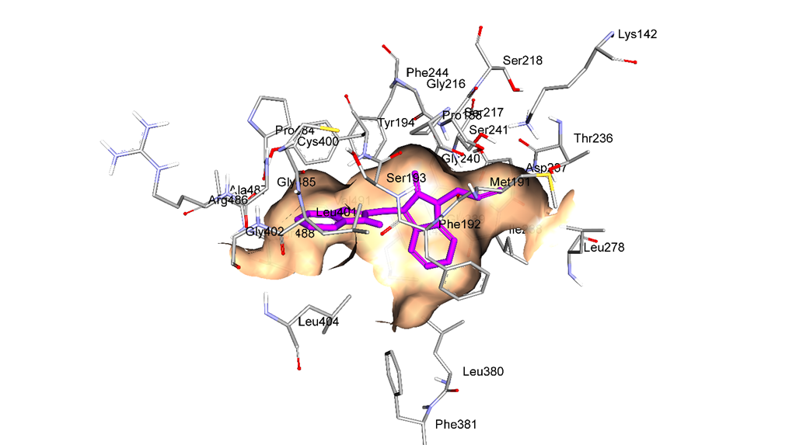
Fig. Docked conformations of most active compound 5e within active site of FAAH
Biography
Presenting author “Shivani Jaiswal”, is persuing her Phd from IIT (BHU), Varanasi, India since 2017-present. She has completed her master’s from IIT (BHU), Varanasi year of 2015. At present she has one first author research paper in Elsevier journal IF:3.743. She has presented 3 international and 2 national conference paper and won First prize for best poster in year of aug 2017 , WHC 17 held at Hyderabad.
Presenting author details
Full name: Shivani Jaiswal
Contact number: 91-8874874618
Twitter account:
Linked In account: linkedin.com/in/shivani-j-3a7867198
Session name/ number:
Category: (Oral presentation/ Poster presentation): Poster presentation

