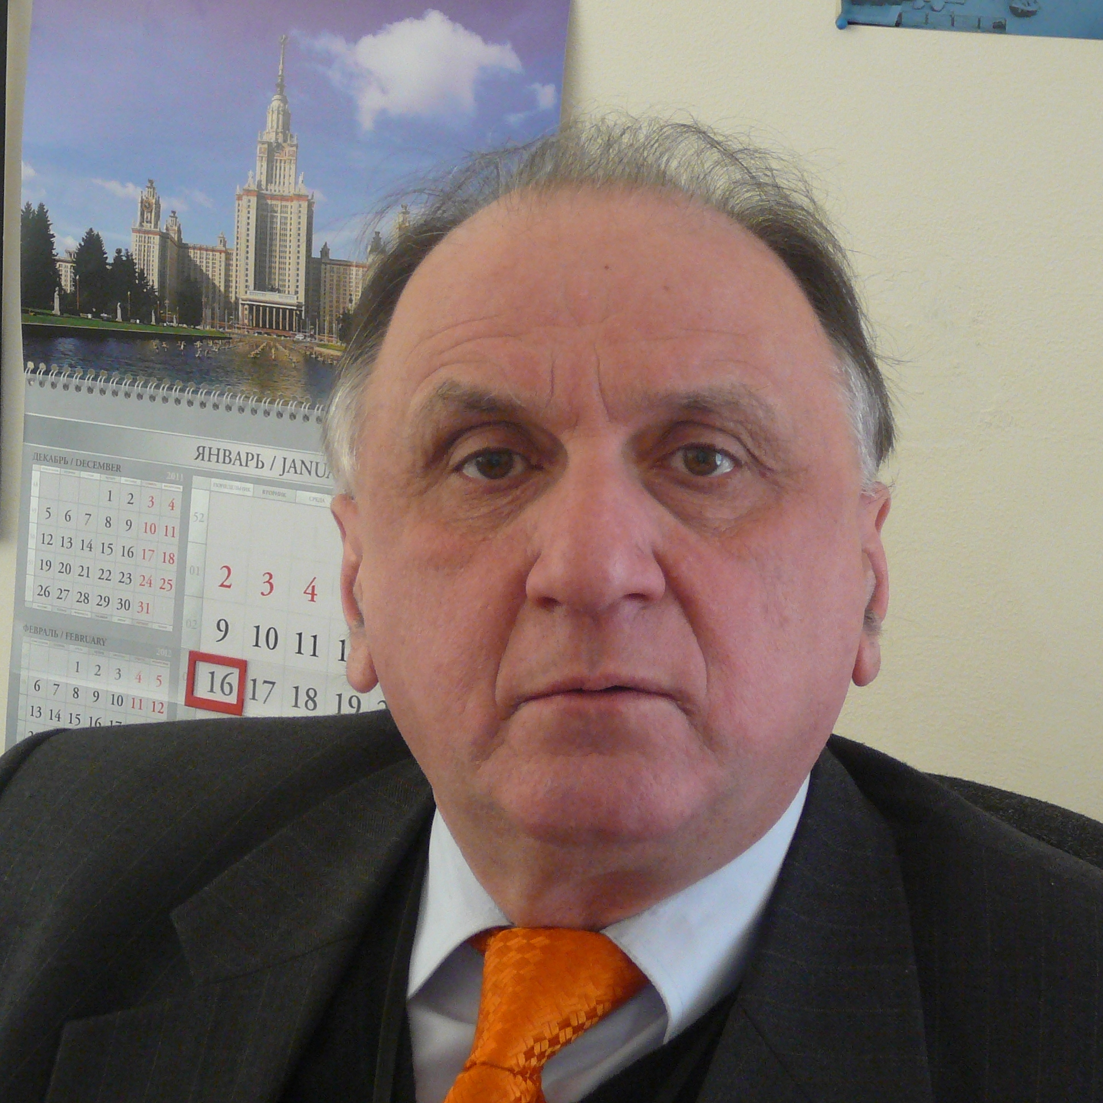
Title: Synthesis of heteroaryl-substituted pyrazolo[1,5-a]pyrimidines by recyclization of pyrimidinium salts
Name: Gevorg G. Danagulyan
Russian-Armenian University, Yerevan 0051, Armenia
Institute of Organic Chemistry, Scientific-Technological Center of Organic and Pharmaceutical Chemistry NAS RA, Yerevan 0014, Armenia

Compounds containing condensed pyrimidine systems and a bridged nitrogen atom are known to present interest as potential analgetics, antitumor drugs, bronchial spasmolytics and breathing stimulants. They form the composition of some drugs. We studied the reaction of
2-(ethoxycarbonyl)methyl-1,4,6-trimethylpyrimidinium iodide with hydrazides of C-pyridyl-,
C-pyrimidinyl-, N-azolyl- and C-pyrazolyl-substituted carboxylic acids. This reaction was shown to result in recyclization and formation of ethyl 2-(pyrimidinylalkyl)- and 2-(azolylalkyl)-5,7-dimethylpyrazolo[1,5-a]pyrimidine-3-carboxylates. It is a new rearrangement of
1,2-dialkylpyrimidinium salts proceeding through the pyrimidine ring recyclization with inclusion of the nucleophilic reagent fragment into the transformation product.
Heterocyclic acids hydrazides, in which a hydrazide fragment is immediately connected with a heterocyclic ring, also undergo a similar reaction. By the reactions of salt 1 with isonicotinic acid hydrazide (isoniazid) and pyrazol-3-carboxylic acid hydrazide we managed to obtain pyrazolo[1,5-a]pyrimidine derivatives that contained in position 2 pyridine and pyrazole rings.
Besides pyrazolopyrimidines, the separation of reaction mixture provided in some cases also another recyclization product, 2-hydroxy-5,7-dimethylpyrazolo[1,5-a]pyrimidine.

Biography
Prof. Danagulyan has completed his PhD at the age of 27 from M. Lomonosov Moscow State University, in 2000 defended ScD thesis in Yerevan. Elected Corresponding Member of the National Academy of Sciences of Armenia (2010). Research areas: Chemistry of nitrogen-containing heterocycles and of biologically active substances. He has published more than 200 papers in reputed journals and is a member of editorial boards of a number of journals.

Presenting author details
Full name: Danagulyan, Gevorg
Contact number: +37494 544 955
Session name/ number: Heterocyclic Chemistry/ 12
Category: Oral presentation

