Fused thieno[2,3-b]pyridines: Synthesis, characterization and biological activities of new condensed pyridothienopyrimidines
Etify A. Bakhite,* Ahmed A. O. Abeed and Ola E. A. Ahmed
Department of Chemistry, Faculty of Science, Assiut University, Assiut 71516, Egypt
E-mail: ebakhite@yahoo.com
Abstract. Reaction of 4-aryl-3-cyano-5-ethoxycarbonyl-6-methylpyridine-2(1H)-thiones 3a,b with chloroacetonitrile gave the corresponding 3-aminothieno[2,3-b]pyridine-2-carbonitriles 5a,b. Condensation of 5a,b with triethyl orthoformate produced the methanimidate derivatives 7a,b. Treatment of 7a,b with hydrazine hydrate at room temperature resulted in the formation of ethyl 3-amino-9-aryl-3,4-dihydro-4-imino-7-methylpyrido[3’,2’:4,5]thieno[3,2-d]pyrimidine-8-carboxylates 8a,b. 3-Amino-4-(4-methoxyphenyl)-5-ethoxycarbonyl-6-methylthieno[2,3-b]pyri-dine-2-carboxamide (6) was prepared and reacted with triethyl orthoformate to give pyrimidine-4(3H)-one derivative 15. Chlorination of 15 with phosphorus oxychloride gave 4-chloropyrimidine 16, which in turn was reacted with hydrazine hydrate to produce ethyl 4-hydrazino-9-(4-methoxyphenyl)-7-methylpyrido[3’,2’:4,5]thieno [3,2-d]pyrimidine-8-carboxylate (18). Compounds 8a,b and 18 were used as precursors for synthesizing other new pyridothienopyrimidines as well as triazolopyridothieno-pyrimidines, and pyridothienopyrimidotriazinoindoles. Structural formulas of all newly synthesized compounds were confirmed by elemental and spectral (IR, N MR and mass) analyses.
KEYWORDS: Thienopyridines; Thienopyrimidines; Pyridothienopyrimidines; Triazolopyridothienopyrimidines; Pyridothienopyrimidotriazinoindoles.
1. Introduction
Many thieno[2,3-b]pyridines have been synthesized and investigated in relation with their biological and pharmacological importance (Bakhite, 2003; Litvinov et al, 2005). Some of them proved to possess antiviral (Schnute et al, 2007; Attaby et al, 2007), antidiabetic (Bahekar et al, 2007), antimicrobial (Abdel-Rahman et al, 2003; Hussin et al, 2000), antitumor (Hayakawa et al, 2004), antiparasitic (Bernardino et al, 2006) and neurotropic activities (Krauze et al, 1999). Also, thienopyrimidine derivatives have been the subject of several chemical and biological studies on account of their wide spectrum of biological activity (Ibrahim et al, 1996; Litvinov, 2004). Furthermore, some pyrido[3',2':4,5]thieno[3,2-d]pyrimidines are reported to exhibit antimicrobial (Abdel-Rahman et al, 2003; Hussin et al, 2000), antiallergic (Quintela et al, 1998), antiprotozoal (Quintela et al, 2003) and antianaphylactic activities (Wagner et al, 1993; Boehm et al, 1992). In view of the above observations and as a continuation of our previous work on pyridothienoyrimidines (Al-Taifi et al, 2016; Bakhite et al 2014; Bakhite et al 2016), we describe herein the synthesis and characterization of the title compounds which are expected to be biologically active ones owing to incorporation of different pharmacophores.
2. Experimental
Starting materials were obtained from commercial suppliers and used without further purification. All melting points were determined on a Gallan-Kamp apparatus and are uncorrected. The IR spectra were recorded on a Shimadzu 470 IR-spectrophotometer (KBr; ν_{max} in cm⁻¹). The NMR spectra were taken on a Varian EM-390, 90 MHz spectrometer or on a Jeol LA 400 MHz FT-NMR spectrometer using TMS as internal standard. Chemical shifts are given in δ ppm and coupling constant (J) is given in Hz. Electron impact (EI) MS spectra were carried out on a JEOL JMS-600 spectrometer. Elemental analyses (C, H, N and S) were performed on an Elemental Analyses system GmbH VARIOEL V2.3 1998 CHNS Mode (Assiut University). The reactions were monitored by TLC.
2.1. Synthesis of 4-aryl-3-cyano-5-ethoxycarbonyl-6-methylpyridine-2(1H)-thiones (3a,b)
These compounds were prepared according to the reported method (Bakhite et al, 2005).
2.2. Synthesis of 4-aryl-3-cyano-2-cyanomethylthio-5-ethoxycarbonyl-6-methyl-pyridines 4a,b
To a suspension of compound 3a,b (10 mmol) and sodium acetate trihydrate (1.36 g, 10 mmol) in ethanol (40 mL), chloroacetonitrile (0.64 mL, 10 mmol) was added. The resulting mixture was stirred at room temperature for 3 h. The white precipitate that formed was collected and recrystallized from ethanol to give 4a,b in the form of white needles.
2.2.1. 3-Cyano-2-cyanomethylthio-5-ethoxycarbonyl-4-(4-methoxyphenyl)-6-methylpyridine (4a)
It was obtained by using compound 3a in the above general procedure; yield: 92 %; m.p.: 121-122 °C (Lit. m.p.: 138-140 °C) (Gad-Elkareem and Abdel-Fattah, 2006). IR (KBr, cm⁻¹): 2250 (C≡N, non conjugated), 2220 (C≡N, conjugated), 1731 (C=O). ¹H NMR (400 MHz, CDCl₃): δ 7.3014-7.3243 (dd, J = 2.3 Hz, 2H, Ar-H), 6.9795-7.0024 (dd, J = 2.3 Hz, 2H, Ar-H), 4.0585-4.1123 (q, J =7.0 Hz, 2H, OCH₂), 4.0711 (s, 2H, SCH₂), 3.8563 (s, 3H, OCH₃), 2.6770 (s, 3H, CH₃), 0.9886-1.0241 (t, J =7.0 Hz, 3H, CH₃). ¹³C NMR (100 MHz, CDCl₃): δ 166.60, 161.08, 159.26, 158.89, 152.60, 129.74, 126.78, 126.26, 115.89, 114.34, 114.16, 105.11, 61.96, 55.41, 23.43, 15.96, 13.70. MS: m/z = 367 (M⁺, 100 %), 352 (M⁺-CH₃, 12 %), 337 (M⁺-2CH₃, 25 %), 322 (M⁺- OC₂H₅, 14 %). Anal. Calcd. for C₁₉H₁₇N₃O₃S (367.1)): C, 62.11; H, 4.66; N, 11.44; S, 8.73 %. Found: C, 62.43; H, 4.49; N, 11.90; S, 8.92 %.
2.2.1 (4-Chlorophenyl)-3-cyano-2-cyanomethylthio-5-ethoxycarbonyl-6-methyl-pyridine (4b)
It was obtained by using compound 3b in the above general procedure; yield: 90 %; m.p.: 97-99 °C. IR (KBr, cm⁻¹): 2248 (C≡N, non conjugated), 2217 (C≡N, conjugated), 1735 (C=O). ¹H NMR (400 MHz, CDCl₃): δ 7.4629-7.4904 (dd, J = 2.3 Hz, 2H, Ar-H), 7.2933-7.3208 (dd, J = 2.3 Hz, 2H, Ar-H), 4.0516-4.1054 (m, 4H, SCH₂ and OCH₂), 2.7022 (s, 3H, CH₃), 0.9817-1.0183 (t, 3H, CH₃). ¹³C NMR (100 MHz, CDCl₃): δ 166.05, 159.77, 159.17, 151.60, 136.55, 132.54, 129.55, 129.19, 126.45, 115.74, 113.65, 104.97, 62.12, 23.55, 16.00, 13.61. MS: m/z = 371 (M⁺, 100 %), 373 (M⁺+2, 42 %), 343 (24 %), 336 (10 %), 326 (M⁺- OC₂H₅, 15 %). Anal. Calcd. for C₁₈H₁₄ClN₃O₂S (371.1): C, 58.14; H, 3.79; N, 11.30; S, 8.62 %. Found: C, 58.46; H, 3.72; N, 11.65; S, 8.27 %.
2.3. Synthesis of 3-amino-4-aryl-5-ethoxycarbonyl-6-methylthieno[2,3-b]pyridine-2-carbonitriles 5a,b
2.3.1. Method (A)
To a mixture of compound 3a,b (10 mmol) and sodium acetate trihydrate (1.50 g, 11 mmol) in ethanol (40 mL), chloroacetonitrile (0.64 mL, 10 mmol) was added. The resulting mixture was heated under reflux for 3 h. The precipitate that formed on cooling was collected and recrystallised from ethanol to give compounds 5a,b in the form of yellow needles.
2.3.1.1. 3-Amino-5-ethoxycarbonyl-4-(4-methoxyphenyl)-6-methylthieno[2,3-b] pyridine-2-carbonitrile (5a)
It was prepared by using compound 3a in the above general procedure; yield: 90 %; m.p.: 184-185 °C (Lit. m.p. 198-200) (Gad-Elkareem and Abdel-Fattah, 2006). IR (KBr, cm⁻¹): 3476, 3342 (NH₂); 2976 (C-H, aliphatic); 2199 (C≡N); 1729 (C=O). ¹H NMR (400 MHz, CDCl₃): δ 7.273-7.303 (dd, J = 2.4 Hz, 2H, Ar-H), 7.008-7.038 (dd, J = 2.4 Hz, 2H, Ar-H), 4.323 (s, 2H, NH₂), 4.016-4.069 (q, J = 7.0 Hz, 2H, OCH₂), 3.884 (s, 3H, OCH₃), 2.679 (s, 3H, CH₃), 0.995-1.031 (t, J = 7.2 Hz, 3H, CH₃ of ester). ¹³C NMR and Dept 135 (100 MHz, CDCl₃): δ 167.51, 161.37, 160.60, 156.35, 149.33, 143.82, 130.01 (CH), 127.63, 125.40, 118.57, 114.79, 114.17 (CH), 61.63 (OCH₂), 55.46 (OCH₃), 23.17(CH₃ at C-6), 13.81(CH₃ of ester group). MS: m/z = 367 (M⁺, 100 %), 339 (M⁺-CO, 10 %), 322 (M⁺-OEt, 15 %), 321 (M⁺- EtOH, 15 %). Anal. Calcd. for C₁₉H₁₇N₃O₃S (367.1): C, 62.11; H, 4.66; N, 11.44; S, 8.73 %. Found: C, 62.00; H, 4.70; N, 11.83; S, 9.02 %.
2.3.1.2. 3-Amino-4-(4-chlorophenyl)-5-ethoxycarbonyl-6-methylthieno[2,3-b] pyridine-2-carbonitrile (5b)
It was prepared by using compound 3b in the above general procedure; yield 93 %; m.p.: 175-176 °C (Lit. m.p. 172-174 °C) (Gad-Elkareem and El-Adasy, 2010). IR (KBr, cm⁻¹): 3484, 3343, 3228 (NH₂), 2977 (C-H aliphatic), 2200 (C≡N), 1727 (C=O). ¹H NMR (400 MHz, CDCl₃): δ 7.496-7.524 (dd, J = 2.4 Hz, 2H, Ar-H), 7.315-7.343 ((dd, J = 2.4 Hz, 2H, Ar-H), 4.234 (s, 2H, NH₂), 4.037-4.091 (q, J = 7.4 Hz, 2H, OCH₂), 2.69 (s, 3H, CH₃), 1.000-1.036 (t, J = 7.2 Hz, 3H, CH₃). ¹³C NMR and Dept 135 (100 MHz, CDCl₃): δ 167.11, 161.44, 156.59, 148.79, 142.54, 136.19, 132.07, 130.12 (CH), 129.05 (CH), 127.13, 118.02, 114.52, 61.81 (OCH₂), 23.26 (CH₃ at C-6), 13.74 (CH₃ of ester group). MS: m/z = 371 (M⁺, 100 %), 373 (M⁺+2, 39 %), 343 (M⁺- CO, 21 %) and 326 (M⁺- OEt, 12 %). Anal. Calcd. for C₁₈H₁₄ClN₃O₂S (371.1): C, 58.14; H, 3.79; N, 11.30; S, 8.62 %. Found: C, 58.23; H, 3.70; N, 11.48; S, 8.72 %.
2.3.2. Method (B)
A suspension of compound 4a,b (10 mmol) and sodium acetate trihydrate (0.14 g, 1 mmol) in ethanol (30 mL) was heated at reflux for 3 h. The crystalline product that formed on cooling was collected and recrystallised from ethanol in the form of yellow needles of 5a,b. These products are identical with those reported in method (A) in all aspects (yield: 83-88 %).
2.3.1.1. 3-Amino-5-ethoxycarbonyl-4-(4-methoxyphenyl)-6-methylthieno[2,3-b] pyridine-2-carboxamide (6)
This compound was prepared according to the reported method (Bakhite et al, 2005).
Synthesis of Novel Pyrido[3',2':4,5]thieno[3,2-d]pyrimidines,
Pyrido [3'',2'':4',5']thieno[3',2':4,5]pyrimido[1,6-a]benzimidazoles
and Related Fused Systems
E. A. Bakhite*
Chemistry Department, Faculty of Science, Assiut University, Assiut 71516, Egypt
A. G. Al-Sehemi
Department of Chemistry, Teachers College at Abha, B.O.Box. 249, Saudi Arabia
Y. Yamada*
Synthesis of Novel Pyrido[3',2':4,5]thieno[3,2-d]pyrimidines,
Pyrido [3'',2'':4',5']thieno[3',2':4,5]pyrimido[1,6-a]benzimidazoles
and Related Fused Systems
E. A. Bakhite*
Chemistry Department, Faculty of Science, Assiut University, Assiut 71516, Egypt
A. G. Al-Sehemi
Department of Chemistry, Teachers College at Abha, B.O.Box. 249, Saudi Arabia
Y. Yamada*
2.4. Synthesis of ethyl N-{4-aryl-2-cyano-5-ethoxycarbonyl-6-methylthieno[2,3-b] pyridin-3-yl}methanimidates 7a,b
A mixture of compound 5a,b (10 mmol), triethyl orthoformate (5 mL) in acetic anhydride (15 mL) was heated under reflux for 2 h and then allowed to cool. The solid that formed was collected and recrystallized from ethanol as white needles of 7a,b.
2.4.1. Ethyl N-{2-cyano-5-ethoxycarbonyl-4-(p-methoxyphenyl)-6-methylthieno [2,3-b]pyridin-3-yl}methanimidate (7a)
It was prepared by using compound 5a in the above general procedure; yield: 90 %; m.p.: 154-155 °C (Lit. m.p.: 160-162 °C) (Gad-Elkareem and Abdel-Fattah, 2006). IR (KBr, cm⁻¹): 2974, 2836 (C-H aliphatic), 2212 (C≡N), 1731 (C=O), 1632 (C=N). ¹H NMR (400 MHz, CDCl₃): δ 7.540 (s, 1H, N=CH), 7.107-7.128 (d, J = 8.4 Hz, 2H, Ar-H), 6.898-6.920 (d, J = 8.8 Hz, 2H, Ar-H), 4.032-4.086 (q, J = 7.2 Hz, 2H, OCH₂ of ester group), 3.843 (s, 3H, OCH₃), 3.607-3.659 (q, J = 6.8 Hz, 2H, OCH₂ of ethoxyl group), 2.694 (s, 3H, CH₃ at C-6), 1.126-1.162 (t, J = 7.2 Hz, 3H, CH₃ of ethoxyl group), 0.982-1.017 (t, J = 7.0 Hz, 3H, CH₃ of ester group). ¹³C NMR and Dept 135 (100 MHz, CDCl₃): δ 167.73, 160.78, 159.91, 156.59 (N=CH), 156.31, 151.25, 145.09, 130.56 (CH), 128.58, 126.82, 122.52, 114.17, 114.01, 112.96 (CH), 91.93, 62.98 (OCH₂), 61.62 (OCH₂), 55.35 (OCH₃), 23.16 (CH₃ at C-6), 13.77 (CH₃ of ester group), 13.68 (CH₃ of ethoxyl group). MS: m/z = 423 (M⁺, 100 %), 378 (M⁺- OEt, 13 %), 367 (46 %) and 132 (13 %). Anal. Calcd. for C₂₂H₂₁N₃O₄S (423.1): C, 62.40; H, 5.00; N, 9.92; S, 7.57 %. Found: C, 62.17; H, 4.79; N, 9.57; S, 7.82 %.
2.4.2. Ethyl N-{4-(4'-chlorophenyl)-2-cyano-5-ethoxycarbonyl-6-methylthieno[2,3-b]pyridin-3-yl}methanimidate (7b)
It was prepared by using compound 5b in the above general procedure; yield: 92 %; m.p.: 146-147 °C. IR (KBr, cm⁻¹): 2981 (C-H aliphatic), 2213 (C≡N), 1727 (C=O), 1634 (C=N). ¹H NMR (400 MHz, CDCl₃): δ 7.595 (s, 1H, N=CH), 7.370-7.396 (dd, J = 2.0 Hz, 2H, Ar-H), 7.141-7.168 (dd, J=2.0 Hz, 2H, Ar-H), 4.038-4.091(q, J = 8.0 Hz, 2H, OCH₂ of ester), 3.568-3.621 (q, J = 7.0 Hz, 2H, OCH₂ of ethoxyl group), 2.703 (s,3H, CH₃), 1.170 -1.205 (t, J = 7.0 Hz, 3H, CH₃ of ethoxyl group), 0.987-1.023 (t, J=7.2 Hz, 3H, CH₃ of ester group). ¹³C NMR and Dept 135 (100 MHz, CDCl₃): δ 167.29, 160.78, 156.89, 156.57(N=CH), 150.86, 143.82, 134.71, 133.22, 130.68 (CH), 128.04, 127.71(CH), 122.17, 113.86, 92.19, 63.20 (OCH₂), 61.78 (OCH₂), 23.24 (CH₃ at C-6), 13.78 (CH₃ of ester group), 13.72 (CH₃ of ethoxyl group). MS: m/z = 427 (M⁺, 100 %), 429 (M⁺+2, 41 %), 382 (M⁺- OEt, 14 %), 371 (60 %), 343 (21 %). Anal. Calcd. for C₂₁H₁₈ClN₃O₃S (427.1): C, 58.95; H, 4.24; N, 9.82; S, 7.49 %. Found: C, 58.82; H, 4.31; N, 9.67; S, 7.72 %.
2.5. Synthesis of ethyl 3-amino-9-aryl-3,4-dihydro-4-imino-7-methylpyrido[3',2': 4,5]thieno[3,2-d]pyrimidine-8-carboxylates 8a,b
To a suspension of compound 7a,b (5 mmol) in dioxane (20 mL), hydrazine hydrate 99 % (2 mL) was added. The reaction mixture was stirred at room temperature for 4 h. The solid that formed was collected and recrystallized from ethanol to give white needles of 8a,b.
2.5.1. Ethyl 3-amino-3,4-dihydro-4-imino-9-(4-methoxyphenyl)-7-methylpyrido [3',2':4,5]thieno[3,2-d]pyrimidine-8-carboxylate (8a)
It was prepared by using compound 7a in the above general procedure; yield: 78 %; m.p.: 204-206 °C. IR (KBr, cm⁻¹): 3306, 3157 (NH, NH₂), 2979 (C-H aliphatic), 1707 (C=O), 1609 (C=N). ¹H NMR (400 MHz, CDCl₃): δ 7.892 (s, 1H, CH pyrimidine), 7.276-7.298 (d, J = 8.8 Hz, 2H, Ar-H), 6.936-6.958 (d, J = 8.8 Hz, 2H, Ar-H), 4.777 (s, 2H, NH₂), 4.054-4.089 (q, J = 7.0 Hz, 2H, OCH₂), 3.877 (s, 3H, OCH₃), 2.716 (s, 3H, CH₃), 1.006 -1.041 (t, J = 7.0 Hz, 3H, CH₃ of ester). ¹³C NMR and Dept 135 (100 MHz, CDCl₃): δ 168.30, 161.91, 159.88, 155.46, 154.47, 148.28 (CH pyrimidine), 145.94, 145.90, 130.71 (CH), 128.69, 126.92, 124.09, 121.46, 112.95 ( CH), 61.58 (OCH₂), 55.26 (OCH₃), 23.14 (CH₃ at C-6), 13.80 (CH₃ of ester group). MS: m/z = 409 (M⁺, 100 %), 393 (M⁺- NH₂, 19 %); 367 (17 %) and 365 (10 %). Anal. Calcd. for C₂₀H₁₉N₅O₃S (409.1): C, 58.67; H, 4.68; N, 17.10; S, 7.83 %. Found: C, 58.44; H, 4.70; N, 17.36; S, 7.61 %.
2.5.2. Ethyl 3-amino-9-(4-chlorophenyl)-3,4-dihydro-4-imino-7-methylpyrido[3',2': 4,5]thieno[3,2-d]pyrimidine-8-carboxylate (8b)
It was prepared by using compound 7b in the above general procedure; yield: 85 %; m.p.: 208-209 °C. IR (KBr, cm⁻¹): 3309, 3161 (NH, NH₂), 2986 (C-H aliphatic), 1708 (C=O), 1613 (C=N). ¹H NMR (400 MHz, CDCl₃): ¹H NMR spectrum of compound VIIb (400 MHz, CDCl₃): δ 7.873 (s, 1H, CH pyrimidine), 7.384-7.406 (dd, J = 2.4 Hz, 2H, Ar-H), 7.270-7.298 (dd, J = 2.4 Hz, 2H, Ar-H), 4.785 (s, 2H, NH₂), 4.052-4.105 (q, J = 7.0 Hz, 2H, OCH₂), 2.727 (s, 3H, CH₃), 1.002 -1.039 (t, J = 7.2 Hz, 3H, CH₃ of ester). ¹³C NMR and Dept 135 (100 MHz, CDCl₃): δ 167.82, 161.93, 155.71, 154.32, 148.39 (CH pyrimidine), 145.68, 144.64, 134.68, 133.10, 130.71 (CH), 128.07, 127.75 (CH), 123.70, 121.69, 61.73 (OCH₂), 23.20 (CH₃ at C-6), 13.72 (CH₃ of ester group). MS: m/z = 413 (M⁺, 100 %), 415 (M⁺+2, 41 %), 397 (M⁺- NH₂, 13 %), 371 (16 %). Anal. Calcd. for C₁₉H₁₆ClN₅O₂S (413.1): C, 55.14; H, 3.90; N, 16.92; S, 7.75 %. Found: C, 55.09; H, 4.11; N, 16.78; S, 8.00 %.
2.6. Synthesis of Ethyl 7-aryl-9-methyl[1,2,4]triazolo[2’’,3’’-c]pyrido[3',2': 4,5]thieno[2,3-e]pyrimidine-8-carboxylates (9a,b); General procedures
2.6.1. Method A)
Compound 8a,b (2 mmol) in triethyl orthoformate (10 mL) was heated at reflux for 3 h. The precipitate that formed while hot was collected and recrystallized from ethanol as white fine needles of compounds 9a,b.
2.6.1.1. Ethyl 7-(p-methoxyphenyl)-9-methyl[1,2,4]triazolo[2’’,3’’-c]pyrido[3',2': 4,5]thieno[2,3-e]pyrimidine-8-carboxylate (9a)
It was prepared by using compound 8a in the above general procedure; m.p.: 205-206 °C; yield: 76 %. IR (KBr, cm⁻¹): 1726 (C=O). ¹H NMR (400 MHz, CDCl₃): δ 9.112 (s, 1H, CH pyrimidine), 8.466 (s, 1H, CH triazole), 7.345-7.366 (d, 2H, Ar-H), 6.996-7.021 (dd, 2H, Ar-H), 4.105-4.148 (q, 2H, OCH₂), 3.914 (s, 3H, OCH₃), 2.774 (s, 3H, CH₃), 1.036-1.054 (t, 3H, CH₃ of ester). MS: m/z = 419 (M⁺, 100 %), 387 (20 %); 347 (11 %). Anal. Calcd. for C₂₁H₁₇N₅O₃S (419.1): C, 60.13; H, 4.09; N, 16.70; S, 7.64 %. Found: C, 60.08; H, 4.11; N, 16.56; S, 7.39 %.
2.6.1.2. Ethyl 7-(p-chlorophenyl)-9-methyl[1,2,4]triazolo[2’’,3’’-c]pyrido[3',2': 4,5]thieno[2,3-e]pyrimidine-8-carboxylate (9b)
It was prepared by using compound 8b in the above general procedure; m.p.: 244-245 °C; yield: 80 %. IR (KBr, cm⁻¹): 2979 (C-H, aliphatic), 1727 (C=O), 1623 cm⁻¹ (C=N) ¹H NMR (400 MHz, CDCl₃): δ 8.981 (s, 1H, CH pyrimidine), 8.475 (s, 1H, CH triazole), 7.450-7.472 (d, 2H, Ar-H), 7.340-7.361 (d, 2H, Ar-H), 4.087-4.141 (q, 2H, OCH₂), 2.787 (s, 3H, CH₃), 1.030-1.065 (t, 3H, CH₃ of ester). MS: m/z = 423 (M⁺, 100 %), 425 (M⁺+2, 40 %). Anal. Calcd. for C₂₀H₁₄ClN₅O₂S (423.1): C, 56.67; H, 3.33; N, 16.52; S, 7.56 %. Found: C, 56.80; H, 3.31; N, 16.77; S, 7.34 %.

2.6.2. Method B)
Compound 18 (1.64 g; 4 mmol) in formic acid 85 % (20 ml) was heated at reflux for 6 h. The precipitate that formed on cooling was collected by filtration and recrystallized from ethanol in the form of white needles of compound 9a (yield: 67 %). This product is identical to that reported above in all aspects.
2.7. Synthesis of ethyl 7-aryl-2,9-dimethyl-[1,2,4]triazolo[2’’,3’’-c]pyrido[3',2': 4,5]thieno[2,3-e]pyrimidine-8-carboxylates 10a,b
Compound 8a,b (2 mmol) in acetic anhydride (10 mL) was heated under reflux for 2 h. The crystalline precipitate that formed while hot was collected by filtration and recrystallized from ethanol as white needles of 10a,b.
2.7.1. Ethyl 2,9-dimethyl-7-(4-methoxyphenyl)-[1,2,4]triazolo[2’’,3’’-c]pyrido[3',2': 4,5]thieno[2,3-e]pyrimidine-8-carboxylate (10a)
It was prepared by using compound 8a in the above general procedure; yield: 88 %; m.p.: 220-221°C. IR (KBr, cm⁻¹): 2964 (C-H aliphatic), 1736 (C=O), 1612 (C=N). ¹H NMR (400 MHz, CDCl₃): δ 7.993 (s, 1H, CH pyrimidine), 7.347-7.364 (dd, J = 1.8 Hz, 2H, Ar-H), 6.996-7.017 (dd, J = 1.8 Hz, 2H, Ar-H), 4.087-4.141 (q, J = 7.0 Hz, 2H, OCH₂), 3.913 (s, 3H, OCH₃), 2.773 (s, 3H, CH₃), 2.679 (s, 3H, CH₃ attached to triazole ring), 1.031-1.066 (t, J = 7.0 Hz, 3H, CH₃ of ester). ¹³C NMR and Dept 135 (100 MHz, CDCl₃): δ 168.16, 165.92, 162.19, 160.05, 156.07, 148.82, 145.57, 144.53, 136.64 (CH pyrimidine), 130.58 (CH), 128.93, 126.99, 122.92, 119.27, 113.24 (CH), 61.67 (OCH₂), 55.32 (OCH₃), 23.22 (CH₃ attached to pyridine ring), 14.56 (CH₃ attached to triazole ring), 13.82 (CH₃ of ester group). MS: m/z = 433 (M⁺, 100 %), 404 (M⁺- Et, 25 %); 388 (M⁺- EtO, 30 %) and 360 (M⁺- CO₂Et, 35 %). Anal. Calcd. for C₂₂H₁₉N₅O₃S (433.1): C, 60.96; H, 4.42; N, 16.16; S, 7.40 %. Found: C, 61.13; H, 4.41; N, 16.00; S, 7.18 %.
2.7.2. Ethyl 7-(4-chlorophenyl)-2,9-dimethyl[1,2,4]triazolo[2’’,3’’-c]pyrido[3',2': 4,5]thieno[2,3-e]pyrimidine-8-carboxylate (10b)
It was prepared by using compound 8b in the above general procedure; yield: 85 %; m.p.: 245-247 °C. IR (KBr, cm⁻¹): 2979 (C-H aliphatic), 1727 (C=O), 1623 (C=N). ¹H NMR (400 MHz, CDCl₃): δ 8.980 (s, 1H, CH pyrimidine), 7.455-7.471 (dd, J = 2.0 Hz, 2H, Ar-H), 7.340-7.361 (dd, J = 2.0 Hz, 2H, Ar-H), 4.087-4.141(q, J = 7.2 Hz, 2H, OCH₂), 2.787 (s, 3H, CH₃), 2.682 (s, 3H, CH₃ attached to triazole ring), 1.030 -1.065 (t, J = 7.0 Hz, 3H, CH₃ of ester) ¹³C NMR and Dept 135 (100 MHz, CDCl₃): δ 167.69, 166.02, 162.20, 156.30, 148.75, 144.28, 144.16, 136.76 (CH pyrimidine), 134.89, 133.20, 130.58 (CH), 128.45, 128.07(CH), 122.56, 119.52, 61.84 (OCH₂), 23.29 (CH₃ attached to pyridine ring), 14.57(CH₃ attached to triazole ring), 13.73 (CH₃ of ester group). MS: m/z = 437 (M⁺, 100 %), 439 (M⁺+2, 41), 408 (M⁺-Et, 25 %), 392 (M⁺-OC₂H₅, 41), 365 (M⁺- CO₂Et, 22 %) and 356 (13%). Anal. Calcd. for C₂₁H₁₆ClN₅O₂S (437.1): C, 57.60; H, 3.68; N, 15.99; S, 7.32 %. Found: C, 57.23; H, 3.70; N, 15.70; S, 7.54 %.
2.8. Synthesis of ethyl 2-anilino-7-aryl-9-methyl-[1,2,4]triazolo[2'',3''-c]pyrido [3',2':4,5]thieno[2,3-e]pyrimidine-8-carboxylates 11a,b
To a solution of compound 8a,b (5 mmol) in pyridine (10 mL, phenyl iso-thiocyanate (0.65 mL; 5 mmol) was added. The reaction mixture was heated on a steam bath for 8 h and then allowed to stand at room temperature overnight. The precipitate that formed was collected and recrystallized from DMF-H₂O mixture as pale yellow crystals of 11a,b.
2.8.1. Ethyl 2-anilino-7-(4-methoxyphenyl)-9-methyl-[1,2,4]triazolo[2'',3''-c]pyrido [3',2':4,5]thieno[2,3-e]pyrimidine-8-carboxylate (11a)
It was prepared by using compound 8a in the above general procedure; yield 73 %; m.p.: 285-286 °C. IR (KBr, cm⁻¹): 3500 (NH), 2976 (C-H aliphatic), 1720 (C=O). ¹H NMR (400 MHz, CDCl₃): δ 6.92-7.83 (m, 11H, CH pyrimidine, NH and Ar-H), 4.02 (q, 2H, OCH₂), 3.77 (s, 3H, OCH₃), 2.68 (s, 3H, CH₃), 0.97 (t, 3H, CH₃ of ester). MS: m/z = 510 (M⁺, 3 %), 393 (M⁺-PhNCN, 100 %), 365 (42 %), 349 (13 %), 321 (18 %). Anal. Calcd. for C₂₇H₂₂N₆O₃S (510.1): C, 63.52; H, 4.34; N, 16.46; S, 6.28 %. Found: C, 63.34; H, 4.11; N, 16.43; S, 6.30 %.
2.8.2. Ethyl 2-anilino-7-(4-chlorophenyl)-9-methyl-[1,2,4]triazolo[2'',3''-c]pyrido [3',2':4,5]thieno[2,3-e]pyrimidine-8-carboxylate (11b)
It was prepared by using compound 8b in the above general procedure; yield: 78 %; m.p.: 300-302 °C. IR (KBr, cm⁻¹): 3500 (NH), 1725 (C=O), 1644 (C=N). ¹H NMR (90 MHz, CF₃CO₂D): δ 8.1 (s, 1H, CH pyrimidine), 7.1-7.7 (m, 9H, Ar-H), 4.0-4.4 (q, 2H, OCH₂), 2.8 (s, 3H, CH₃), 1.0-1.3 (t, 3H, CH₃ of ester). MS: m/z = 514 (M⁺, 10 %), 397 (M⁺-PhNCN, 100 %), 369 (58 %), 353 (20 %), 325 (27 %). Anal. Calcd. for C₂₆H₁₉ClN₆O₂S (514.1): C, 60.64; H, 3.72; N, 16.32; S, 6.23 %. Found: C, 60.59; H, 3.83; N, 16.16; S, 6.11 %.
2.9. Condensation of Compounds 8a,b with Isatin; Formation of Fused Hexacyclic Compounds 12a,b
A mixture of compound 8a,b (2 mmol) and isatin (0.30 g, 2 mmol) in ethanol (20 mL) was heated under reflux for 3 h. The precipitate that formed while hot collected and recrystallized from dioxane as red crystals of 12a,b.
2.9.1. 3-Ethoxycarbonyl-4-(4-methoxyphenyl)-2-methylpyrido[3''',2''':4'',5'']thieno [3'',2'':4',5']pyrimido[1',6':2,3][1,2,4]triazino[5,6-b]indole (12a)
It was prepared by using compound 8a in the above general procedure; yield: 82 %; m.p.: 334-335 °C. IR (KBr, cm⁻¹): 2947 (CH aliphatic), 1727 (C=O), 1634 (C=N). δ ¹³C NMR and Dept 135 (100 MHz, CDCl₃): MS: m/z = 520 (M⁺, 100 %), 519 (M⁺-H, 29 %), 491(M⁺-Et, 26 %). Anal. Calcd. for C₂₈H₂₀N₆O₃S (520.1): C, 64.60; H, 3.87; N, 16.14; S, 6.16 %. Found: C, 64.51; H, 3.91; N, 16.00; S, 6.18 %.
2.9.2. 4-(4-Chlorophenyl)-3-ethoxycarbonyl-2-methylpyrido[3''',2''':4'',5'']thieno [3'',2'':4',5']pyrimido[1',6':2,3][1,2,4]triazino[5,6-b]indole (12b)
It was prepared by using compound 8b in the above general procedure; yield: 81%; m.p.: 342-343 °C. IR (KBr, cm⁻¹): 1727 (C=O), 1631 (C=N). ¹H NMR (90 MHz, CF₃CO₂D): δ 9.7 (s, 1H, CH pyrimidine), 7.4-8.7 (m, 8H, Ar-H), 4.2-4.6 (q, 2H, OCH₂), 3.2 (s, 3H, CH₃), 1.0-1.3 (t, 3H, CH₃ of ester). MS: m/z = 524 (M⁺, 100 %), 526 (M⁺+2, 40 %), 495 (M⁺-Et, 28 %), 451 (M⁺-CO₂Et, 14 %). Anal. Calcd. for C₂₇H₁₇ClN₆O₂S (524.1): C, 61.77; H, 3.26; N, 16.01; S, 6.11 %. Found: C, 61.40; H, 3.23; N, 15.89; S, 6.07 %.
2.10. Synthesis of ethyl 8-(4-methoxyphenyl)-10-methyl-3-phenyl-2H-pyrido[3'',2'': 4',5']thieno[3',2':4,5]pyrimido[1,6-b][1,2,4]triazine-9-carboxylate (13)
To a mixture of compound 8a (0.82 g, 2 mmol) and phenacyl bromide (0.40 g; 2 mmol) in ethanol (20 mL), anhydrous sodium acetate (0.33 g; 4 mmol) was added. The reaction mixture was heated under reflux for 3 h. The precipitate that formed while hot was filtered, washed with water and recrystallized from ethanol to give pale yellow needles of 13; yield: 81 %; m.p.: 237-238 °C. IR (KBr, cm⁻¹): 2836 (C-H, aliphatic), 1716 (C=O), 1671 (C=N). ¹H NMR (400 MHz, CDCl₃): 7.80 (s, 1H, CH pyrimidine), 6.88-7.73 (m, 9H, Ar-H), 4.76 (s, 2H, CH₂ of triazine ring), 4.01-4.02 (q, 2H, OCH₂), 3.81 (s, 3H, OCH₃), 2.64 (s, 3H, CH₃), 0.97 (s, 3H, CH₃). MS: m/z = 509 (M⁺, 100 %), 405 (M⁺-PhCN, 23 %), 377 (17 %). Anal. Calcd. for C₂₈H₂₃N₅O₃S (509.1): C, 66.00; H, 4.55; N, 13.74; S, 6.29 %. Found: C, 65.87; H, 4.41; N, 13.80; S, 6.40 %.
2.11. Ethyl 9-(4-methoxyphenyl)-7-methyl-4-oxo-3,4-dihydropyrido[3’,2’:4,5] thieno[3,2-d]pyrimidine-8-carboxylate (15)
A mixture of compound 6 (1.92 g, 5 mmol) and triethyl orthoformate (5 mL) in acetic anhydride (15 mL) was heated under reflux for 4 h. The precipitate that formed while hot was collected by filtration, washed with ethanol and crystallized from DMF to give compound 15 in the form of white needles; yield: 80 %; m.p.: 298-299 °C. IR (KBr, cm⁻¹): 3220 (NH), 1731 (C=O, ester), 1659 (C=O, pyrimidinone). ¹H NMR (400 MHz, DMSO-d₆): 12.75 (s, 1H, NH), 8.03 (s,1H, CH pyrimidinone), 7.26-7.28 (s, J = 8.0 Hz, 2H, Ar-H), 6.98-7.00 (d, J = 8.0 Hz, 2H, Ar-H), 4.06-4.08 (q, 2H, OCH₂), 3.83 (s, 3H, OCH₃), 2.64 (s, 3H, CH₃ at C-7), 0.95-0.97 (t, 3H, CH₃ of ester). MS: m/z = 395 (M⁺, 100 %), 366 (M⁺- Et, 28 %), 350 (M⁺-OC₂H₅, 36 %), 322 (M⁺- CO₂Et, 22 %). Anal. Calcd. for C₂₀H₁₇N₃O₄S (395.1): C, 60.75; H, 4.33; N, 10.63; S, 8.11 %. Found: C, 60.66; H, 4.41; N, 10.86; S, 7.85 %.
2.12. Synthesis of ethyl 4-chloro-9-(4-methoxyphenyl)-7-methylpyrido[3’,2’: 4,5]thieno[3,2-d]pyrimidine-8-carboxylate (16)
A suspension of compound 15 (1.97 g, 5 mmol) in an excess amount of phosphours oxychloride (25 mL) was heated under reflux on a steam bath for 3 h. The reaction mixture was cooled and then poured with vigorous stirring into ice-cooled water (150 mL). The solid that separated was filtered and crystallized from ethanol as pale yellow crystals of compound 16; yield: 79 %; m.p.: 166-167 °C. IR (KBr, cm⁻¹): 2936 (C-H aliphatic), 1732 (C=O), 1608 (C=N). ¹H NMR (400 MHz, CDCl₃): δ 8.811 (s, 1H, CH pyrimidine), 7.319-7.347 (dd, J = 2.4 Hz, 2H, Ar-H), 6.992-7.014 (dd, J = 2.4 Hz, 2H, Ar-H), 4.089-4.142 (q, J = 7.0 Hz, 2H, OCH₂), 3.905 (s, 3H, OCH₃), 2.776 (s, 3H, CH₃), 1.026-1.062 (t, J = 7.2 Hz, 3H, CH₃ of ester). Anal. Calcd. for C₂₀H₁₆ClN₃O₃S (413.1): C, 58.04; H, 3.90; N, 10.15; S, 7.75; Cl, 8.57 %. Found: C, 57.87; H, 4.11; N, 10.14; S, 8.13; Cl, 8.40 %.
2.13. Synthesis of ethyl 9-(4-chlorophenyl)-8-ethoxycarbonyl-7-methyl-4-thioxo-3,4-dihydropyrido[3’,2’:4,5]thieno[3,2-d]pyrimidine-8-carboxylate (17)
A mixture of chloro compound 16 (2.07 g; 5 mmol) and thiourea (0.76 g; 10 mmol) in ethanol (30 mL) was heated under reflux for 6 h and then allowed to cool. The precipitated solid was collected, dissolved in sodium hydroxide solution 8 % (20 mL) and filtered. The clear filtrate was acidified with acetic acid whereby a yellow product precipitated. It was collected by filtration and crystallized from acetic acid as yellow crystals of 17; yield: 80 %; m.p.: 276-277 °C. IR (KBr, cm⁻¹): 3150 (NH aliphatic), 1730 (C=O, ester). ¹H NMR (400 MHz, CDCl₃): δ 8.383 (s,1H, CH pyrimidine), 7.344-7.367 (dd, J = 2.2 Hz, 2H, Ar-H), 6.973-6.994 (dd, J = 2.0 Hz, 2H, Ar-H), 6.650 (s, 1H, NH), 4.063-4.117 (q, J = 7.2 Hz, 2H, OCH₂), 3.891 (s,3H, OCH₃), 2.748 (s, 3H, CH₃), 1.016-1.052 (t, J = 7.2 Hz, 3H, CH₃ of ester). Anal. Calcd. for C₂₀H₁₇N₃O₃S₂ (411.1): C, 58.38; H, 4.16; N, 10.21; S, 15.58 %. Found: C, 58.17; H, 4.30; N, 10.08; S, 15.29 %.
2.14. Synthesis of ethyl 4-hydrazino-9-(4-methoxyphenyl)-7-methylpyrido[3’,2’: 4,5]thieno[3,2-d]pyrimidine-8-carboxylate (18)
A mixture of compound 16 (2.07 g; 5 mmol) and hydrazine hydrate 99% (1.0 ml, 20 mmol) in ethanol (20 mL) was heated at reflux for 2 h. The precipitate was collected and recrystallized from dioxane to give white crystals of 18; yield: 88 %; m.p.: 239-240 °C. IR (KBr, cm⁻¹): 3380, 3251 (NHNH₂), 2972 (C-H aliphatic), 1723 (C=O), 1659 (C=N). ¹H NMR (400 MHz, CDCl₃): δ 9.04 (s, 1H, NH), 7.38 (s, 1H, CH pyrimidine), 6.93 -7.29 (m, 6H, NH₂ and Ar-H), 4.03-4.06 (q, 2H, OCH₂), 3.85 (s, 3H, OCH₃), 2.71 (s, 3H, CH₃), 0.98 -1.00 (t, 3H, CH₃ of ester). Anal. Calcd. for C₂₀H₁₉N₅O₃S (409.1): C, 58.67; H, 4.68; N, 17.10; S, 7.83 %. Found: C, 58.56; H, 4.43; N, 17.41; S, 7.62 %.
2.15. Condensation of hydrazino compound 18 with 4-chlorobenzaldehyde or acetophenone; Formation of hydrazones 19 and 20 respectively
To a mixture of compound 18 (2.05 g; 5 mmol) and 4-chlorobenzaldehyde or acetophenone (5 mmol) in ethanol (20 mL), few drops of acetic acid were added. The reaction mixture was heated under reflux for 4 h. The solid that formed while hot was collected and recrystallized DMF-H₂O mixture to give yellow crystals of compounds 19 and 20 respectively.

2.15.1. Ethyl 4-(4-chlorobenzylidenehydrazino)-9-(4-methoxyphenyl)-7-methyl- pyrido[3',2':4,5]thieno[3,2-d]pyrimidine-8-carboxylate (19)

Yield: 90 %; M.p.: 250-252 °C. IR (KBr, cm⁻¹): 3200 (NH), 2981 (C-H, aliphatic), 1722 (C=O), 1598 (C=N). ¹H NMR (400 MHz, CDCl₃): δ 9.540 (br. s, 1H, NH), 8.455 (s, 1H, CH pyrimidine), 7.805 (s, 1H, N=CH), 7.744-7.764 (d, J = 8.0 Hz, 2H, Ar-H), 7.435-7.456 (d, J = 8.4 Hz, 2H, Ar-H), 7.363-7.385 (d, J = 8.8 Hz, 2H, Ar-H), 6.982-7.004 (d, J = 8.8 Hz, 2H, Ar-H), 4.080-4.134 (q, J = 7.2 Hz, 2H, OCH₂), 3.895 (s, 3H, OCH₃), 2.788 (s, 3H, CH₃), 1.031-1.066 (t, J = 7.0 Hz, 3H, CH₃ of ester). MS: m/z = 531 (M⁺, 71%), 533 (M⁺-ClC₆H₄CH=N, 100 %), 533 (M⁺+2, 27 %), 365 (43 %), 321 (30 %). Anal. Calcd. for C₂₇H₂₂ClN₅O₃S (531.1): C, 60.96; H, 4.17; N, 13.16; S, 6.03 %. Found: C, 60.78; H, 4.20; N, 13.00; S, 6.19 %.

2.15.2. Acetophenone 8-ethoxycarbonyl-9-(4-methoxyphenyl)-7-methylpyrido [3',2':4,5]thieno[3,2-d]pyrimidin-4-ylhydrazone (20)
Yield: 88 %; m.p.: 225-226 °C. IR (KBr, cm⁻¹): 3186 (NH), at 2974, 2926 (C-H, aliphatic), 1725 (C=O), 1610 (C=N).¹H NMR (400 MHz, CDCl₃): δ 8.648 (s, 1H, NH), 8.469 (s, 1H, CH pyrimidine), 7.957 (d, 2H, Ar-H), 7.259-7.512 (m, 5H, Ar-H), 6.986-7008 (d, 2H, Ar-H), 4.073-4.127 (q, J = 7.4 Hz, 2H, OCH₂), 3.900 (s, 3H, OCH₃), 2.780 (s, 3H, CH₃), 2.365 (s, 3H, CH₃ of hydrazone), 1.023 -1.060 (t, J = 7.4 Hz, 3H, CH₃ of ester). MS: m/z = 511 (M⁺, 14 %) 77 (C₆H₅⁺, 100 %). Anal. Calcd. for C₂₈H₂₅N₅O₃S (511.1): C, 65.74; H, 4.93; N, 13.69; S, 6.27 %. Found: C, 65.52; H, 4.70; N, 13.83; S, 6.02 %.
2.16. Synthesis of ethyl 4-(3,5-dimethyl-1-pyrazolyl)-9-(4-methoxyphenyl)-7-methylpyrido[3’,2’:4,5]thieno[3,2-d]pyrimidine-8-carboxylate (21)
A mixture of 18 (2.05 g; 5 mmol) and acetylacetone (15 mL) was gently heated at reflux for 4 h. The reaction mixture was triturated with ethanol (15 mL) and then left to cool. The precipitated product was collected and recrystallized from ethanol to give white crystals of 21; yield: 77 %; m.p.: 146-147 °C. IR (KBr, cm⁻¹): 2977, 2838 (C-H, aliphatic), 1726 (C=O), 1610 (C=N). ¹H NMR (400 MHz, CDCl₃): δ 8.734 (s, 1H, CH pyrimidine), 7.364-7.386 (d, J = 8.8 Hz, 2H, Ar-H), 6.996-7.017 (d, J = 8.4 Hz, 2H, Ar-H), 6.093 (s, 1H, CH pyrazole), 4.076-4.129 (q, J = 7.0 Hz, 2H, OCH₂), 3.910 (s, 3H, OCH₃), 2.785 (s, 3H, CH₃), 2.773 (s, 3H, CH₃ attached to pyrazole ring), 2.383 (s, 3H, CH₃ attached to pyrazole ring), 1.025-1.061 (t, J = 7.2 Hz, 3H, CH₃ of ester). MS: m/z = 473 (M⁺, 100 %), 444 (M⁺-Et, 25 %), 428 (M⁺-OEt, 11%), 400 (M⁺-CO₂Et, 10 %). Anal. Calcd. for C₂₅H₂₃N₅O₃S (473.1): C, 63.41; H, 4.90; N, 14.79; S, 6.77 %. Found: C, 63.09; H, 4.88; N, 14.70; S, 8.10 %.
2.17. Synthesis of ethyl 4-(5-amino-4-ethoxycarbonyl-1-pyrazolyl)-9-(4-methoxy-phenyl)-7-methylpyrido[3’,2’:4,5]thieno[3,2-d]pyrimidine-8-carboxylate (22)
A mixture of 18 (2.05 g; 5 mmol) and ethoxymethylene ethyl cyanoacetate (0.85g; 5 mmol) in ethanol was heated at reflux for 4 h and then left to cool. The precipitated product was collected and recrystallized from ethanol to give white crystals of 22; yield: 80 %; m.p.: 193-194 °C. IR (KBr, cm⁻¹): 3416, 3300 (NH₂), 2981, 2934, 2839 (C-H, aliphatic), 1720 (C=O, ester), 1689 (C=O, ester group attached to pyrazole ring), 1626 (C=N). ¹H NMR (400 MHz, CDCl₃): 8.738 (s, 1H, CH pyrimidine), 7.994 (s, 1H, CH pyrazole), 7.650 (br. s, 2H, NH₂), 7.351-7.372 (dd, 1.8 Hz, 2H, Ar-H), 6.997-7.018 (dd, 1.6 Hz, 2H, Ar-H), 4.299-4.353 (q, J = 7.0 Hz, 2H, OCH₂), 4.079-4.133 (q, J = 7.0 Hz, 2H, OCH₂), 3.911 (s, 3H, OCH₃), 2.778 (s, 3H, CH₃), 1.360-1.395 (t, J = 7.0 Hz, 3H, CH₃ of ester), 1.026-1.061 (t, J = 7.0 Hz, 3H, CH₃ of ester). MS: m/z = 532 (M,⁺ 100 %), 485 (21%), 457 (15%). Anal. Calcd. for C₂₆H₂₄N₆O₅S (532.1): C, 58.64; H, 4.54; N, 15.78; S, 6.02 %. Found: C, 58.43; H, 4.70; N, 15.83; S, 6.00 %.
2.18. Synthesis of ethyl 7-(4-methoxyphenyl-9-methyl-[1,2,4]triazolo[4”,3”-c]pyrido [3’,2’:4,5]thieno[2,3-c]pyrimidine-8-carboxylate (24)
Compound 18 (2.05 g; 5 mmol) in triethyl orthoformate (15 mL) was heated at reflux for 4 h. The precipitate that formed while hot was collected and recrystallized from ethanol as white crystals of 24; yield: 76 %; m. p.: 228-229 °C. IR (KBr, cm⁻¹): 3103 (C-H, aromatic), 1723 (C=O, ester), 1609 (C=N) ¹H NMR (400 MHz, CDCl₃): δ 8.949 (s, 1H, CH pyrimidine), 8.760 (s, 1H, CH triazole), 7.319-7.347 (dd, J =2.4 Hz, 2H, Ar-H), 6.981-7.009 (dd, J = 2.2 Hz, 2H, Ar-H), 4.091-4.144 (q, J = 7.2 Hz, 2H, OCH₂), 3.905 (s, 3H, OCH₃), 2.773 (s, 3H, CH₃), 1.033-1.069 (t, J = 7.2 Hz, 3H, CH₃ of ester). Anal. Calcd. for C₂₁H₁₇N₅O₃S (419.1): C, 60.13; H, 4.09; N, 16.70; S, 7.64 %. Found: C, 60.24; H, 4.32; N, 16.58; S, 7.60 %.
3.11. Biological activity

The antimicrobial activity of fifteen compounds was tested against six bacterial and six fungal strains provided by the Assiut University Mycological Centre (AUMC). These strains were isolated from different sources in Egypt and some of them were involved in human diseases (Staphylococcus aureus, Aspergillus flavus, Candida albicans, Geotrichum candidum, Scopulariopsis brevicaulis and Trichophyton rubrum), plant diseases (Fusarium oxysporum) or frequently reported from contaminated soil, water and food substances (Bacillus cereus, Micrococcus luteus, Escherichia coli, Pseudomonas aeruginosa, Serratia marcescens). To prepare inocula for bioassay, bacterial strains were individually cultured for 48 h in 100 ml conical flasks containing 30 ml nutrient broth medium. Fungi were grown for 7 days in 100 ml conical containing 30 ml Sabouraud's dextrose broth. Bioassay was performed in 10 cm sterile plastic Petri plates in which microbial suspension (1 ml/ plate) and 15 ml appropriate agar medium (15 ml/ plate) were poured. Nutrient agar and Sabouraud's dextrose agar were respectively used for bacteria and fungi.¹⁴⁹ After solidification of media, 5 mm diameter cavities were cut in the solidified agar (4 cavities/ plate) using sterile cork borer. Organic compounds dissolved in dimethyl sulfoxide (DMSO) at 2 % w/ v (=20 mg / ml) were pipette in the cavities (20 ul/ cavity). Cultures were then incubated at 28 C for 48 h in case of bacteria and up to 7 days in case of fungi. Results were read as the diameter of inhibition zone around cavities (Johanson and Caes; 2010; Kwon-Chung and Bennett, 1992).
3. Results and discussion
The broad synthetic utility reported for several 3-cyano-pyridine-2(1H)-thiones as starting materials of many heterocyclic systems, especially thieno[2,3-b]pyridines, prompted us to use 4-aryl-3-cyano-5-ethoxycarbonyl-6-methylpyridine-2(1H)-thiones 3a,b as starting compounds in this investigation. These compounds (3a,b) were prepared by the reaction of arylidenecyanothioacetamides 2a,b with ethyl acetoacetate (1) in the presence of piperidine as a basic catalyst, according to the reported methods (Bakhite et al. 2005) (Scheme 1).
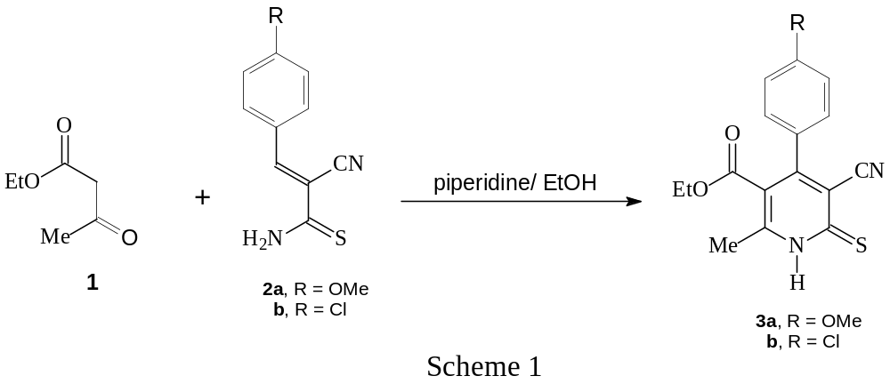
Reaction of 4-aryl-3-cyano-5-ethoxycarbonyl-6-methyl-pyridine-2(1H)-thiones 3a,b with chloroacetonitrile, by refluxing in ethanol in the presence of sodium acetate, gave the corresponding 3-aminothieno[2,3-b]pyridine-2-carbonitriles 5a,b rather than the expected 2-(cyanomethylthio)pyridines 4a,b. The latter compounds (4a,b) were carefully obtained by reacting 3a,b with chloroacetonitrile at room temperature. Heating compounds 4a,b, in ethanol containing sodium acetate, resulted in cyclization and formation of the corresponding isomers 5a,b (Scheme 2). In contrast, 3-amino-4-(4-methoxyphenyl)-5-ethoxycarbonyl-6-methylthieno[2,3-b]pyridine-2-carboxamide 6 was prepared by reacting compounds 3a with chloroacetamide in ethanol containing slightly excess amount of sodium ethoxide according to our reported method (Bakhite et al. 2005) (Scheme 2).
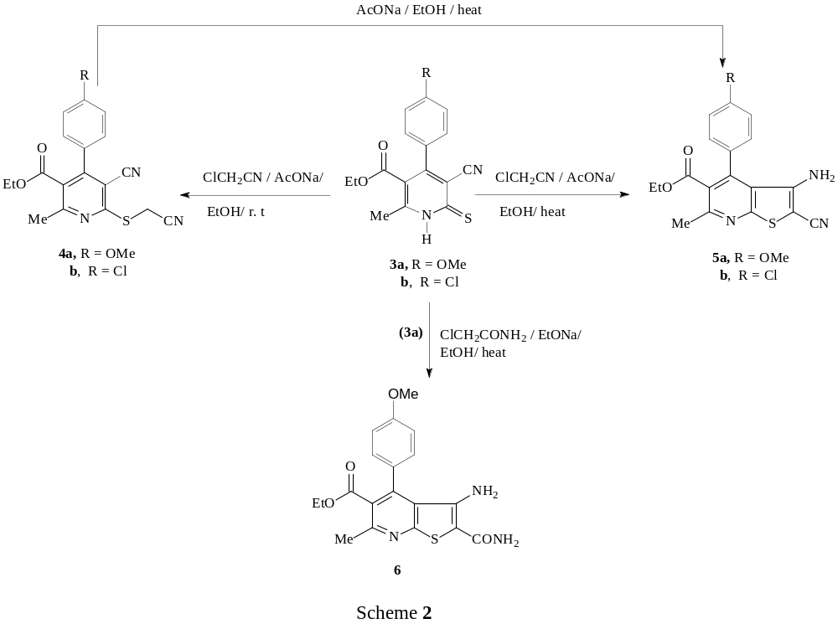
The condensation of o-aminocarbonitriles 5a,b with triethyl orthoformate by refluxing in acetic anhydride produced the methanimidate derivatives 7a,b. Treatment of compounds 7a,b with hydrazine hydrate in dioxane at room temperature resulted in the formation of ethyl 3-amino-9-aryl-3,4-dihydro-4-imino-7-methylpyrido[3’,2’: 4,5]thieno[3,2-d]pyrimidine-8-carboxylates 8a,b in good yields (Scheme 3).
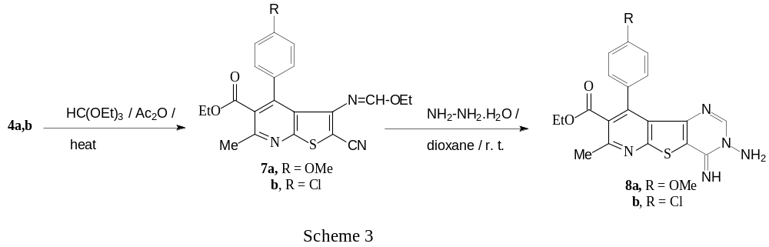
Compounds 8a,b having the aminoimine structure, were utilized as new precursors for synthesizing novel fused heterocyclic compounds containing pyridothienopyrimidine moiety.
Refluxing compounds 8a,b with an excess amount of triethyl orthoformate, under neat condition, furnished ethyl 7-aryl-9-methyl-[1,2,4]triazolo[2’’,3’’-c]pyrido[3',2': 4,5]thieno[2,3-e]pyrimidine-8-carboxylates 9a,b. The 2-methyl analogues 10a,b were prepared by reacting of 8a,b with acetic anhydride at reflux temperature. Heating compounds 8a,b with phenyl iso-thiocyanate in dry pyridine for long time led to the formation of anilinotriazolopyridothienopyrimidines 11a,b. When compounds 8a,b were allowed to react with isatin, a cyclocondensation reaction occurred and the fused hexacyclic compounds 12a,b were obtained in good yields (Scheme 4).
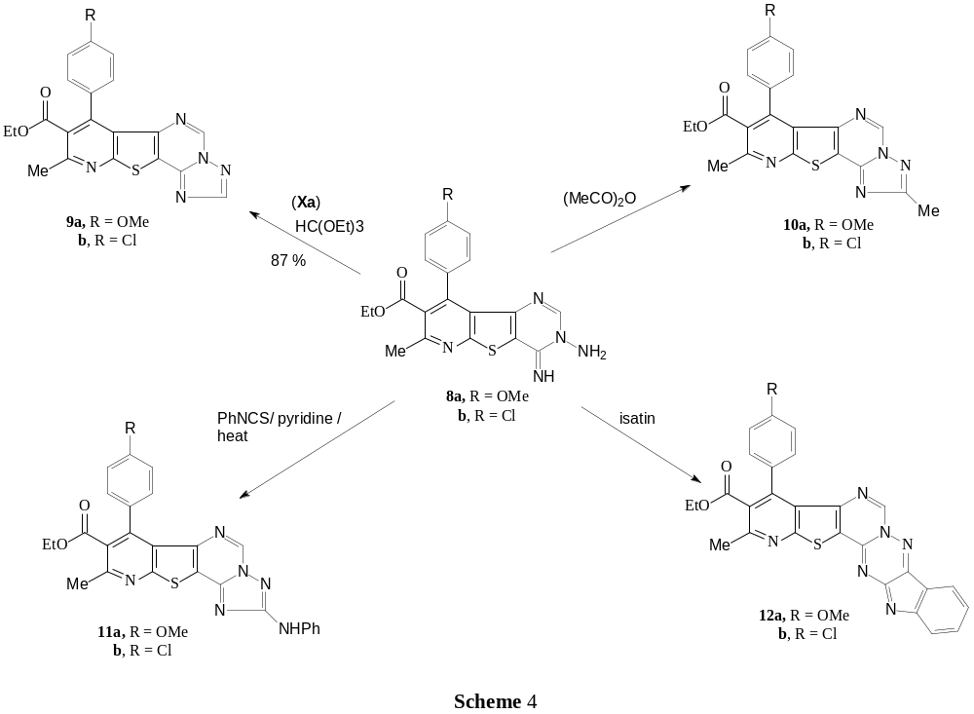
On treatment of compound 8a with phenacyl bromide in boiling ethanol containing an equimolar amount of sodium acetate, the product was identified as 2H-pyrido[3'',2'':4',5']thieno[3',2':4,5]pyrimido[1,6-b][1,2,4]triazine 13 rather than the related isomer 14 (Scheme 5). This assignment based on the spectral data of this product. Thus, its IR spectra revealed the absence of any band attributed to ν_{NH} and its ¹H NMR spectrum confirms the presence of a characteristic signal corresponding to CH₂ group in the triazine ring of compound 13.
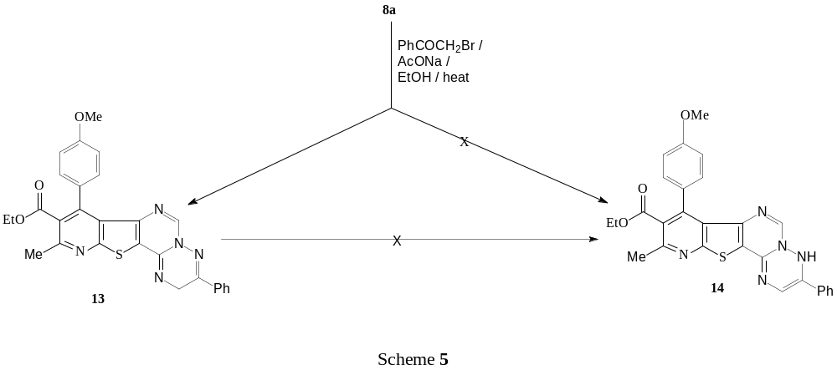
Refluxing o-aminocarboxamide 6 with triethyl orthoformate in acetic anhydride led to the formation of ethyl 9-(4-methoxyhenyl)-7-methyl-4-oxo-3,4-dihydropyrido[3',2':4,5]thieno[3,2-d]pyrimidine-8-carboxylate 15. Chlorination of 15, by heating with an excess amount of phosphorus oxychloride, produced ethyl 4-chloro-9-(4-methoxyphenyl)-7-methylpyrido[3',2':4,5]thieno[3,2-d]pyrimidine-8-carboxylate (16) in good yield. Chloro compound 16 underwent a nucleophilic substitution reaction upon treatment with thiourea to give pyrimidine-2(1H)-thione 17. Also, reaction of 16 with hydrazine hydrate gave 4-hydrazinopyrimidine derivative 18 (Scheme 6).
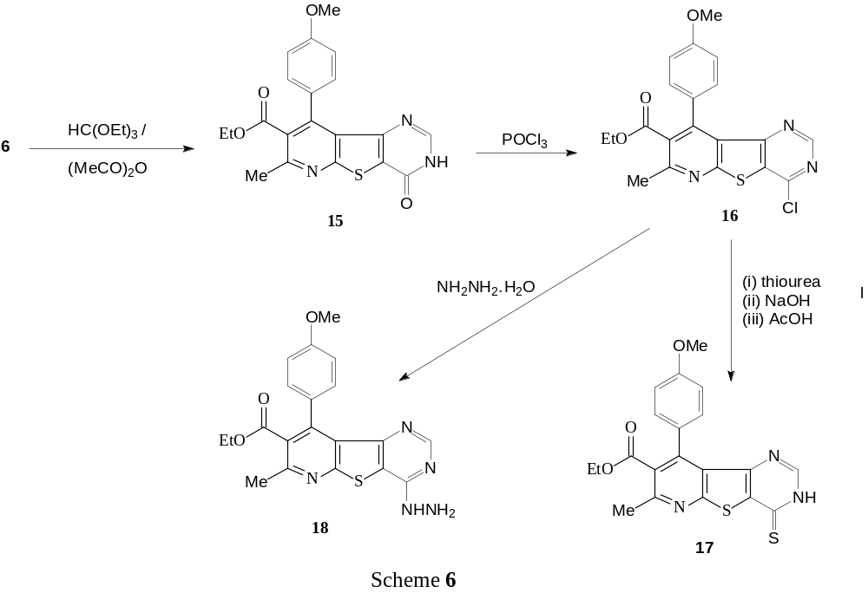
The compound 18 was also served as a facile point to departure to other pyridothienopyrimidine derivatives. Thus, its condensation with 4-chlorobenz-aldehyde gave 4-(4-chlorobenzylidene)hydrazinopyrimidine derivative 19. Similarly, the acetophenone hydrazone 20 was obtained by reaction of 18 with acetophenone (Scheme 7). Heating compound 18 with acetylacetone at reflux temperature produced the dimethylpyrazole derivative 21. Treatment of compound 18 with ethyl ethoxymethylene cyanoacetate led to the formation of ethyl 4-(3'-amino-4'-ethoxycarbonylpyrazol-2'-yl)-7-methyl-9-(4-methoxyphenyl)pyrido[3',2':4,5]thieno [3,2-d]pyrimidine-8-carboxylate (22) (Scheme 7).
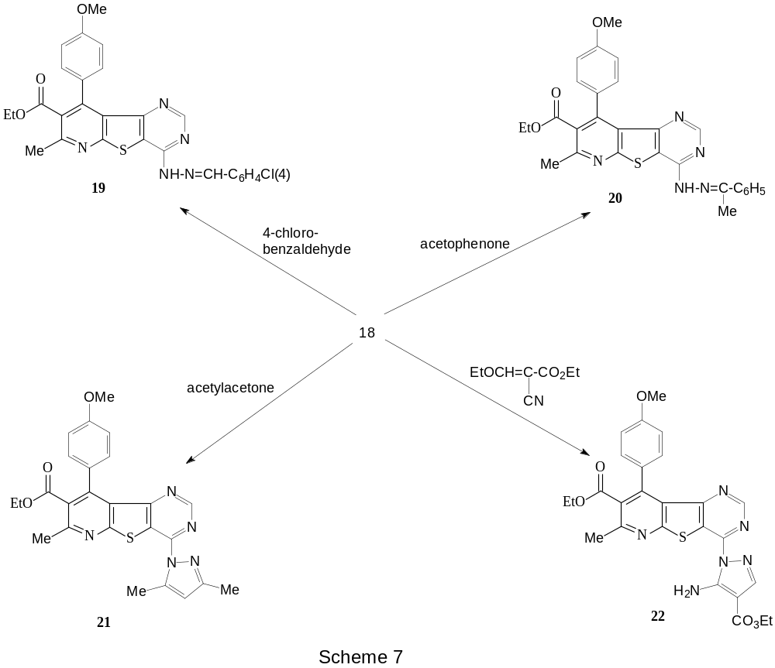
Heating hydrazino compound 18 in formic acid for long time resulted in the formation of triazolo derivative 9a rather than the expected isomer 24 (Scheme 8). From thermodynamic point of view (Wagner et al., 1991), the compound 9a seems to be more stable than the corresponding isomer 24. The pathway of the latter reaction may be involve firstly the usual formation of compound 24 via the intermedicay of acid hydrazide 23. Under the applied reaction conditions (Wagner et al., 1991), compound 24 underwent spontaneously Dimroth rearrangement in situ to give the most stable isomer 9a (Scheme 8). The triazole intermediate 24 was successfully prepared by heating hydrazino compound 18 with triethyl orthoformate, under neat condition, at reflux temperature (Scheme 8).

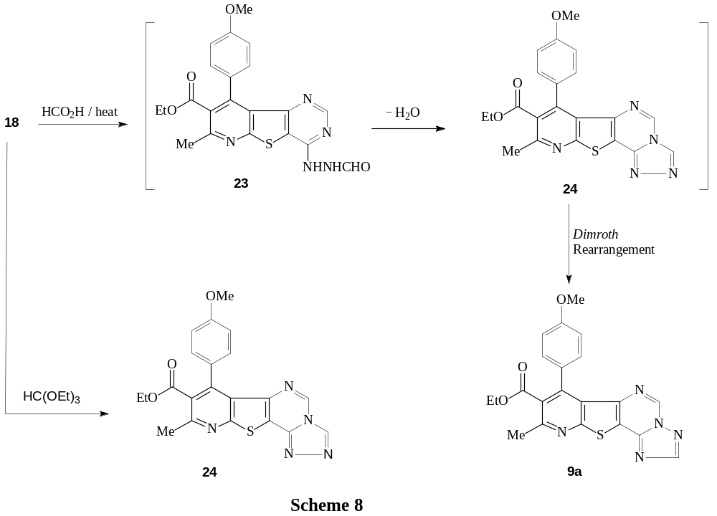
Beside elemental and spectral analyses, The above structure (9a) was further confirmed by comparison with authentic sample (m. p., mixed m.p. and TLC) previously prepared in this paper.
The mechanism of Dimroth rearrangement under investingation is given in scheme 9 (Allen et al., 1959). This rearrangement is promoted here by aqueous acid (Formic acid 85%). It involves initially covalent hydration of 24. The hydroxy group enters position 5, then the pyrimidine ring opens and forms the carbonyl intermediate A; the CO group then attacks the more nucleophilic N-2 of the triazole ring and cyclizes to give the rearranged triazolopyrimidine 9a.
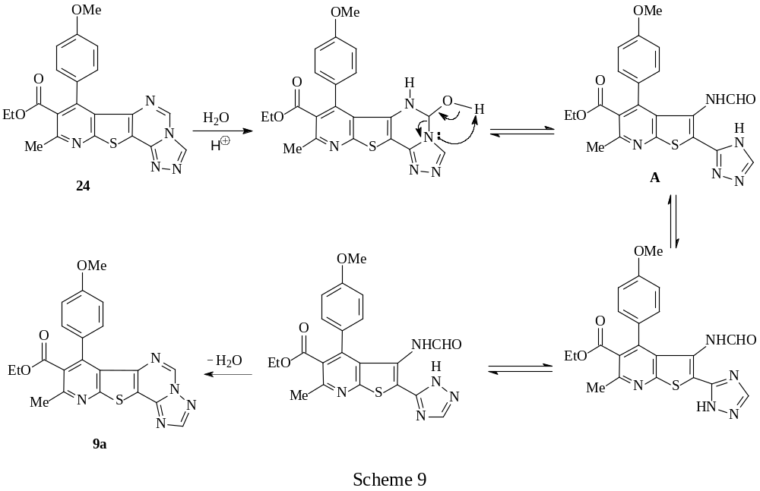
The structural formulas of all newly synthesized compounds were confirmed by elemental analyses and spectral data (experimental part).
2.Biological Activity
Among the synthesized compounds, thirteen samples were evaluated for their antimicrobial activities against six strains of bacteria (Bacillus cereus, Micrococcus luteus, Staphylococcus aureus, Escherichia coli, Pseudomonas aeruginosa and Serratia marcescens) and six strains of fungi (Aspergillus flavus, Candida albicans, Fusarium oxysporum, Geotrichum candidum, Scopulariopsis brevicaulis and Trichophyton rubrum) (Johanson and Caes; 2010; Kwon-Chung and Bennett, 1992).
The bioassay results, which are given in tables 1 and 2, revealed that: (i) most of the tested compounds possess mild to strong activity against, at least, one bacterial or fungal strain, (ii) only one compound (4a) showed no activity against all used strains of bacteria and fungi, (iii) sex compounds (3a, 3b, 4a, 4b, 7b and 21 exhibit no activity against all fungal strains used and (iv) Compounds 11a and 15 showed partial inhibition zones towards Fusarium oxysporum of 14 and 12 mm. respectively and (v) compounds 11a, 15 and 19 showed partial inhibition zones towards Geotrichum candidum of 16, 14, and 13 mm. respectively.
Table 1: Antibacterial activities of some representative compounds (inhibition zones in mm).
Compd.  No. | B. cereus | M. luteus | S.aureus | E.Coli | P. aeru. | S. marc.
3a | 0 | 0 | 6 | 0 | 0 | 0
3b | 0 | 0 | 7 | 0 | 0 | 0
4a | 0 | 0 | 0 | 0 | 0 | 0
4b | 0 | 0 | 0 | 6 | 0 | 0
5a | 0 | 0 | 0 | 6 | 0 | 0
5b | 0 | 0 | 0 | 7 | 0 | 0
6 | 0 | 6 | 6 | 9 | 0 | 0
7b | 6 | 0 | 0 | 6 | 0 | 0
10a | 8 | 10 | 8 | 12 | 9 | 12
11a | 9 | 9 | 10 | 0 | 11 | 10
15 | 0 | 10 | 8 | 12 | 10 | 11
19 | 7 | 10 | 8 | 9 | 9 | 9
20 | 9 | 10 | 10 | 7 | 10 | 12
21 | 6 | 8 | 0 | 8 | 8 | 8
Control | 11 | 20 | 13 | 16 | 13 | 20
Control = Chloramphenicol

Table 2: Antifungal activities of some representative compounds (inhibition zones in mm).
Compd.  No. | A. flavus | C. albica. | F. oxyspo. | G. candid. | S. brevic. | T. rubru.
3a | 0 | 0 | 0 | 0 | 0 | 0
3b | 0 | 0 | 0 | 0 | 0 | 0
4a | 0 | 0 | 0 | 0 | 0 | 0
4b | 0 | 0 | 0 | 0 | 0 | 0
5a | 0 | 10 | 0 | 0 | 0 | 0
5b | 0 | 9 | 0 | 0 | 0 | 0
6 | 7 | 10 | 0 | 0 | 0 | 0
7b | 0 | 0 | 0 | 0 | 0 | 0
10a | 0 | 0 | 0 | 11 | 0 | 10
11a | 8 | 12 | 14 p.i. | 16 p.i. | 0 | 0
15 | 0 | 9 | 12 p.i. | 14 p.i. | 0 | 10
19 | 0 | 8 | 0 | 13 p.i. | 0 | 12
20 | 0 | 8 | 0 | 14 | 0 | 0
21 | 0 | 0 | 0 | 0 | 0 | 0
Control | 40 | 12 | 12 | 14 | 28 | 40
Control = Clotrimazole, p.i. = partial inhibitio
4. Conclusion
In this paper, Ethyl 3-amino-9-aryl-3,4-dihydro-4-imino-7-methylpyrido[3',2':4,5] thieno[3,2-d]pyrimidine-8-carboxylates 8a,b and Ethyl 4-chloro-9-(4-methoxy-phenyl)-7-methylpyrido[3',2':4,5]thieno[3,2-d]pyrimidine-8-carboxylate (16) were synthesized and used as keys intermediate for synthesizing the promising pyridothienopyrimidines as well as triazolopyridothienopyrimidines and pyridothieno-pyrimidotriazinoindoles.
Acknowledgements
The authors are grateful to Prof. Y. Yamada, professor of chemistry, Faculty of Education, Utsunomiya University, Mine, Utsunomiya 321-8505, Japan for his help in carrying out the NMR and mass spectra of the compounds.
References
Abdel-Rahman, A.E., Bakhite, E.A., Al-Taifi, E.A., 2003. Synthesis and antimicrobial
testing of some new S-substituted-thiopyridines, thienopyridines, pyridothieno-
pyrimidines and pyridothienotriazines Pharmazie 58, 372-377.
Allen, C. F. H., Beilfuss, H. R., Burness, D. M., Reynolds, G. A., Tinker, J. F.,
VanAllan, J. A.,1959. The structure of certain polyazaindenes. II. The product
from ethyl acetoacetate and 3-amino-1,2,4-triazole. J. Org. Chem. 24, 787-793.
Al-Taifi, E. A., Thabet, E. A., Bakhite, E. A., El-Emary, T. I., 2016. Synthesis
of some new pyridines, thienopyridines and pyridothienopyrimidines bearing 1,3-
diphenyl-1H-pyrazole moiety AshEse Journal of Physical Science. 2, 033-041.
Attaby, F. A., Elghandour, A. H. H., Ali, M. A., Ibrahem, Y. M., 2007. Synthesis,
Reactions, and Antiviral Activity of 6′-Amino-2′-thioxo-1′,2′-dihydro-3,4′-
bipyridine-3′,5′-dicarbonitrile Phosphorous, Sulfur, and Silicon, 182, 695-709.
Bahekar, R. H., Jain, M. R., Jadav, P. A., Prajapati, V. M., Patel, D. N., Gupta, A. A.,
Sharma, A.; Tom, R., Bandyopadhya, D., Modi, H., Patel, P. R., 2007 Synthesis
and antidiabetic activity of 2,5-disubstituted-3-imidazol-2-yl-pyrrolo[2,3-
b] pyridines and thieno[2,3-b]pyridines. Bioorg. Med. Chem. 15, 6782-6795
Bakhite, E.A.-G., 2003. Recent trends in the chemistry of thienopyridines.
Phosphorus, Sulfur and Silicon 178, 929-992.
Bakhite, E A, Al-Sehemi, A. G., Yamada, Y., 2005. Synthesis of novel
pyrido[3′,2′:4,5]thieno[3,2-d]pyrimidines,pyrido[3″,2″:4′,5′]thieno[3′,2′:4,5]
pyrimido[l,6-a]benzimidazoles and related fused systems
, J Heterocyclic Chem, 42, 1069-1077
Bakhite, E. A., Abdel-Rahman, A. E., Al-Taifi, E. A., 2014. Fluorine-containing
heterocycles: Part III. Synthesis of some new furo[2,3-b]-, pyrazolo[3,4-b]- and
thieno[2,3-b]pyridines with anticipated biological activities, Arabian Journal of
Chemistry 7, 936-946
Bakhite, E. A., Abeed, A. A. O., Ahmed, O. E. A., 2016. Synthesis and biological
activity of some new fused thieno[2,3-b]pyridine derivatives; pyridothieno-
pyrimidinones and pyridothienotriazinones, Assiut University Journal of
Chemistry (AUJC) 45, 47-57
Bernardino, A. M. R., Pinheiro, L. C. da S., Rodrigues, C. R., Loureiro, N. I., Castro,
H. C., Lanfredi-Rangel, A., Sabtini-Lopes, J., Borges, J. C., Carvalho, J. M.,
Romeiro, G. A., Ferreira, V. F., Fruguphetti, I. C. P. P., Vannier-Santos, M. A.,
2006. Design, synthesis, SAR, and biological evaluation of new 4-
(phenylamino)thieno[2,3-b]pyridine derivatives
Bioorg. Med. Chem. 14, 5765-5770.
Boehm, N., Krasselt, U., Leistner, S., Wagner, G., 1992. Pharmazie 47. 897.
Gad El-Kareem, M. A. M., El-Adasy, A. A. A. M., 2010. Synthesis and Antibacterial
Activity of Some New Ethyl Thionicotinates, Thieno[2,3-b]pyridines,
Pyrido[3′,2′:4,5]thieno[3,2-d]pyrimidines, and Pyrido[3′,2′:4,5]thieno[3,2-
d][1,2,3]triazines Containing Sulfonamide Moieties
Phosphorous, Sulfur, and Silicon, 185, 411-421.
Gad El-Kareem, M. A. M., Abdel-Fattah, A. M., Elneairy, M. A. A. 2006. Pyridine-
2(1H)-thione in Heterocyclic Synthesis: Synthesis of Some New Nicotinic Acid
Ester, Thieno[2,3-b]pyridine, Pyrido[3′,2′: 4,5]thieno[3,2-d]pyrimidine, and
Thiazolylpyrazolo[3,4-b]pyridine Derivatives. Phosphorous, Sulfur, and Silicon,
181, 891-911.
Hayakawa, I., Shioya, R., Agatsuma, T., Furukawa, H., Sugano, Y., 2004.
Thienopyridine and benzofuran derivatives as potent anti-tumor agents possessing
different structure-activity relationships. Bioorg. Med. Chem. Lett. 14, 3411-3414.
Hussin, A. M., Abu-Shanab, F. A., Ishak, E. A., 2000. Polycyclic pyridines: Synthesis of pyridothienopyrimidines pyridothienotriazines and pyridothienotriazepines Phosphorous, Sulfur, and Silicon, 159, 55-68.
Ibrahim, Y. A., Elwahy, A. H. M., Kadry, A. M., 1996. Thienopyrimidines: Synthesis, reactions, and biological activity. Advances in Heterocyclic Chemistry, 65, 235-281.
Johanson, T. R., Caes, C. L. 2010. Laboratory Experiments in Microbiology. Ninth
Edition, San Franciso, USA, pp. 470.
Krauze, A., Germame, S, Eberlins, O., Sturms, I., Klusa, V., Duburs, G. 1999. Derivatives of 3-cyano-6-phenyl-4-(3`-pyridyl)-pyridine-2(1H)-thione and their neurotropic activity. Eur J. Med. Chem. 34, 301-310.
Kwon-Chung, K. J., Bennett, J. E. 1991. Medical Mycology. Lea & Febiger, Philadelphia, P. A. (1992).
Litvinov, V. P., 2004. Thienopyrimidines: synthesis, properties, and biological activity
Russ. Chem. Bull. Intern. Ed., 53, 487-516.
Litvinov, V. P., Dotsenko, V. V., Krivokolysko, S. G., 2005. Thienopyridines: synthesis,
properties, and biological activity. Russ. Chem. Bull. Intern. Ed. 54, 864-904.
Quintela, J. M., Peinador, C., Veiga, C., Gonzales, L., Botana, L. M., Alfonso, A.,
Riguera, R.,1998. Synthesis and antiallergic activity of pyridothienopyrimidines
Bioorg. Med. Chem. 6, 1911-1925.
Quintela, J. M., Peinador, C., Gonzales, L., Iglesias, R., Parama, A., Alvares, F., Sanmartin,
M. L., Riguera, R., 2003. Piperazine N-substituted naphthyridines,
pyridothienopyrimidines and pyridothienotriazines: new antiprotozoals active against
Philasterides dicentrarchi. Eur. J. Med. Chem. 38, 265-275.
Schnute, M. E., Anderson, D. J., Brideau, R. J., Ciske, F. L., Collier, S. A., Cudahy,
M. M., Eggen, M., Genin, M. J., Hopkins, T. A., Judge, T. M., Kim, E. J.,
Knechtel, M. L., Nair, S. K., Nieman, J. A., Oien, N. L., Scott, A., Tanis, S. P.,
Vaillancount, V. A., Wathen, M. W., Wieber, J.L., 2007. 2-Aryl-2-
hydroxyethylamine substituted 4-oxo-4,7-dihydrothieno[2,3-b]pyridines as broad-
spectrum inhibitors of human herpesvirus polymerases. Bioorg. Med. Chem.
Lett. 17, 3349-3353.
Wagner, G, Krasselt, U, Leistner, S, 1991. Pharamazie 46, 409.
Wagner, G., Leistner, S., Vieweg, H., Krasselt, U. Prantz, J. 1993. Synthesis of
thieno(2,3-b)pyridines with oxalamidic acid or an oxalamidic alkylester residues
and of 4-alkoxy-pyrido(3',2':4,5)thieno(3,2-d)pyridine-2-carboxylic acid derivates.
Pharmazie 48, 342-346.

