NATURAL PRODUCTS USES IN DRUG SYNTHSIS

Abstracts

Although traditionally natural products have played an important role in drug discovery, in the past few years most Big pharma
Company Years companies have either terminated or considerably scaled down their natural product operatons. This is despite a
significant number of natural product-derived drugs being ranked in the top 35 world wide selling ethical drugs in 2000, 2001,
and 2002. There were 15 new natural productderived drugs launched from 2000 to 2003, as well as 15 natural product-derived compounds in Phase III clinical trials or registration at the end of 2003. Recently, there has been a renewed interest in natural
product research due to the failure of alternative drug discovery methods to deliver many lead compounds in key therapeutic areas such as immunosuppression, anti-infectives, and metabolic diseases. To continue to be competitive with other drug discovery methods, natural product research needs to continually improve the speed of the screening, isolation, and structure elucidation processes, as well addressing the suitability of screens for natural product extracts and dealing with issues involved with large-scale compound supply.

Keywords
Types of natural products, natural products are derived from plants,insects, fungi, natural products in drug therapy and drug screening.
Streptomyces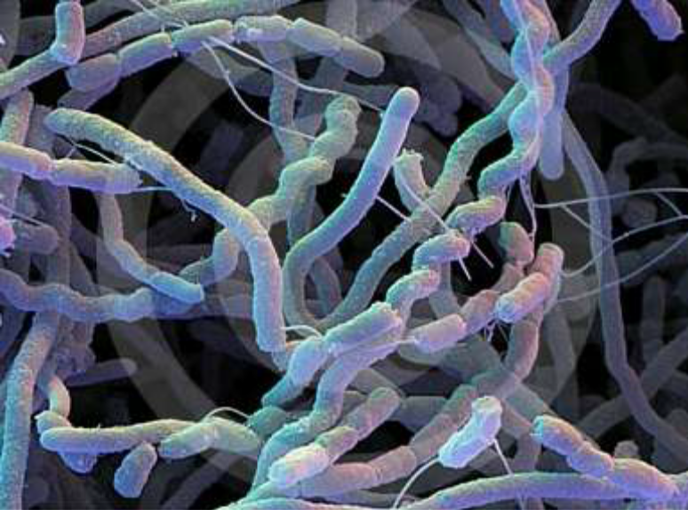
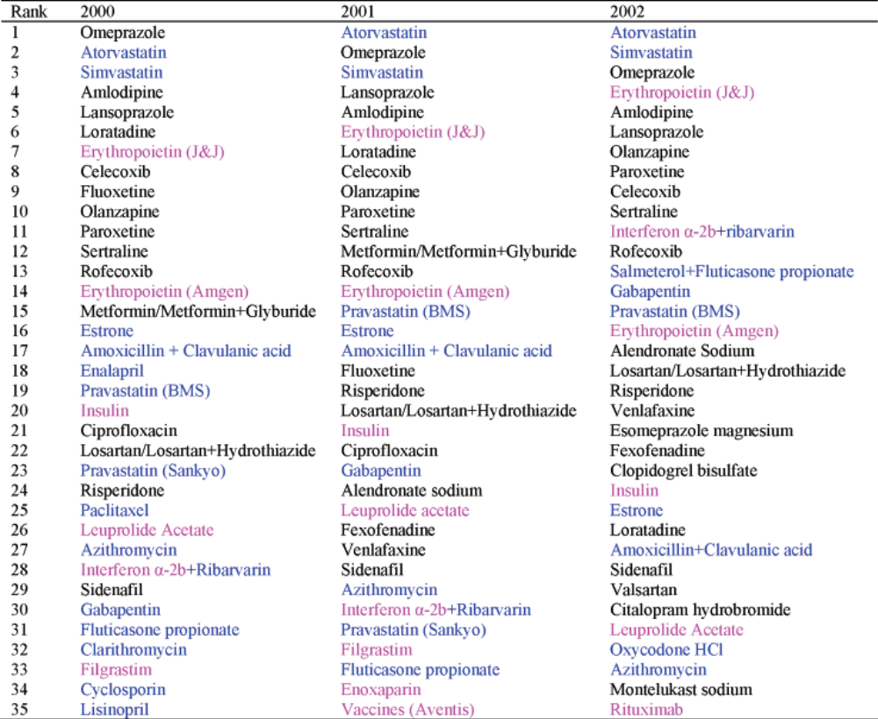

Introduction to Natural Products Chemistry
Natural Product : A chemical substance produced by a living organism; a term
used commonly in reference to chemical substances found in nature that have
distinctive pharmacological effects.
Main Classes of Natural Products:
- Carbohydrates,
- Lipids
- Proteins
- Nucleic Acids

Carbohydrates

A broad category of chemical compounds, also reffered as Sugars. The most abundant
class of bio-organic molecules on Earth. Although relatively low in human, it constitute
about 75% by mass of dry plant materials.
Main functions: Energy storage, structure element , source of carbon of the biosynthesis
of other subtsances, “Markers” on cell surface for cell-cell recognition.

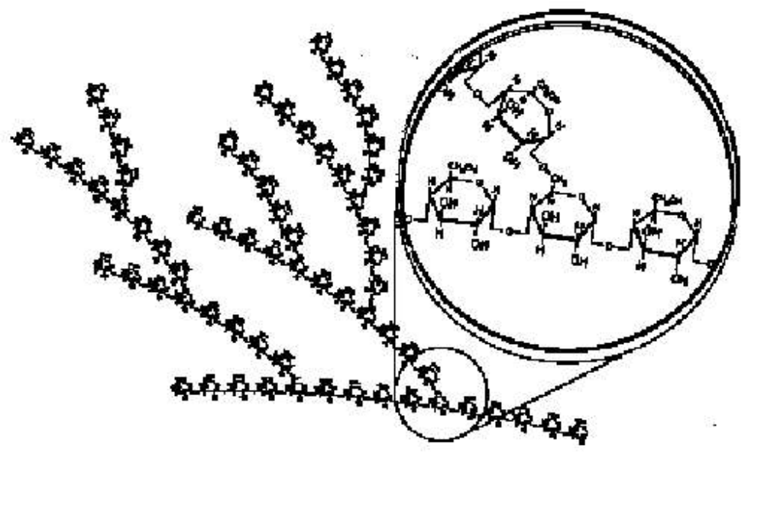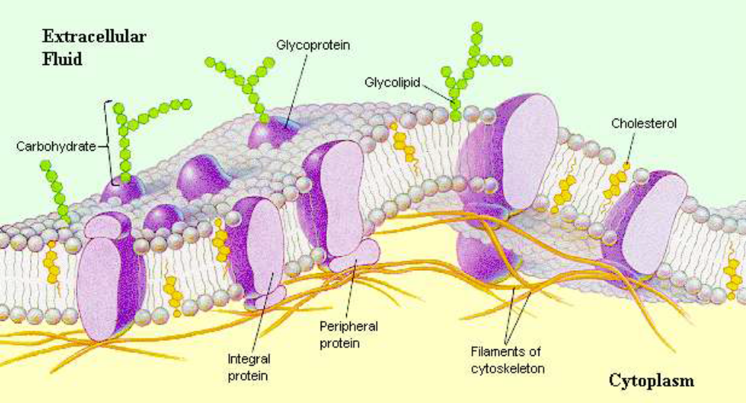

Lipids

A broad category of chemical compounds, also reffered as Fat. Most of those products
are non polar fat, oil, or wax that does not (or poorly) dissolves in water.
Main functions: Main componant of cells membrane, energy storage, communication
A broad category of chemical compounds composed of amino acids. Includins
Aminoacids, polypetides, Enzymes.
PROTIENS
Main functions: Very large variety of functions, from maintenance or repairing of
existing tissues and synthesis of new ones to the catalysis of all the bio-chemical
reactions that take place in a living organism (Enzyms).

(primary structure)
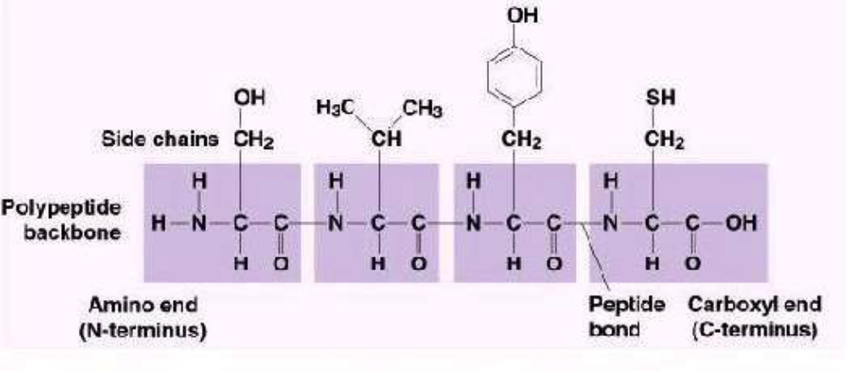

(secondary structure) (Teriary structure)

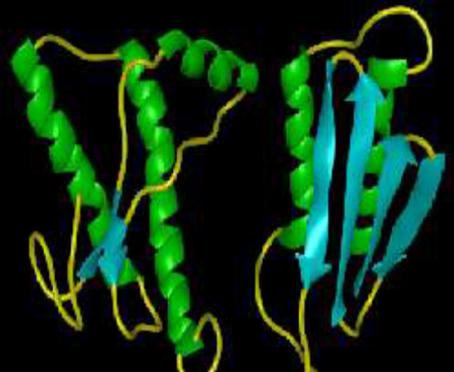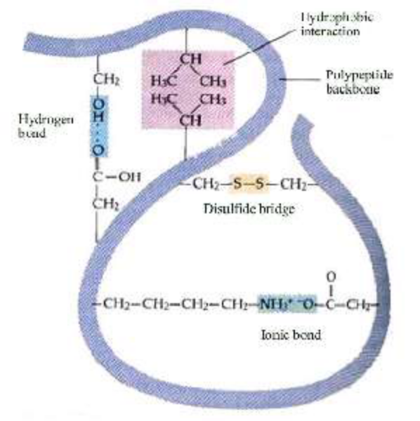

Nucleic Acids

A category of complex chemical compounds involved in the transmition of genetic
information (DNA) and its transfert as information to the cell (RNA).
Main functions: Genetic information,
some simple nucleotides acts as source
of energy for chemical reaction (ATP, GTP,...). Phosphate group Sugar: Ribose (RNA),
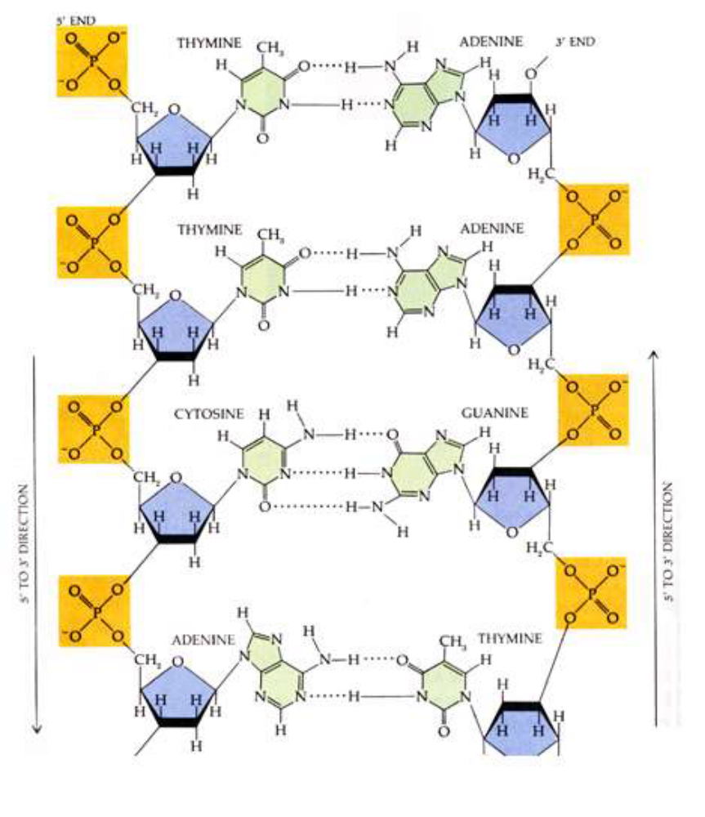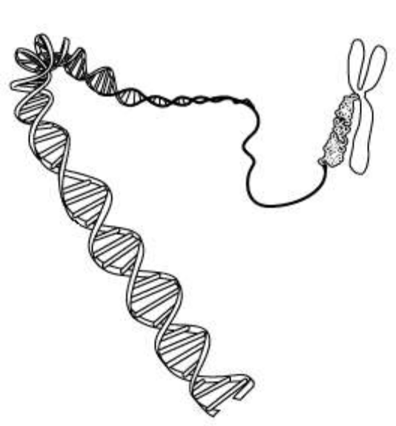

Metabolism
The Metabolism is the sum of all the chemical reactions that take place in a
living organism.
Primary Metabolism: All the chemical reactions necessary for the live of the
organism by itself.
Primary Metabolites: All the chemical products involved in the Primary
Metabolism.
Secondary Metabolites: All the chemical products that are produced by the
living organism but are NOT involved in the primary metabolism. Not necessary
for the live of the organism by itself but usefull for interaction with others
(chemical communication, chemical defences).

Tobacco plants derivied from nicotine
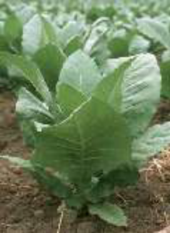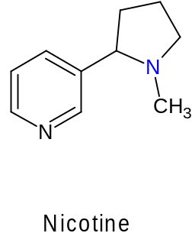

Hormones, Pheromones and Allomones
Hormones: Chemical products use in the tranfer of information between tissues
or organs within a Body, in order to coordinate their activity.
Pheromones: Chemical products used between individuals of the same specie in
order to induce a specific behavior (Chemical communication).
Allomones: Chemical products released by an organism wich has a negative
effect on another organism (Chemical defence).
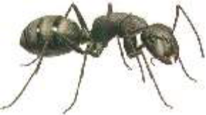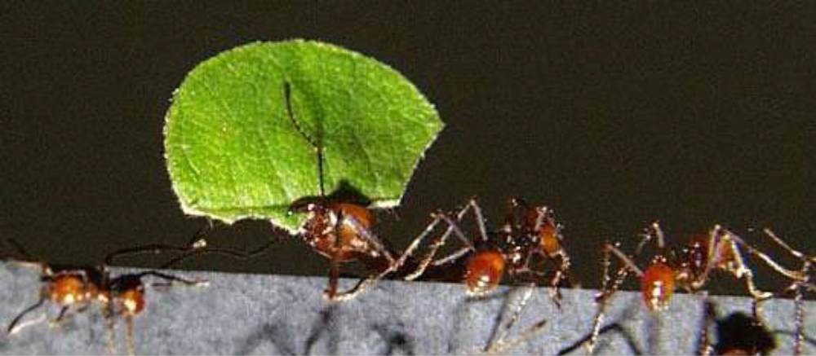
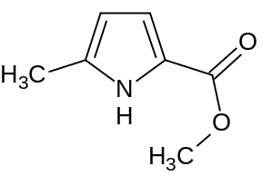
Intoduction to Medicinal Chemistry
Evolution gave different organism different “Chemical Tools” to
communicate with individuals of the same specie or to defend themselves
against predators.
Question : As we share the same kind of Primary Metabolism,
doesn't those “Chemical Tools” have an effect on the human body?
Answer : Yes, and some times those “Chemical Tools” can be used as Medicinal Drugs.

Natural Products in Drug Therapy
• About 50% of drugs in clinical use today are natural products, or chemically modified natural produts
• Sources for natural product-derived drugs: (a) directly from plant/animal,(b) genetic engineering, (c) semisynthesis (d) total synthesis
• Pharmaceutical research involving natural products was stagnant/declining in 1990s, but increasing again in the current decade
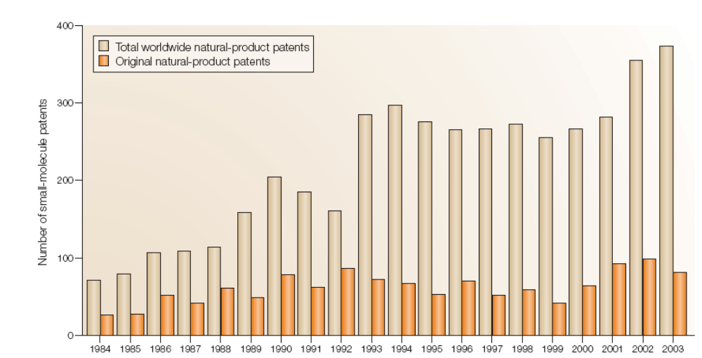
Why the Decline Natural Products Research in the pharmaceutical Industry?
• Advent of high-throughput screening (HTS) allows more compounds to be assessed for hits
• Natural products are typically extracted as mixtures (10-100s) of compounds with largly varying concentrations, which can (a) make identifying actual active compound more difficult; (b) add more work in additional purification; (c) give poor results with catalysis/binding assays
• Combinatorial chemistry/synthetic libraries are better suited for HTS than natural product extract libraries, leading to an industrial trend toward purely synthetic libraries
• Major decline in “big pharma” research on infectious disease therapy
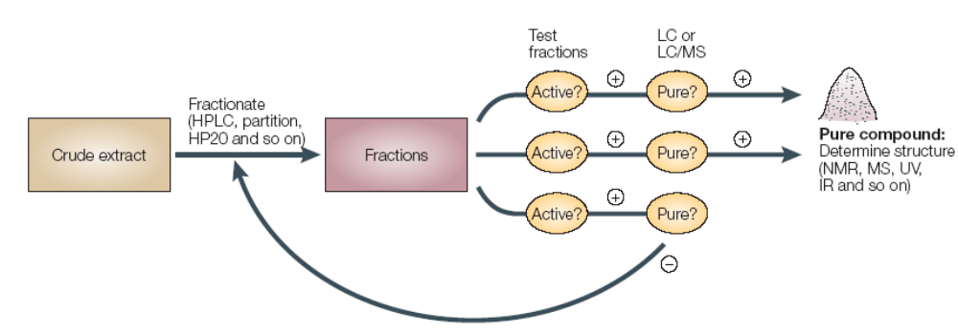
Problems with Combinatorial Libraries in Drug Screening
• Libraries designed to maximize number of compounds screened (106) may yield no hits due to lack of bio chemically relevant structure
• Compounds that are hits are often unselective in their binding/activity
• Overall, R&D expectations have not been realized

Advantages of Natural Product Libraries in Drug Screening
• Recent advances in purification and analysis technology allows for natural product library HTS
• Natural products have been selected through evolution to interact with
macromolecules (eg proteins)
• This includes natural selection of 3D structures and pharmacophores
• Many natural products are “priveleged structures,” allowing them to interact with
multiple biological targets in various types of organisms
• This is reinforced by research in the last 5-10 years which shows that the protein
fold space found in nature is smaller than previously predicted
• At the same time, natural products are typically specific in their ability to modulate
protein-protein interactions (signal transduction, immune response, mitosis, and apoptosis)
• Natural products typically do not violate Lapinski’s “Rule of Five”

Types of Natural Product Derived Therapeutics
1) Unaltered natural product as a drug
2) Semi-synthetic analog: chemical manipulation (typically functional group interconversion) of a natural product 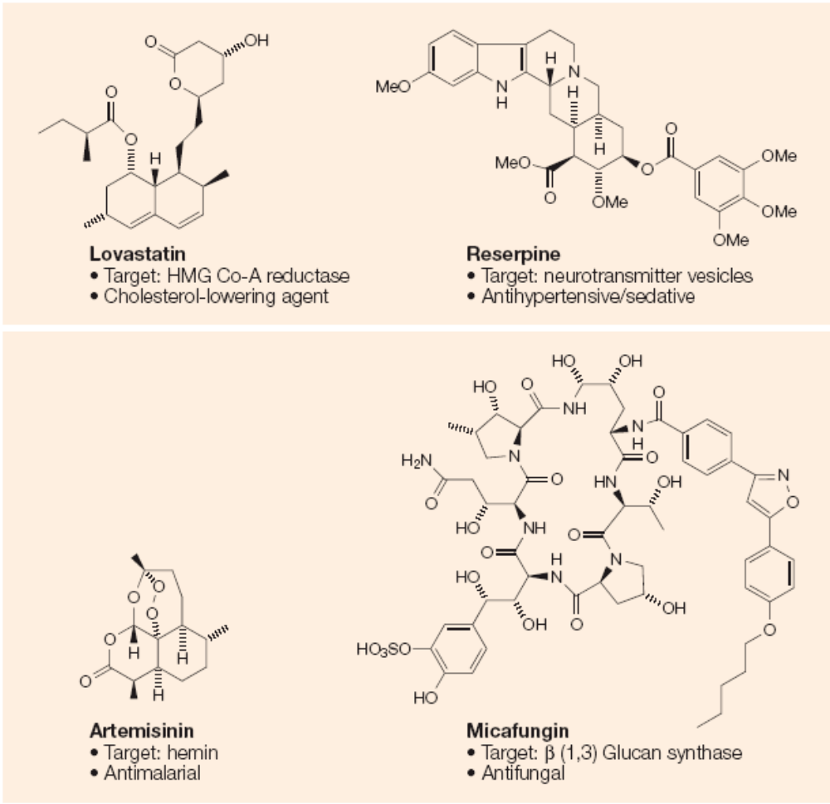
Example: exchanging a sugar on a natural product possible disadvantagessupply of natural product,limitations to available analogues due to native functionality
3) Analogs from diverted total synthesis
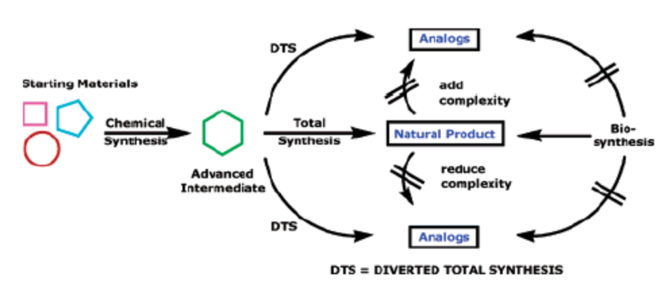
Bryostatin: Potent Anti-cancer Natural product

•Macrocyclic lactones from the marine invertebrate bugula neritina, first isolated in 1968; fully characterized in 1982
•Bryostatins consist of at least 20 members, which vary at R1 and R2
•Isolated yields have varied between 10-3% to 10-8%
•Anti-cancer properties: apoptosis induction, isolated in 1968; fully characterized in 1982
•Currently in phase I and II clinical trials
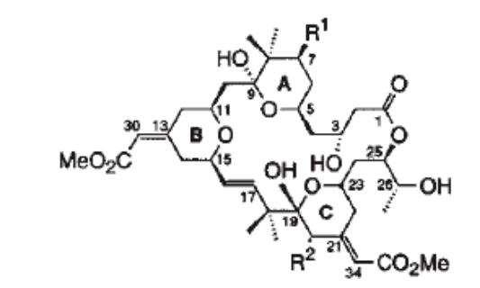
Bryostatin: Binding to PKC
•Protein Kinase C (PKC) family of serine/threonine kinases is involved in signal
transduction, and is important in the biochemistry of cancer
•Bryostatin binds to PKC w/ high affinity
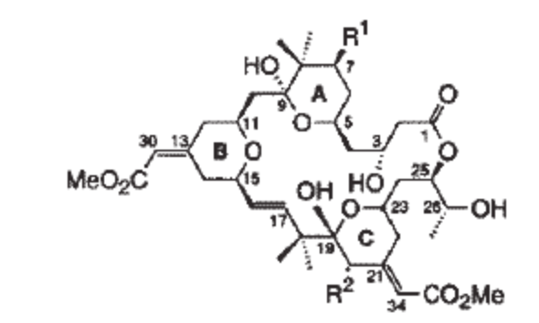
Bryostatin: Previous Total Synthesis
•Bryostatin 7 (R1=R2 = OAc) : Masamune, 1990
•Bryostatin 2 (R1= OH, R2 = O2CC7H11) : Evans, 1998
•Both total synthesis require >60 steps, making them untenable in process
Wender’s Bryolog Targets
•Hypothesis by Wender et al. (1988): pharmacophore region of byrostatin include
C1, C19, and C26 oxygen atoms (bryostatin 1 Ki= 1.35 nM)

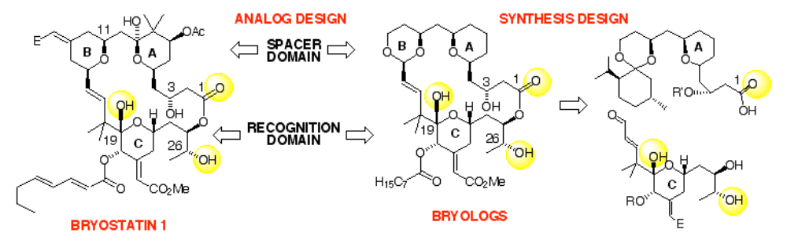

Migrastatin and Cell Migration
•Anti-cancer agent’s mode of action is typically cell death
•An alternative cancer therapy could rely on inhibition of cell migration
•Cell migration is observed in a number of normal physiological processes
(ovulation, wound healing, inflammation, embryonic development)
•Cell migration also observed in tumor angiogenesis, cancer
cell invasion, and metastasis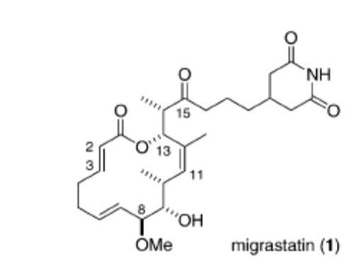
•Migrastatin was isolated by Imoto and Kosan bioscience researchers in 2000
from Streptomyces bacteria
•Migrastatin has an IC50 of 29 ⎧M in wound healing assays
Retrosynthetic Analysis of Migrastatin
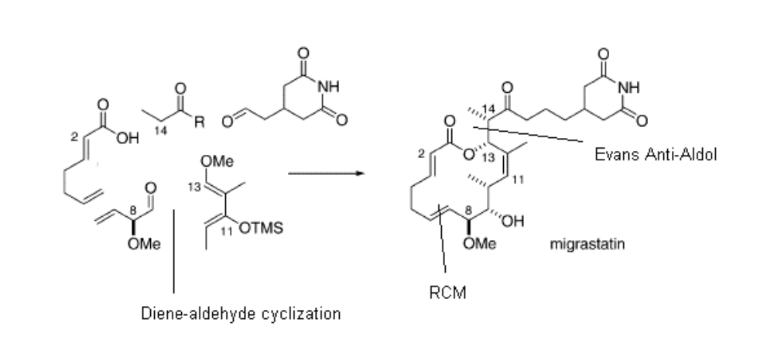
Serendipitous Biproduct 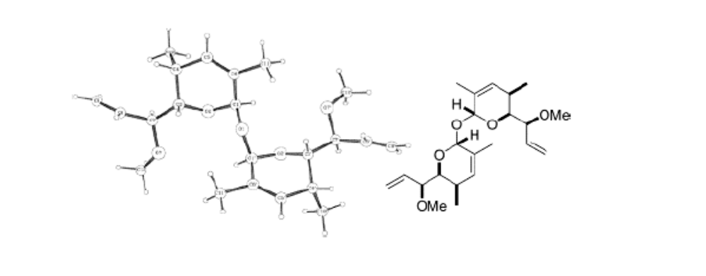
•15% yield of this dimer biproduct obtained during Ferrier rearrangement
when run at 0.3 M (scale-up conditions), though not significantly
observed at 0.1 M (small scale conditions)
•On the bright side, biproduct is crystalline
Derivitization of Migrastatin through Diverted Total Synthesis
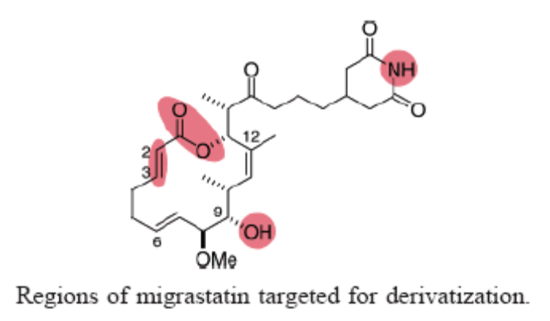
Additional Reading: 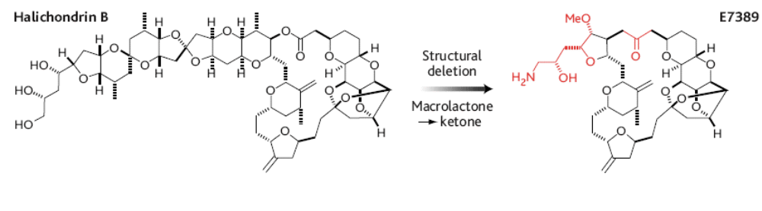
Halichondrin B and E7389
•Halichondrin B is a highly cytotoxic (antimitotic) marine natural product.
Total synthesis: Kishi, 1992
• Recent diverted total synthesis has led to simplified analog E7389 with
similar antimitotic activity. Also, replacement of lactone with ketone
has made E7389 more robust in vivo
•E7389 currently in phase I clinical trialss

Referencess

Paul A. Wender, P. A.; De Brabander, J.; Harran, P. G.; Jimenez, J.-M.; Koehler, M. F. T.; Lippa, B.;
Park, C.-M.; Shiozaki, M. J. Am. Chem. Soc. 1998, 120, 4534.
Wender, P. A.; Cribbs, C. M.; Koehler, K. F.; Sharkey, N. A.; Herald, C. L.; Kamano, Y.; Pettit, G. R.;
Blumberg, P. M. Proc. Natl. Acad. Sci. U.S.A. 1988, 85, 7197.
http://www.stanford.edu/group/pawender/html
Paul A. Wender, P. A.; De Brabander, J.; Harran, P. G.; Jimenez, J.-M.; Koehler, M. F. T.; Lippa, B.;
Park, C.-M.; Shiozaki, M. J. Am. Chem. Soc. 1998, 120, 4534.
Wender, P. A.; Cribbs, C. M.; Koehler, K. F.; Sharkey, N. A.; Herald, C. L.; Kamano, Y.; Pettit, G. R.;
Blumberg, P. M. Proc. Natl. Acad. Sci. U.S.A. 1988, 85, 7197.
http://www.stanford.edu/group/pawender/html

Kageyama, M.; Tamura, T.; Nantz, M. H.; Roberts, J. C.; Somfai, P.; Whritenour, D. C.; Masamune, S.
J. Am. Chem. Soc.1990, 112, 7407.
Evans, D. A.; Carter, P. H.; Carreira, E. M.; Prunet, J. A.; Charette, A. B.; Lautens, M. Angew Chem Int.
Ed. 1998, 37, 2354.

Gaul, C.; Njardarson, J. T.; Shan, D.; Dorn, D. C.; Wu, K.-D.; Tong, W. P.; Huang, X.-Y.;
Moore, M. A. S.; Danishefsky, S. J. J. Am. Chem. Soc. 2004, 126, 11326.
1.Jump up^ Hodgkin DC, Kamper J, Mackay M, Pickworth J, Trueblood KN, White JG (July 1956). "Structure of vitamin B12". Nature 178 (4524): 64–6. doi:10.1038/178064a0.PMID 13348621.
  - ^ Jump up to:ª ^{b} Woodward RB (1973). "The total synthesis of vitamin B 12". Pure Appl. Chem. 33 (1): 145–77.doi:10.1351/pac197333010145. PMID 4684454.
  - ^ Jump up to:ª ^{b} Eschenmoser A (January 1988). "Vitamin B12: Experiments Concerning the Origin of Its Molecular Structure". Angewandte Chemie International Edition in English 27 (1): 5–39. doi:10.1002/anie.198800051.
  - ^ Jump up to:ª ^{b} Heathcock CH (1996). "As We Head into the 21st Century, Is there Still Value in Total Synthesis of Natural Products as a Research Endeavor?". Chemical Synthesis. NATO ASI Series 320. pp. 223–243.doi:10.1007/978-94-009-0255-8_9.
^ Jump up to:ª ^{b} Nicolaou KC, Vourloumis D, Winssinger N, Baran PS(January 2000). "The Art and Science of Total Synthesis at the Dawn of the Twenty-First Century" (PDF). Angew. Chem. Int. Ed. Engl. 39 (1): 44–122.doi:10.1002/(SICI)1521-3773(20000103)39:1<44::AID-ANIE44>3.0.CO;2-L

